Name: _____________________________ (please print)
Signature: __________________________

ECE 3455 -- Exam #1
March 5, 2005
Keep this exam closed until you are told to begin.

1. This exam is closed book, closed notes. You may use one 8.5” x 11” crib sheet, or its equivalent.
2. Show all work on these pages. Show all work necessary to complete the problem. A solution without the appropriate work shown will receive no credit. A solution that is not given in a reasonable order will lose credit. Clearly indicate your answer (for example by enclosing it in a box).
3. It is assumed that your work will begin on the same page as the problem statement. If you choose to begin your work on another page, you must indicate this on the page with the problem statement, with a clear indication of where the work can be found. If your work continues on to another page, indicate clearly where your work can be found. Failure to indicate this clearly will result in a loss of credit.
4. Show all units in solutions, intermediate results, and figures. Units in the exam will be included between square brackets.
5. Do not use red ink. Do not use red pencil.
6. You will have 90 minutes to work on this exam.

1. ________________/35
2. ________________/35
3. ________________/30
4. ________________/15
Total = 115

Room for extra work
1. {35 Points} Use the semilog graph paper on the next two pages to plot the straight-line approximations to the magnitude and phase Bode plots for H(ω), where
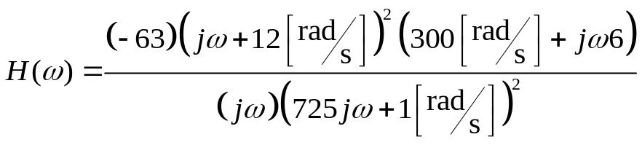.
Include in your frequency range all the nonzero zeroes and poles.

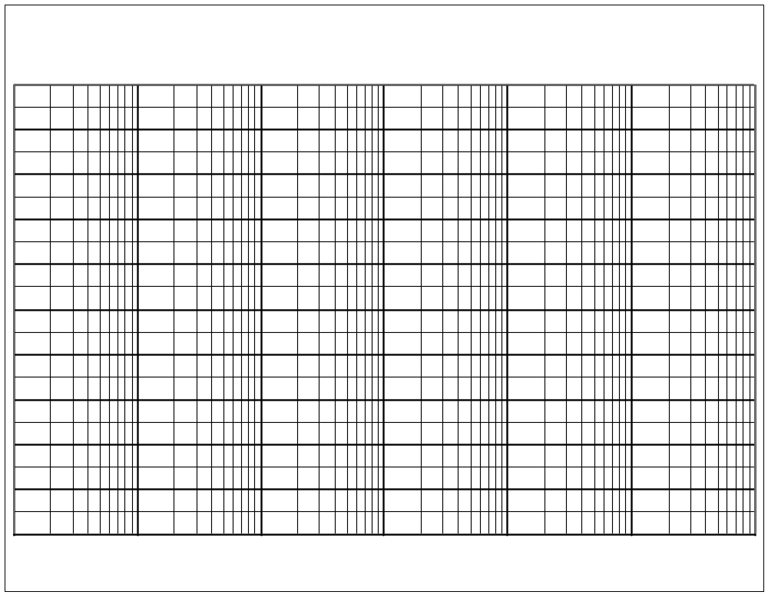
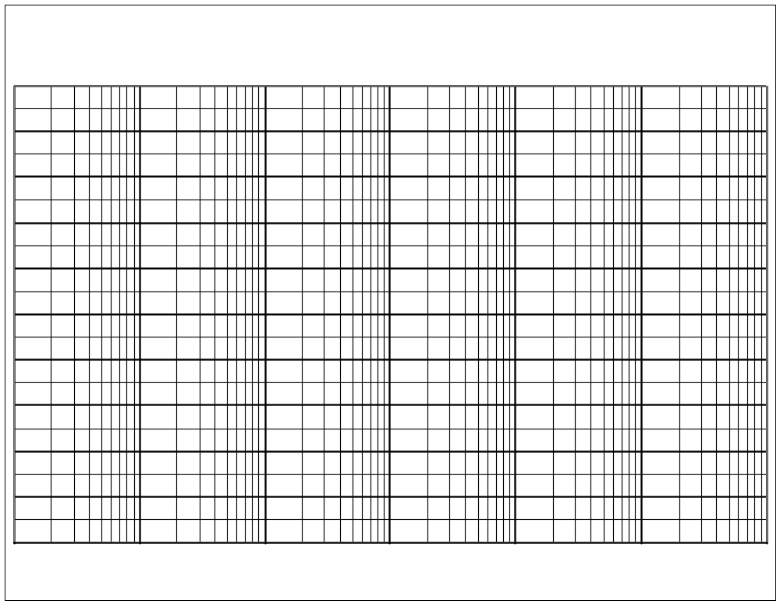
Room for extra work

2. {35 Points} Use the circuit below to find the following values.
- Find the output resistance seen by the load.
- Find the input resistance seen by the source.
It is known that
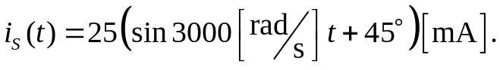
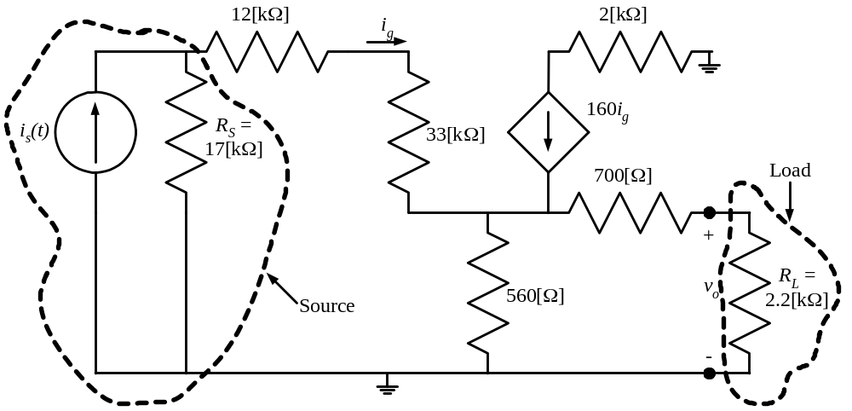

Room for extra work

3. {30 Points} A typical 10X oscilloscope probe is made up of a resistor in parallel with a variable capacitor.
- How does one adjust the setting for the variable capacitor?
- Why is the capacitor made variable, and not the resistor?
- Are there any reasons why the capacitor is in parallel with the resistor, and not in series with the resistor? Would it be sufficient to have the time constant for the probe be equal to the time constant of the oscilloscope, and have the resistor and capacitor be in series?
- Why do they not build the circuitry for the probe into the input of the oscilloscope itself, so that the probe would not be necessary?

Give your answers in complete sentences, using equations or diagrams as necessary to be clear.

Room for extra work

- {15 Points} Assume ideal op amps. Find the voltage gain, V_{Q}/V_{I}.
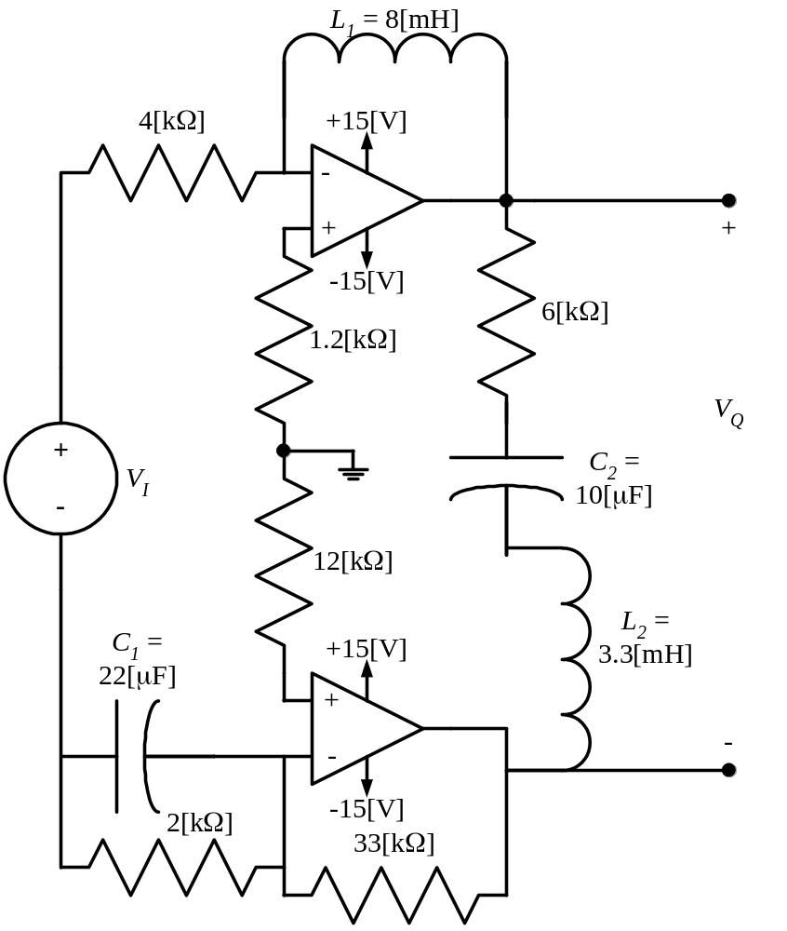

Solutions:
1. {35 Points} Use the semilog graph paper on the next two pages to plot the straight-line approximations to the magnitude and phase Bode plots for H(ω), where
.
Include in your frequency range all the nonzero zeroes and poles.
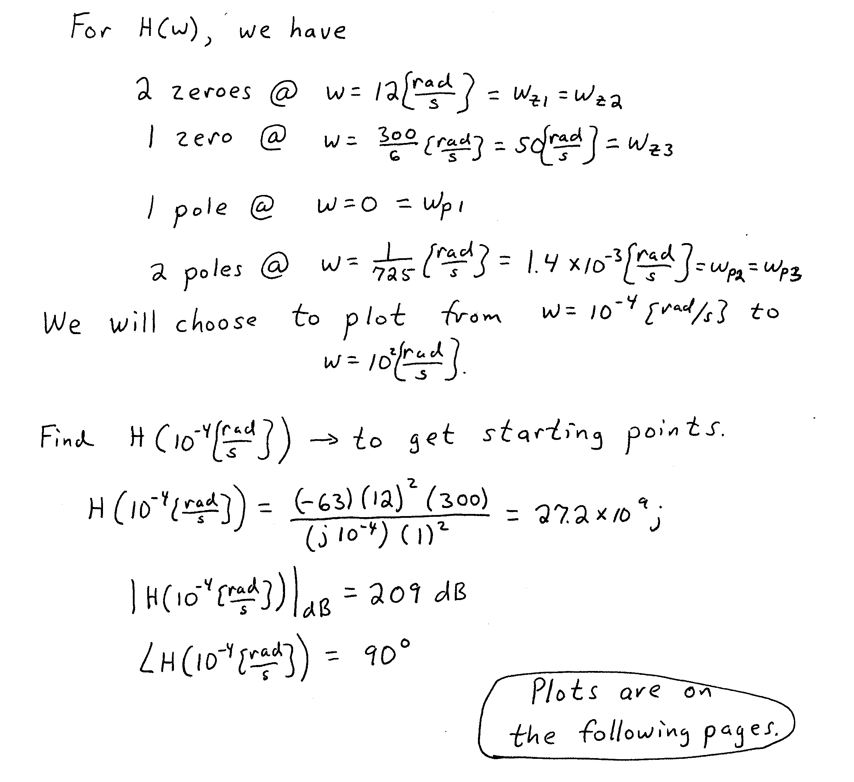
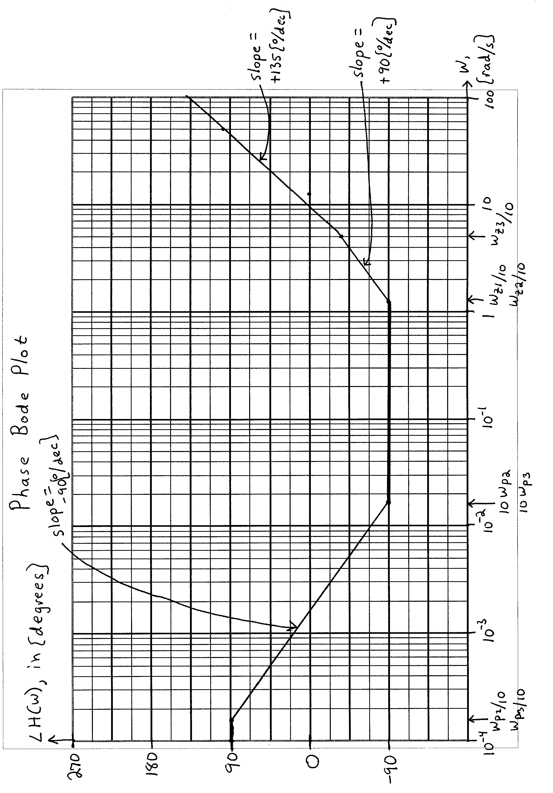
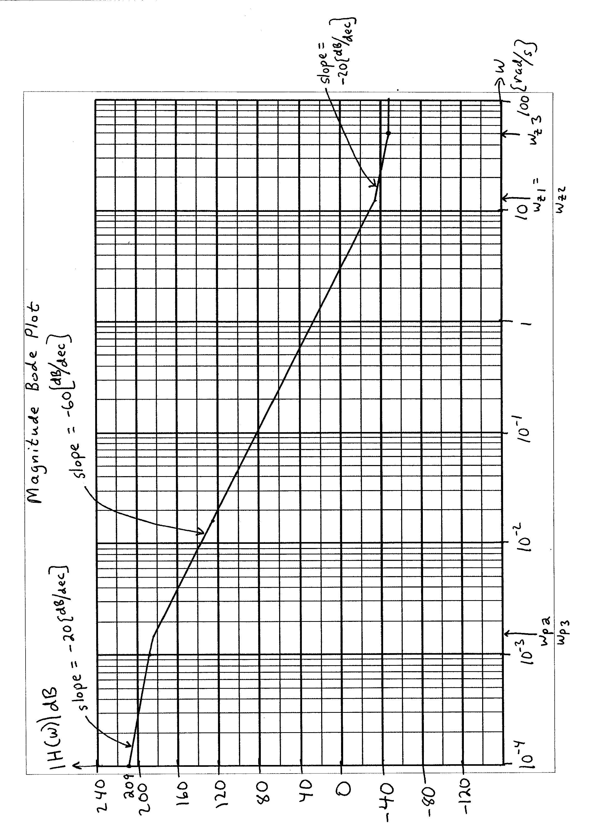
2. {35 Points} Use the circuit below to find the following values.
- Find the output resistance seen by the load.
- Find the input resistance seen by the source.
It is known that
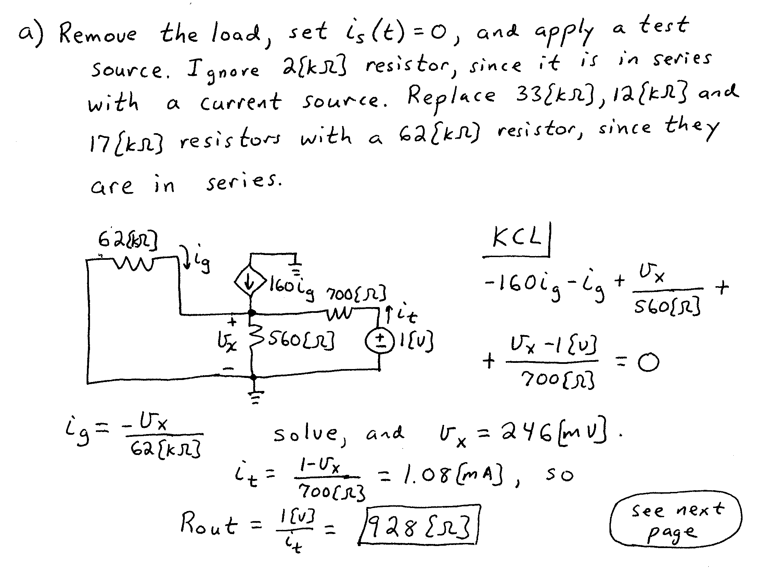
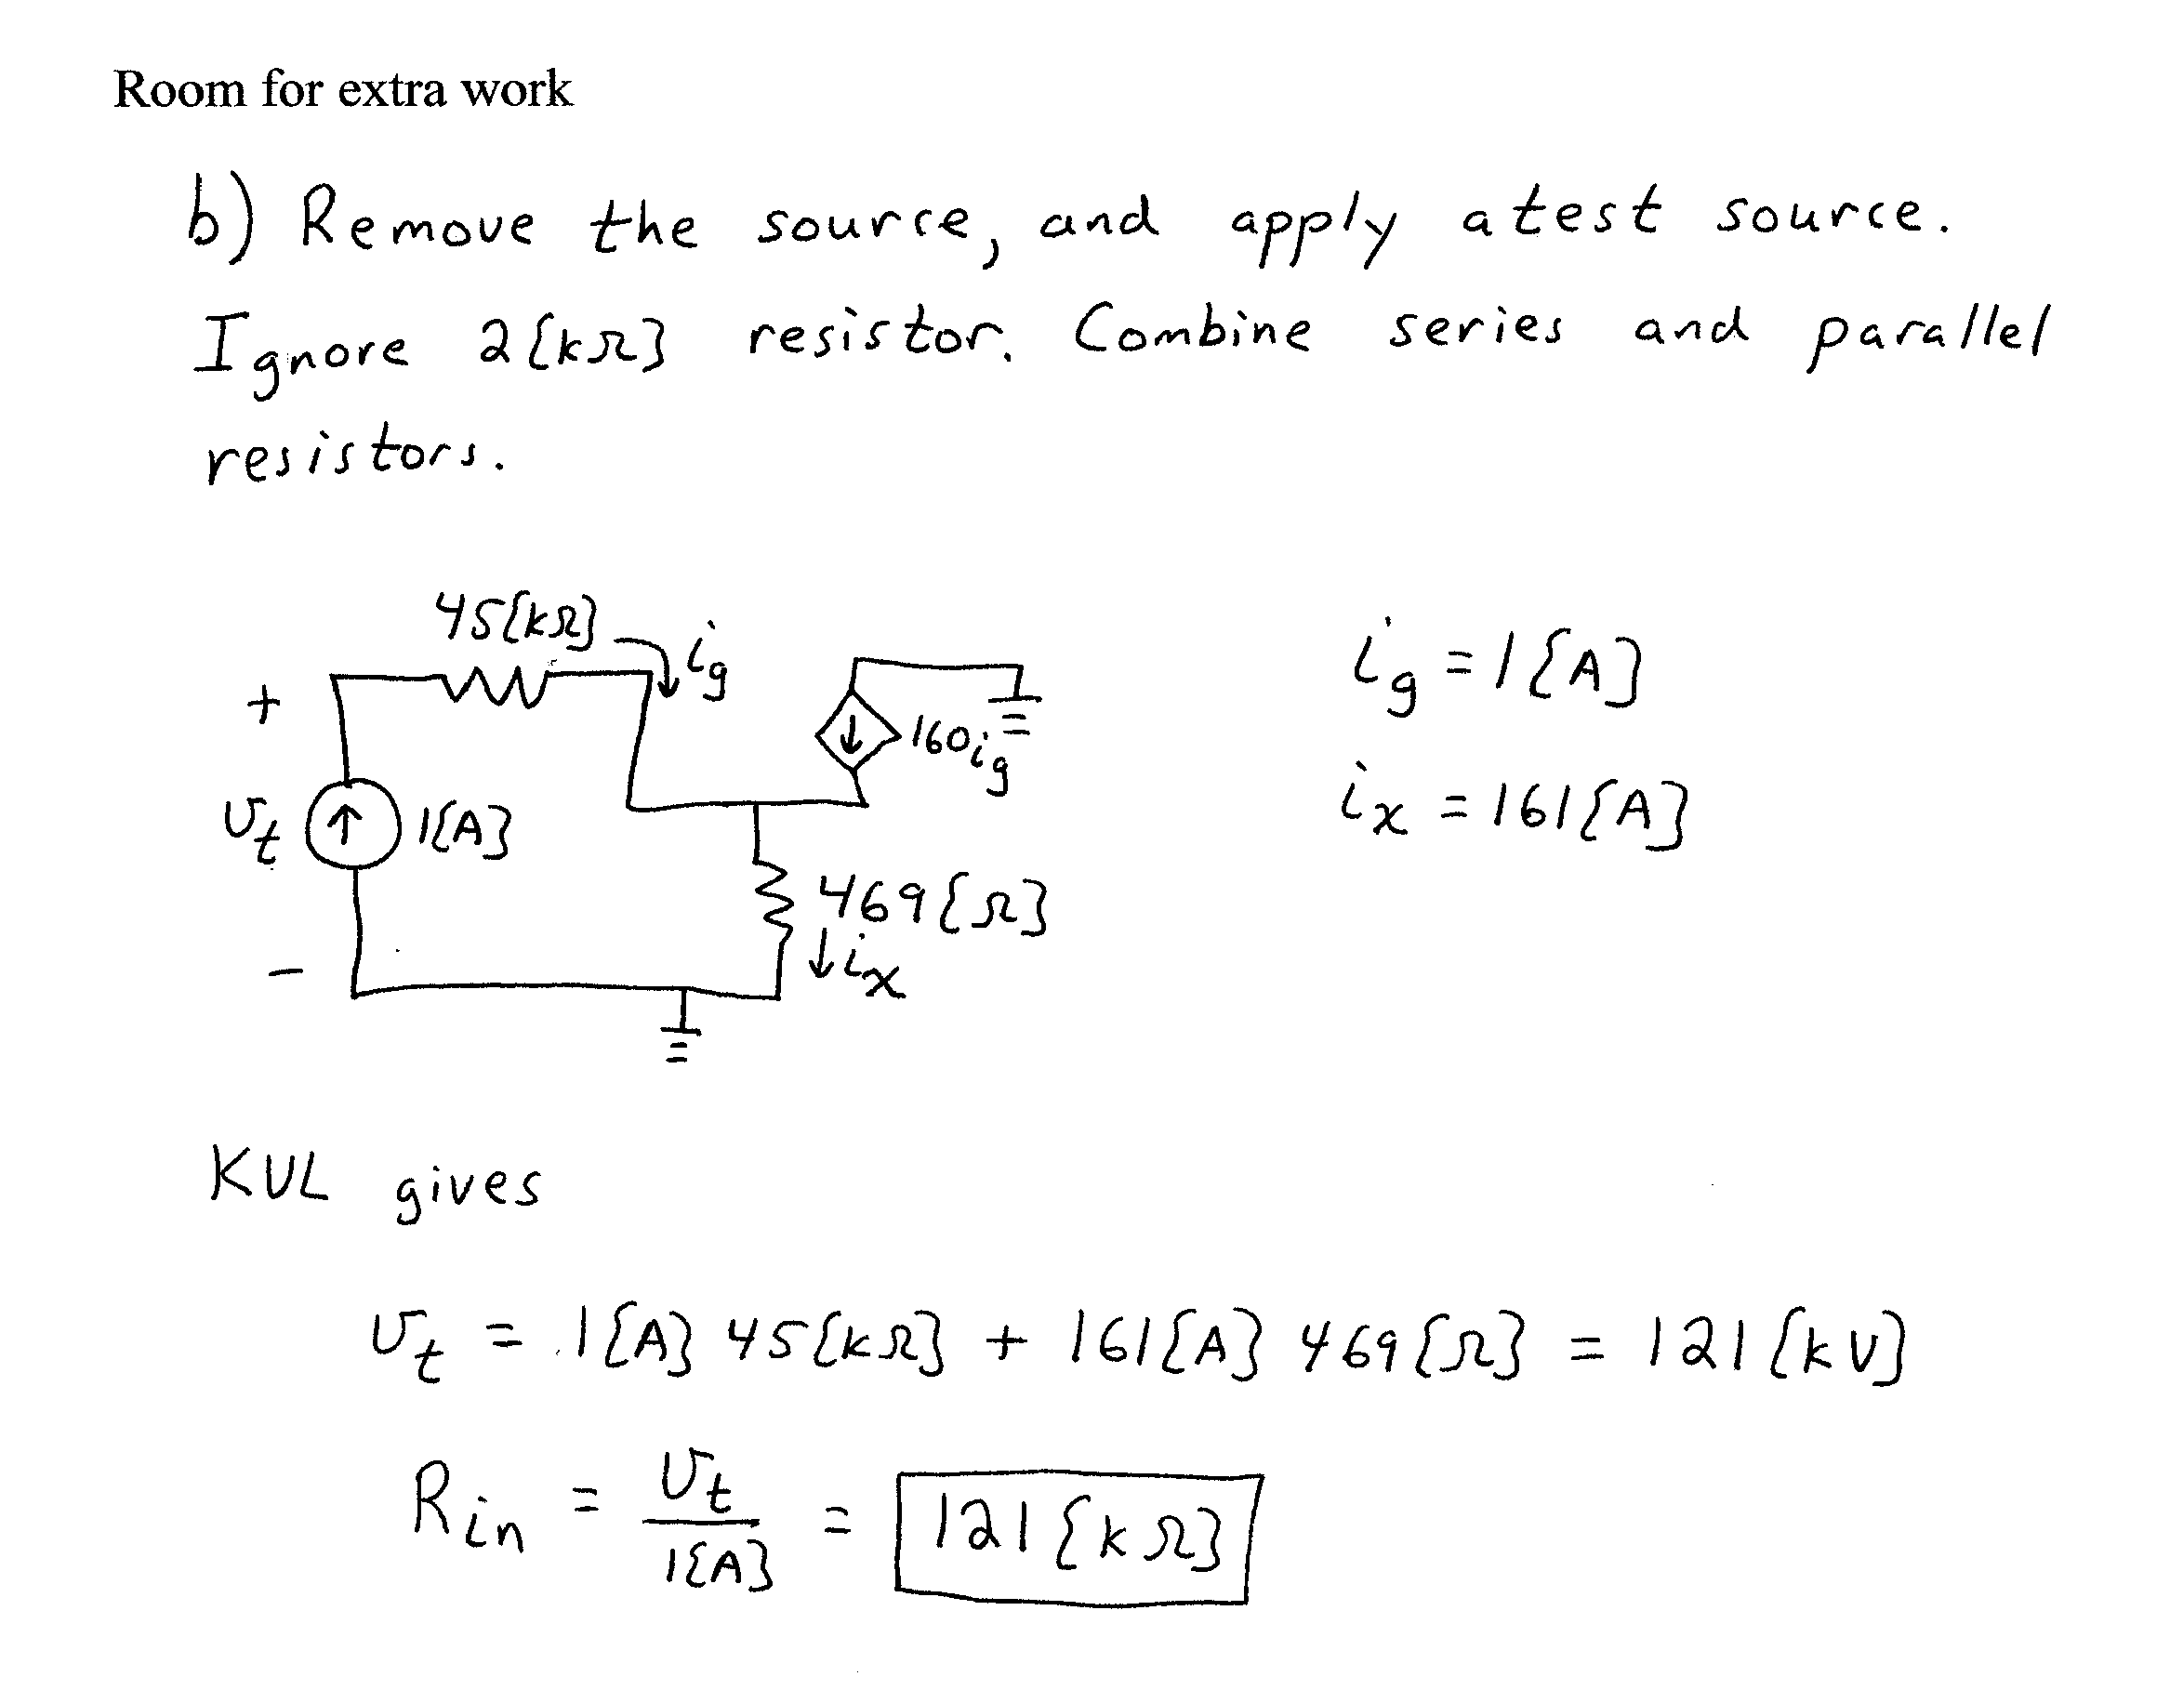
3. {30 Points} A typical 10X oscilloscope probe is made up of a resistor in parallel with a variable capacitor.
- How does one adjust the setting for the variable capacitor?
- Why is the capacitor made variable, and not the resistor?
- Are there any reasons why the capacitor is in parallel with the resistor, and not in series with the resistor? Would it be sufficient to have the time constant for the probe be equal to the time constant of the oscilloscope, and have the resistor and capacitor be in series?
- Why do they not build the circuitry for the probe into the input of the oscilloscope itself, so that the probe would not be necessary?

Give your answers in complete sentences, using equations or diagrams as necessary to be clear.
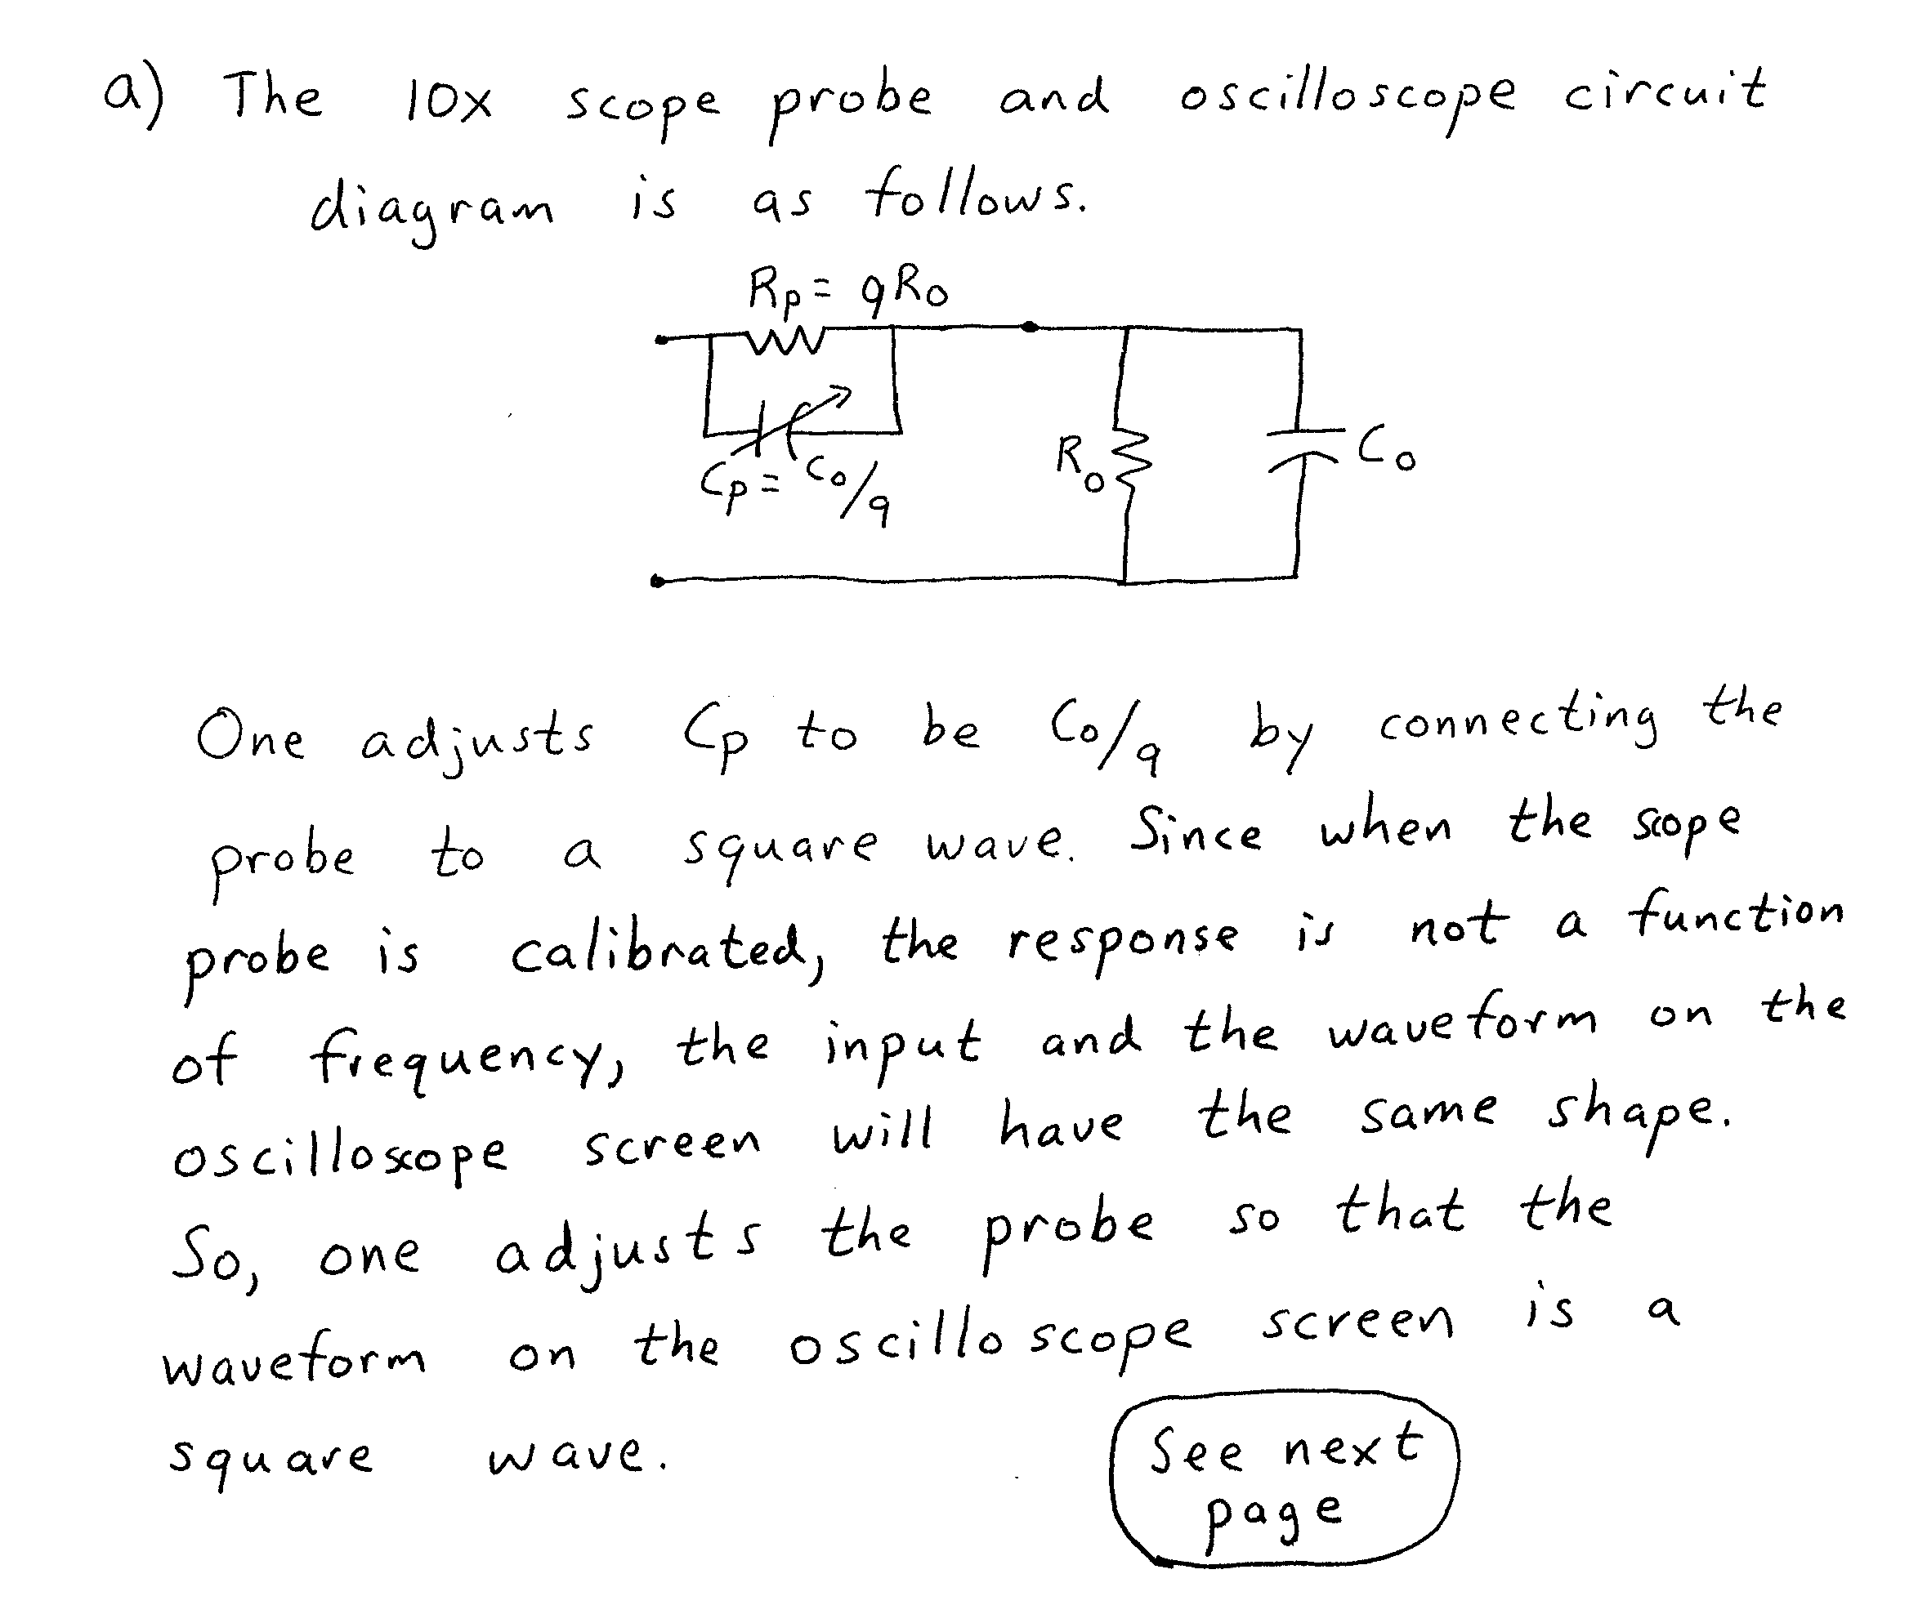
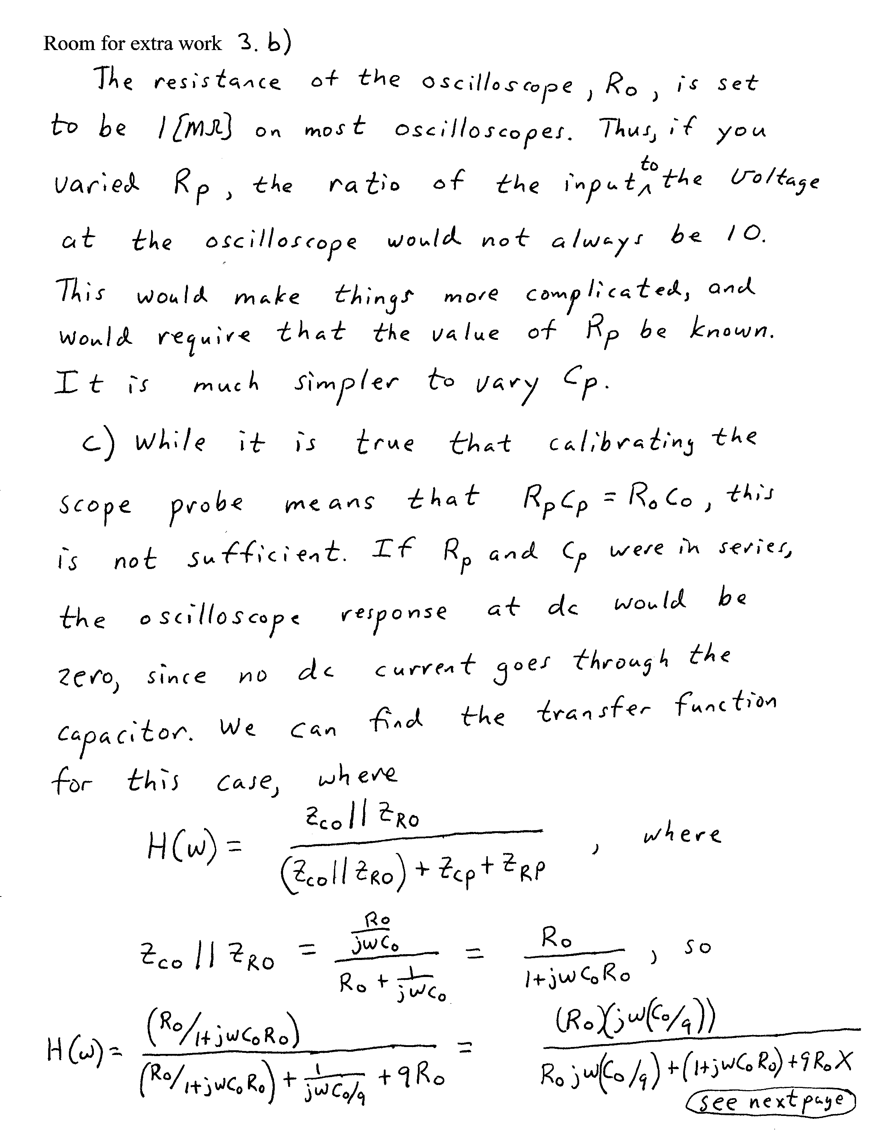
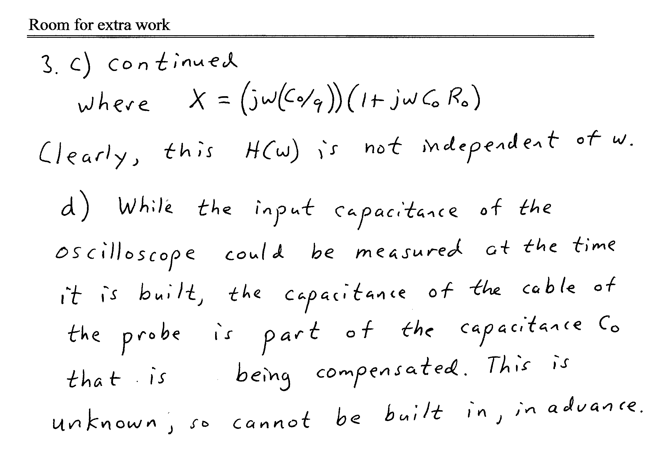

4. {15 Points} Assume ideal op amps. Find the voltage gain, V_{Q}/V_{I}.


