Name: _____________________________ (please print)
Signature: __________________________

ECE 3455 – Final Exam
May 4, 2005
Keep this exam closed until you are told to begin.

1. This exam is closed book, closed notes. You may use one 8.5” x 11” crib sheet, or its equivalent.
2. Show all work on these pages. Show all work necessary to complete the problem. A solution without the appropriate work shown will receive no credit. A solution that is not given in a reasonable order will lose credit. Clearly indicate your answer (for example by enclosing it in a box).
3. It is assumed that your work will begin on the same page as the problem statement. If you choose to begin your work on another page, you must indicate this on the page with the problem statement, with a clear indication of where the work can be found. If your work continues on to another page, indicate clearly where your work can be found. Failure to indicate this clearly will result in a loss of credit.
4. Show all units in solutions, intermediate results, and figures. Units in the exam will be included between square brackets.
5. Do not use red ink. Do not use red pencil.
6. You will have 180 minutes to work on this exam.

1. ________________/25
2. ________________/25
3. ________________/25
4. ________________/25
5. ________________/10
Total = 110

Room for extra work
1. {25 Points} The straight-line approximation to the magnitude Bode plot for H(ω) is given in the figure below. All the poles and zeroes in this transfer function are in the range of frequencies that are plotted. It is given that
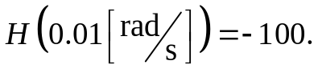
Find a numerical expression for H(ω).
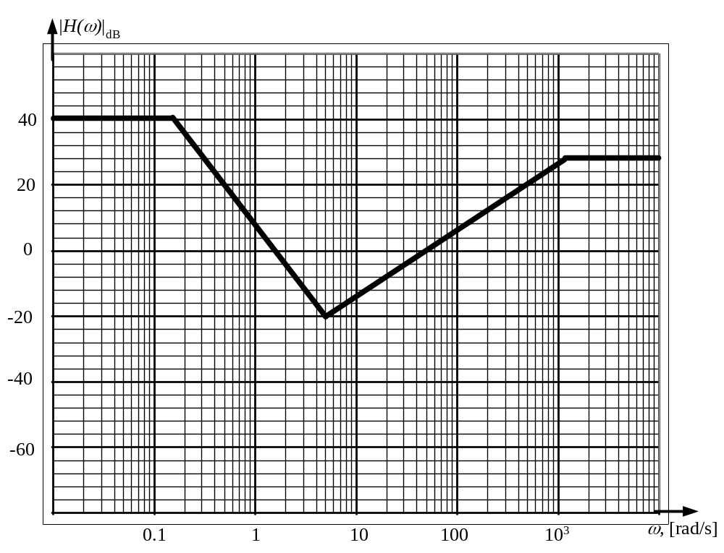
Room for extra work

2. {25 Points} Assume an ideal op amp in the circuit that is shown below.
- Find v_{Q} as a function of v_{i}.
- Find the voltage gain, v_{q}/v_{i}.
- Find the input resistance as seen by the signal source, v_{i}.
- Find the output resistance seen by the 1[kΩ] resistor, R_{L}.
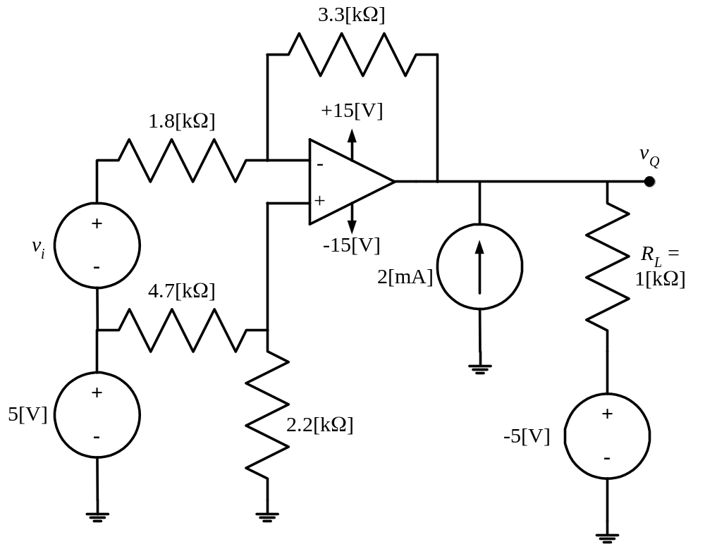

Room for extra work

3. {25 Points} A new device has been devised, and is called a Houstonor. The schematic symbol for the Houstonor is shown in Figure 1, and its characteristic curve is given in Figure 2. This device is connected into the circuit in Figure 3.
- Find I_{X} and V_{X}.
- Plot the load line for the circuit in Figure 3 on the characteristic curve for the Houstonor.
- Compare the solution from the load line with your solutions in part a). Do they agree?
- Are there any values of V_{S}, I_{S}, and R that would yield more than one solution? Are there any values of V_{S}, I_{S}, and R that would yield no solution? Explain your answers.
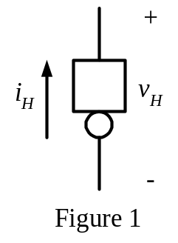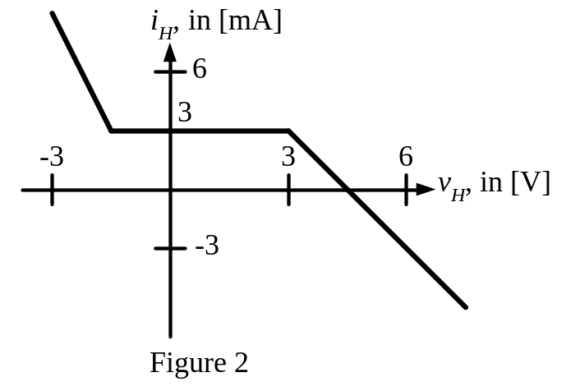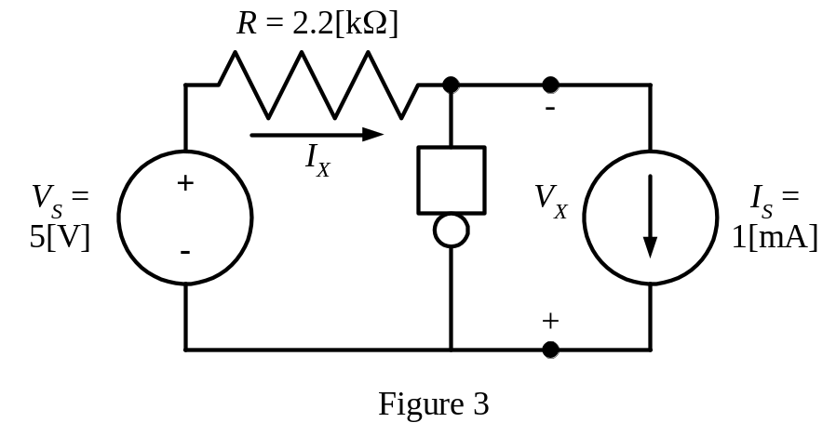

Room for extra work

4. {25 Points} The transistor in the circuit that follows has a β = 100, and operates at room temperature.
- Find the voltage gain, v_{o}/v_{s}, in the passband.
- Find the input resistance seen by the source, v_{s}, in the passband.
- Find the output resistance seen by the load, R_{L}, in the passband.

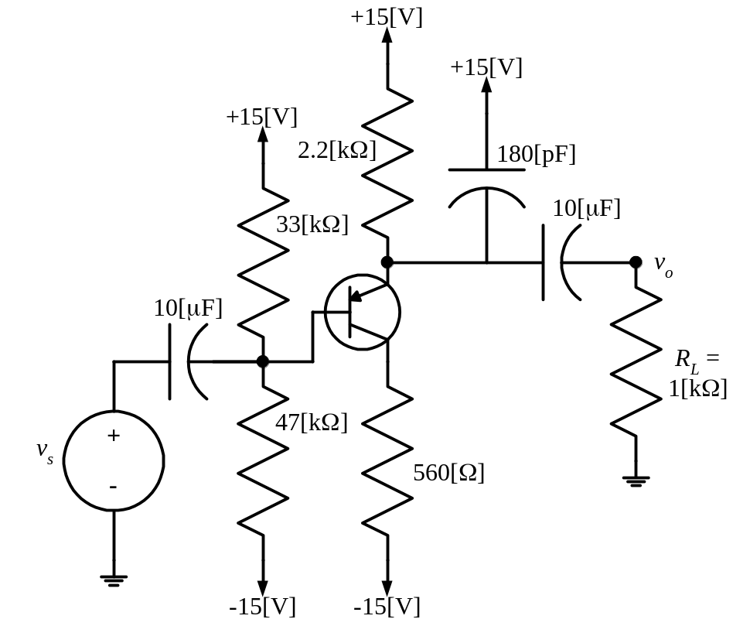

Room for extra work

5. {10 Points} Assume an ideal op amp. Describe, quantitatively, the voltage v_{A}(t). Show your equations, and all other necessary work.

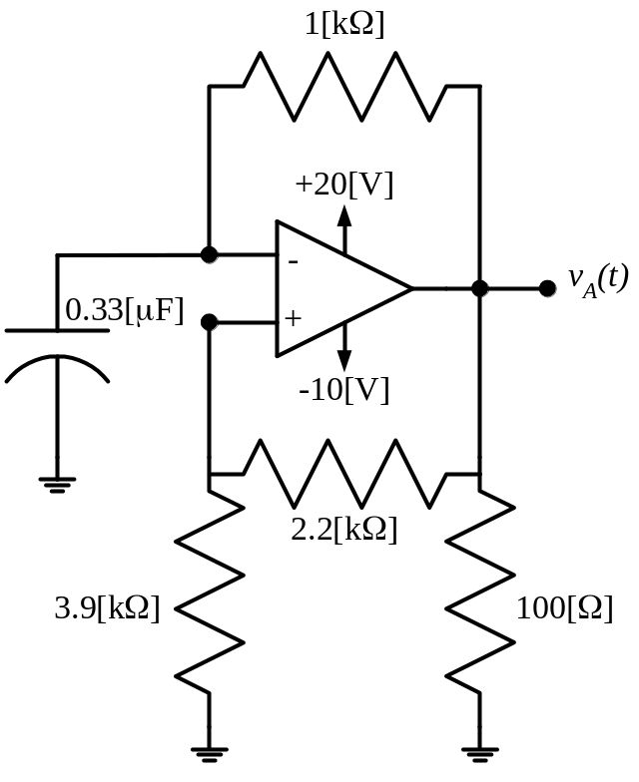

1. {25 Points} The straight-line approximation to the magnitude Bode plot for H(ω) is given in the figure below. All the poles and zeroes in this transfer function are in the range of frequencies that are plotted. It is given that
Find a numerical expression for H(ω).
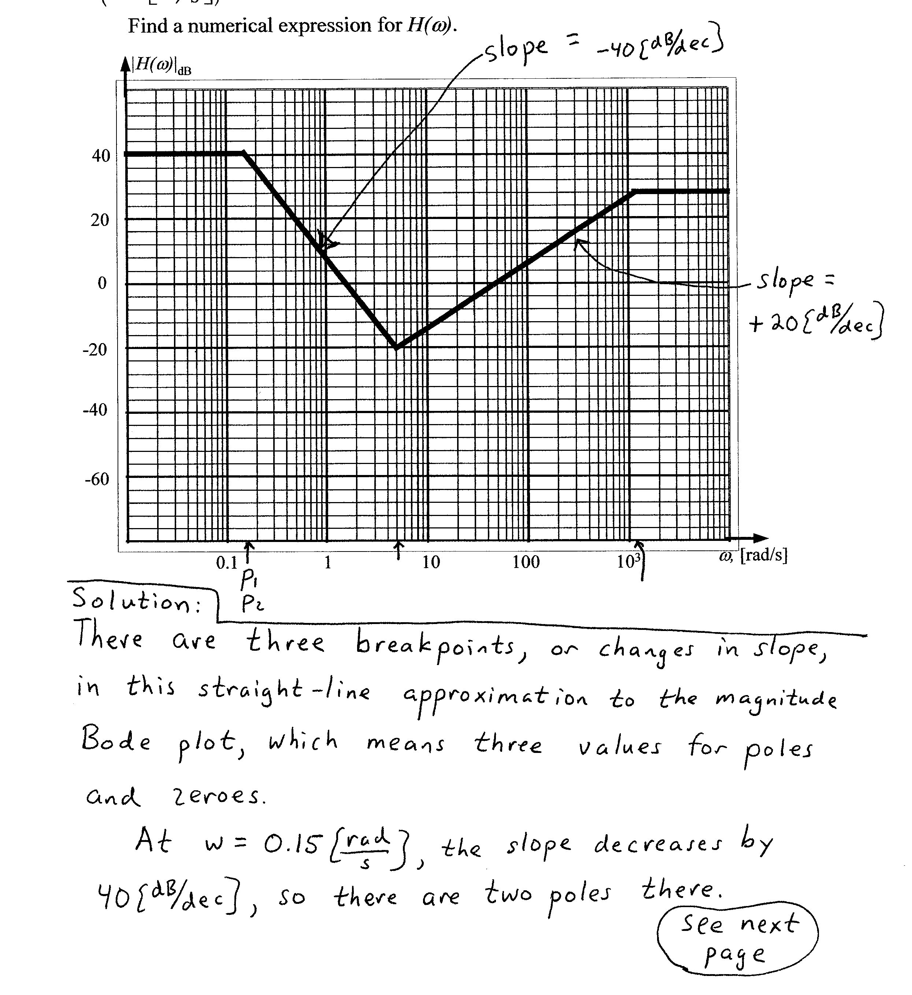
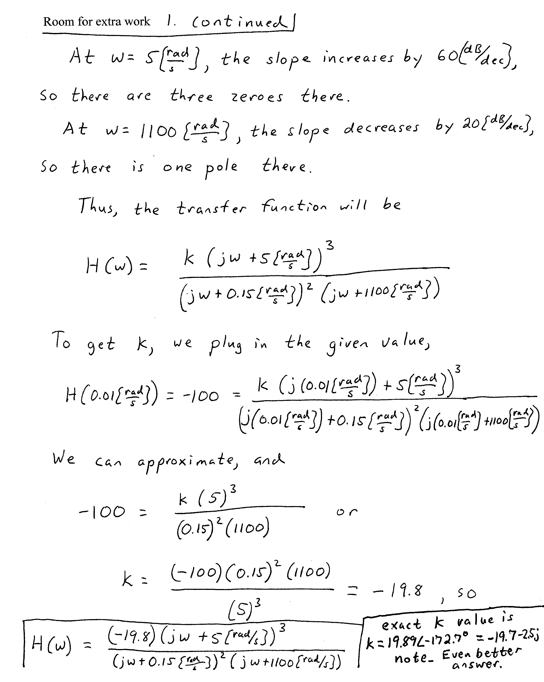

2. {25 Points} Assume an ideal op amp in the circuit that is shown below.
- Find v_{Q} as a function of v_{i}.
- Find the voltage gain, v_{q}/v_{i}.
- Find the input resistance as seen by the signal source, v_{i}.
- Find the output resistance seen by the 1[kΩ] resistor, R_{L}.
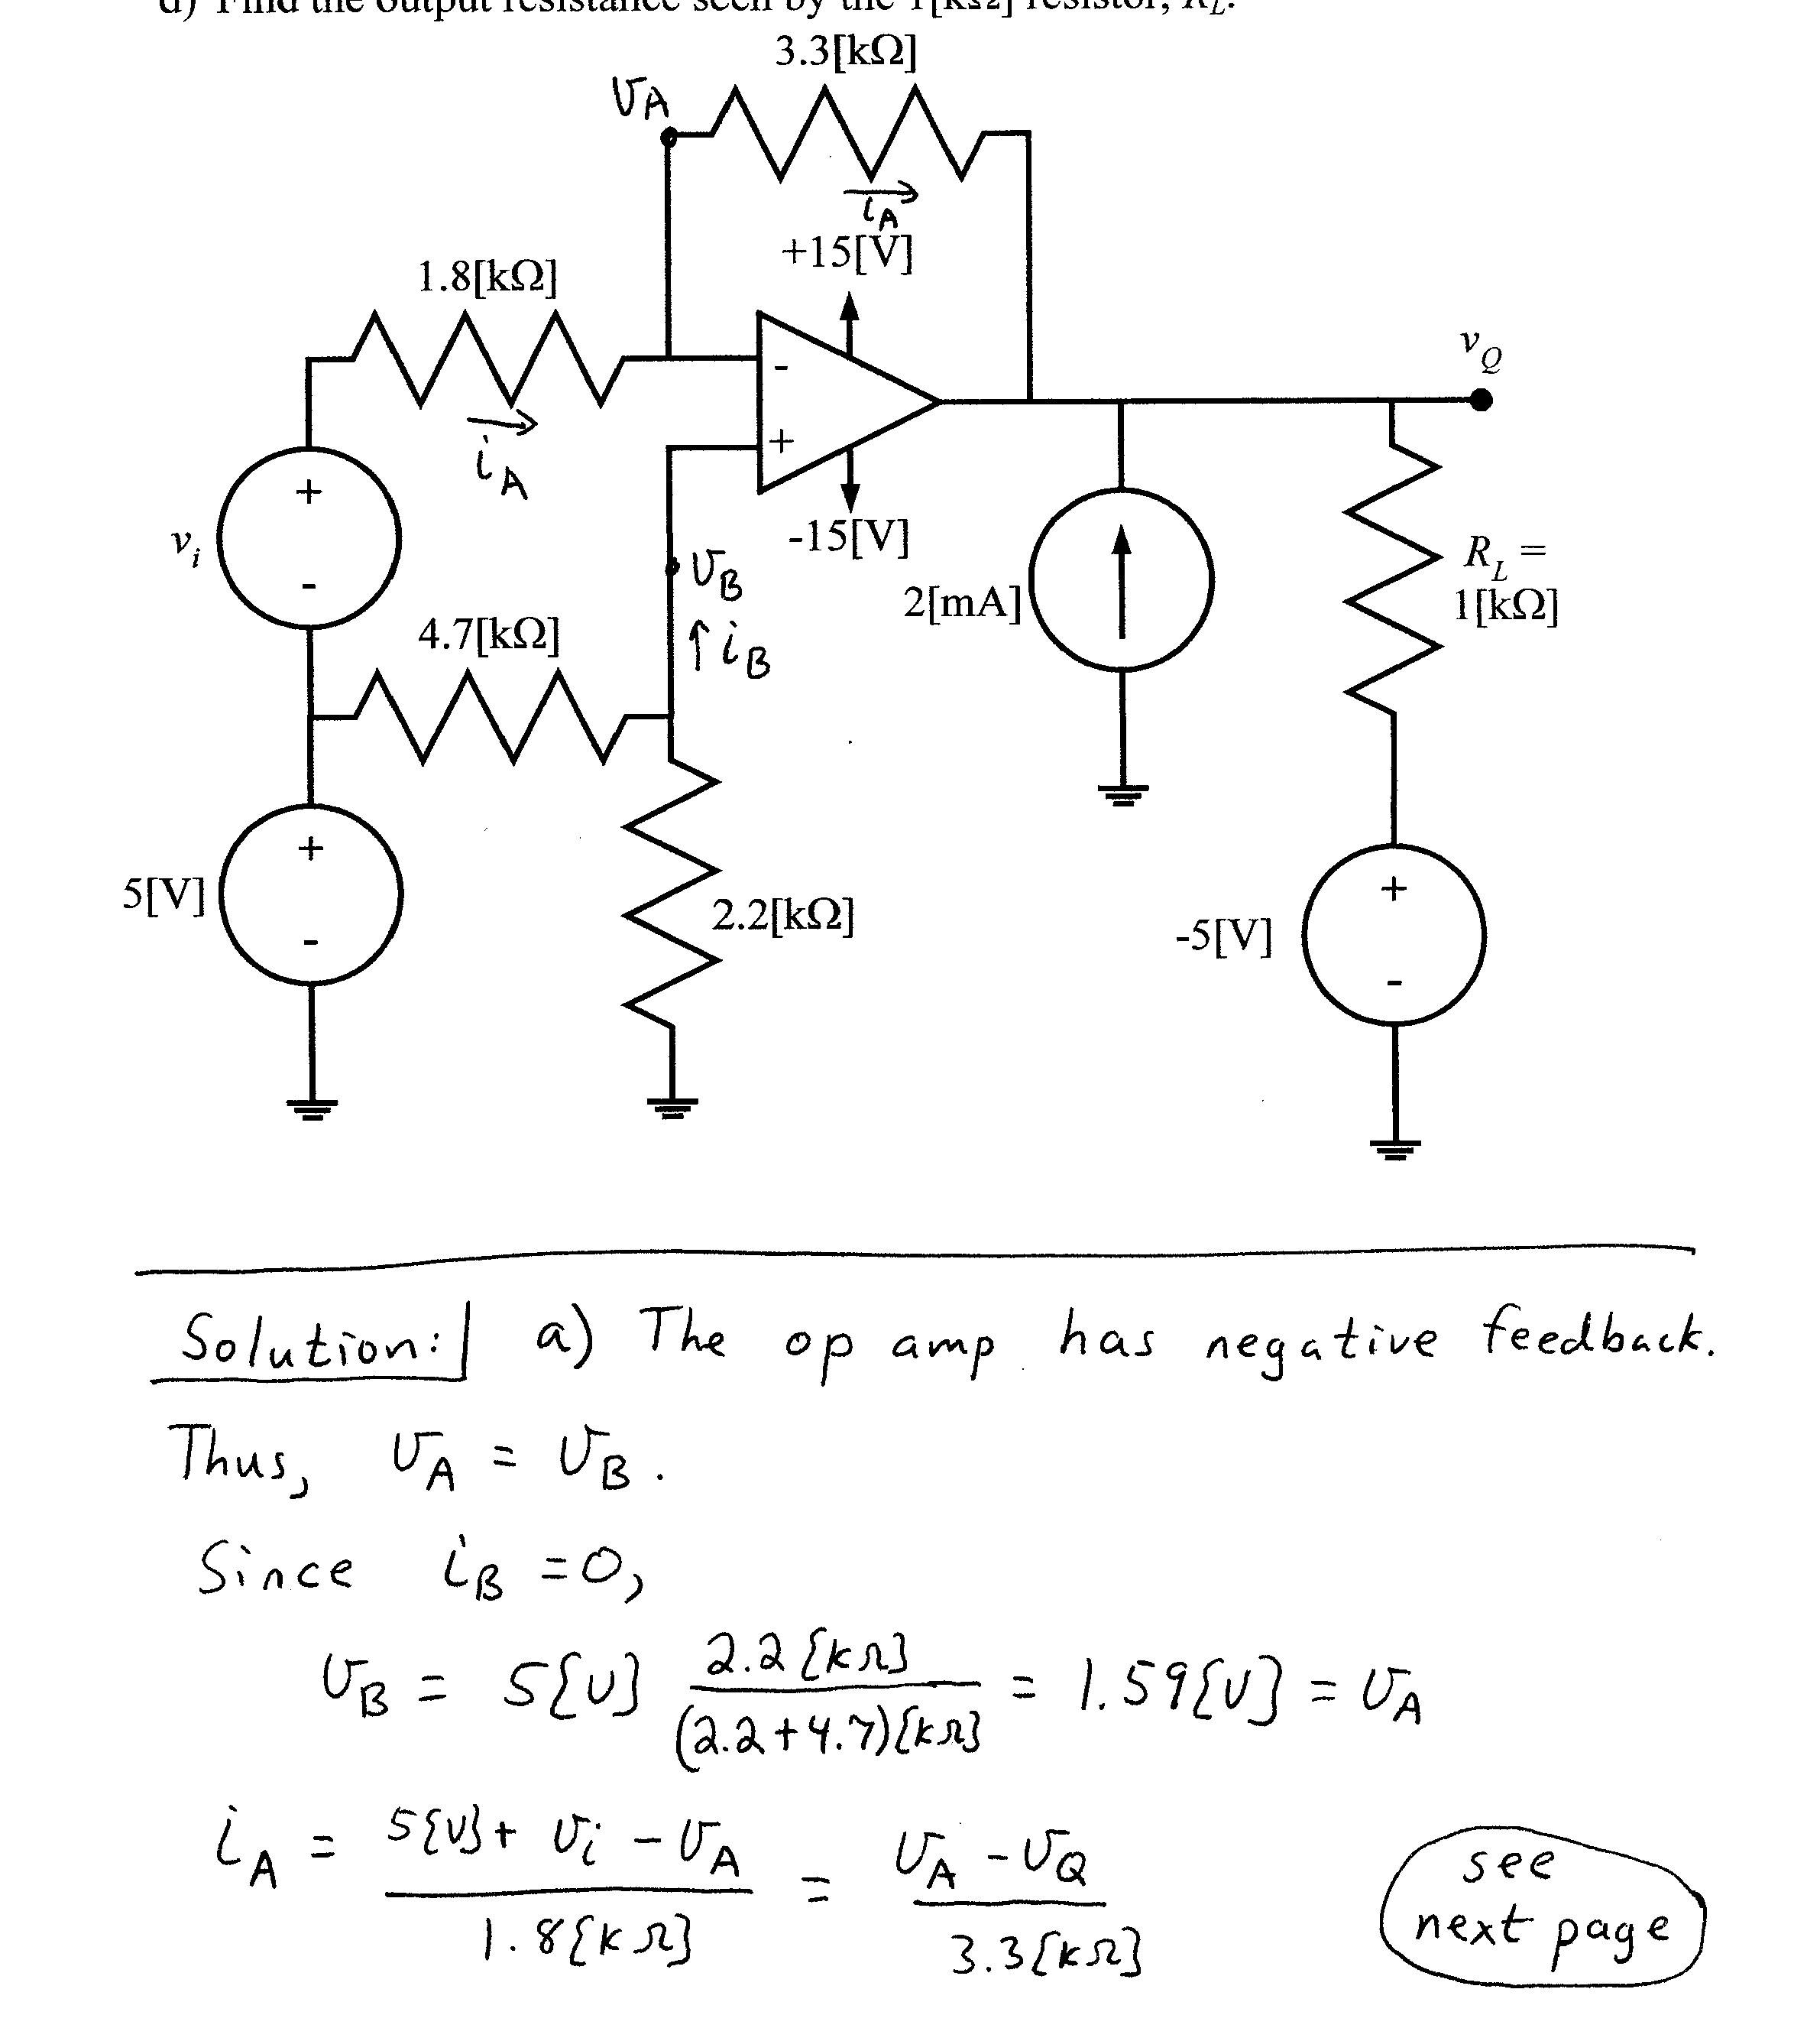
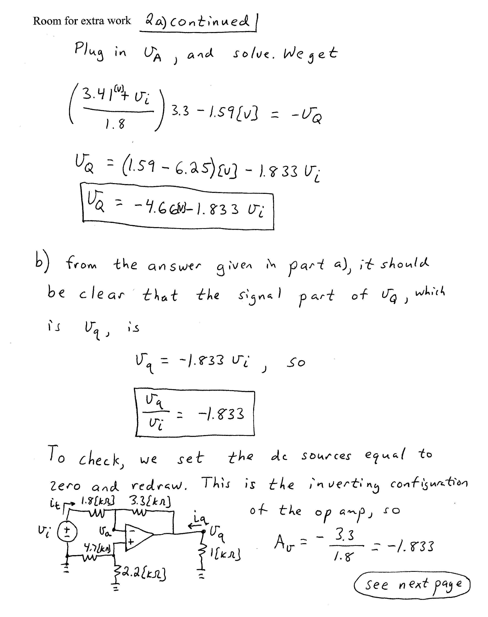
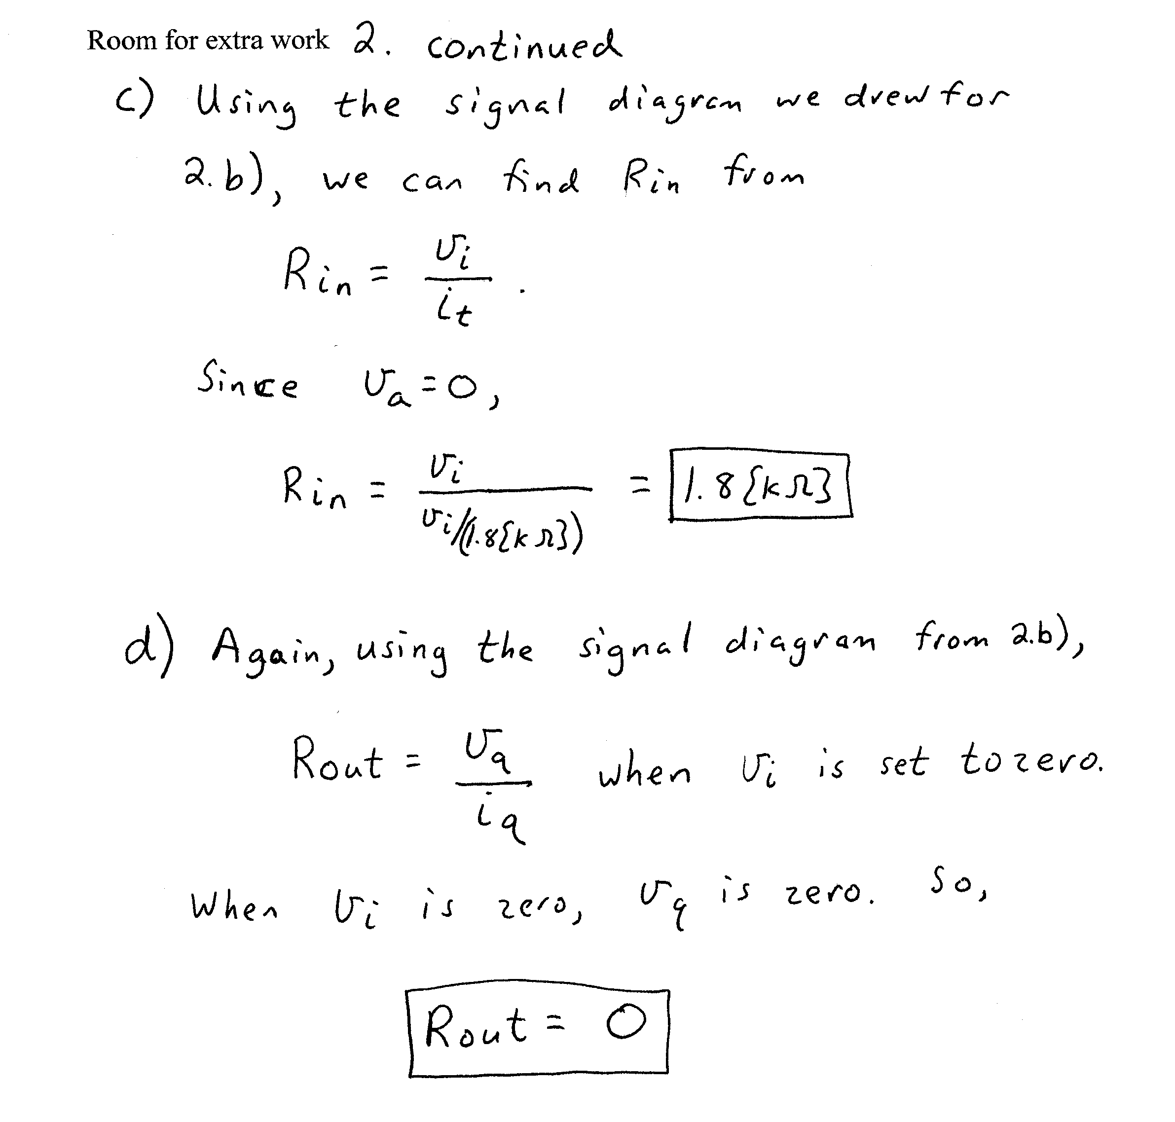

3. {25 Points} A new device has been devised, and is called a Houstonor. The schematic symbol for the Houstonor is shown in Figure 1, and its characteristic curve is given in Figure 2. This device is connected into the circuit in Figure 3.
- Find I_{X} and V_{X}.
- Plot the load line for the circuit in Figure 3 on the characteristic curve for the Houstonor.
- Compare the solution from the load line with your solutions in part a). Do they agree?
- Are there any values of V_{S}, I_{S}, and R that would yield more than one solution? Are there any values of V_{S}, I_{S}, and R that would yield no solution? Explain your answers.
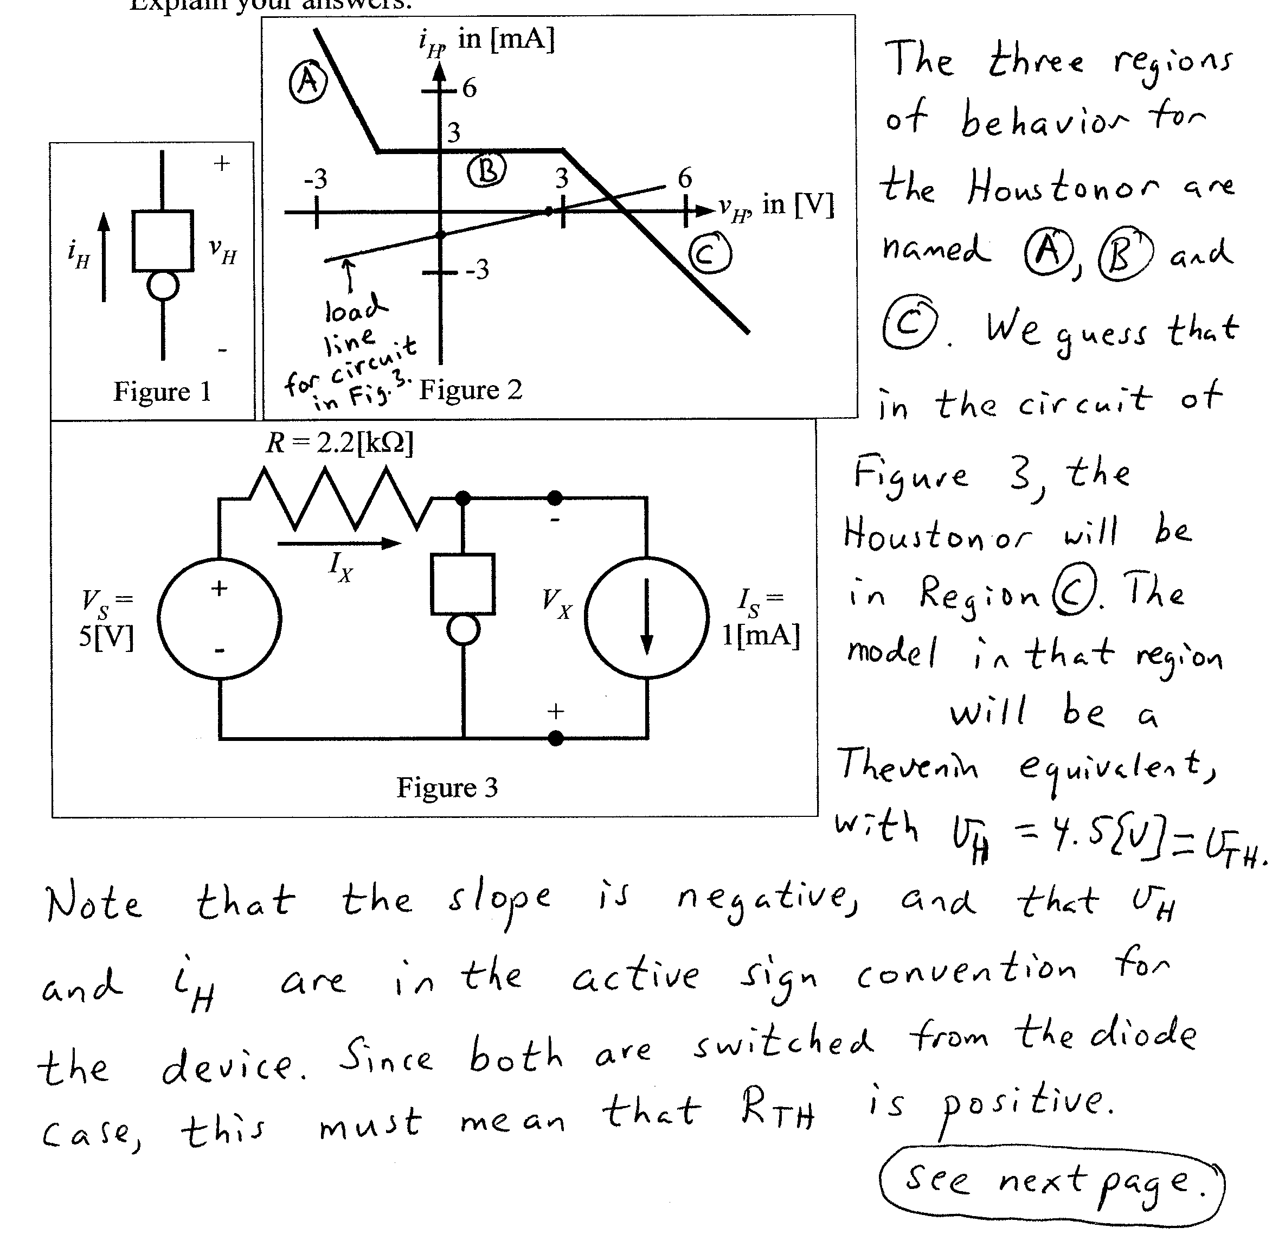
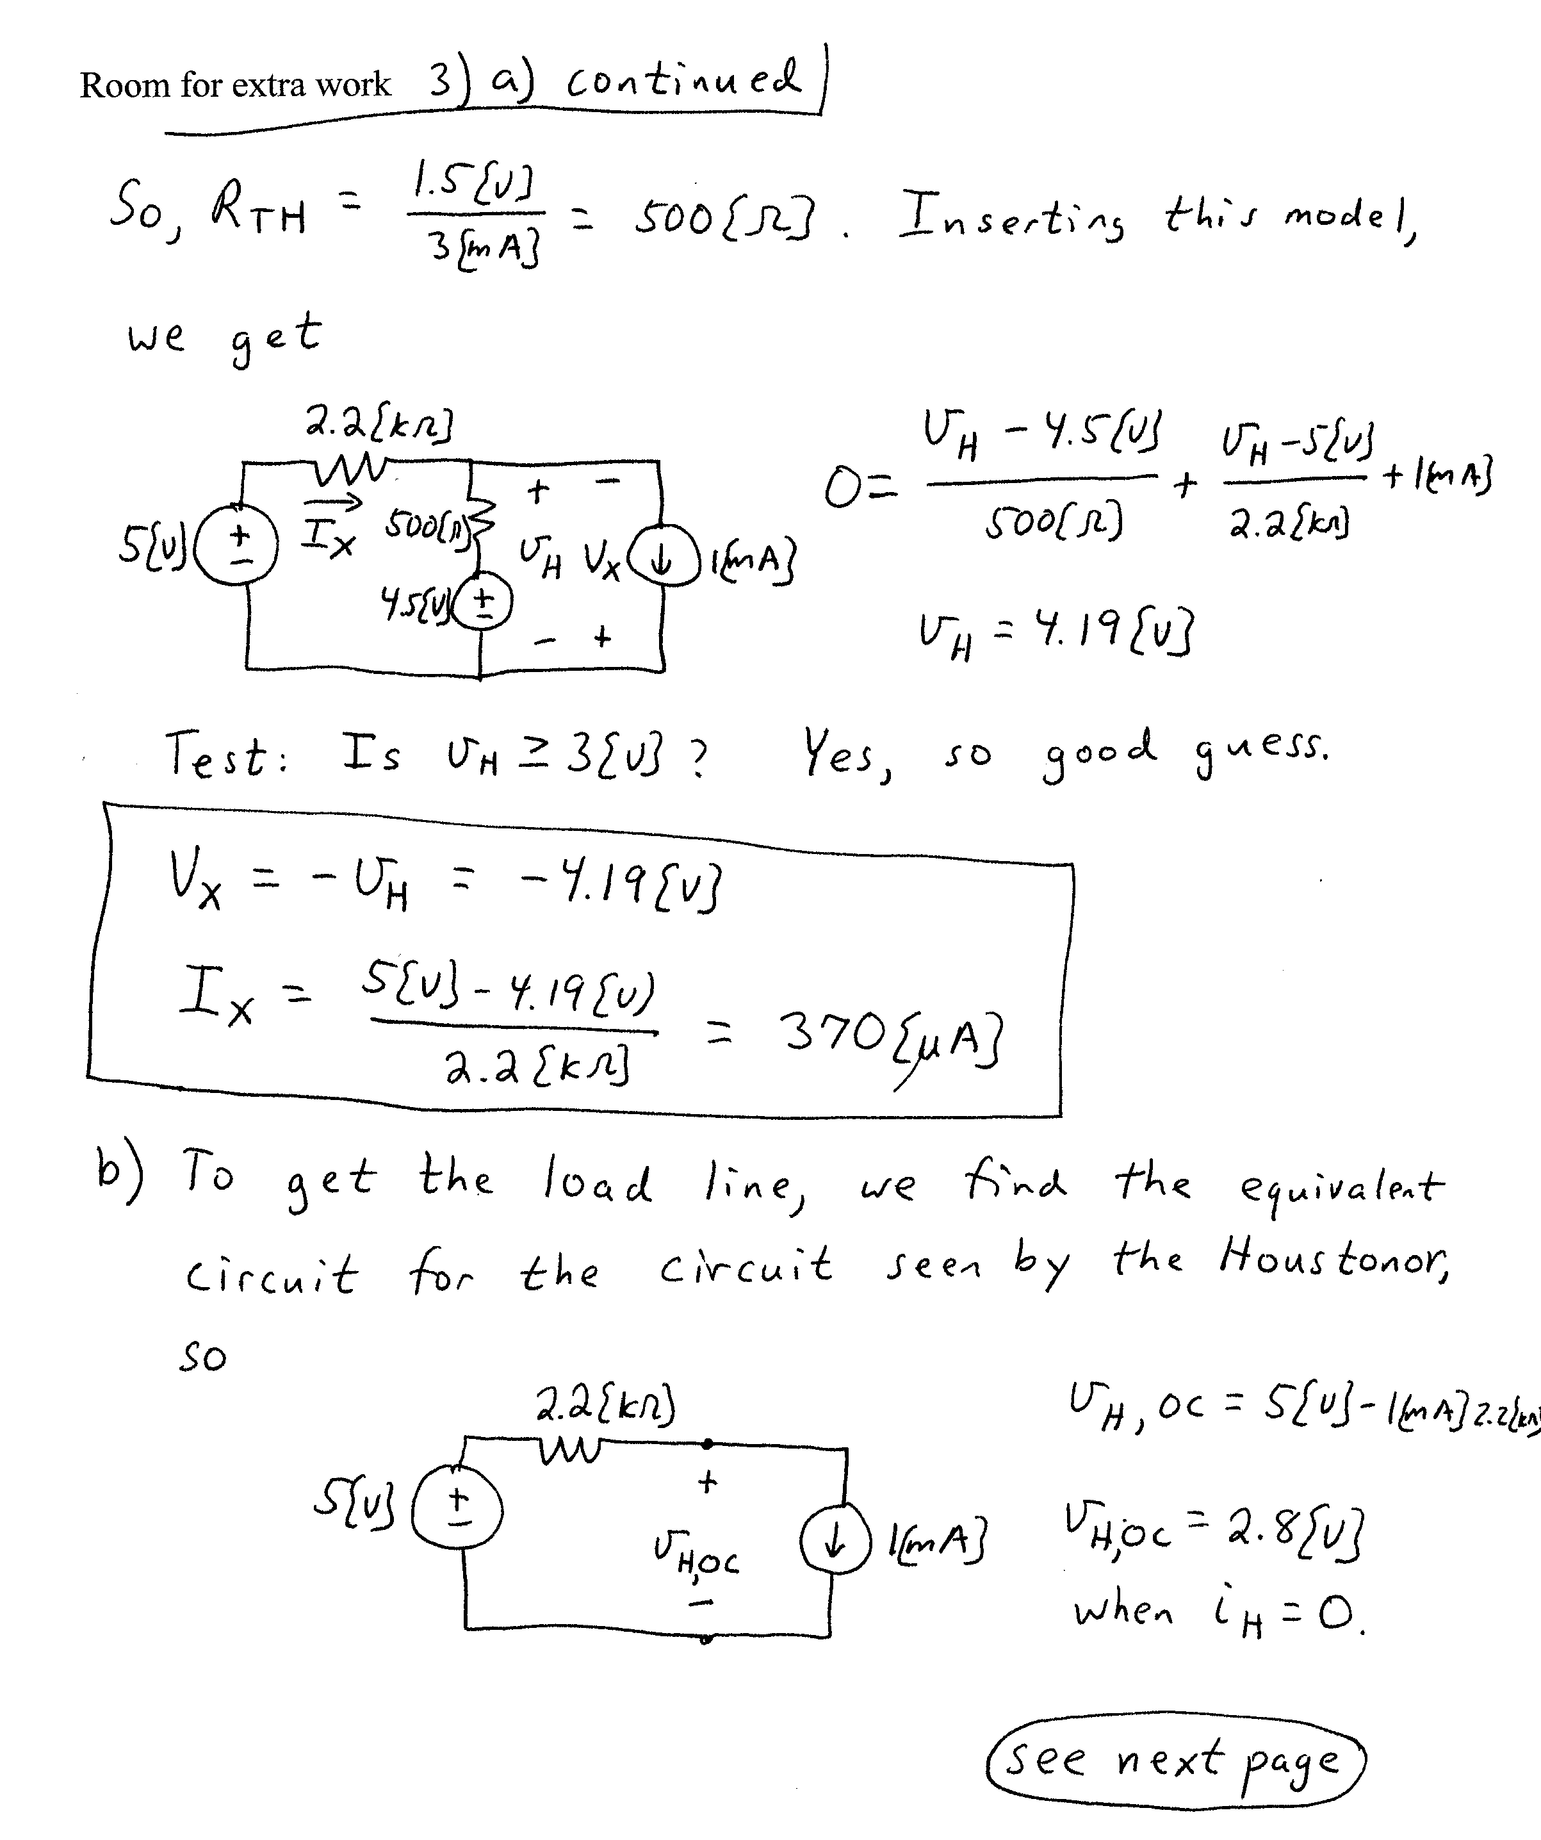
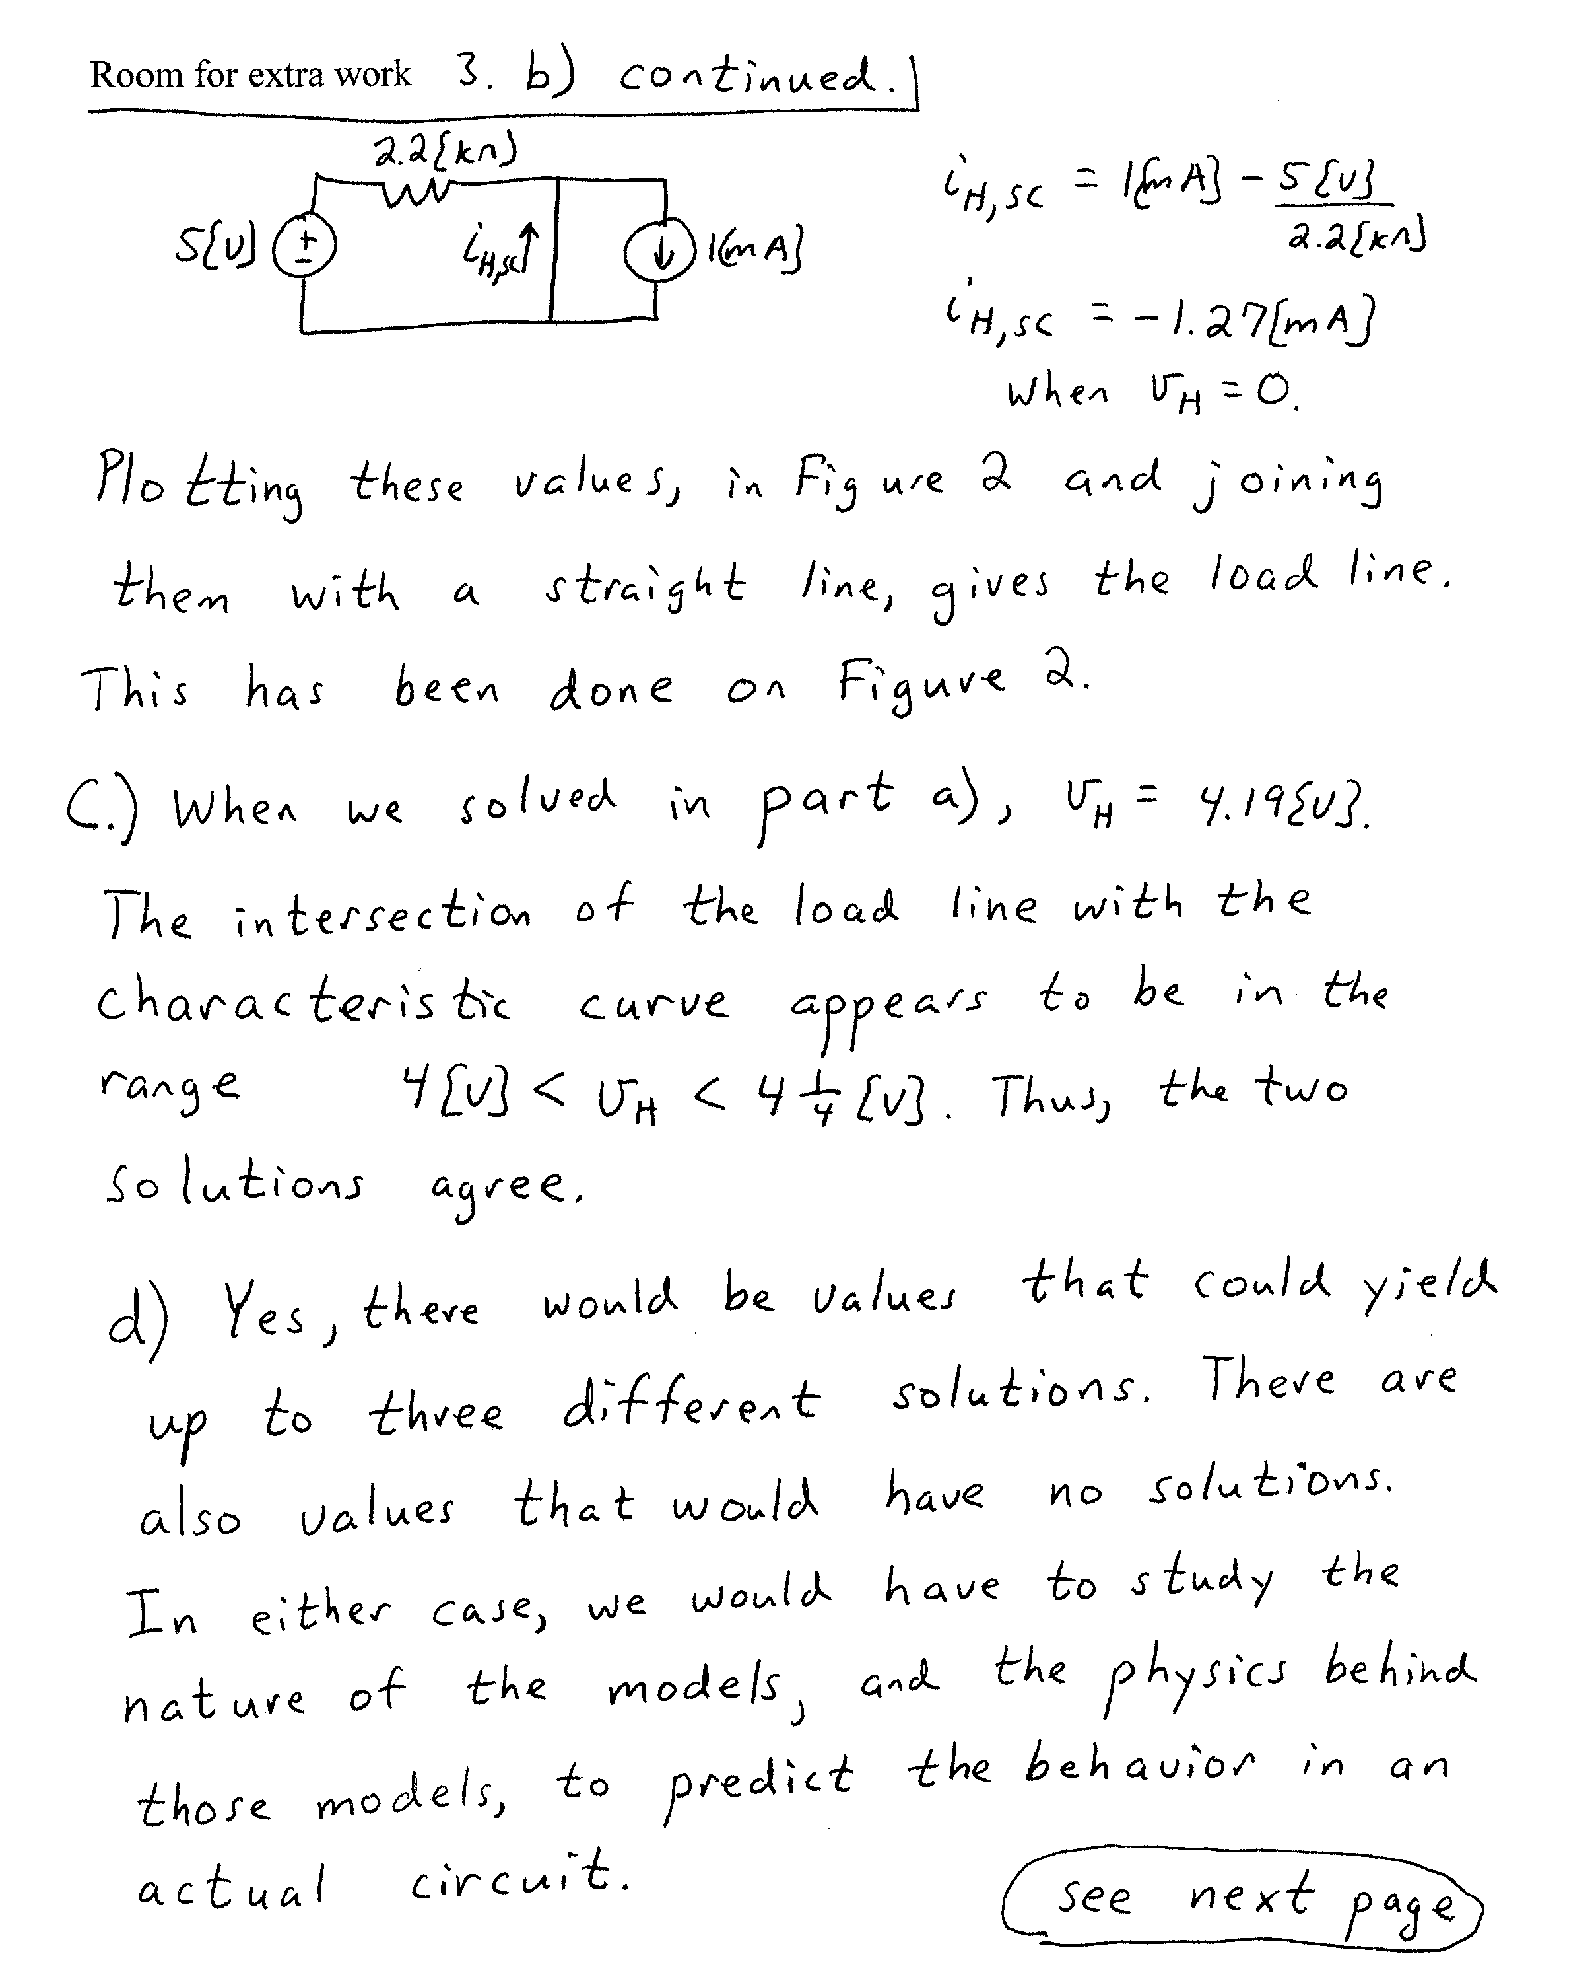
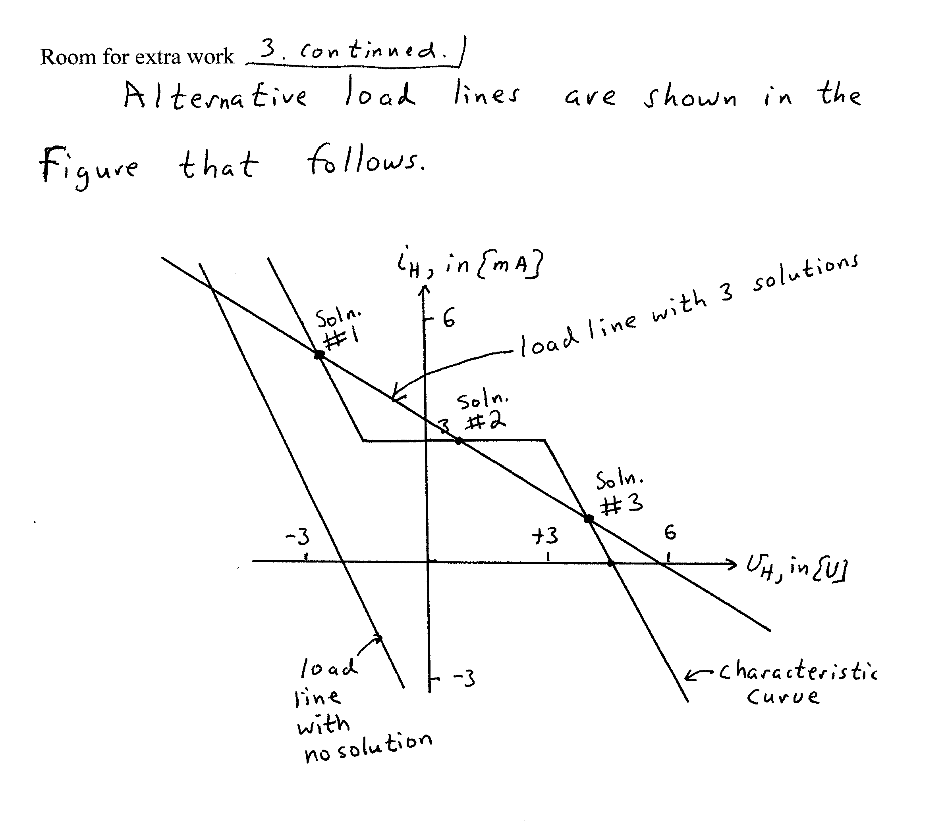

4. {25 Points} The transistor in the circuit that follows has a β = 100, and operates at room temperature.
- Find the voltage gain, v_{o}/v_{s}, in the passband.
- Find the input resistance seen by the source, v_{s}, in the passband.
- Find the output resistance seen by the load, R_{L}, in the passband.

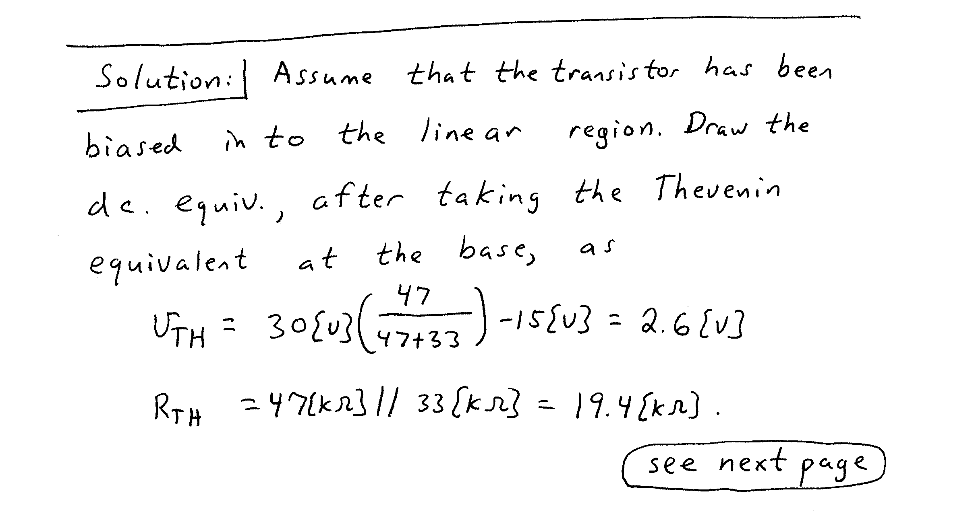
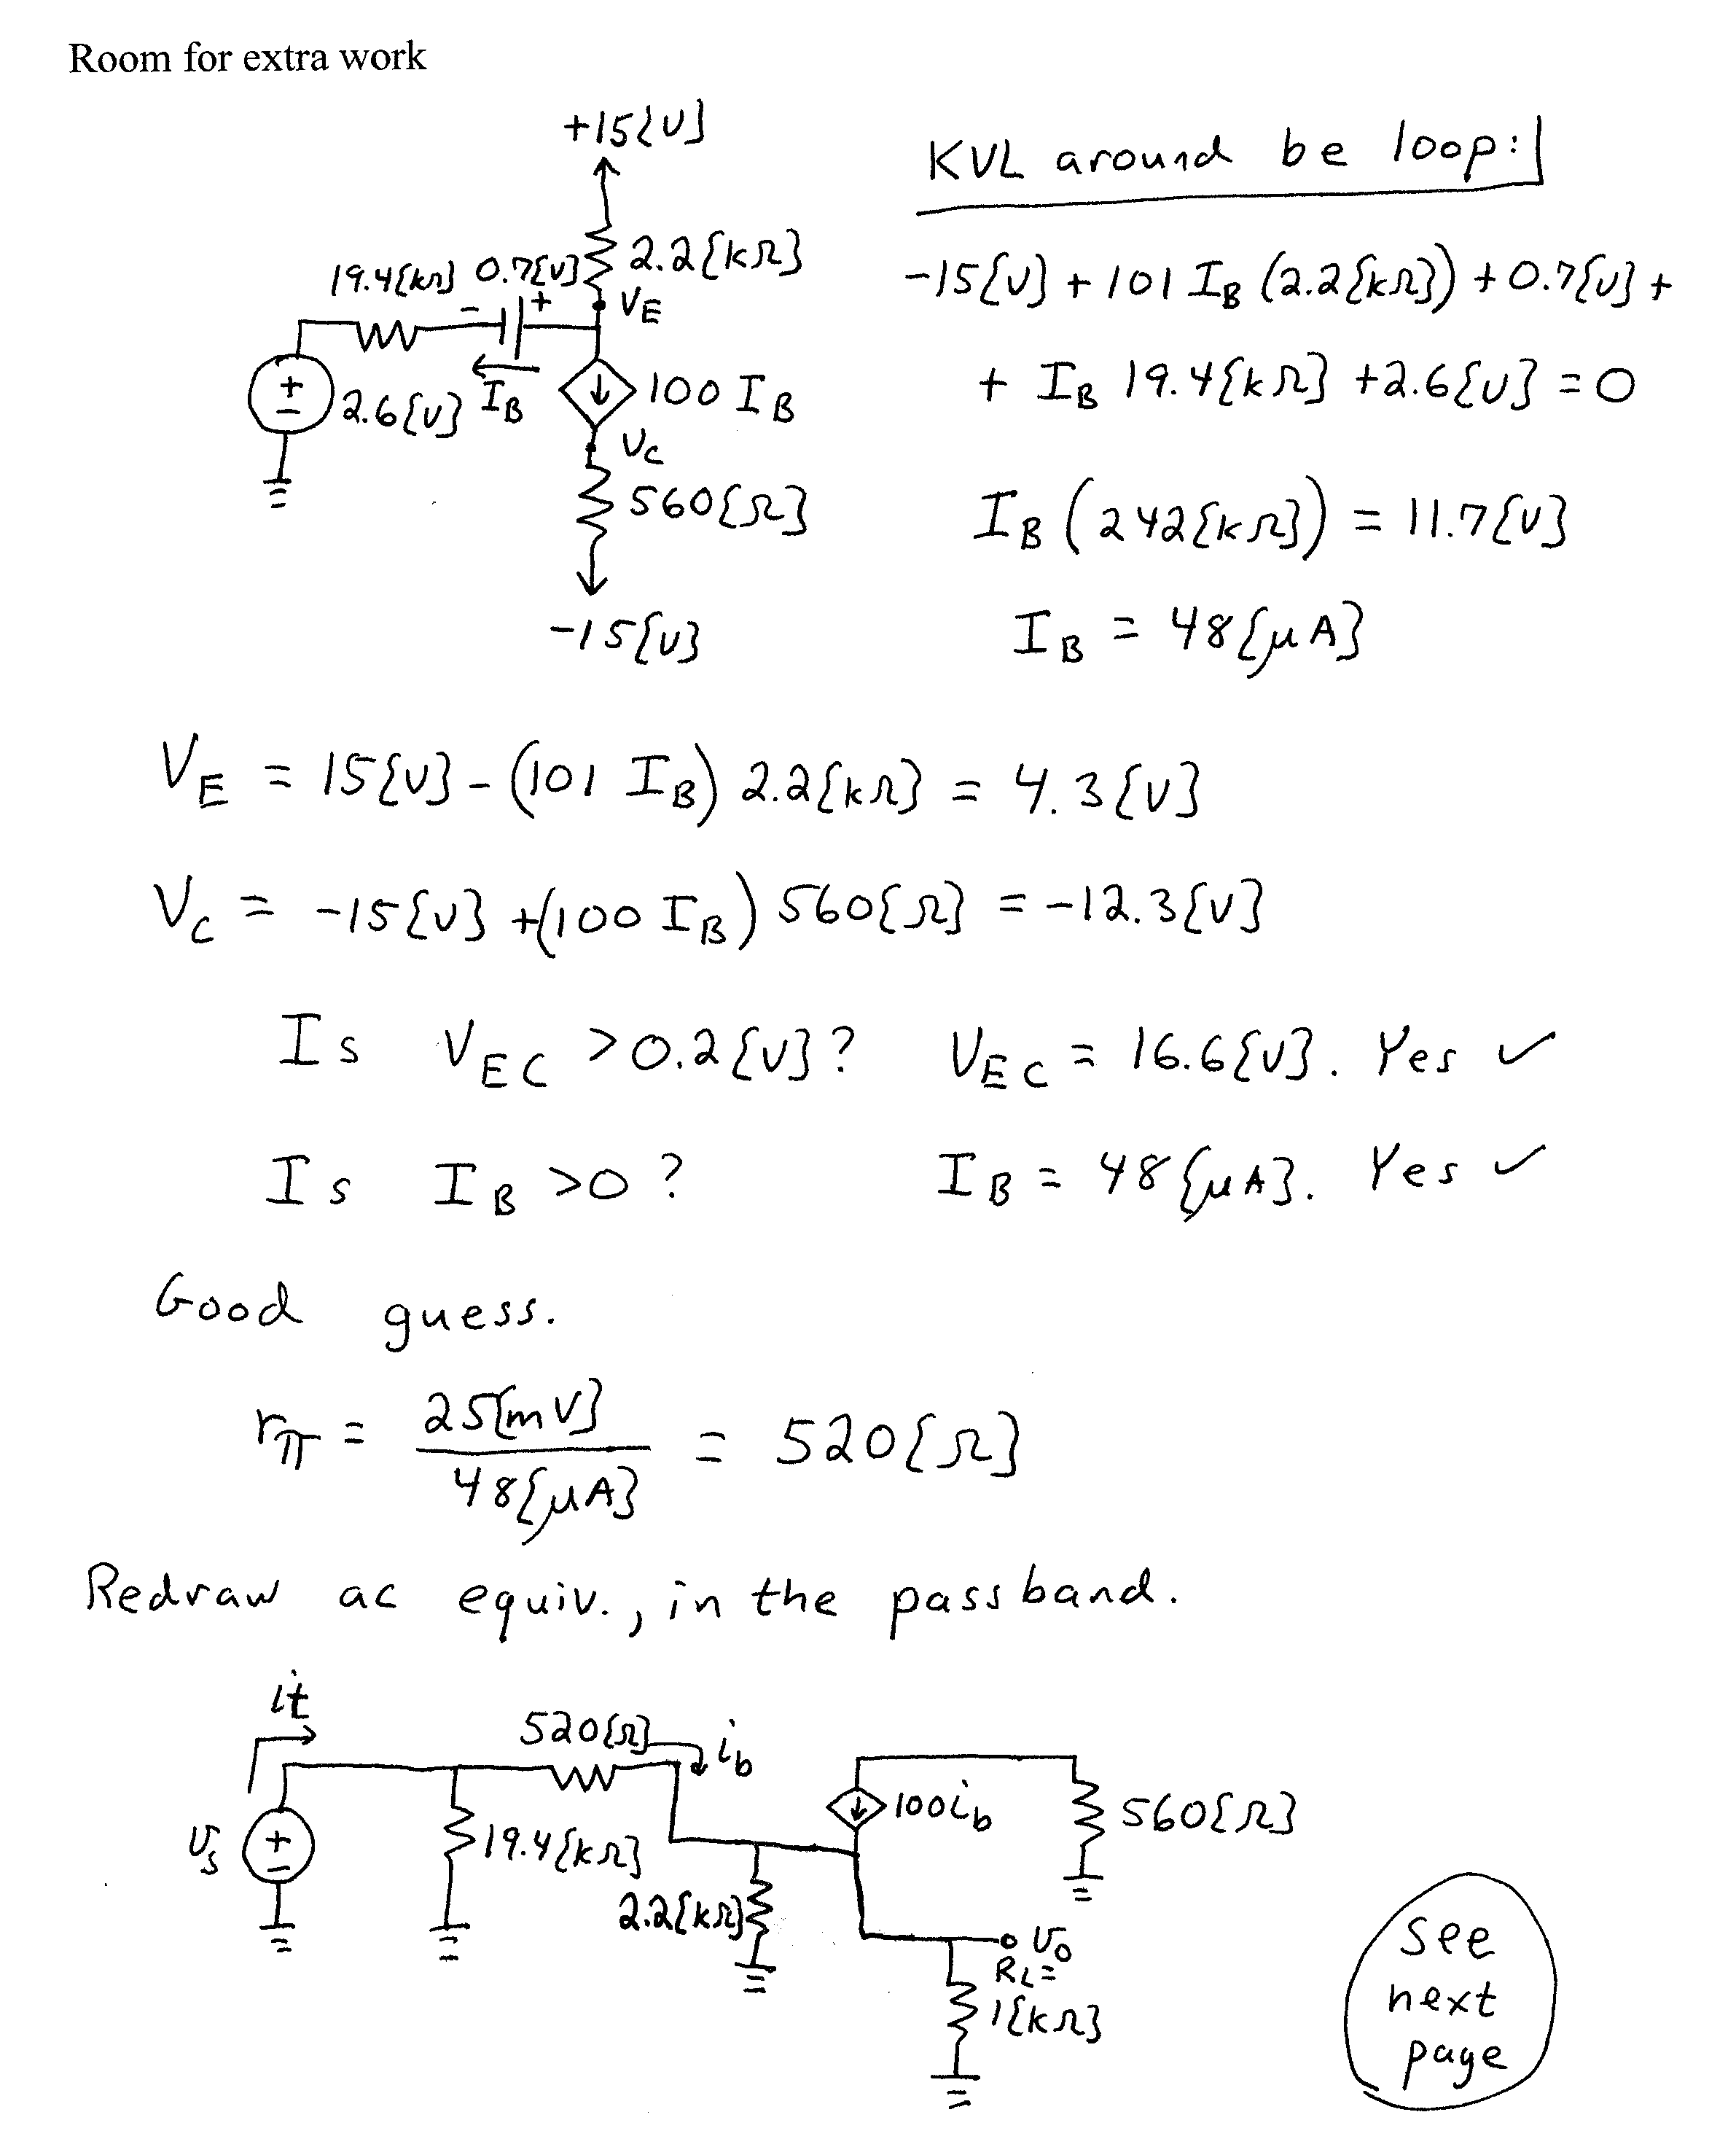
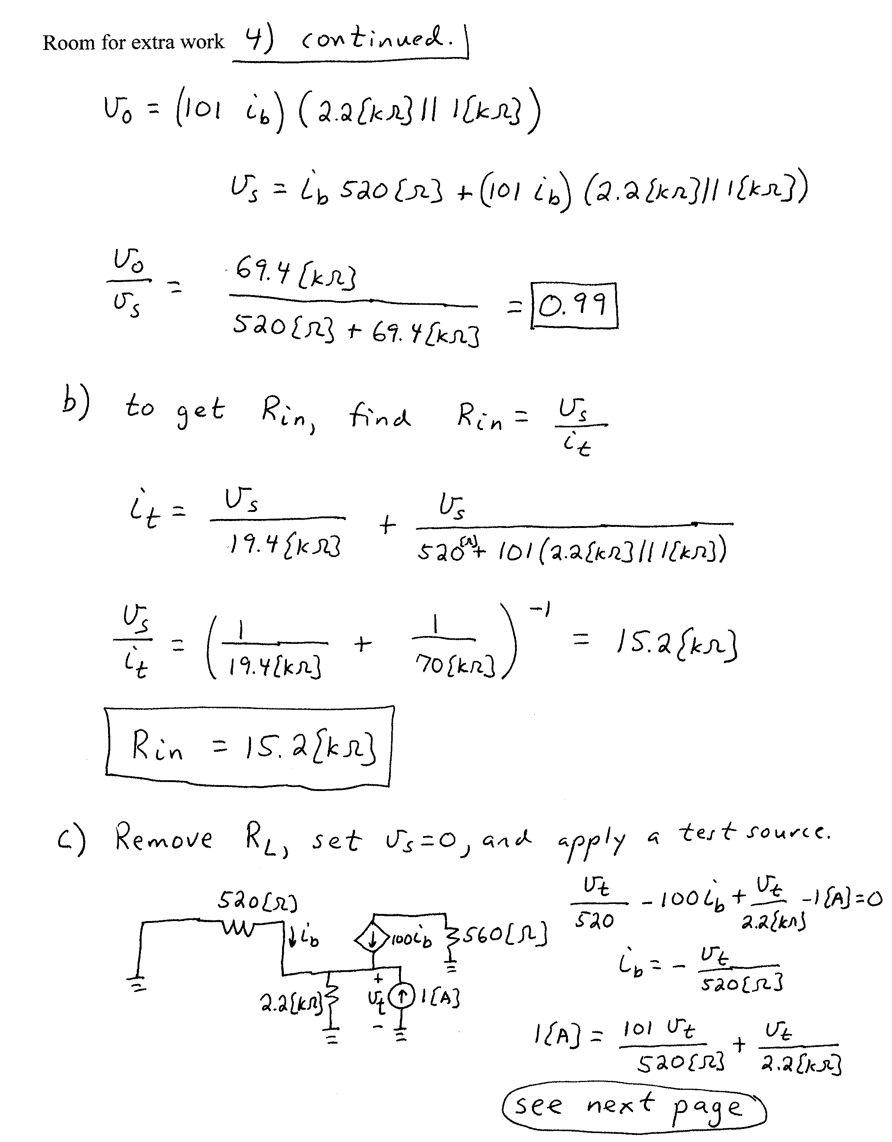
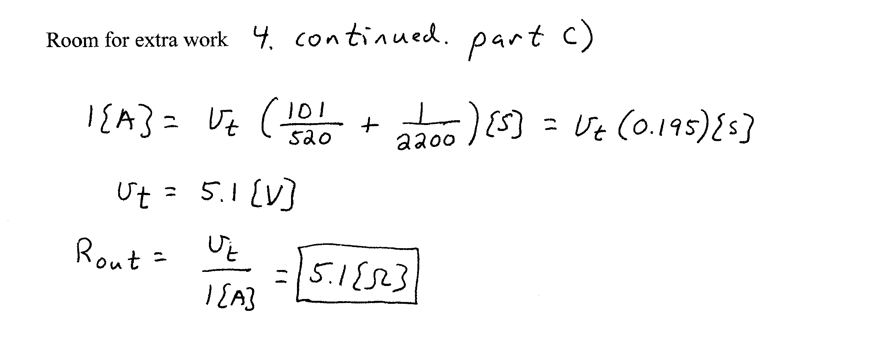

5. {10 Points} Assume an ideal op amp. Describe, quantitatively, the voltage v_{A}(t). Show your equations, and all other necessary work.


