Name: _____________________________ (please print)
Signature: __________________________

ECE 3455 –Exam 1
March 6, 2010

Keep this exam closed until you are told to begin.

1. This exam is closed book, closed notes. You may use one 8.5” x 11” crib sheet, or its equivalent.
2. Show all work on these pages. Show all work necessary to complete the problem. A solution without the appropriate work shown will receive no credit. A solution that is not given in a reasonable order will lose credit. Clearly indicate your answer (for example by enclosing it in a box). If your answer is a plot, no box is needed.
3. It is assumed that your work will begin on the same page as the problem statement. If you choose to begin your work on another page, you must indicate this on the page with the problem statement, with a clear indication of where the work can be found. If your work continues on to another page, indicate clearly where your work can be found. Failure to indicate this clearly will result in a loss of credit.
4. Show all units in solutions, intermediate results, and figures. Units in the exam will be included between square brackets.
5. Do not use red ink. Do not use red pencil.
6. You will have 90 minutes to work on this exam.

1. ________________/40
2. ________________/40
3. ________________/40
Total = 120
Room for extra work
1. {40 Points} Three identical amplifiers are to be connected together to make a single amplifier. Two possible connection schemes are considered, and are shown in the figures below. The equivalent circuit for these identical amplifiers has an input resistance of zero, an output resistance of 1[kΩ], and a short-circuit current gain of 10. None of these amplifiers is connected to ground.
a) Compare the two options available to you, and pick the option that will maximize the power delivered to the load resistor R_{L}. Find this maximum power as a function of the source voltage, v_{s}. You should choose the polarities of the amplifiers to obtain the maximum value in each case.
b) Consider these two options, and consider the possibility of extending each of the two connection schemes to n identical amplifiers, with arbitrary values of R_{in}, R_{out}, and A_{isc}. Find an equivalent amplifier model for each scheme, as a function of n.
c) Generalize from your results in b) to explain what the advantage(s) of each connection scheme would be.

Room for extra work

2. {40 Points} Assume an ideal op amp.
a) Find the transfer function H(f) = V_{o} /V_{i} for the circuit shown below.
b) Find the poles and zeroes for the transfer function that you found in part a).
c) Draw the straight-line approximations to the magnitude and phase Bode plot for the H(f) that you found in part a). Include all nonzero poles and zeroes in the range of frequencies that you plot. Use the semi log graph paper provided for you.

Room for extra work

3. {40 Points} Use the circuit below to find the numerical value of the following quantities. Assume ideal op amps.
- Find v_{y}(t).
- Find i_{x}(t).
- Find the transconductance, i_{o}/v_{s}.
- Find an amplifier model that could be used to replace everything seen by the load R_{L}, and the source v_{s}(t). Your amplifier model should have no more than 3 circuit elements in it.

Solutions:
1. {40 Points} Three identical amplifiers are to be connected together to make a single amplifier. Two possible connection schemes are considered, and are shown in the figures below. The equivalent circuit for these identical amplifiers has an input resistance of zero, an output resistance of 1[kΩ], and a short-circuit current gain of 10. None of these amplifiers is connected to ground.
a) Compare the two options available to you, and pick the option that will maximize the power delivered to the load resistor R_{L}. Find this maximum power as a function of the source voltage, v_{s}. You should choose the polarities of the amplifiers to obtain the maximum value in each case.
b) Consider these two options, and consider the possibility of extending each of the two connection schemes to n identical amplifiers, with arbitrary values of R_{in}, R_{out}, and A_{isc}. Find an equivalent amplifier model for each scheme, as a function of n.
c) Generalize from your results in b) to explain what the advantage(s) of each connection scheme would be.
The solution begins on the next page. See next page.
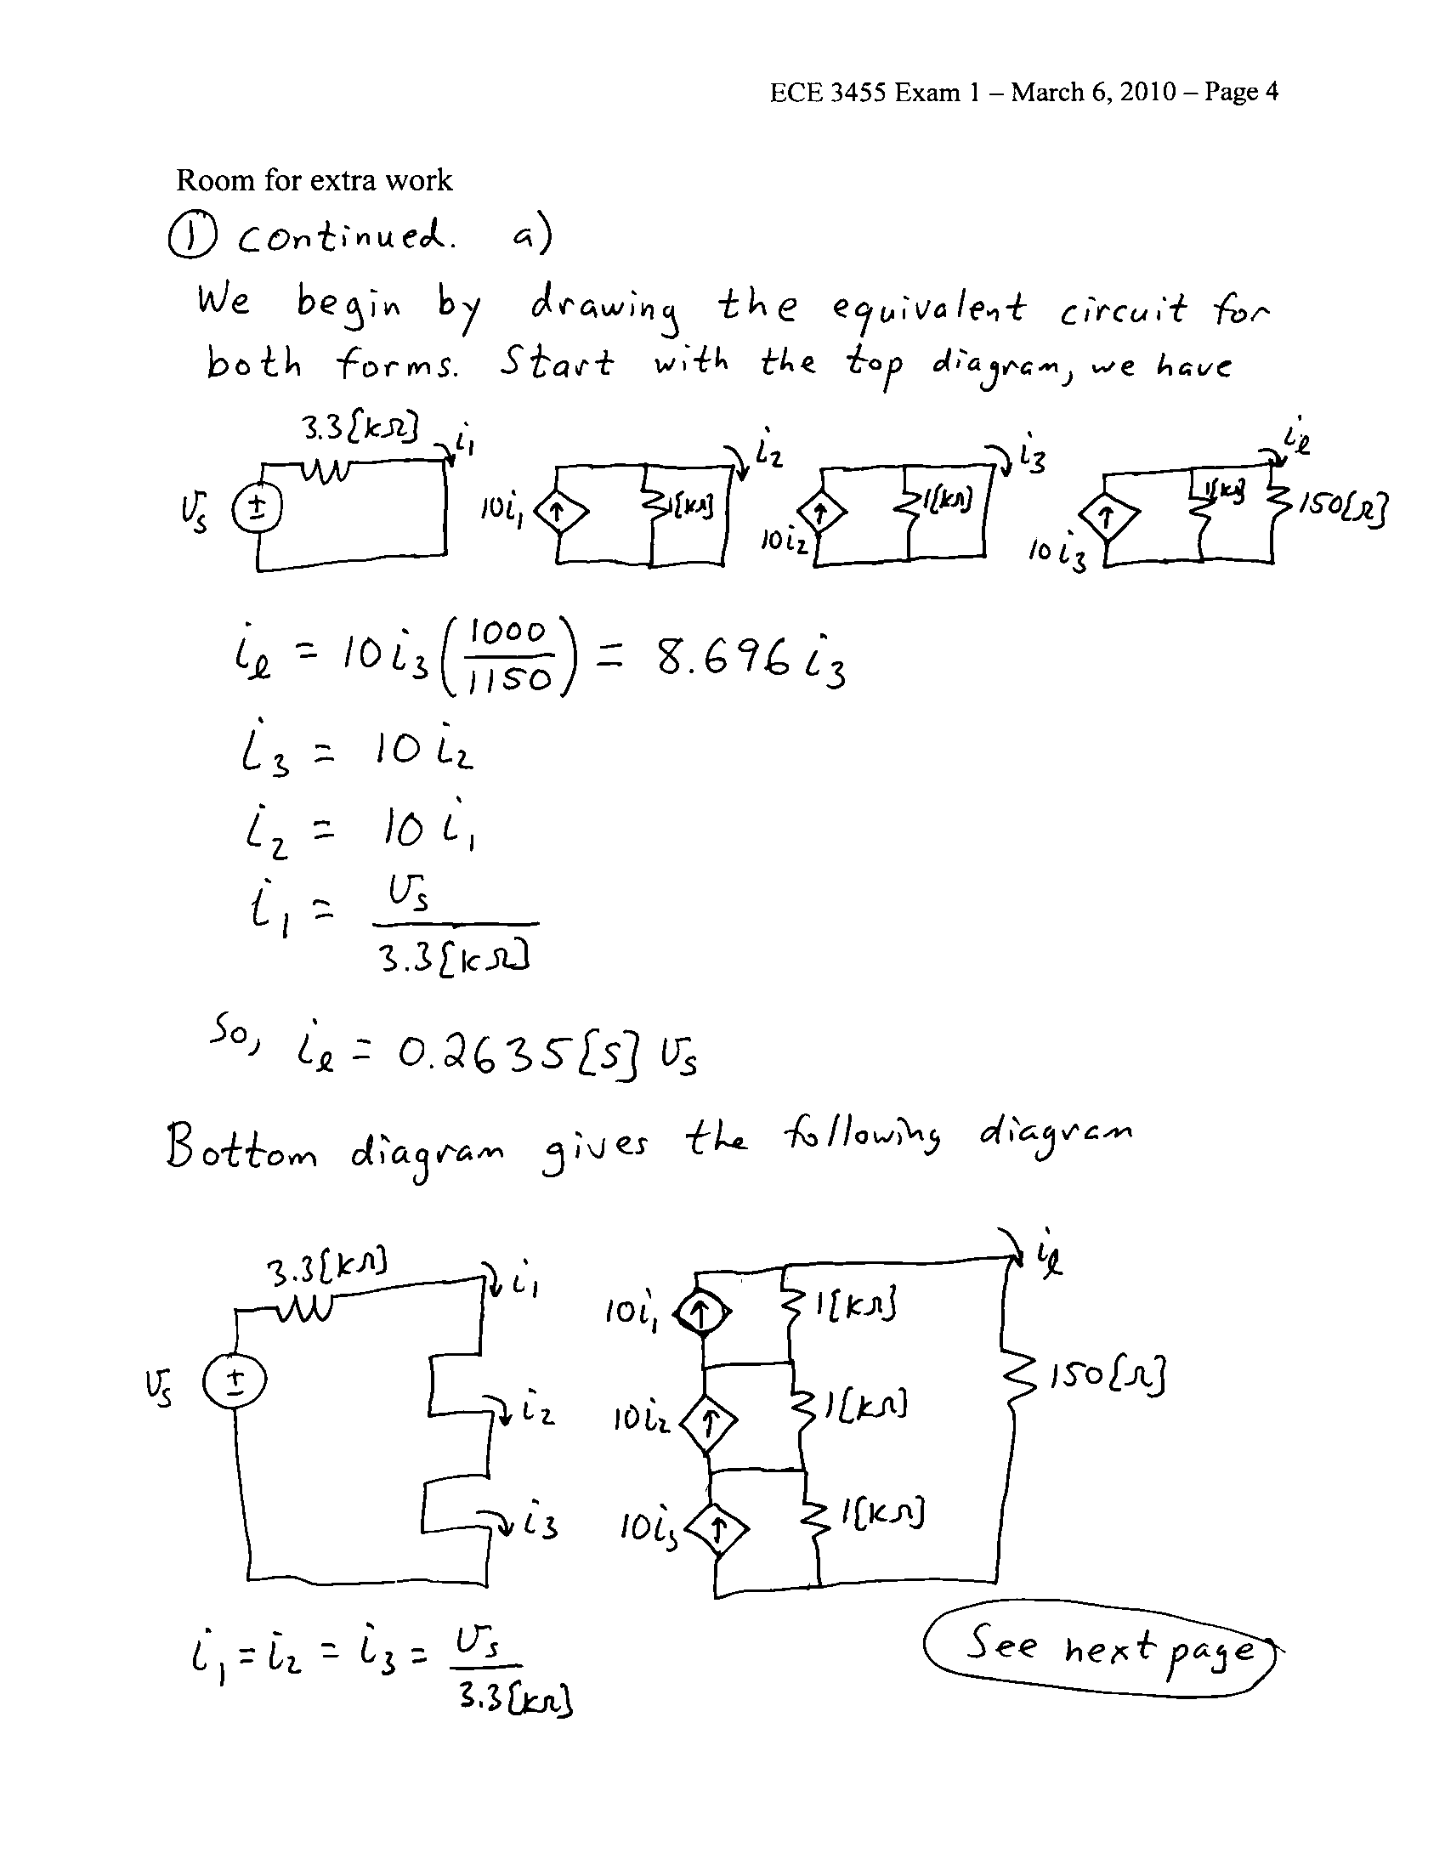
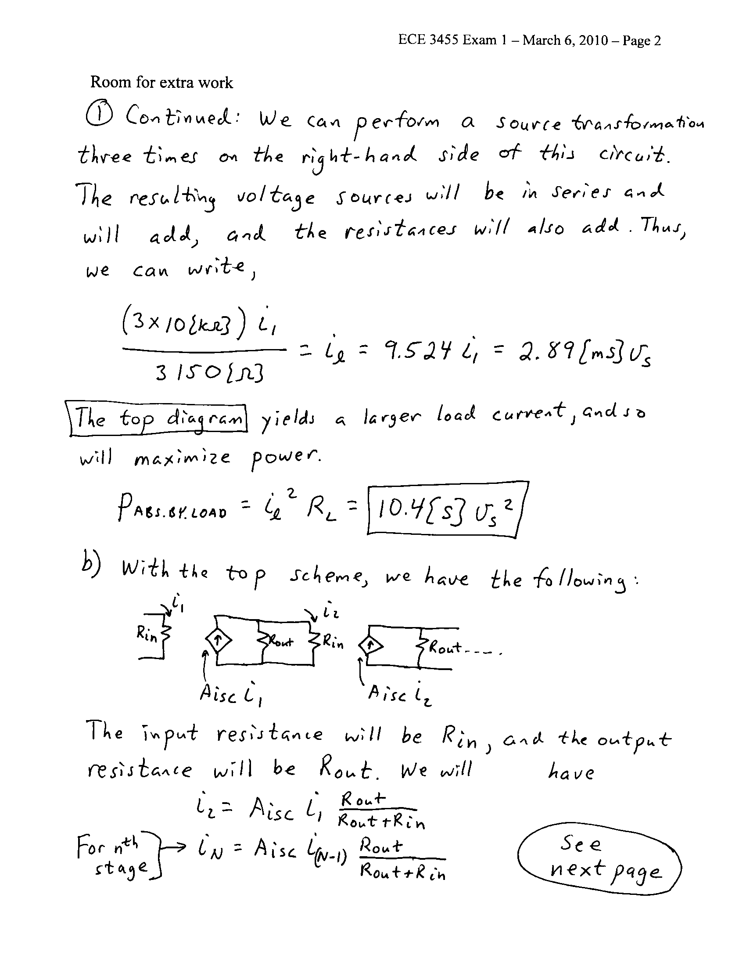
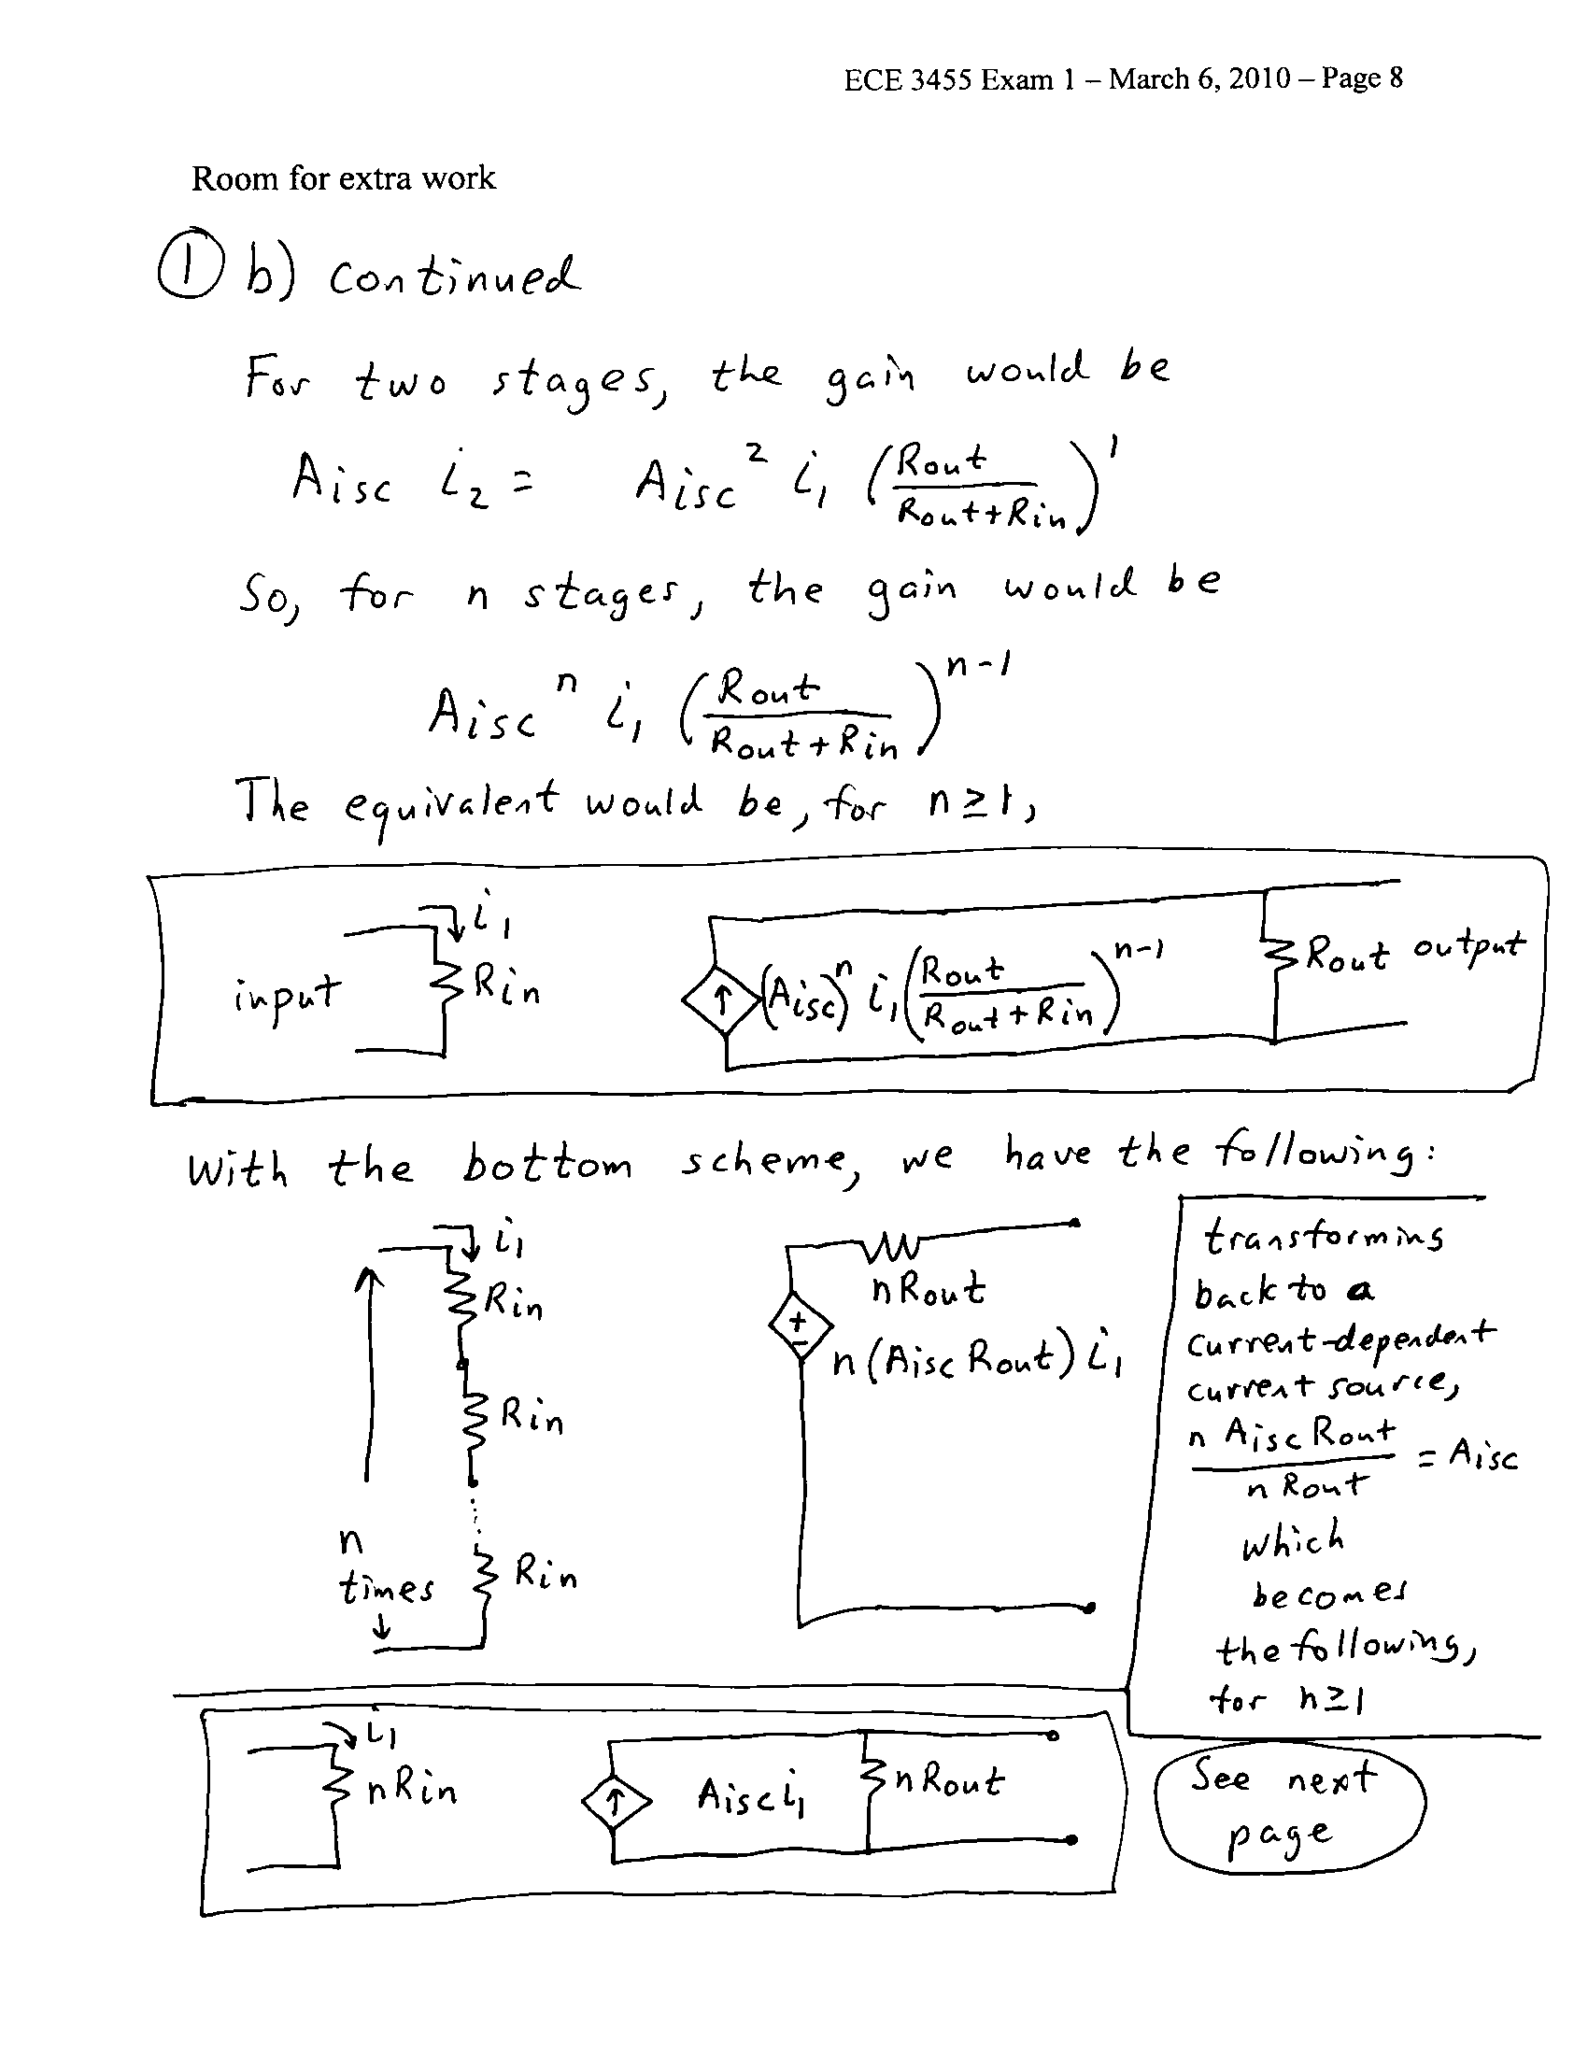

2. {40 Points} Assume an ideal op amp.
a) Find the transfer function H(f) = V_{o} /V_{i} for the circuit shown below.
b) Find the poles and zeroes for the transfer function that you found in part a).
c) Draw the straight-line approximations to the magnitude and phase Bode plot for the H(f) that you found in part a). Include all nonzero poles and zeroes in the range of frequencies that you plot. Use the semi log graph paper provided for you.

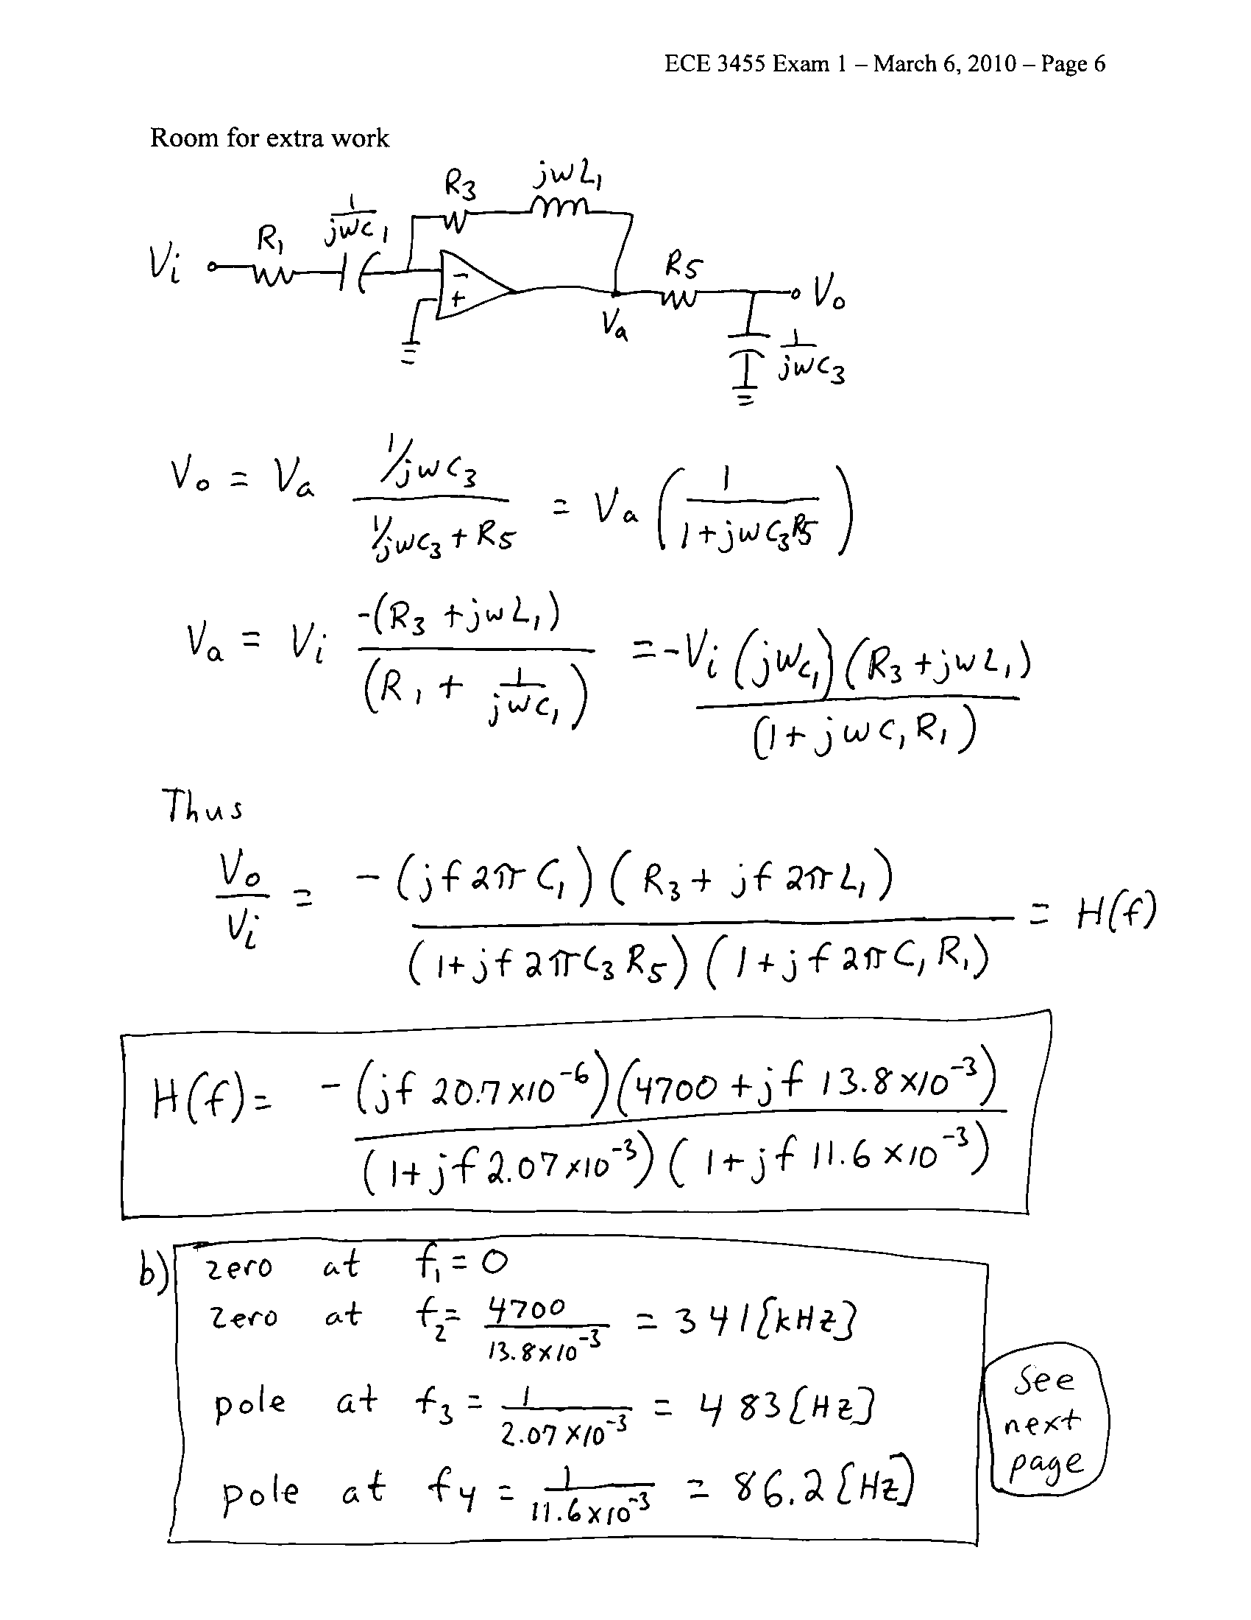
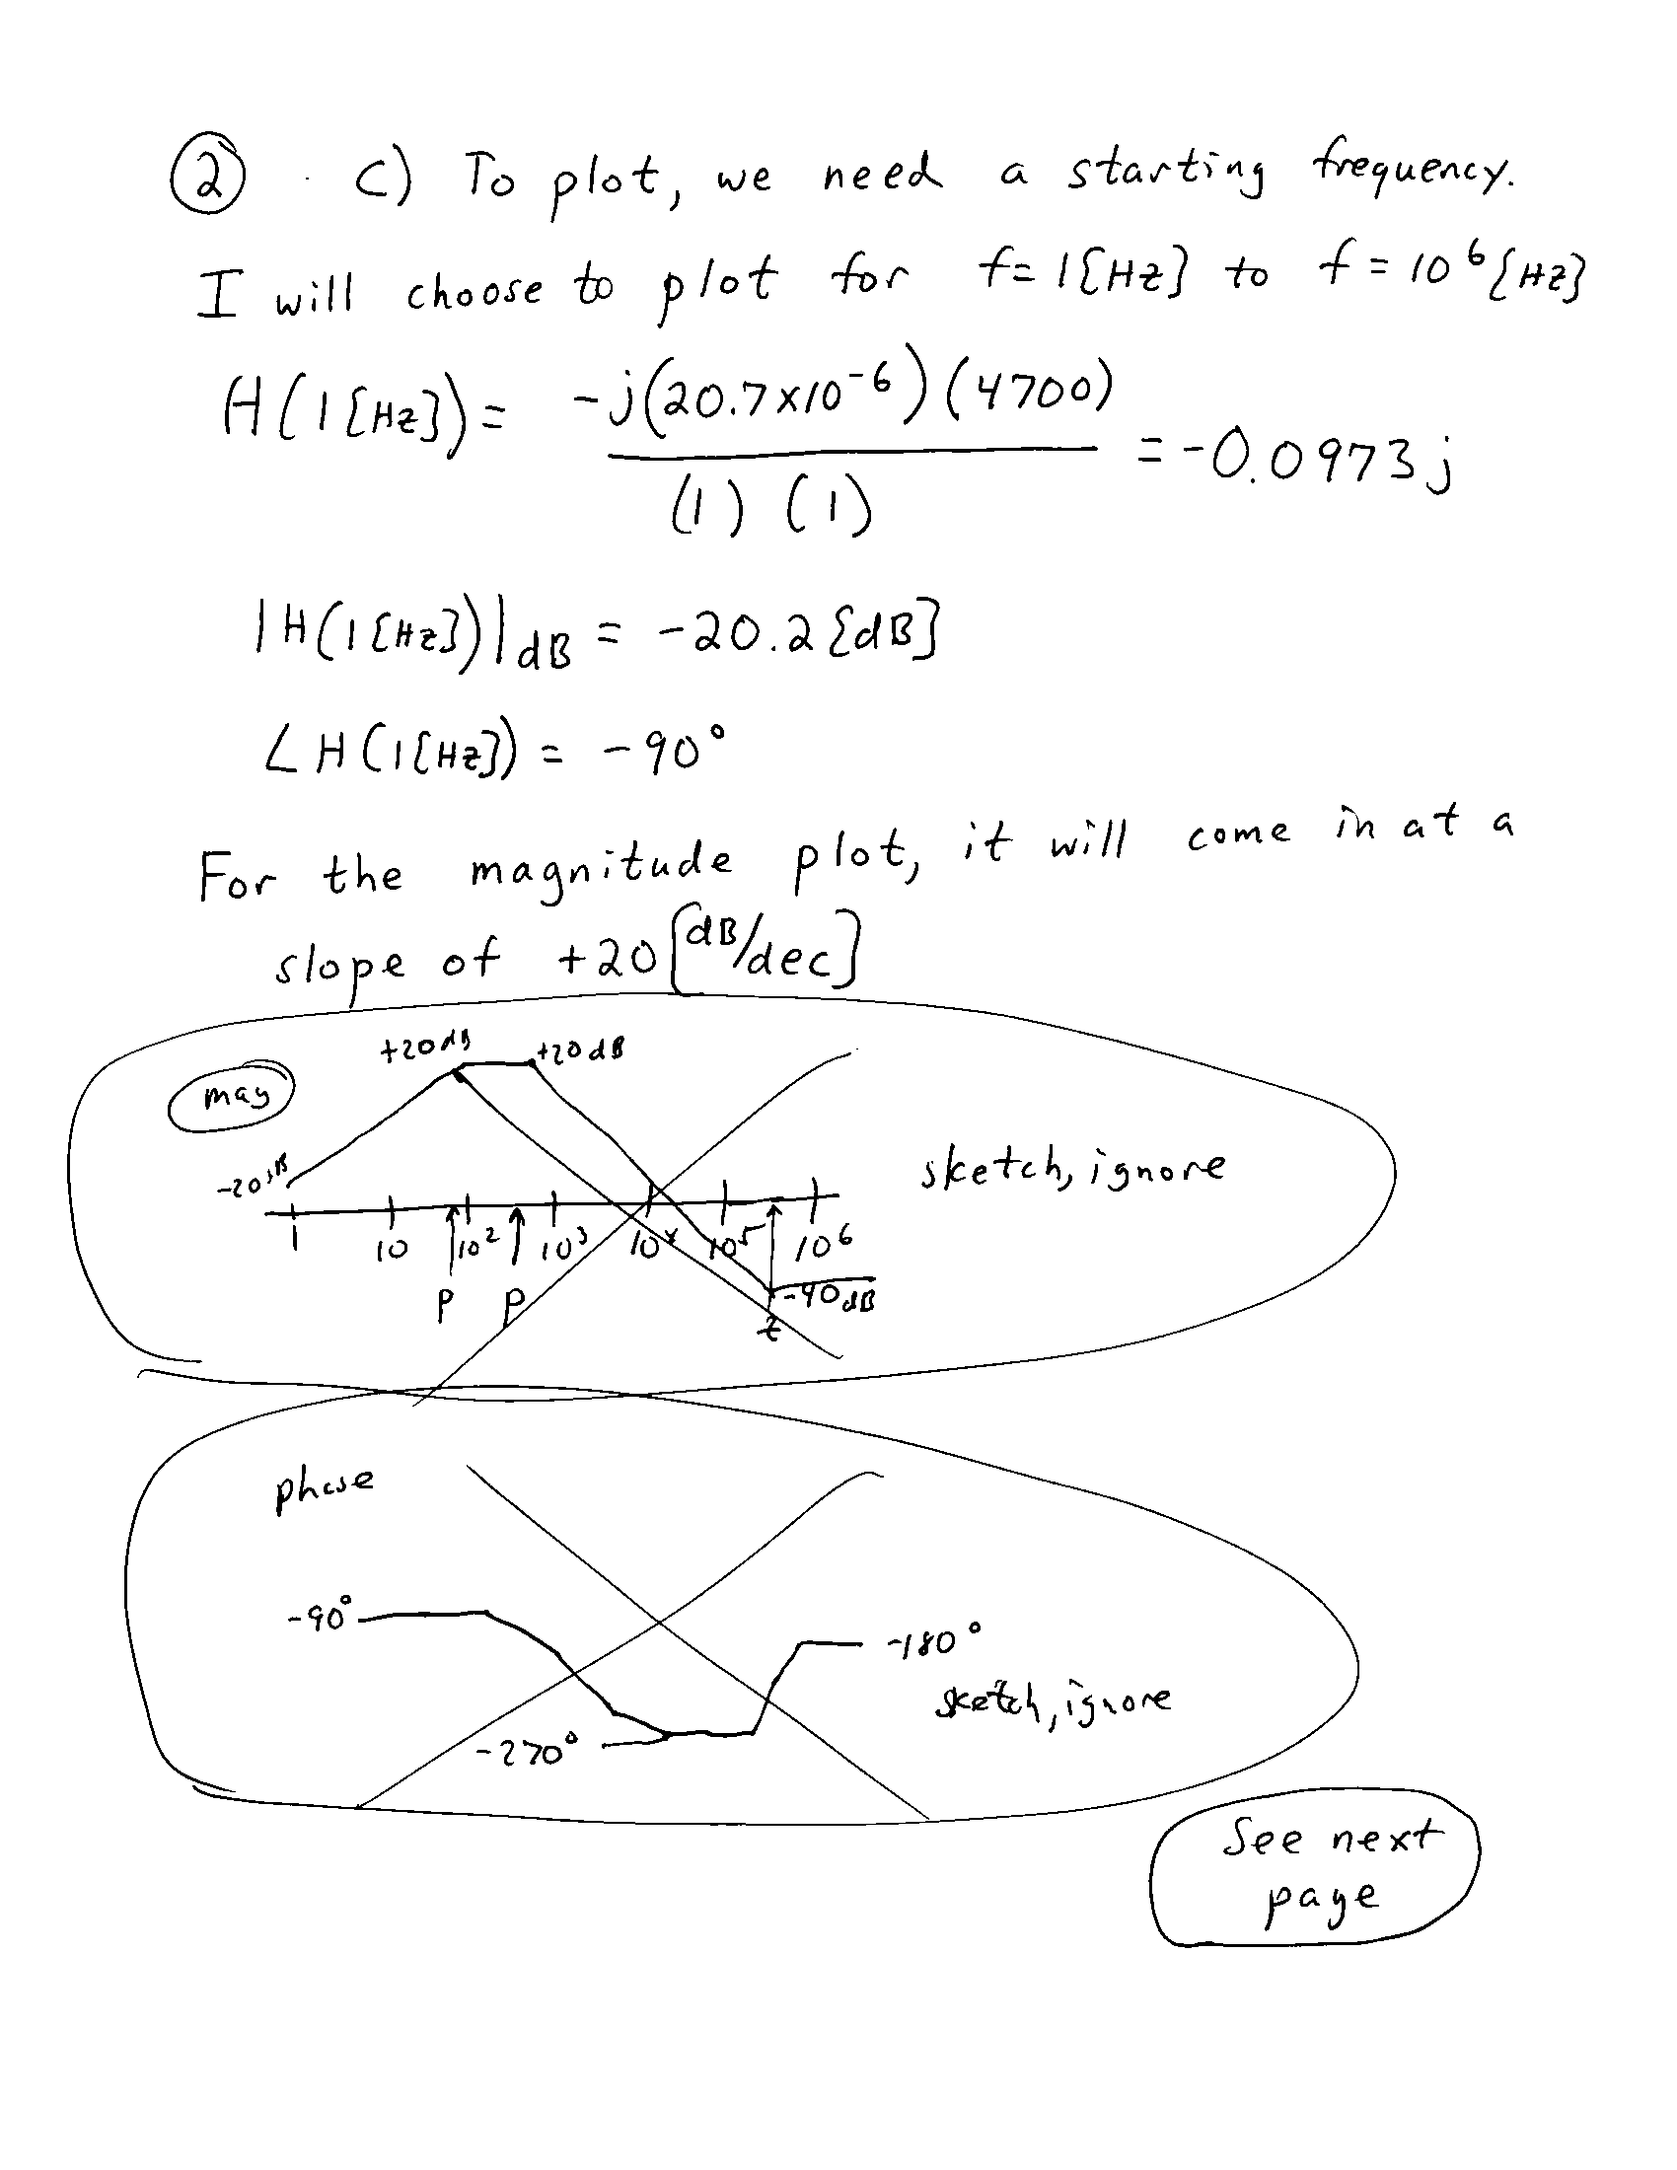
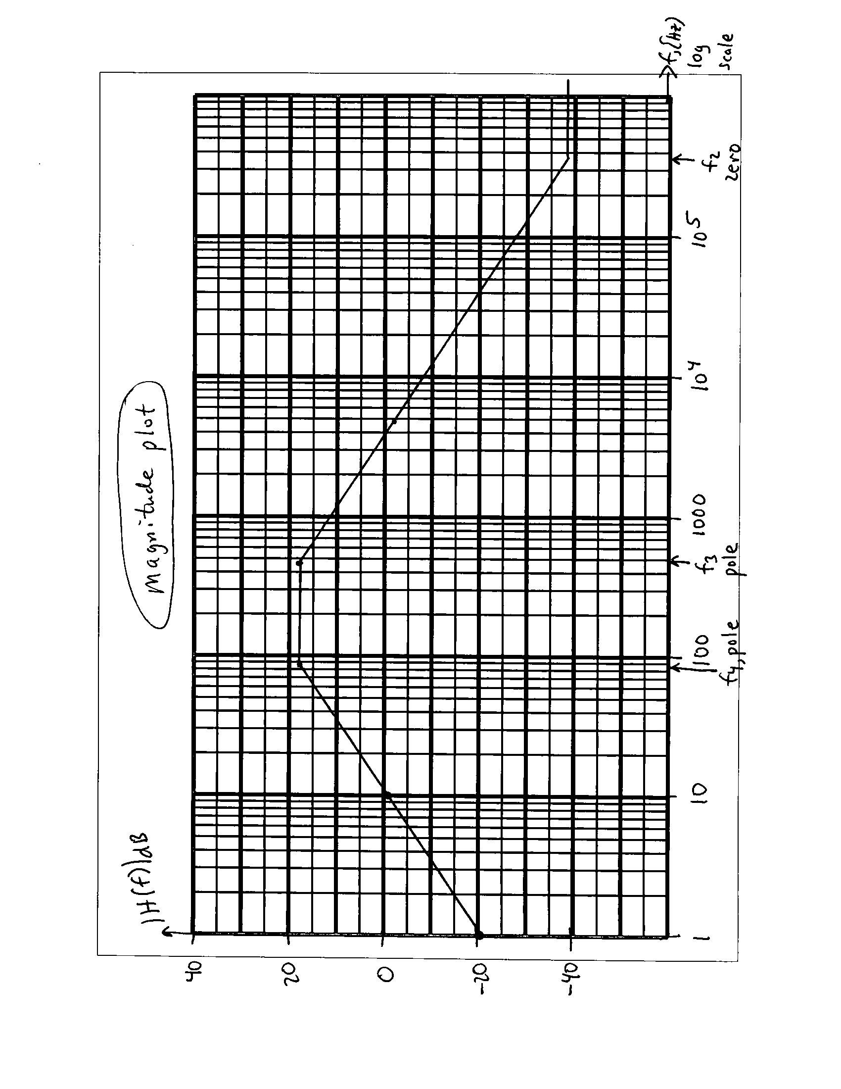
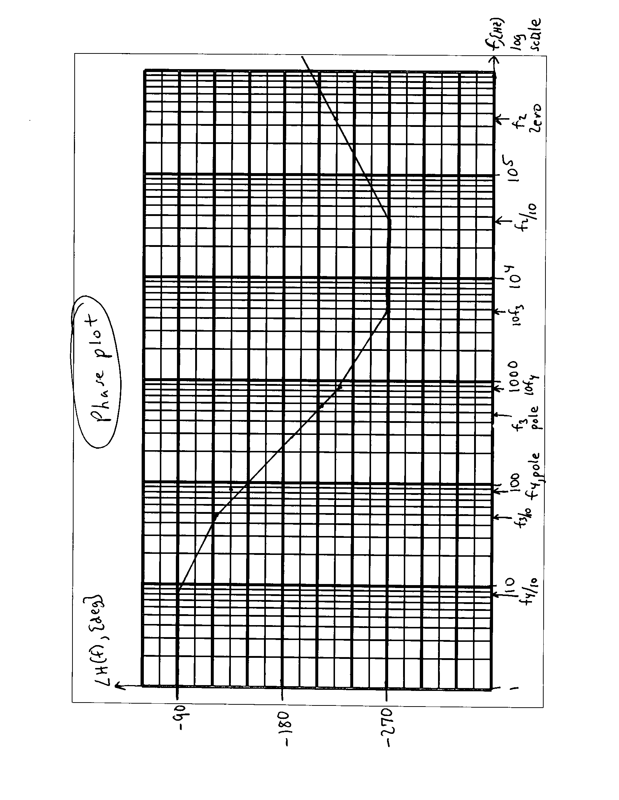
3. {40 Points} Use the circuit below to find the numerical value of the following quantities. Assume ideal op amps.
- Find v_{y}(t).
- Find i_{x}(t).
- Find the transconductance, i_{o}/v_{s}.
- Find an amplifier model that could be used to replace everything seen by the load R_{L}, and the source v_{s}(t). Your amplifier model should have no more than 3 circuit elements in it.
