Name: _____________________________ (please print)
Signature: __________________________

ECE 3455 –Exam 2
April 17, 2010

Keep this exam closed until you are told to begin.

1. This exam is closed book, closed notes. You may use one 8.5” x 11” crib sheet, or its equivalent.
2. Show all work on these pages. Show all work necessary to complete the problem. A solution without the appropriate work shown will receive no credit. A solution that is not given in a reasonable order will lose credit. Clearly indicate your answer (for example by enclosing it in a box). If your answer is a plot, no box is needed.
3. It is assumed that your work will begin on the same page as the problem statement. If you choose to begin your work on another page, you must indicate this on the page with the problem statement, with a clear indication of where the work can be found. If your work continues on to another page, indicate clearly where your work can be found. Failure to indicate this clearly will result in a loss of credit.
4. Show all units in solutions, intermediate results, and figures. Units in the exam will be included between square brackets.
5. Do not use red ink. Do not use red pencil.
6. You will have 90 minutes to work on this exam.

1. ________________/40
2. ________________/40
3. ________________/40
Total = 120
Room for extra work
1. {40 Points} Assume that each of the diodes in the circuit given can be modeled using a piecewise-linear model with V_{f} = 1[V], r_{d} = 1[kΩ], and I_{s} = 1[mA]. Find V_{X}. I expect that you will be able to complete at least four guesses in the time period given. Remember that you will be graded primarily on the approach that you take to the problem. Define the names of your regions clearly. State your guesses, and test them explicitly.

Room for extra work

2. {40 Points} Assume an ideal op amp. Assume that each of the diodes in the circuit given can be modeled using a piecewise-linear model with V_{f} = 0.7[V],
r_{d} = 1.2[kΩ], and I_{s} = 0. Remember that you will be graded primarily on the approach that you take to the problem.
a) Find the transfer characteristic v_{O}/v_{I} for the circuit shown below, for the range
-15[V] < v_{I} < +15[V].
b) Sketch the transfer characteristic v_{O}/v_{I} for the circuit shown below, for the range -15[V] < v_{I} < +15[V]. Label the important points on your sketch with numerical values.

Room for extra work

3. {40 Points} A nonlinear device called a teeparteeyor has a schematic symbol shown in Figure 1. The transfer characteristic for this teeparteeyor is given in the plot in Figure 2.
- On the plot in Figure 2, draw the load line for the device assuming that the device has been connected to the circuit shown in Figure 3. Use this load line to solve for i_{X}.
- Pick a straight line near the solution, and use that straight line to get a model for the teeparteeyor device that could be used to solve circuits like the one given in Figure 3.
- Insert the model found in part b) in the circuit shown in Figure 3, and use this to solve for i_{X}.
- Compare your two solutions for i_{X}. Comment on the differences between these two solutions, if any.
Room for extra work
Solutions:
1. {40 Points} Assume that each of the diodes in the circuit given can be modeled using a piecewise-linear model with V_{f} = 1[V], r_{d} = 1[kΩ], and I_{s} = 1[mA]. Find V_{X}. I expect that you will be able to complete at least four guesses in the time period given. Remember that you will be graded primarily on the approach that you take to the problem. Define the names of your regions clearly. State your guesses, and test them explicitly.
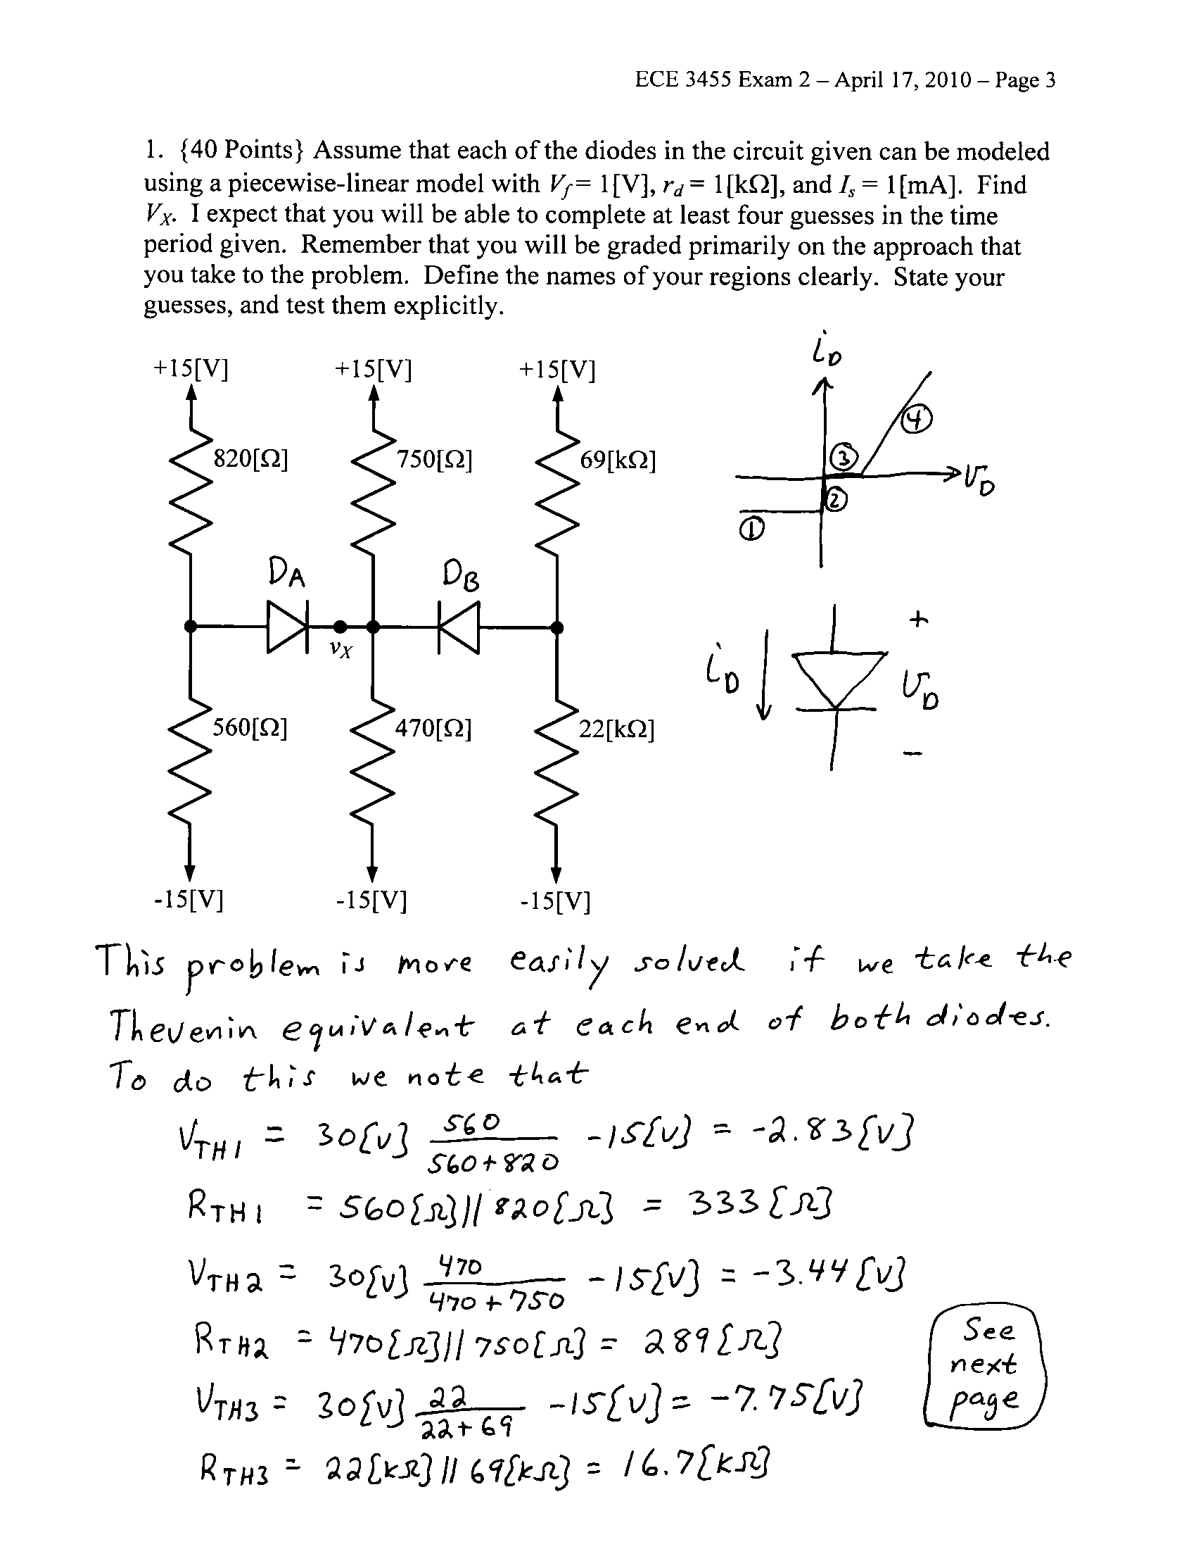
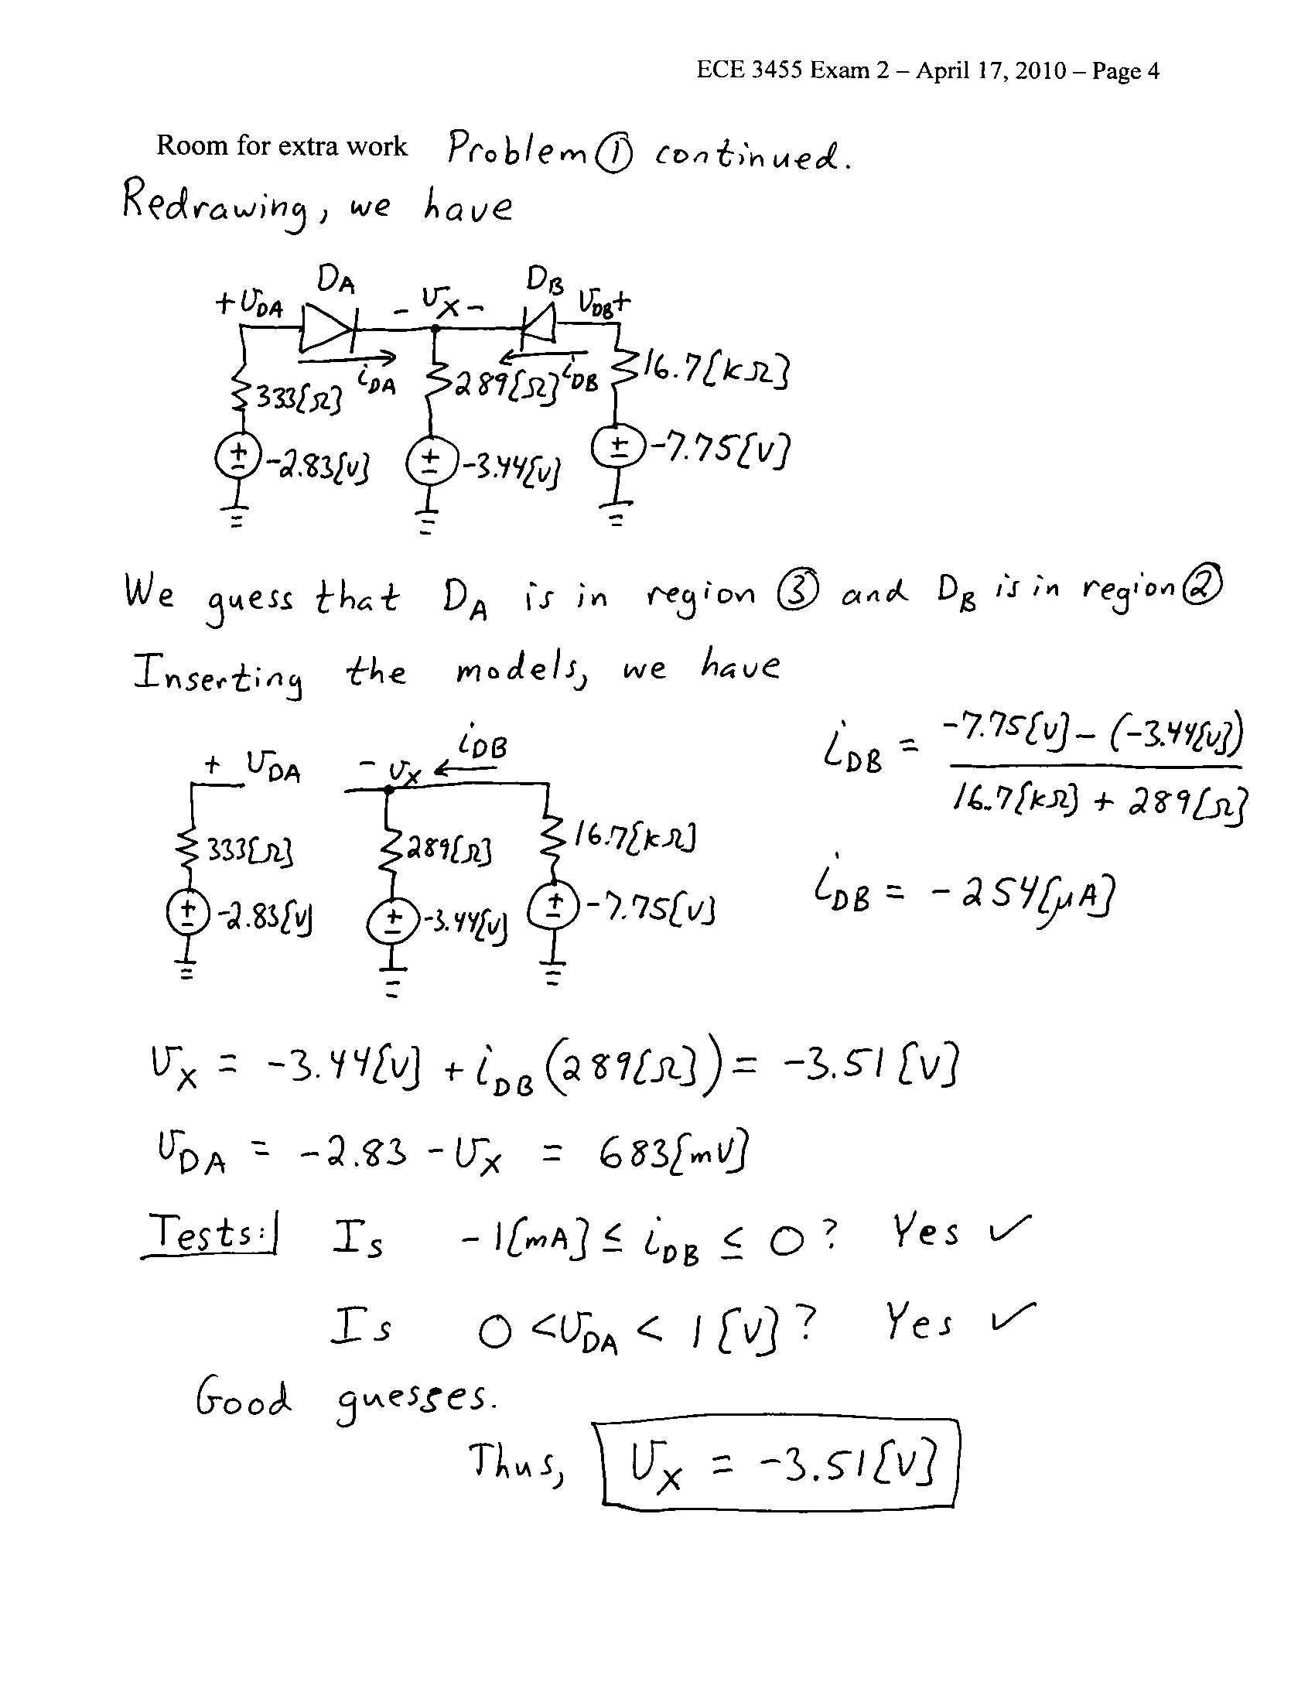

2. {40 Points} Assume an ideal op amp. Assume that each of the diodes in the circuit given can be modeled using a piecewise-linear model with V_{f} = 0.7[V],
r_{d} = 1.2[kΩ], and I_{s} = 0. Remember that you will be graded primarily on the approach that you take to the problem.
a) Find the transfer characteristic v_{O}/v_{I} for the circuit shown below, for the range
-15[V] < v_{I} < +15[V].
b) Sketch the transfer characteristic v_{O}/v_{I} for the circuit shown below, for the range
-15[V] < v_{I} < +15[V]. Label the important points on your sketch with numerical values.
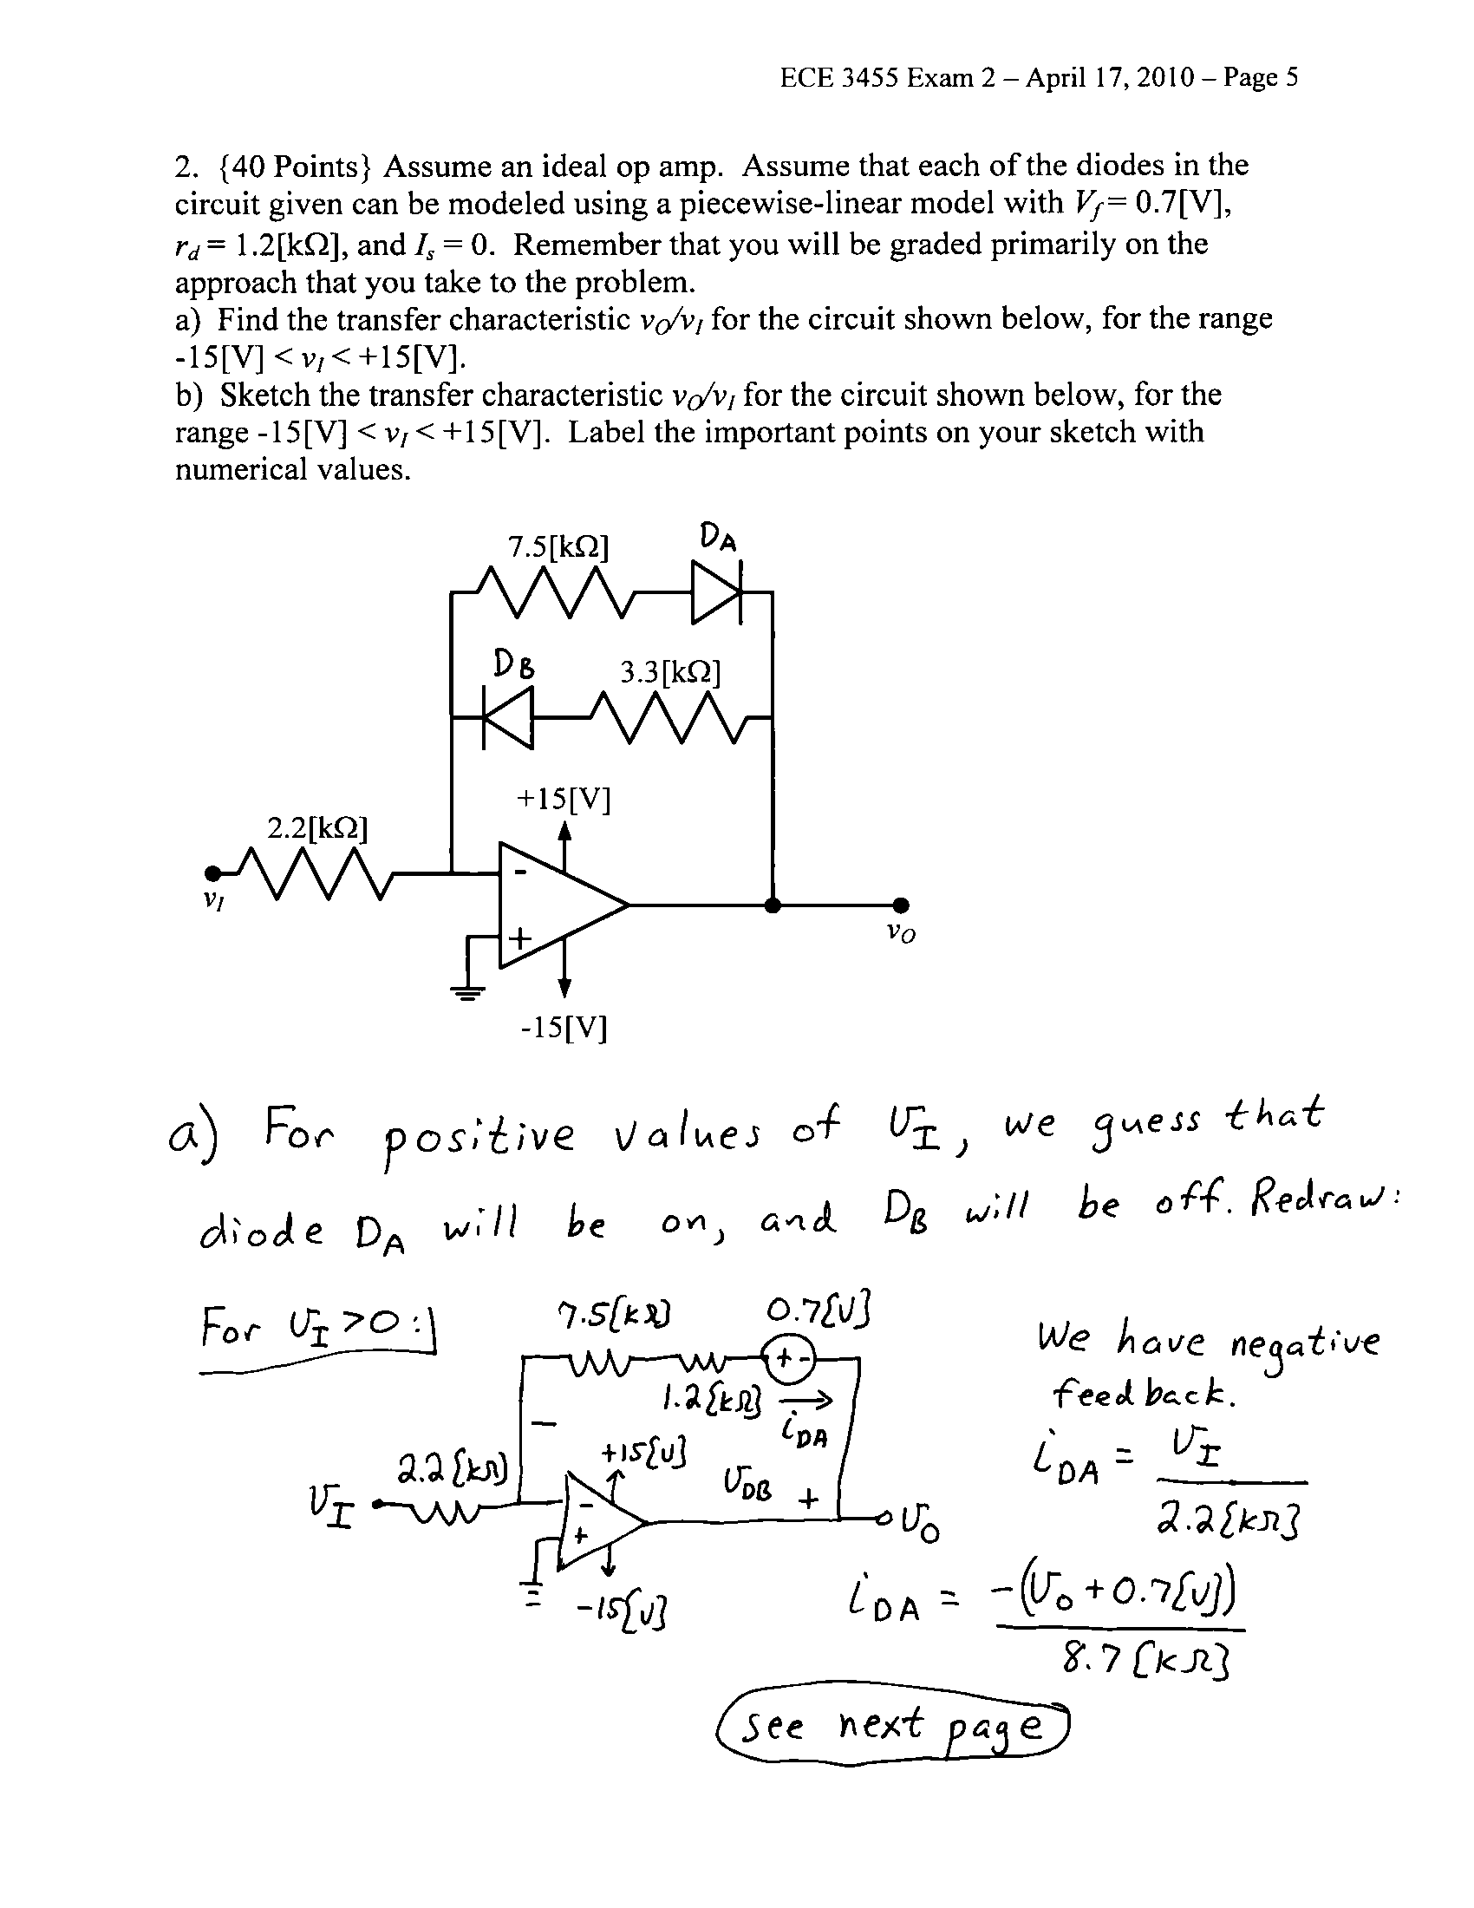
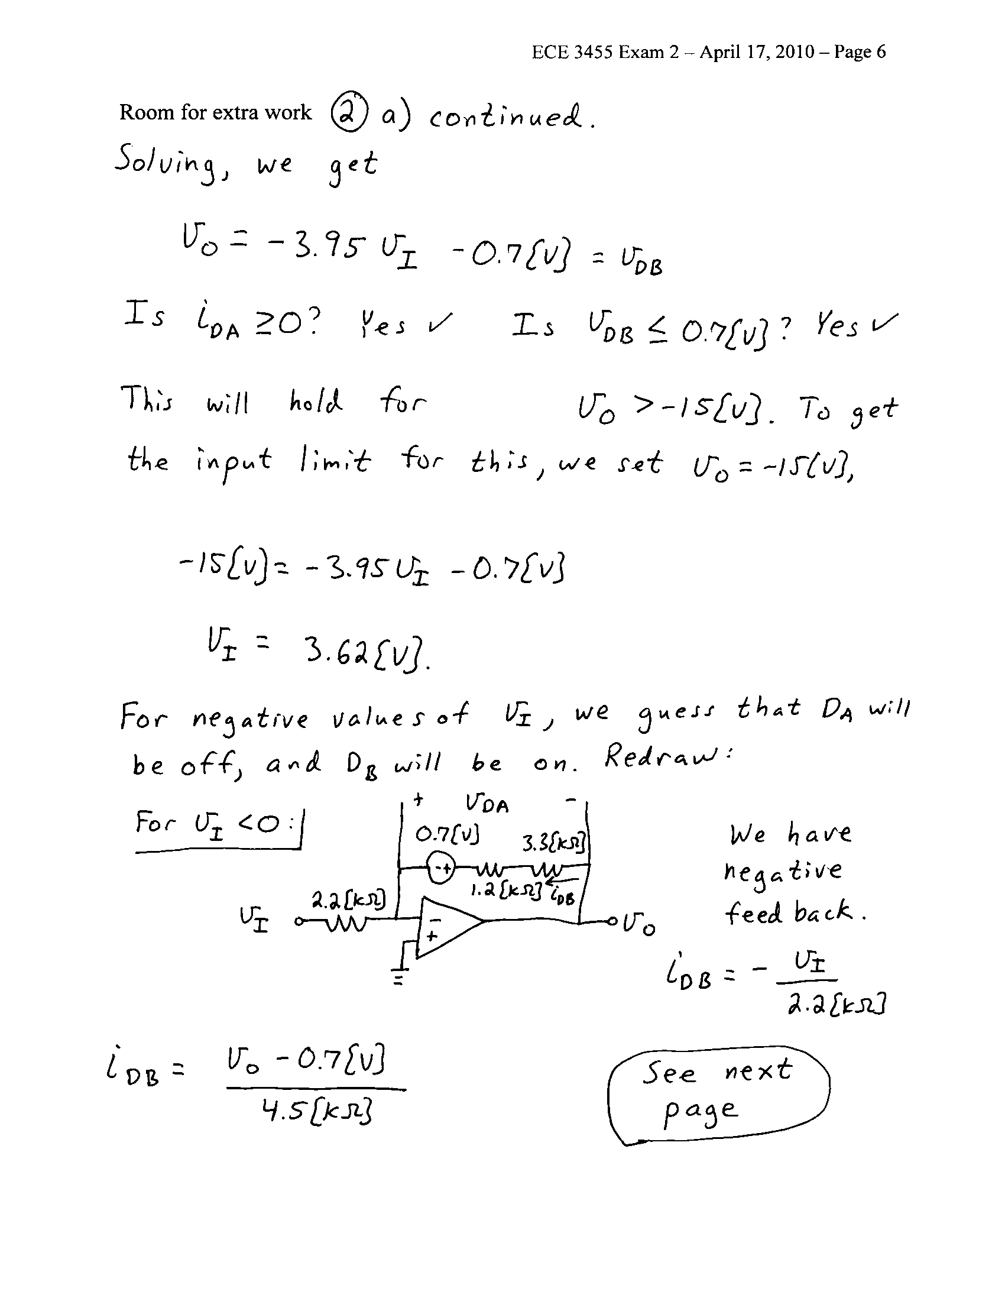
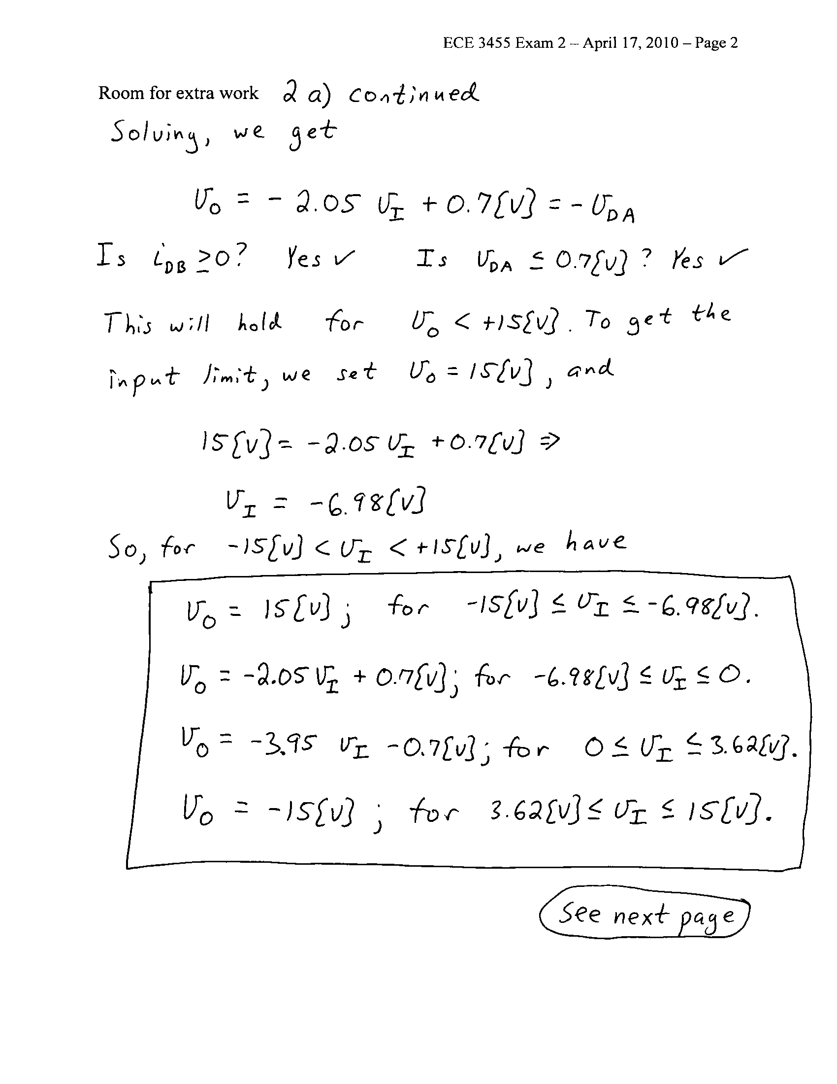

3. {40 Points} A nonlinear device called a teeparteeyor has a schematic symbol shown in
Figure 1. The transfer characteristic for this teeparteeyor is given in the plot in Figure 2.
- On the plot in Figure 2, draw the load line for the device assuming that the device has been connected to the circuit shown in Figure 3. Use this load line to solve for i_{X}.
- Pick a straight line near the solution, and use that straight line to get a model for the teeparteeyor device that could be used to solve circuits like the one given in Figure 3.
- Insert the model found in part b) in the circuit shown in Figure 3, and use this to solve for i_{X}.
- Compare your two solutions for i_{X}. Comment on the differences between these two solutions, if any.
