Name: _____________________________ (please print)
Signature: __________________________

ECE 3455 – Final Exam
May 8, 2010

Keep this exam closed until you are told to begin.

1. This exam is closed book, closed notes. You may use two 8.5” x 11” crib sheets, or their equivalent.
2. Show all work on these pages. Show all work necessary to complete the problem. A solution without the appropriate work shown will receive no credit. A solution that is not given in a reasonable order will lose credit. Clearly indicate your answer (for example by enclosing it in a box). If your answer is a plot, no box is needed.
3. It is assumed that your work will begin on the same page as the problem statement. If you choose to begin your work on another page, you must indicate this on the page with the problem statement, with a clear indication of where the work can be found. If your work continues on to another page, indicate clearly where your work can be found. Failure to indicate this clearly will result in a loss of credit.
4. Show all units in solutions, intermediate results, and figures. Units in the exam will be included between square brackets.
5. Do not use red ink. Do not use red pencil.
6. You will have 170 minutes to work on this exam.

1. ________________/20
2. ________________/20
3. ________________/10
4. ________________/30
5. ________________/40
Total = 120
Room for extra work
1. {20 Points} Use the circuit below to find the numerical value of the following quantities. Assume ideal op amps.
- Find v_{A} if v_{I} = 50[mV].
- Find the input resistance seen by the source v_{I}(t), assuming that the amplitude of the source was less than 50[mV].
- Find the range of input values for v_{I}(t) that would keep the value of the input resistance equal to the value found in part b).
- If v_{I}(t) was a sinusoidal voltage, what would you expect v_{B}(t) would look like? Make sure that your answer is quantitative. Does your answer depend on the amplitude of the sinusoidal voltage? How would it depend on that?

Room for extra work

2. {20 Points} A nonlinear device called an ayetripuleeyor has a schematic symbol shown in Figure 1. The transfer characteristic for this ayetripuleeyor is given in the plot in Figure 3 on the next page.
- On the plot in Figure 3, draw the load line for the device assuming that the device has been connected to the circuit shown in Figure 2. Use this load line to solve for i_{X}.
- Pick a straight line near the solution, and use that straight line to get a model for the ayetripuleeyor device that could be used to solve circuits like the one given in Figure 2.
- Insert the model found in part b) in the circuit shown in Figure 2, and use this to solve for i_{X}.
- It is possible to place the ayetripuleeyor device in a circuit where there would be more than one solution for i_{X}. Devise such a circuit, and show how more than one solution would be possible.

Problem 2 continues here.

Room for extra work

3. {10 Points} Assume that each of the diodes in the circuit given can be modeled using a piecewise-linear model with V_{f} = 1[V], r_{d} = 1[kΩ], and I_{s} = 1[mA]. Find V_{X}. I expect that you will be able to complete at least four guesses in the time period given. Remember that you will be graded primarily on the approach that you take to the problem. Define the names of your regions clearly. State your guesses, and test them explicitly.

Room for extra work

4. {30 Points} Assume that the transistor in this problem operates at room temperature, and has β = 100.
a) Find the voltage gain v_{o}/v_{i} in the passband.
b) Find the input resistance seen by the source v_{i}(t) in the passband.
c) Find the transfer function V_{o}/V_{i} assuming that the source v_{i}(t) is a small signal.
d) Plot the straight-line approximation to the magnitude Bode plot for the transfer function you obtained in part b). Use one of the sheets of semilog graph paper at the end of this exam. Pick one of your poles, and place it near the center of the frequency axis in your plot.

Room for extra work

5. {40 Points} Design a circuit that will meet the specifications given below. You have available an unlimited number of ideal op amps and transistors with
β = 200. You may use any number of resistors, inductors, capacitors, and potentiometers, with any values. You have available an unlimited number of diodes with V_{f} = 0.7[V], r_{d} = 1[kΩ], and I_{s} = 0. You have two dc power supplies, at +15[V] and -15[V].
The specifications follow:
- You are to produce a waveform which approximates a sine wave. An approximation to a sine wave can be achieved by filtering a square wave using a low-pass filter with a breakpoint frequency just above the repetition rate of the square wave.
- You are to produce this sine wave approximation so that it will have a frequency of 250[Hz].
- From the sine wave, you are to produce a half-wave rectified version of that sine wave.
- From this rectified sine wave, you are to produce a waveform in the form given in the plot below. The “floor value” and the “size” are defined in the plot. The “floor value” should be variable, with a value controlled by a potentiometer. The “floor value” should be in the range between -4[V] and +4[V]. The “size” should be 2.70[V]. The “size” should not be changed when there are changes in the “floor value”.
Explain how your design meets the specifications using complete sentences.

Solutions:
1. {20 Points} Use the circuit below to find the numerical value of the following quantities. Assume ideal op amps.
- Find v_{A} if v_{I} = 50[mV].
- Find the input resistance seen by the source v_{I}(t), assuming that the amplitude of the source was less than 50[mV].
- Find the range of input values for v_{I}(t) that would keep the value of the input resistance equal to the value found in part b).
- If v_{I}(t) was a sinusoidal voltage, what would you expect v_{B}(t) would look like? Make sure that your answer is quantitative. Does your answer depend on the amplitude of the sinusoidal voltage? How would it depend on that?
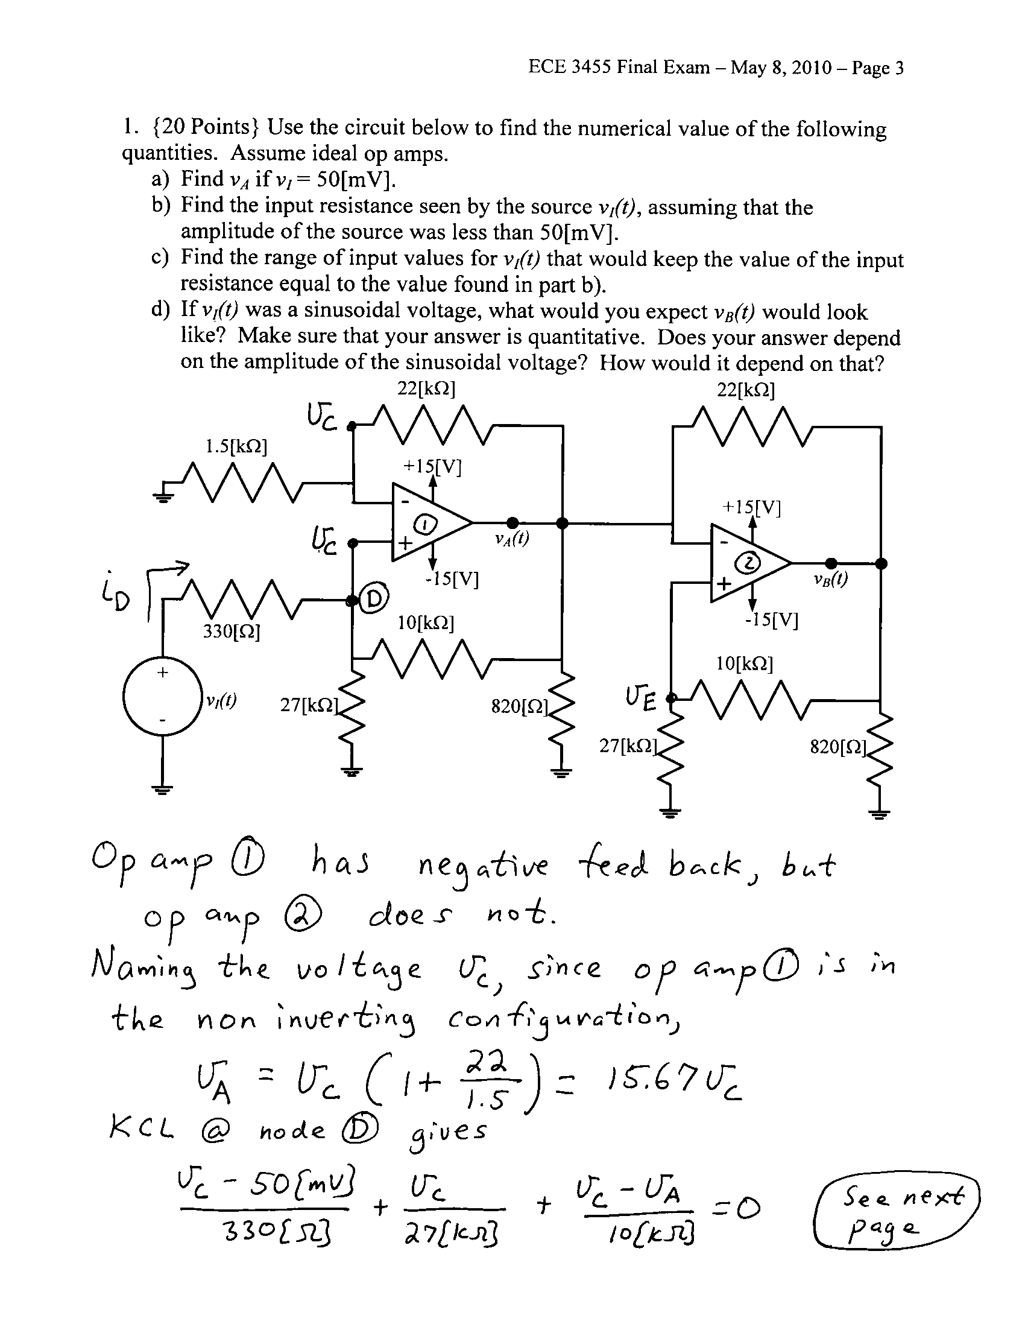
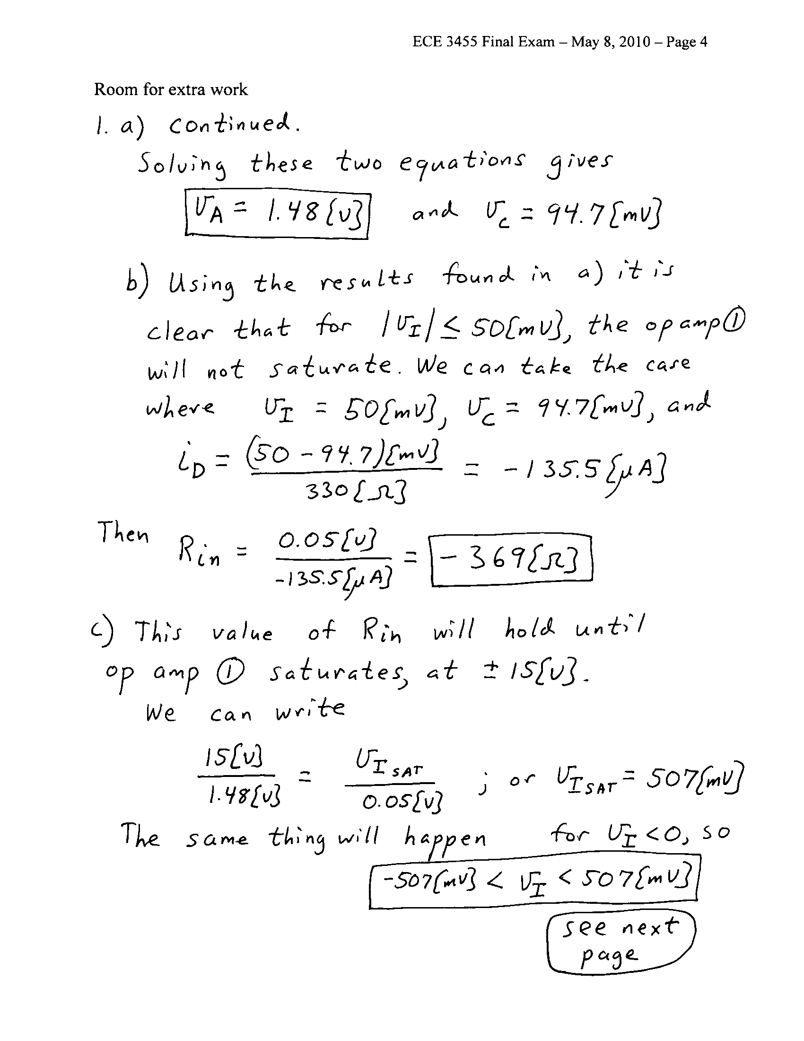
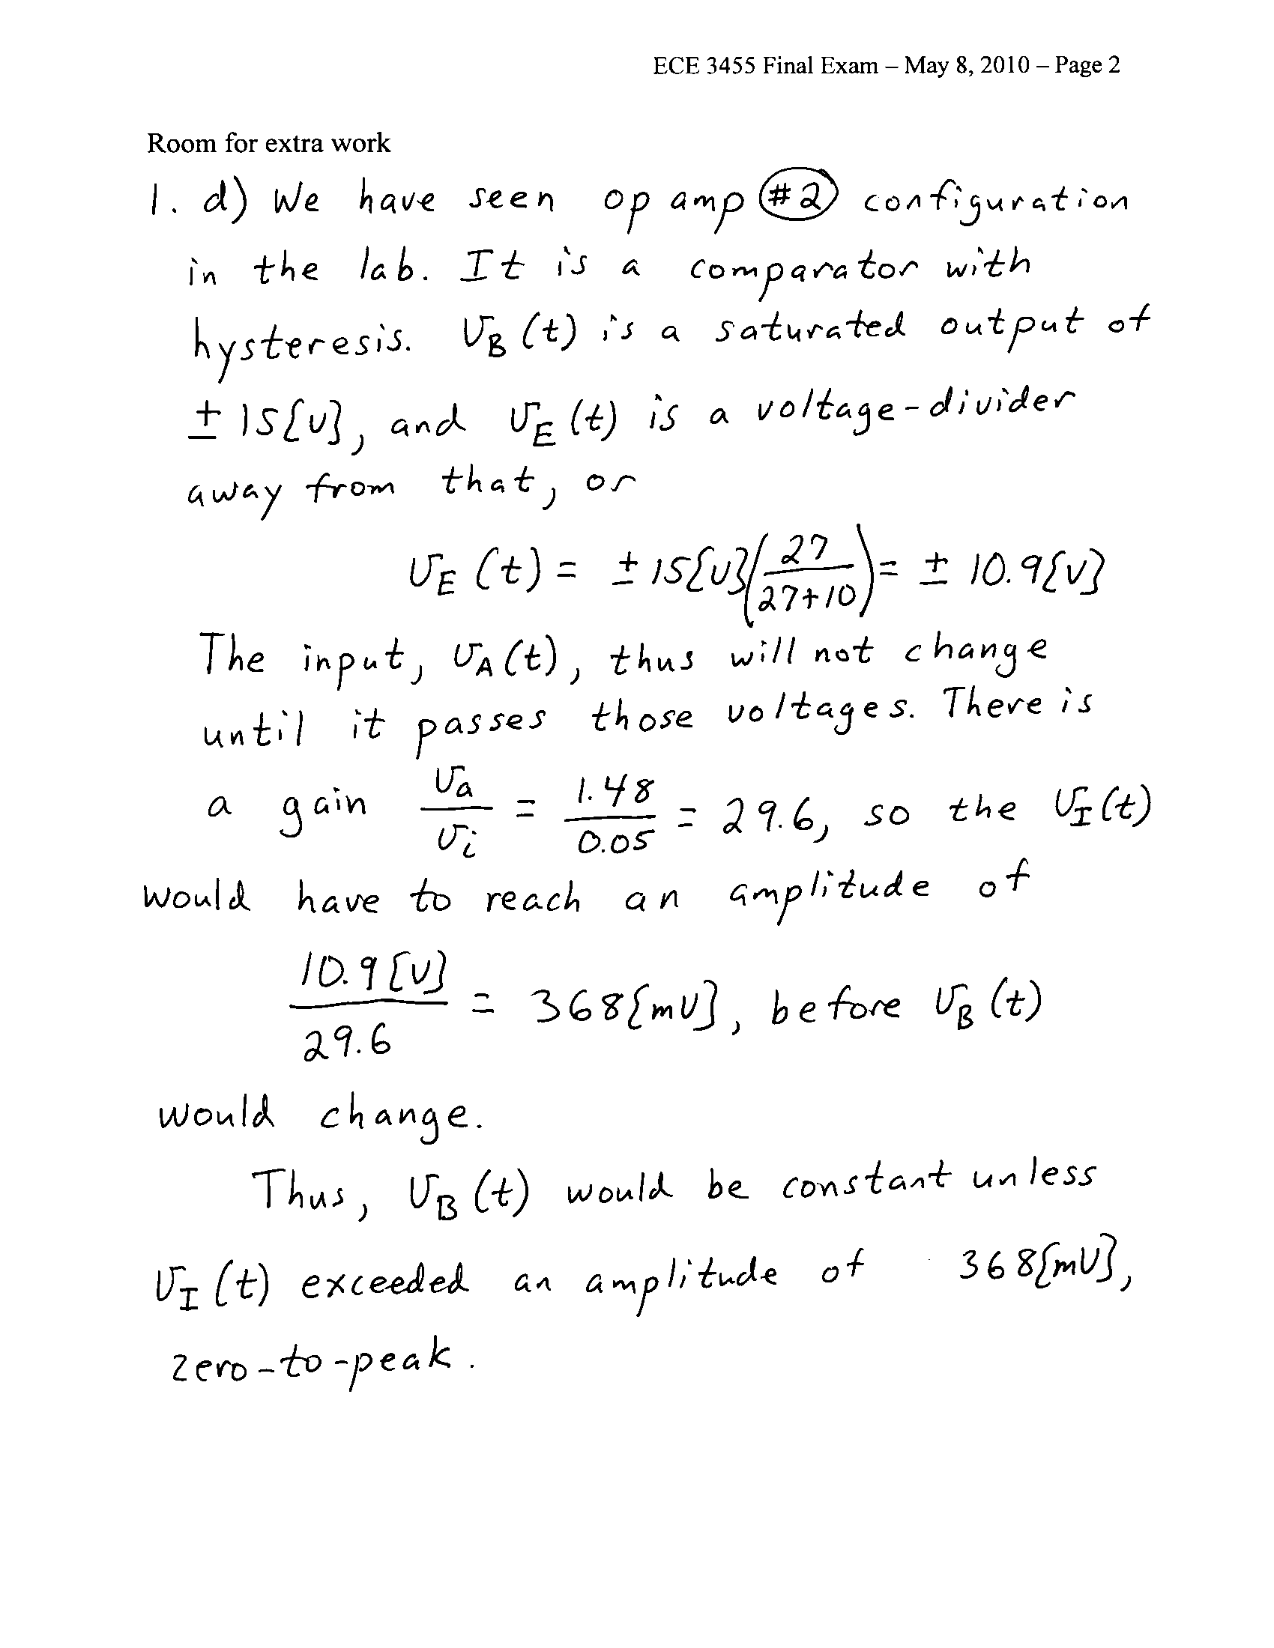

2. {20 Points} A nonlinear device called an ayetripuleeyor has a schematic symbol shown in Figure 1. The transfer characteristic for this ayetripuleeyor is given in the plot in Figure 3 on the next page.
- On the plot in Figure 3, draw the load line for the device assuming that the device has been connected to the circuit shown in Figure 2. Use this load line to solve for i_{X}.
- Pick a straight line near the solution, and use that straight line to get a model for the ayetripuleeyor device that could be used to solve circuits like the one given in Figure 2.
- Insert the model found in part b) in the circuit shown in Figure 2, and use this to solve for i_{X}.
- It is possible to place the ayetripuleeyor device in a circuit where there would be more than one solution for i_{X}. Devise such a circuit, and show how more than one solution would be possible.
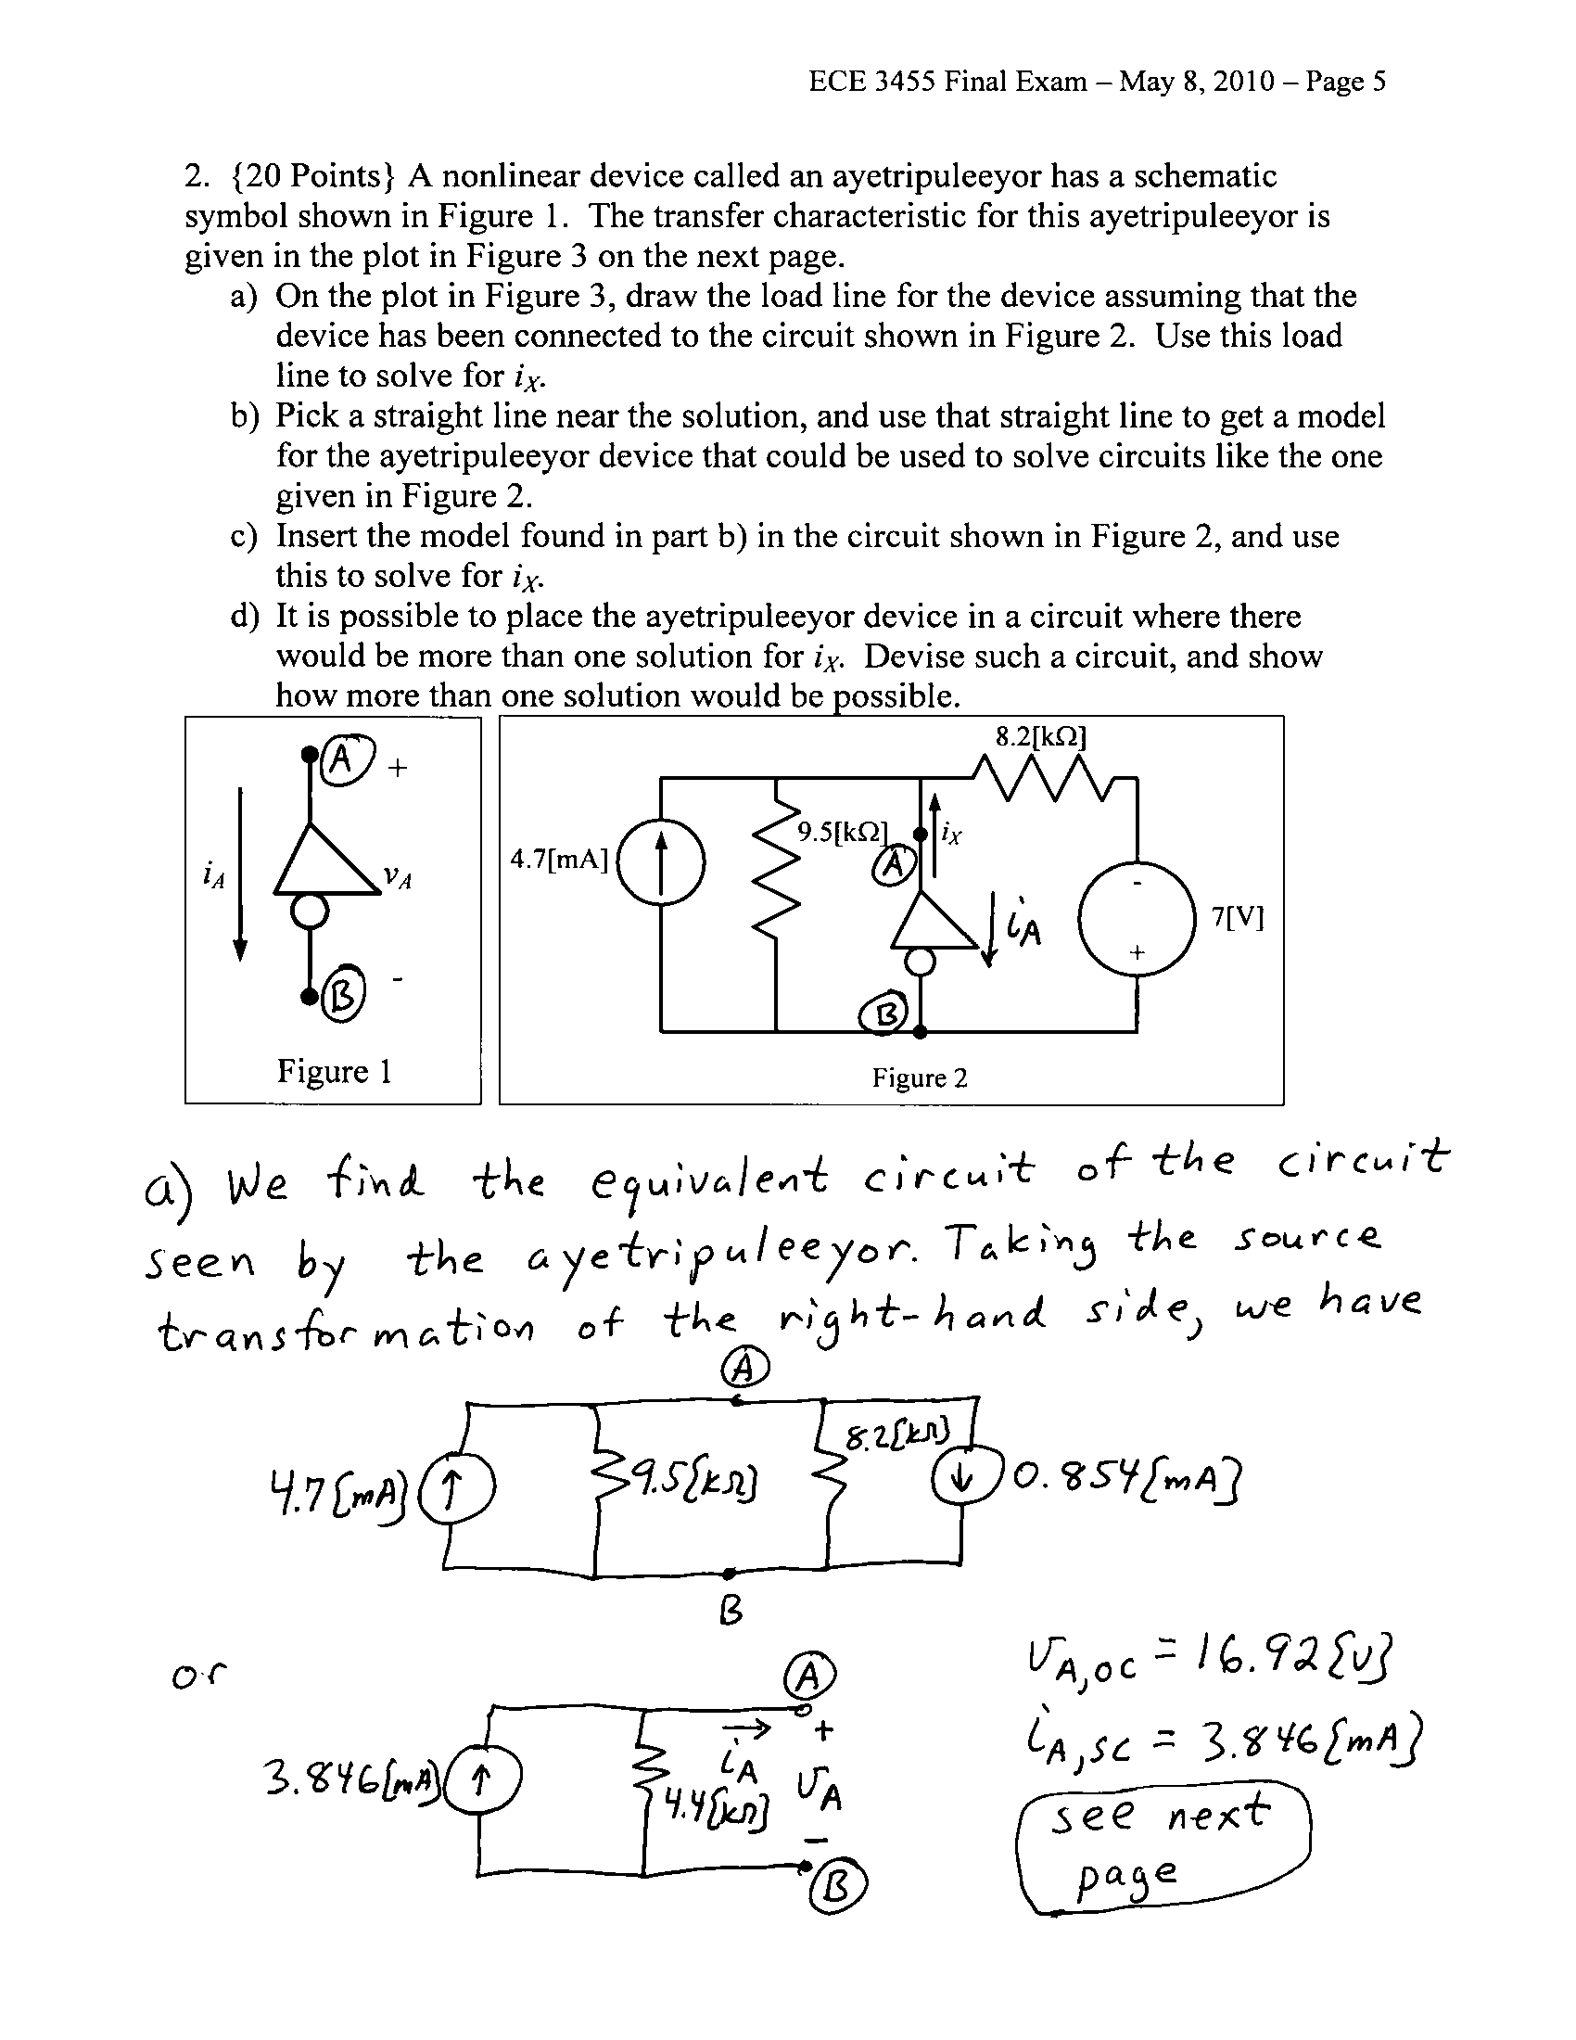
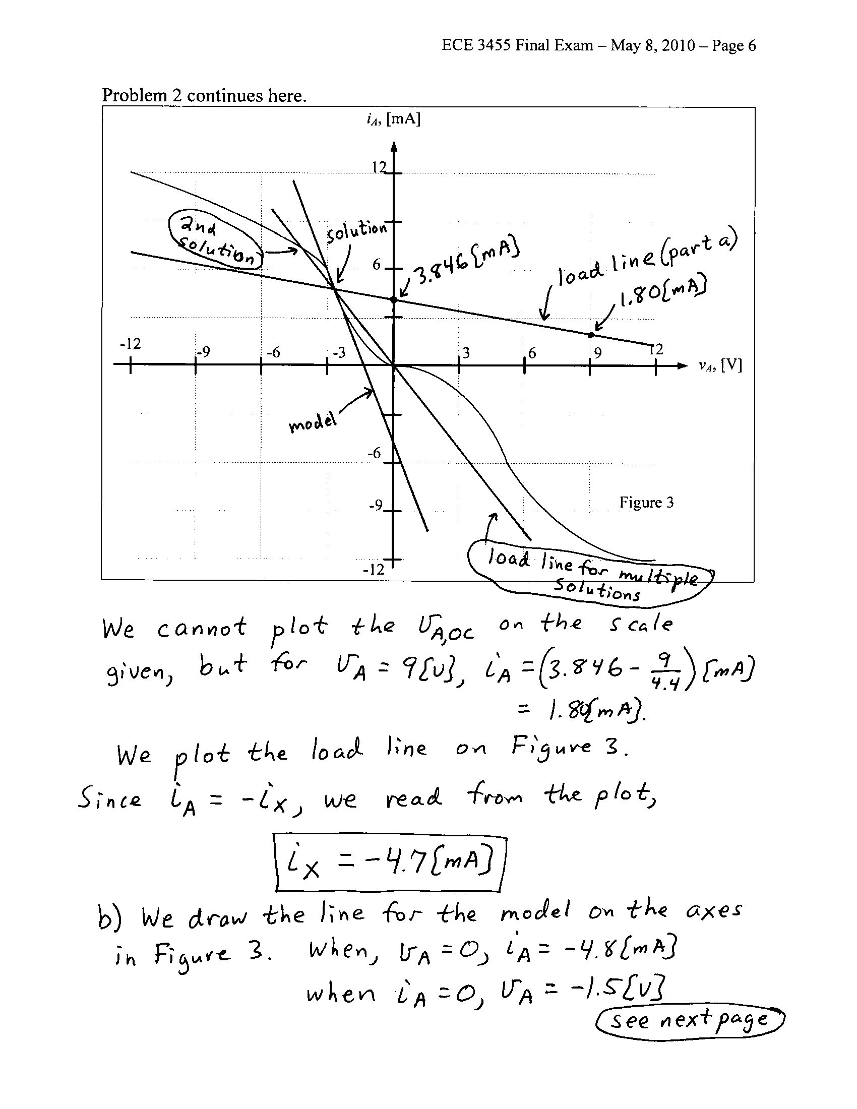
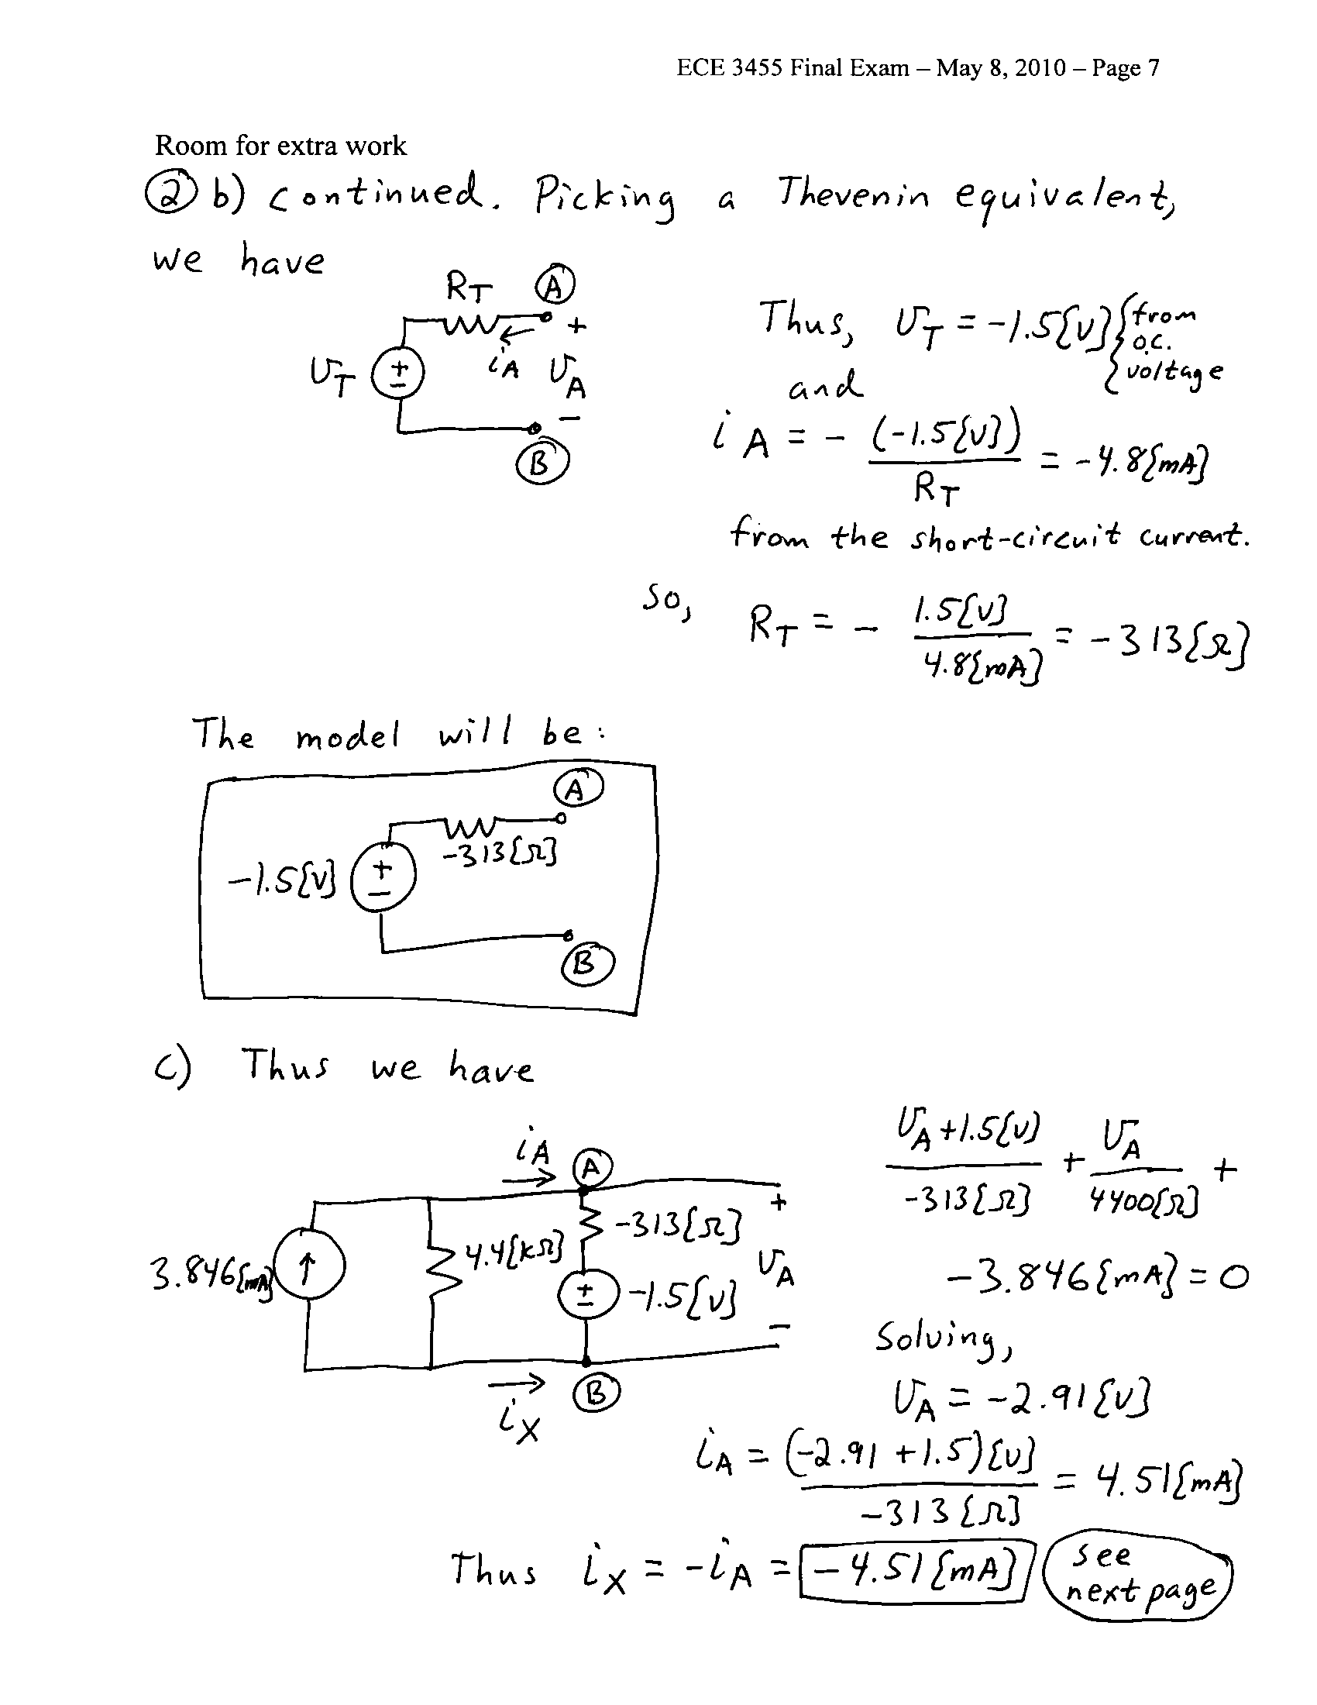
3. {10 Points} Assume that each of the diodes in the circuit given can be modeled using a piecewise-linear model with V_{f} = 1[V], r_{d} = 1[kΩ], and I_{s} = 1[mA]. Find V_{X}. I expect that you will be able to complete at least four guesses in the time period given. Remember that you will be graded primarily on the approach that you take to the problem. Define the names of your regions clearly. State your guesses, and test them explicitly.
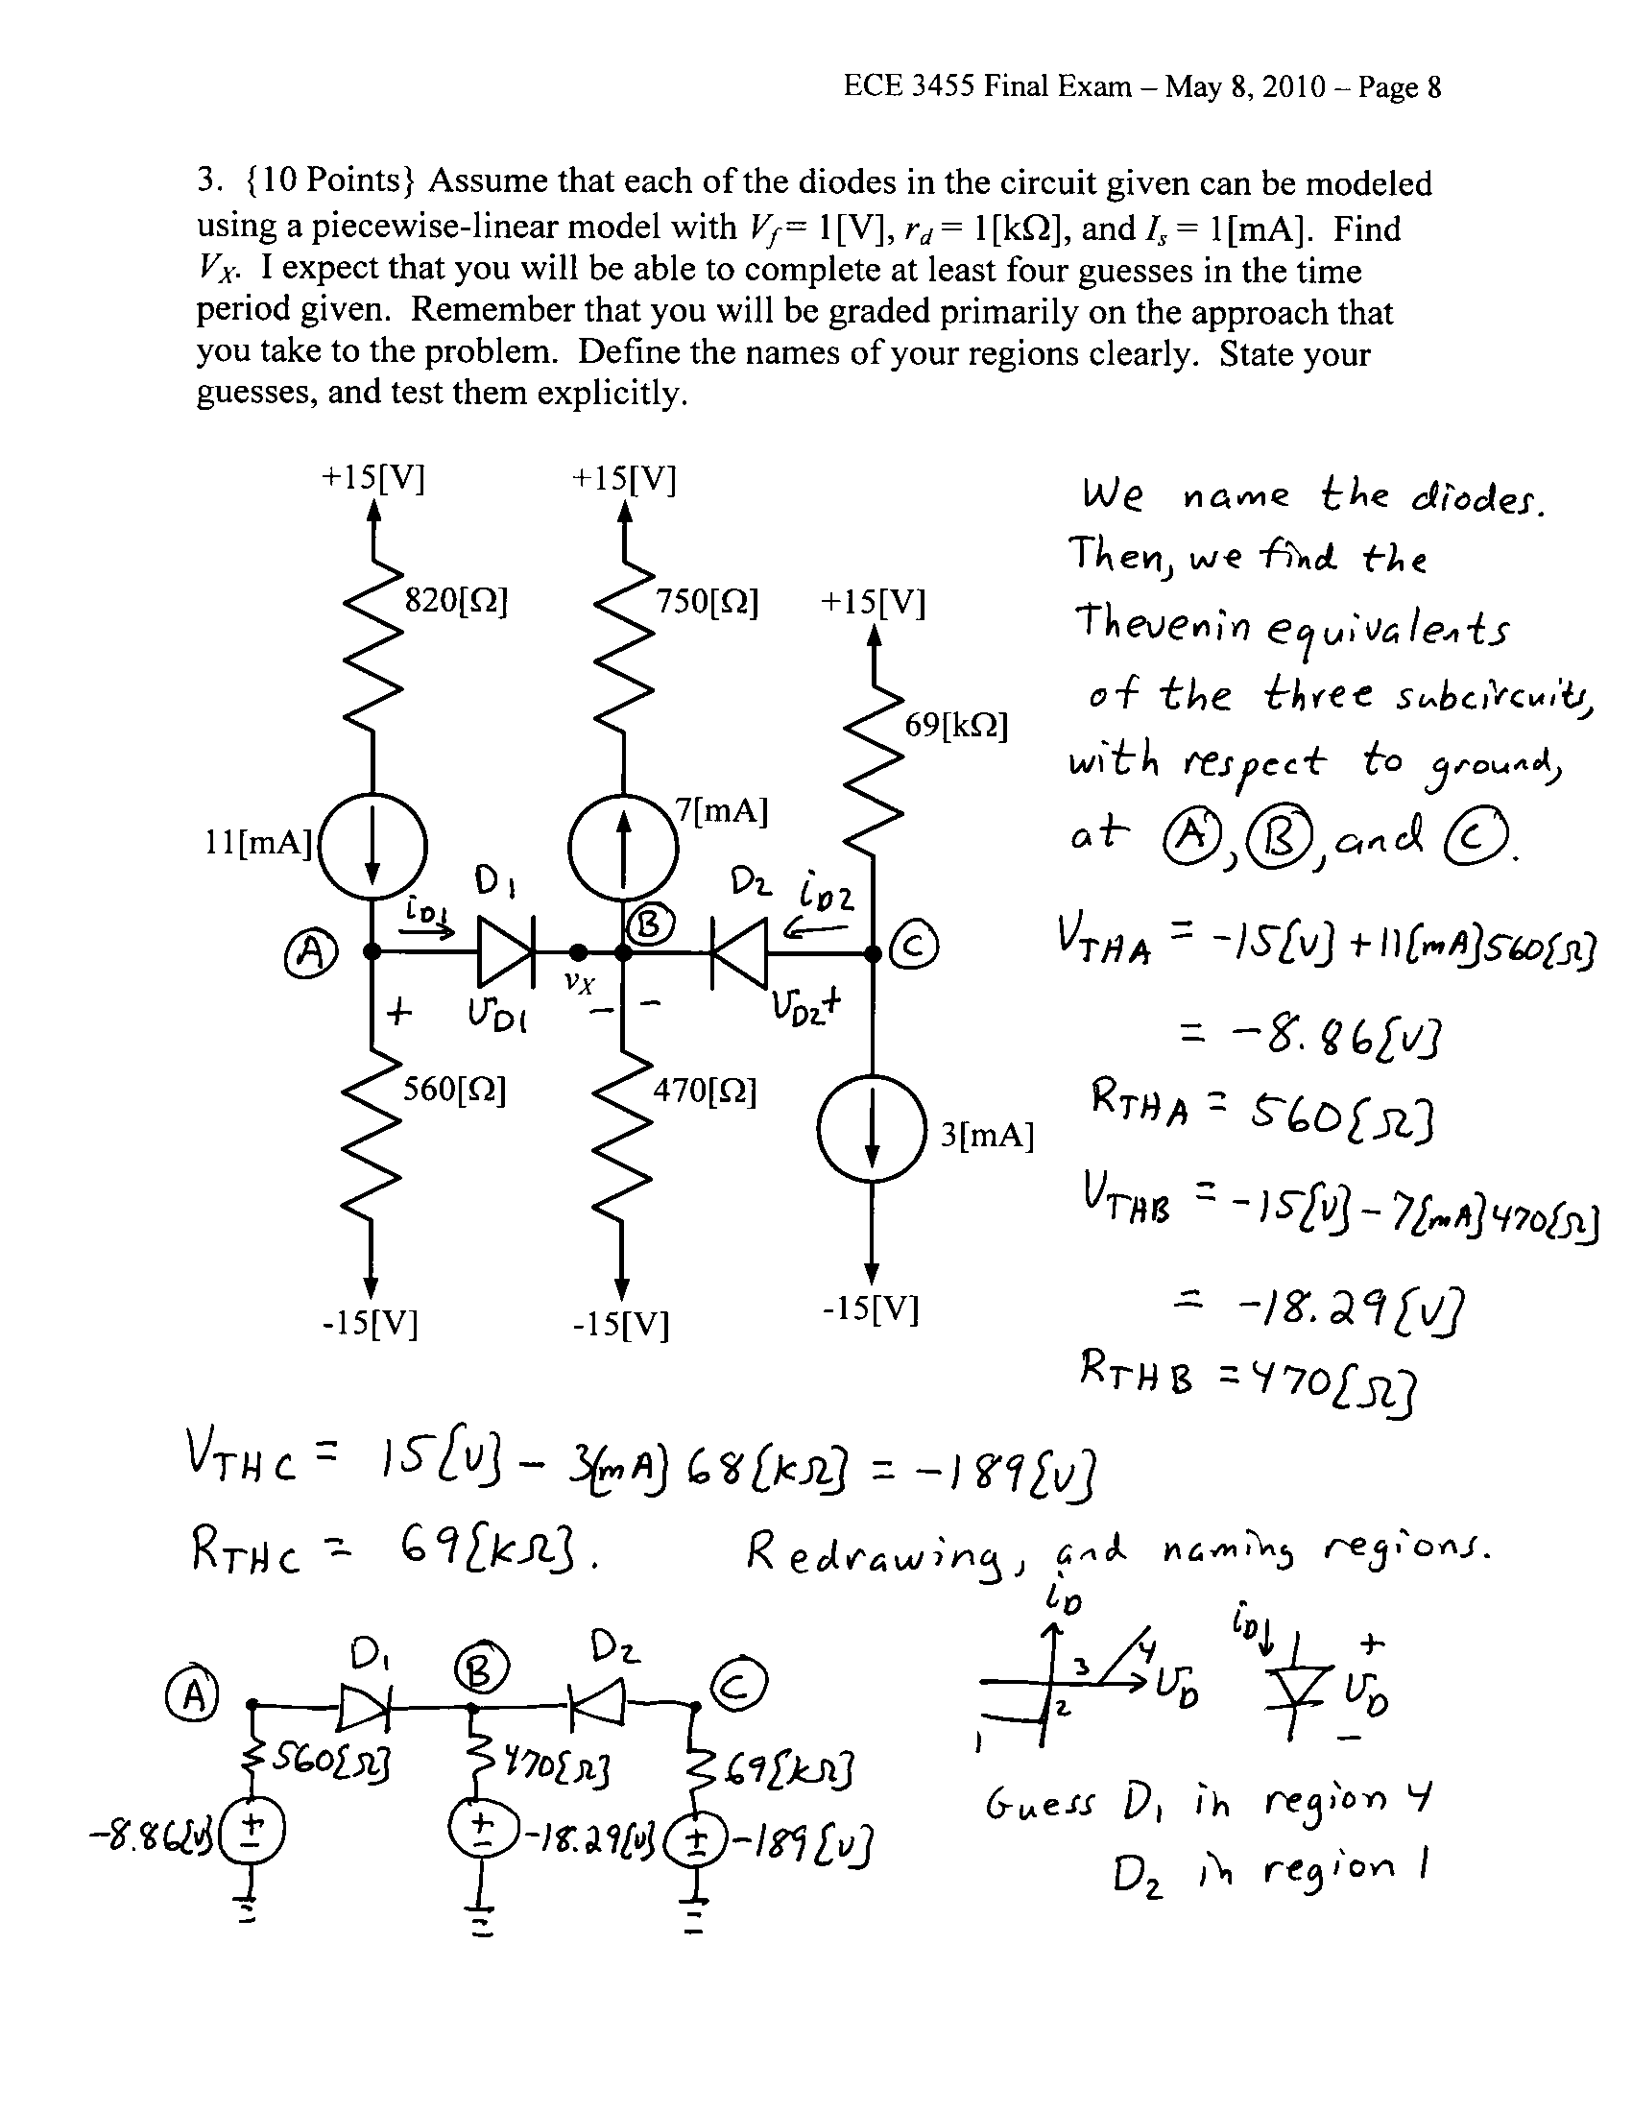
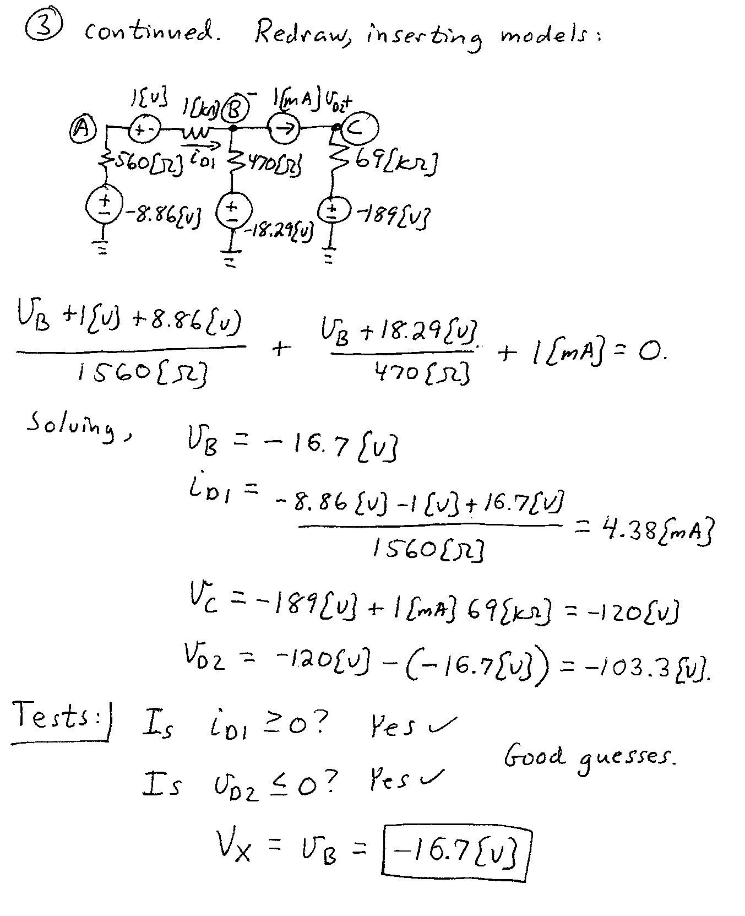

4. {30 Points} Assume that the transistor in this problem operates at room temperature, and has β = 100.
a) Find the voltage gain v_{o}/v_{i} in the passband.
b) Find the input resistance seen by the source v_{i}(t) in the passband.
c) Find the transfer function V_{o}/V_{i} assuming that the source v_{i}(t) is a small signal.
d) Plot the straight-line approximation to the magnitude Bode plot for the transfer function you obtained in part b). Use one of the sheets of semilog graph paper at the end of this exam. Pick one of your poles, and place it near the center of the frequency axis in your plot.
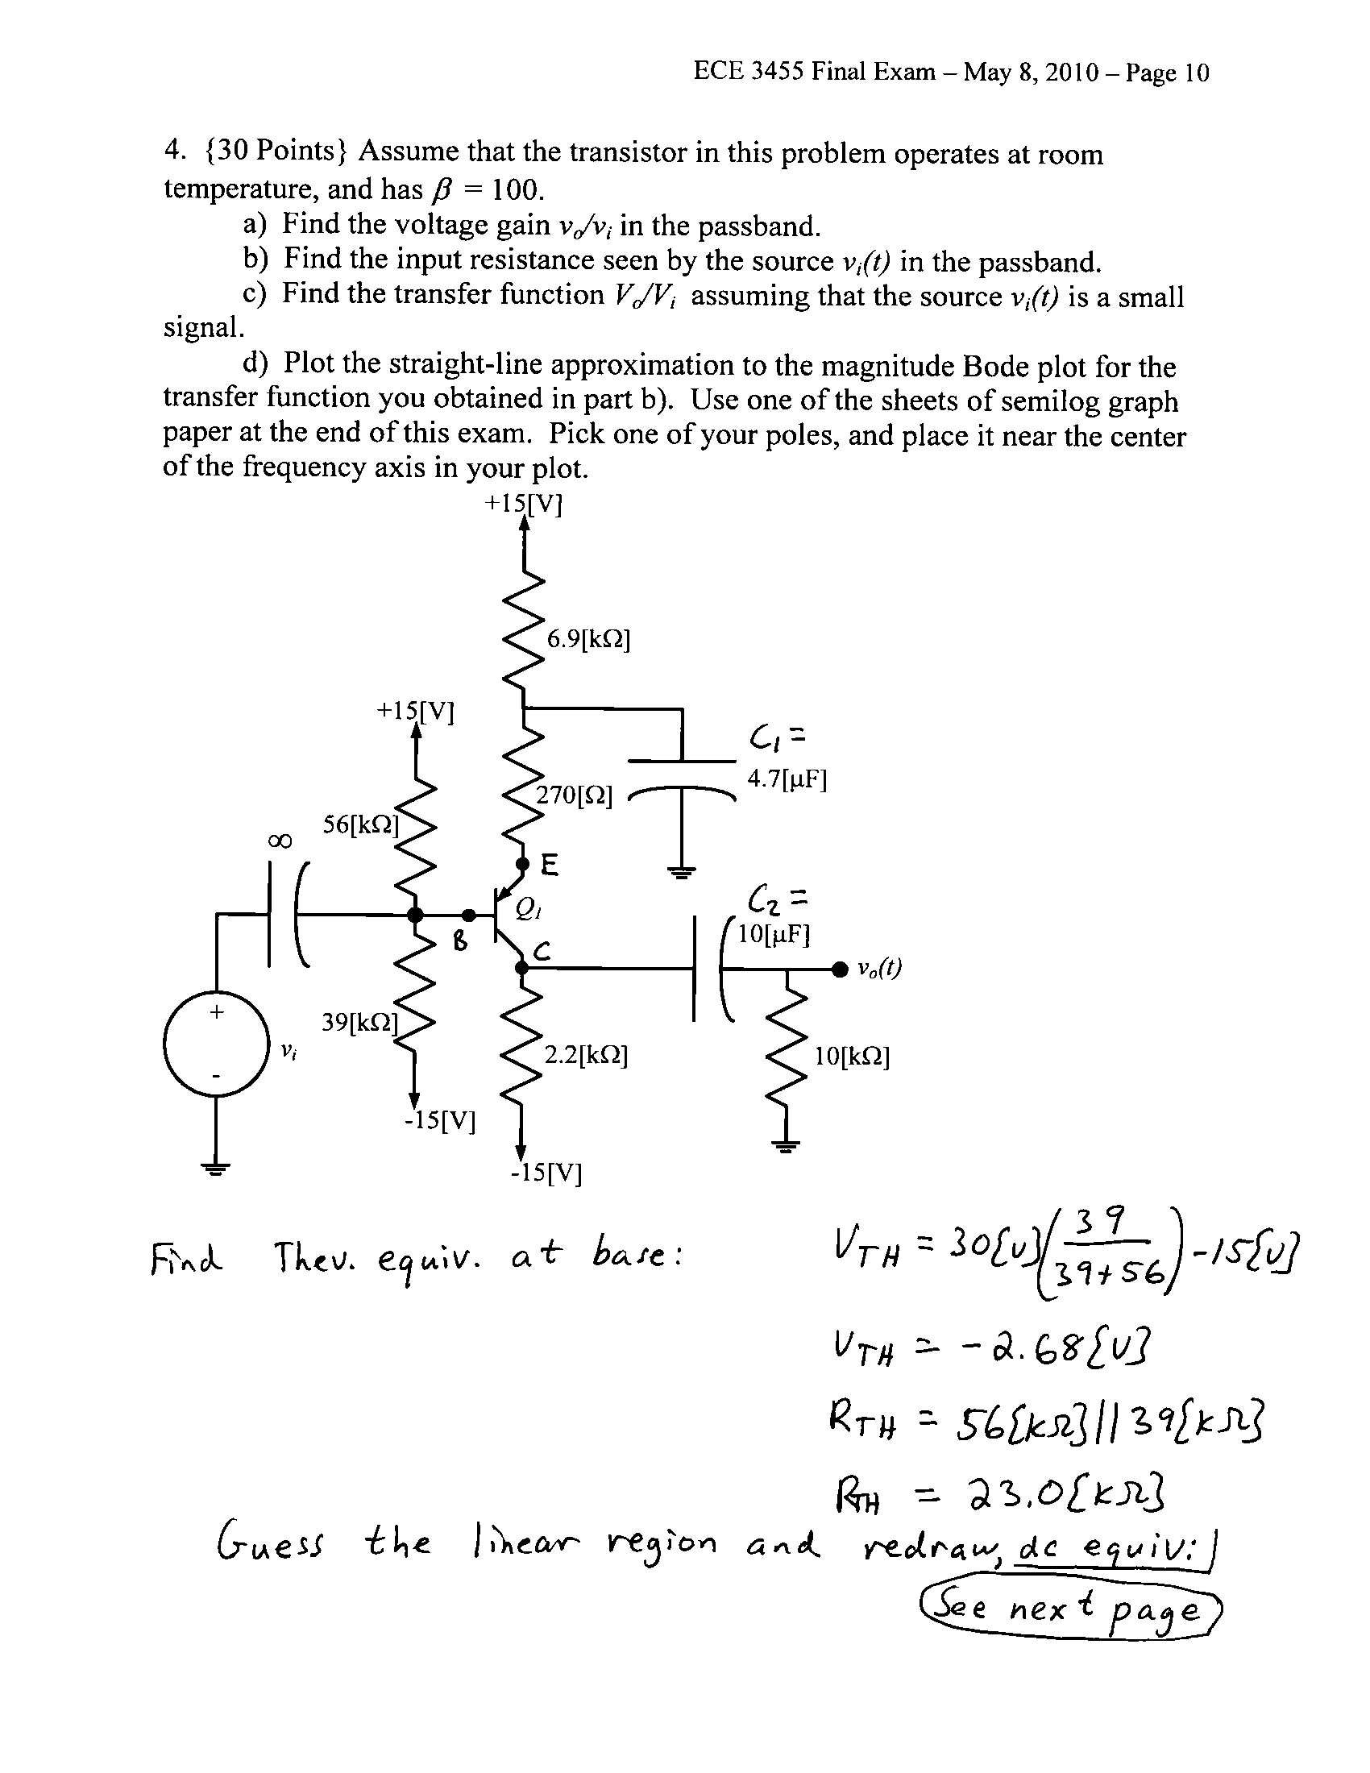
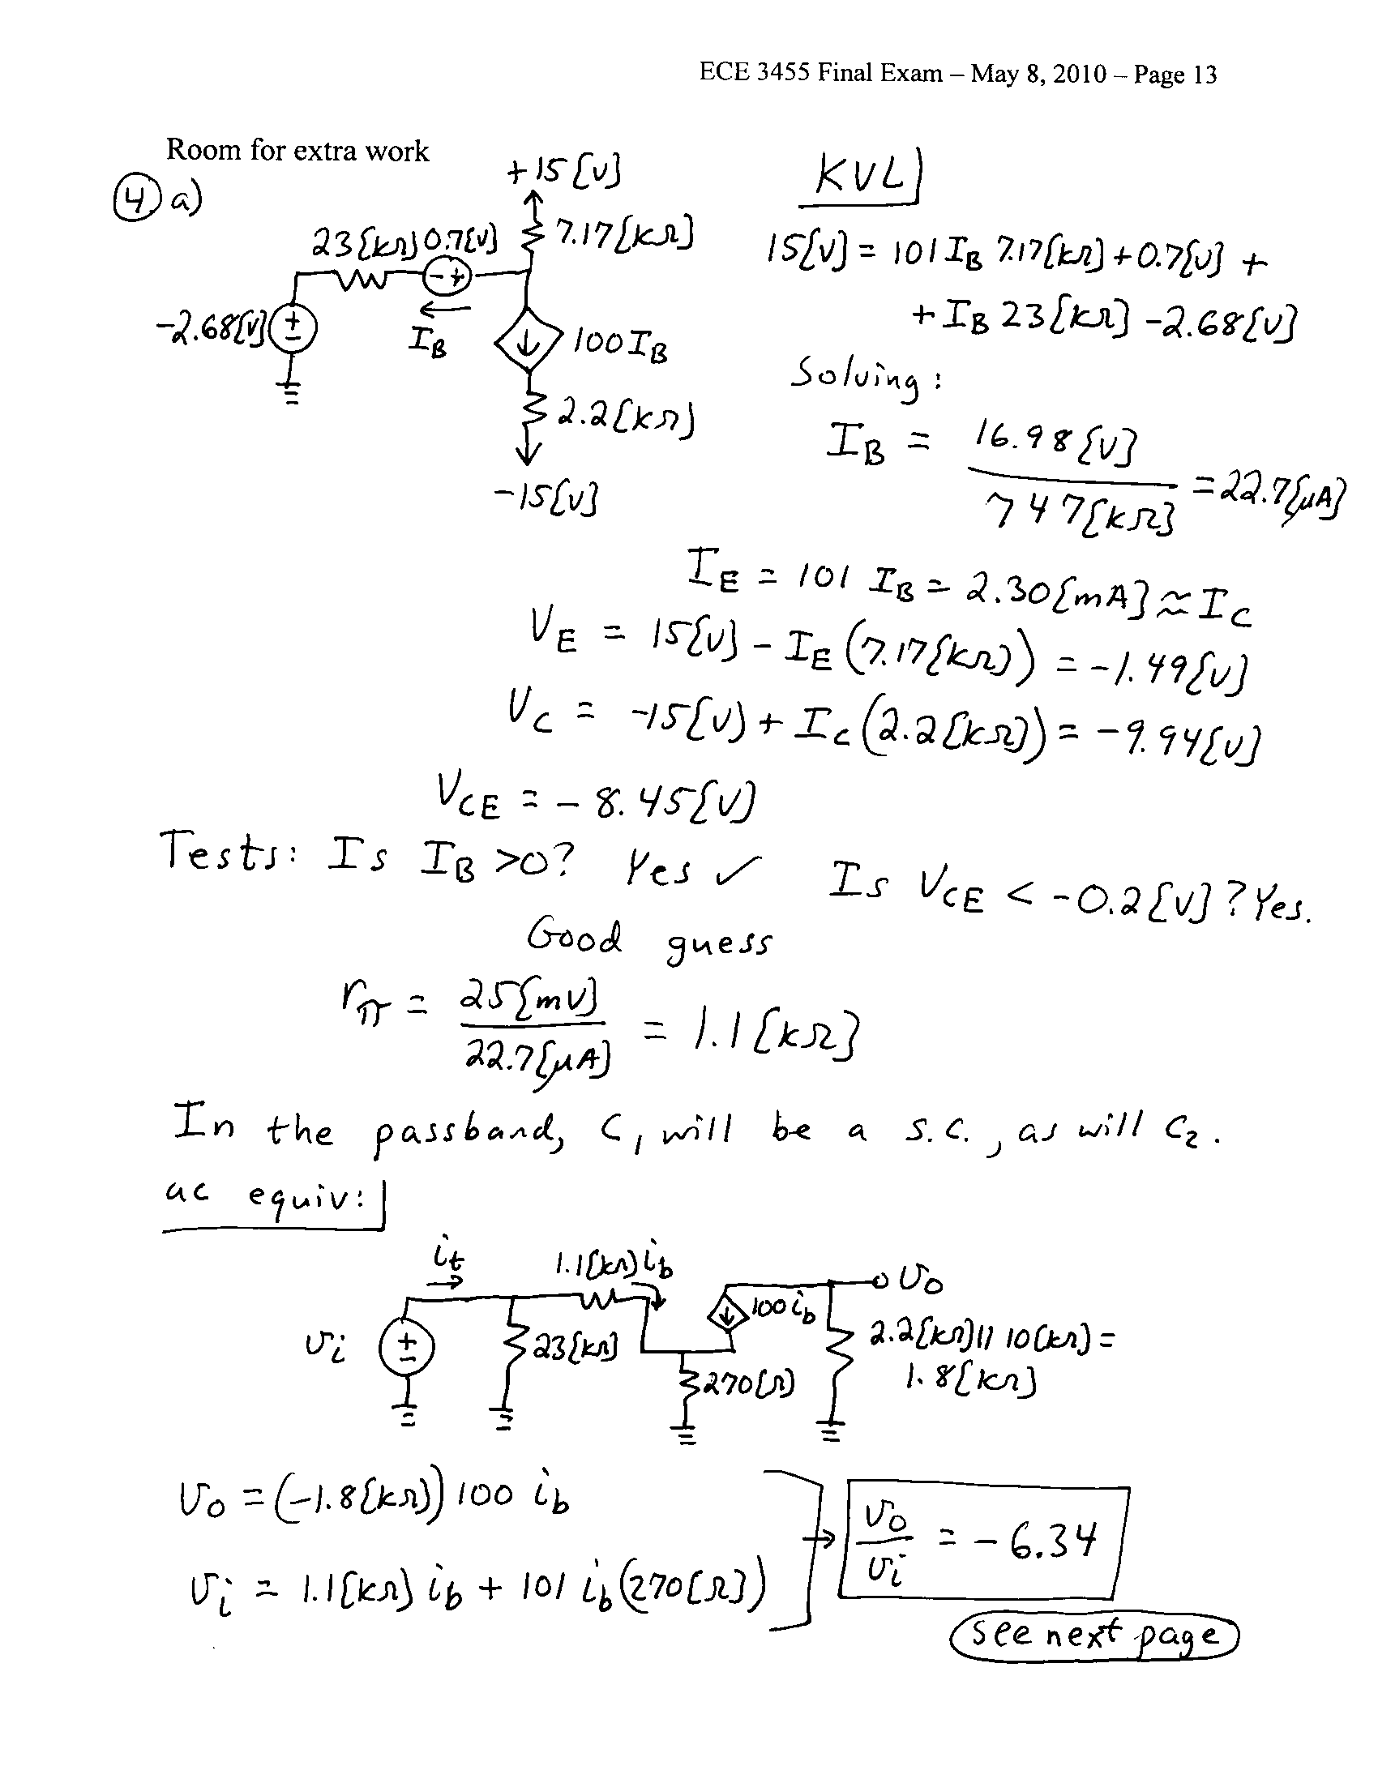
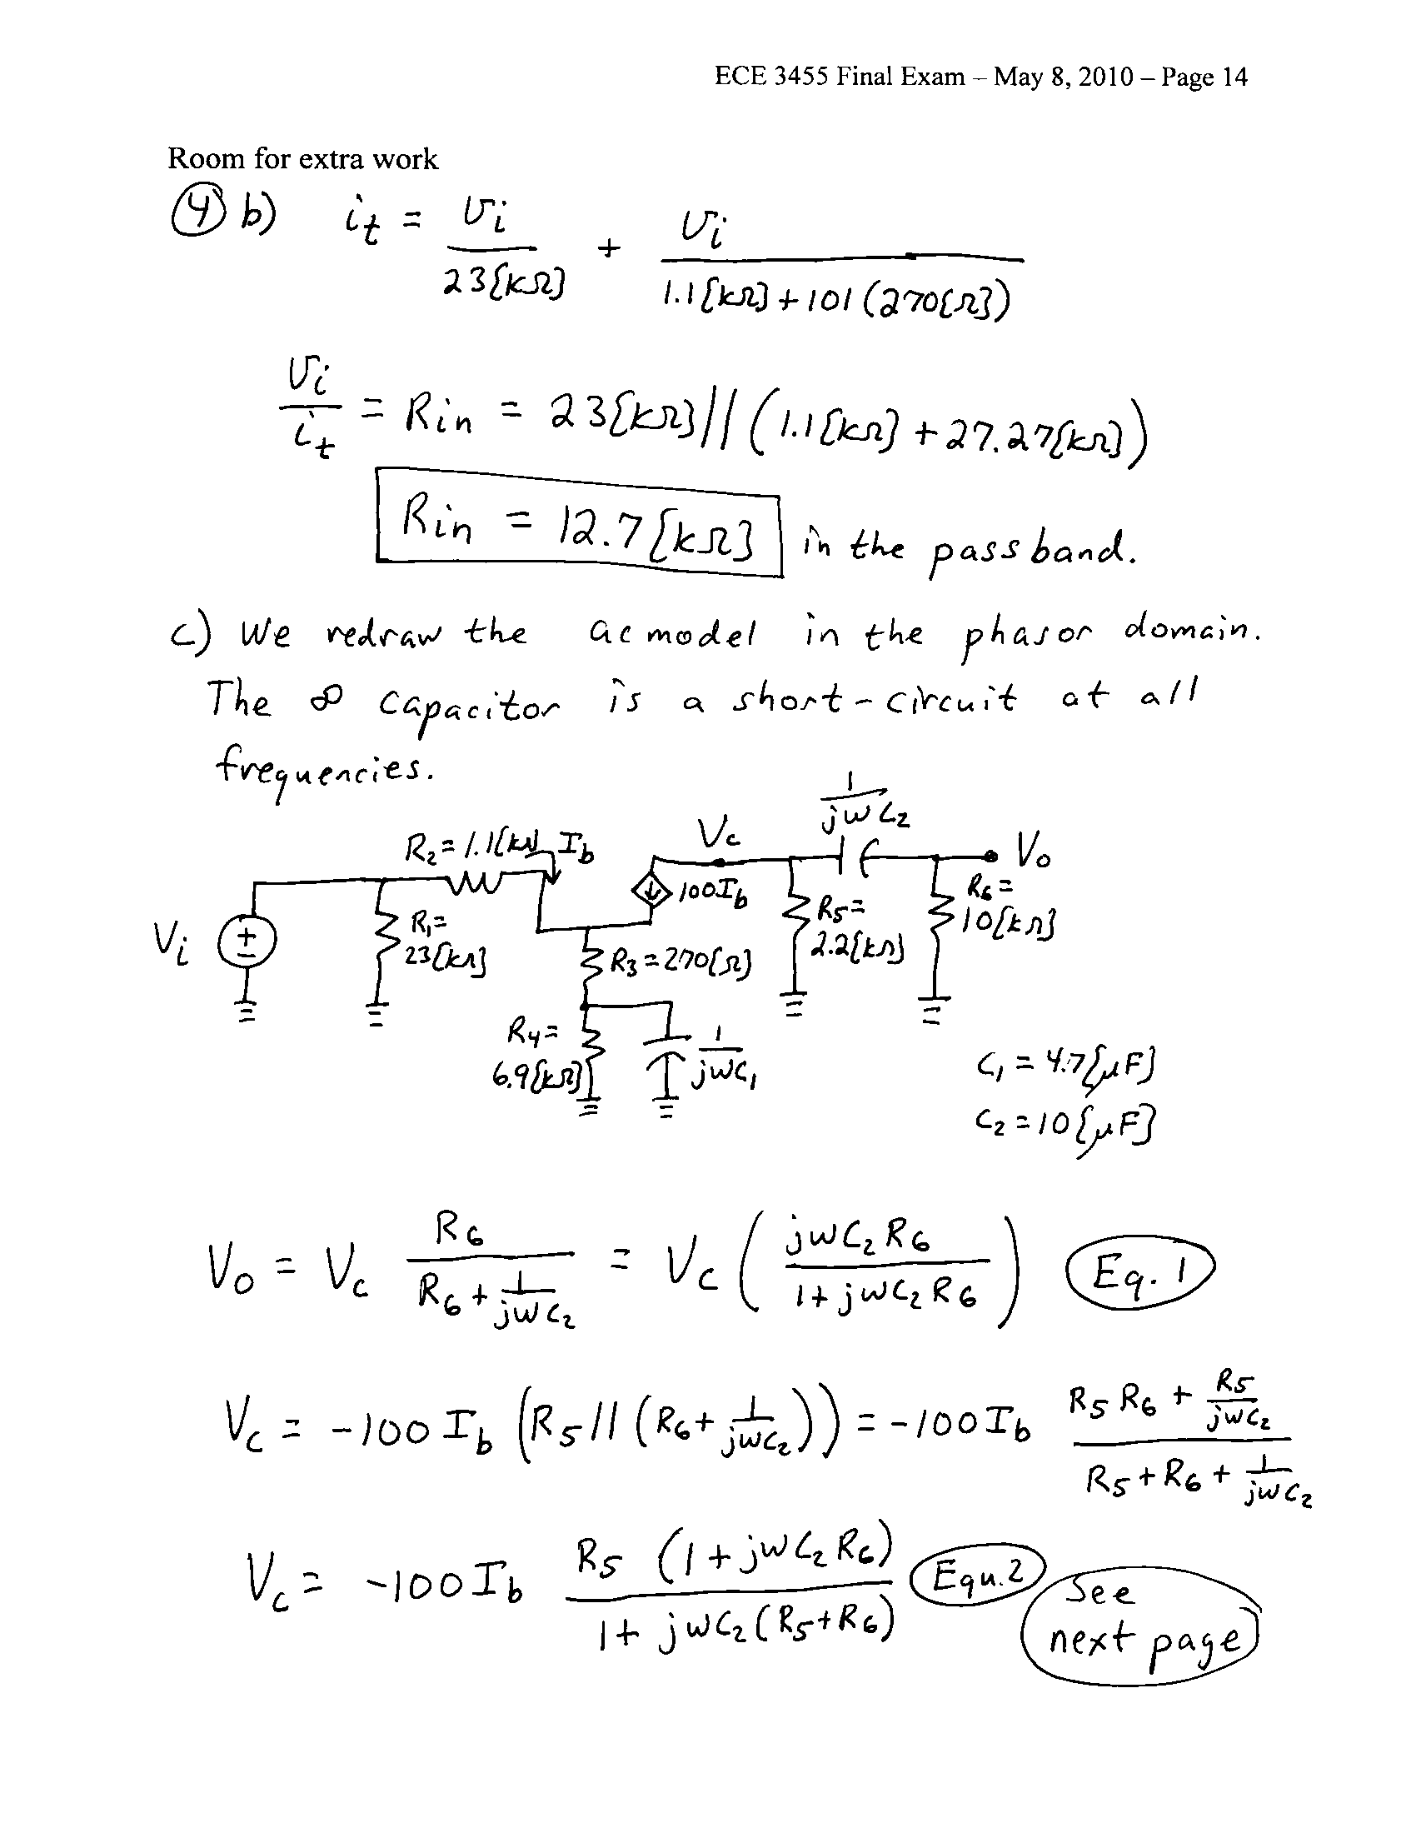
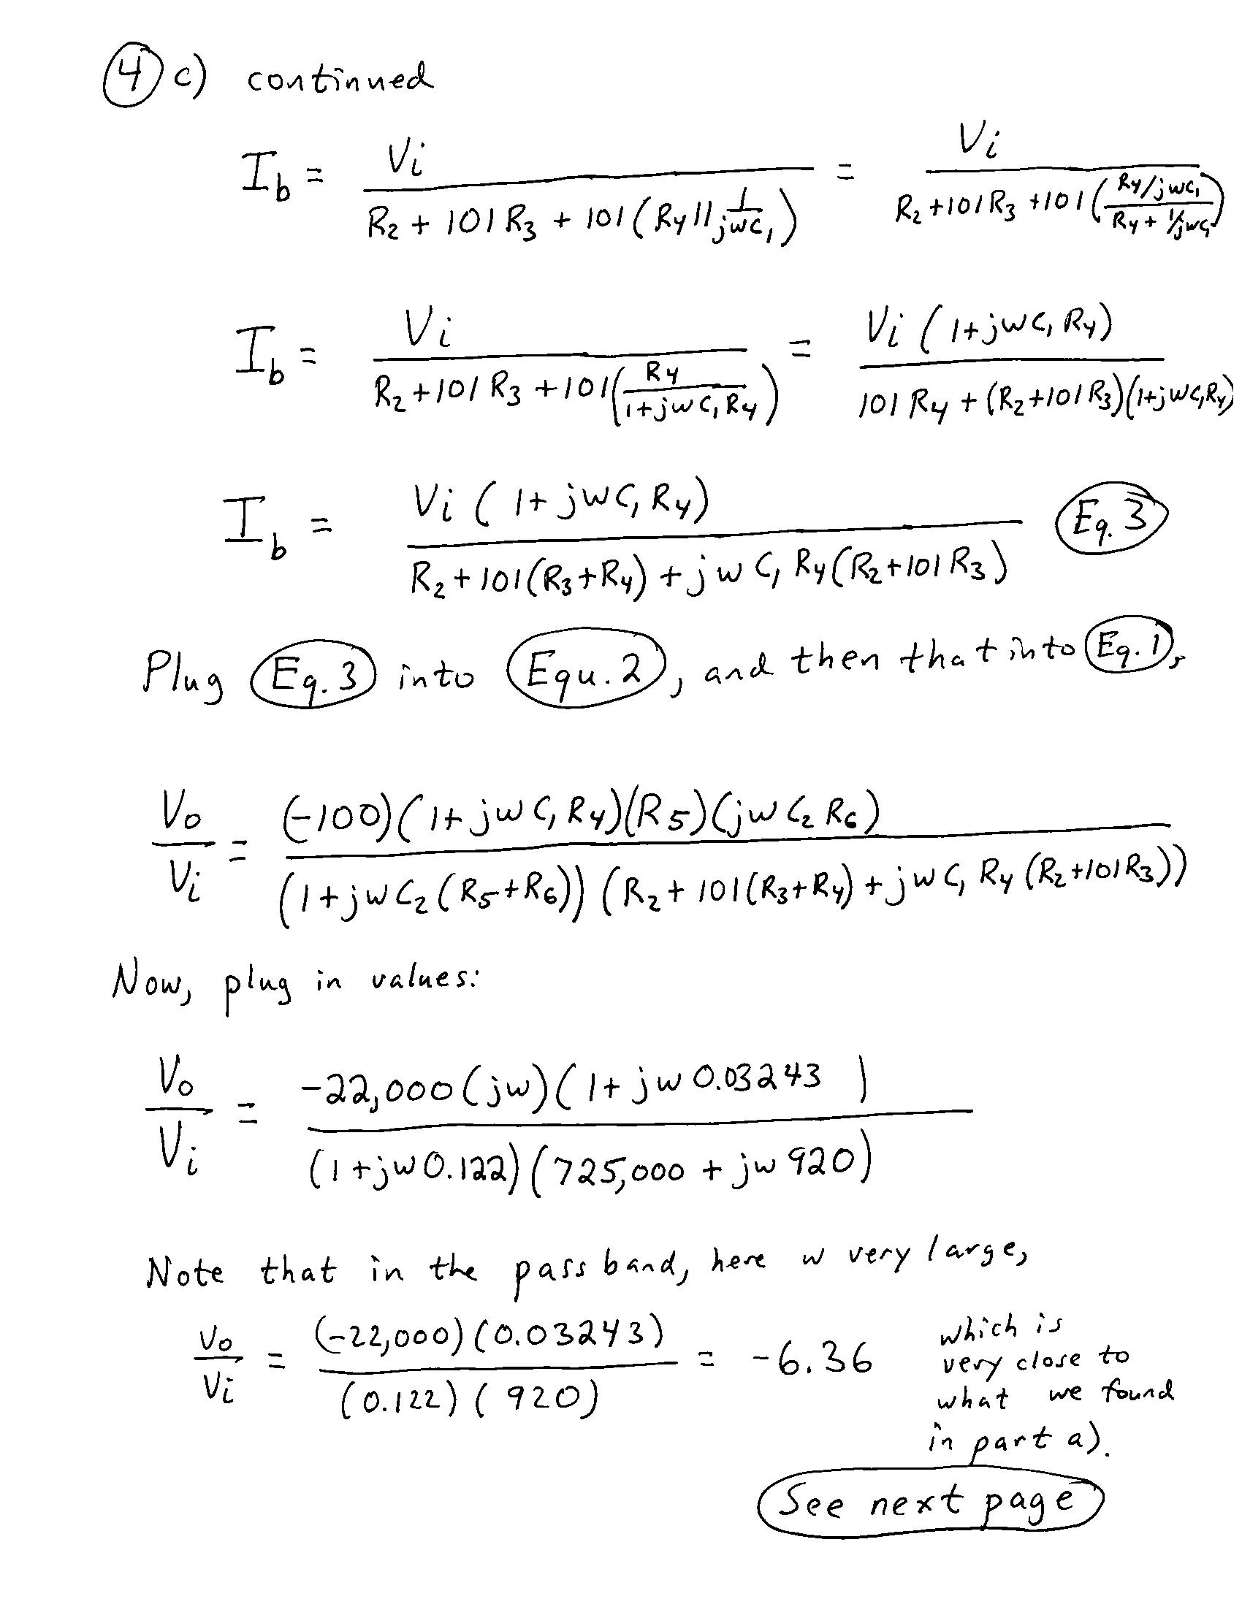
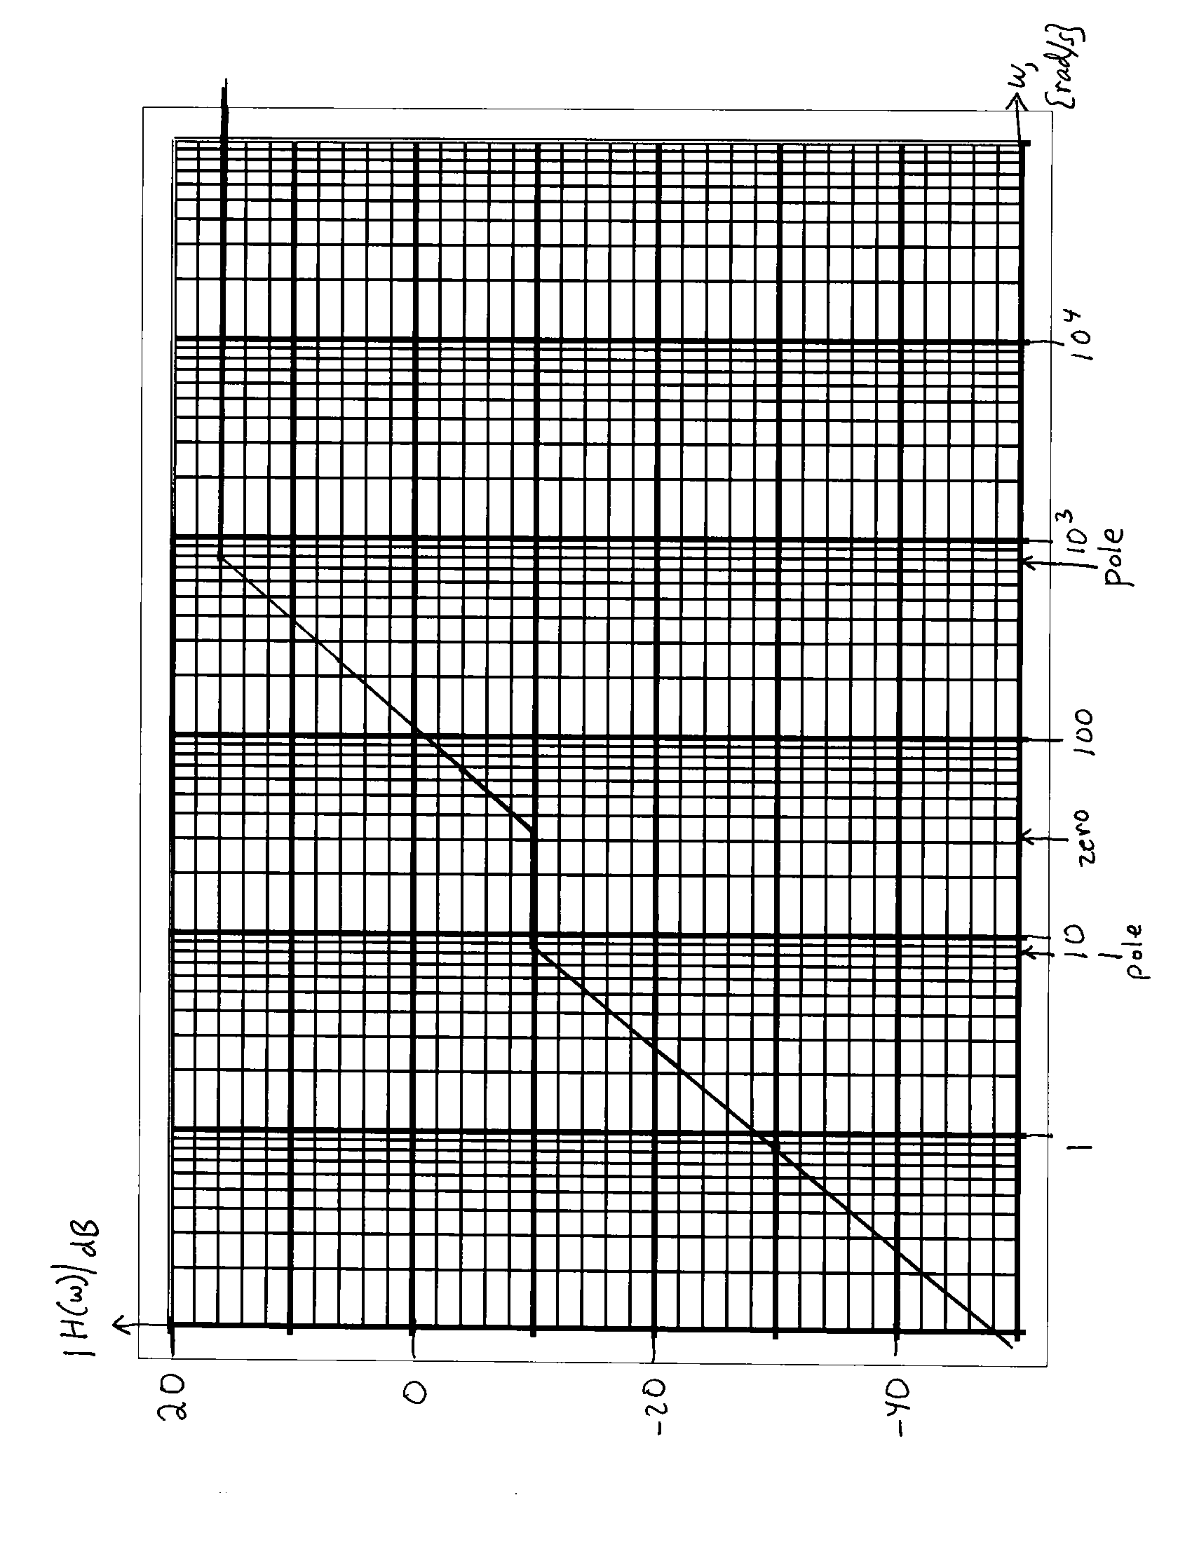
5. {40 Points} Design a circuit that will meet the specifications given below. You have available an unlimited number of ideal op amps and transistors with
β = 200. You may use any number of resistors, inductors, capacitors, and potentiometers, with any values. You have available an unlimited number of diodes with V_{f} = 0.7[V], r_{d} = 1[kΩ], and I_{s} = 0. You have two dc power supplies, at +15[V] and -15[V].
The specifications follow:
- You are to produce a waveform which approximates a sine wave. An approximation to a sine wave can be achieved by filtering a square wave using a low-pass filter with a breakpoint frequency just above the repetition rate of the square wave.
- You are to produce this sine wave approximation so that it will have a frequency of 250[Hz].
- From the sine wave, you are to produce a half-wave rectified version of that sine wave.
- From this rectified sine wave, you are to produce a waveform in the form given in the plot below. The “floor value” and the “size” are defined in the plot. The “floor value” should be variable, with a value controlled by a potentiometer. The “floor value” should be in the range between -4[V] and +4[V]. The “size” should be 2.70[V]. The “size” should not be changed when there are changes in the “floor value”.
Explain how your design meets the specifications using complete sentences.
