Name: _____________________________ (please print)
Signature: __________________________

ECE 3355 – Exam 1
March 4, 2017

Keep this exam closed until you are told to begin.

1. This exam is closed book, closed notes. You may use one 8.5” x 11” crib sheet, or its equivalent.
2. Show all work on these pages. Show all work necessary to complete the problem. A solution without the appropriate work shown will receive no credit. A solution that is not given in a reasonable order will lose credit. Clearly indicate your answer (for example by enclosing it in a box). If your answer is a plot, no box is needed.
3. It is assumed that your work will begin on the same page as the problem statement. If you choose to begin your work on another page, you must indicate this on the page with the problem statement, with a clear indication of where the work can be found. If your work continues on to another page, indicate clearly where your work can be found. Failure to indicate this clearly will result in a loss of credit.
4. Show all units in solutions, intermediate results, and figures. Units in the exam will be included between square brackets.
5. Do not use red ink. Do not use red pencil.
6. You will have 90 minutes to work on this exam.

1. ________________/20
2. ________________/40
3. ________________/40
Total = 100
Room for extra work
1. {20 Points} An oscilloscope input can be modeled as a 370[kΩ] resistor in parallel with a 57[pF] capacitor. Design a five-times probe that could be used with this oscilloscope to allow signals to be viewed on the screen without distortion, that is, with the proper shape. Draw a circuit diagram, showing the oscilloscope and your five-times probe, with the values of all of the components. Find the transfer function of the probe and oscilloscope combination.

Room for extra work

2. {40 Points} Assume that an amplifier has the equivalent circuit shown in Figure 1. The source v_{s}(t) has an rms value of 1.5[V_{rms}].
a) Find the output resistance seen by the load, R_{L}, if this amplifier is connected in Figure 2, with the terminals connected as indicated by the numbers.
b) Find the output resistance seen by the load, R_{L}, if this amplifier is connected in Figure 3, with the terminals connected as indicated by the numbers.

Room for extra work

Room for extra work

3. {40 Points} The circuit shown in Figure 2 has the straight-line approximation to the magnitude Bode plot shown in Figure 1. The frequency axis in this plot is not drawn to scale. Find the values for L₁ and L₂ that will make the circuit in Figure 2 give the response shown in Figure 1.

Solutions:
1. {20 Points} An oscilloscope input can be modeled as a 370[kΩ] resistor in parallel with a 57[pF] capacitor. Design a five-times probe that could be used with this oscilloscope to allow signals to be viewed on the screen without distortion, that is, with the proper shape. Draw a circuit diagram, showing the oscilloscope and your five-times probe, with the values of all of the components. Find the transfer function of the probe and oscilloscope combination.
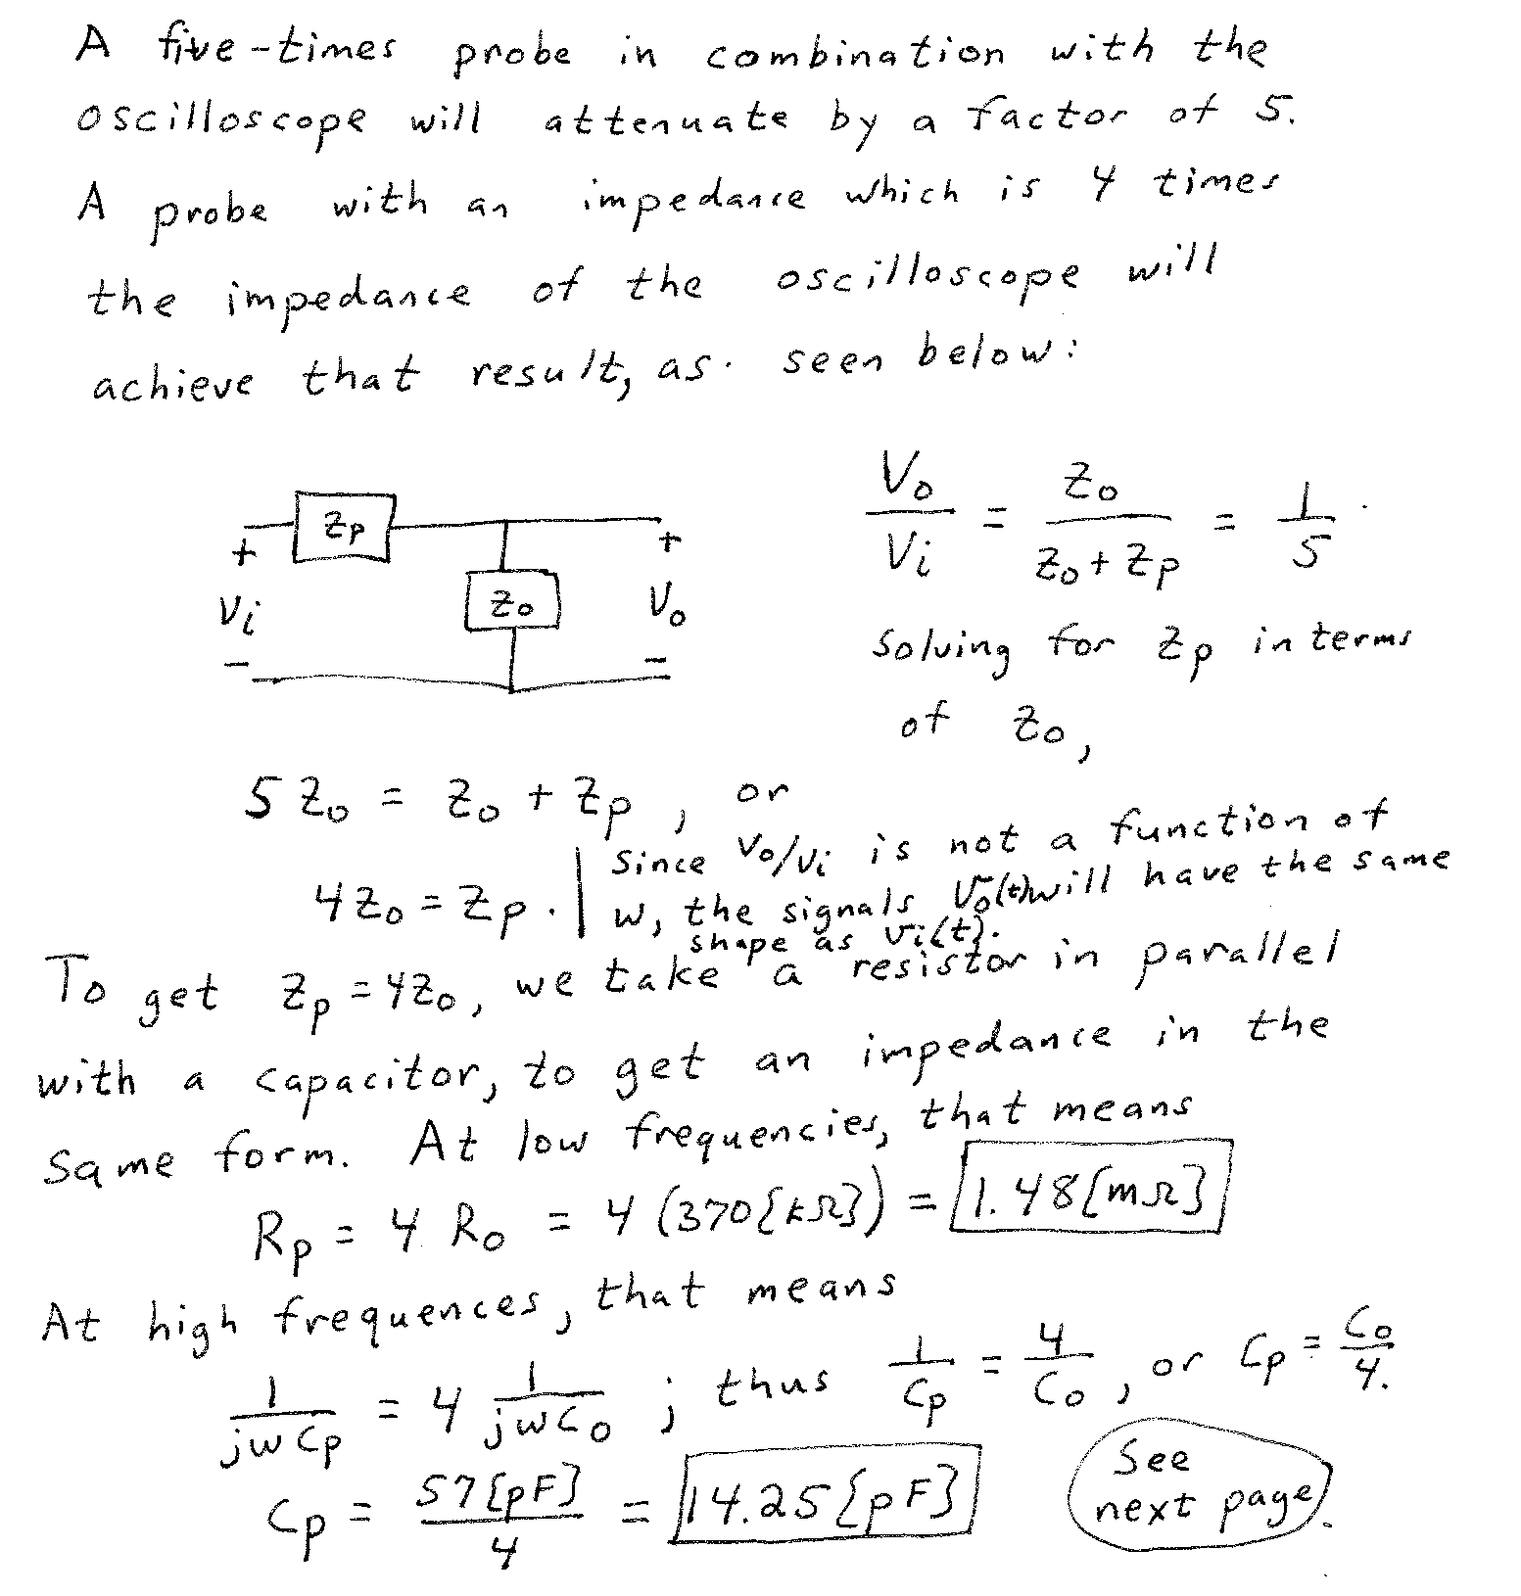
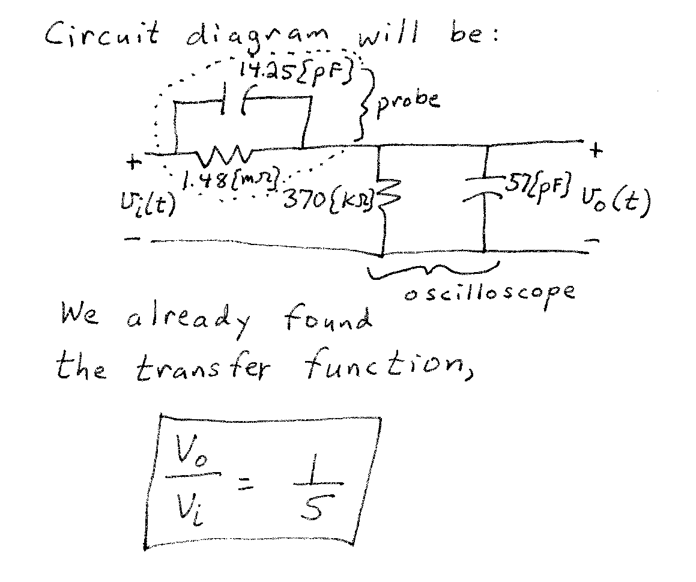

2. {40 Points} Assume that an amplifier has the equivalent circuit shown in Figure 1. The source v_{s}(t) has an rms value of 1.5[V_{rms}].
a) Find the output resistance seen by the load, R_{L}, if this amplifier is connected in Figure 2, with the terminals connected as indicated by the numbers.
b) Find the output resistance seen by the load, R_{L}, if this amplifier is connected in Figure 3, with the terminals connected as indicated by the numbers.

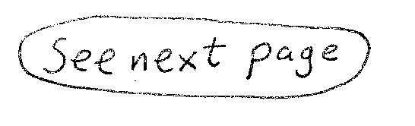
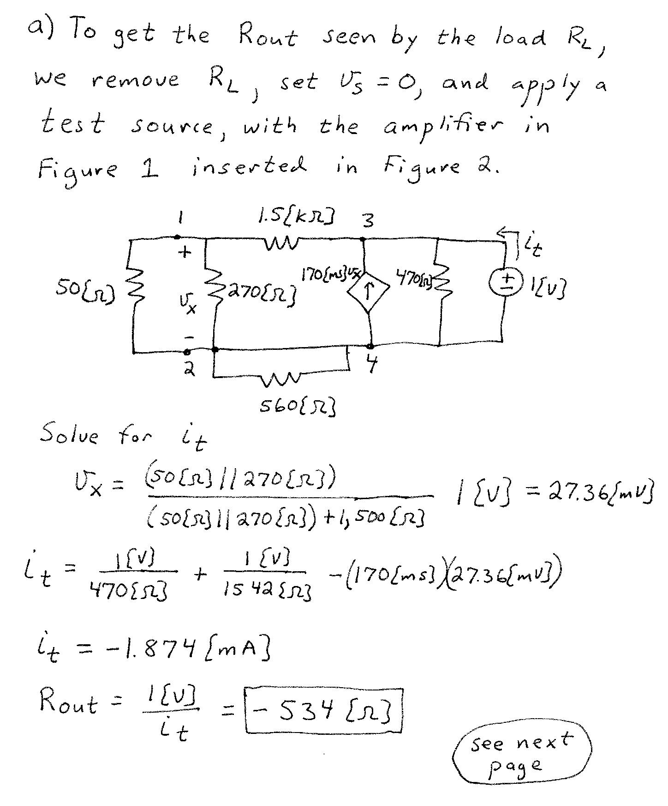
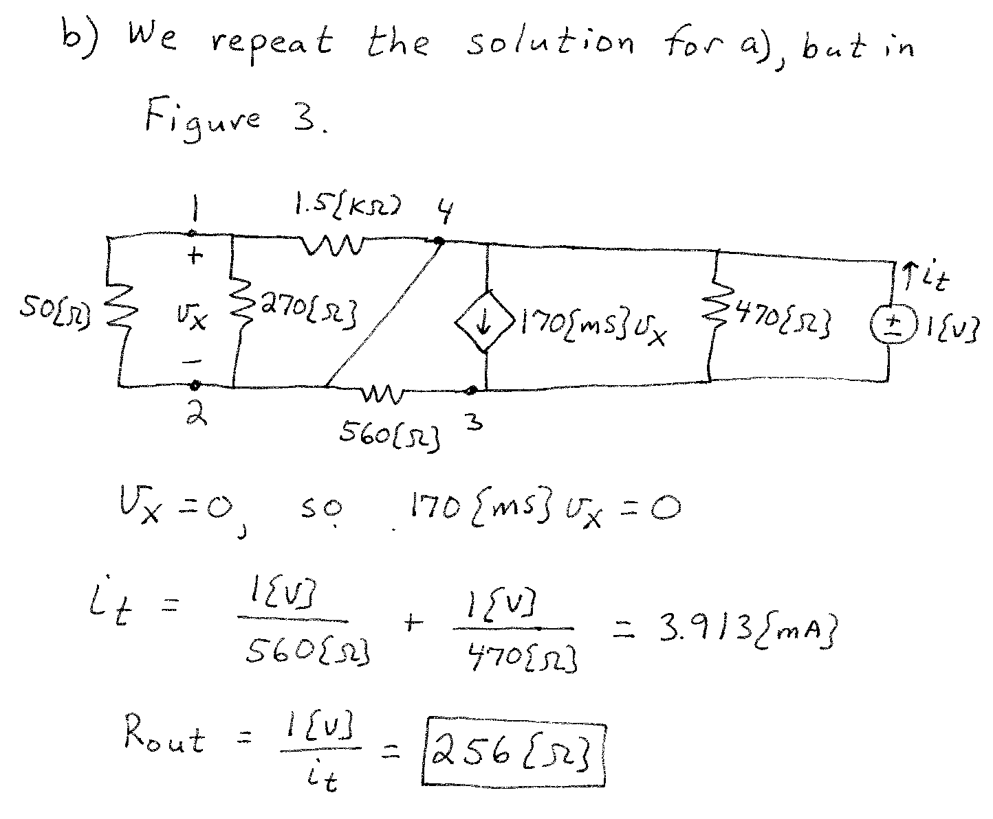
3. {40 Points} The circuit shown in Figure 2 has the straight-line approximation to the magnitude Bode plot shown in Figure 1. The frequency axis in this plot is not drawn to scale. Find the values for L₁ and L₂ that will make the circuit in Figure 2 give the response shown in Figure 1.
