Name: _____________________________ (please print)
Signature: __________________________

ECE 3355 – Final Exam
May 3, 2017

Keep this exam closed until you are told to begin.

1. This exam is closed book, closed notes. You may use one 8.5” x 11” crib sheet, or its equivalent.
2. Show all work on these pages. Show all work necessary to complete the problem. A solution without the appropriate work shown will receive no credit. A solution that is not given in a reasonable order will lose credit. Clearly indicate your answer (for example by enclosing it in a box). If your answer is a plot, no box is needed.
3. It is assumed that your work will begin on the same page as the problem statement. If you choose to begin your work on another page, you must indicate this on the page with the problem statement, with a clear indication of where the work can be found. If your work continues on to another page, indicate clearly where your work can be found. Failure to indicate this clearly will result in a loss of credit.
4. Show all units in solutions, intermediate results, and figures. Units in the exam will be included between square brackets.
5. Do not use red ink. Do not use red pencil.
6. You will have 170 minutes to work on this exam.

1. ________________/40
2. ________________/40
3. ________________/40
4. ________________/40
5. ________________/40
Total = 200
Room for extra work

1. {40 Points} Use the transfer function given for this problem.
- Find the poles and zeroes for this transfer function.
- Plot the straight-line approximation to the magnitude Bode plot for this transfer function. Use a frequency range that includes all non-zero poles and zeroes.

2. {40 Points} Assume that the diodes can be modeled using a piece-wise linear diode model with V_{f} = 1[V], r_{d} = 1[kΩ], and I_{s} = 1[mA]. Find V_{A}. Show your work, stating your tests explicitly. Define all variables appropriately. You are expected to be able to complete at least two reasonable guesses, if needed, in the time period allotted.

Room for extra work

3. {40 Points} A device known as a Hiltrumpor, has the symbol shown below in Figure 1. The characteristic curve for this device is given in Figure 2. Assume that the device is placed in the circuit in Figure 3.
a) Find the value of R_{X} so that the Q point for this device will be in the location indicated in Figure 2.
b) Using the value that you found in part a) for R_{X}, draw the load line on Figure 2 for the dc circuit as seen by the Hiltrumpor. If you cannot solve part a), pick an arbitrary value for R_{X}, and draw the load line for your choice.
c) Find the signal model for the Hiltrumpor device at the Q point.

Room for extra work

4. {40 Points} The characteristic curves for a device, called a Frammulator, are shown in Figures 1 and 2. The device schematic symbol is shown in Figure 3.
- Find a small-signal model that could be used for this device when it is biased into Region D, shown on the characteristic curves.
- Find a second small-signal model that could be used for this device when it is biased into Region D, shown on the characteristic curves. This model should be equivalent to the model you found in part a).
- What names would we use for each of the two models you found? We learned these names at the beginning of this course.
- Are there any other models that could be used for this region? Explain why or why not.
Room for extra work

Room for extra work

5. {40 Points} Use the circuit shown to solve this problem. Assume that for the transistor, β = 200, and that it is operating at room temperature. Assume that the op amp is ideal.
a) Find the voltage gain v_{a}/v_{i} in the passband.
b) Find the input resistance in the passband, as seen by the source.
c) In this circuit, assume that a new capacitor could be placed across resistor R₅. If this new capacitor were treated as a short circuit in a particular range of frequencies, would the gain increase or decrease in that range of frequencies? Explain your answer, briefly.

1. {40 Points} Use the transfer function given for this problem.
- Find the poles and zeroes for this transfer function.
- Plot the straight-line approximation to the magnitude Bode plot for this transfer function. Use a frequency range that includes all non-zero poles and zeroes.
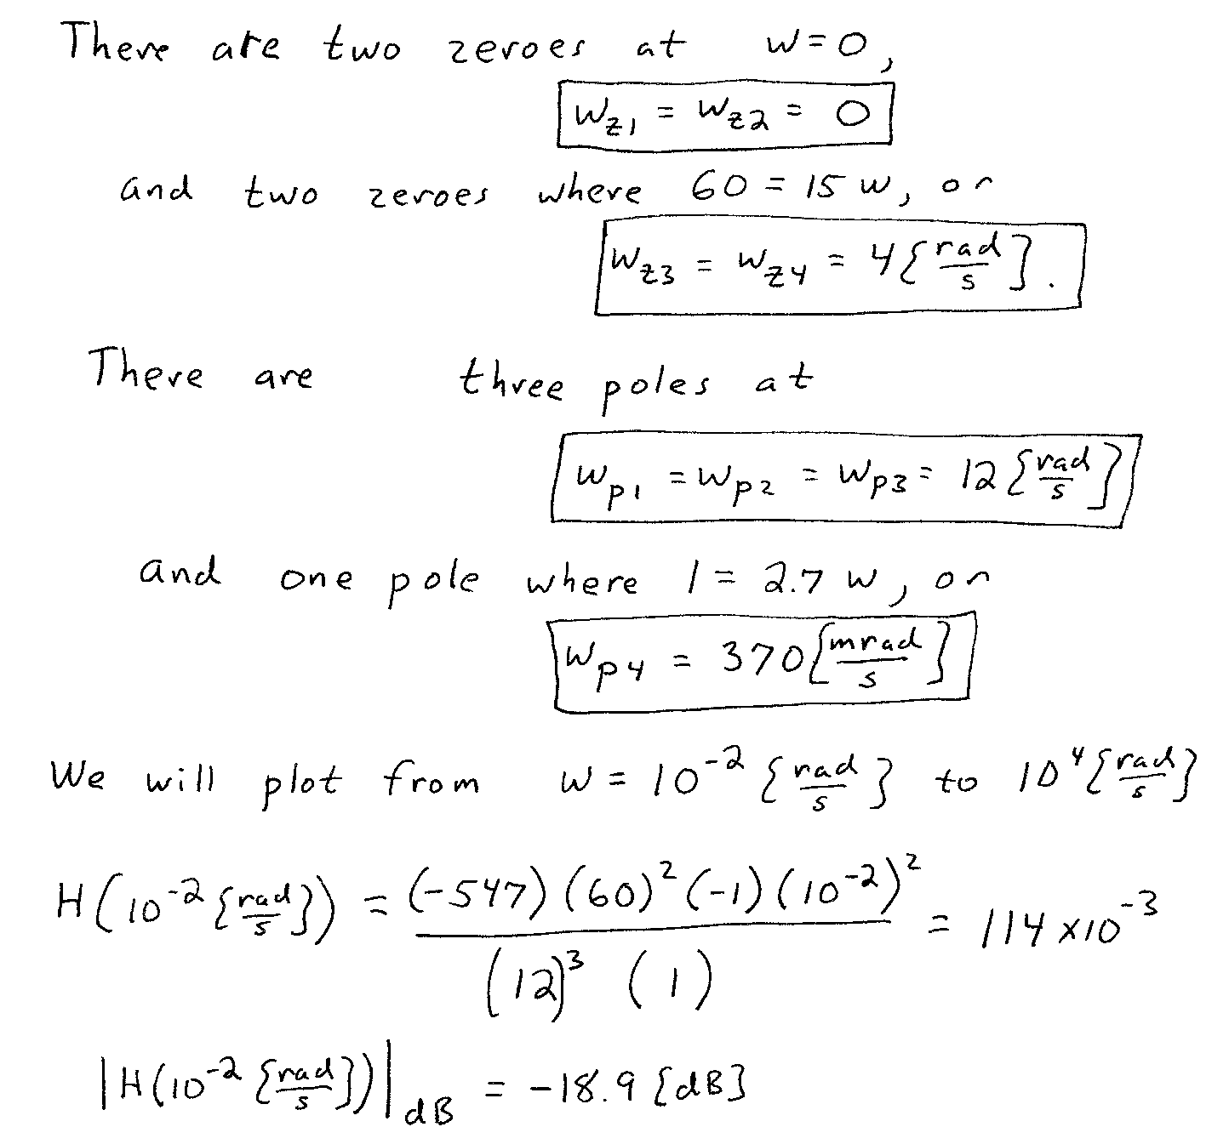
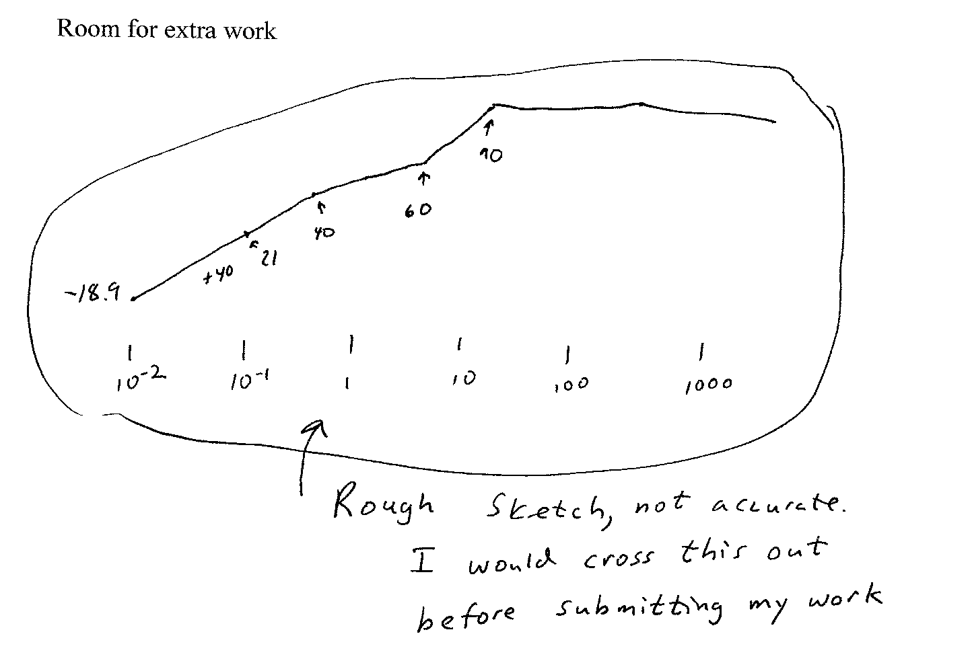
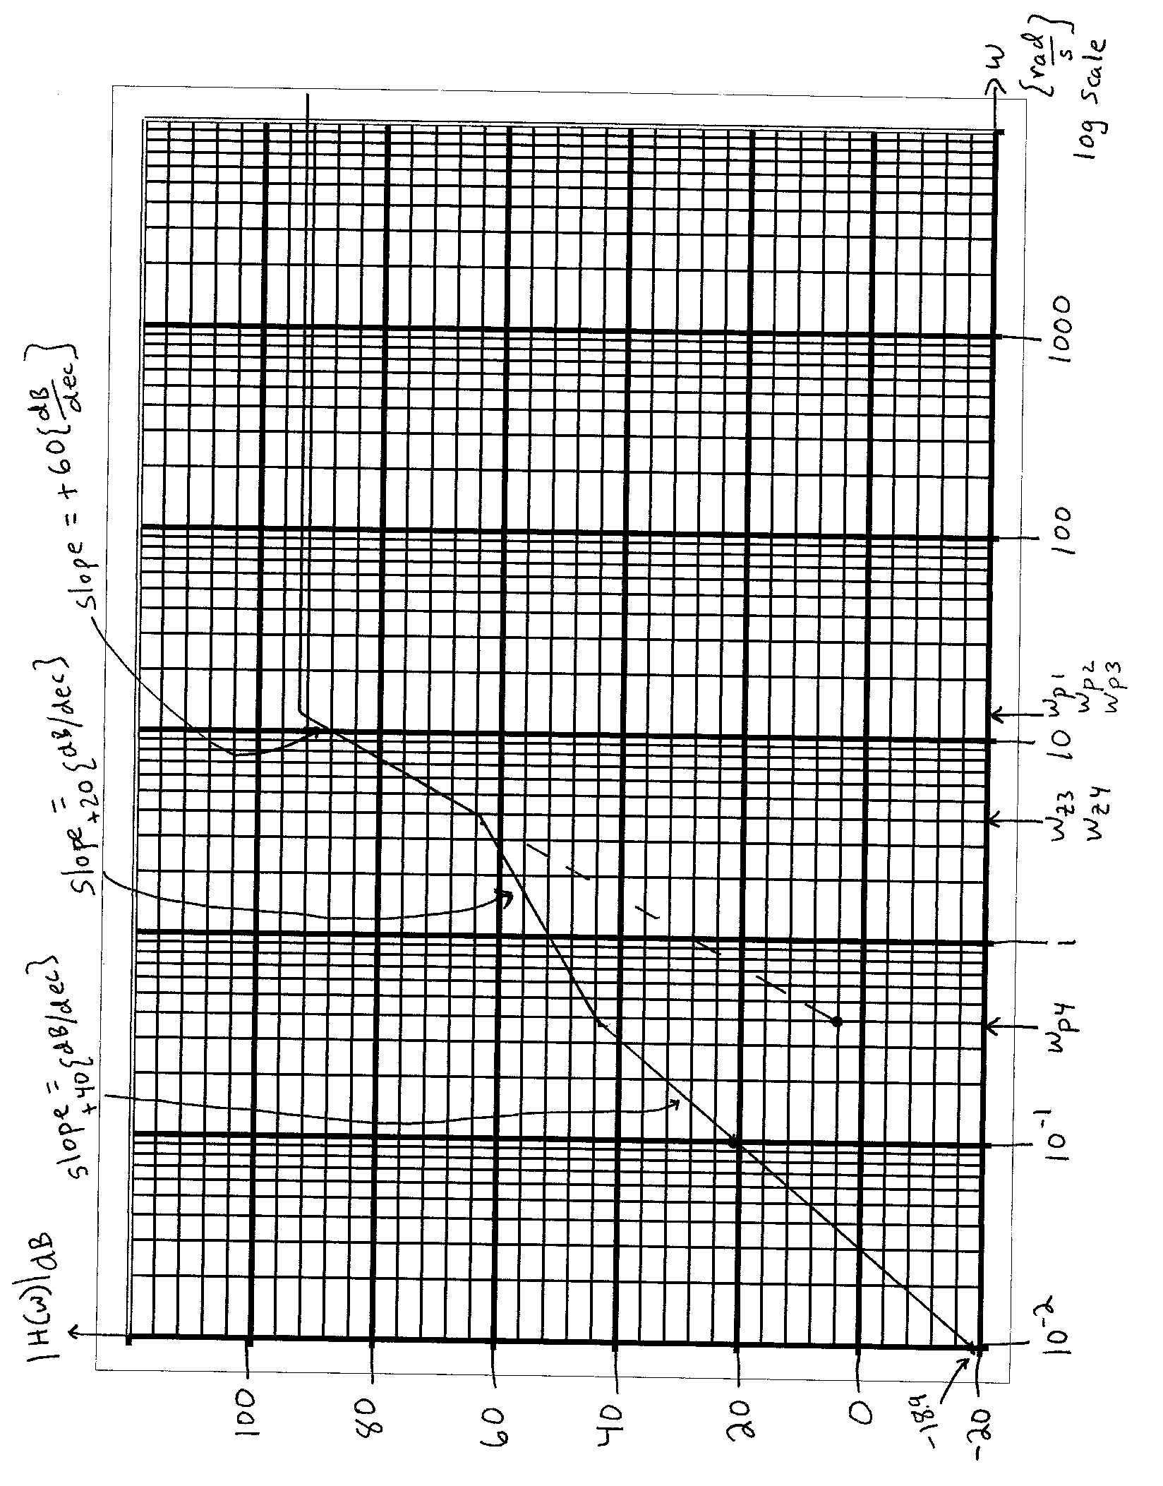

2. {40 Points} Assume that the diodes can be modeled using a piece-wise linear diode model with V_{f} = 1[V], r_{d} = 1[kΩ], and I_{s} = 1[mA]. Find V_{A}. Show your work, stating your tests explicitly. Define all variables appropriately. You are expected to be able to complete at least two reasonable guesses, if needed, in the time period allotted.
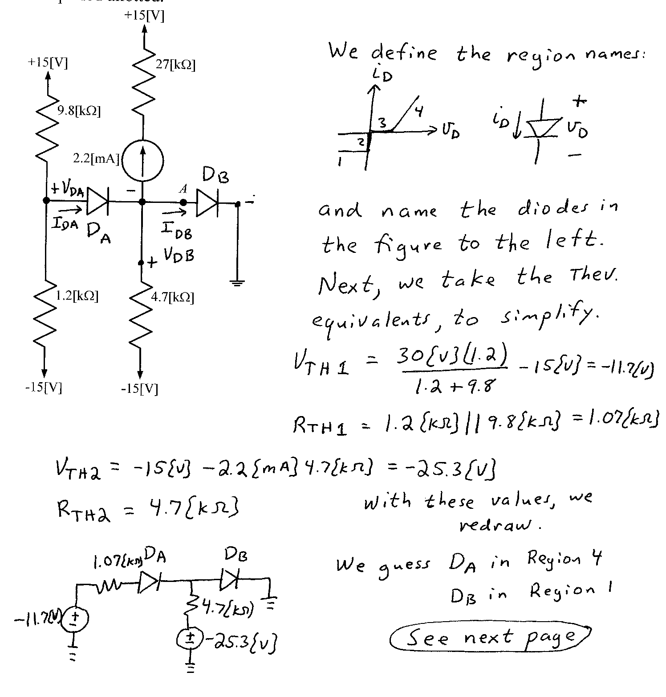
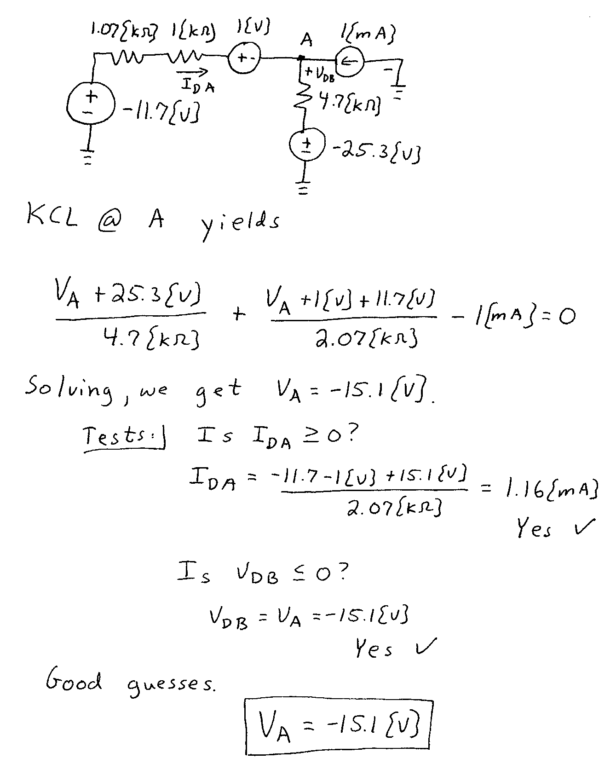

3. {40 Points} A device known as a Hiltrumpor, has the symbol shown below in Figure 1. The characteristic curve for this device is given in Figure 2. Assume that the device is placed in the circuit in Figure 3.
a) Find the value of R_{X} so that the Q point for this device will be in the location indicated in Figure 2.
b) Using the value that you found in part a) for R_{X}, draw the load line on Figure 2 for the dc circuit as seen by the Hiltrumpor. If you cannot solve part a), pick an arbitrary value for R_{X}, and draw the load line for your choice.
c) Find the signal model for the Hiltrumpor device at the Q point.

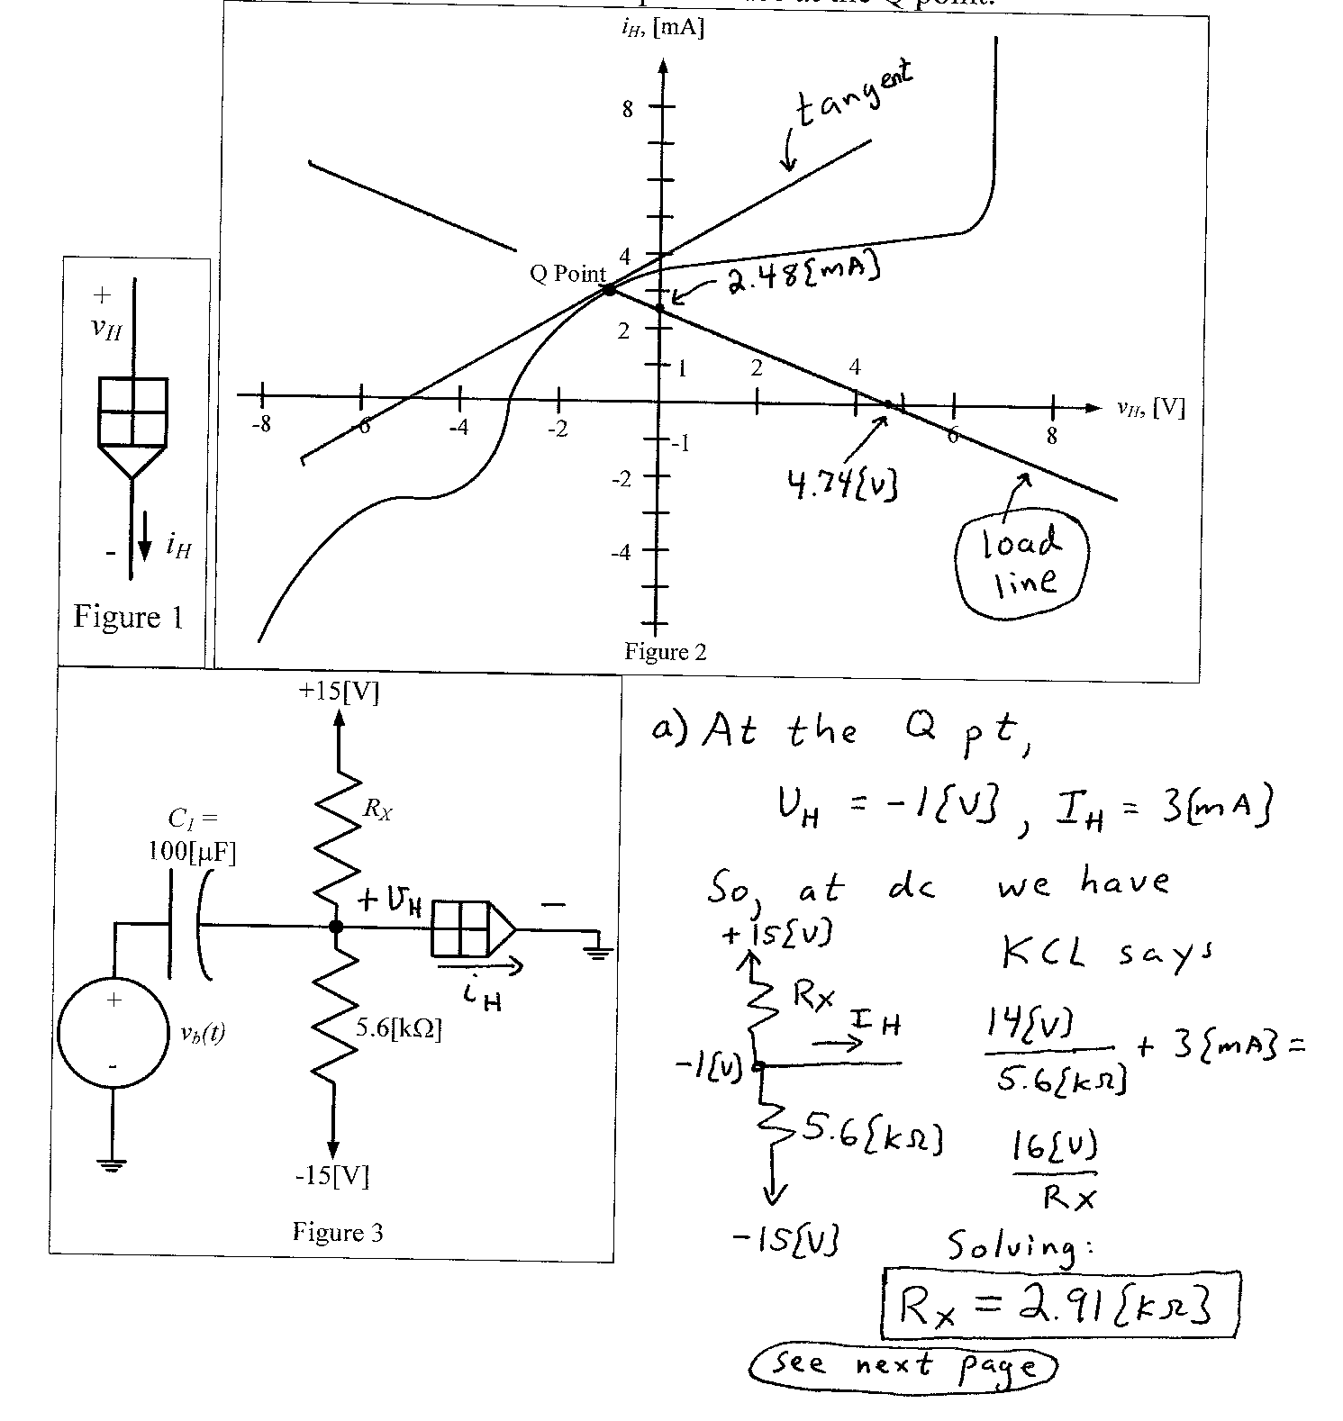
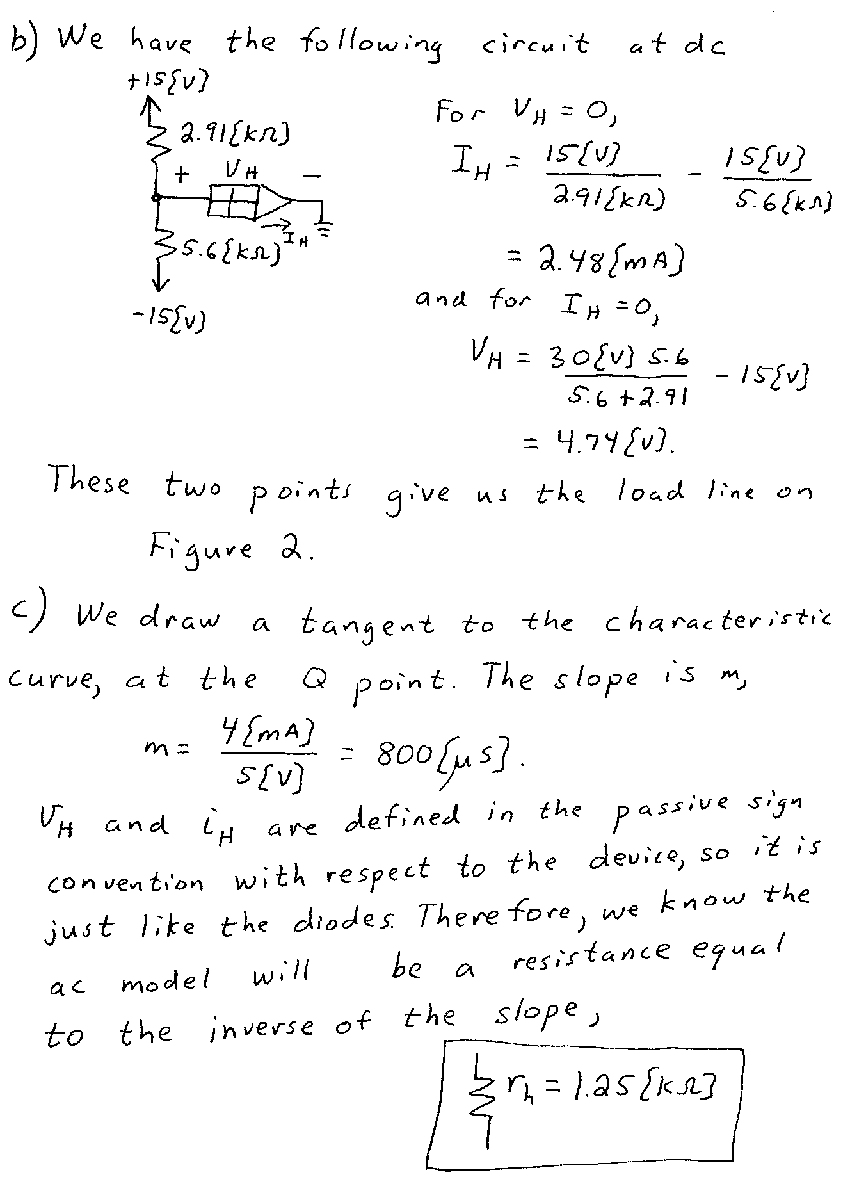

4. {40 Points} The characteristic curves for a device, called a Frammulator, are shown in Figures 1 and 2. The device schematic symbol is shown in Figure 3.
- Find a small-signal model that could be used for this device when it is biased into Region D, shown on the characteristic curves.
- Find a second small-signal model that could be used for this device when it is biased into Region D, shown on the characteristic curves. This model should be equivalent to the model you found in part a).
- What names would we use for each of the two models you found? We learned these names at the beginning of this course.
- Are there any other models that could be used for this region? Explain why or why not.
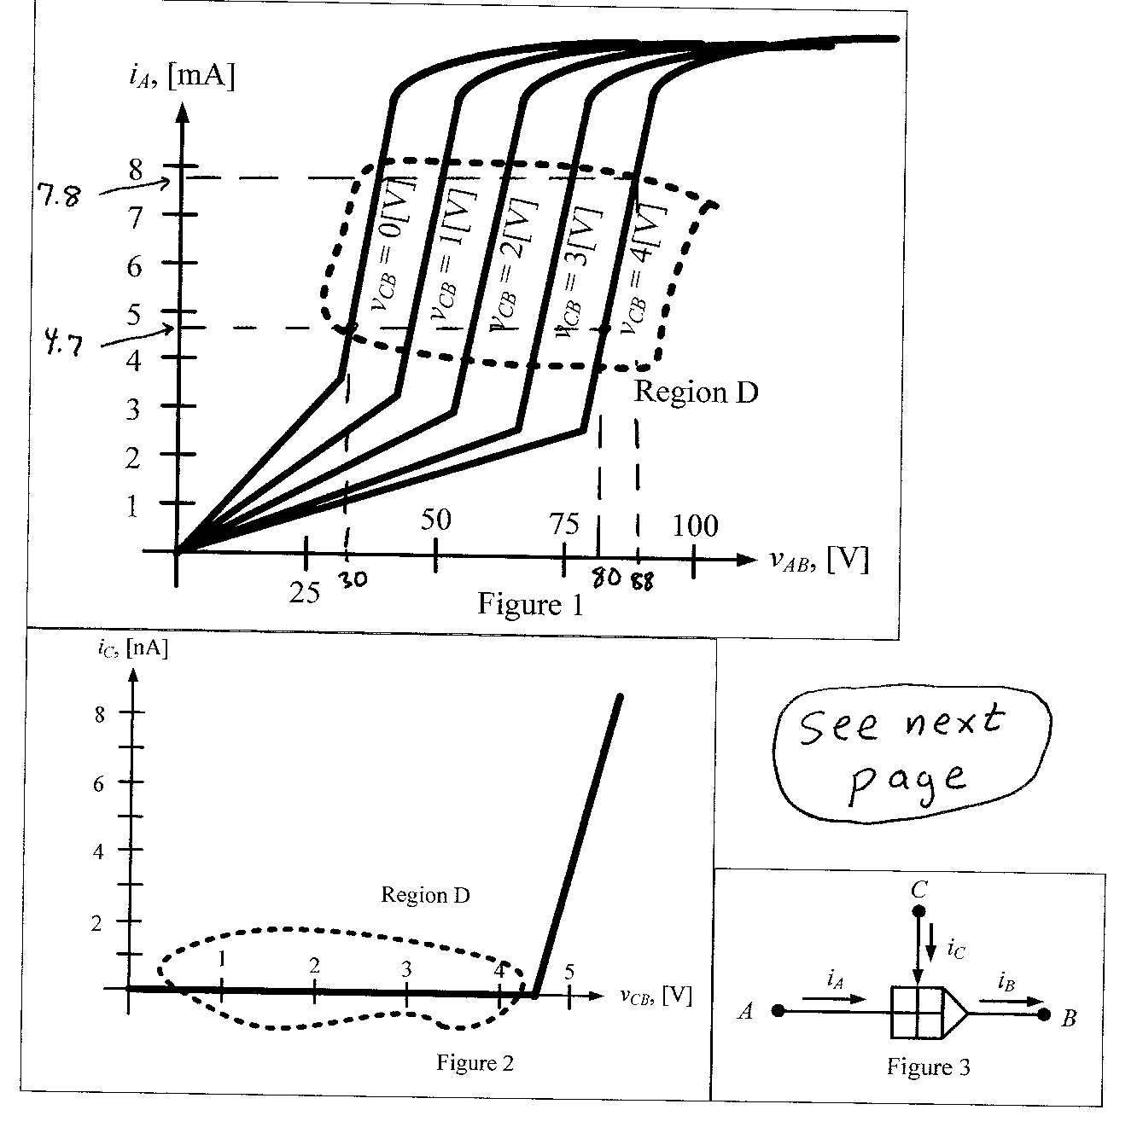
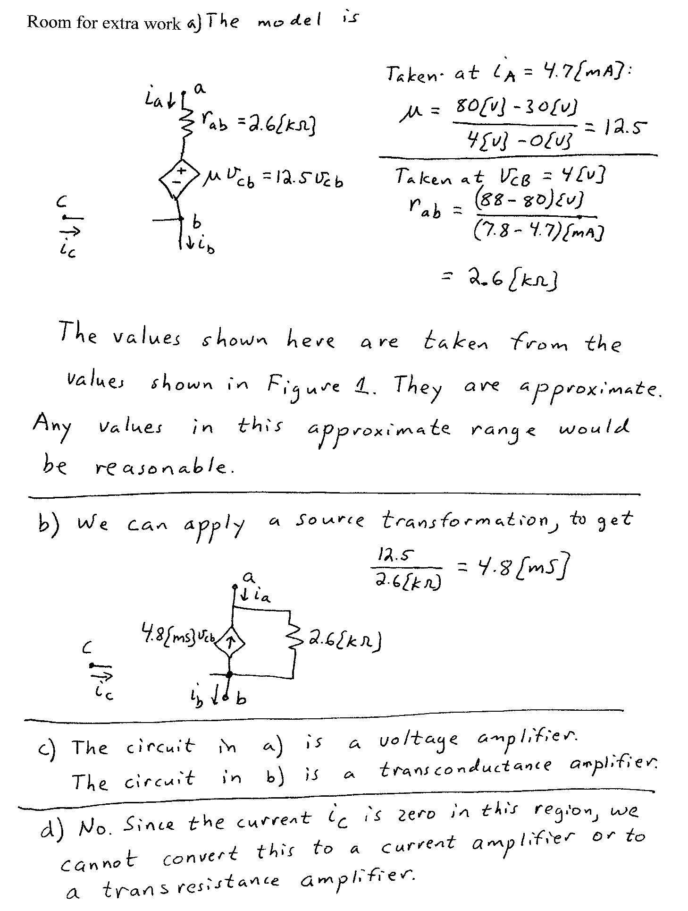
5. {40 Points} Use the circuit shown to solve this problem. Assume that for the transistor, β = 200, and that it is operating at room temperature. Assume that the op amp is ideal.
a) Find the voltage gain v_{a}/v_{i} in the passband.
b) Find the input resistance in the passband, as seen by the source.
c) In this circuit, assume that a new capacitor could be placed across resistor R₅. If this new capacitor were treated as a short circuit in a particular range of frequencies, would the gain increase or decrease in that range of frequencies? Explain your answer, briefly.
