Name: _____________________________ (please print)
Signature: __________________________

ECE 3355 – Exam 1
March 24, 2018

Keep this exam closed until you are told to begin.

1. This exam is closed book, closed notes. You may use one 8.5” x 11” crib sheet, or its equivalent.
2. Show all work on these pages. Show all work necessary to complete the problem. A solution without the appropriate work shown will receive no credit. A solution that is not given in a reasonable order will lose credit. Clearly indicate your answer (for example by enclosing it in a box). If your answer is a plot, no box is needed.
3. It is assumed that your work will begin on the same page as the problem statement. If you choose to begin your work on another page, you must indicate this on the page with the problem statement, with a clear indication of where the work can be found. If your work continues on to another page, indicate clearly where your work can be found. Failure to indicate this clearly will result in a loss of credit.
4. Show all units in solutions, intermediate results, and figures. Units in the exam will be included between square brackets.
5. Do not use red ink. Do not use red pencil.
6. You will have 90 minutes to work on this exam.

1. ________________/18
2. ________________/20
3. ________________/30
4. ________________/32
Total = 100
Room for extra work

1. {18 Points} Assume that
- What is I_{A}?
- What is i_{a}?
- What is V_{a}?
- What is ∠V_{a}?
- What is |V_{a}|?
- What is Im(V_{a})?

2. {20 Points} Assume that the input of an oscilloscope can be modeled as a 1[MΩ] resistor in series with a 37[μH] inductor. Assume that a probe can be placed in series with the input of the oscilloscope to allow signals to be viewed on the oscilloscope screen without distortion, that is, with the proper shape, despite the resistor and inductor at the input of the oscilloscope. Design such a probe, and state the effect of the probe. If using the probe amplifies or attenuates the signal being measured, explain why and how much amplification or attenuation results.

Room for extra work

3. {30 Points} The straight-line approximation to the magnitude Bode plot for the transfer function H(f) is shown below. The values for the non-zeroes slopes are indicated. The plot is not drawn to scale here.
a) Find the poles and zeroes for the transfer function H(f). If there is more than one pole or zero at one frequency, indicate the number of poles or zeroes at that frequency.
b) Write a transfer function for H(f) that would produce the straight-line approximation to the magnitude Bode plot shown. There is more than one solution possible. Show only one solution. Indicate briefly how you obtained your solution.

Room for extra work

4. {32 Points} Assume ideal op amps.
a) With v_{A} = 2[V], and v_{B} = 1[V], find v_{E}.
b) Find the range or ranges of v_{B} that will cause op amp #2 to saturate, if
v_{A} = 2[V].

Room for extra work

1. {18 Points} Assume that
- What is I_{A}?
- What is i_{a}?
- What is V_{a}?
- What is ∠V_{a}?
- What is |V_{a}|?
- What is Im(V_{a})?
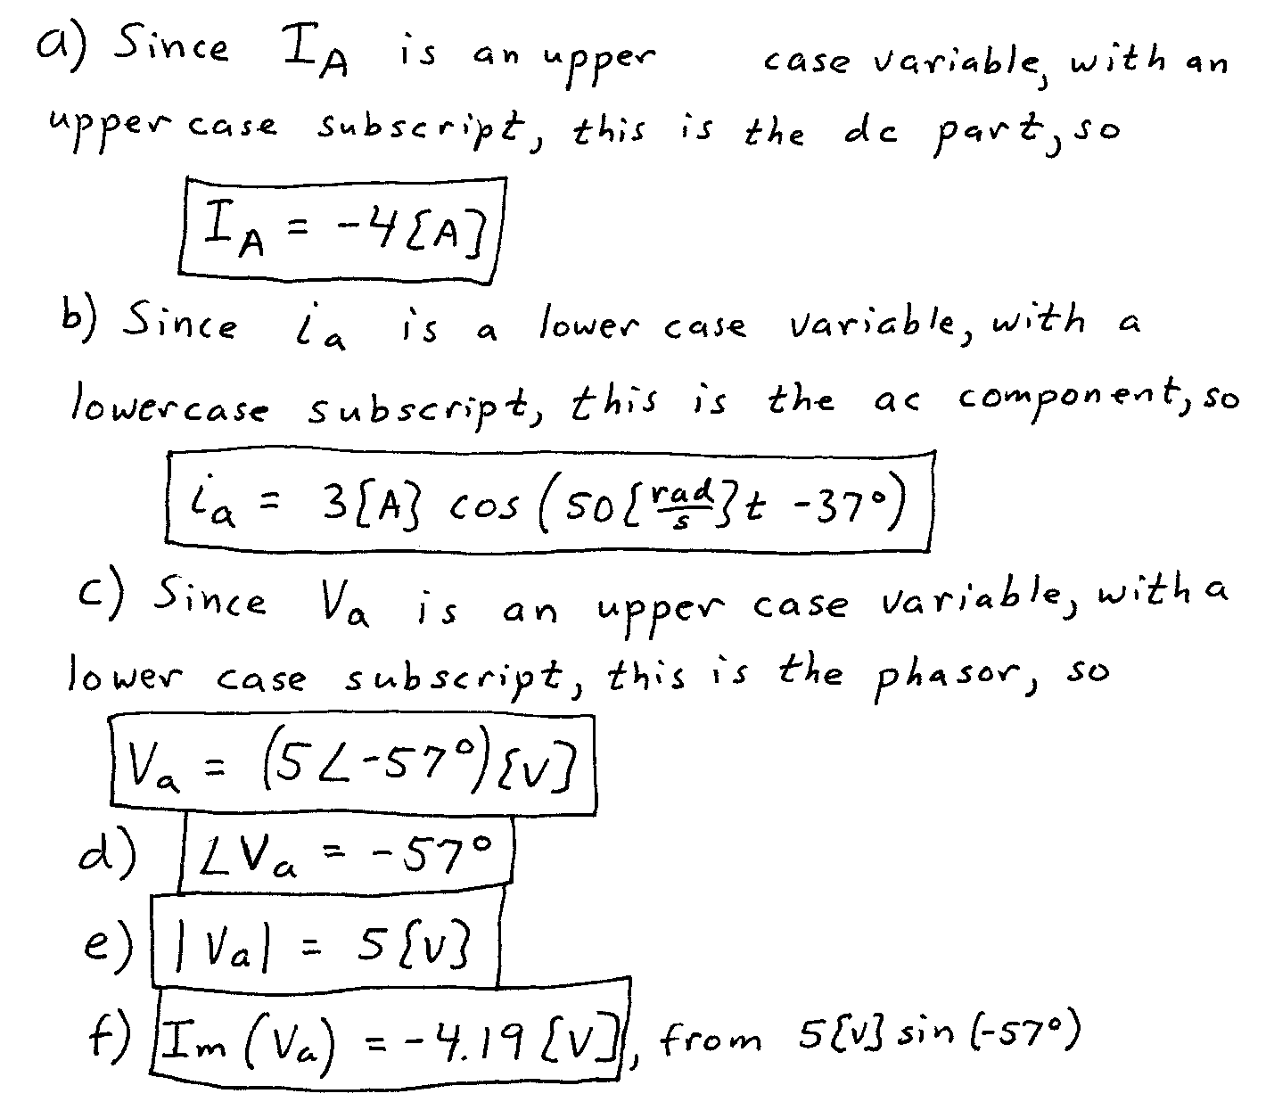

2. {20 Points} Assume that the input of an oscilloscope can be modeled as a 1[MΩ] resistor in series with a 37[μH] inductor. Assume that a probe can be placed in series with the input of the oscilloscope to allow signals to be viewed on the oscilloscope screen without distortion, that is, with the proper shape, despite the resistor and inductor at the input of the oscilloscope. Design such a probe, and state the effect of the probe. If using the probe amplifies or attenuates the signal being measured, explain why and how much amplification or attenuation results.
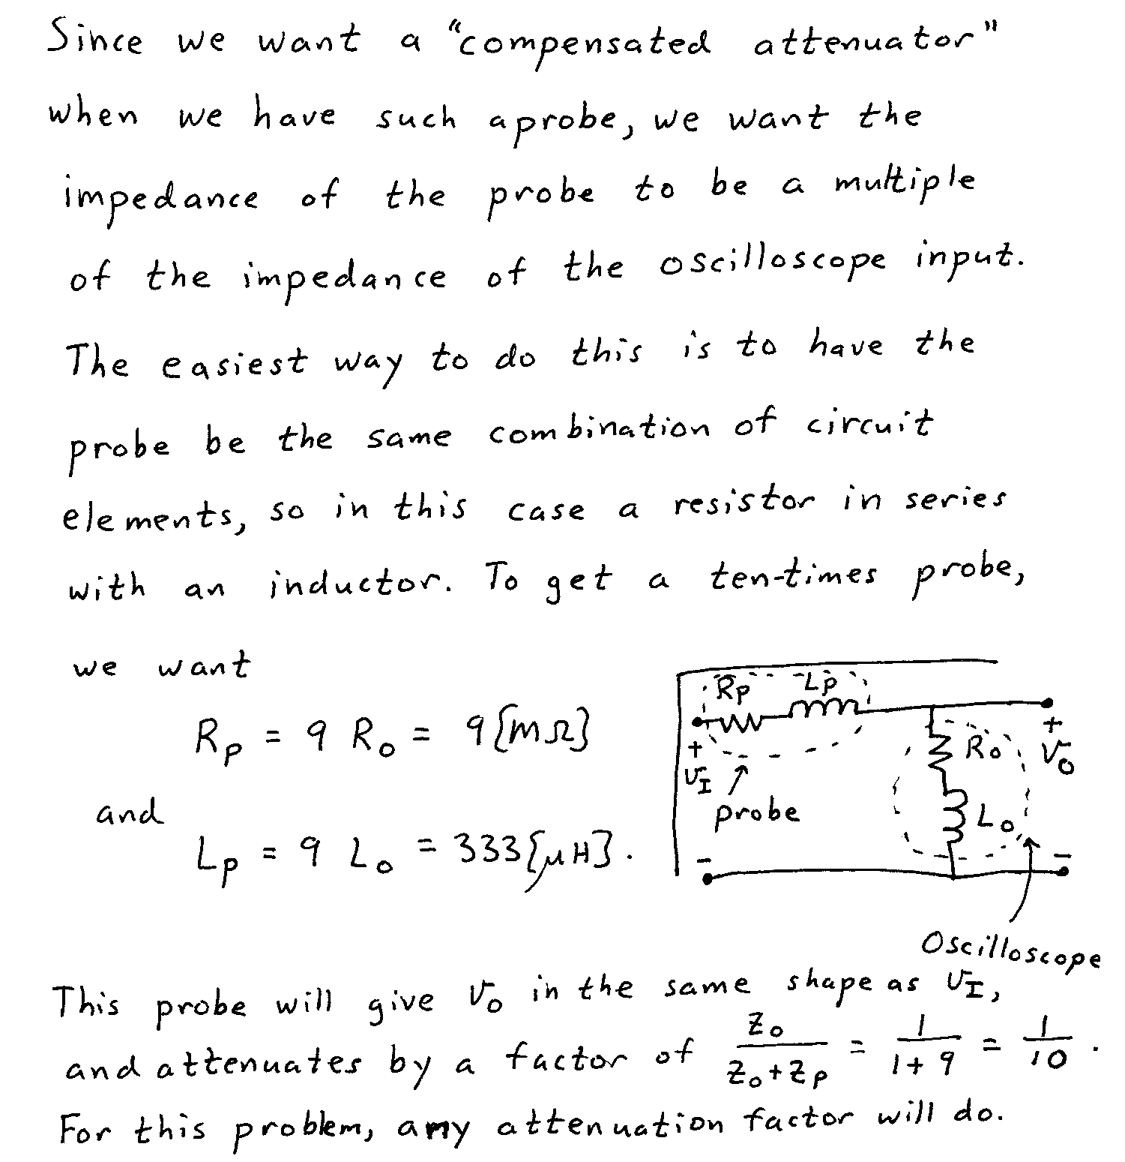

3. {30 Points} The straight-line approximation to the magnitude Bode plot for the transfer function H(f) is shown below. The values for the non-zeroes slopes are indicated. The plot is not drawn to scale here.
a) Find the poles and zeroes for the transfer function H(f). If there is more than one pole or zero at one frequency, indicate the number of poles or zeroes at that frequency.
b) Write a transfer function for H(f) that would produce the straight-line approximation to the magnitude Bode plot shown. There is more than one solution possible. Show only one solution. Indicate briefly how you obtained your solution.
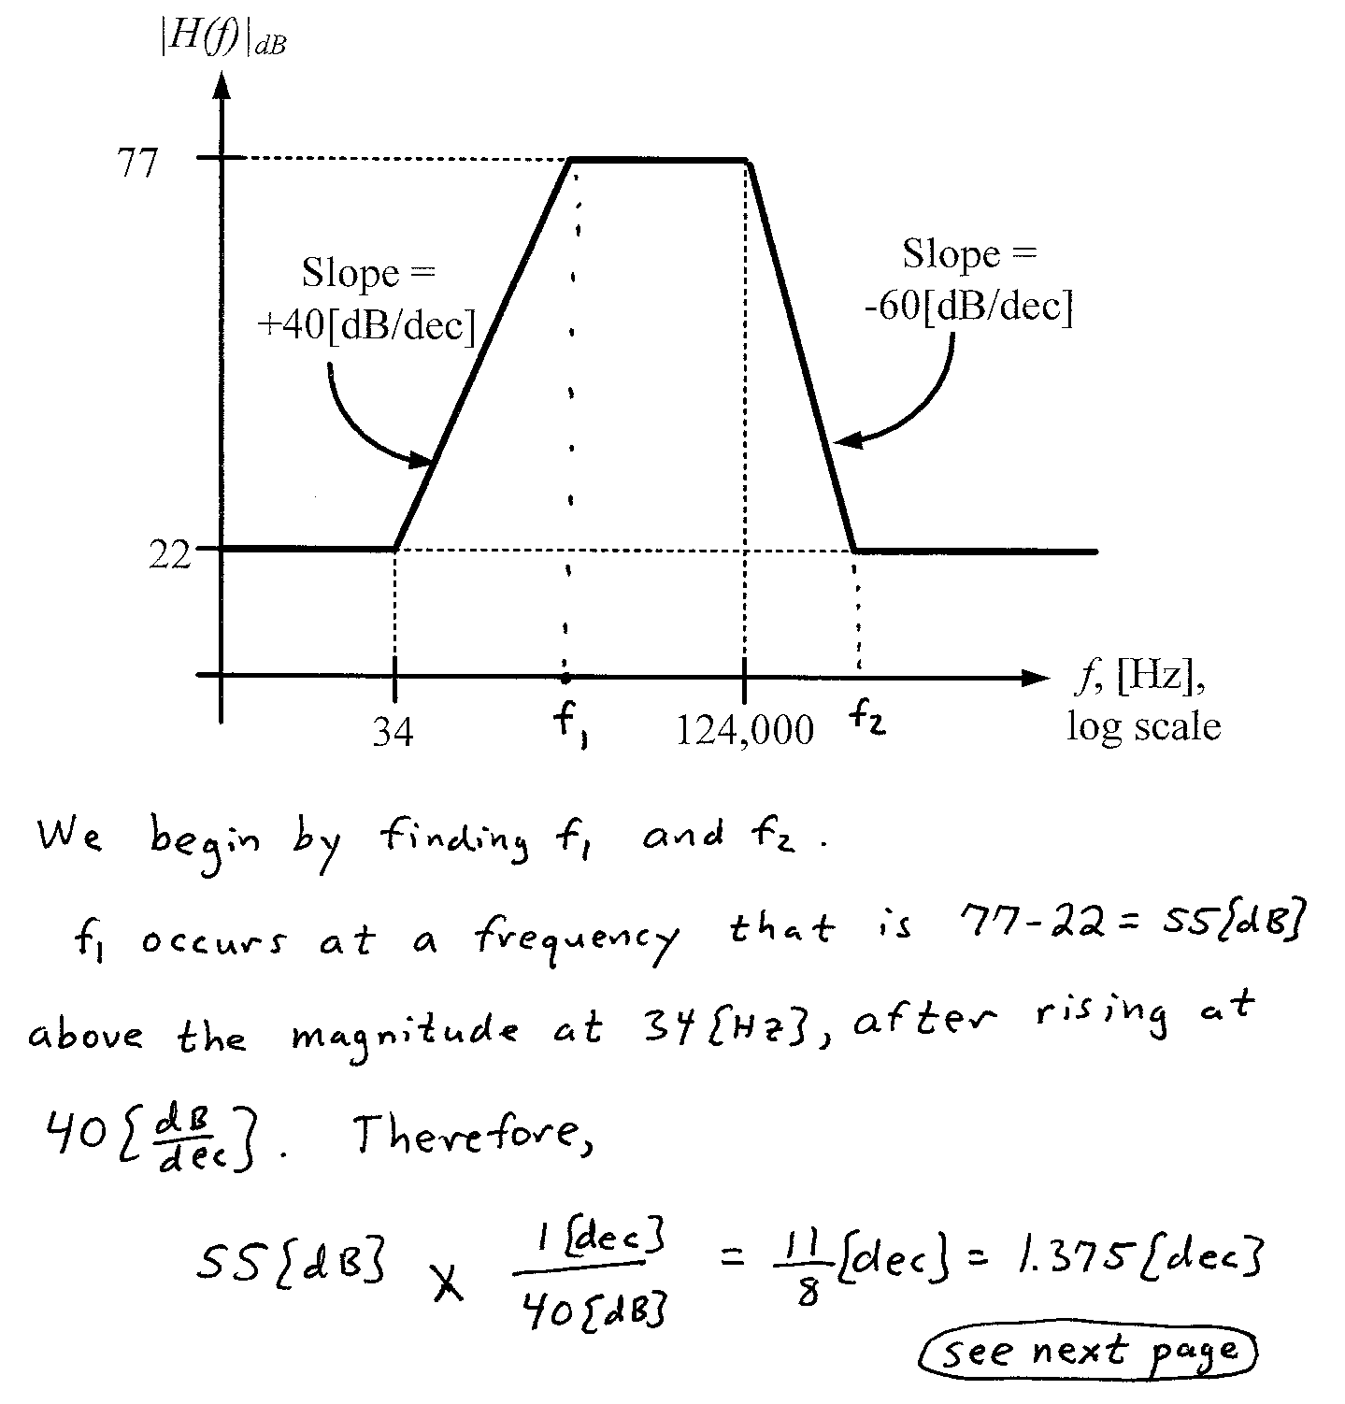
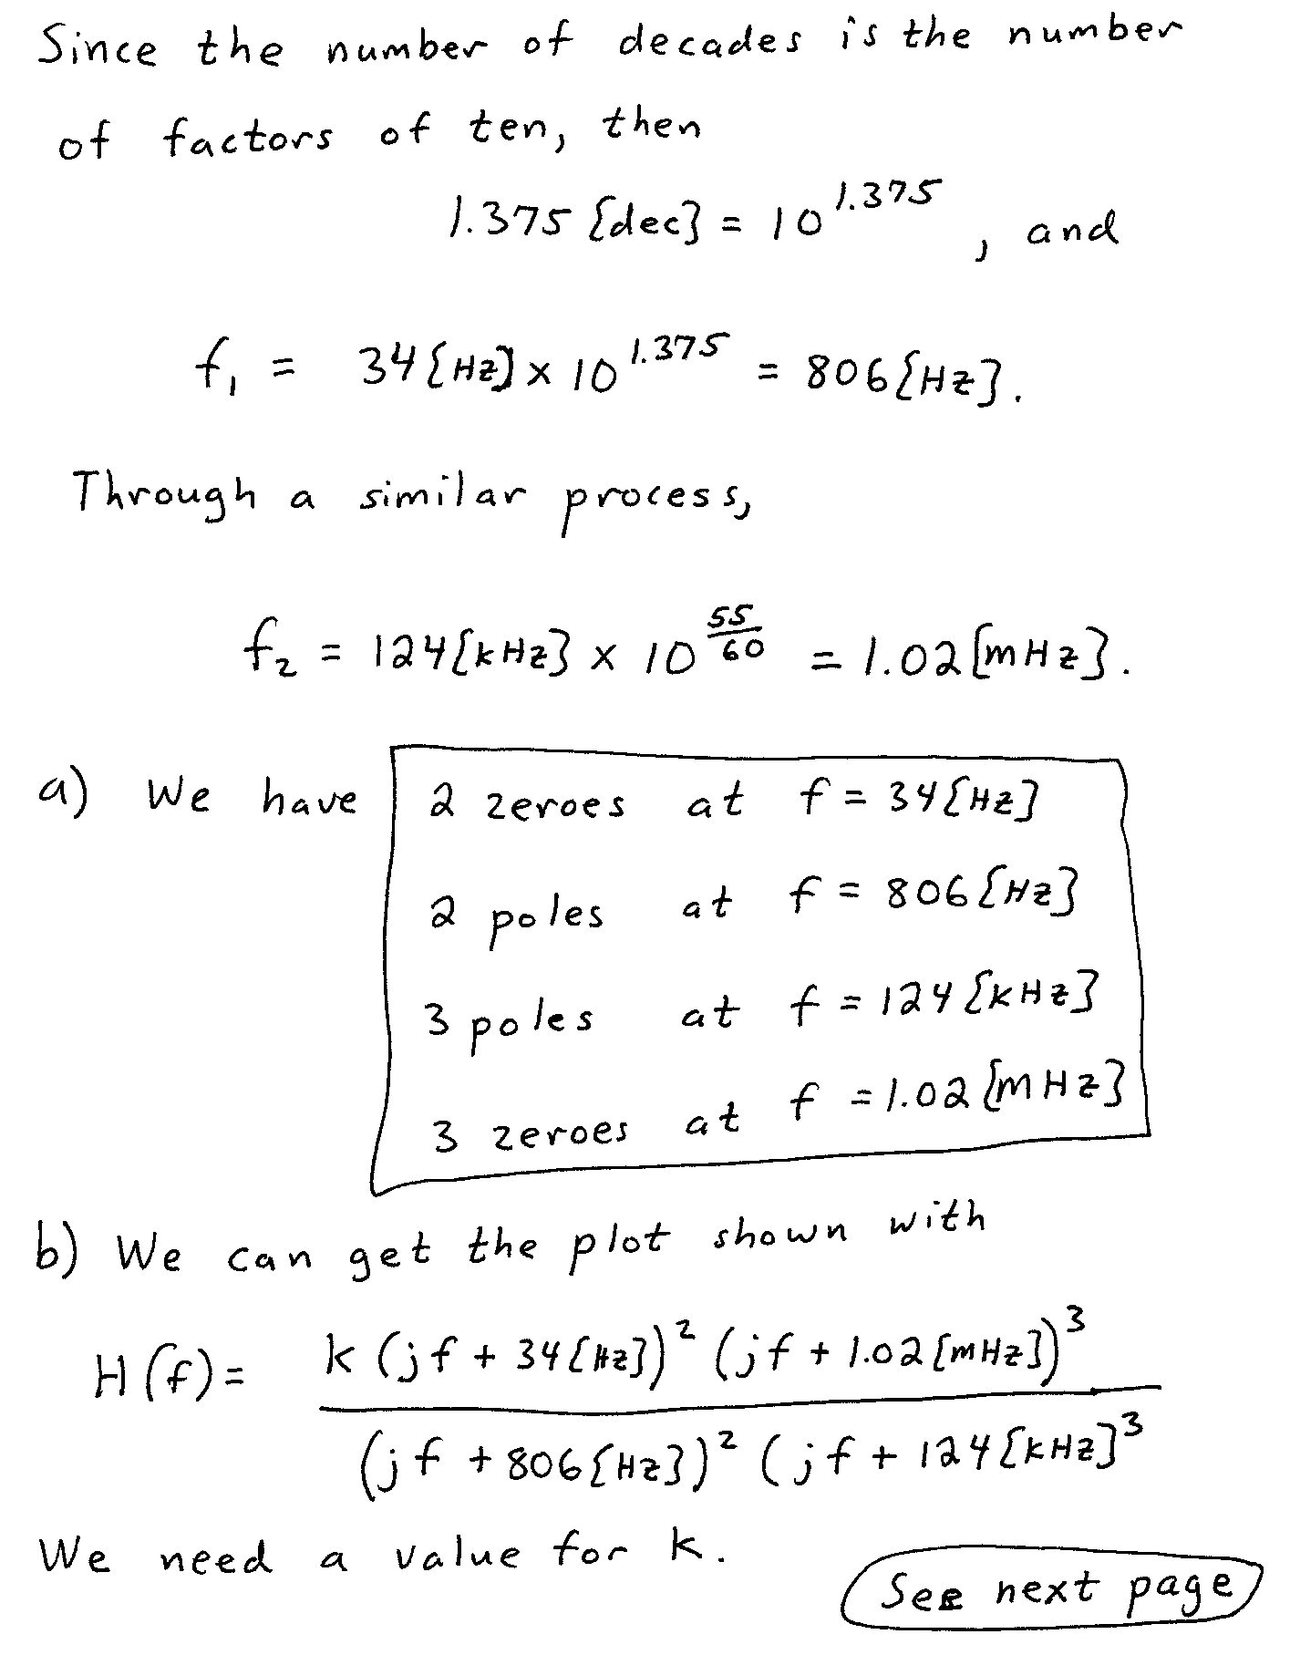
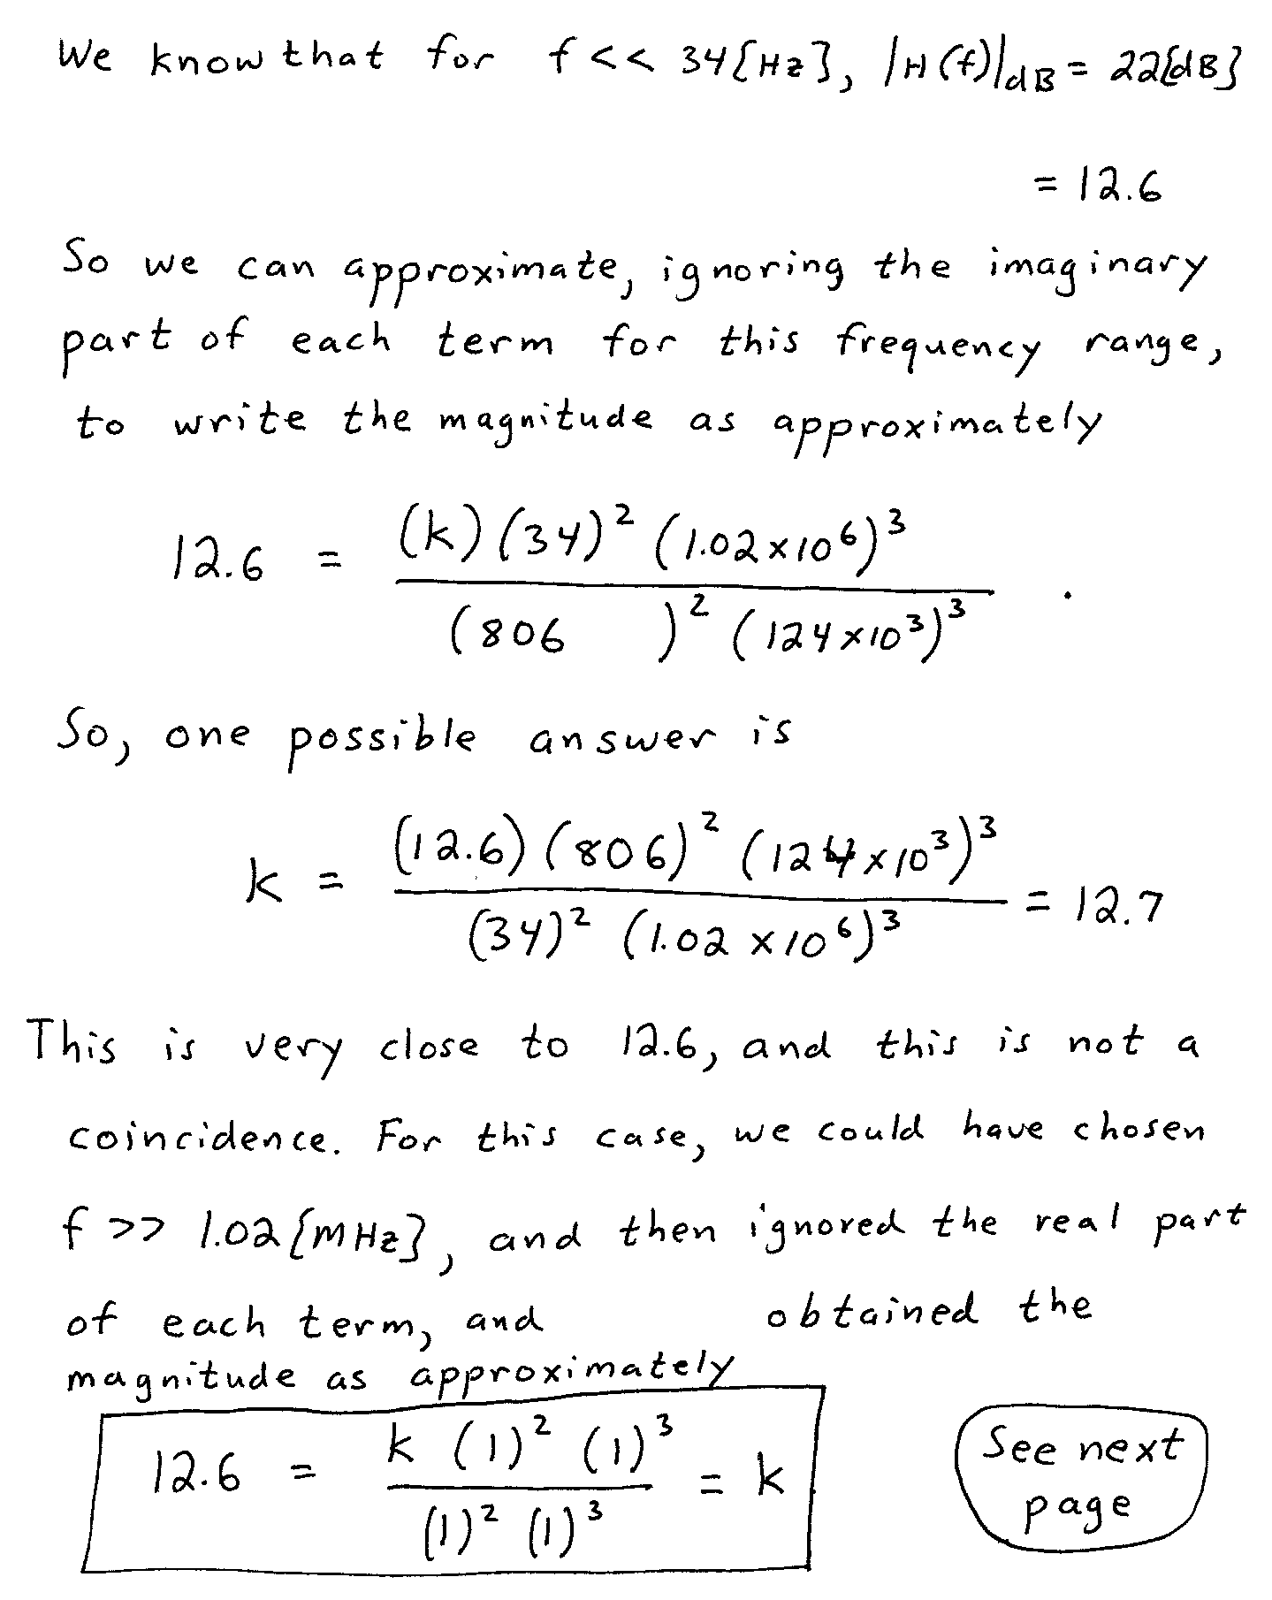
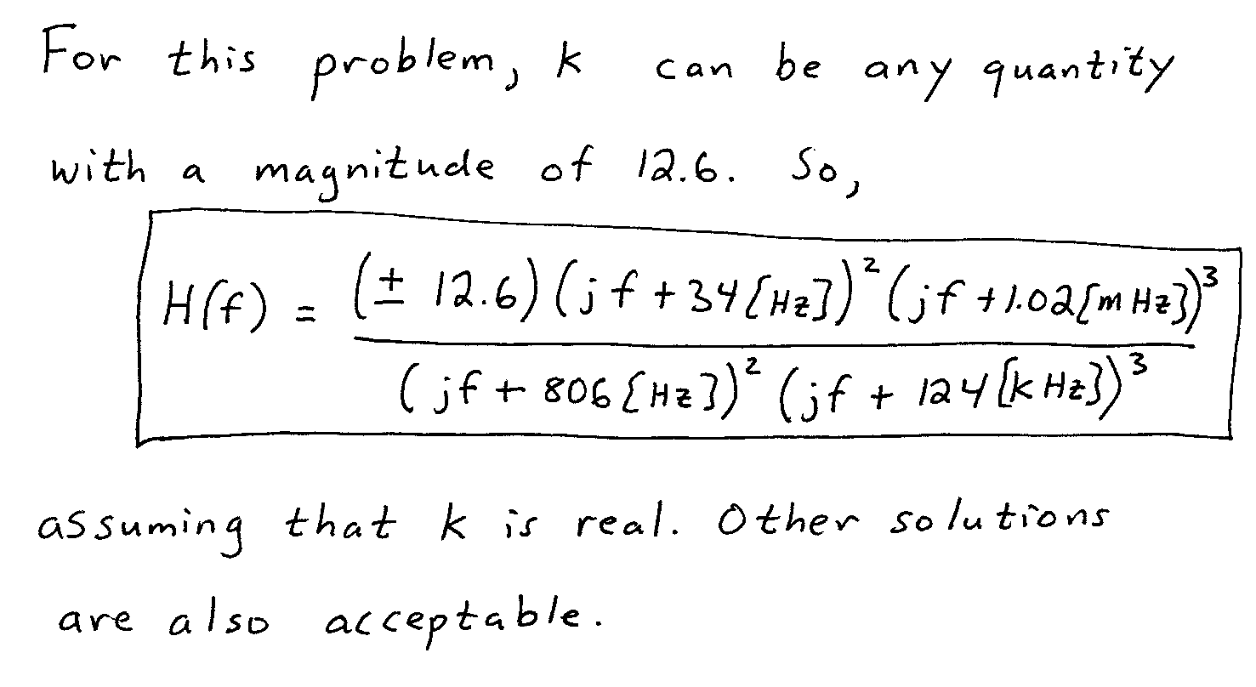

4. {32 Points} Assume ideal op amps.
a) With v_{A} = 2[V], and v_{B} = 1[V], find v_{E}.
b) Find the range or ranges of v_{B} that will cause op amp #2 to saturate, if
v_{A} = 2[V].
