Name: _____________________________ (please print)
Signature: __________________________

ECE 3355 – Final Exam
May 3, 2018

Keep this exam closed until you are told to begin.

1. This exam is closed book, closed notes. You may use one 8.5” x 11” crib sheet, or its equivalent.
2. Show all work on these pages. Show all work necessary to complete the problem. A solution without the appropriate work shown will receive no credit. A solution that is not given in a reasonable order will lose credit. Clearly indicate your answer (for example by enclosing it in a box). If your answer is a plot, no box is needed.
3. It is assumed that your work will begin on the same page as the problem statement. If you choose to begin your work on another page, you must indicate this on the page with the problem statement, with a clear indication of where the work can be found. If your work continues on to another page, indicate clearly where your work can be found. Failure to indicate this clearly will result in a loss of credit.
4. Show all units in solutions, intermediate results, and figures. Units in the exam will be included between square brackets.
5. Do not use red ink. Do not use red pencil.
6. You will have 170 minutes to work on this exam.

1. ________________/40
2. ________________/40
3. ________________/40
4. ________________/40
5. ________________/40
Total = 200
Room for extra work

1. {40 Points} Use the transfer function given for this problem.
Plot the straight-line approximations to the magnitude Bode plot and the phase Bode plot for this transfer function. Plot as a function of frequency f and use a frequency range from 100[Hz] to 100[MHz]. Use the semilog graph paper provided on the next two pages.

2. {40 Points} Assume ideal op amps.
a) Find the transconductance i_{a} /v_{in}.
b) Find the transfer function V_{a} /V_{in}.
c) Find the input impedance seen by the voltage source.
d) Find the output impedance seen by the 1[kΩ] resistor, assuming that this resistor is the load.
e) Find the output impedance seen by the C₂ capacitor, assuming that this capacitor is the load.

Room for extra work

3. {40 Points} A device known as a Filler, has the symbol shown below in Figure 1. The characteristic curve for this device is given in Figure 2. Assume that the device is placed in the circuit in Figure 3.
a) Find all of the solutions for i_{A} that will be valid in this situation.
b) Find the signal models for the Filler device if small signals were applied at each of the solutions you found in part a).

Room for extra work

4. {40 Points} The characteristic curves for a device, called an Astrolator, are shown in Figures 1 and 2. The device schematic symbol is shown in Figure 3.
- Find a small-signal model that could be used for this device when it is biased into Region D, shown on the characteristic curves.
- Find a second small-signal model that could be used for this device when it is biased into Region D, shown on the characteristic curves. This model should be equivalent to the model you found in part a).
- What names would we use for each of the two models you found? We learned these names at the beginning of this course.
- Are there any other models that could be used for this region? Explain why or why not.
Room for extra work

Room for extra work

5. {40 Points} Use the circuit shown to solve this problem. Assume that for the transistor, β = 200, and that it is operating at room temperature.
a) Find the voltage V_{A} if I_{F} = 2[mA].
b) Find the voltage V_{A} if I_{F} = -2[mA].
c) Find the range of I_{F} that will cause the transistor Q₁ to be saturated.

1. {40 Points} Use the transfer function given for this problem.
Plot the straight-line approximations to the magnitude Bode plot and the phase Bode plot for this transfer function. Plot as a function of frequency f and use a frequency range from 100[Hz] to 100[MHz]. Use the semilog graph paper provided on the next two pages.
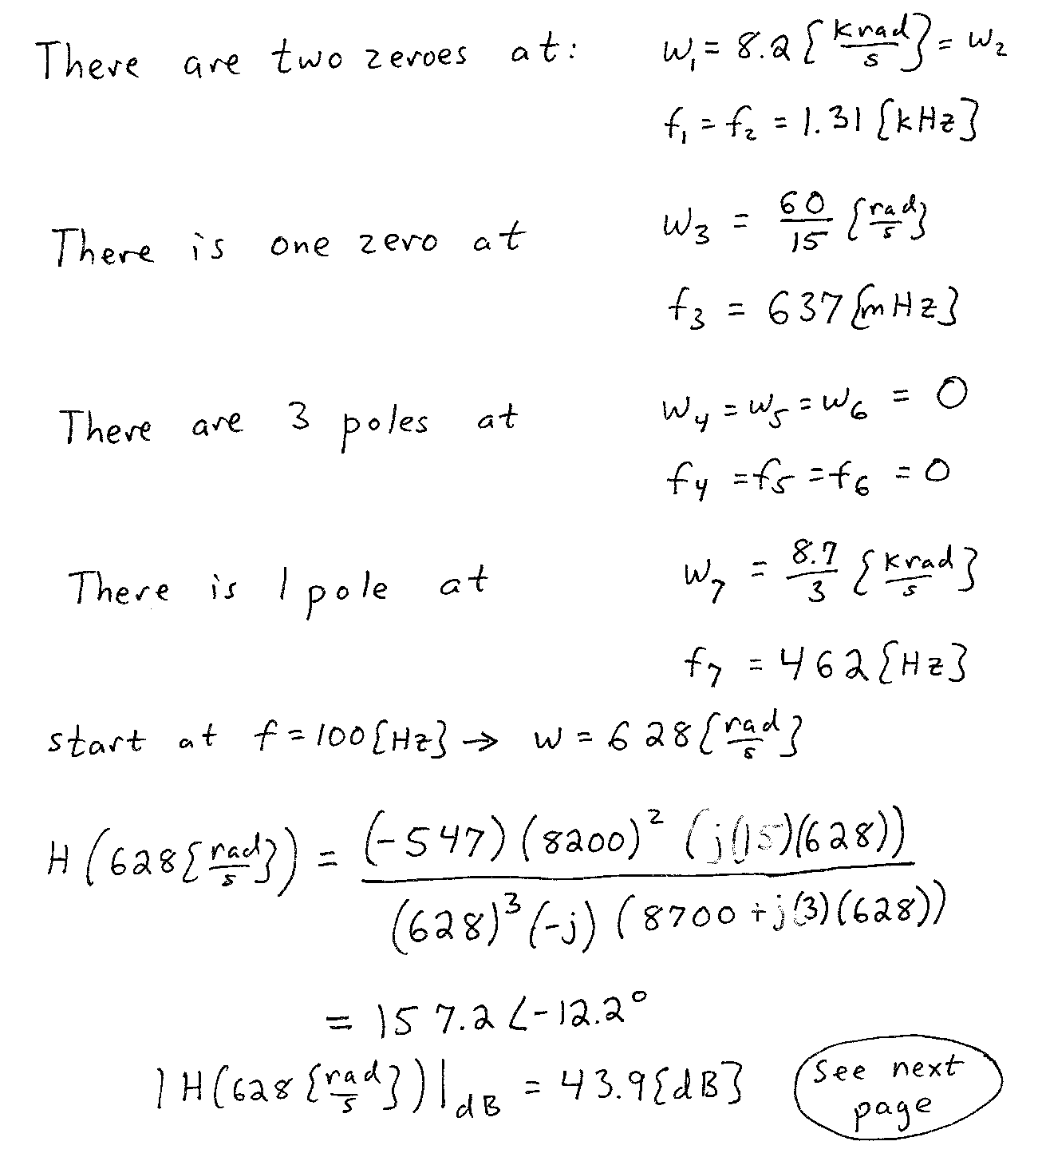
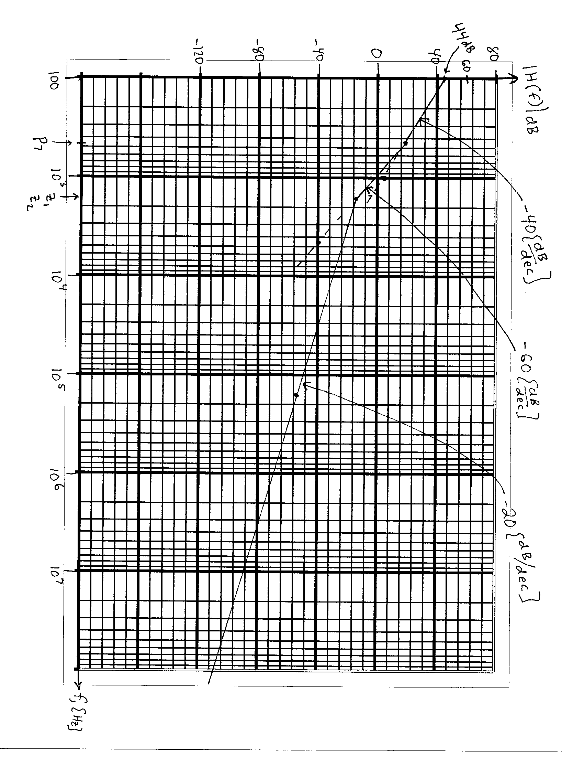
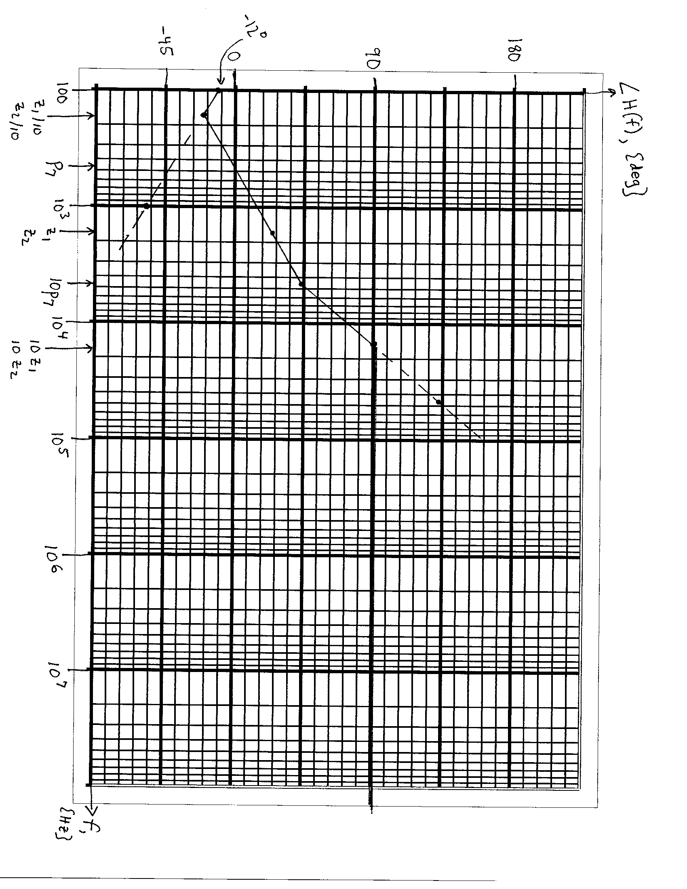

2. {40 Points} Assume ideal op amps.
a) Find the transconductance i_{a} /v_{in}.
b) Find the transfer function V_{a} /V_{in}.
c) Find the input impedance seen by the voltage source.
d) Find the output impedance seen by the 1[kΩ] resistor, assuming that this resistor is the load.
e) Find the output impedance seen by the C₂ capacitor, assuming that this capacitor is the load.
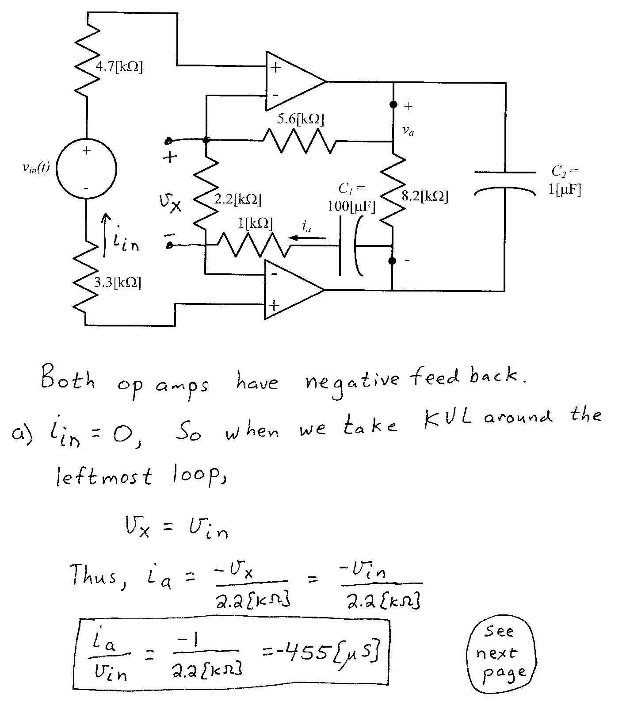
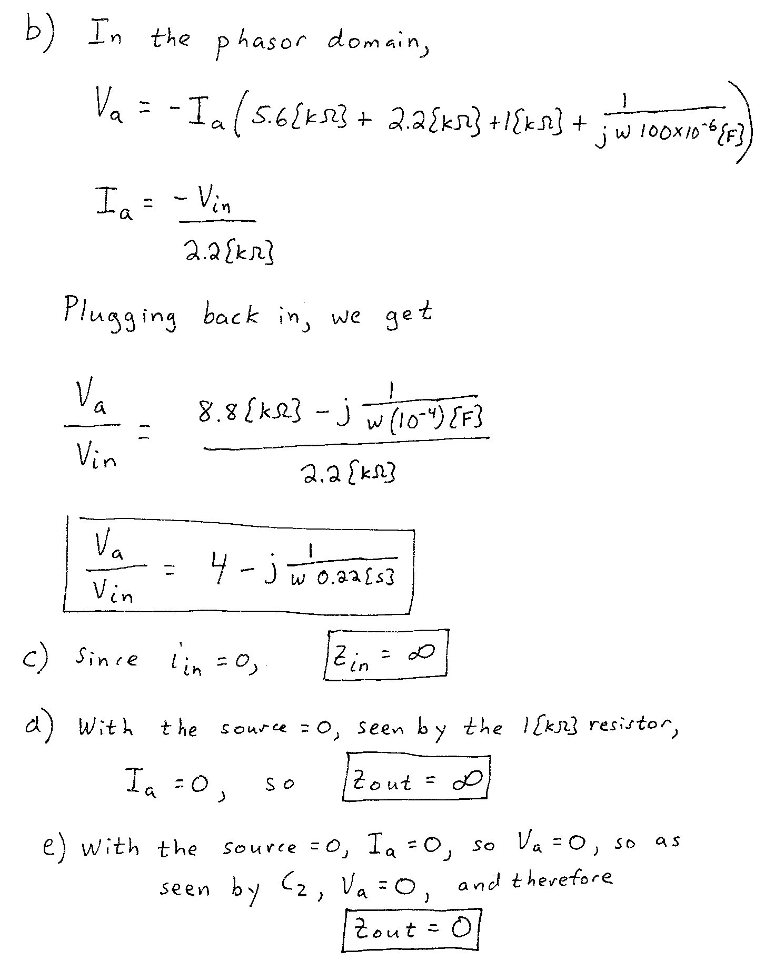

3. {40 Points} A device known as a Filler, has the symbol shown below in Figure 1. The characteristic curve for this device is given in Figure 2. Assume that the device is placed in the circuit in Figure 3.
a) Find all of the solutions for i_{A} that will be valid in this situation.
b) Find the signal models for the Filler device if small signals were applied at each of the solutions you found in part a).
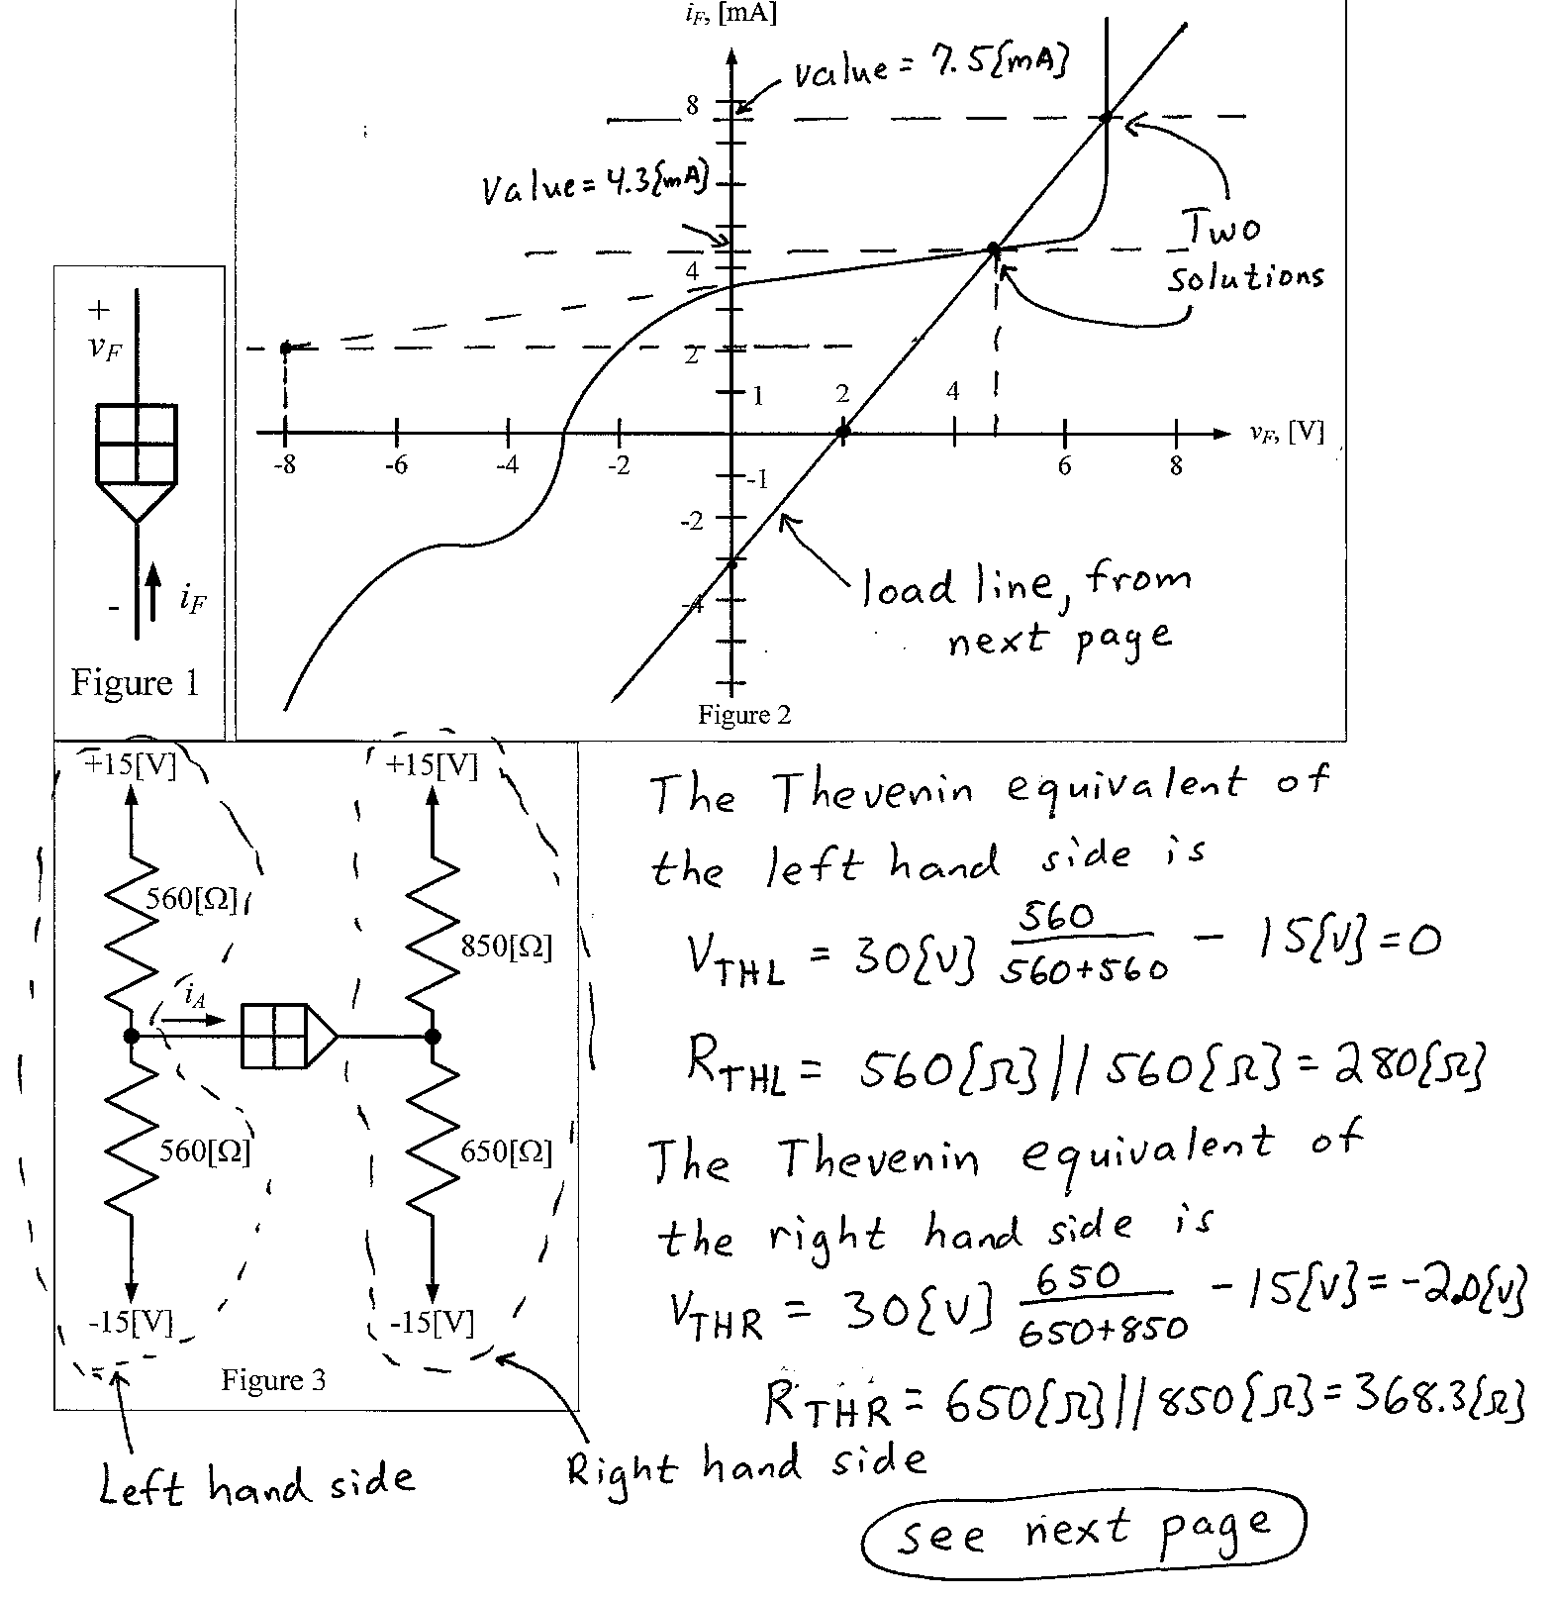
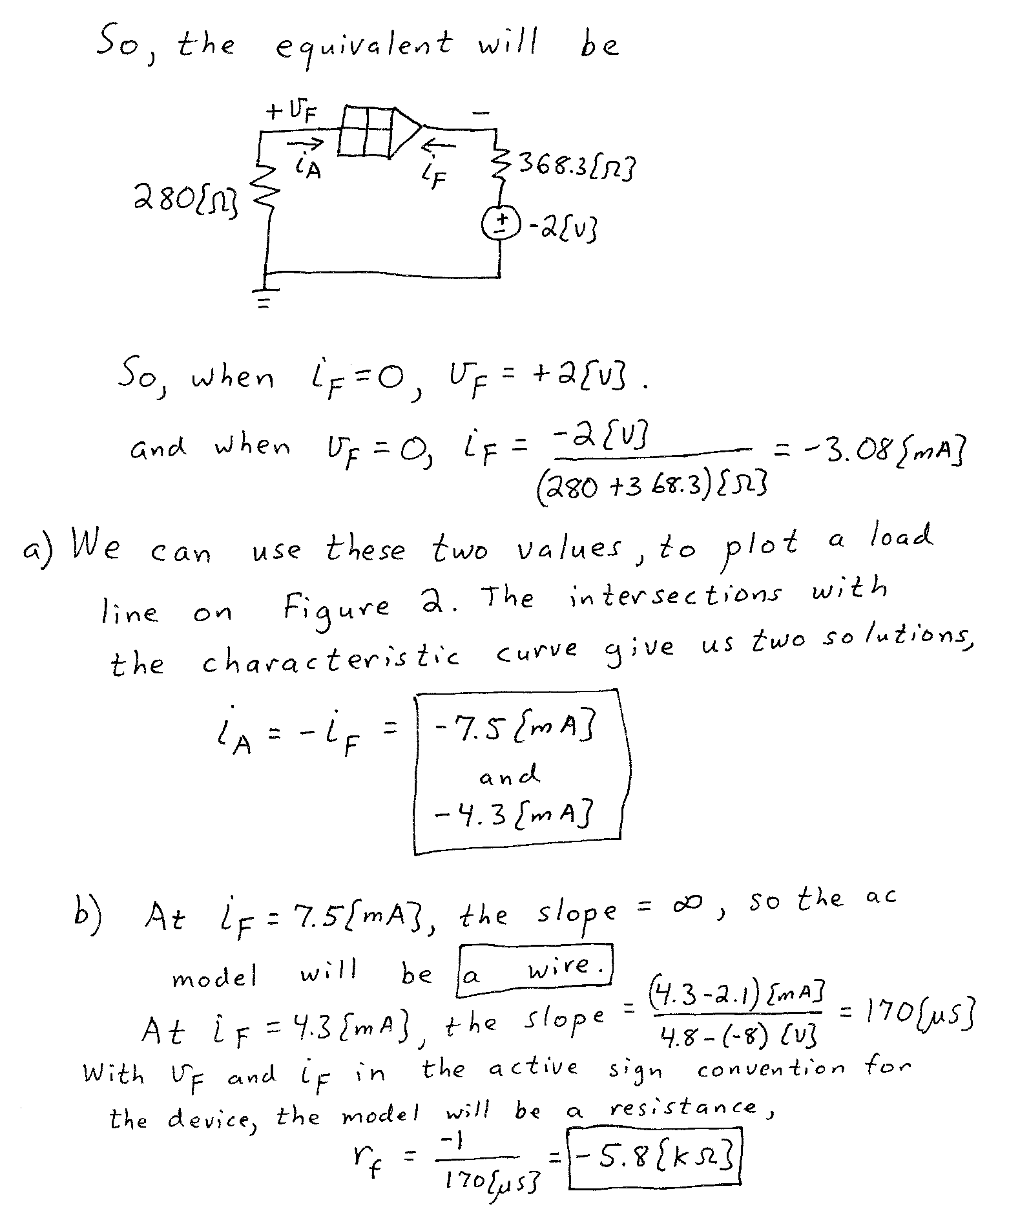

4. {40 Points} The characteristic curves for a device, called an Astrolator, are shown in Figures 1 and 2. The device schematic symbol is shown in Figure 3.
- Find a small-signal model that could be used for this device when it is biased into Region D, shown on the characteristic curves.
- Find a second small-signal model that could be used for this device when it is biased into Region D, shown on the characteristic curves. This model should be equivalent to the model you found in part a).
- What names would we use for each of the two models you found? We learned these names at the beginning of this course.
- Are there any other models that could be used for this region? Explain why or why not.
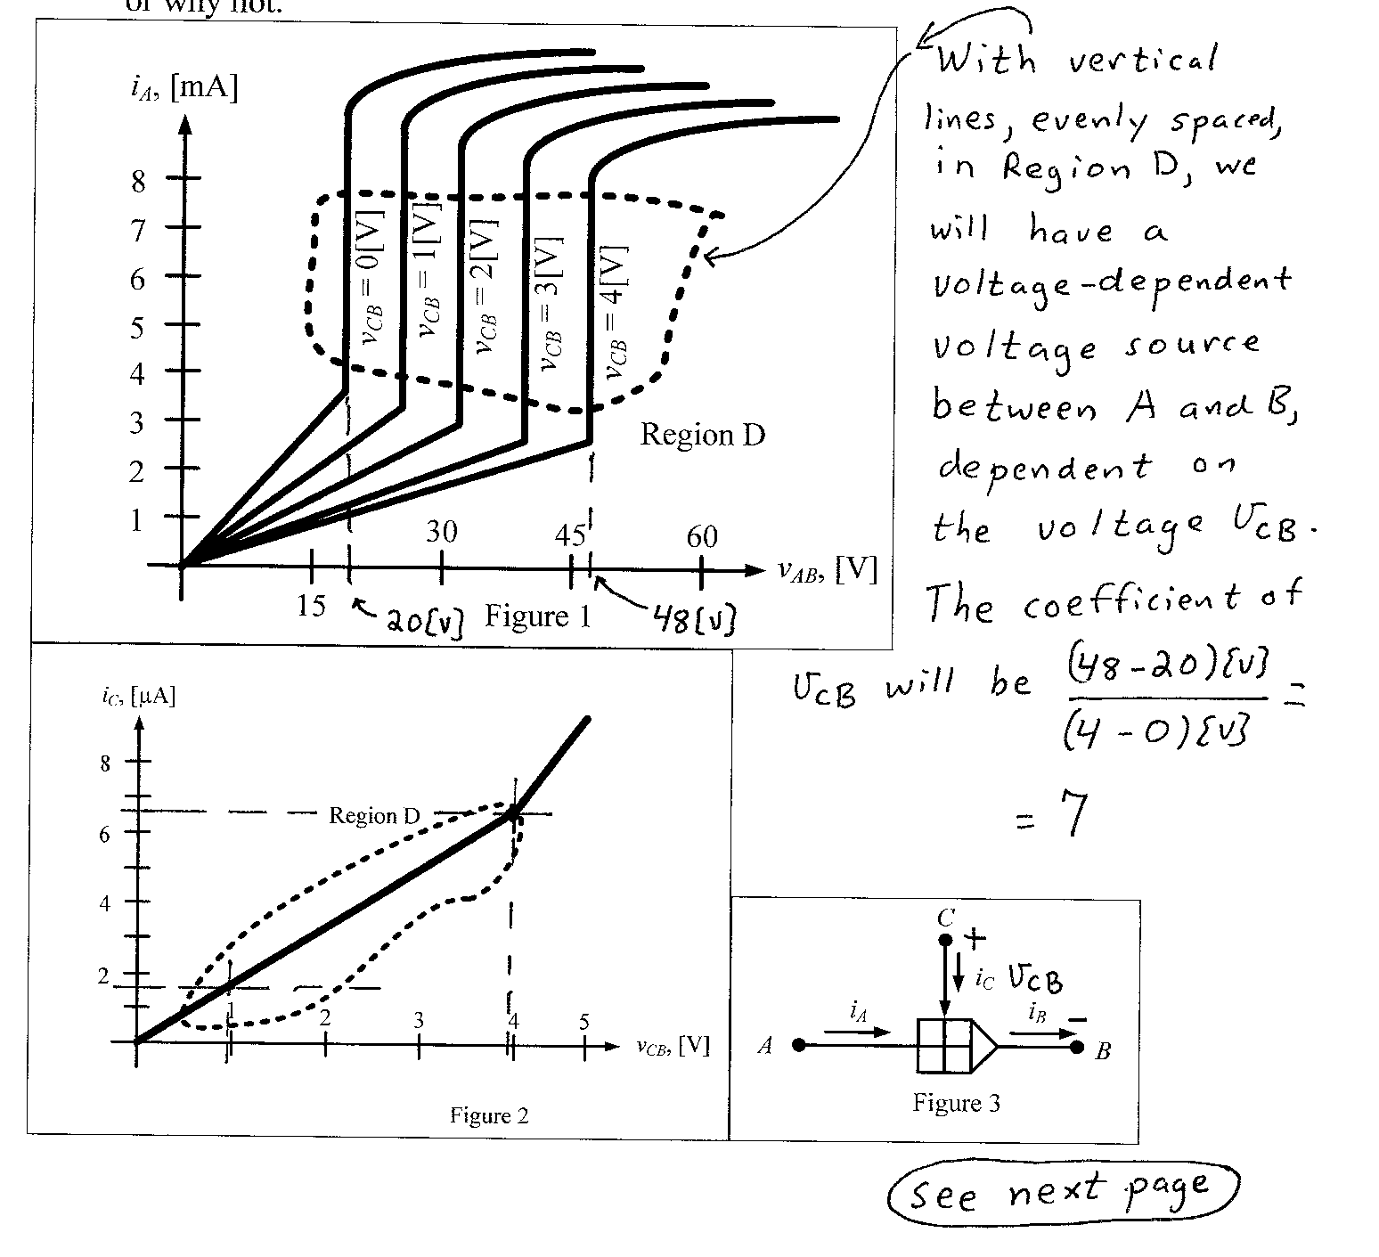
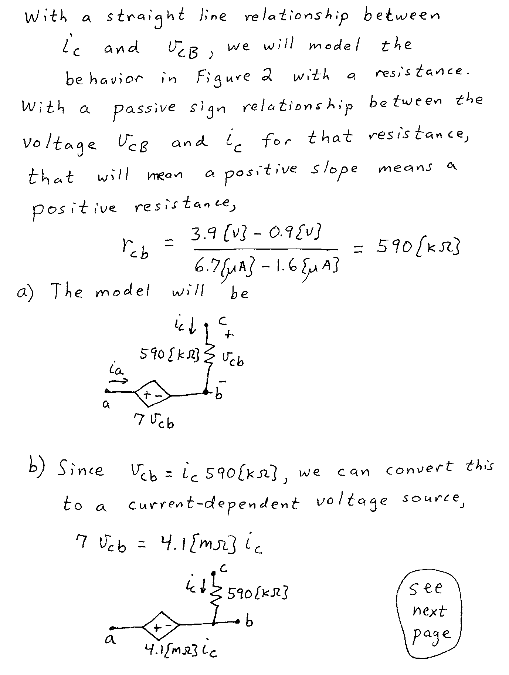
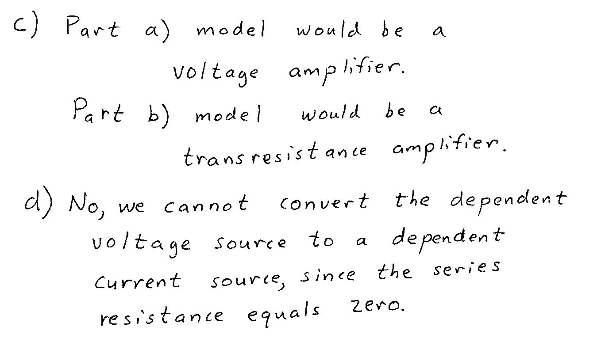
5. {40 Points} Use the circuit shown to solve this problem. Assume that for the transistor, β = 200, and that it is operating at room temperature.
a) Find the voltage V_{A} if I_{F} = 2[mA].
b) Find the voltage V_{A} if I_{F} = -2[mA].
c) Find the range of I_{F} that will cause the transistor Q₁ to be saturated.
