Name: _____________________________ (please print)
Signature: __________________________

ECE 3355 – Exam 1
March 2, 2019

Keep this exam closed until you are told to begin.

1. This exam is closed book, closed notes. You may use one 8.5” x 11” crib sheet, or its equivalent.
2. Show all work on these pages. Show all work necessary to complete the problem. A solution without the appropriate work shown will receive no credit. A solution that is not given in a reasonable order will lose credit. Clearly indicate your answer (for example by enclosing it in a box). If your answer is a plot, no box is needed.
3. It is assumed that your work will begin on the same page as the problem statement. If you choose to begin your work on another page, you must indicate this on the page with the problem statement, with a clear indication of where the work can be found. If your work continues on to another page, indicate clearly where your work can be found. Failure to indicate this clearly will result in a loss of credit.
4. Show all units in solutions, intermediate results, and figures. Units in the exam will be included between square brackets.
5. Do not use red ink. Do not use red pencil.
6. You will have 90 minutes to work on this exam.

1. ________________/40
2. ________________/25
3. ________________/35
Total = 100
Room for extra work

1. {40 Points} Two identical versions of a transconductance amplifier are connected in the circuit in Figure 1. The amplifier equivalent circuit is given in Figure 2. The terminal labels in Figure 1 show the polarities of the connections for the amplifiers. Find the transresistance gain, v_{out}/i_{e}, for this situation.

Room for extra work

2. {25 Points} Assume that the input of an oscilloscope can be modeled as a 4.7[MΩ] resistor in parallel with a 59[μH] inductor.
a) Design a seven-times probe that could be used with this oscilloscope to produce a waveform on the oscilloscope screen with the same shape as the input.
b) What would be the advantages and disadvantages of using the seven-times probe that you have designed. Give you answer in complete sentences.
c) Find the impedance of your seven-times probe at 12[GHz].

Room for extra work

3. {35 Points} For the transfer function H(ω) given below, plot the straight-line approximation to the magnitude Bode plot. Use the semilog graph paper given on the following pages. Extra graph paper is provided in case you need it. Plot as a function of frequency f. Use the frequency range from f = 10[Hz] to f = 10[MHz].
a) Using your plot, estimate the magnitude of the gain at 100[Hz]. Do not give your answer in [dB].
b) Find ∠H(10[MHz]) .

Room for extra work

1. {40 Points} Two identical versions of a transconductance amplifier are connected in the circuit in Figure 1. The amplifier equivalent circuit is given in Figure 2. The terminal labels in Figure 1 show the polarities of the connections for the amplifiers. Find the transresistance gain, v_{out}/i_{e}, for this situation.
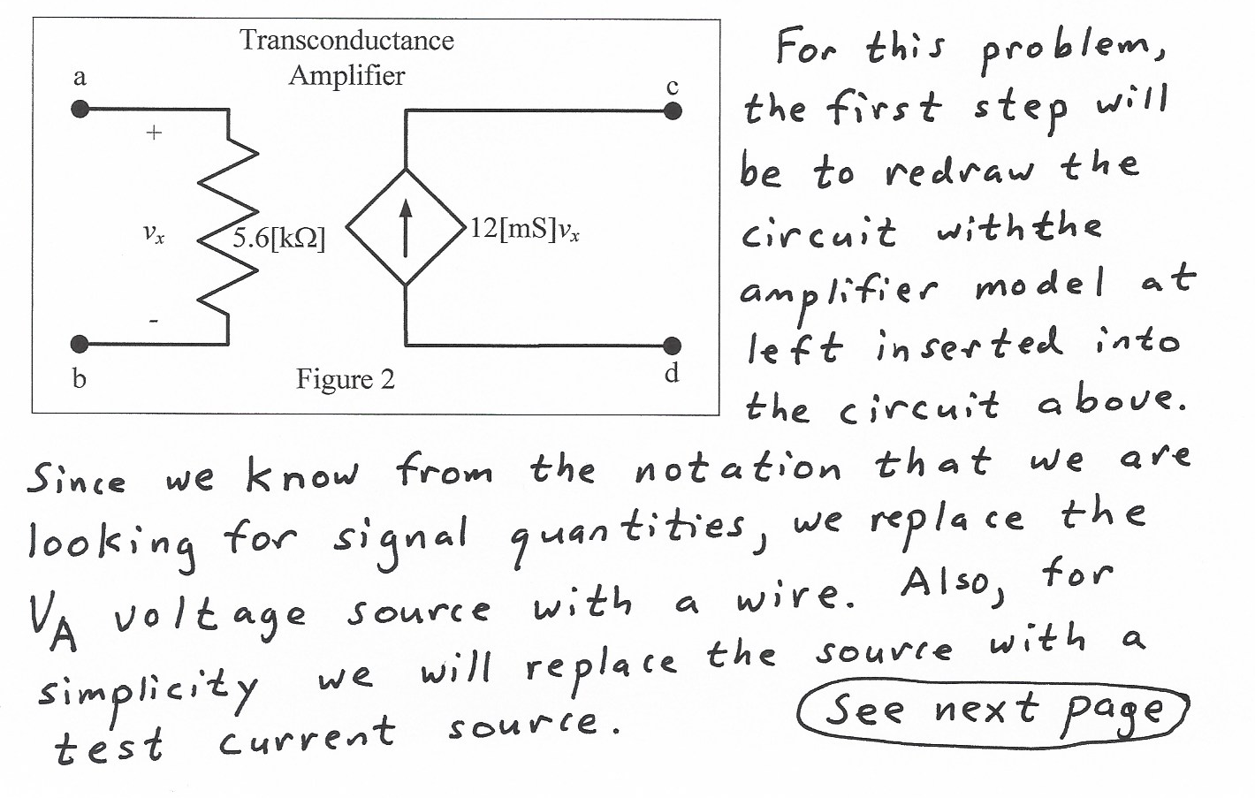
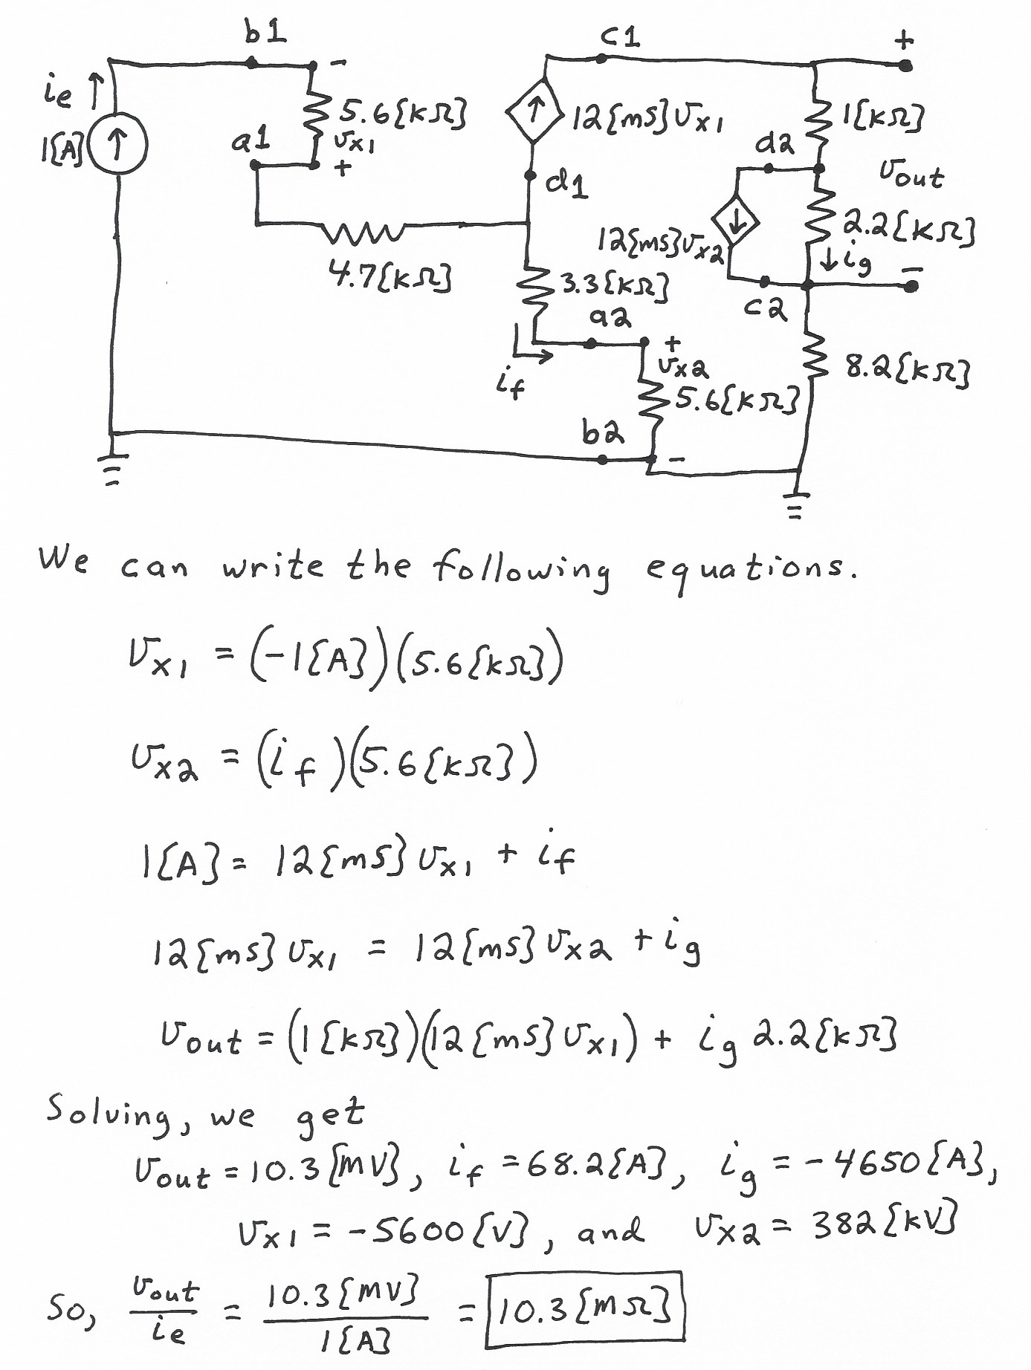
2. {25 Points} Assume that the input of an oscilloscope can be modeled as a 4.7[MΩ] resistor in parallel with a 59[μH] inductor.
a) Design a seven-times probe that could be used with this oscilloscope to produce a waveform on the oscilloscope screen with the same shape as the input.
b) What would be the advantages and disadvantages of using the seven-times probe that you have designed. Give you answer in complete sentences.
c) Find the impedance of your seven-times probe at 12[GHz].
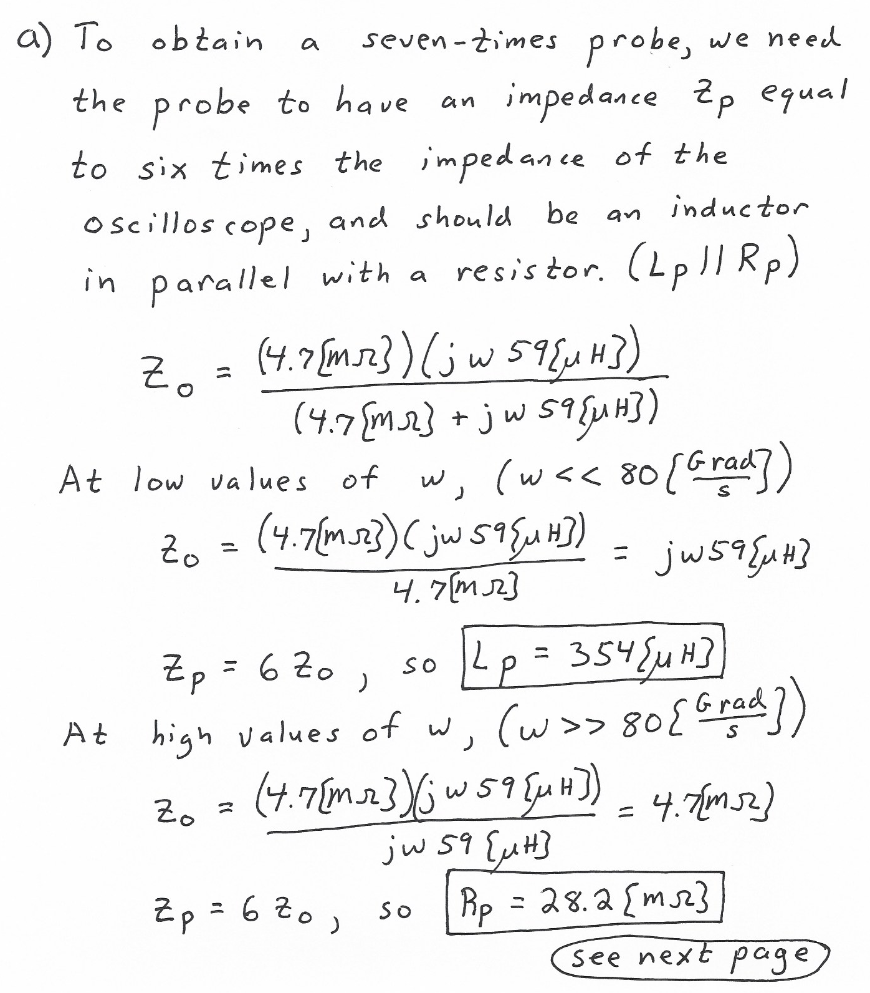
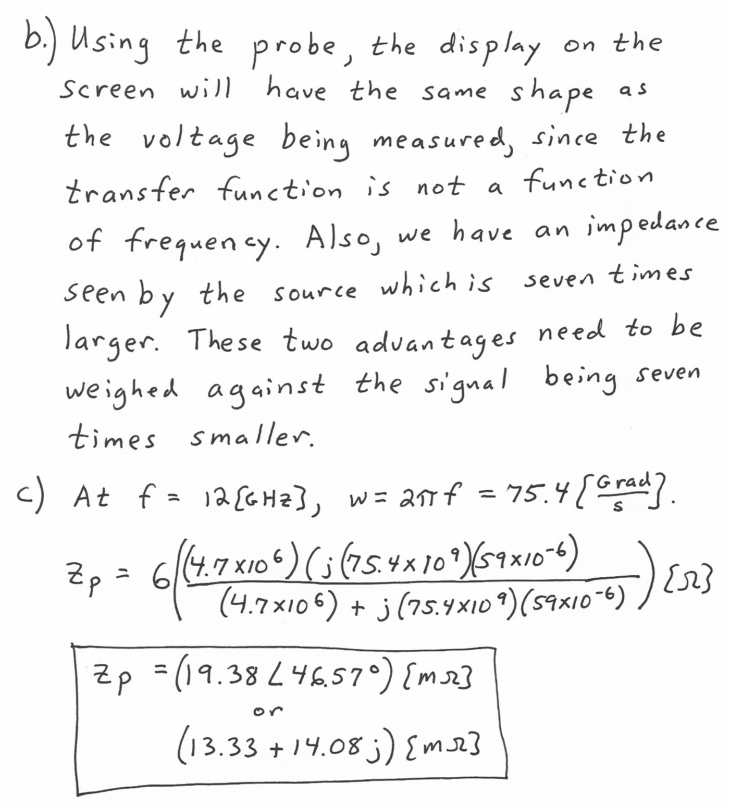

3. {35 Points} For the transfer function H(ω) given below, plot the straight-line approximation to the magnitude Bode plot. Use the semilog graph paper given on the following pages. Extra graph paper is provided in case you need it. Plot as a function of frequency f. Use the frequency range from f = 10[Hz] to f = 10[MHz].
a) Using your plot, estimate the magnitude of the gain at 100[Hz]. Do not give your answer in [dB].
b) Find ∠H(10[MHz]) .
