Name: _____________________________ (please print)
Signature: __________________________

ECE 3355 –Exam 2
April 13, 2019

Keep this exam closed until you are told to begin.

1. This exam is closed book, closed notes. You may use one 8.5” x 11” crib sheet, or its equivalent.
2. Show all work on these pages. Show all work necessary to complete the problem. A solution without the appropriate work shown will receive no credit. A solution that is not given in a reasonable order will lose credit. Clearly indicate your answer (for example by enclosing it in a box). If your answer is a plot, no box is needed.
3. It is assumed that your work will begin on the same page as the problem statement. If you choose to begin your work on another page, you must indicate this on the page with the problem statement, with a clear indication of where the work can be found. If your work continues on to another page, indicate clearly where your work can be found. Failure to indicate this clearly will result in a loss of credit.
4. Show all units in solutions, intermediate results, and figures. Units in the exam will be included between square brackets.
5. Do not use red ink. Do not use red pencil.
6. You will have 90 minutes to work on this exam.

1. ________________/35
2. ________________/30
3. ________________/35
Total = 100
Room for extra work
1. {35 Points} Assume the op amps in the circuit shown are ideal.
a) For the case where v_{X} = 1[V], find v_{A}.
b) For the case where v_{X} = 1[V], find v_{B}.
c) Find the range of values for v_{X}, so that all three op amps are not saturated.

Room for extra work

2. {30 Points} Assume an ideal op amp.
a) Find the numerical values of all of the poles and all of the zeroes for the transfer function V_{o}/V_{i}.
b) Assume that you wanted to change this circuit, to change one of the poles to be at 100[Hz]. Describe which component value you would change, and what value you would change it to. There may be more than one solution to this part, but you are only required to describe one solution.

Room for extra work

3. {35 Points} Assume that the diodes can be modeled using a piece-wise linear diode model with V_{f} = 1[V], r_{d} = 1[kΩ], and I_{s} = 1[mA]. Find V_{A}. Show your work, stating your tests explicitly. Define all variables appropriately. You are expected to be able to complete at least two reasonable guesses, if needed, in the time period allotted.

Room for extra work
1. {35 Points} Assume the op amps in the circuit shown are ideal.
a) For the case where v_{X} = 1[V], find v_{A}.
b) For the case where v_{X} = 1[V], find v_{B}.
c) Find the range of values for v_{X}, so that all three op amps are not saturated.
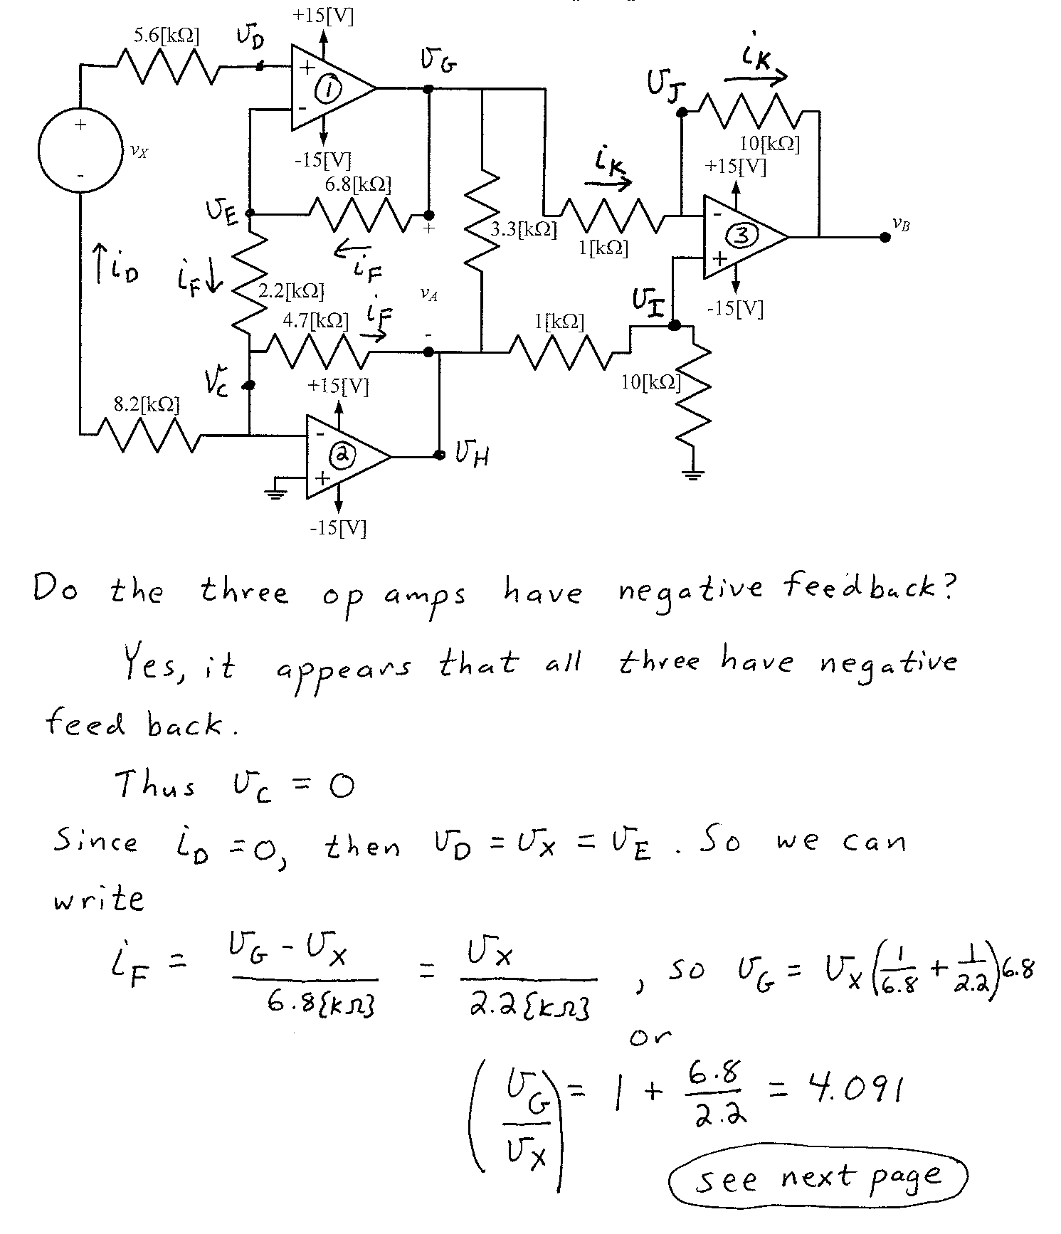
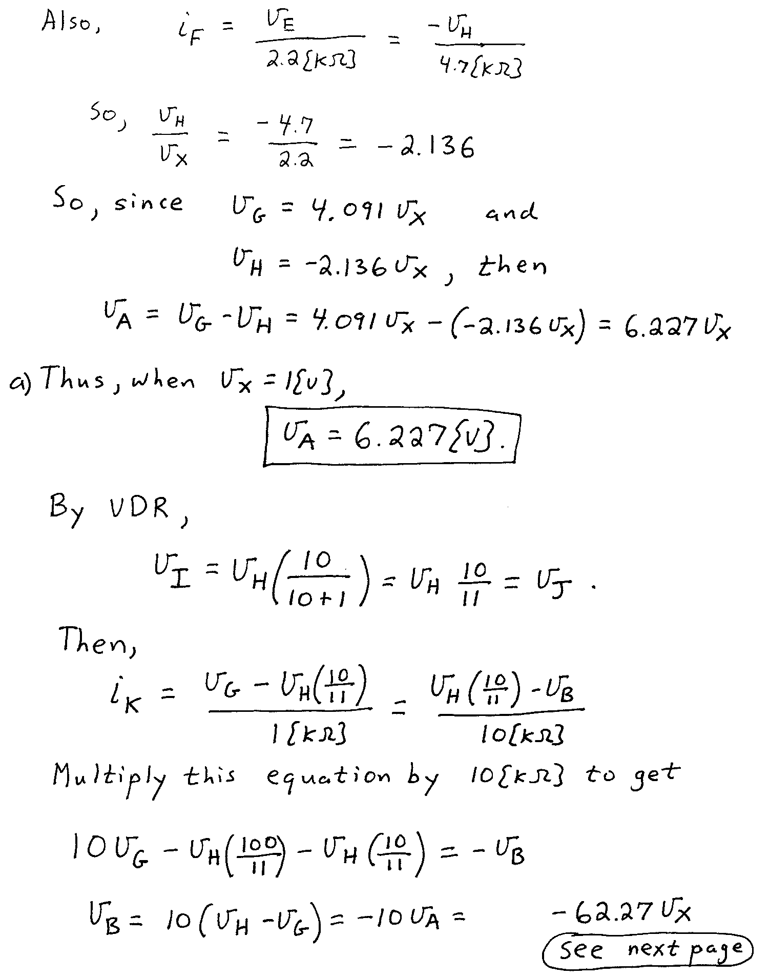
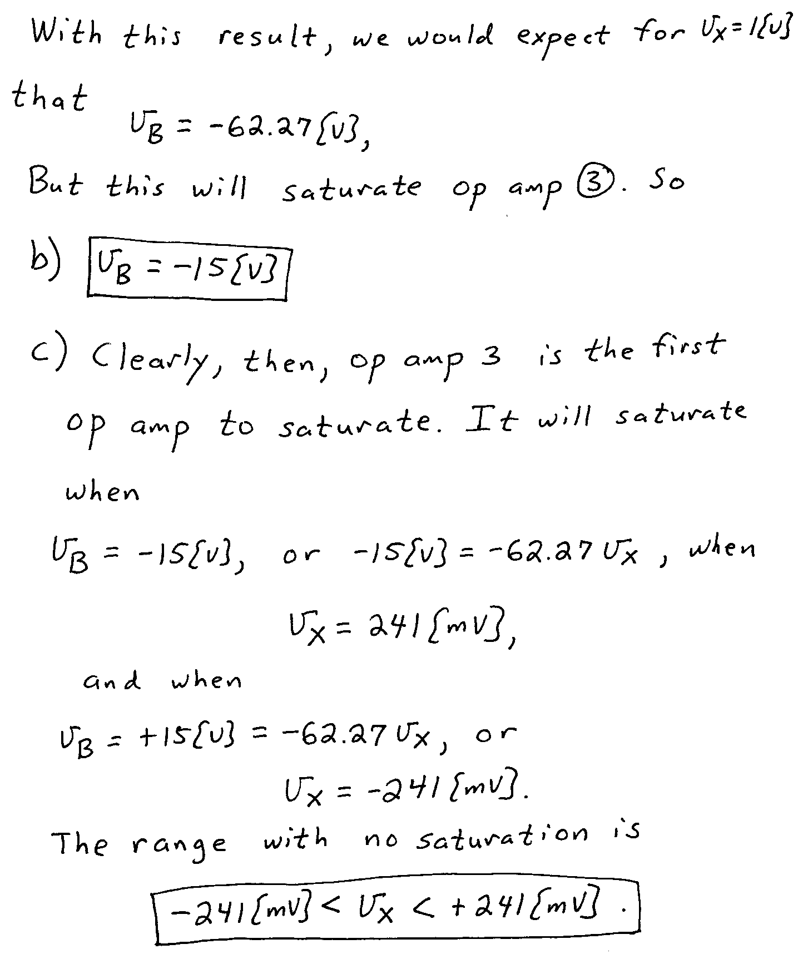

2. {30 Points} Assume an ideal op amp.
a) Find the numerical values of all of the poles and all of the zeroes for the transfer function V_{o}/V_{i}.
b) Assume that you wanted to change this circuit, to change one of the poles to be at 100[Hz]. Describe which component value you would change, and what value you would change it to. There may be more than one solution to this part, but you are only required to describe one solution.
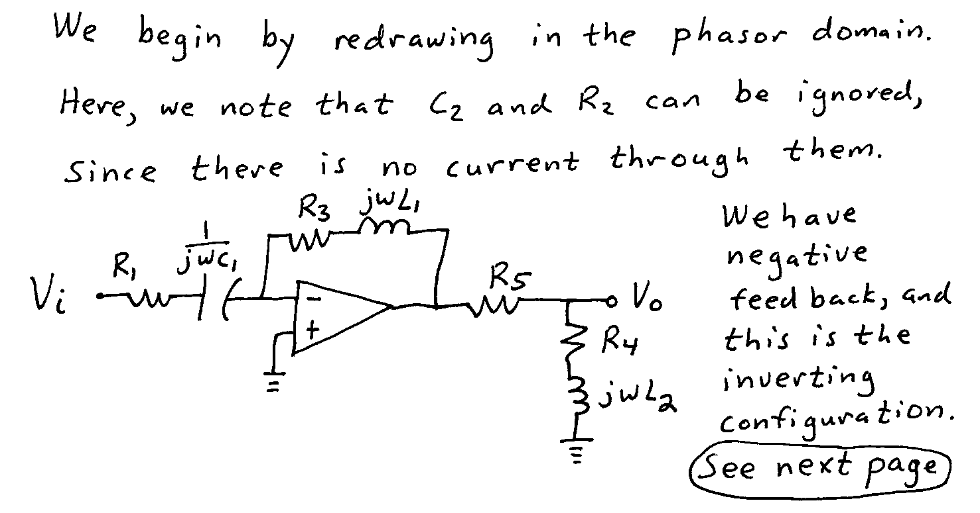
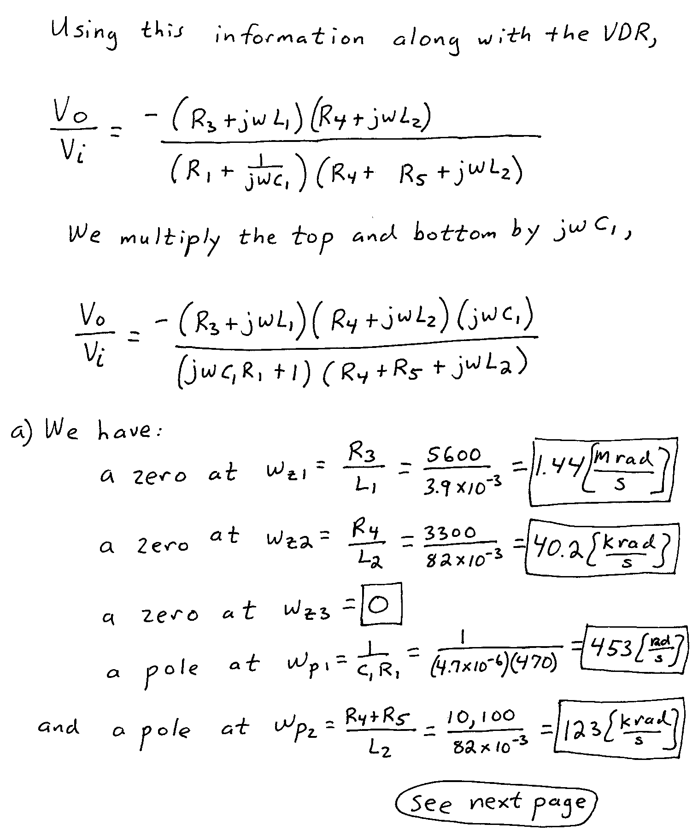
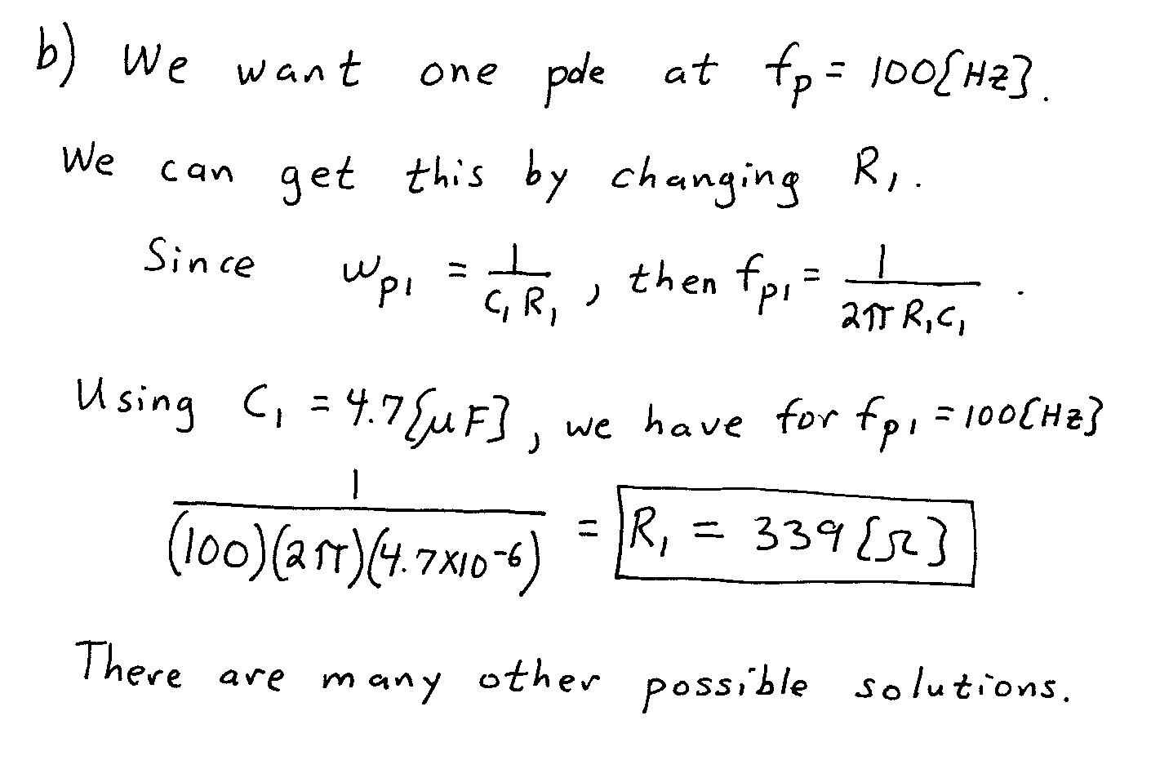

3. {35 Points} Assume that the diodes can be modeled using a piece-wise linear diode model with V_{f} = 1[V], r_{d} = 1[kΩ], and I_{s} = 1[mA]. Find V_{A}. Show your work, stating your tests explicitly. Define all variables appropriately. You are expected to be able to complete at least two reasonable guesses, if needed, in the time period allotted.
