Name: _____________________________ (please print)
Signature: __________________________

ECE 3355 – Final Exam
May 2, 2019

Keep this exam closed until you are told to begin.

1. This exam is closed book, closed notes. You may use one 8.5” x 11” crib sheet, or its equivalent.
2. Show all work on these pages. Show all work necessary to complete the problem. A solution without the appropriate work shown will receive no credit. A solution that is not given in a reasonable order will lose credit. Clearly indicate your answer (for example by enclosing it in a box). If your answer is a plot, no box is needed.
3. It is assumed that your work will begin on the same page as the problem statement. If you choose to begin your work on another page, you must indicate this on the page with the problem statement, with a clear indication of where the work can be found. If your work continues on to another page, indicate clearly where your work can be found. Failure to indicate this clearly will result in a loss of credit.
4. Show all units in solutions, intermediate results, and figures. Units in the exam will be included between square brackets.
5. Do not use red ink. Do not use red pencil.
6. You will have 160 minutes to work on this exam.

1. ________________/40
2. ________________/40
3. ________________/40
4. ________________/40
5. ________________/40
6. ________________/40
Total = 240
Room for extra work

1. {40 Points} Assume an ideal op amp in the circuit below.
Plot the straight-line approximation to the magnitude Bode plot for H(ω) = V_{o}/V_{i}. Use a range from 1[rad/s] to 1[Mrad/s]. Use the semilog graph paper provided on the next two pages. An extra sheet is provided for your use.

2. {40 Points} Assume ideal op amps.
a) Find i_{A}.
a) Find i_{L}.

Room for extra work

3. {40 Points} Assume that the diodes can be modeled using a piece-wise linear diode model with V_{f} = 1[V], r_{d} = 1[kΩ], and I_{s} = 1[mA]. Find V_{A}. Show your work, stating your tests explicitly. Define all variables appropriately. You are expected to be able to complete at least two reasonable guesses, if needed, in the time period allotted.

Room for extra work

4. {40 Points} A device known as a Aryactor, has the symbol shown below in Figure 1. The characteristic curve for this device is given in Figure 2. Assume that the device is placed in the circuit in Figure 3.
Find all of the solutions for i_{X} that will be valid in this situation.

Room for extra work

5. {40 Points} Assume that the diodes can be modeled using a piece-wise linear diode model with V_{f} = 0.7[V], r_{d} = 500[Ω], and I_{s} = 0. Assume an ideal op amp. Sketch the transfer characteristic, v_{O} versus v_{I}, for -15[V] < v_{I} < +15[V].

Room for extra work

6. {40 Points} Use the circuit shown to solve this problem. Assume that for the transistor, β = 100, and that it is operating at room temperature. The source v_{s}(t) has a range of values, -1[V] < v_{s} < +1[V].
Find the output resistance for signals as seen by the load R_{L}, in the passband.

1. {40 Points} Assume an ideal op amp in the circuit below.
Plot the straight-line approximation to the magnitude Bode plot for H(ω) = V_{o}/V_{i}. Use a range from 1[rad/s] to 1[Mrad/s]. Use the semilog graph paper provided on the next two pages. An extra sheet is provided for your use.
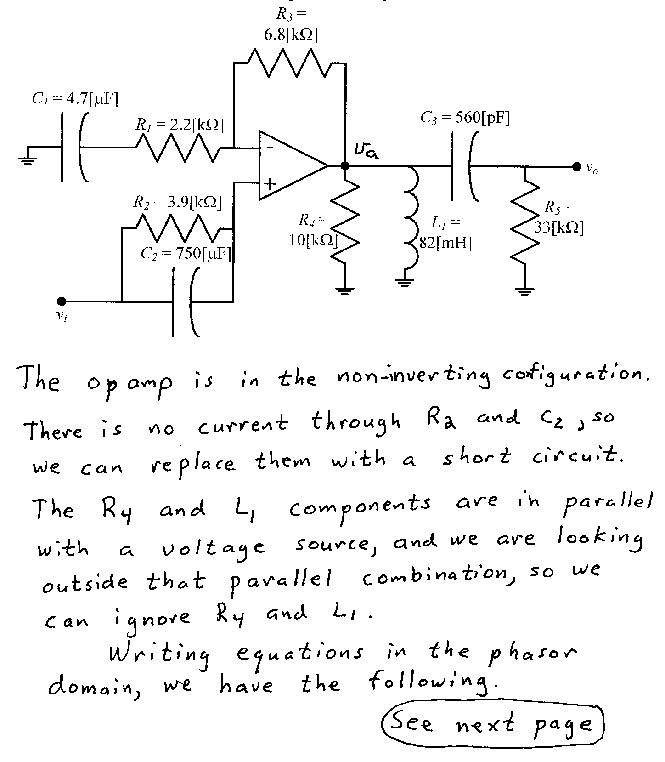
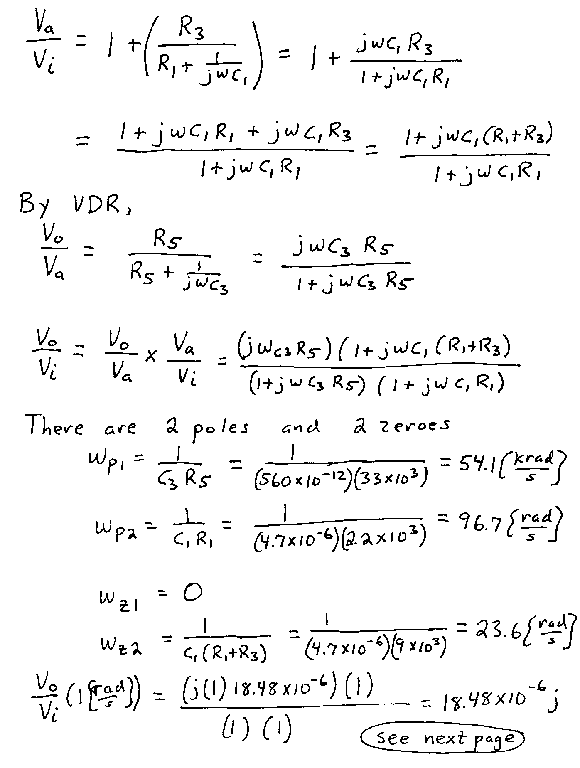
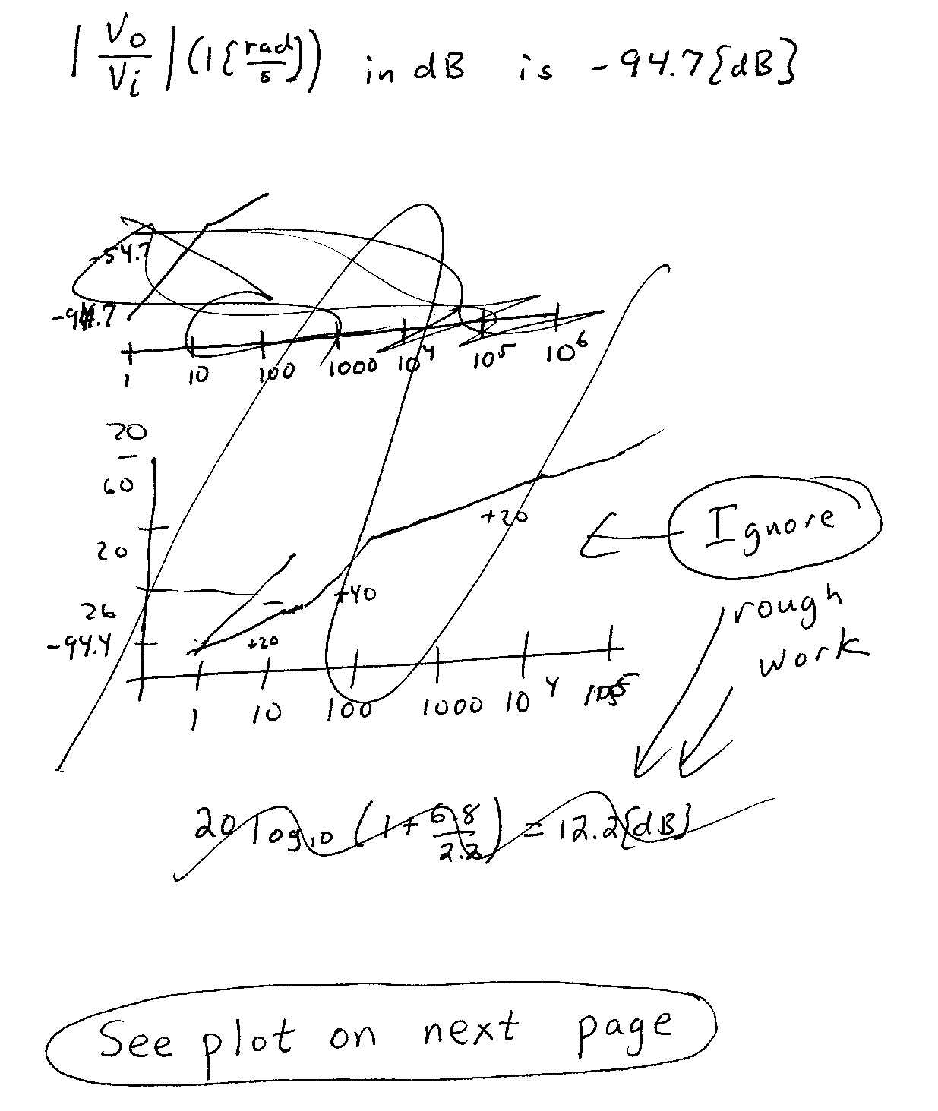
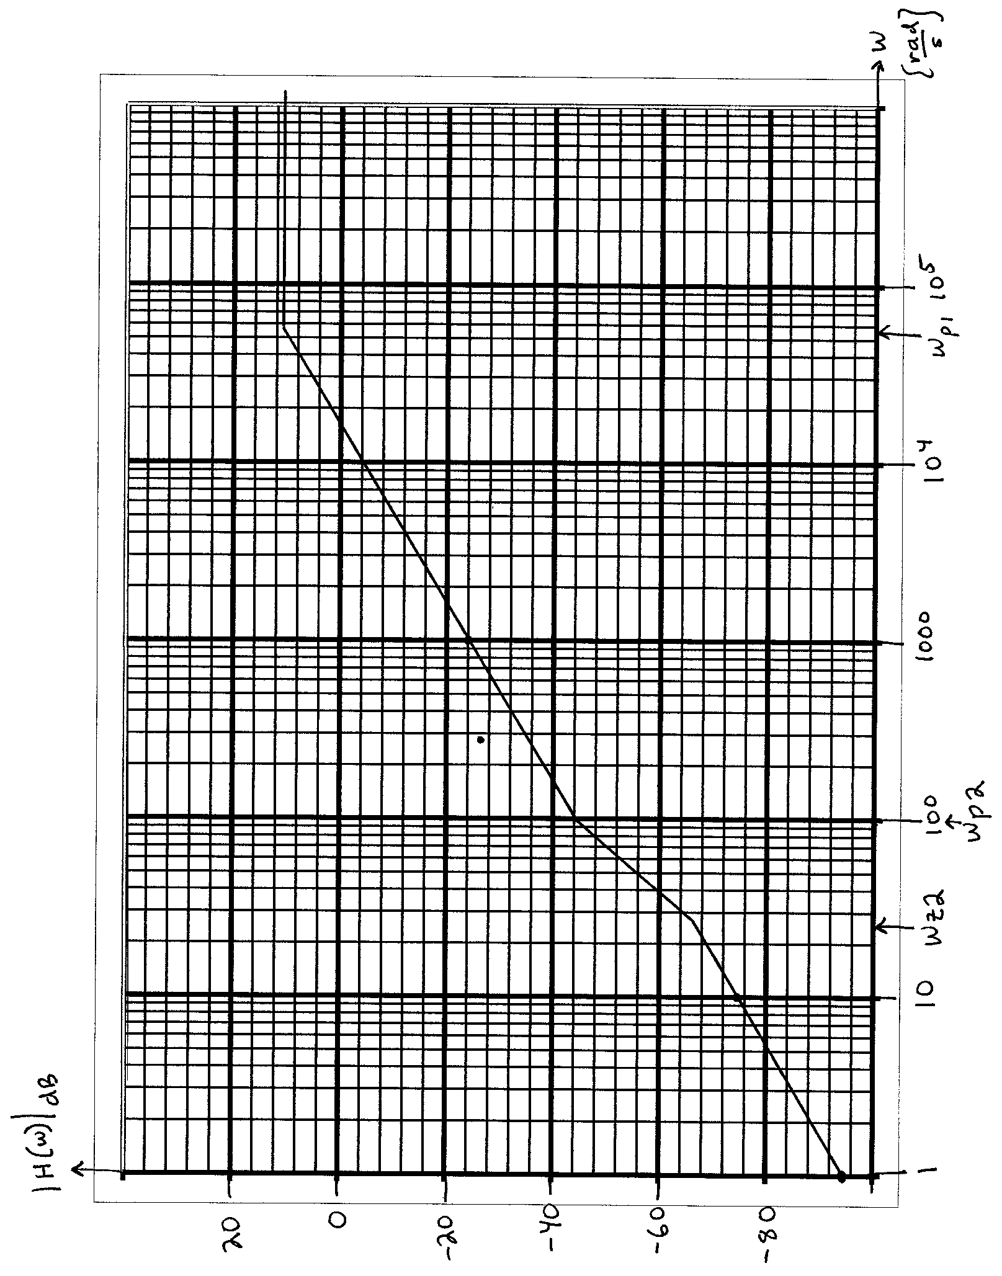

2. {40 Points} Assume ideal op amps.
a) Find i_{A}.
a) Find i_{L}.
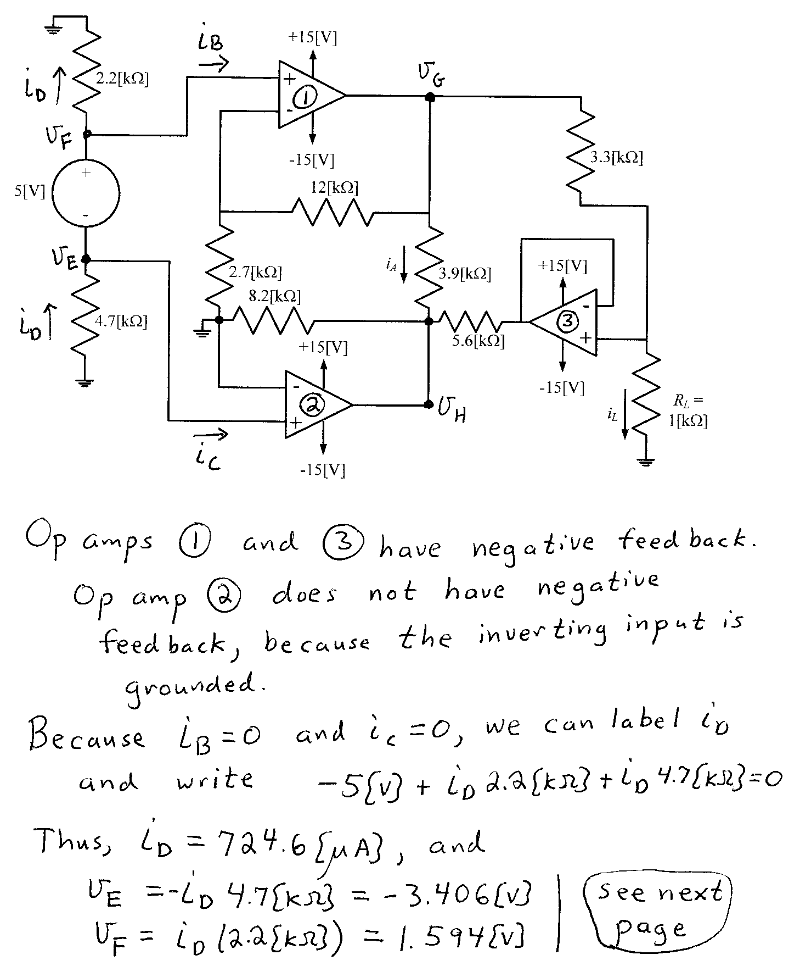
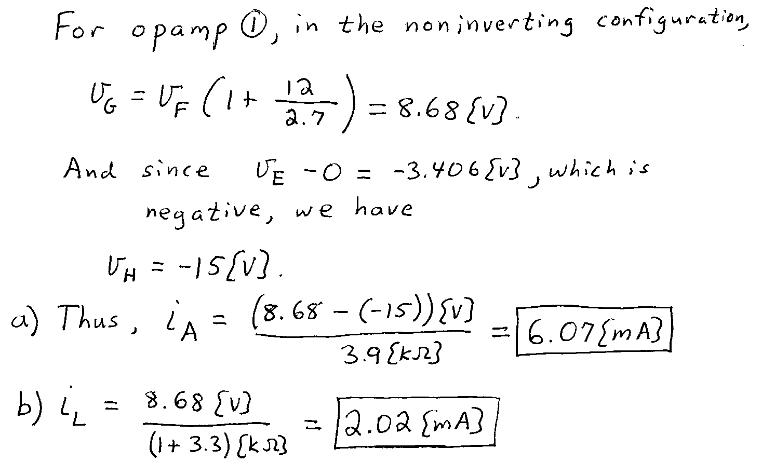

3. {40 Points} Assume that the diodes can be modeled using a piece-wise linear diode model with V_{f} = 1[V], r_{d} = 1[kΩ], and I_{s} = 1[mA]. Find V_{A}. Show your work, stating your tests explicitly. Define all variables appropriately. You are expected to be able to complete at least two reasonable guesses, if needed, in the time period allotted.
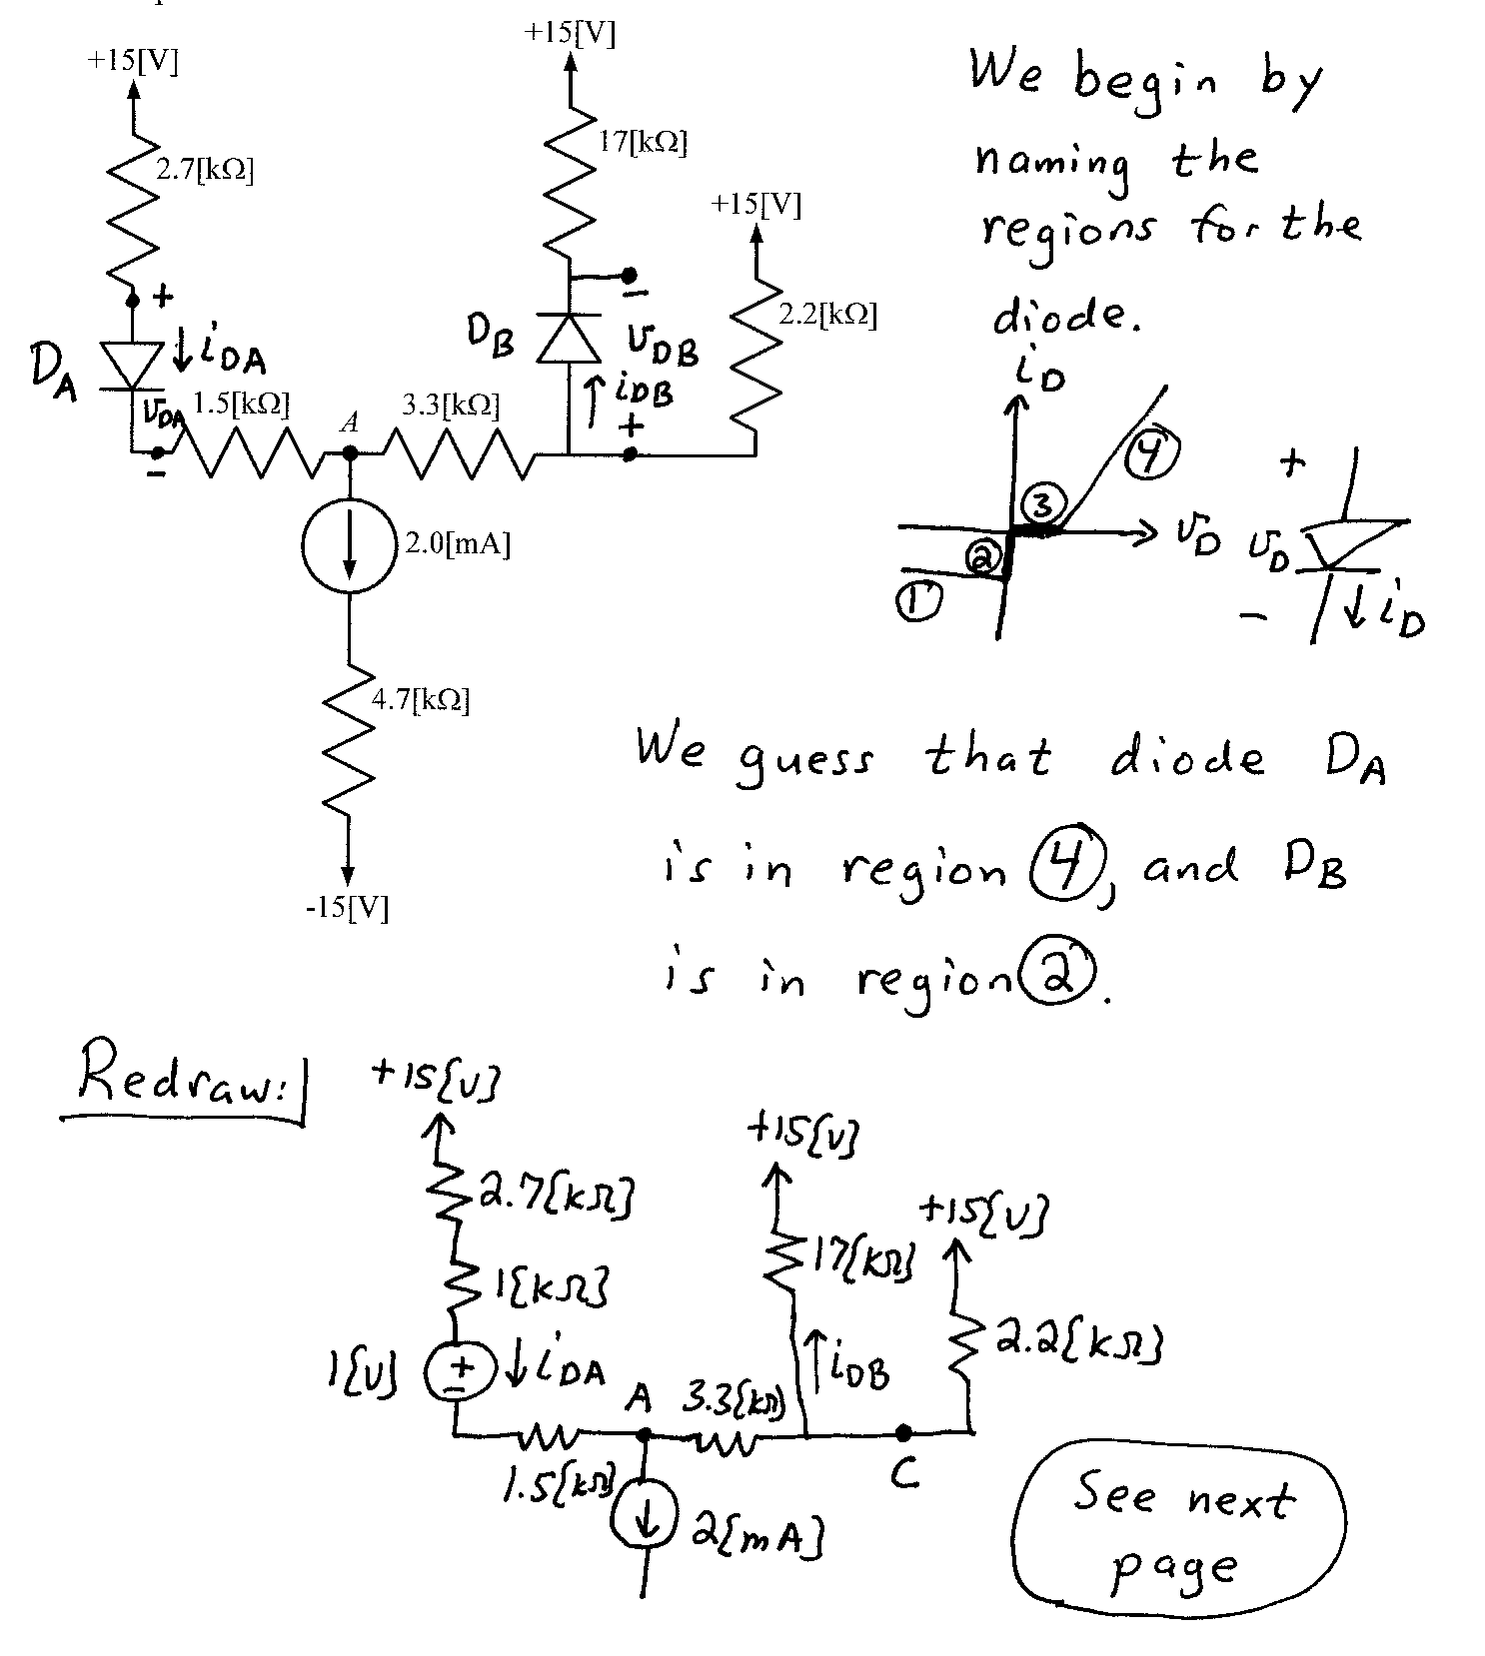
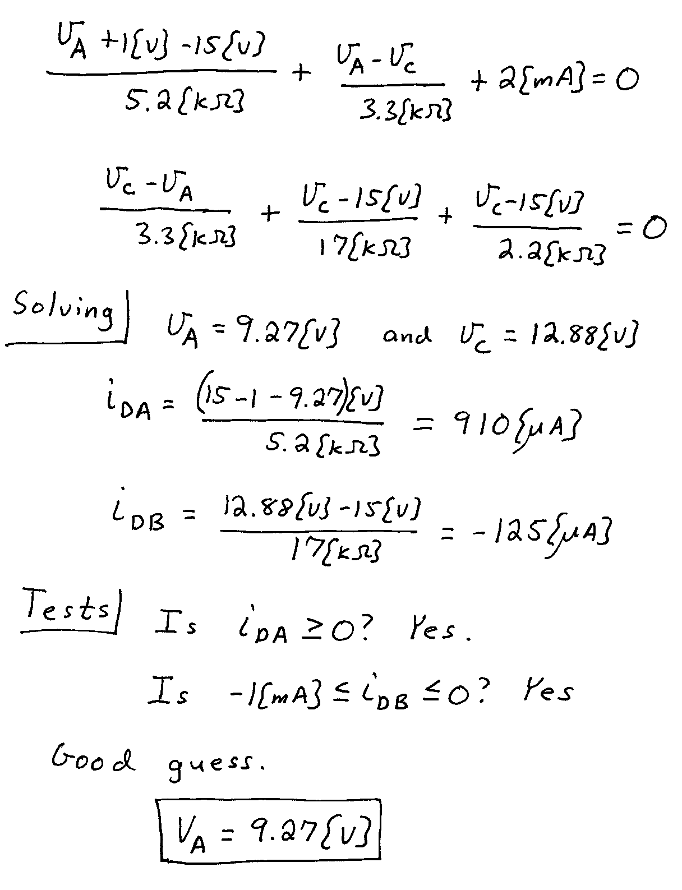

4. {40 Points} A device known as a Aryactor, has the symbol shown below in Figure 1. The characteristic curve for this device is given in Figure 2. Assume that the device is placed in the circuit in Figure 3.
Find all of the solutions for i_{X} that will be valid in this situation.
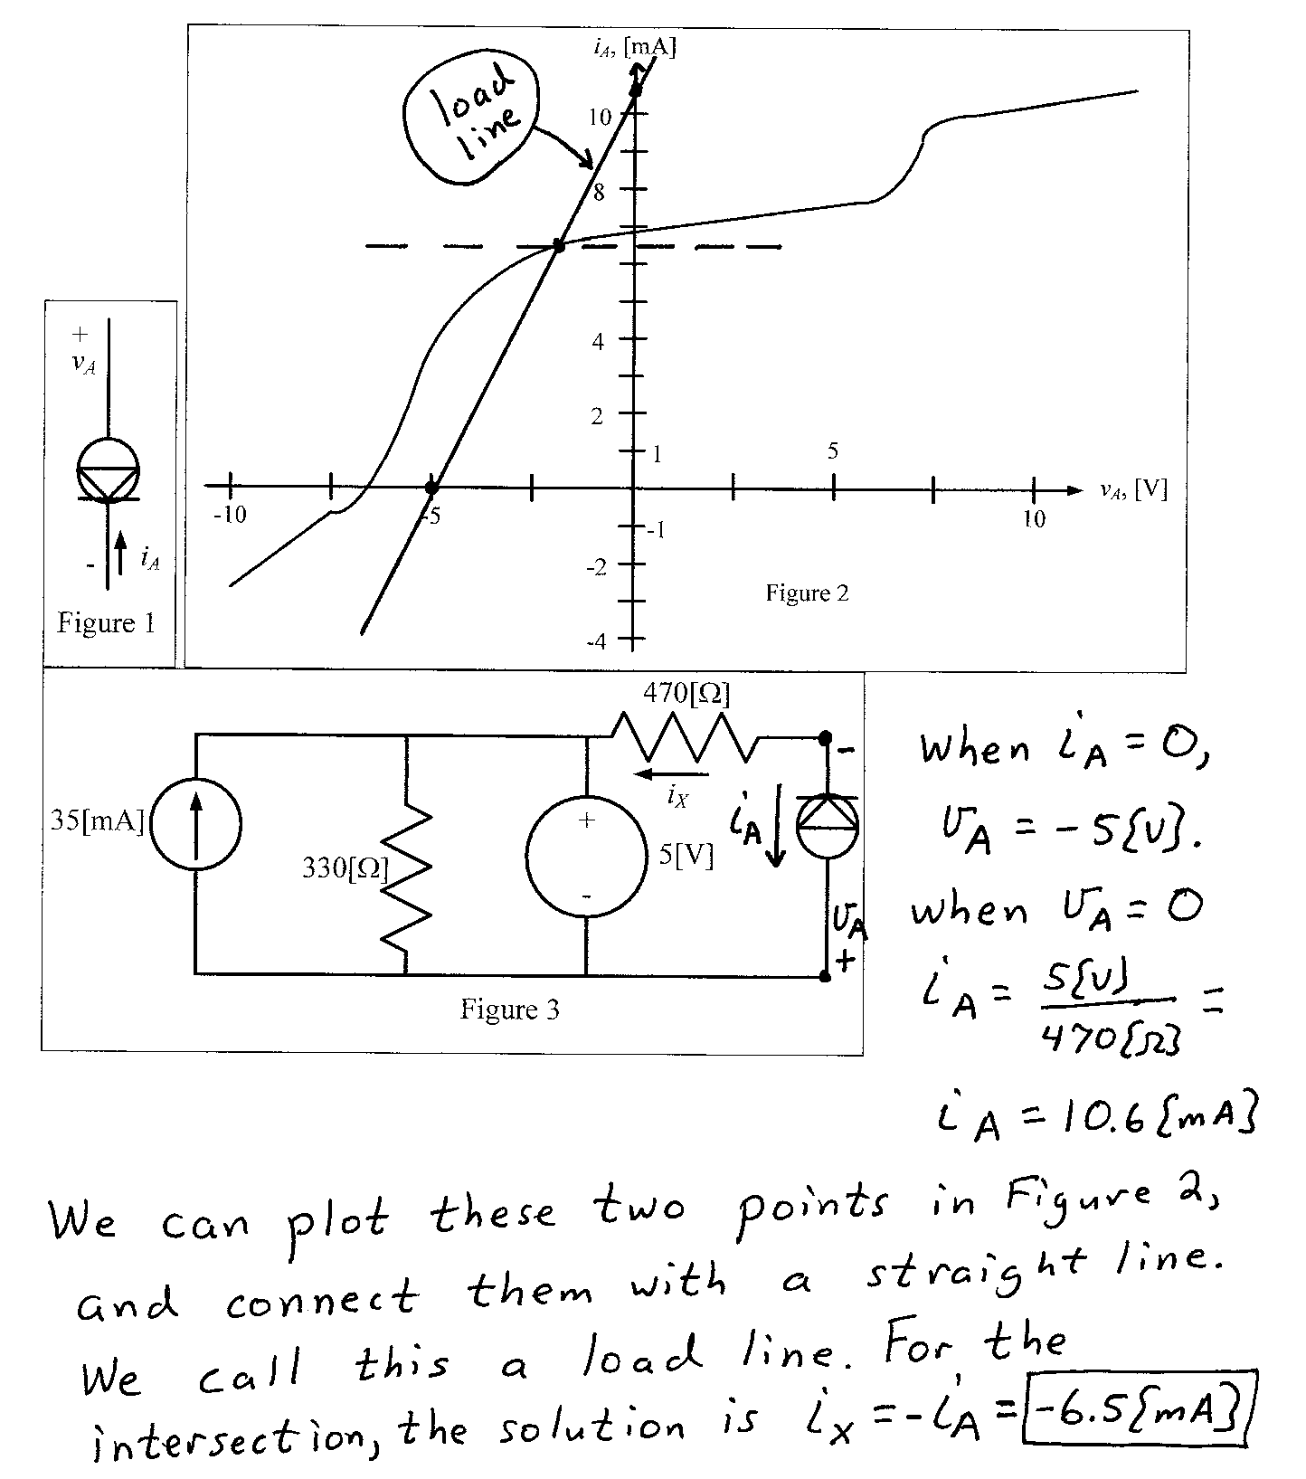

5. {40 Points} Assume that the diodes can be modeled using a piece-wise linear diode model with V_{f} = 0.7[V], r_{d} = 500[Ω], and I_{s} = 0. Assume an ideal op amp. Sketch the transfer characteristic, v_{O} versus v_{I}, for -15[V] < v_{I} < +15[V].
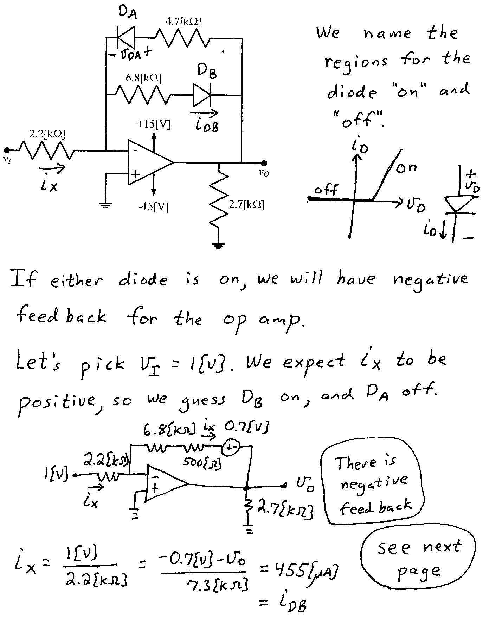
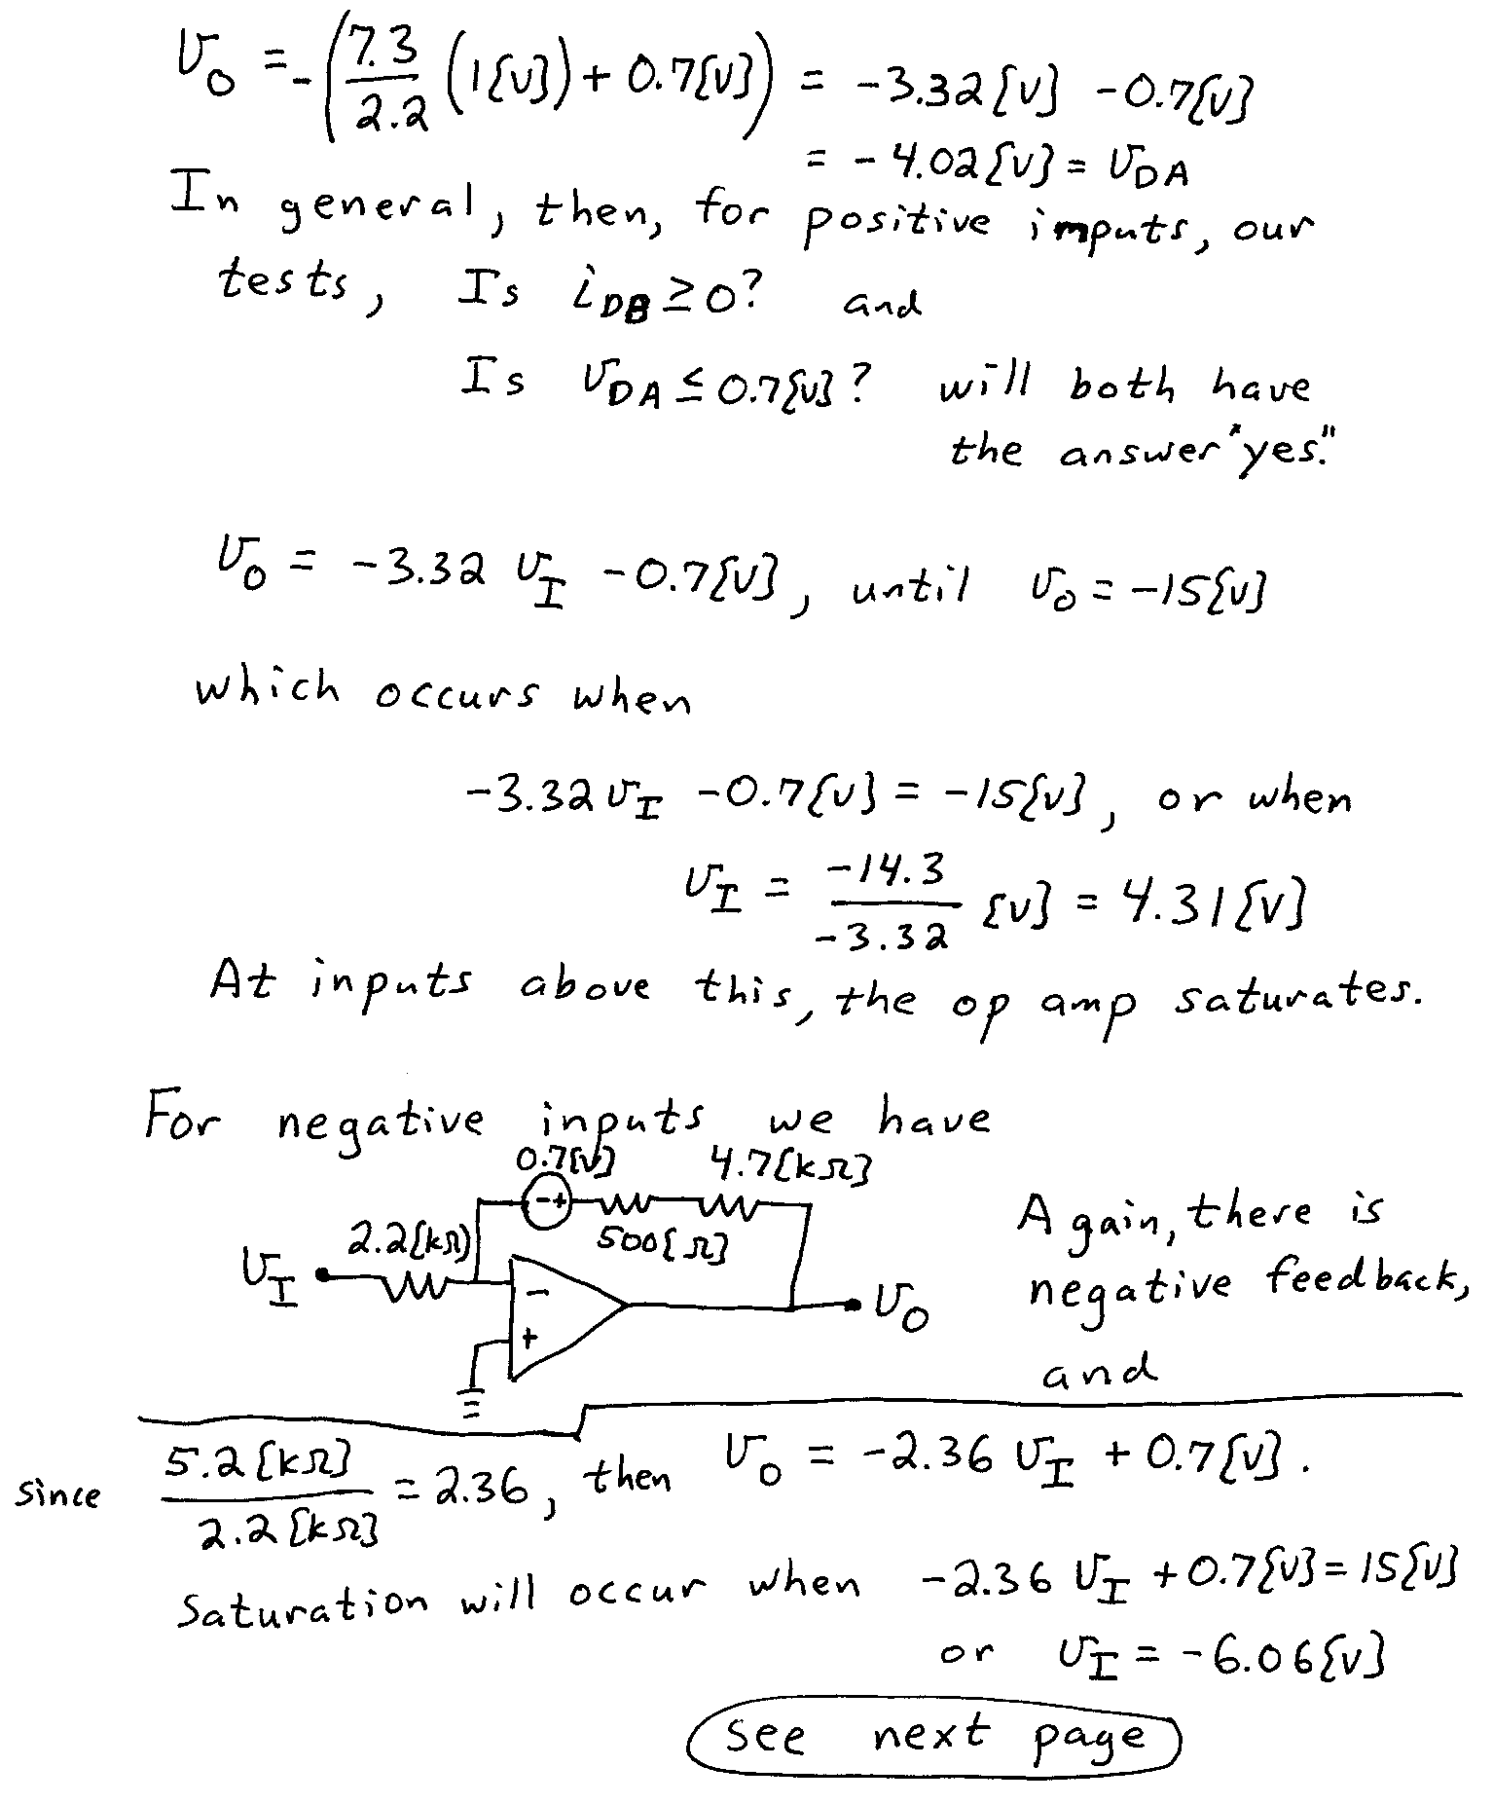
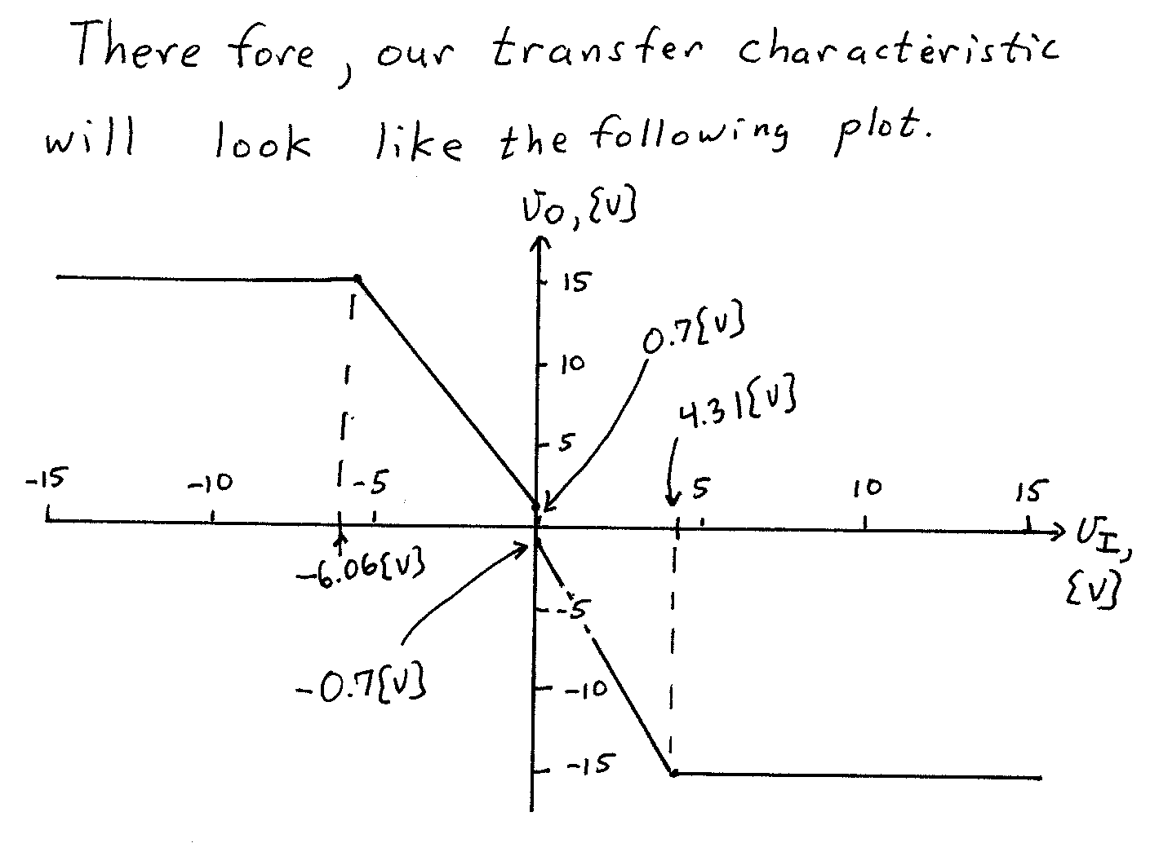
6. {40 Points} Use the circuit shown to solve this problem. Assume that for the transistor, β = 100, and that it is operating at room temperature. The source v_{s}(t) has a range of values, -1[V] < v_{s} < +1[V].
Find the output resistance for signals as seen by the load R_{L}, in the passband.
