Name: _____________________________ (please print)
Signature: __________________________

ECE 3355 – Quizzes #5 and #6
April 25, 2019

Keep this quiz closed and face up until you are told to begin.

1. These quizzes are closed book, closed notes. You may use one 8.5” x 11” crib sheet, or its equivalent.
2. Show all work on these pages. Show all work necessary to complete the problem. A solution without the appropriate work shown will receive no credit. A solution which is not given in a reasonable order will lose credit.
3. It is assumed that your work will begin on the same page as the problem statement. If you choose to begin your work on another page, you must indicate this on the page with the problem statement, with a clear indication of where the work can be found. If your work continues on to another page, indicate clearly where your work can be found. Failure to indicate this clearly will result in a loss of credit.
4. Show all units in solutions, intermediate results, and figures. Units in the quiz will be included between square brackets.
5. Do not use red ink. Do not use red pencil.
6. You will have 60 minutes to work on these quizzes.

5) ________________/20

6) ________________/20
Room for extra work

Use the circuit shown to solve this problem. Assume that for the transistor,
β = 100, and that it is operating at room temperature. Find the voltage gain v_{o}/v_{i}, in the passband.

Room for extra work

Use the circuit shown to solve this problem. Assume that for the transistor,
β = 40, and that it is operating at room temperature. Assume that the transistor is biased into the linear region, with r_{π} = 230[Ω]. For this voltage amplifier, find the input resistance seen by the v_{i} source, in the passband.

Room for extra work
ECE 3355 – Quizzes #5 and #6 – April 25, 2019 – Solution
Use the circuit shown to solve this problem. Assume that for the transistor,
β = 100, and that it is operating at room temperature. Find the voltage gain v_{o}/v_{i}, in the passband.
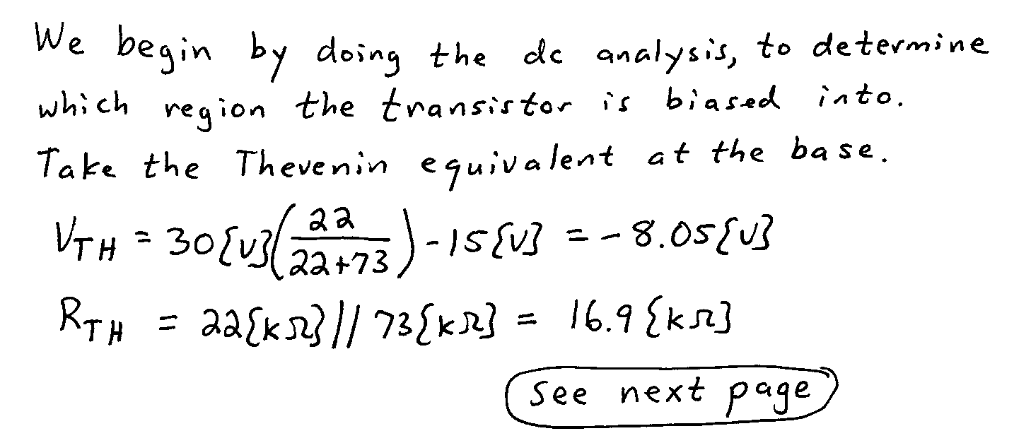
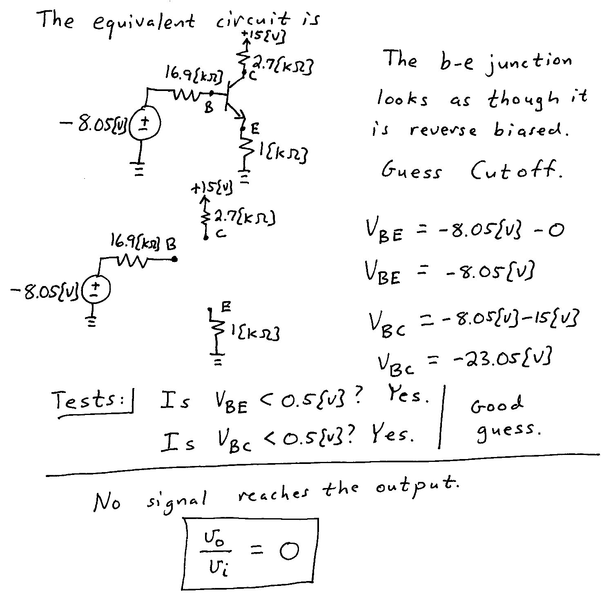
Use the circuit shown to solve this problem. Assume that for the transistor,
β = 40, and that it is operating at room temperature. Assume that the transistor is biased into the linear region, with r_{π} = 230[Ω]. For this voltage amplifier, find the input resistance seen by the v_{i} source, in the passband.
The capacitor C₁, will be a short-circuit in the passband, because if it were an open-circuit, the signal would not reach the transistor, and the output would be zero.
The capacitor C₂, will be a short-circuit in the passband, because if it were an open-circuit, the gain would be smaller, since more signal would be fed back to the input.
The capacitor C₃, will be a short-circuit in the passband, because if it were an open-circuit, the signal would not reach the load resistor R_{L}, and the output would be zero.
The capacitor C₄, will be an open-circuit in the passband, because if it were a short-circuit, the output would be shorted, and the output voltage would be zero.
