Name: _____________________________ (please print)
Signature: __________________________

ECE 3355 – Exam 1
Shattuck Section
February 22, 2020

Keep this exam closed until you are told to begin.

1. This exam is closed book, closed notes. You may use one 8.5” x 11” crib sheet, or its equivalent.
2. Show all work on these pages. Show all work necessary to complete the problem. A solution without the appropriate work shown will receive no credit. A solution that is not given in a reasonable order will lose credit. Clearly indicate your answer (for example by enclosing it in a box). If your answer is a plot, no box is needed.
3. It is assumed that your work will begin on the same page as the problem statement. If you choose to begin your work on another page, you must indicate this on the page with the problem statement, with a clear indication of where the work can be found. If your work continues on to another page, indicate clearly where your work can be found. Failure to indicate this clearly will result in a loss of credit.
4. Show all units in solutions, intermediate results, and figures. Units in the exam will be included between square brackets.
5. Do not use red ink. Do not use red pencil.
6. You will have 90 minutes to work on this exam.

1. ________________/40
2. ________________/20
3. ________________/40
Total = 100
Room for extra work

1. {40 Points} The amplifier in Figure 2 is connected to the circuit as shown in Figure 1. The exact connection locations are given by the letters on the terminals. The voltage source v_{s}(t) is an audio device with amplitudes less than 2[V] peak-to-peak and a frequency range from 15[Hz] to 25[kHz].
a) Find the input resistance seen by the Source, with the Source defined as in the label in Figure 1.
b) Find the output resistance seen by the Load.
c) Find the voltage gain, v_{out}/v_{in}, in [dB].

Room for extra work

2. {20 Points} An oscilloscope input of a new model oscilloscope can be modeled as a 10[MΩ] resistance in series with a 250[pF] capacitor.
a) Design a seven-times probe that could be used with this oscilloscope to produce a waveform on the oscilloscope screen with the same shape as the input. Draw your probe circuit, showing numerical values for all components.
b) What would be the advantages and disadvantages of using the seven-times probe that you have designed. Give your answer in complete sentences.
c) Find the impedance of your seven-times probe at 120[Hz].

Room for extra work

3. {40 Points} Use the transfer function H(ω) given below for this problem,
- Assuming that every other number in this transfer function has the correct units, determine the correct units for the number 750. These units are given as [X] in the transfer function to show that these units are not yet known. If you think the number 750 is dimensionless, state that.
- Find all of the poles and zeroes for this transfer function. If you have more than one pole or zero at a given angular frequency, state how many you have. Convert these angular frequencies to frequency, in [Hz].
- Plot the straight-line approximation to the phase Bode plot. Use the semilog graph paper given on the following pages. Extra graph paper is provided in case you need it. Plot as a function of angular frequency ω. Use the frequency range from ω = 100[μrad/s] to ω = 100[rad/s].
- Use your plot to estimate ∠H(100[rad/s]). Compare this value to the actual phase at this angular frequency.

1. {40 Points} The amplifier in Figure 2 is connected to the circuit as shown in Figure 1. The exact connection locations are given by the letters on the terminals. The voltage source v_{s}(t) is an audio device with amplitudes less than 2[V] peak-to-peak and a frequency range from 15[Hz] to 25[kHz].
a) Find the input resistance seen by the Source, with the Source defined as in the label in Figure 1.
b) Find the output resistance seen by the Load.
c) Find the voltage gain, v_{out}/v_{in}, in [dB].
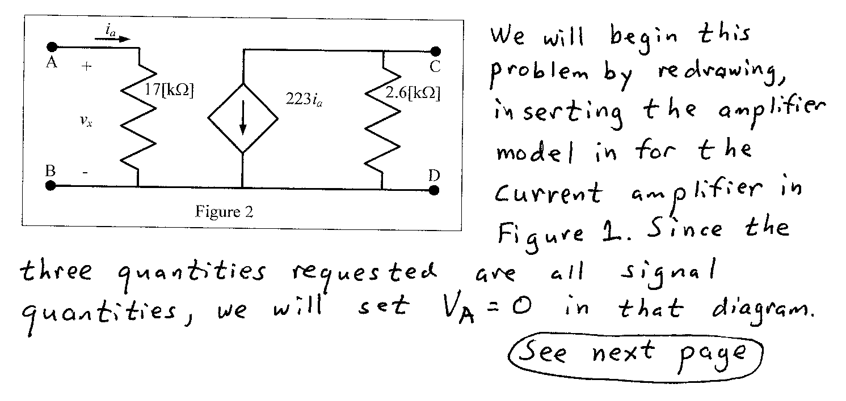
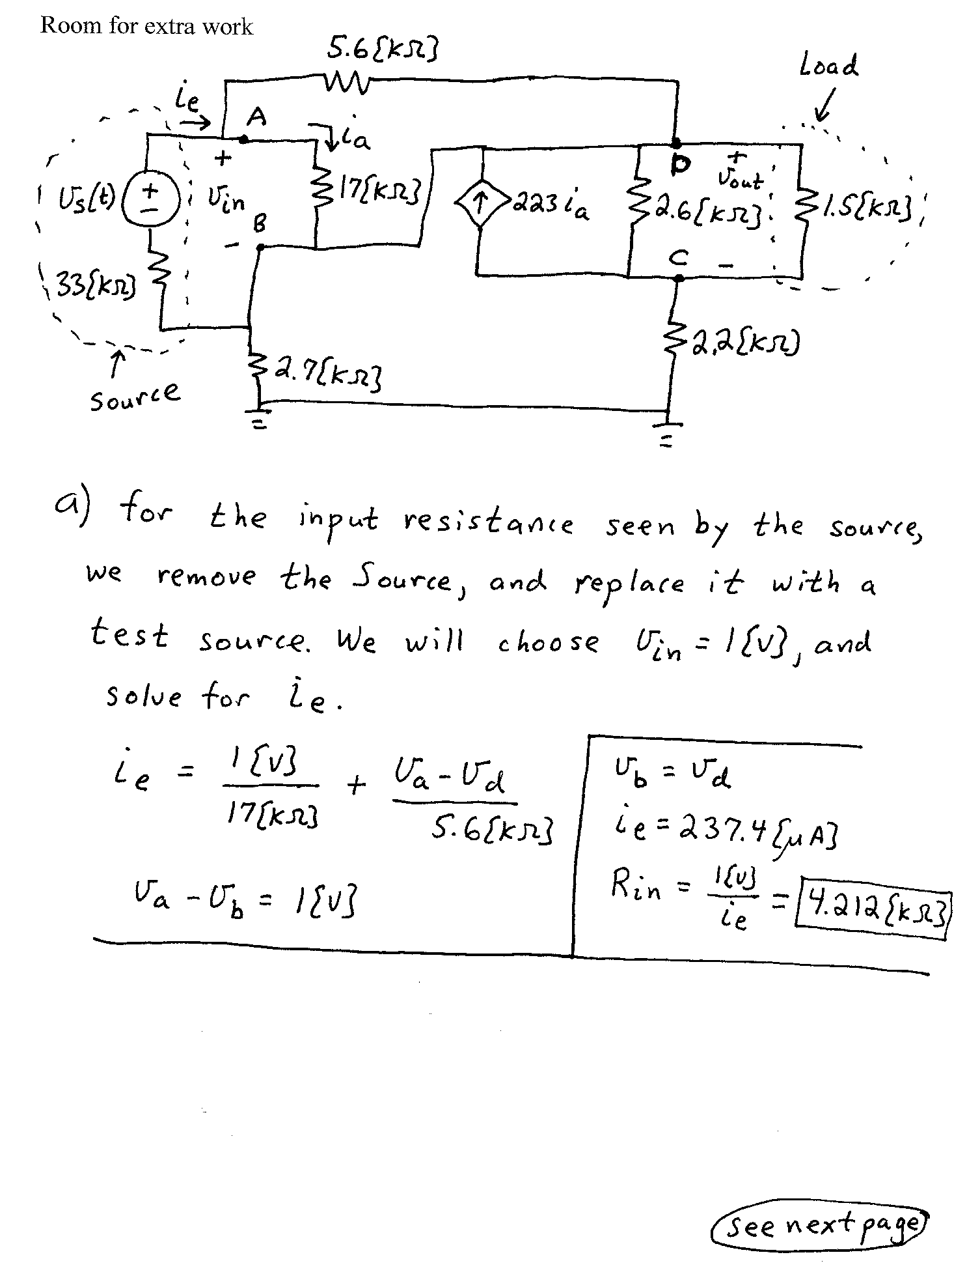
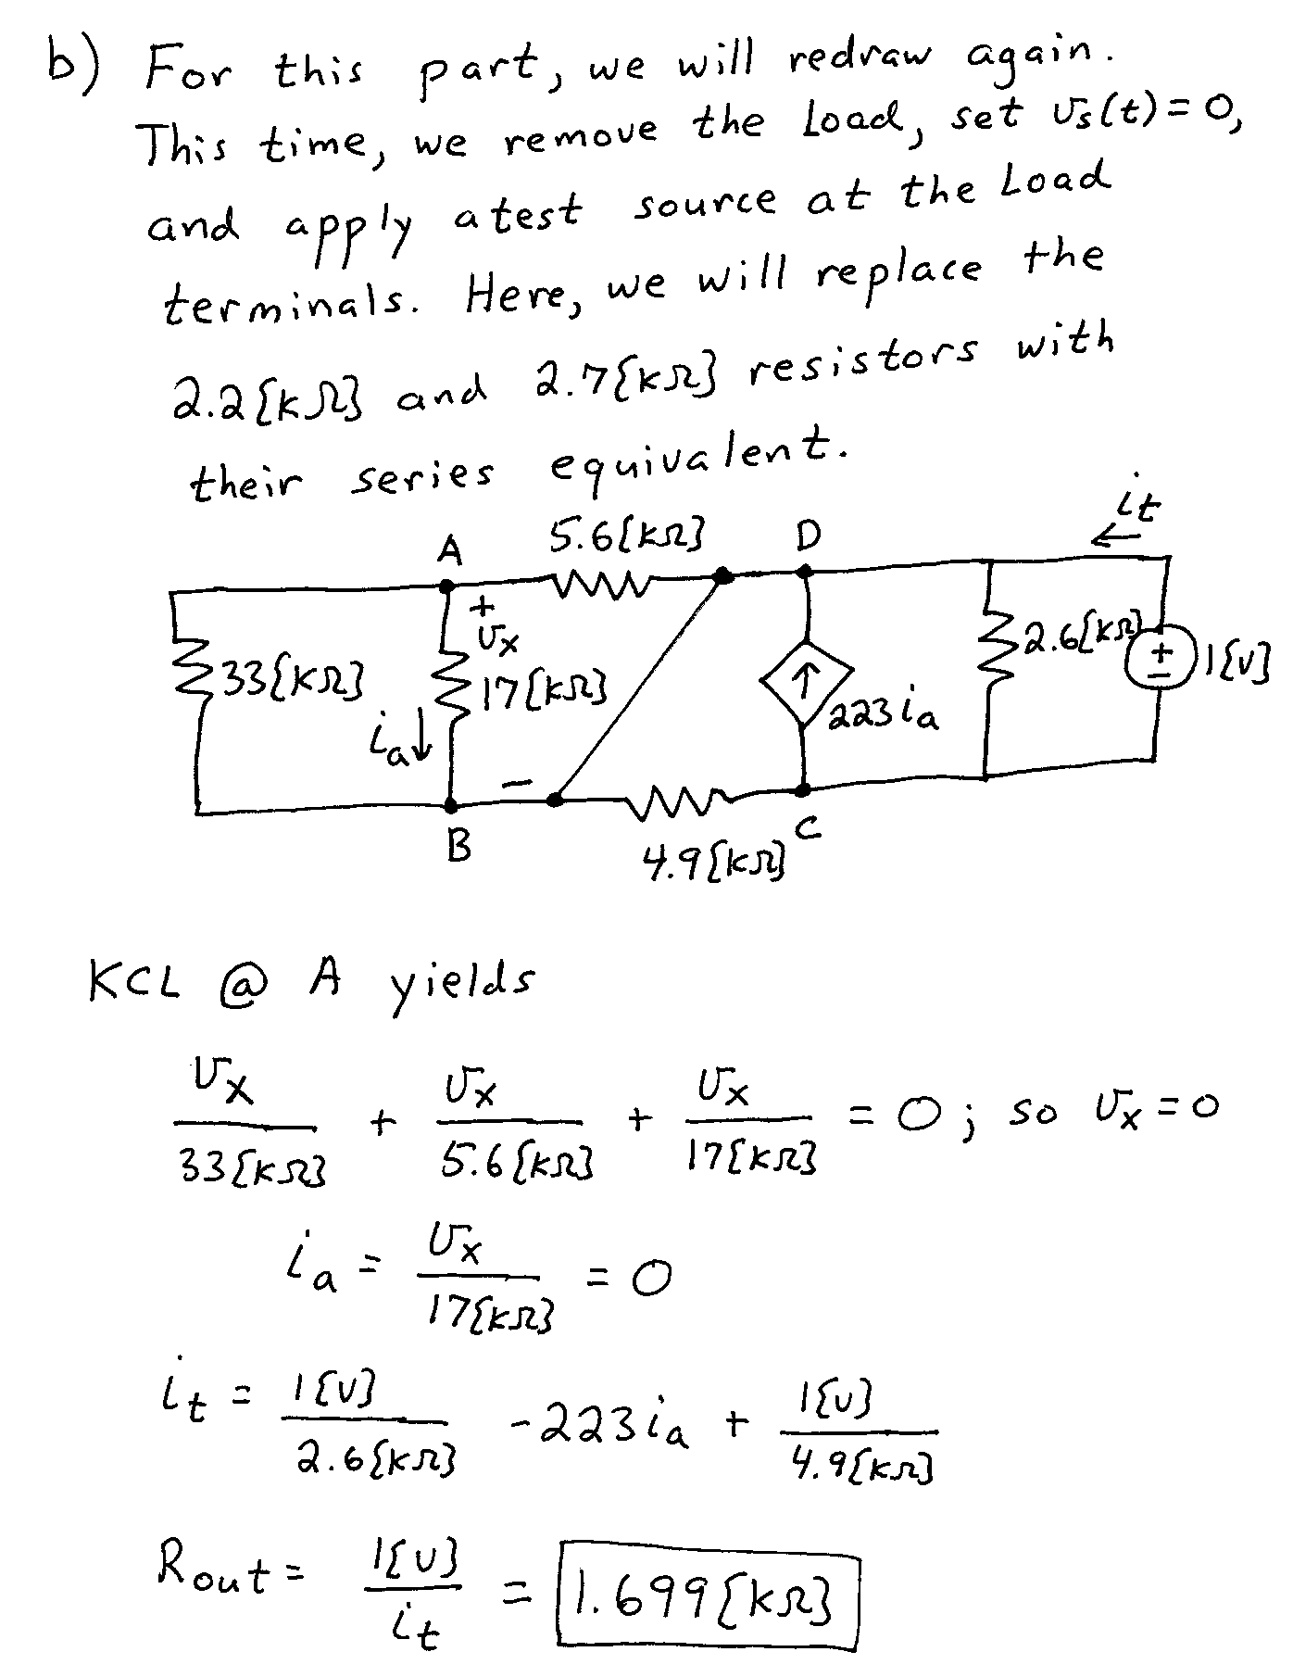
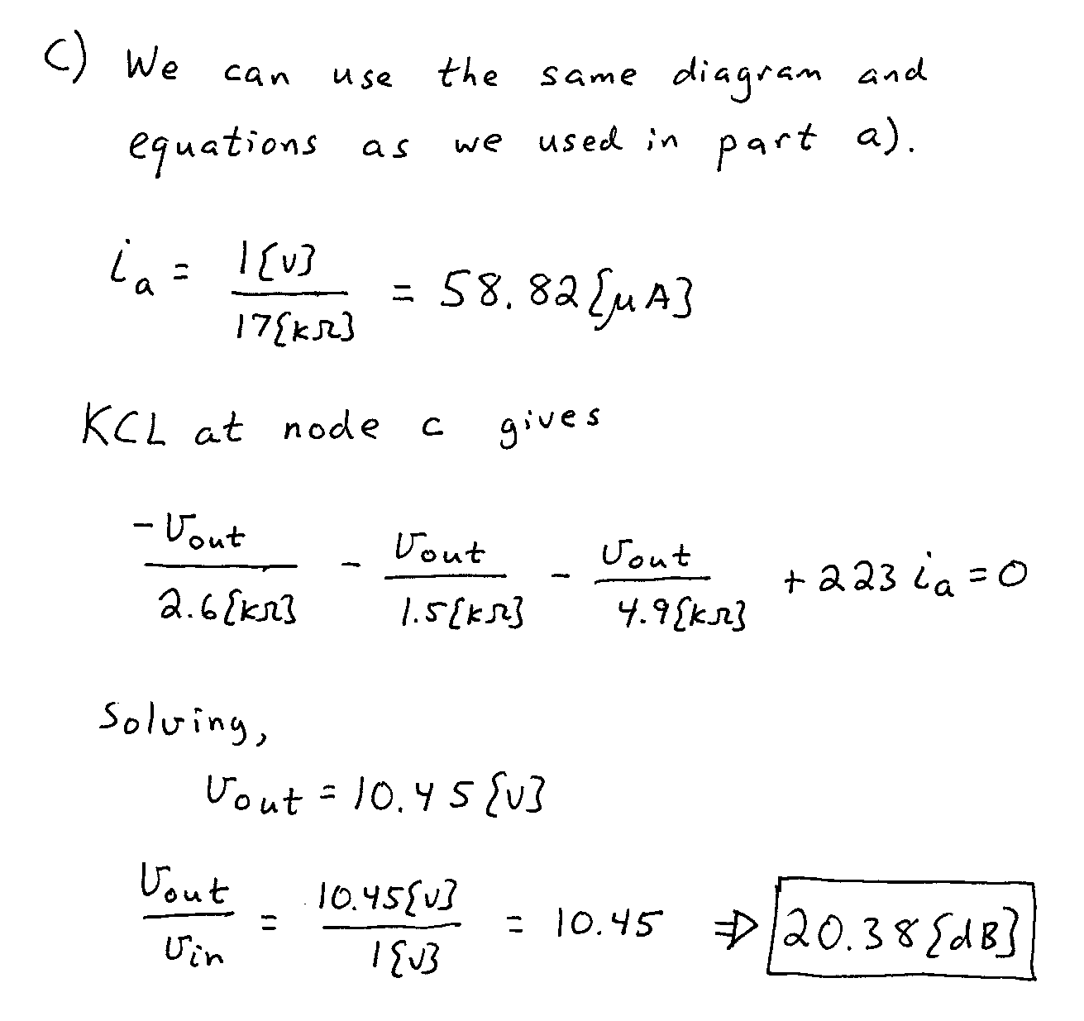

2. {20 Points} An oscilloscope input of a new model oscilloscope can be modeled as a 10[MΩ] resistance in series with a 250[pF] capacitor.
a) Design a seven-times probe that could be used with this oscilloscope to produce a waveform on the oscilloscope screen with the same shape as the input. Draw your probe circuit, showing numerical values for all components.
b) What would be the advantages and disadvantages of using the seven-times probe that you have designed. Give your answer in complete sentences.
c) Find the impedance of your seven-times probe at 120[Hz].
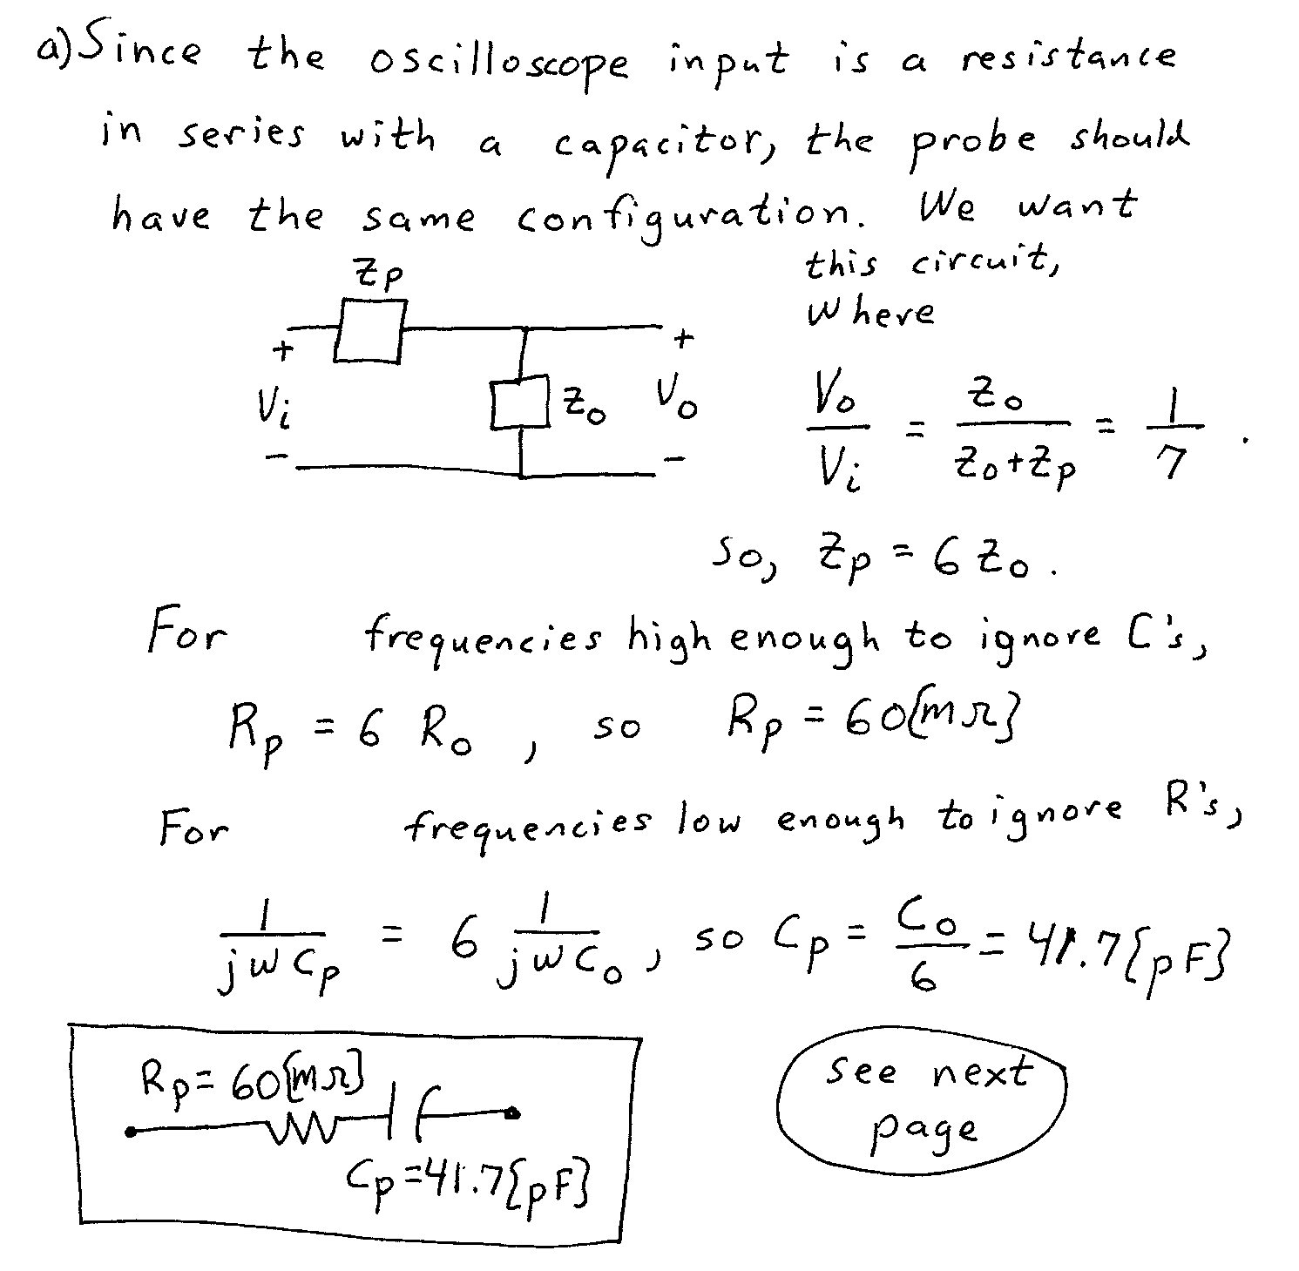
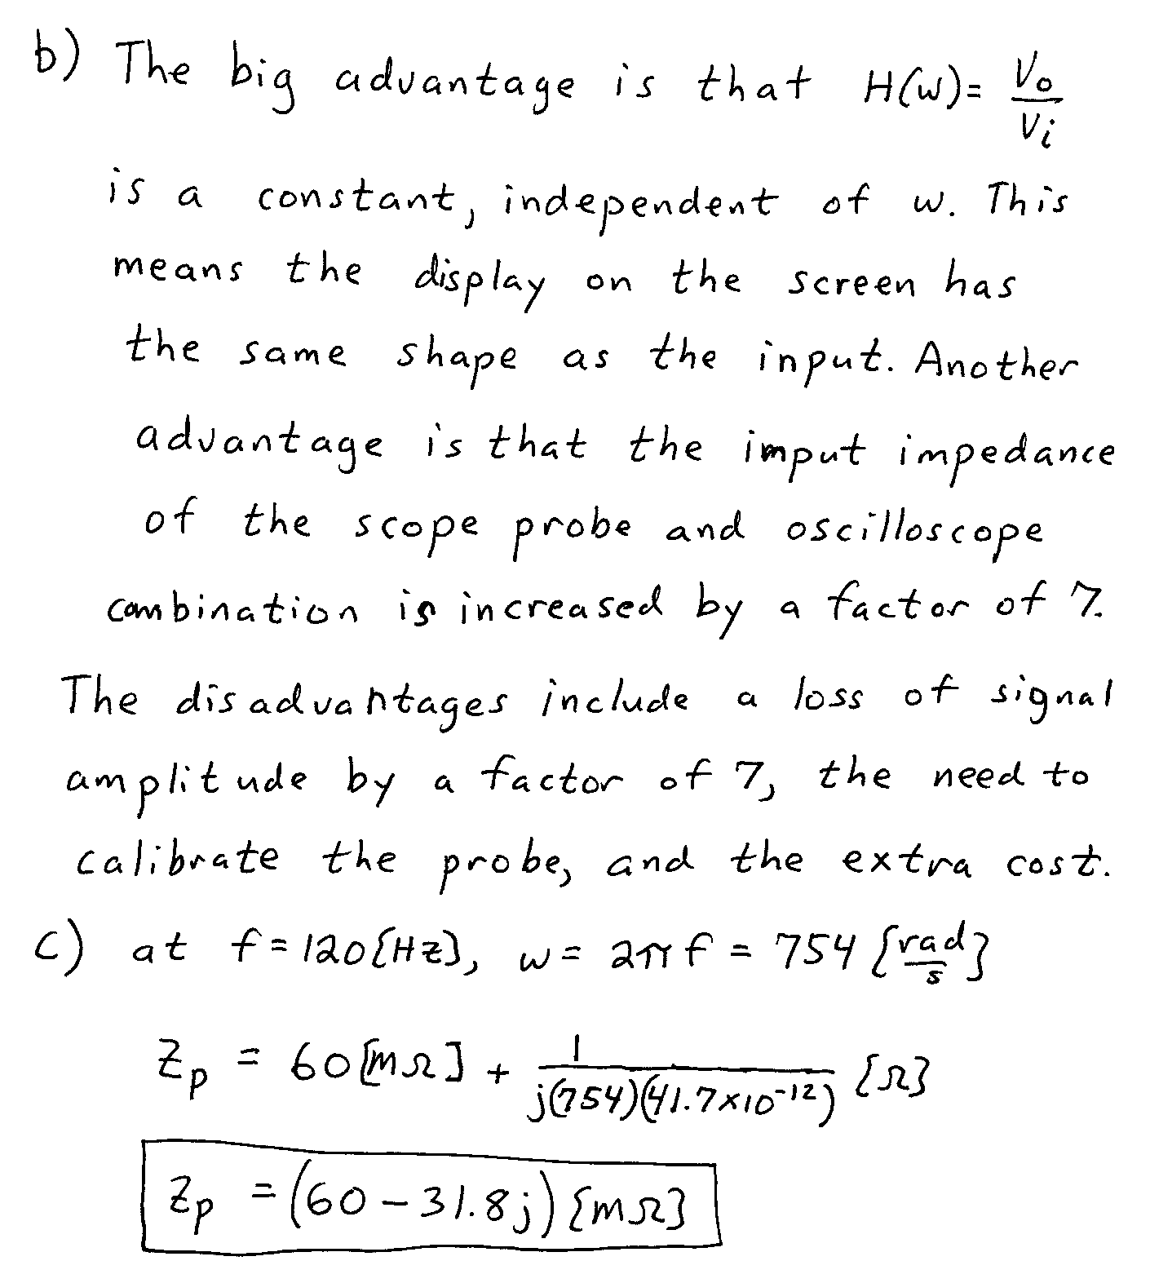

3. {40 Points} Use the transfer function H(ω) given below for this problem,
- Assuming that every other number in this transfer function has the correct units, determine the correct units for the number 750. These units are given as [X] in the transfer function to show that these units are not yet known. If you think the number 750 is dimensionless, state that.
- Find all of the poles and zeroes for this transfer function. If you have more than one pole or zero at a given angular frequency, state how many you have. Convert these angular frequencies to frequency, in [Hz].
- Plot the straight-line approximation to the phase Bode plot. Use the semilog graph paper given on the following pages. Extra graph paper is provided in case you need it. Plot as a function of angular frequency ω. Use the frequency range from ω = 100[μrad/s] to ω = 100[rad/s].
- Use your plot to estimate ∠H(100[rad/s]). Compare this value to the actual phase at this angular frequency.
