Name: _____________________________ (please print)
Signature: __________________________

ECE 3455 -- Exam #1
June 21, 2000

1. This quiz is open book, open notes.
2. Show all work on these pages. Show all work necessary to complete the problem. If you go on to another page, indicate clearly where your work can be found. A solution without the work shown will receive no credit.
3. Show all units in expressions and figures. Units in the quiz will be included between square brackets.
4. Do not use red ink.
5. You will have 90 minutes to work on this quiz.

1. ________________/30

2. ________________/40

3. ________________/30

Room for extra work
1) (30 Points) The model for an amplifier is given in Figure 1. Two of these amplifiers are connected as in Figure 2. Find the transresistance gain, v_{o}/i_{s}.
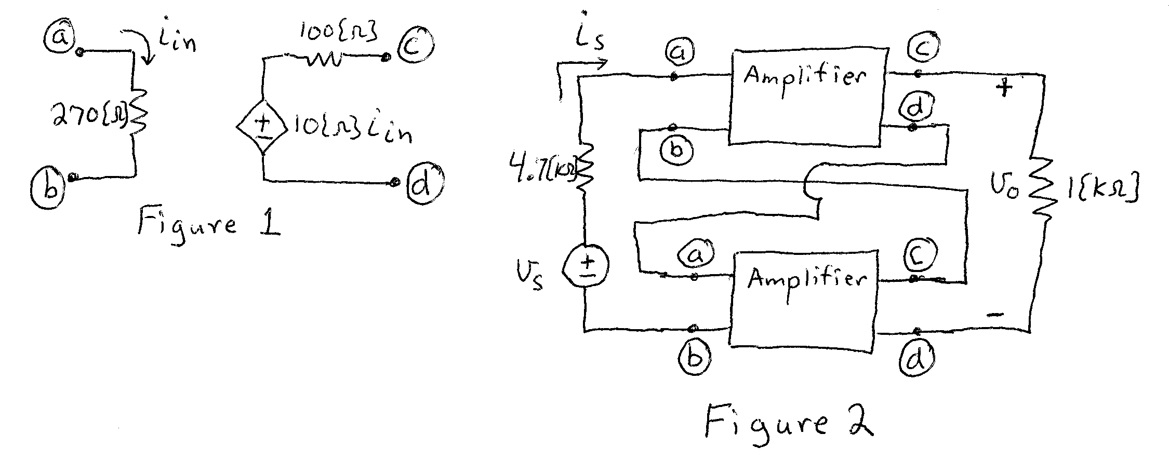
Room for extra work
2) (40 Points) (A transfer function, H(f), has 3 poles at 1[kHz], 2 zeroes at 8[kHz], and 1 pole at 200[kHz]. There are no other poles or zeroes. It is known that
H(8[Hz]) = 25j.
a) Draw the straight-line approximations to the magnitude and phase Bode plots on the axes on the pages that follow.
b) Estimate the value of the transfer function at 1[MHz].
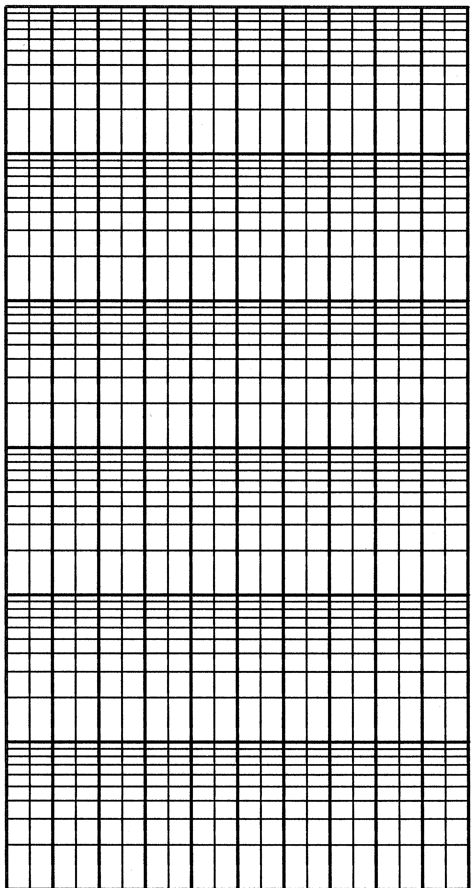
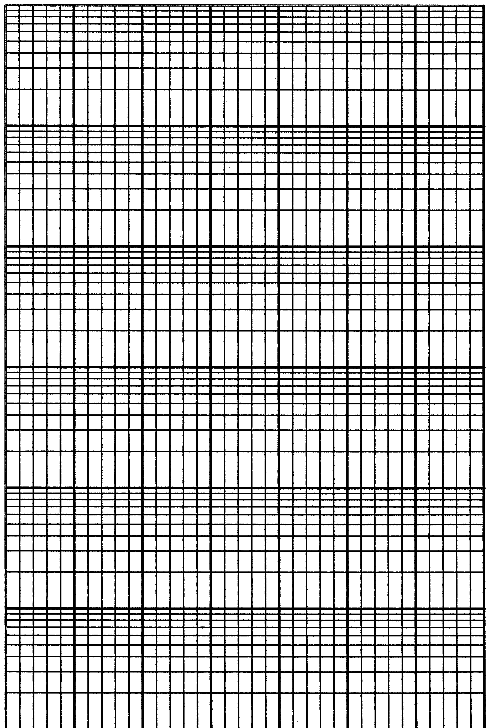
3) (30 Points) In the circuit below, assume that there is negative feedback. Find the input resistance seen by the source, v_{s}.
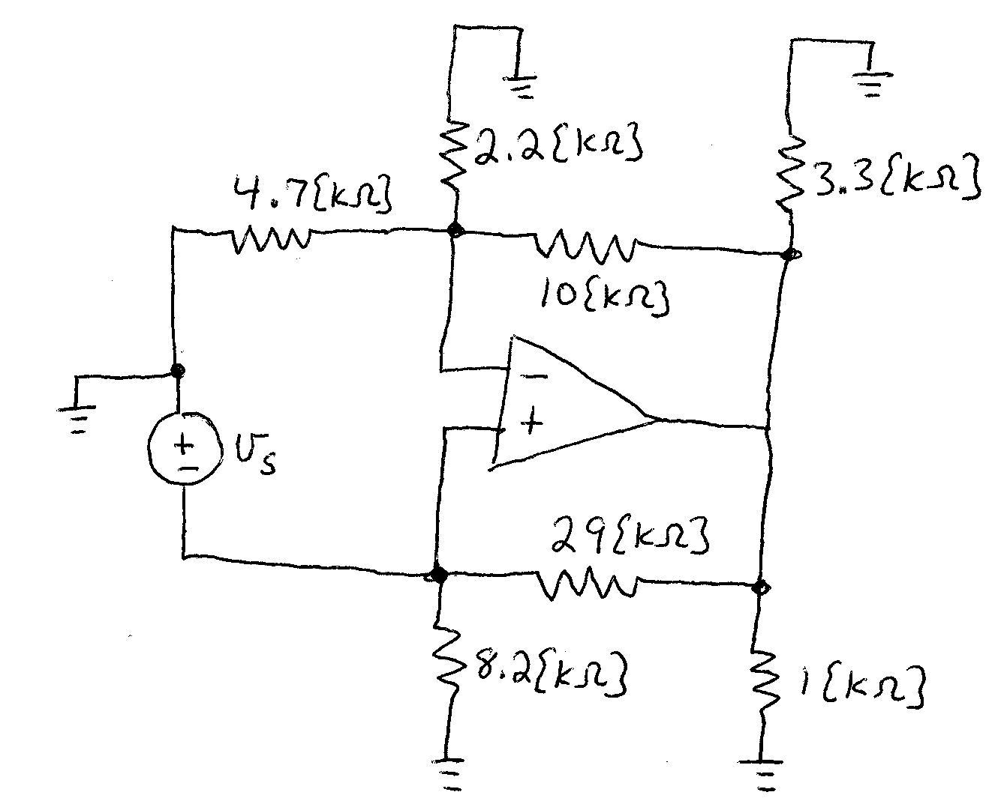
Room for Extra Work
1) (30 Points) The model for an amplifier is given in Figure 1. Two of these amplifiers are connected as in Figure 2. Find the transresistance gain, v_{o}/i_{s}.
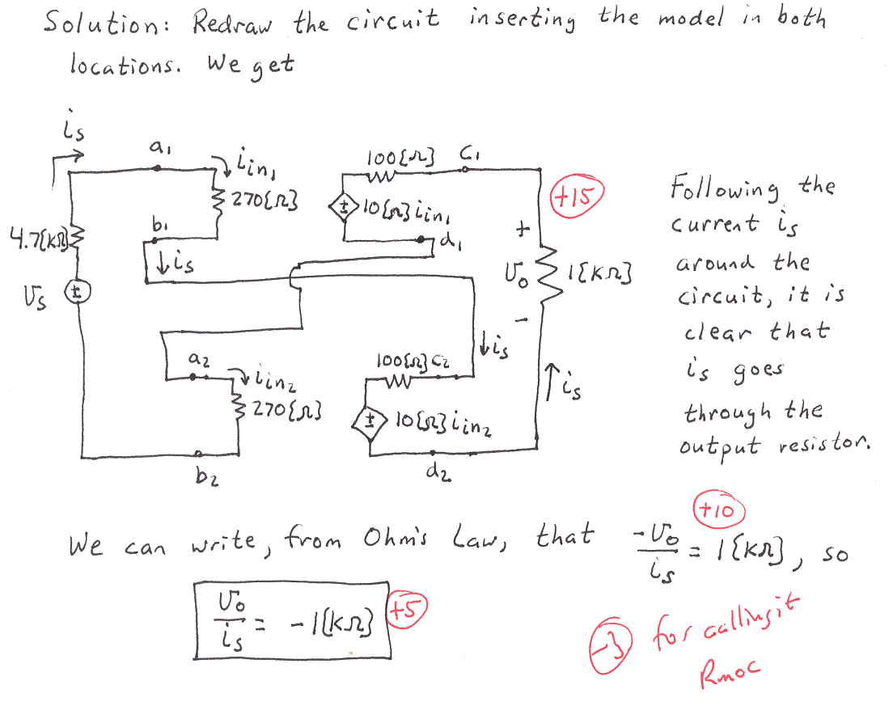
2) (40 Points) (A transfer function, H(f), has 3 poles at 1[kHz], 2 zeroes at 8[kHz], and 1 pole at 200[kHz]. There are no other poles or zeroes. It is known that
H(8[Hz]) = 25j.
a) Draw the straight-line approximations to the magnitude and phase Bode plots on the axes on the pages that follow.
b) Estimate the value of the transfer function at 1[MHz].

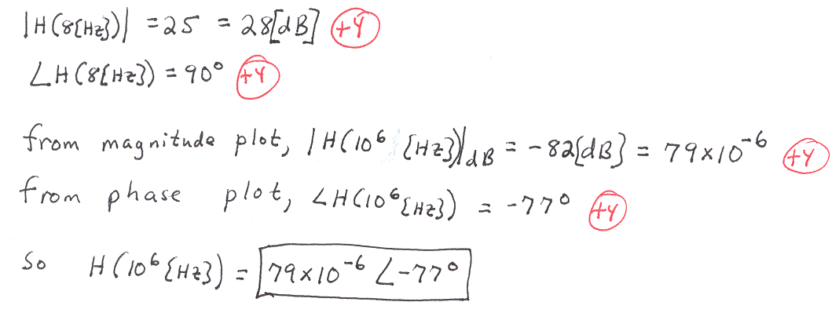
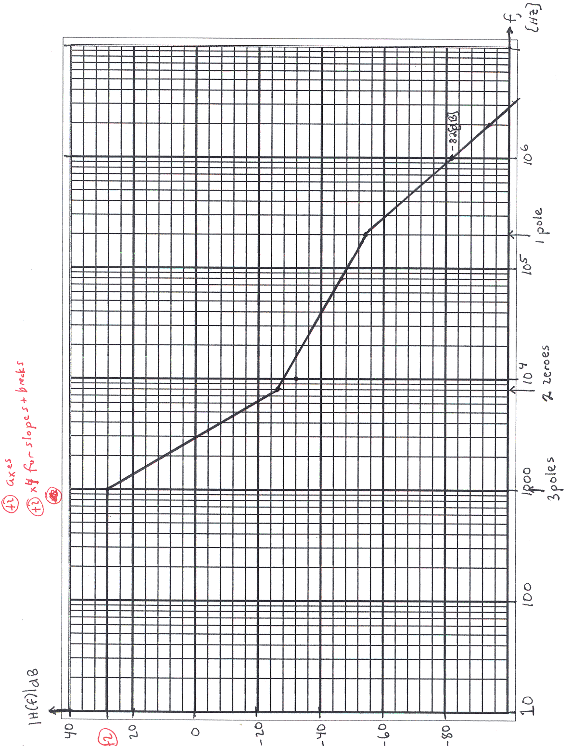
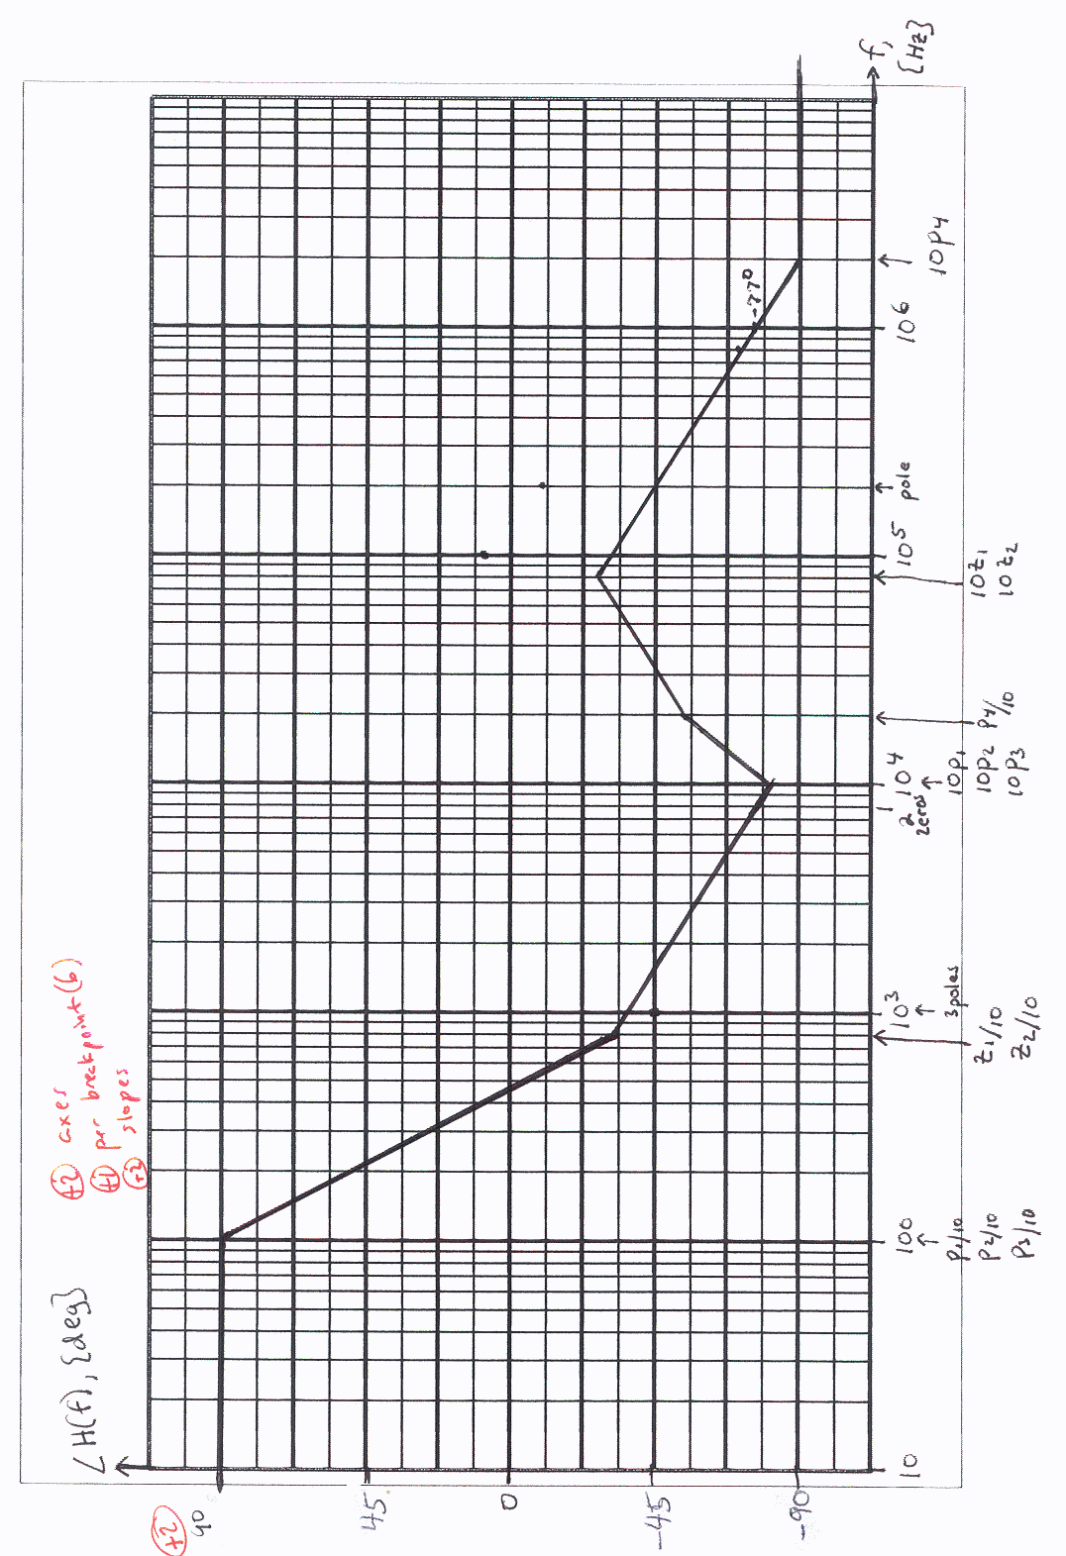
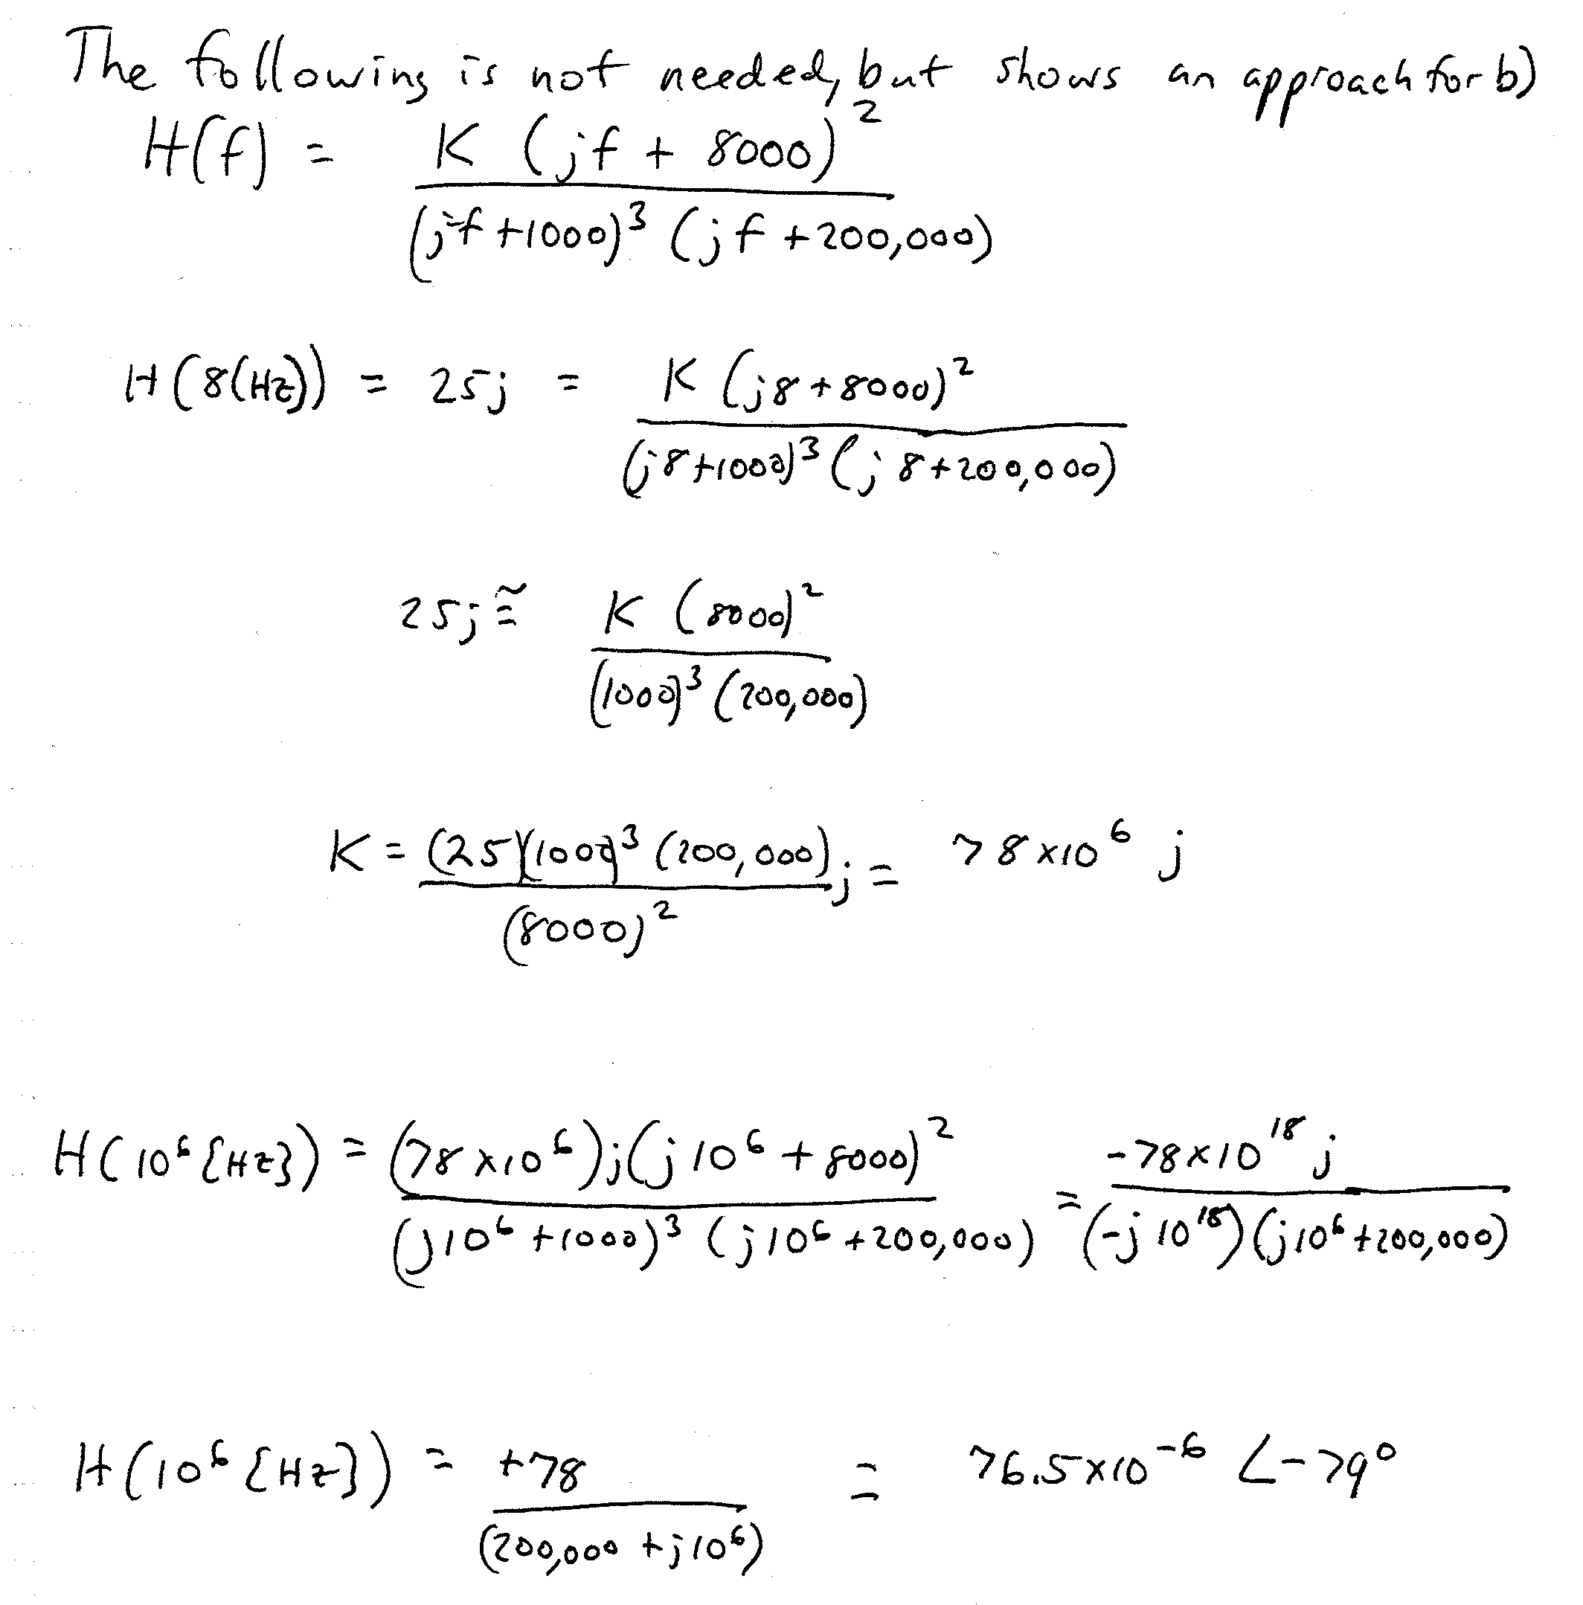
3) (30 Points) In the circuit below, assume that there is negative feedback. Find the input resistance seen by the source, v_{s}.



