Name: _____________________________ (please print)
Signature: __________________________

ECE 3455 -- Exam #1
July 6, 2006
Keep this exam closed until you are told to begin.

1. This exam is closed book, closed notes. You may use one 8.5” x 11” crib sheet, or its equivalent.
2. Show all work on these pages. Show all work necessary to complete the problem. A solution without the appropriate work shown will receive no credit. A solution that is not given in a reasonable order will lose credit. Clearly indicate your answer (for example by enclosing it in a box).
3. It is assumed that your work will begin on the same page as the problem statement. If you choose to begin your work on another page, you must indicate this on the page with the problem statement, with a clear indication of where the work can be found. If your work continues on to another page, indicate clearly where your work can be found. Failure to indicate this clearly will result in a loss of credit.
4. Show all units in solutions, intermediate results, figures, and plots. Units in the exam will be included between square brackets.
5. Do not use red ink. Do not use red pencil.
6. You will have 100 minutes to work on this exam.

1. ________________/30
2. ________________/40
3. ________________/30
Total = 100
Room for extra work

1. {30 Points} Two identical transconductance amplifiers, with the equivalent circuit shown in Figure 1, are connected together in the circuit in Figure 2. Note that the terminal numbers shown in each figure indicate how each amplifier is connected.
- Find the transresistance, v_{l} /i_{s}, for the no load case (R_{L} = ∞).
- Find the voltage gain, v_{l} /v_{i}, in dB, for the no load case (R_{L} = ∞).
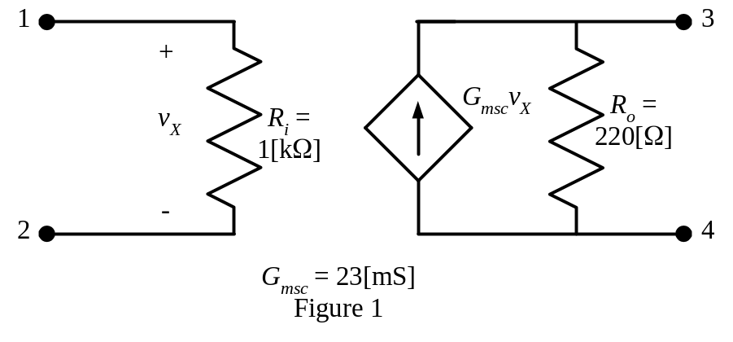
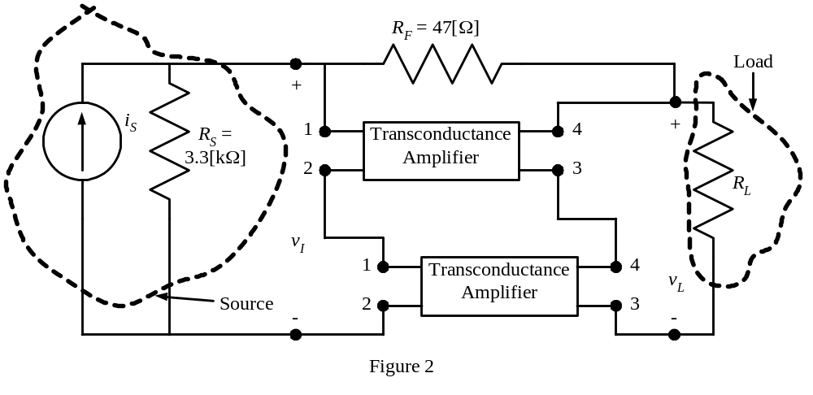

Room for extra work
2. {40 Points} The transfer function, H(ω), for a circuit is given as
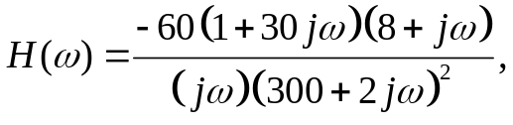
for ω in [rad/s]. Plot the straight-line approximations to the magnitude and the phase Bode plots for this transfer function, as a function of frequency, f, in [Hz]. Use the semilog graph paper on the next pages. Include in your frequency range all of the nonzero zeroes and poles.

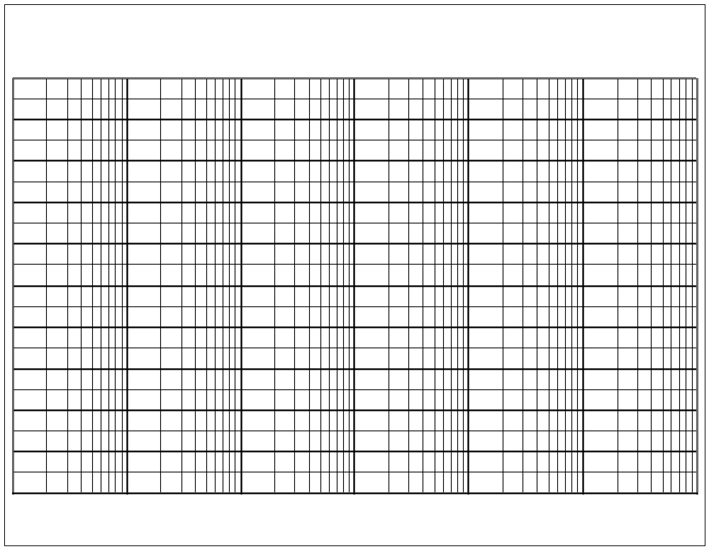
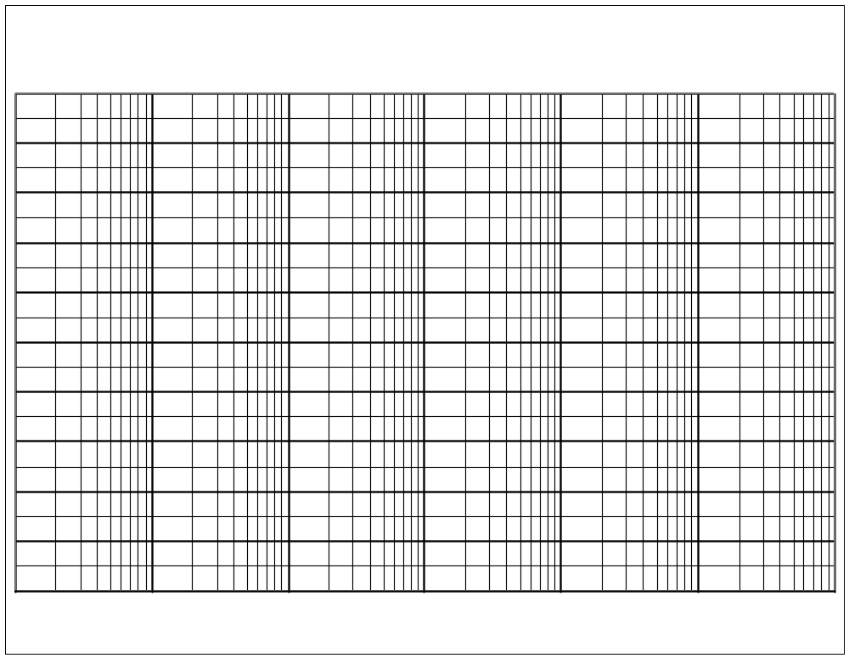
Room for extra work

3. {30 Points} Assume ideal op amps.
- Find v_{A}(t) as a function of v_{S}(t).
- Find v_{O}(t) as a function of v_{S}(t).
- Find v_{a}(t) as a function of v_{s}(t).
- Find v_{o}(t) as a function of v_{s}(t).

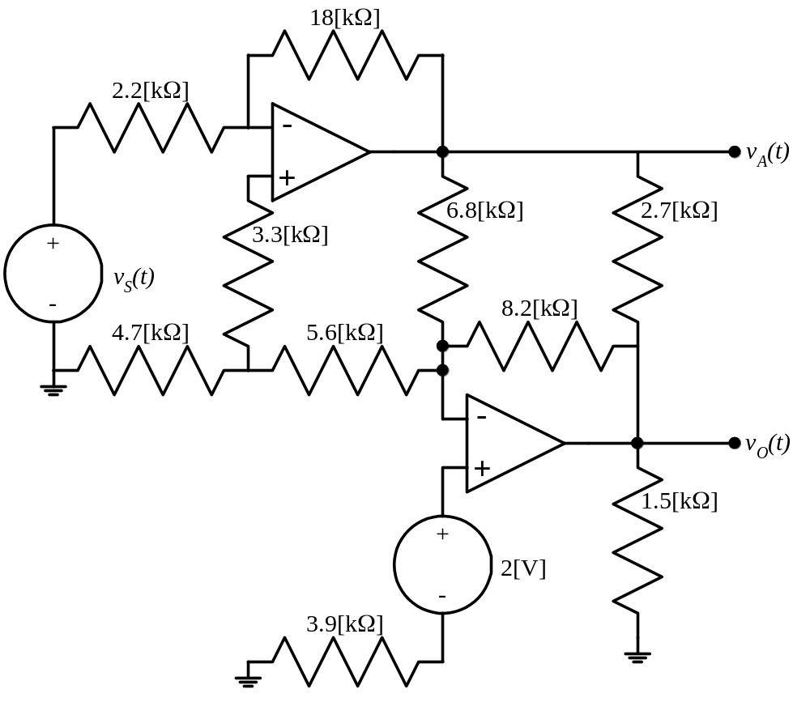

1. {30 Points} Two identical transconductance amplifiers, with the equivalent circuit shown in Figure 1, are connected together in the circuit in Figure 2. Note that the terminal numbers shown in each figure indicate how each amplifier is connected.
- Find the transresistance, v_{l} /i_{s}, for the no load case (R_{L} = ∞).
- Find the voltage gain, v_{l} /v_{i}, in dB, for the no load case (R_{L} = ∞).
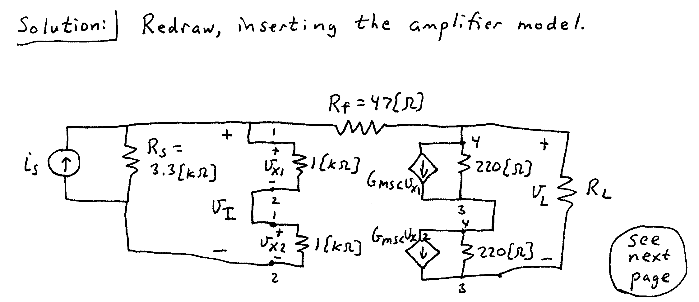
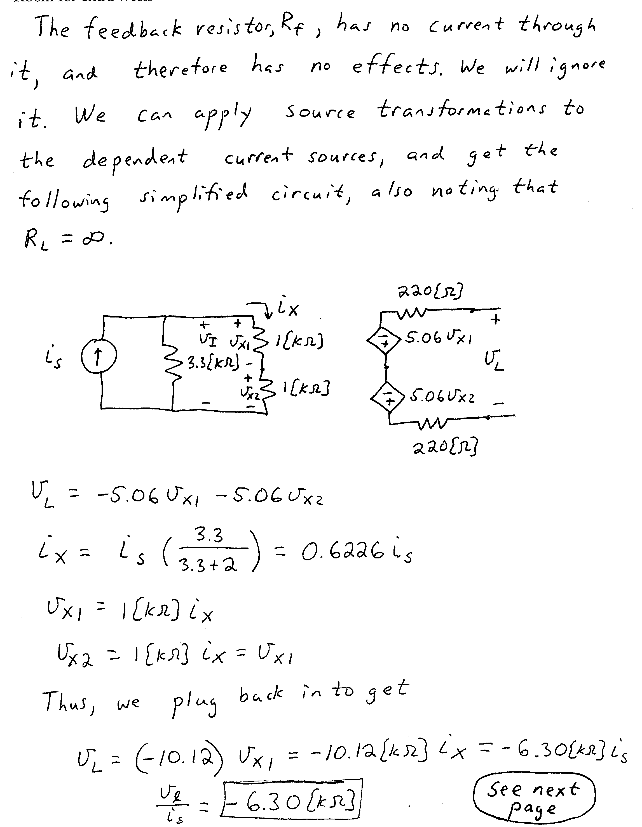
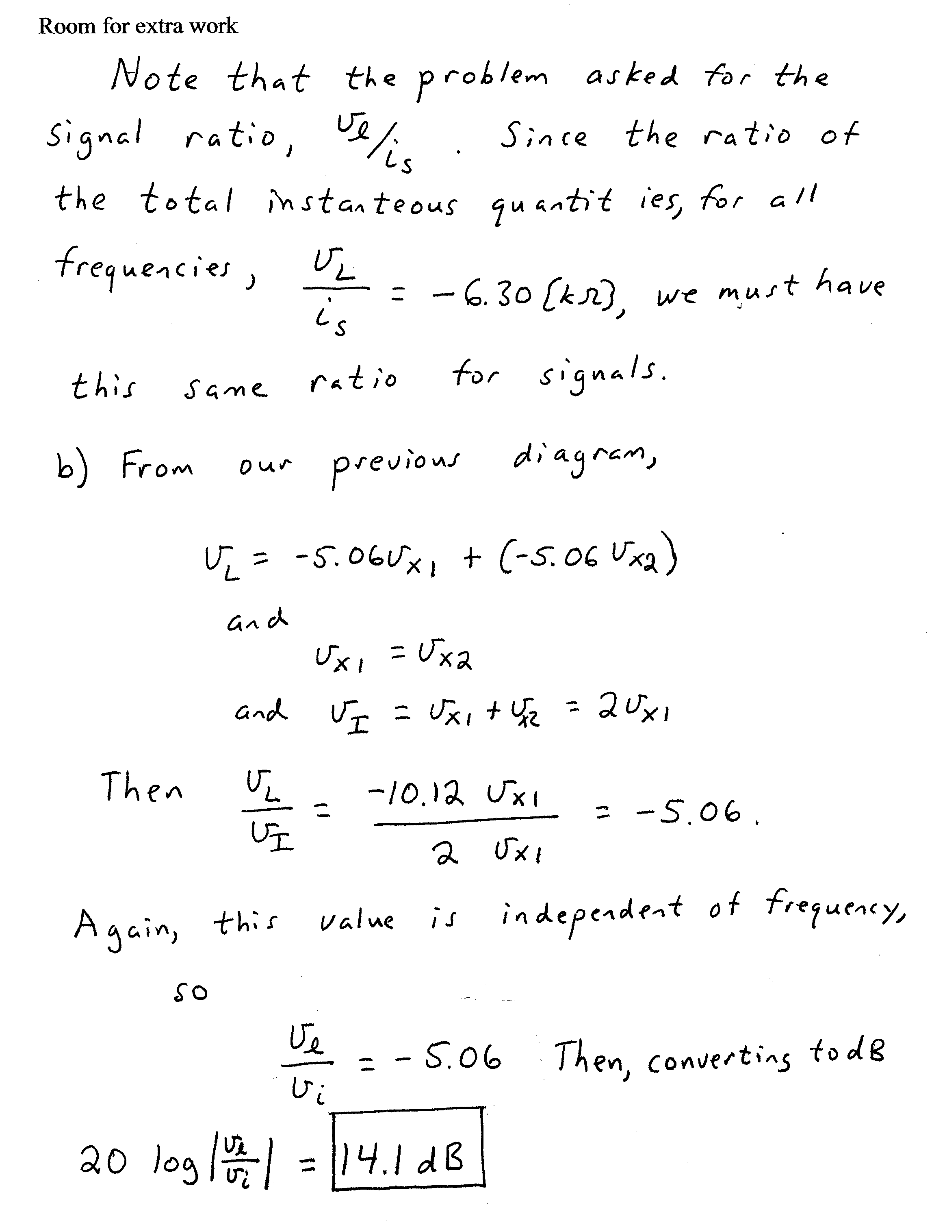

2. {40 Points} The transfer function, H(ω), for a circuit is given as
for ω in [rad/s]. Plot the straight-line approximations to the magnitude and the phase Bode plots for this transfer function, as a function of frequency, f, in [Hz]. Use the semilog graph paper on the next pages. Include in your frequency range all of the nonzero zeroes and poles.
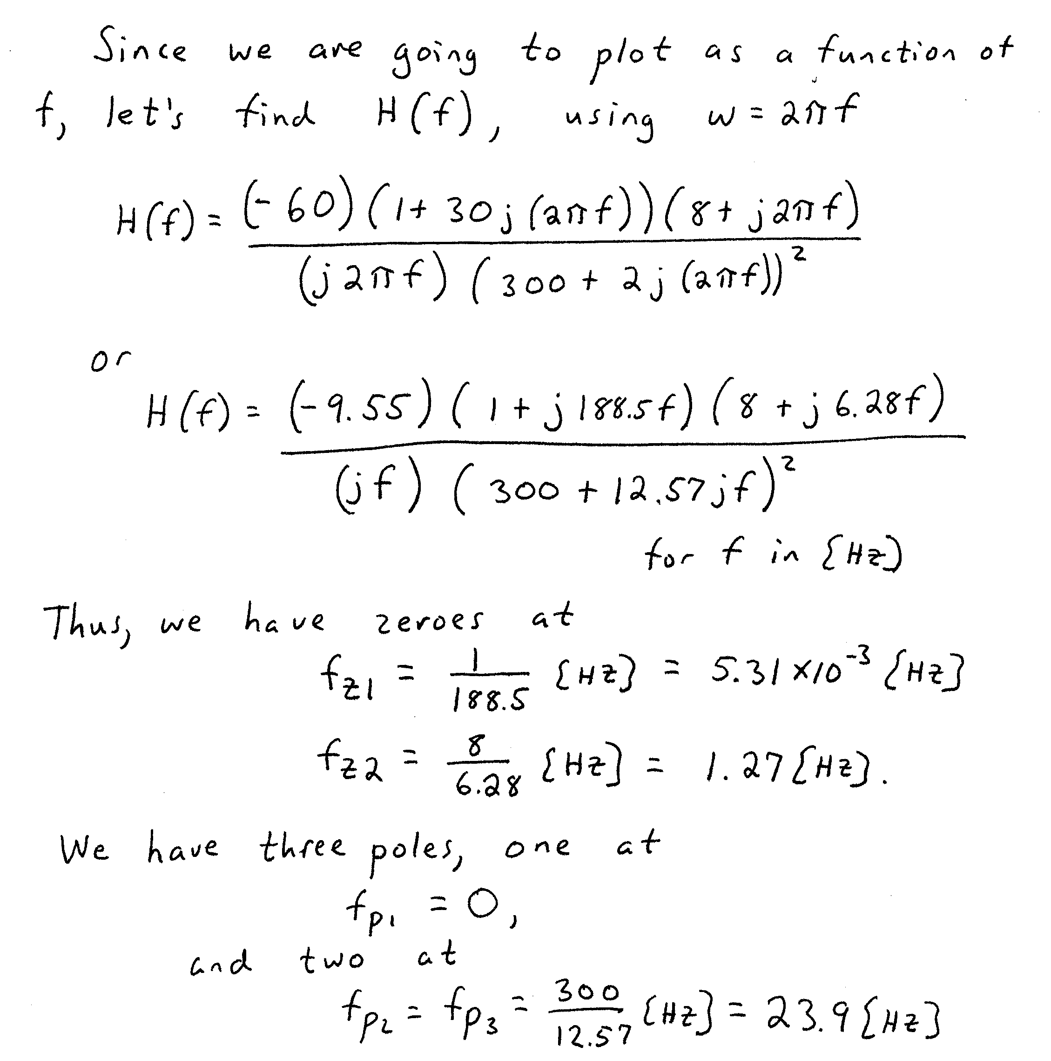
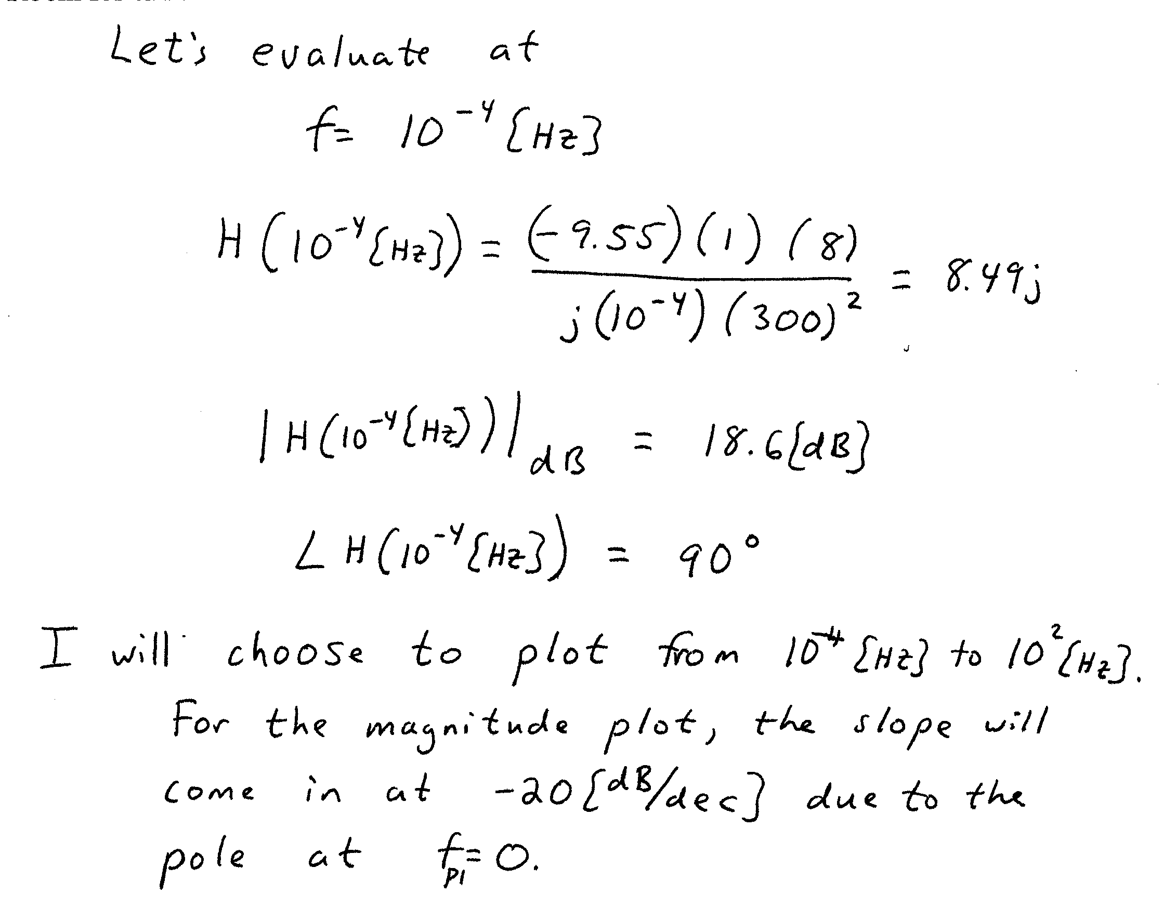
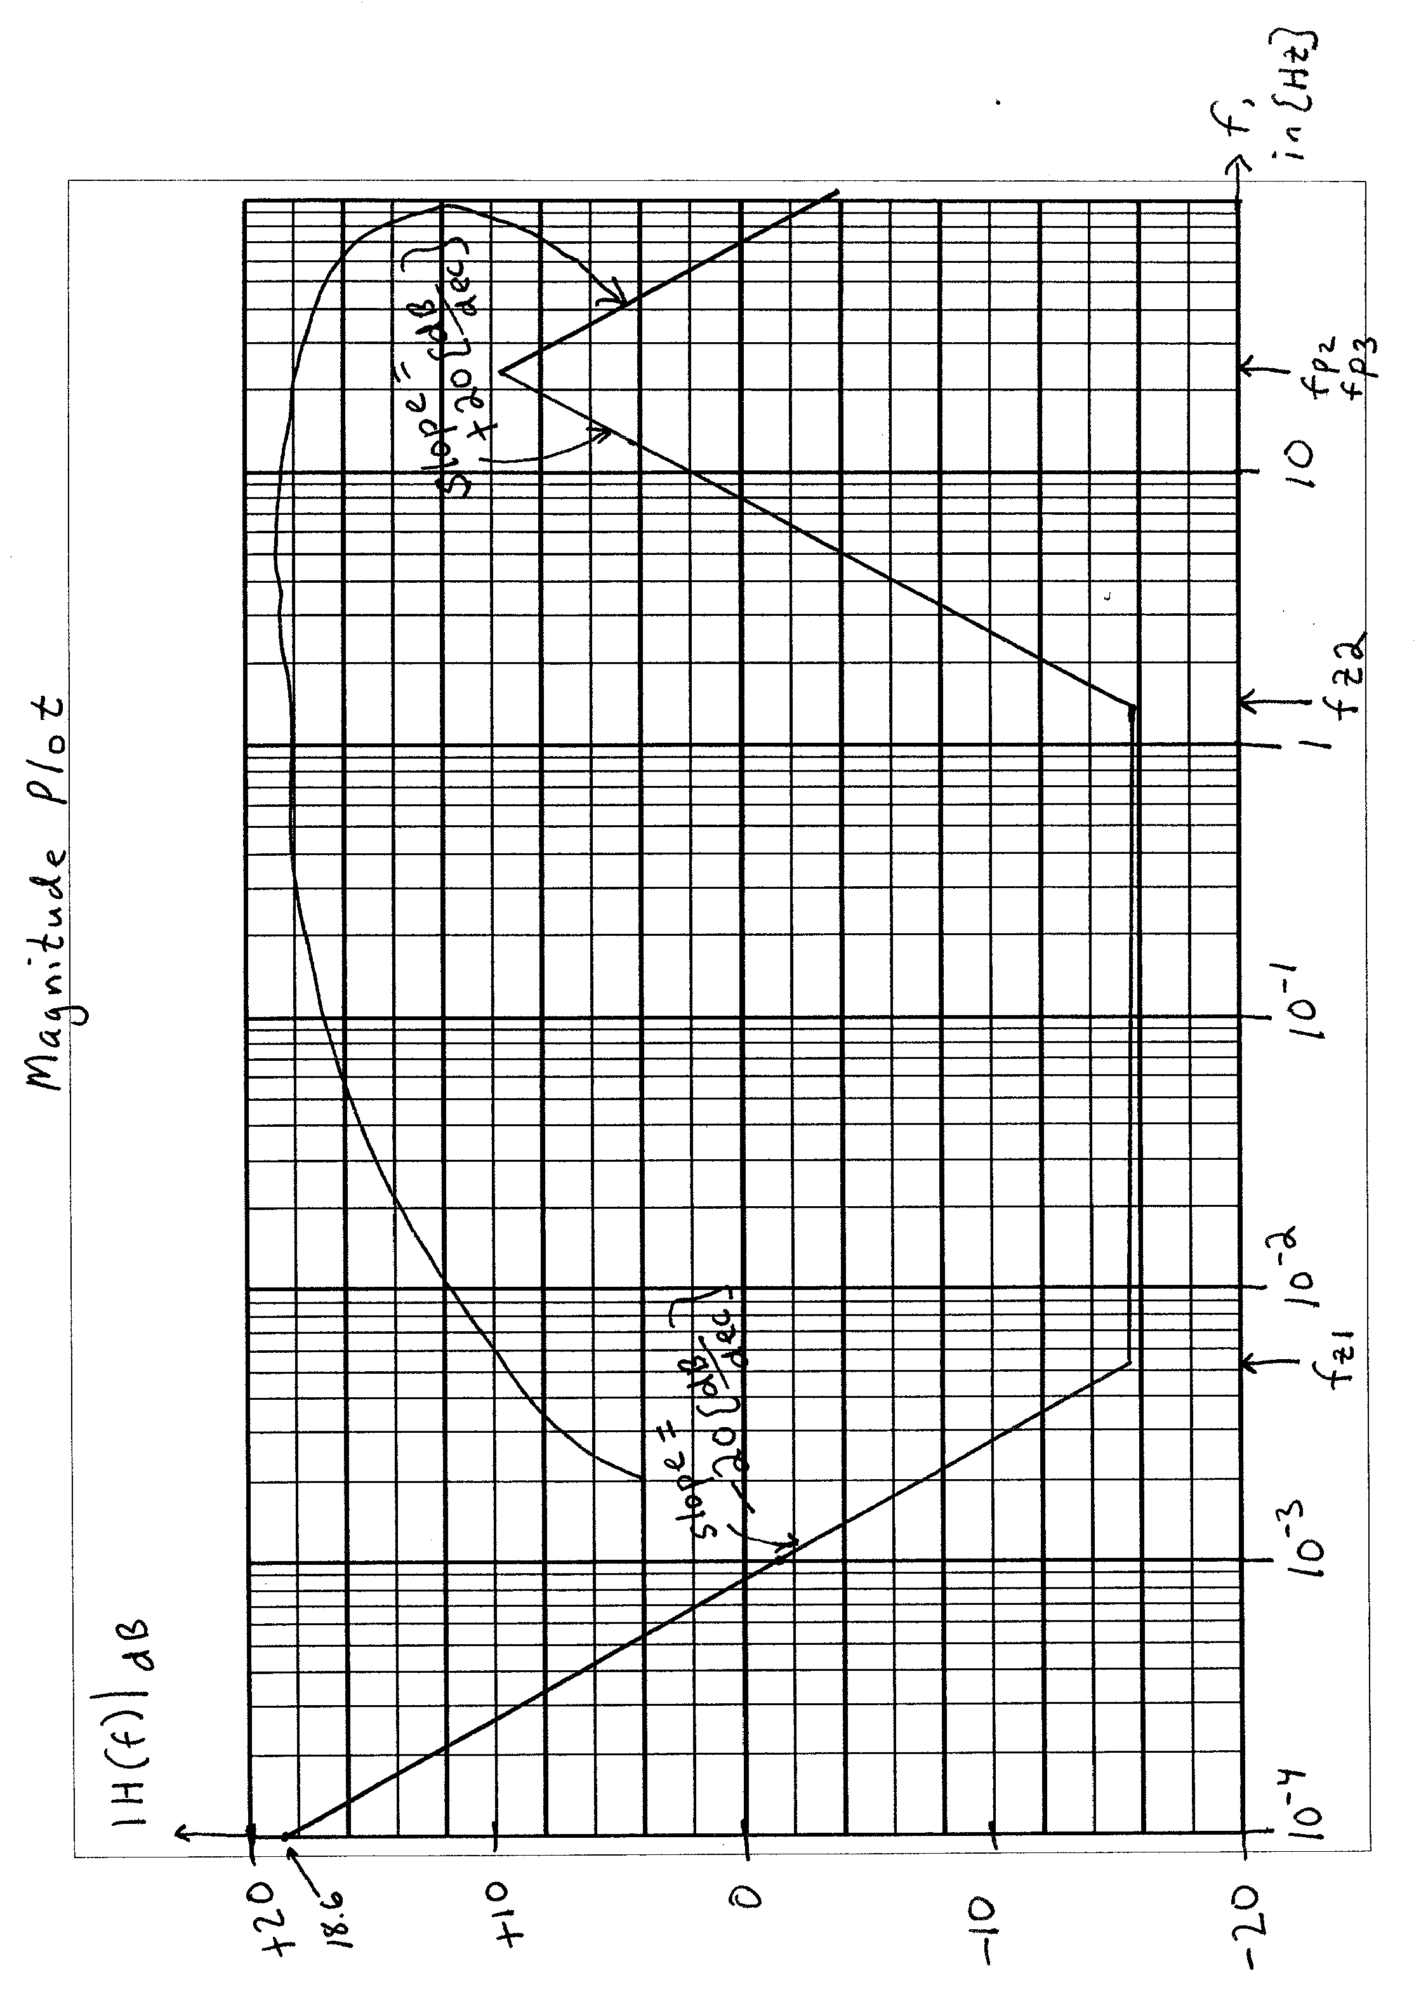
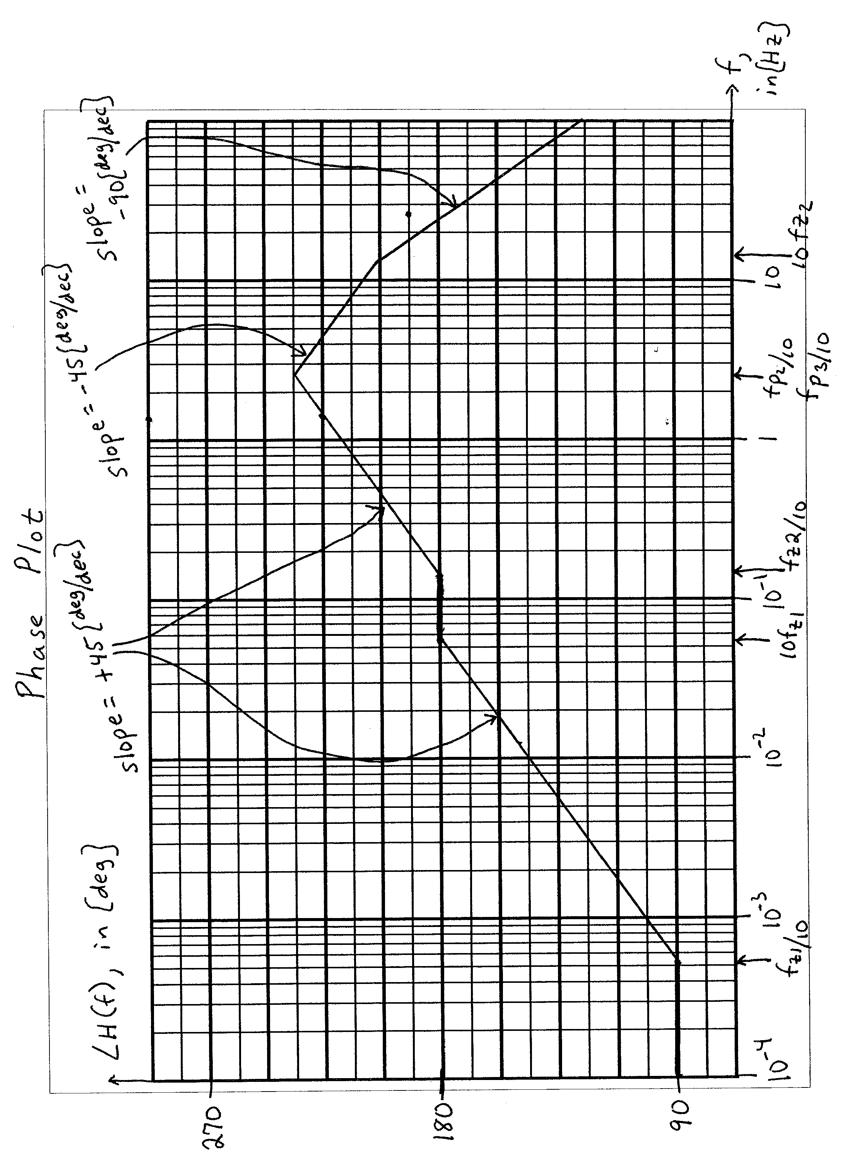
3. {30 Points} Assume ideal op amps.
- Find v_{A}(t) as a function of v_{S}(t).
- Find v_{O}(t) as a function of v_{S}(t).
- Find v_{a}(t) as a function of v_{s}(t).
- Find v_{o}(t) as a function of v_{s}(t).


