Name: _____________________________ (please print)
Signature: __________________________

ECE 3455 – Final Exam
August 10, 2006
Keep this exam closed until you are told to begin.

1. This exam is closed book, closed notes. You may use one 8.5” x 11” crib sheet, or its equivalent.
2. Show all work on these pages. Show all work necessary to complete the problem. A solution without the appropriate work shown will receive no credit. A solution that is not given in a reasonable order will lose credit. Clearly indicate your answer (for example by enclosing it in a box).
3. It is assumed that your work will begin on the same page as the problem statement. If you choose to begin your work on another page, you must indicate this on the page with the problem statement, with a clear indication of where the work can be found. If your work continues on to another page, indicate clearly where your work can be found. Failure to indicate this clearly will result in a loss of credit.
4. Show all units in solutions, intermediate results, and figures. Units in the exam will be included between square brackets.
5. Do not use red ink. Do not use red pencil.
6. You will have 170 minutes to work on this exam.

1. ________________/25
2. ________________/25
3. ________________/25
4. ________________/25
5. ________________/10
Total = 110
Room for extra work

1. {25 Points} Assume an ideal op amp. For this problem, you should assume that the op amp has negative feedback.
- Find the voltage gain, v_{o}/v_{a}.
- Find the input resistance seen by the source.
- Find the output resistance seen by the load, as a function of the source resistance R_{S}. In other words, assume that the source can be modeled as a Thévenin equivalent, and solve as function of the Thévenin resistance, R_{S}.
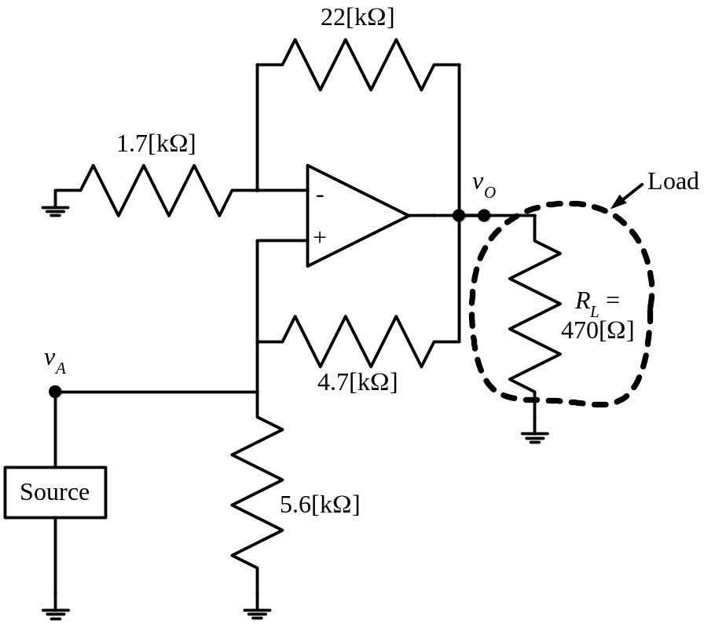

Room for extra work

2. {25 Points} Assume ideal op amps. The voltage v_{i}(t) represents a sinusoidal voltage source, with a zero mean, and a peak-to-peak amplitude in the range of about 10[μV]. Describe, quantitatively, the nature of the output voltage, v_{A}(t). Consider the behavior when v_{i}(t) > 0, and when v_{i}(t) < 0.
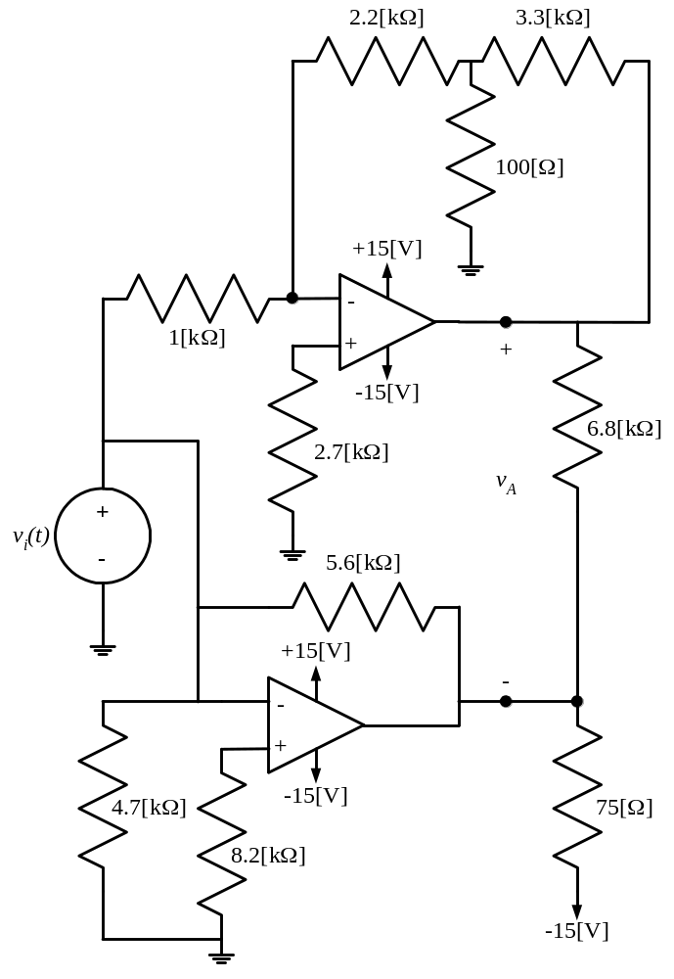

Room for extra work

3. {25 Points} The pnp transistor in this circuit has a β = 150, and operates at room temperature.
- Find the voltage gain, v_{l}/v_{s}, in the passband.
- Find the input resistance seen by the source, in the passband.
- Find the output resistance seen by the load, in the passband.
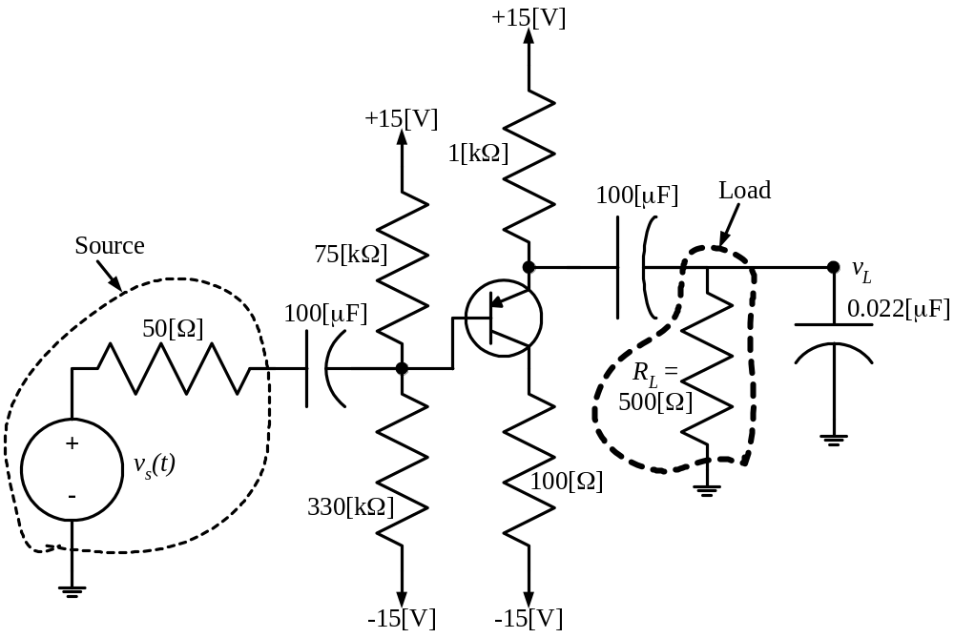

Room for extra work

4. {25 Points} A new device, known as a Barcelonor, has the schematic symbol as shown in Figure 1. Using the polarities defined in this figure, a characteristic curve for this device is plotted in Figure 2.
Two identical versions of this Barcelonor are inserted in the circuit shown in Figure 3. Find V_{X}.
Show your work. You are expected to be able to complete at least two guesses in the time period allotted. You will be graded on the basis of the process in your solution. State your guesses, and test them explicitly.
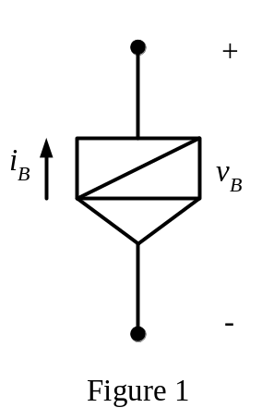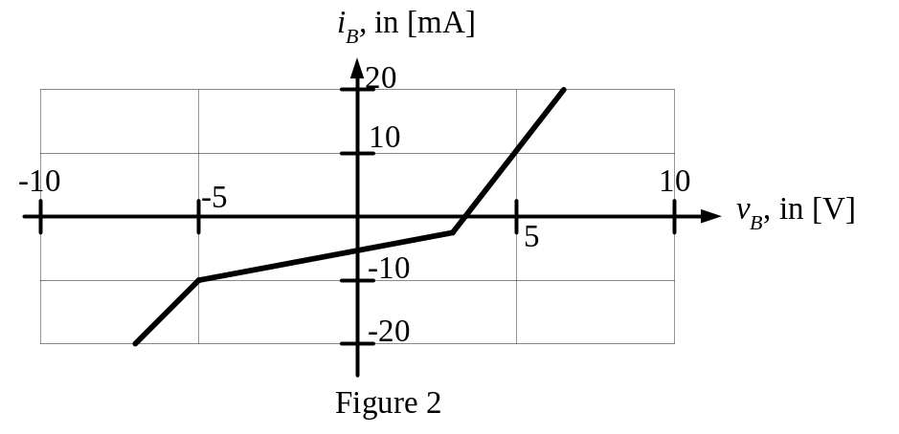
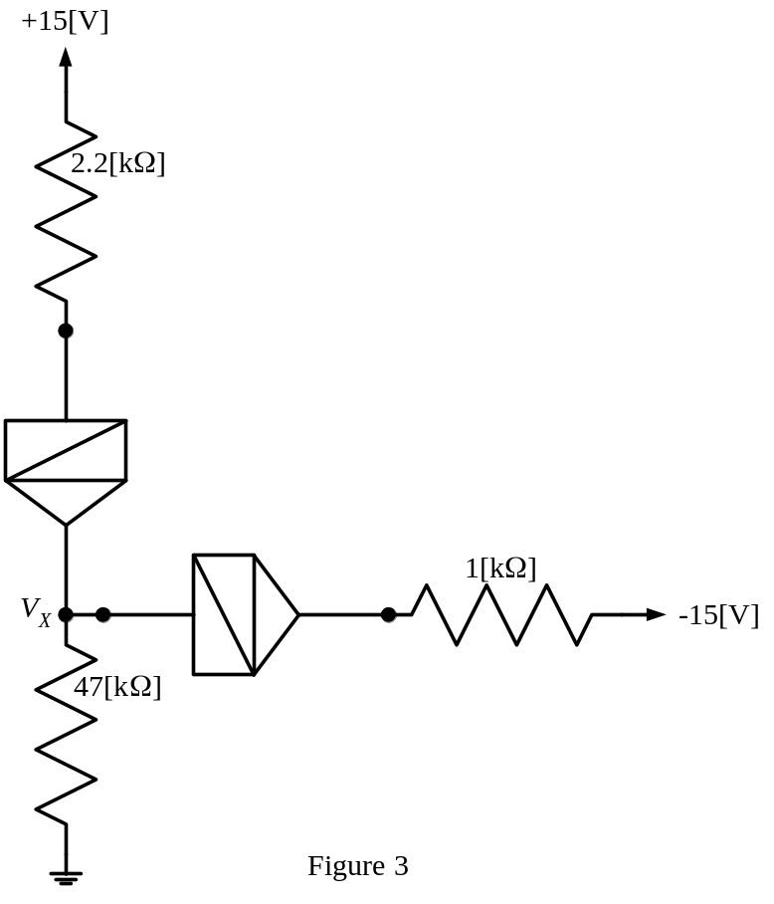
Room for extra work
5. {10 Points} Assume that a series voltage regulator is connected to the output of a full-wave rectifier based dc power supply, similar to the one you worked with in the laboratory. Describe the effect of the series voltage regulator on the ripple voltage of the power supply, using complete sentences. Can you use the formula for the ripple voltage, given below, to reasonably approximate the ripple voltage in this case? Explain your answer in complete sentences.
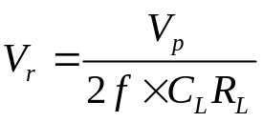

Solutions:
1. {25 Points} Assume an ideal op amp. For this problem, you should assume that the op amp has negative feedback.
- Find the voltage gain, v_{o}/v_{a}.
- Find the input resistance seen by the source.
- Find the output resistance seen by the load, as a function of the source resistance R_{S}. In other words, assume that the source can be modeled as a Thévenin equivalent, and solve as function of the Thévenin resistance, R_{S}.
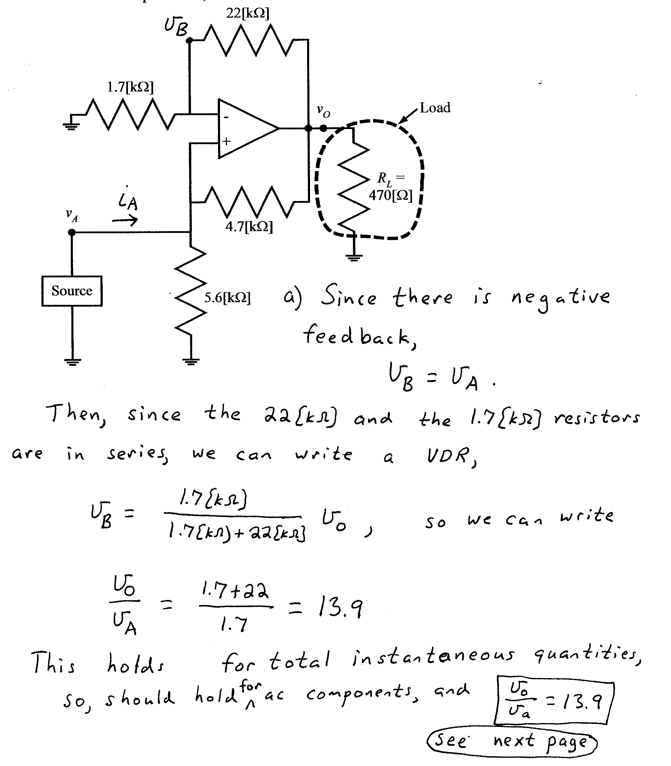
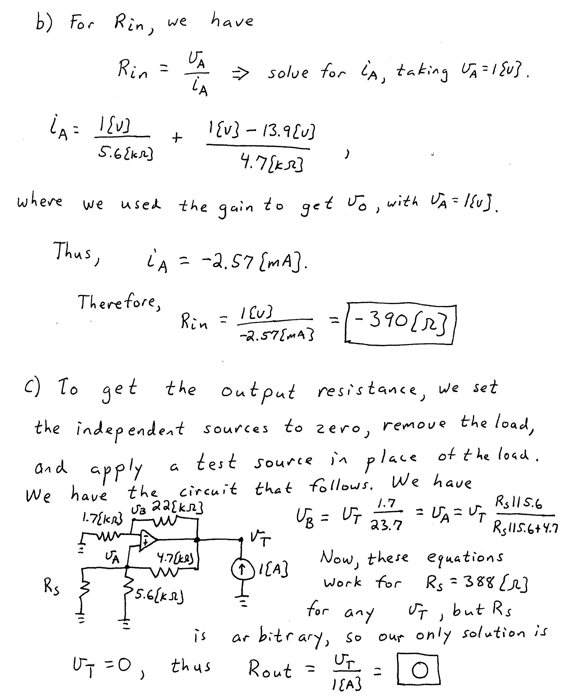

2. {25 Points} Assume ideal op amps. The voltage v_{i}(t) represents a sinusoidal voltage source, with a zero mean, and a peak-to-peak amplitude in the range of about 10[μV]. Describe, quantitatively, the nature of the output voltage, v_{A}(t). Consider the behavior when v_{i}(t) > 0, and when v_{i}(t) < 0.
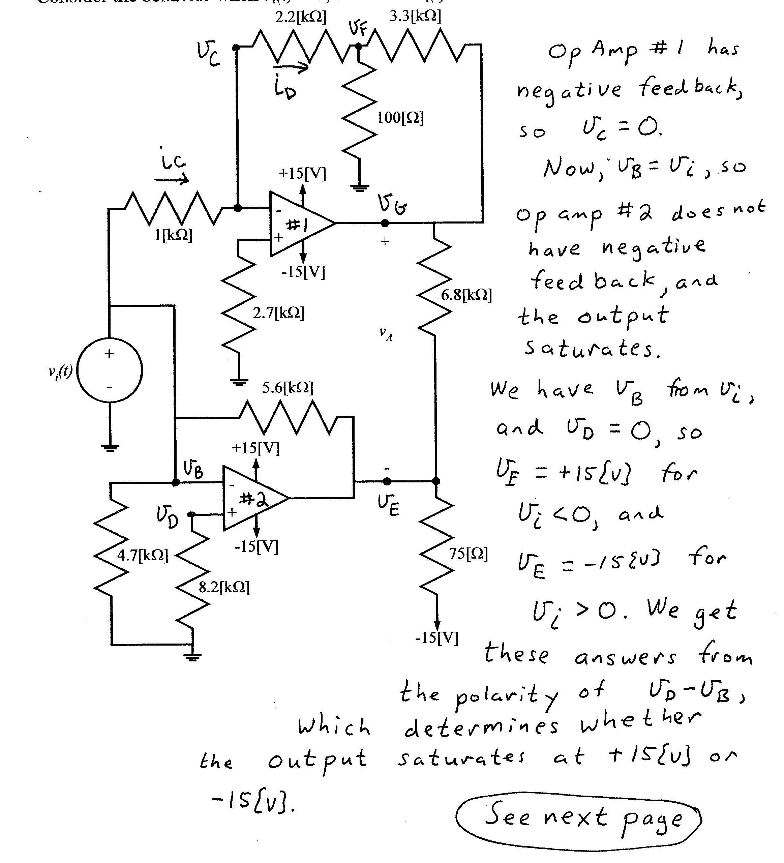
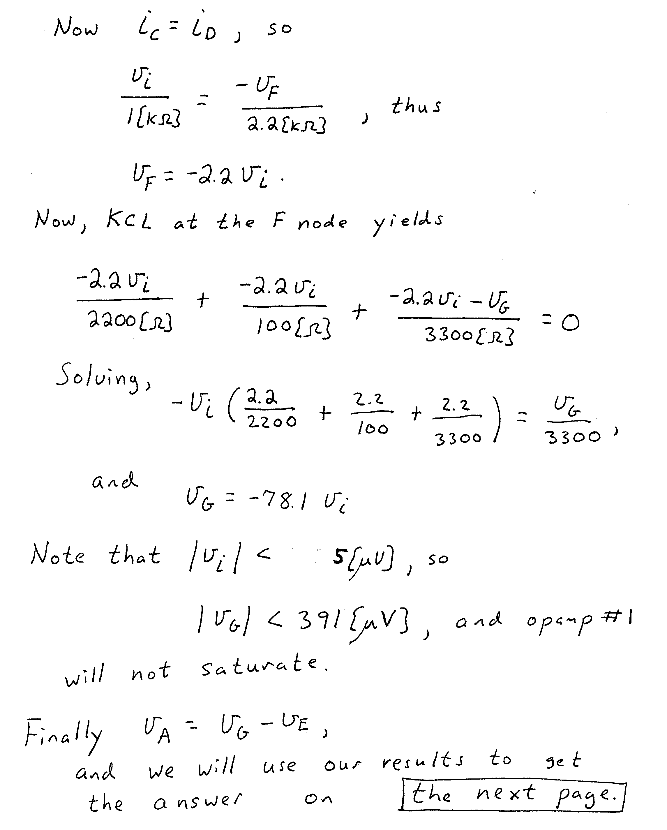
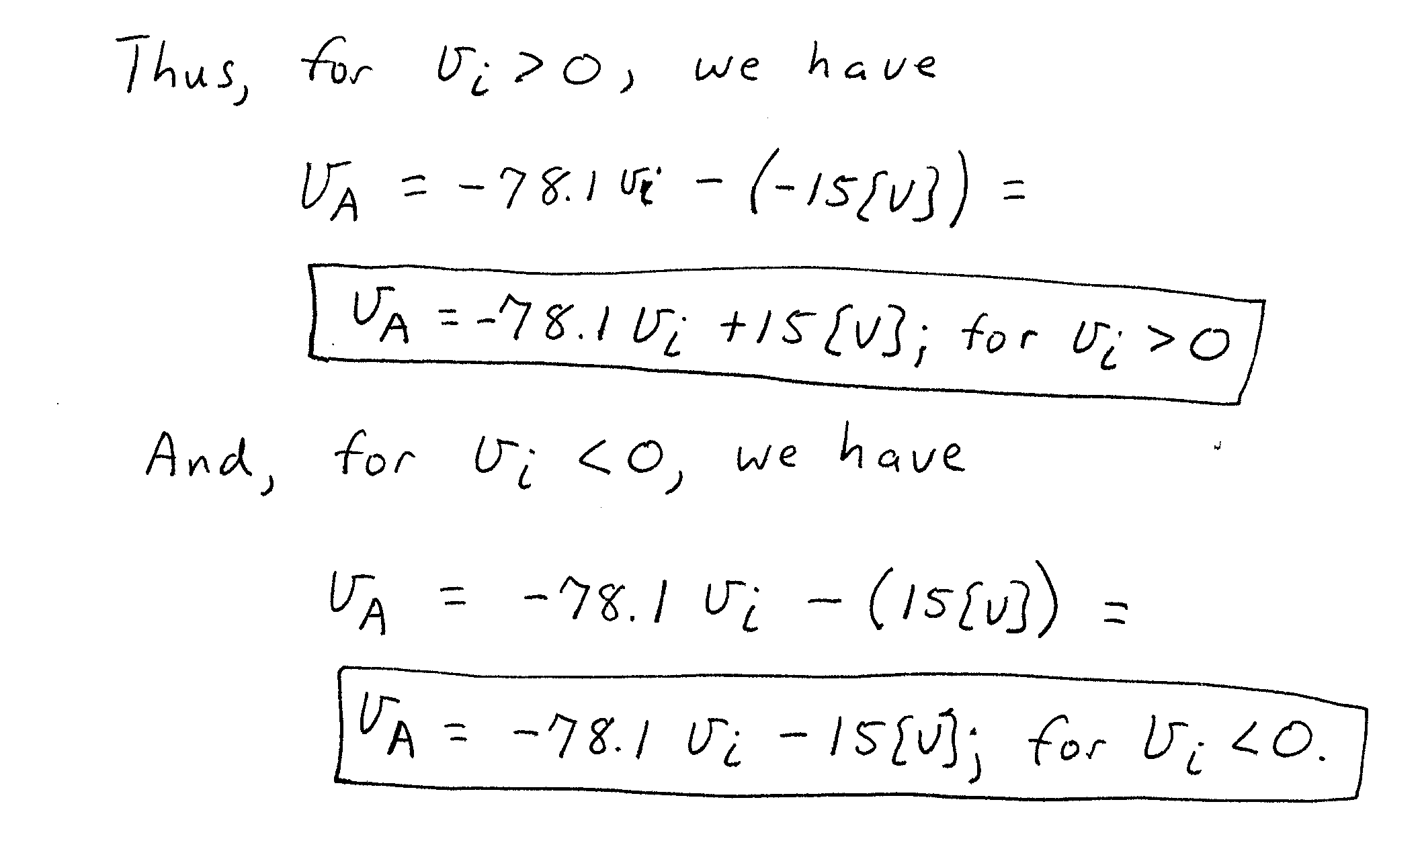

3. {25 Points} The pnp transistor in this circuit has a β = 150, and operates at room temperature.
- Find the voltage gain, v_{l}/v_{s}, in the passband.
- Find the input resistance seen by the source, in the passband.
- Find the output resistance seen by the load, in the passband.
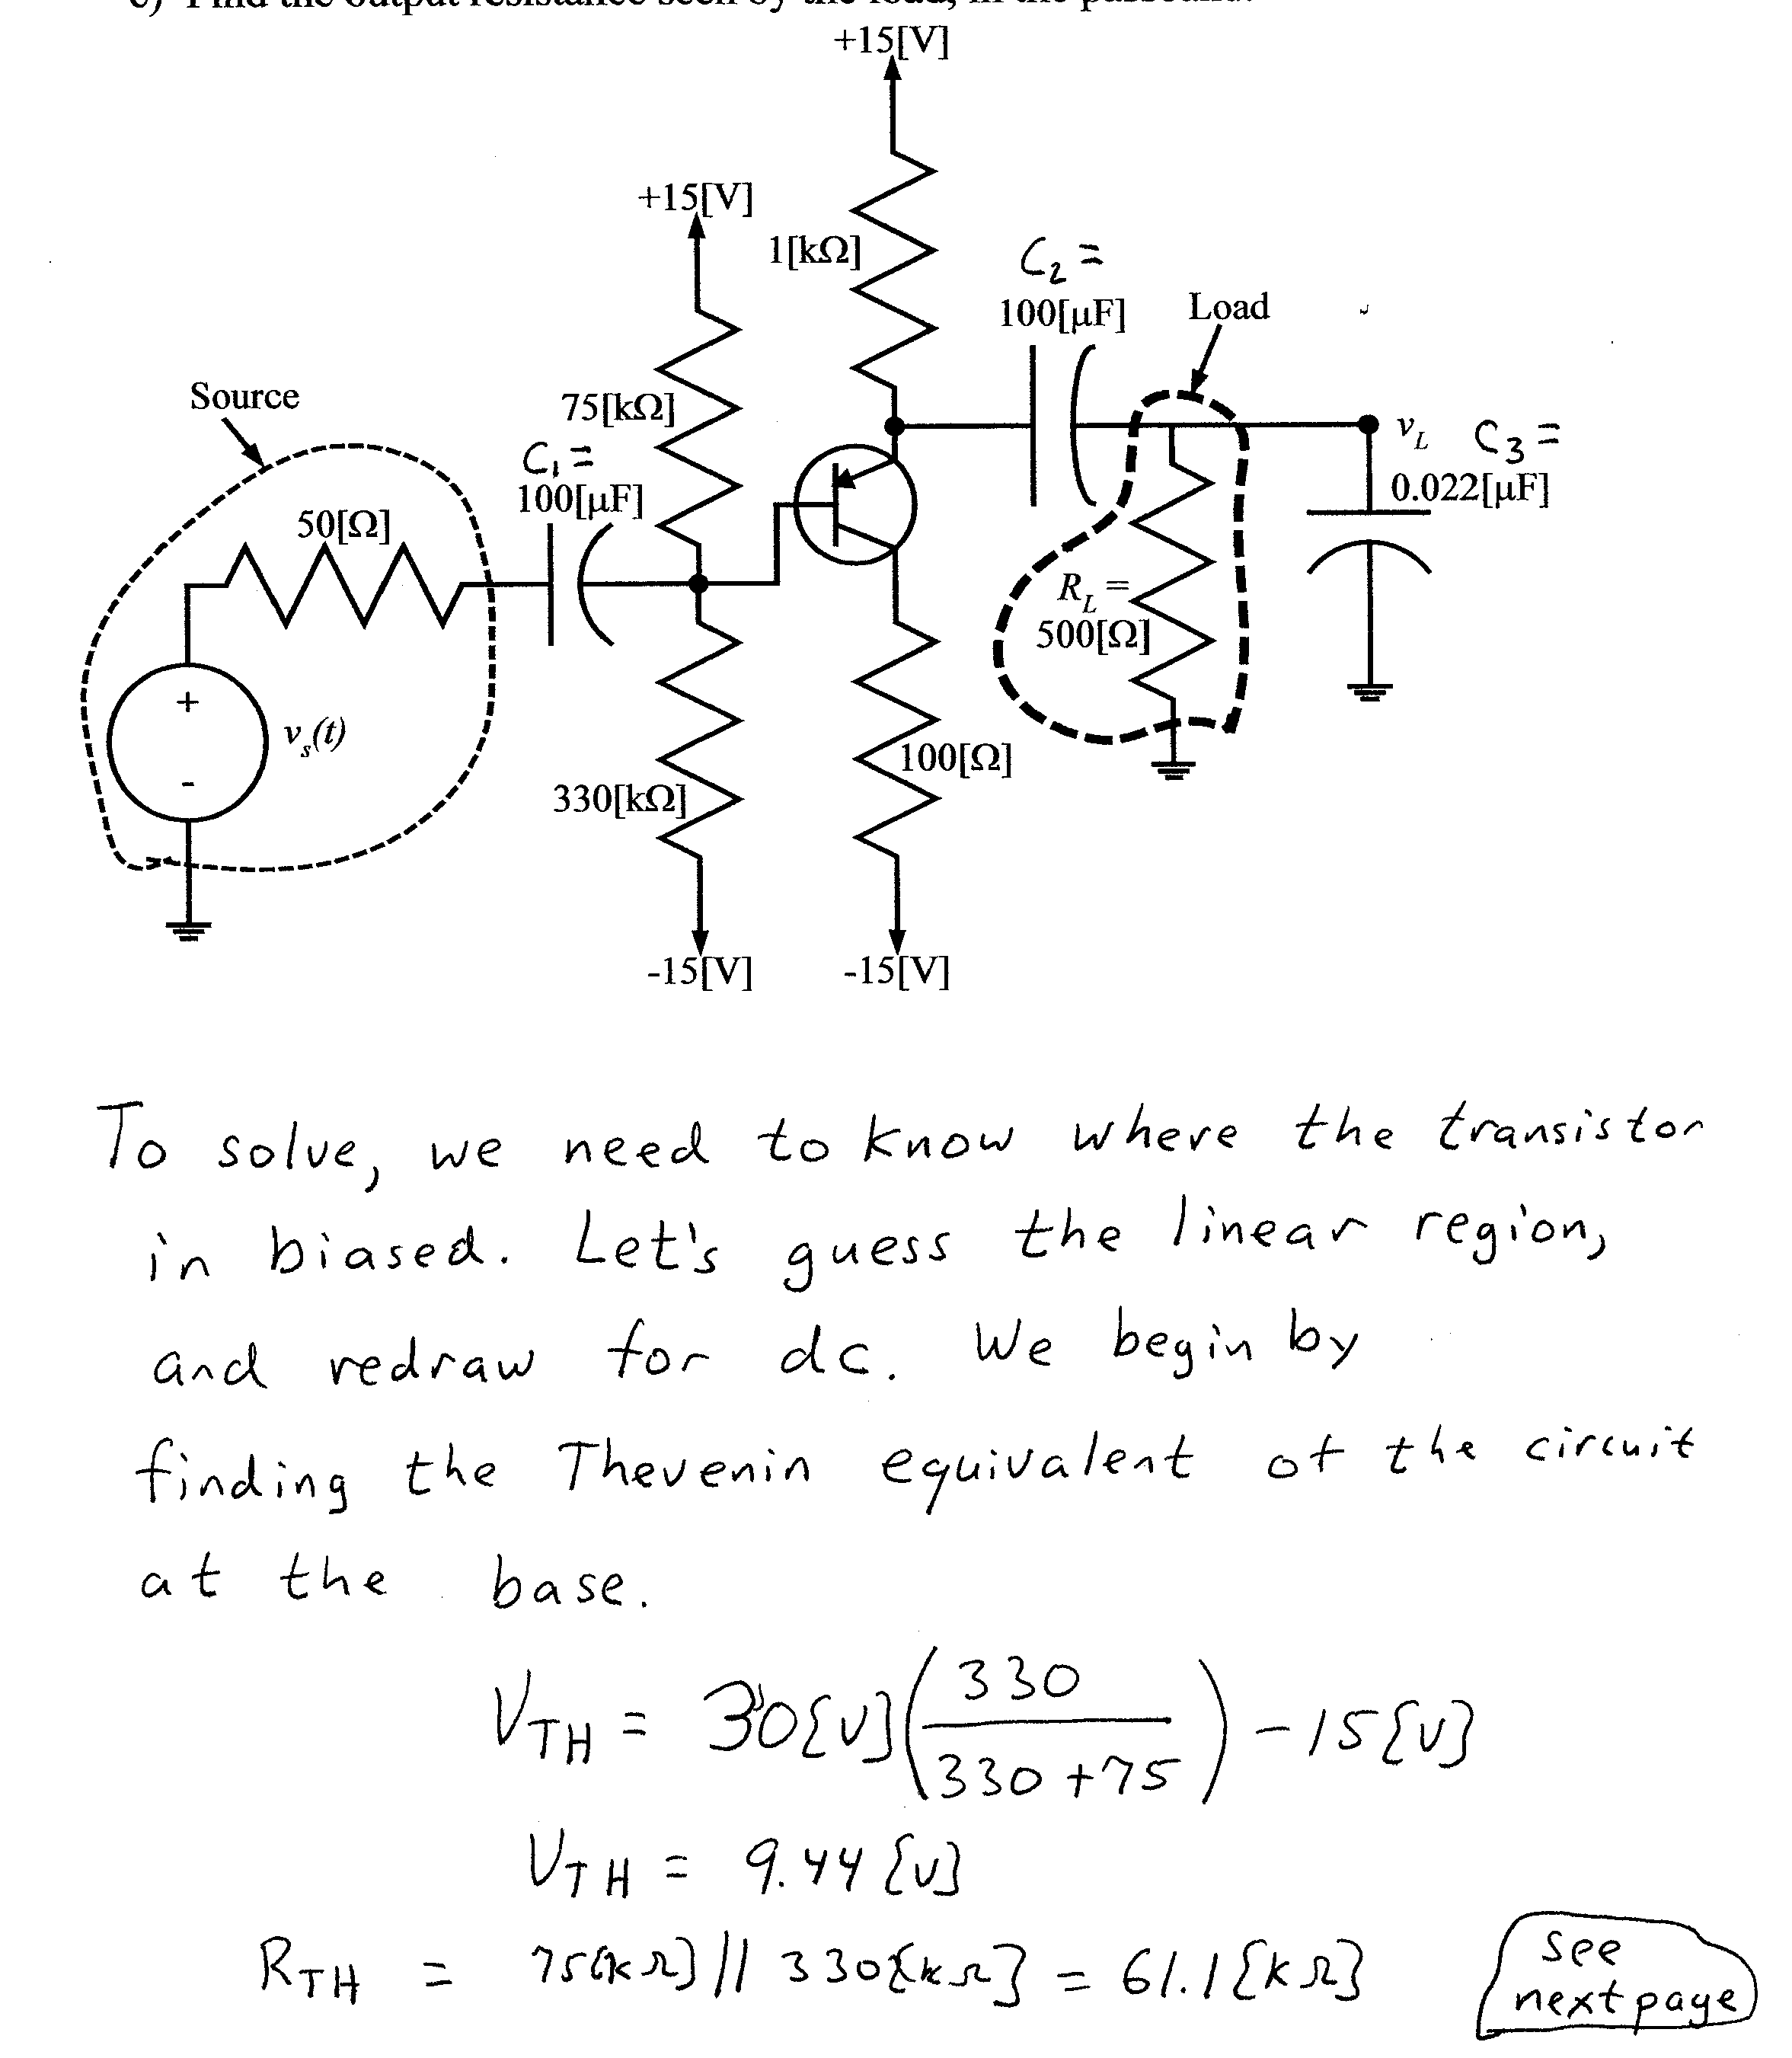
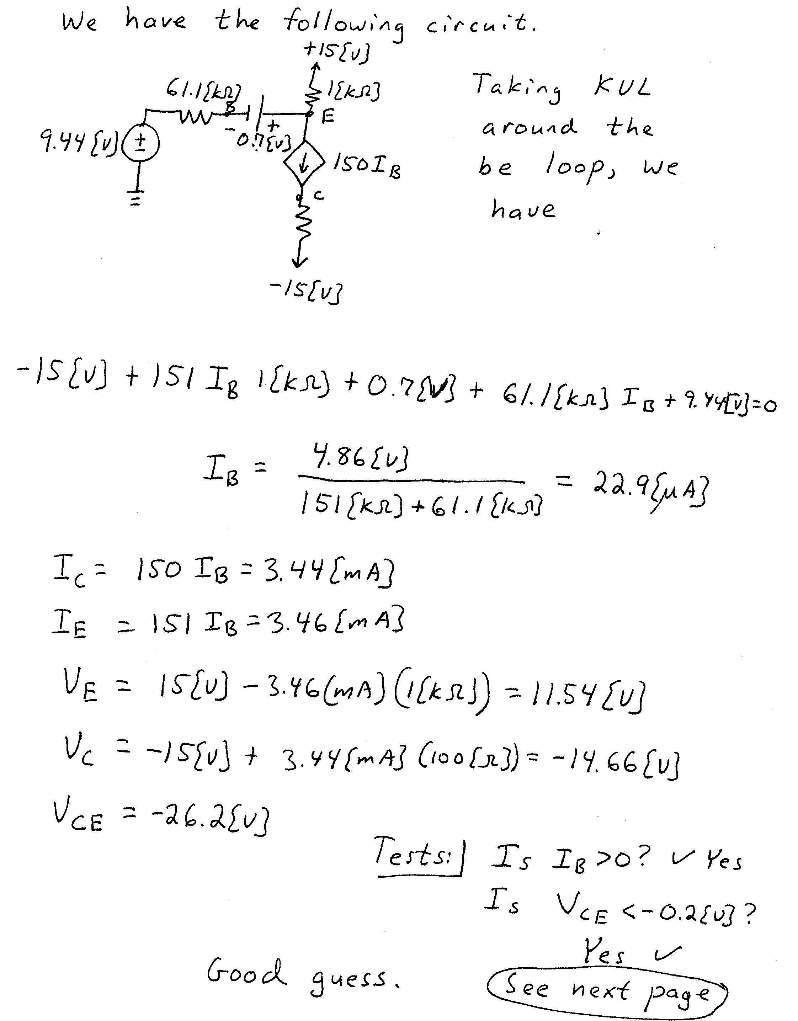
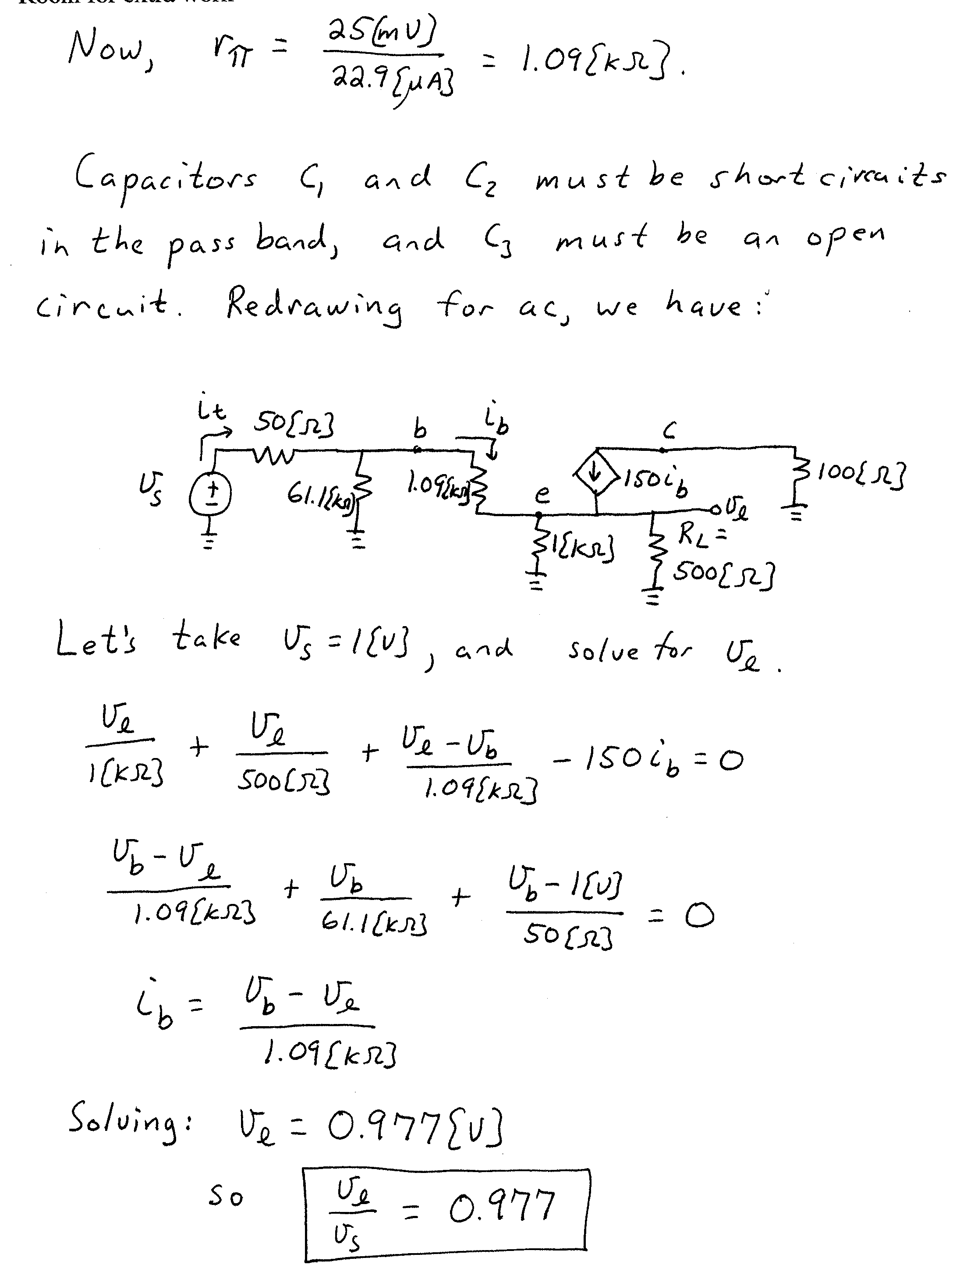
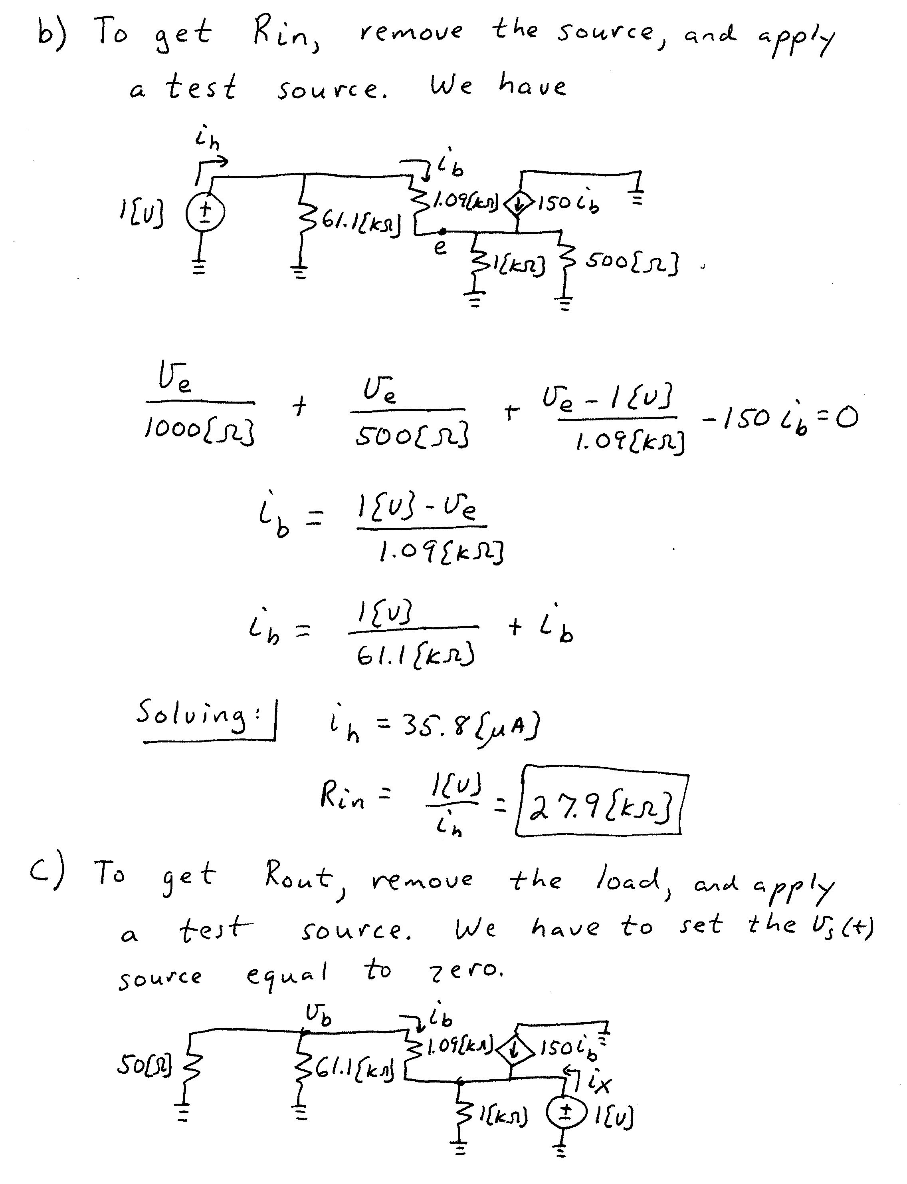
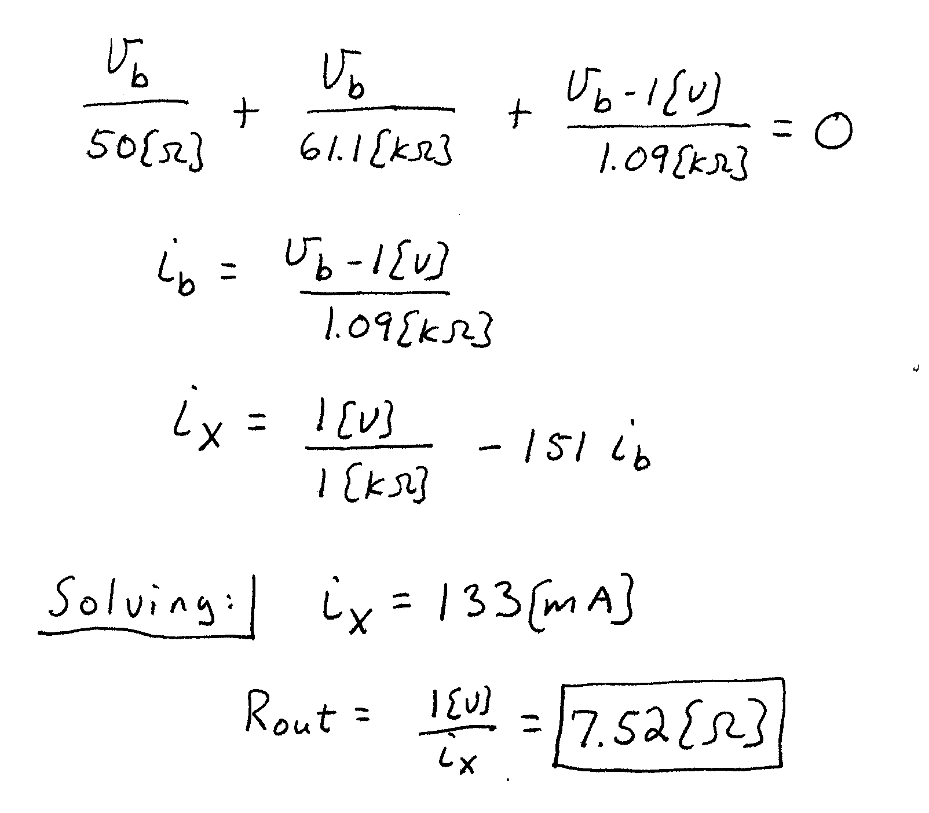

4. {25 Points} A new device, known as a Barcelonor, has the schematic symbol as shown in Figure 1. Using the polarities defined in this figure, a characteristic curve for this device is plotted in Figure 2.
Two identical versions of this Barcelonor are inserted in the circuit shown in Figure 3. Find V_{X}.
Show your work. You are expected to be able to complete at least two guesses in the time period allotted. You will be graded on the basis of the process in your solution. State your guesses, and test them explicitly.
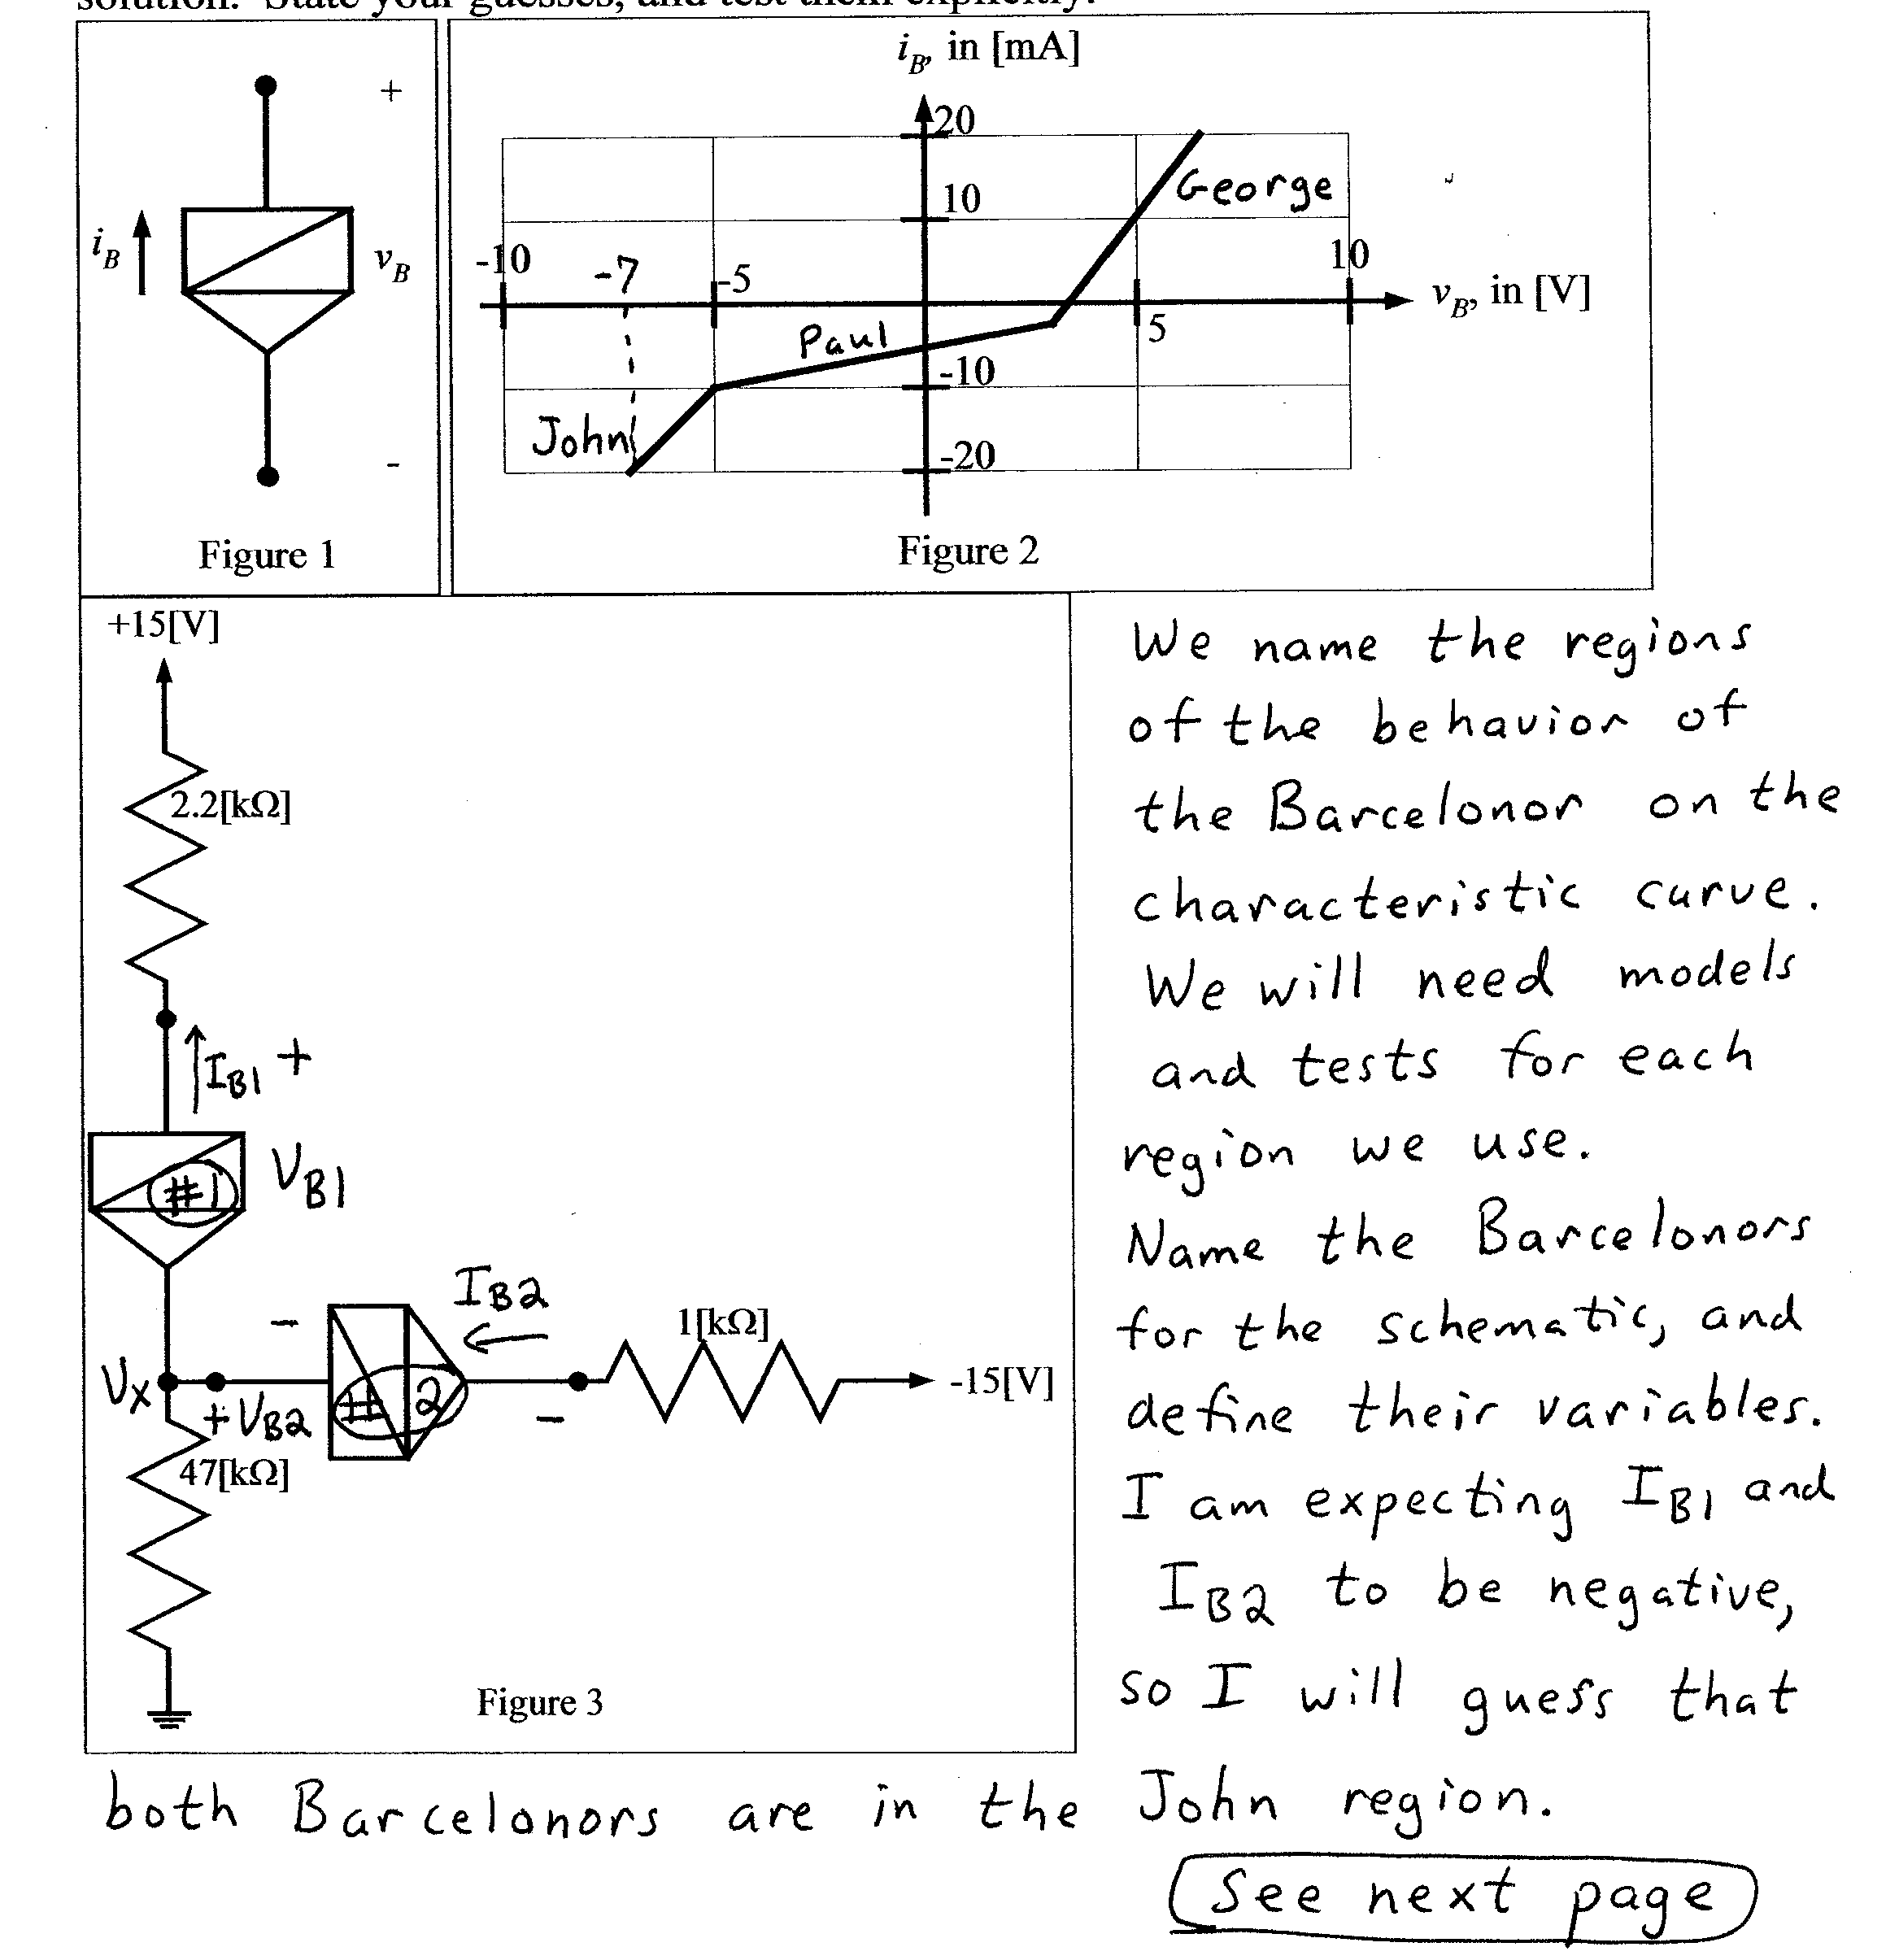
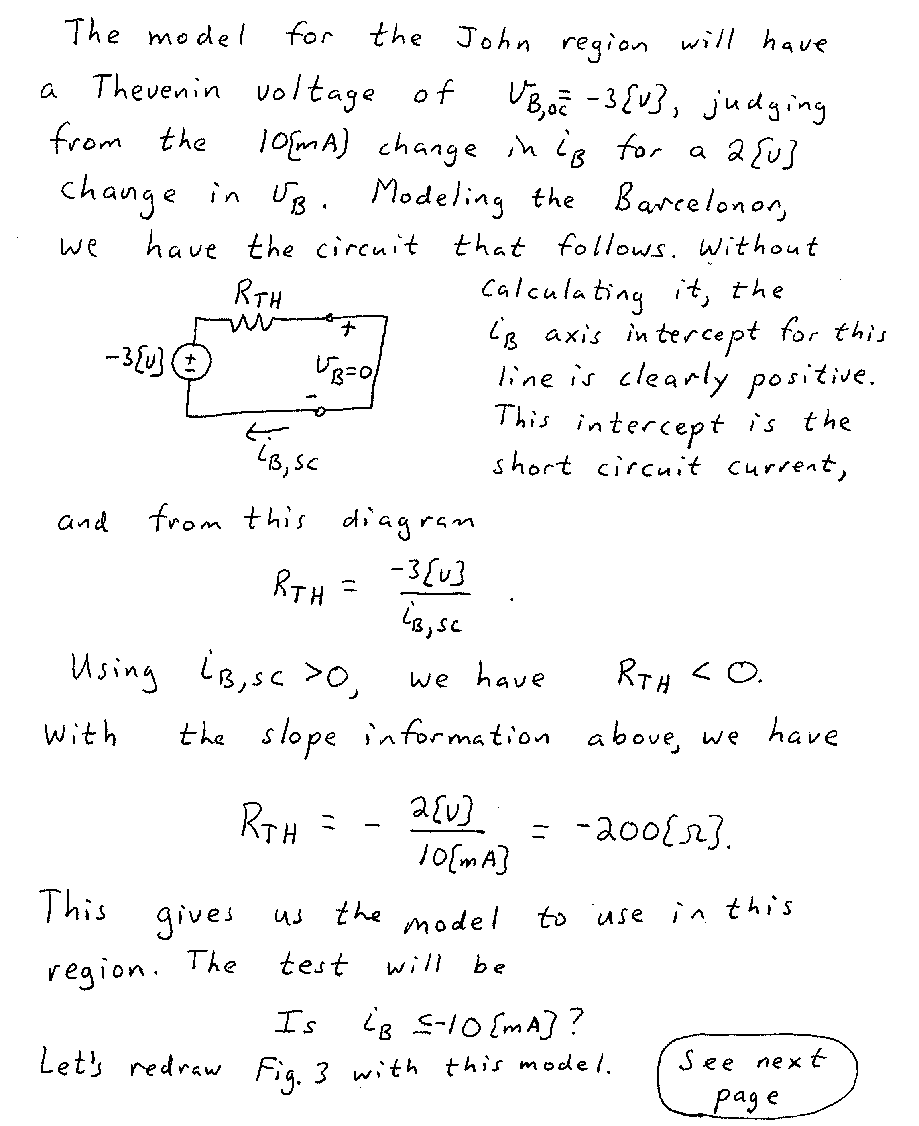
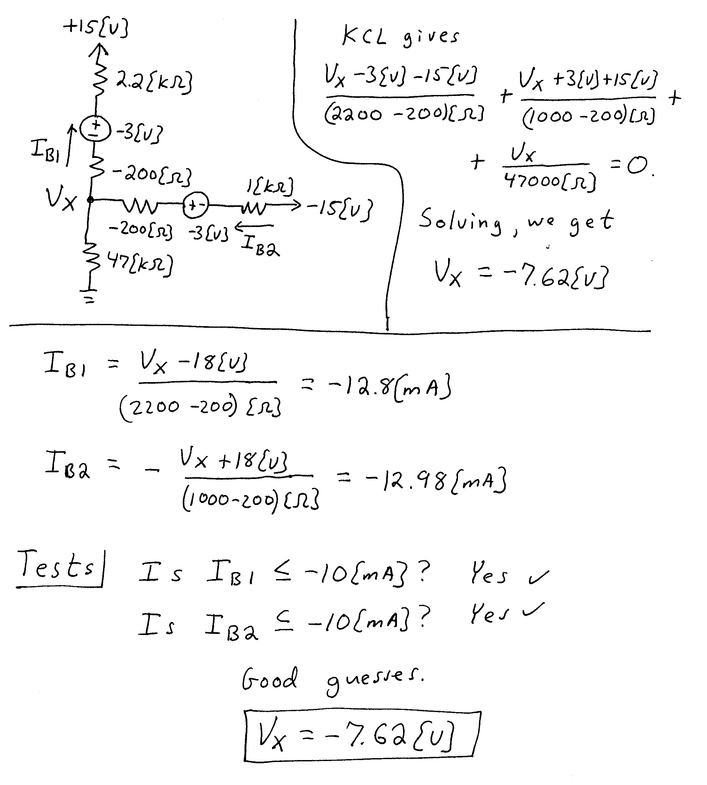

5. {10 Points} Assume that a series voltage regulator is connected to the output of a full-wave rectifier based dc power supply, similar to the one you worked with in the laboratory. Describe the effect of the series voltage regulator on the ripple voltage of the power supply, using complete sentences. Can you use the formula for the ripple voltage, given below, to reasonably approximate the ripple voltage in this case? Explain your answer in complete sentences.


