Name: _____________________________ (please print)
Signature: __________________________

ECE 3455 – Midsemester Exam
July 3, 2007

Keep this exam closed until you are told to begin.

1. This exam is closed book, closed notes. You may use one 8.5” x 11” crib sheet, or its equivalent.
2. Show all work on these pages. Show all work necessary to complete the problem. A solution without the appropriate work shown will receive no credit. A solution that is not given in a reasonable order will lose credit. Clearly indicate your answer (for example by enclosing it in a box).
3. It is assumed that your work will begin on the same page as the problem statement. If you choose to begin your work on another page, you must indicate this on the page with the problem statement, with a clear indication of where the work can be found. If your work continues on to another page, indicate clearly where your work can be found. Failure to indicate this clearly will result in a loss of credit.
4. Show all units in solutions, intermediate results, and figures. Units in the exam will be included between square brackets.
5. Do not use red ink. Do not use red pencil.
6. You will have 100 minutes to work on this exam.

1. ________________/40
2. ________________/20
3. ________________/40
Total = 100
Room for extra work
1. {40 Points} Use the circuit below to find the numerical value of the following quantities. Assume ideal op amps.
a) Find the transconductance i_{o}/v_{s}.
b) Find the input resistance seen by the source.
c) Find the output resistance seen by the load, R_{L}.
d) Find an amplifier model that could be used to model this circuit, with respect to the source and the load, and behave the same way. Draw the model, and attach the source and the load.

Room for extra work

2. {20 Points} An oscilloscope input can be modeled as a 1[MΩ] resistance in parallel with a 53[pF] capacitance.
For a digital computer that works with base-8 arithmetic, there is a perceived need for an 8X probe to use with this oscilloscope. The goal is to have the display on the oscilloscope be the same shape as the signal being measured.
Design the 8X probe, and show that using it will allow the oscilloscope to display waveforms with the same shape as the input waveforms.

Room for extra work

3. {40 Points} Use the circuit below to find the numerical value of the following quantities. Assume ideal op amps.
- Find V_{o}/V_{i}.
- Find V_{O}/V_{I}.
- Find the voltage gain v_{o}/v_{i}, at 10[kHz].
- Plot the straight-line approximations to the magnitude and phase Bode plots for the transfer function for this circuit, using the semilog graph paper on the next two pages.

1. {40 Points} Use the circuit below to find the numerical value of the following quantities. Assume ideal op amps.
a) Find the transconductance i_{o}/v_{s}.
b) Find the input resistance seen by the source.
c) Find the output resistance seen by the load, R_{L}.
d) Find an amplifier model that could be used to model this circuit, with respect to the source and the load, and behave the same way. Draw the model, and attach the source and the load.
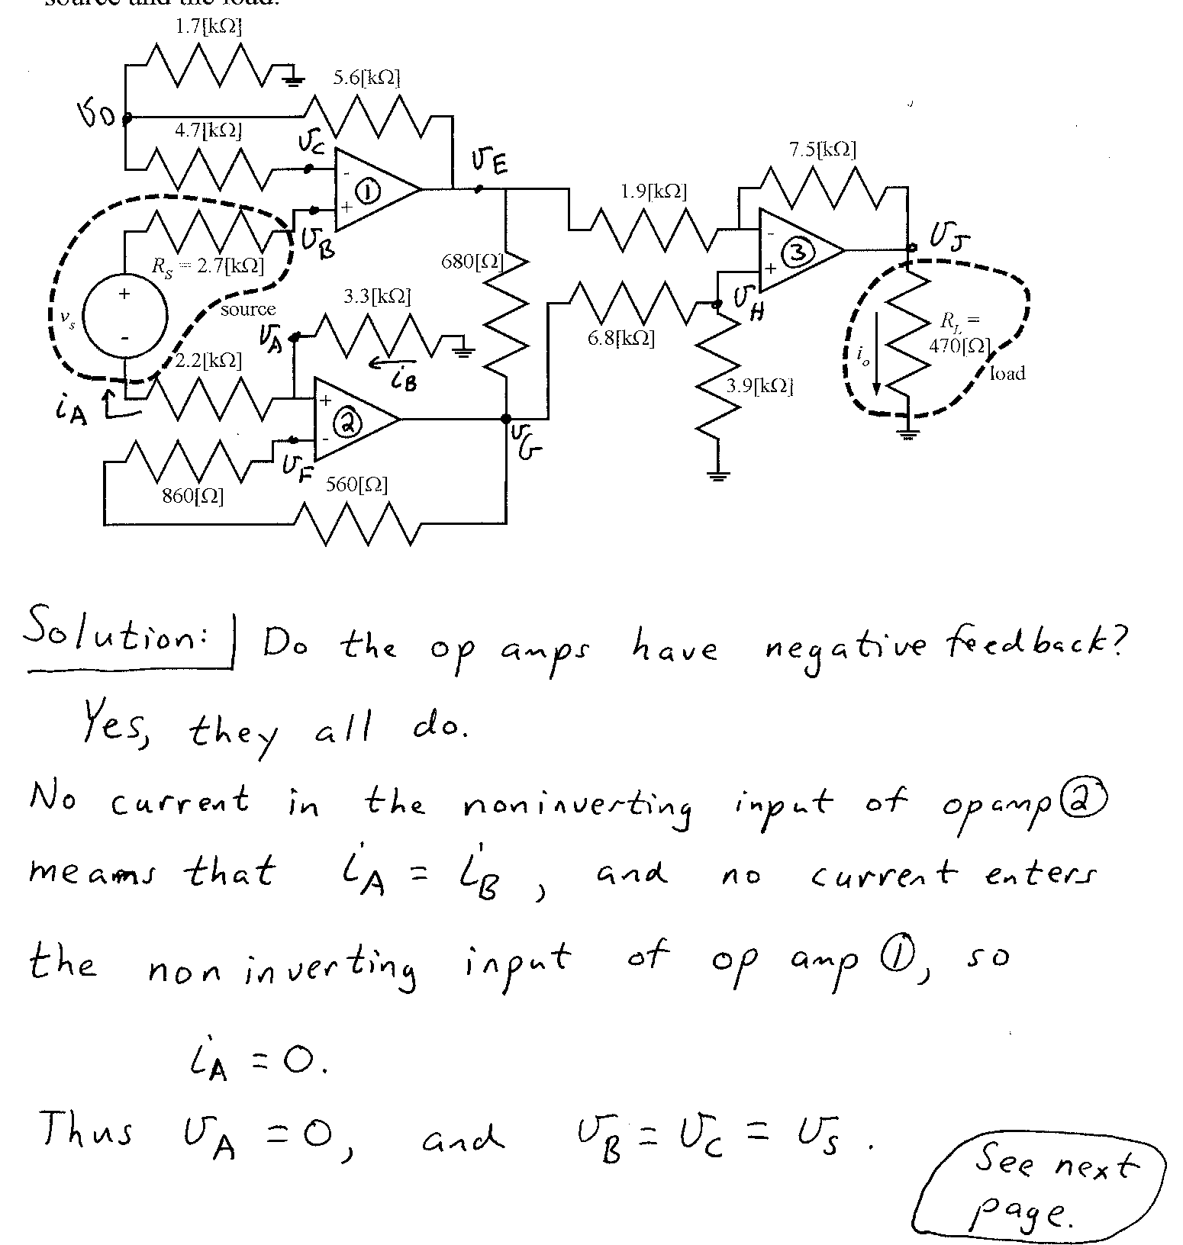
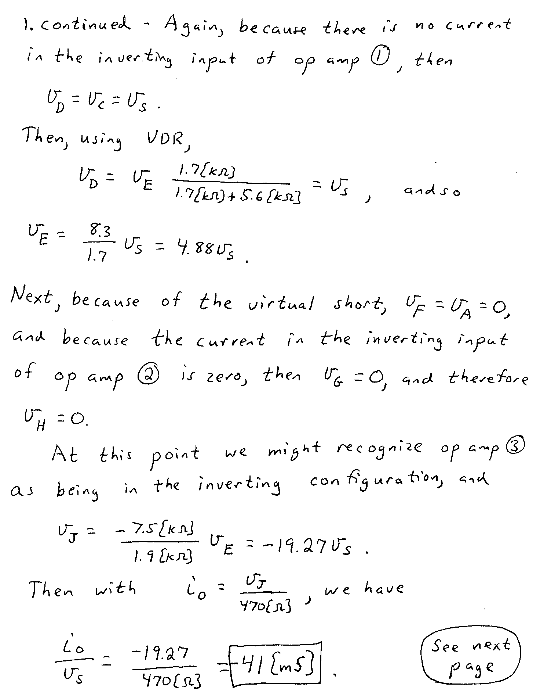
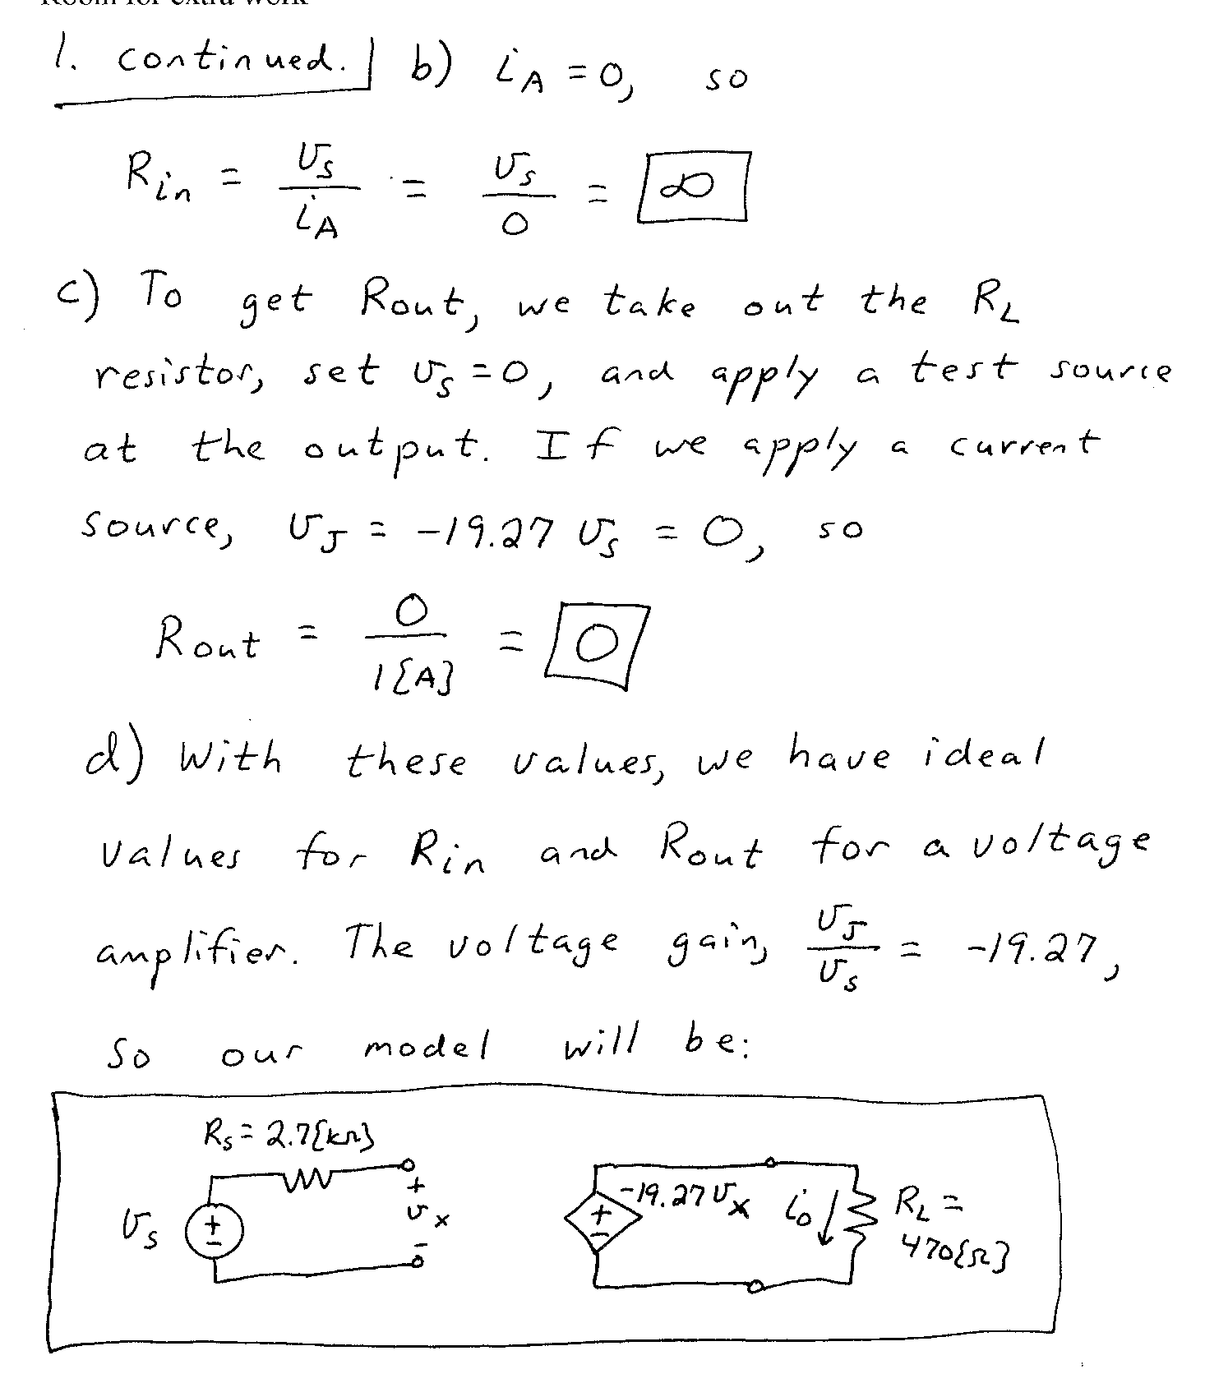

2. {20 Points} An oscilloscope input can be modeled as a 1[MΩ] resistance in parallel with a 53[pF] capacitance.
For a digital computer that works with base-8 arithmetic, there is a perceived need for an 8X probe to use with this oscilloscope. The goal is to have the display on the oscilloscope be the same shape as the signal being measured.
Design the 8X probe, and show that using it will allow the oscilloscope to display waveforms with the same shape as the input waveforms.
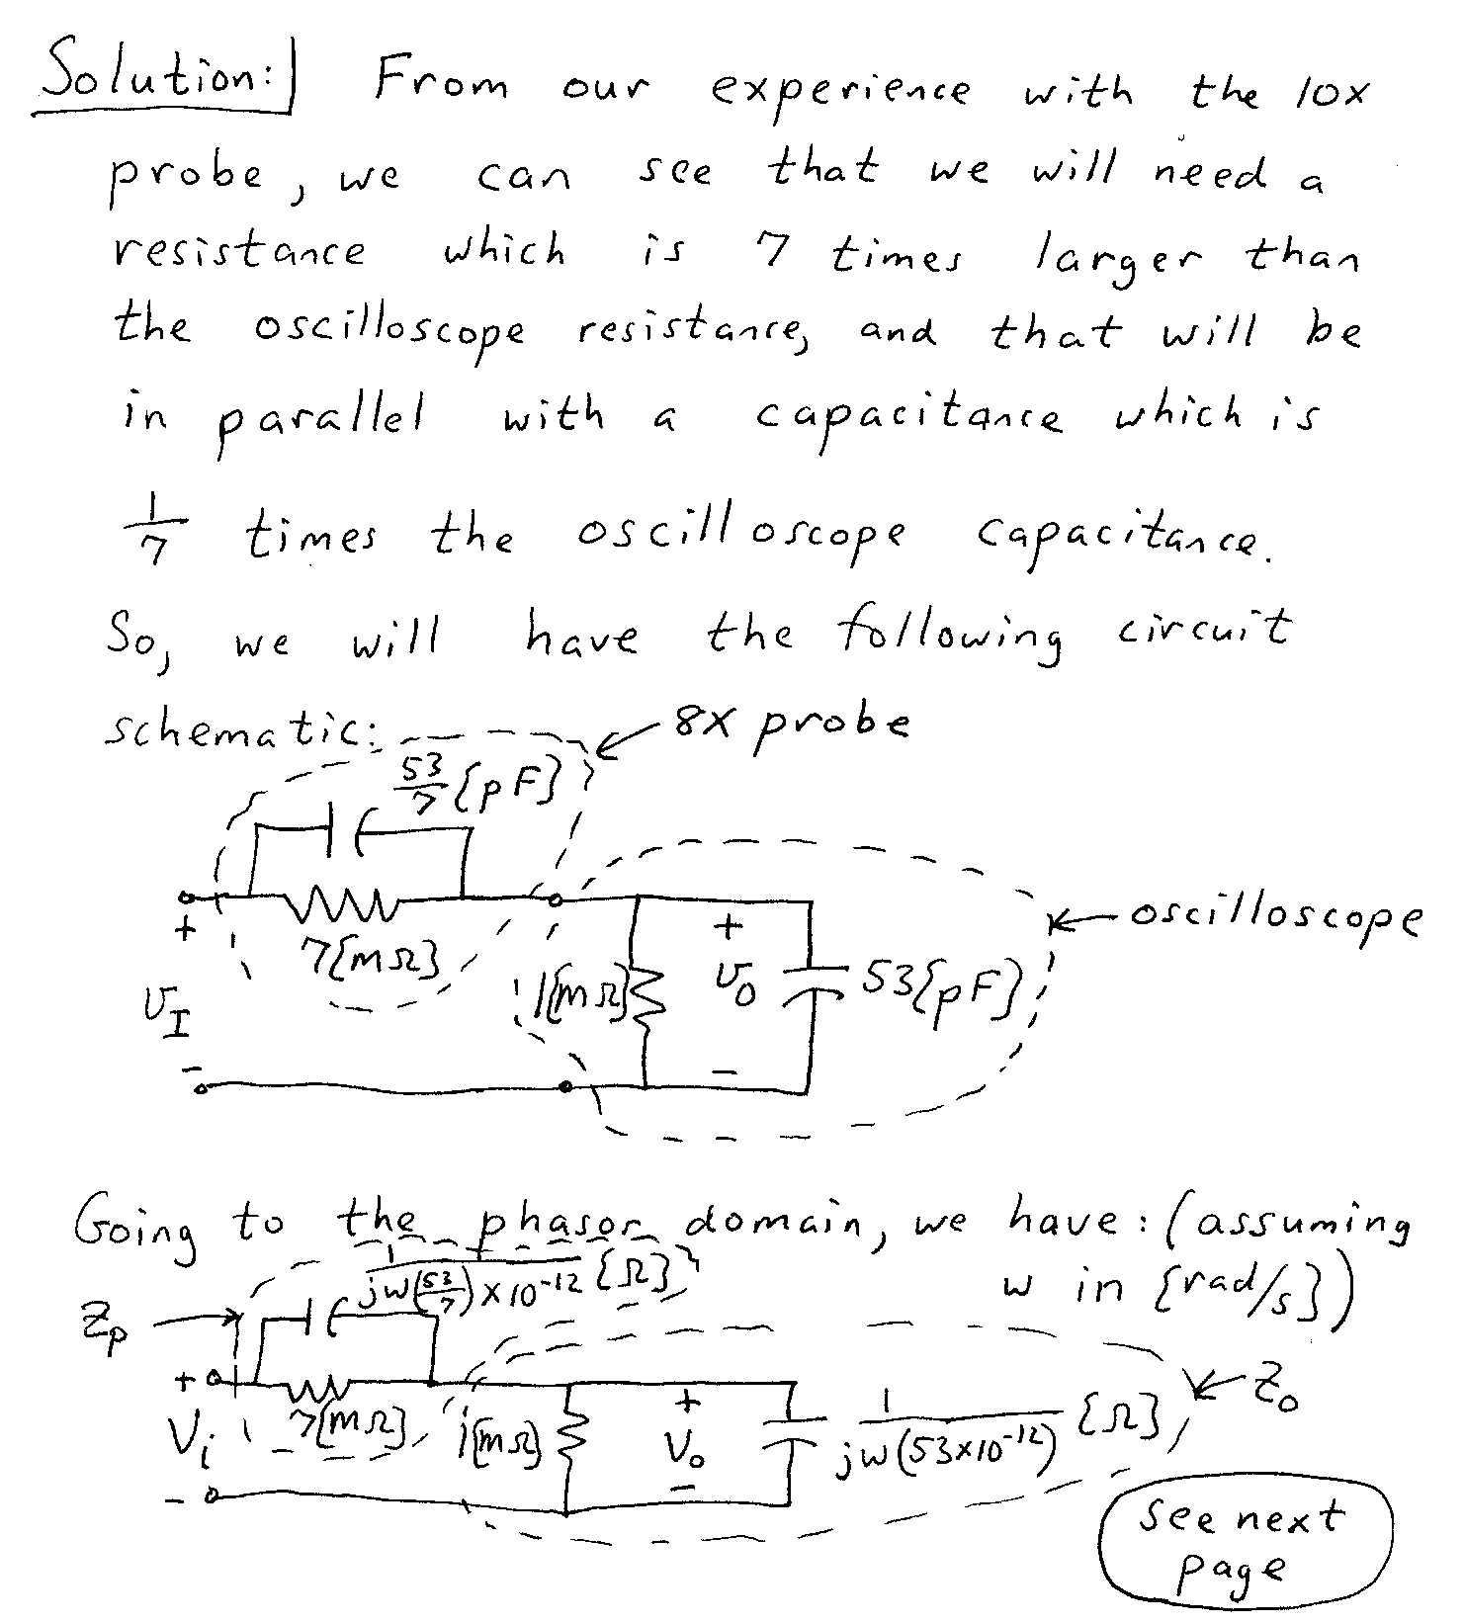
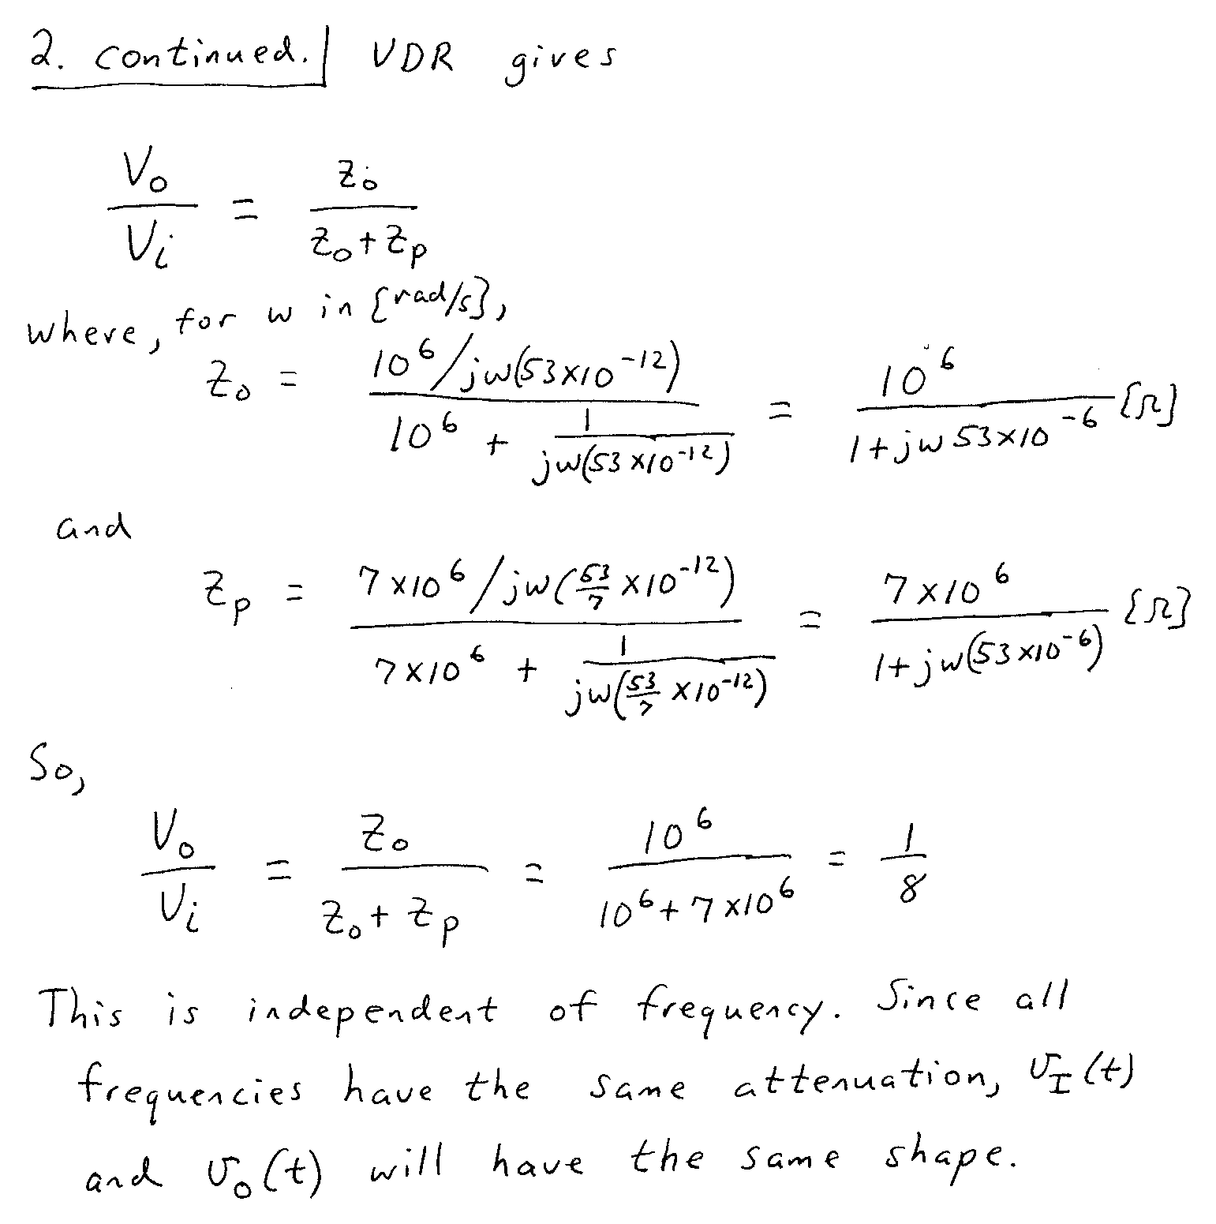

3. {40 Points} Use the circuit below to find the numerical value of the following quantities. Assume ideal op amps.
- Find V_{o}/V_{i}.
- Find V_{O}/V_{I}.
- Find the voltage gain v_{o}/v_{i}, at 10[kHz].
- Plot the straight-line approximations to the magnitude and phase Bode plots for the transfer function for this circuit, using the semilog graph paper on the next two pages.
