Name: _____________________________ (please print)
Signature: __________________________

ECE 3455 – Final Exam
August 7, 2009

Keep this exam closed until you are told to begin.

1. This exam is closed book, closed notes. You may use one 8.5” x 11” crib sheet, or its equivalent.
2. Show all work on these pages. Show all work necessary to complete the problem. A solution without the appropriate work shown will receive no credit. A solution that is not given in a reasonable order will lose credit. Clearly indicate your answer (for example by enclosing it in a box).
3. It is assumed that your work will begin on the same page as the problem statement. If you choose to begin your work on another page, you must indicate this on the page with the problem statement, with a clear indication of where the work can be found. If your work continues on to another page, indicate clearly where your work can be found. Failure to indicate this clearly will result in a loss of credit.
4. Show all units in solutions, intermediate results, and figures. Units in the exam will be included between square brackets.
5. Do not use red ink. Do not use red pencil.
6. You will have 170 minutes to work on this exam.

1. ________________/25
2. ________________/25
3. ________________/25
4. ________________/25
5. ________________/25
Total = 125
Note that there are 125 points possible on this exam. However, the usual grading scheme will be used, which means that you only need to complete four problems to earn 100 points. You are welcome to work all five problems, and averages over 100 will be used in the grading spreadsheet. Earn points.
Room for extra work
1. {25 Points} Use the circuit below to find the numerical values of the following quantities. Assume ideal op amps.
- Find v_{L}.
- Find i_{O3}.
- Find the output resistance seen by the load, R_{L}.

Room for extra work

2. {25 Points} Assume that each of the diodes in the circuit given can be modeled using a piecewise-linear model with V_{f} = 1[V], r_{d} = 1[kΩ], and
I_{s} = 1[mA]. Assume an ideal op amp. Find V_{O}. I expect that you will be able to complete at least two guesses in the time period given. Remember that you will be graded primarily on the approach that you take to the problem. Define the names of your regions clearly. State your guesses, and test them explicitly.

Room for extra work

3. {25 Points} Assume ideal op amps. It is given that SWA was open and SWB was closed for a long time before t = 0. Assume that time t = 0 is defined as the time of one of the transitions from +15[V] to -10[V] for v_{A}.
a) Find numerical expressions for v_{B}(t) for 0 < t < 100[ms].
b) Sketch v_{B}(t) for 0 < t < 100[ms], showing quantitative scales.

Room for extra work

4. {25 Points} For the circuit given below, assume that the transistor has β = 35 and operates at room temperature.
a) Find the transconductance i_{l} /v_{s}, in the passband.
b) Find the current gain i_{l} /i_{s}, in the passband, in [dB].
c) How many poles and how many zeroes would be in the transfer function H(ω) = V_{l} /V_{s}?

Room for extra work

5. {25 Points} A device known as a brazilior has the schematic symbol shown in Fig. 1. The characteristic curves for this device are shown in Fig. 2 and Fig. 3. A brazilior has been connected in the circuit in Fig. 4, on the next page. (Hint: you can draw a load line on Fig. 2 based on the information in the schematic in Fig. 4.)
a) Find the small signal voltage gain v_{r} /v_{s}, in the passband.
b) Find the small signal input resistance seen by v_{s}(t), in the passband.
c) Find the small signal output resistance seen by R_{L}, in the passband.

Solutions:
1. {25 Points} Use the circuit below to find the numerical values of the following quantities. Assume ideal op amps.
- Find v_{L}.
- Find i_{O3}.
- Find the output resistance seen by the load, R_{L}.
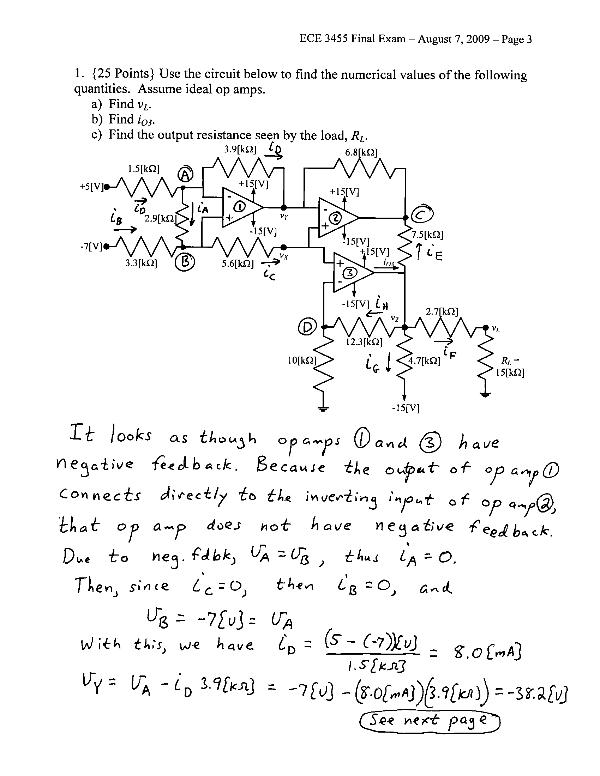
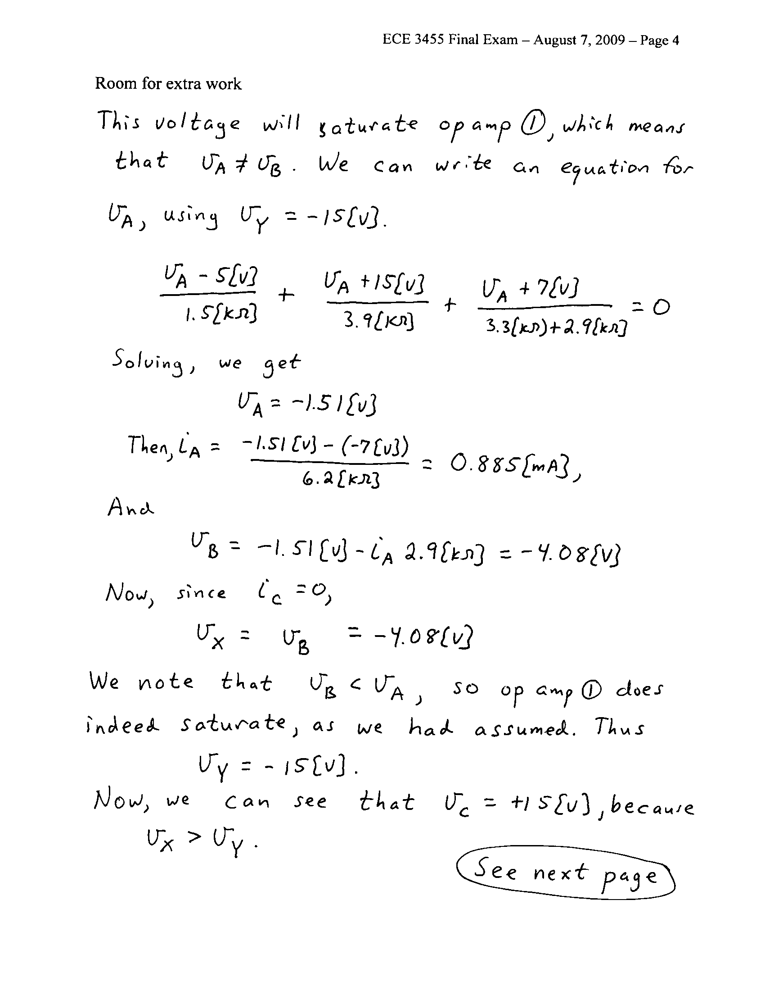
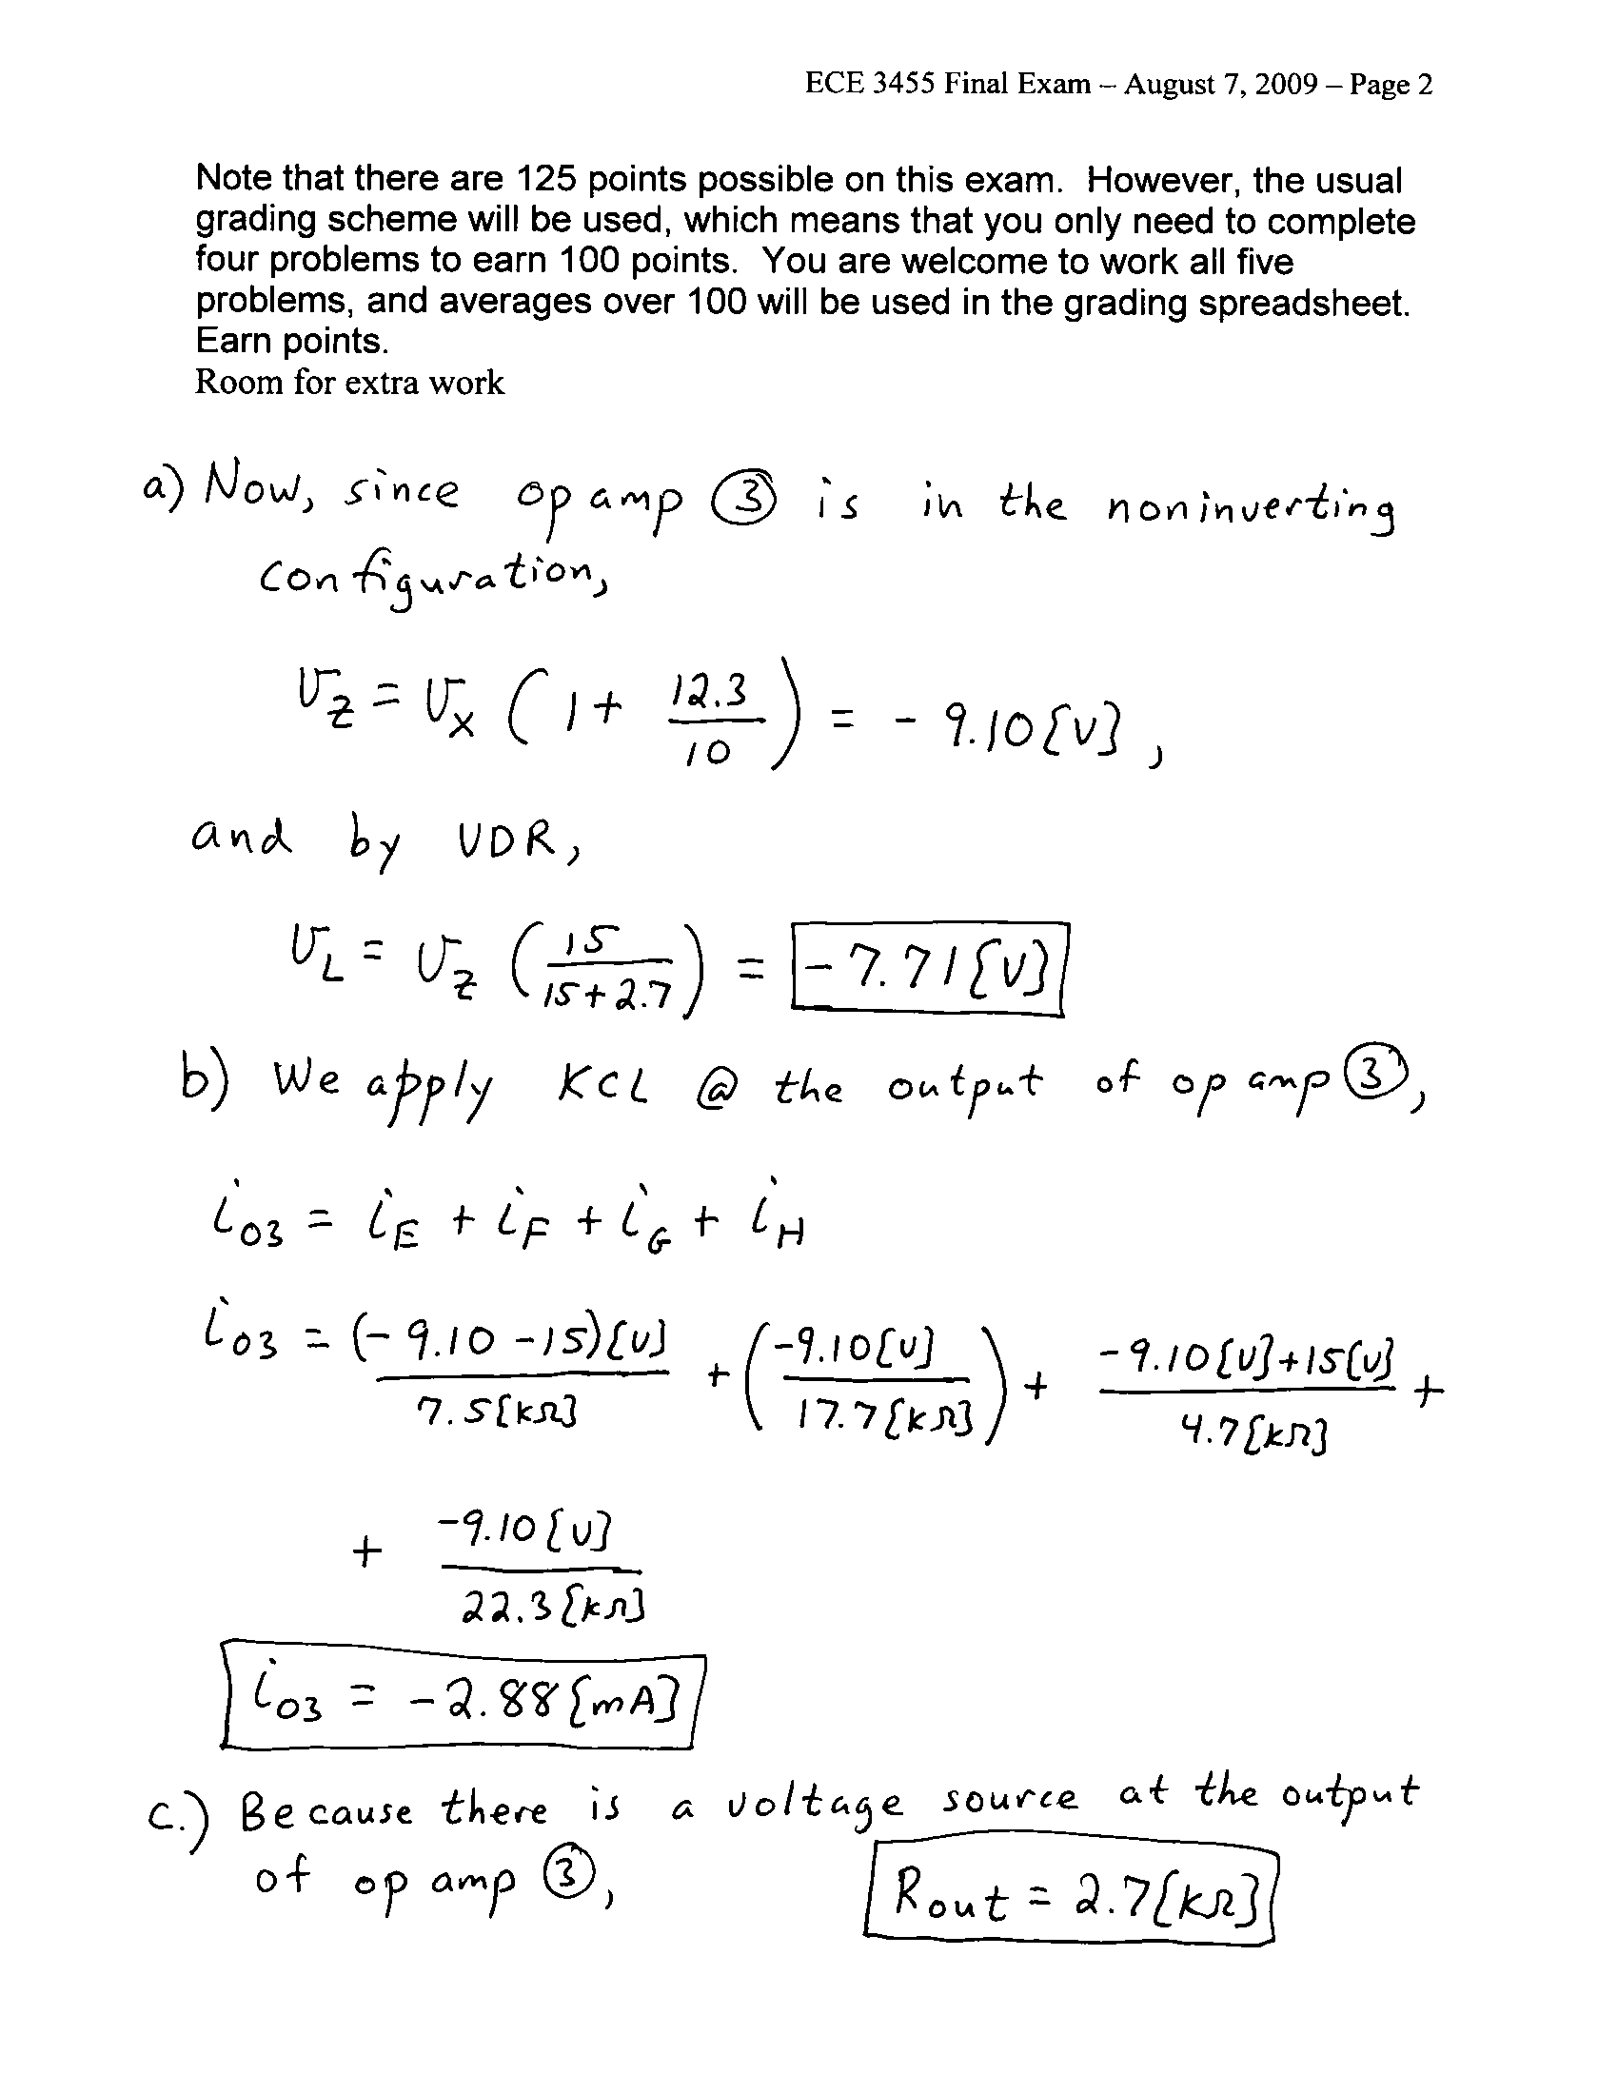

2. {25 Points} Assume that each of the diodes in the circuit given can be modeled using a piecewise-linear model with V_{f} = 1[V], r_{d} = 1[kΩ], and
I_{s} = 1[mA]. Assume an ideal op amp. Find V_{O}. I expect that you will be able to complete at least two guesses in the time period given. Remember that you will be graded primarily on the approach that you take to the problem. Define the names of your regions clearly. State your guesses, and test them explicitly.
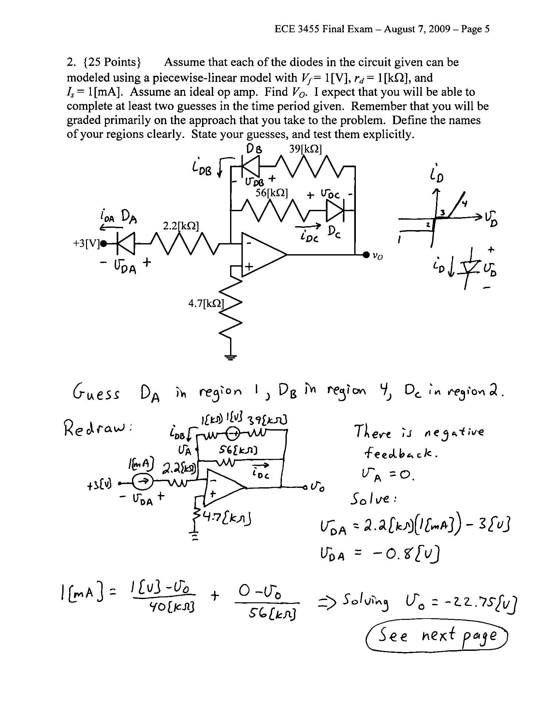
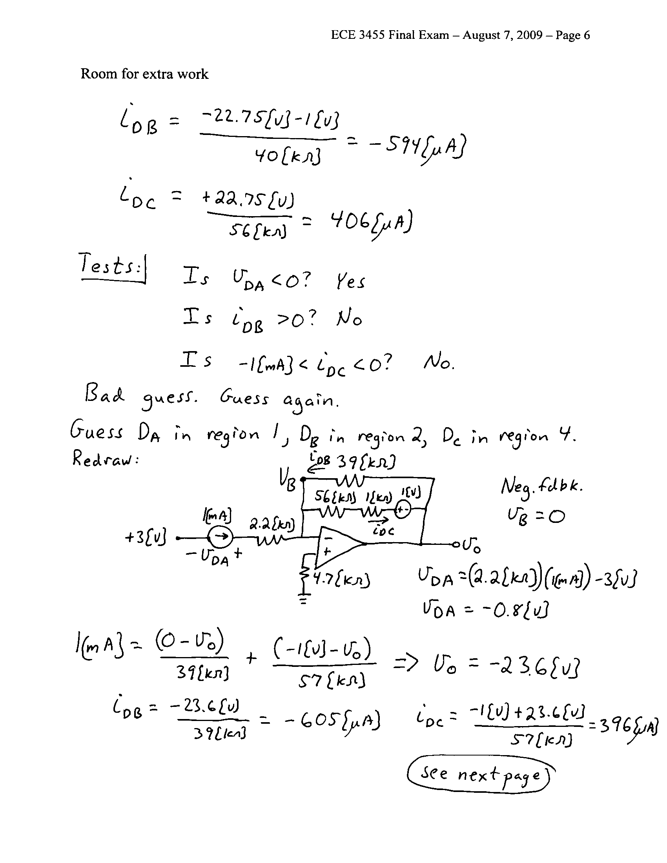
3. {25 Points} Assume ideal op amps. It is given that SWA was open and SWB was closed for a long time before t = 0. Assume that time t = 0 is defined as the time of one of the transitions from +15[V] to -10[V] for v_{A}.
a) Find numerical expressions for v_{B}(t) for 0 < t < 100[ms].
b) Sketch v_{B}(t) for 0 < t < 100[ms], showing quantitative scales.

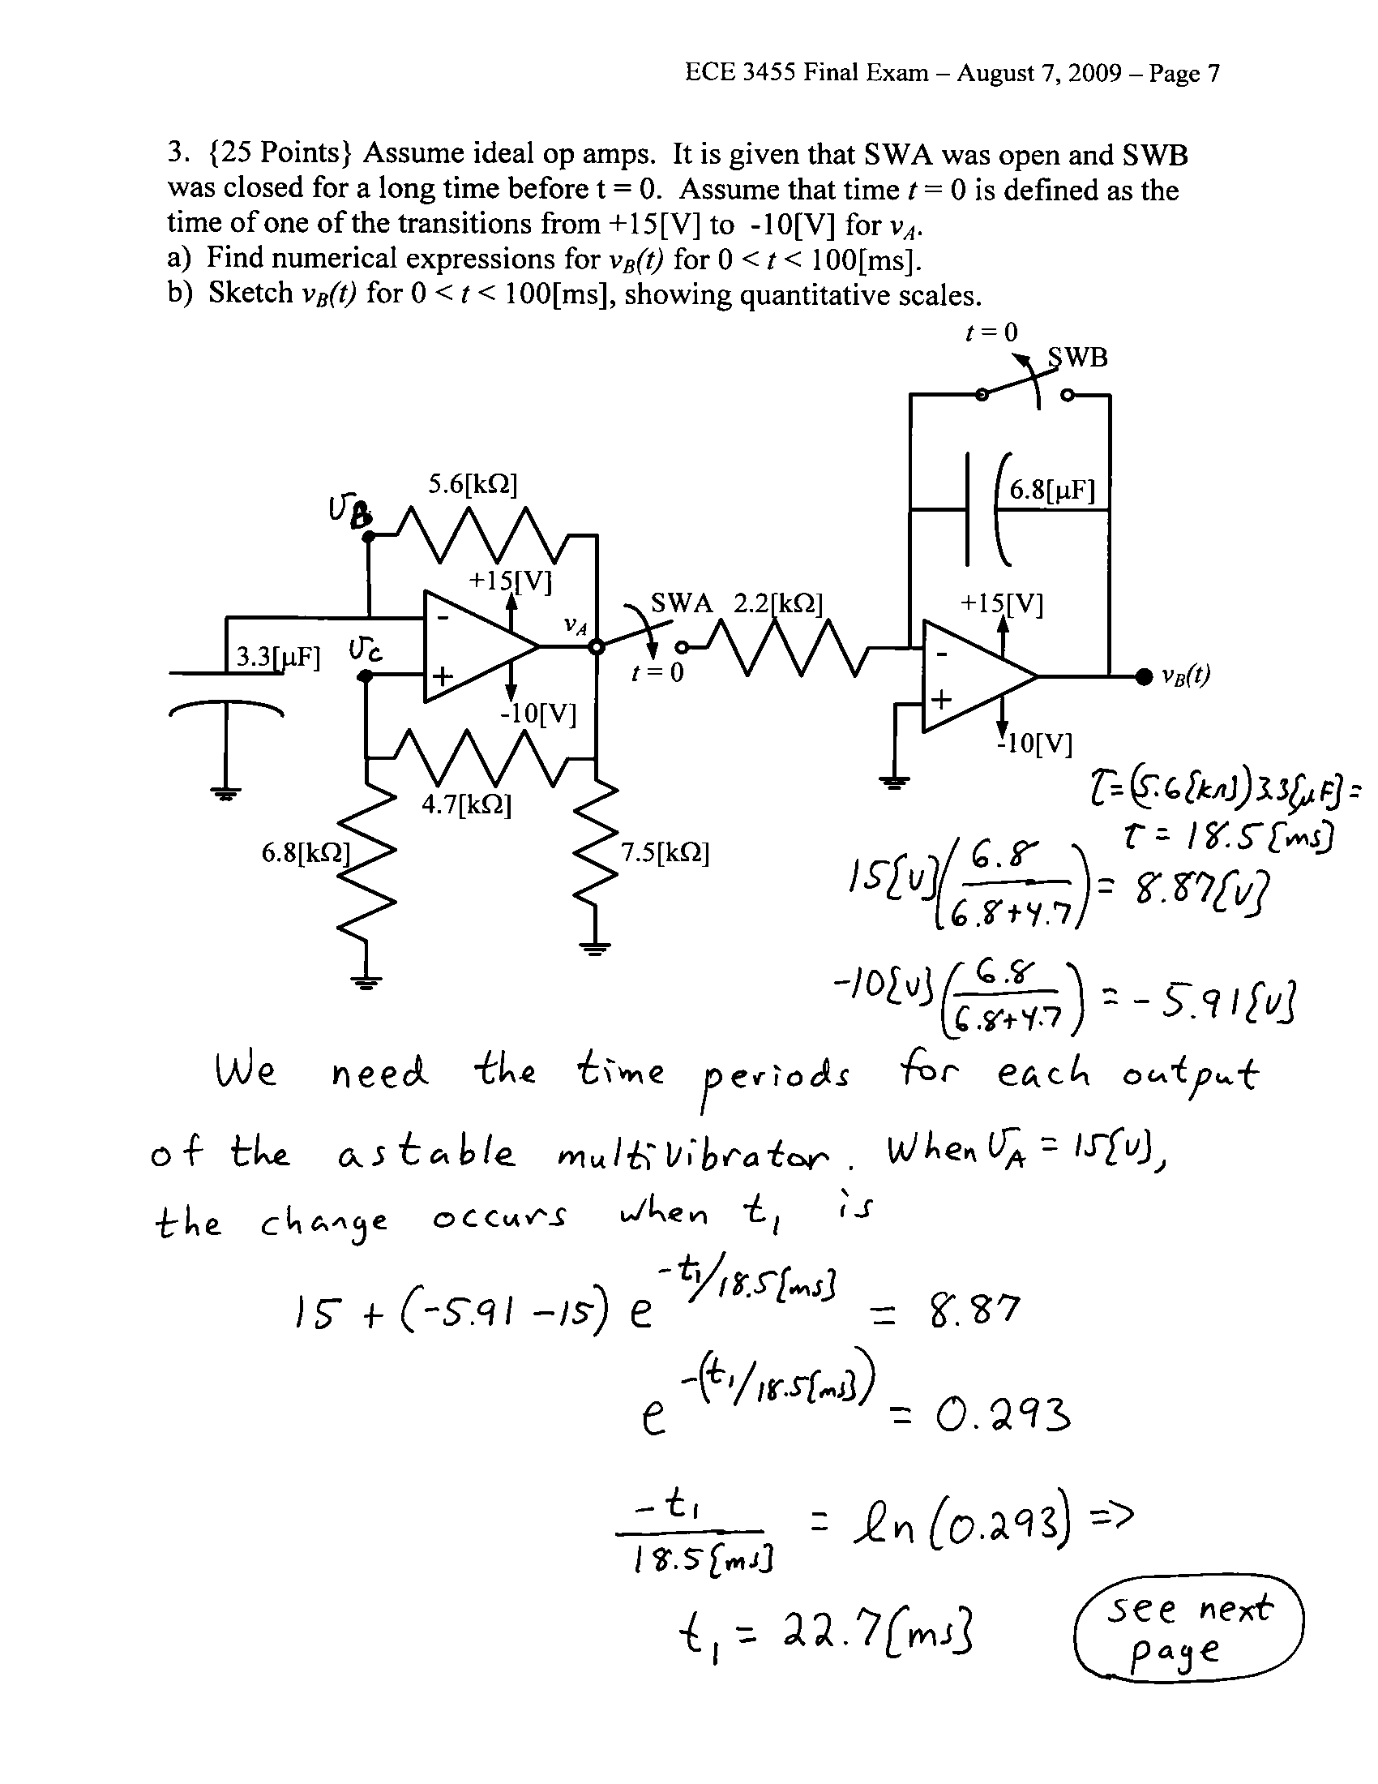
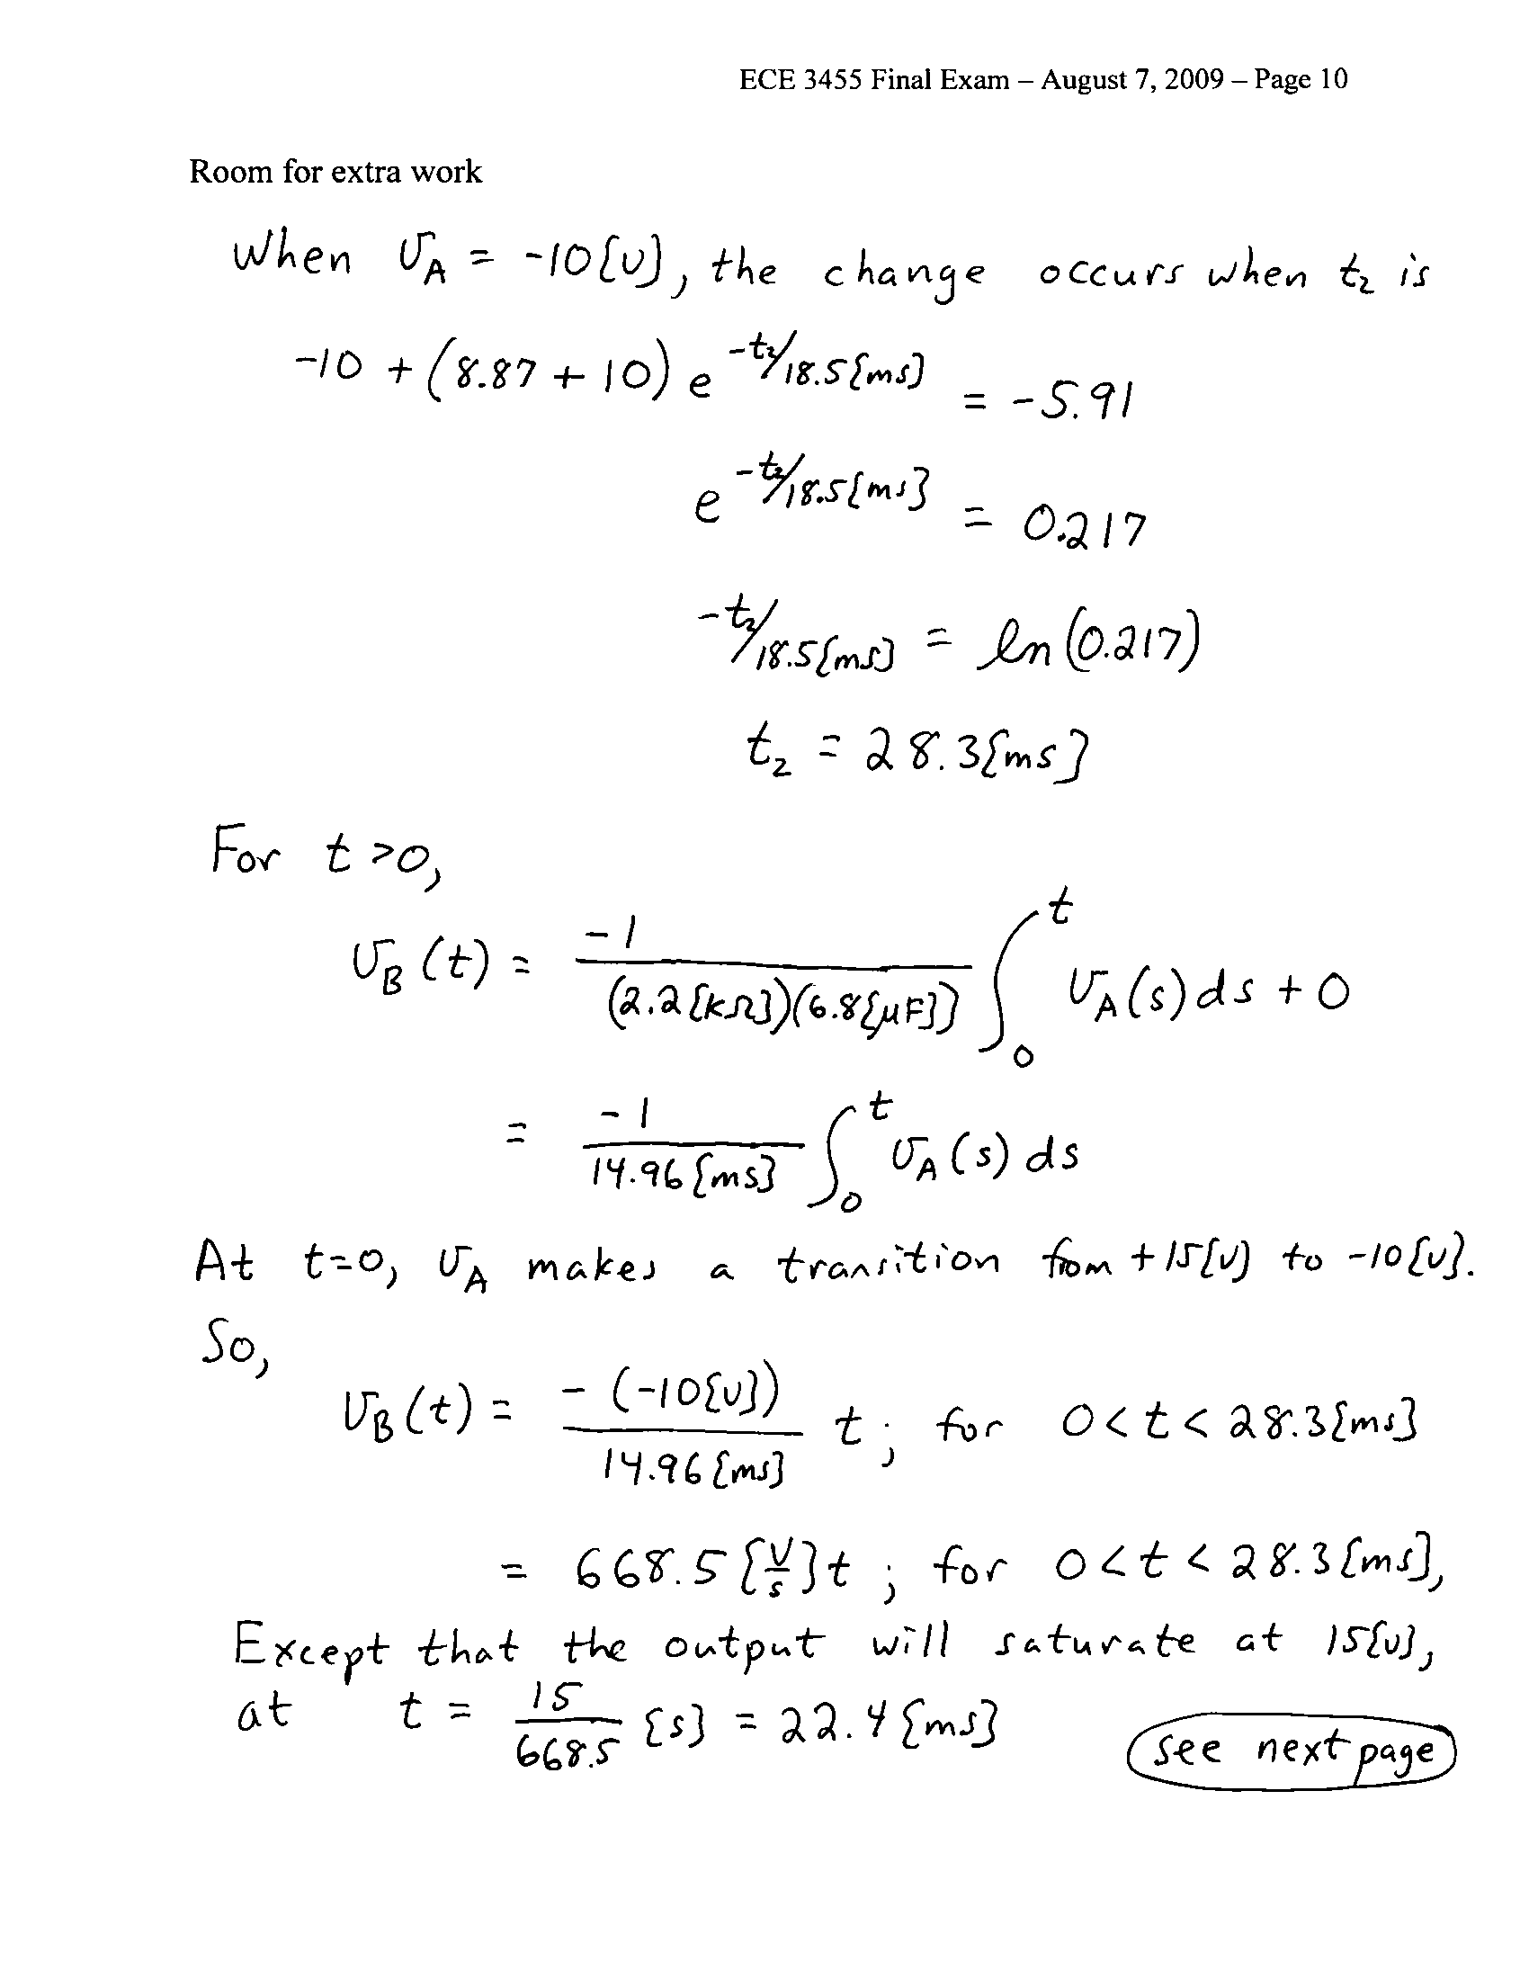
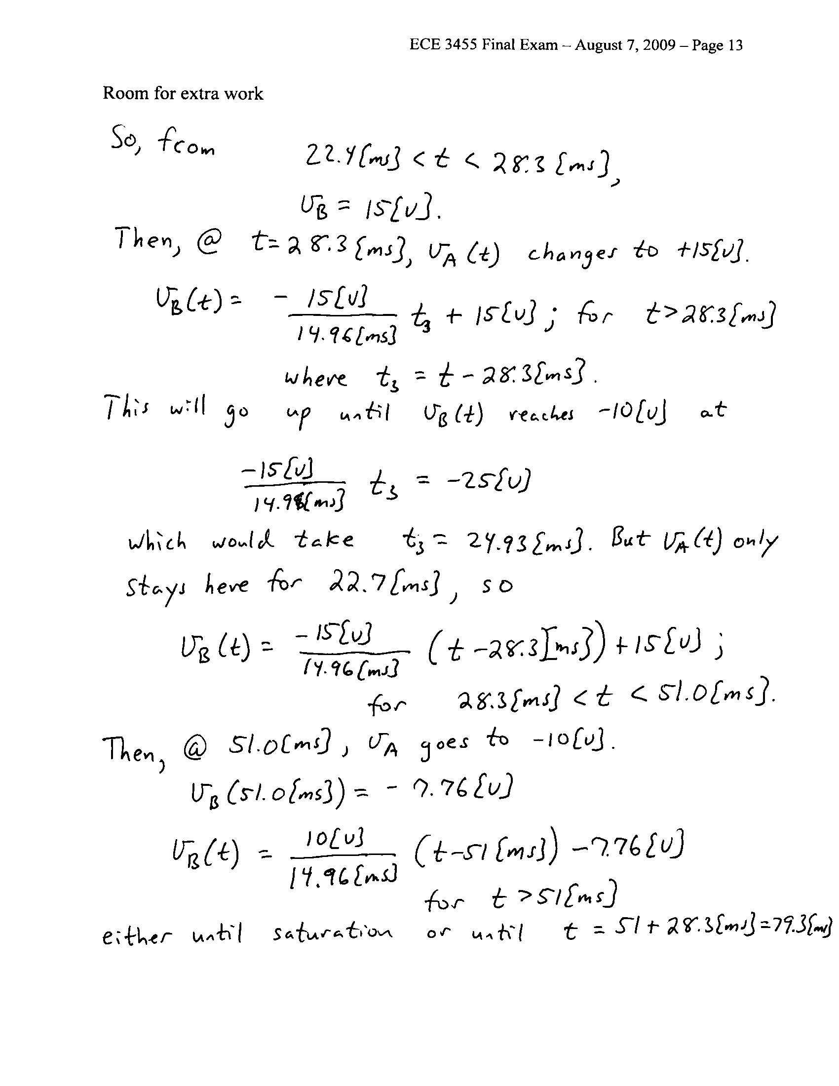
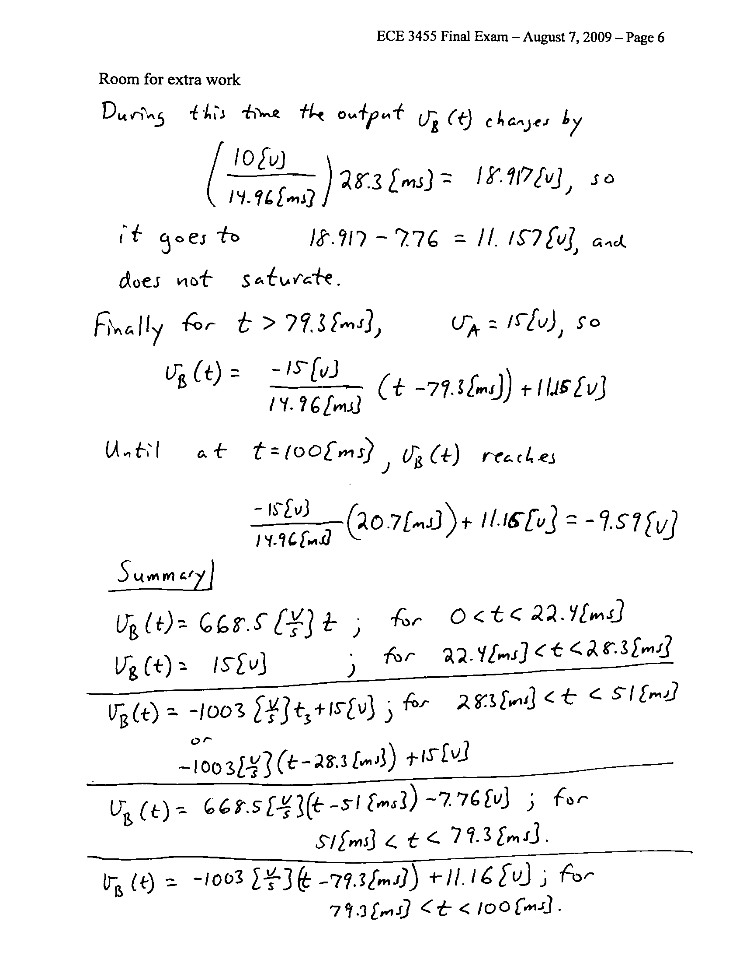

4. {25 Points} For the circuit given below, assume that the transistor has β = 35 and operates at room temperature.
a) Find the transconductance i_{l} /v_{s}, in the passband.
b) Find the current gain i_{l} /i_{s}, in the passband, in [dB].
c) How many poles and how many zeroes would be in the transfer function H(ω) = V_{l} /V_{s}?

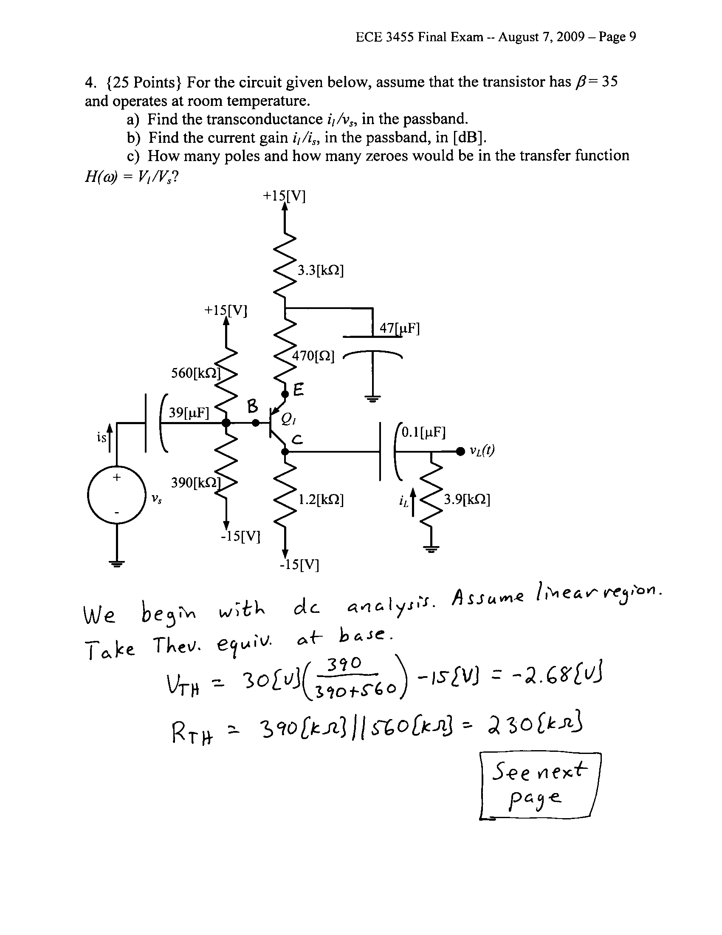
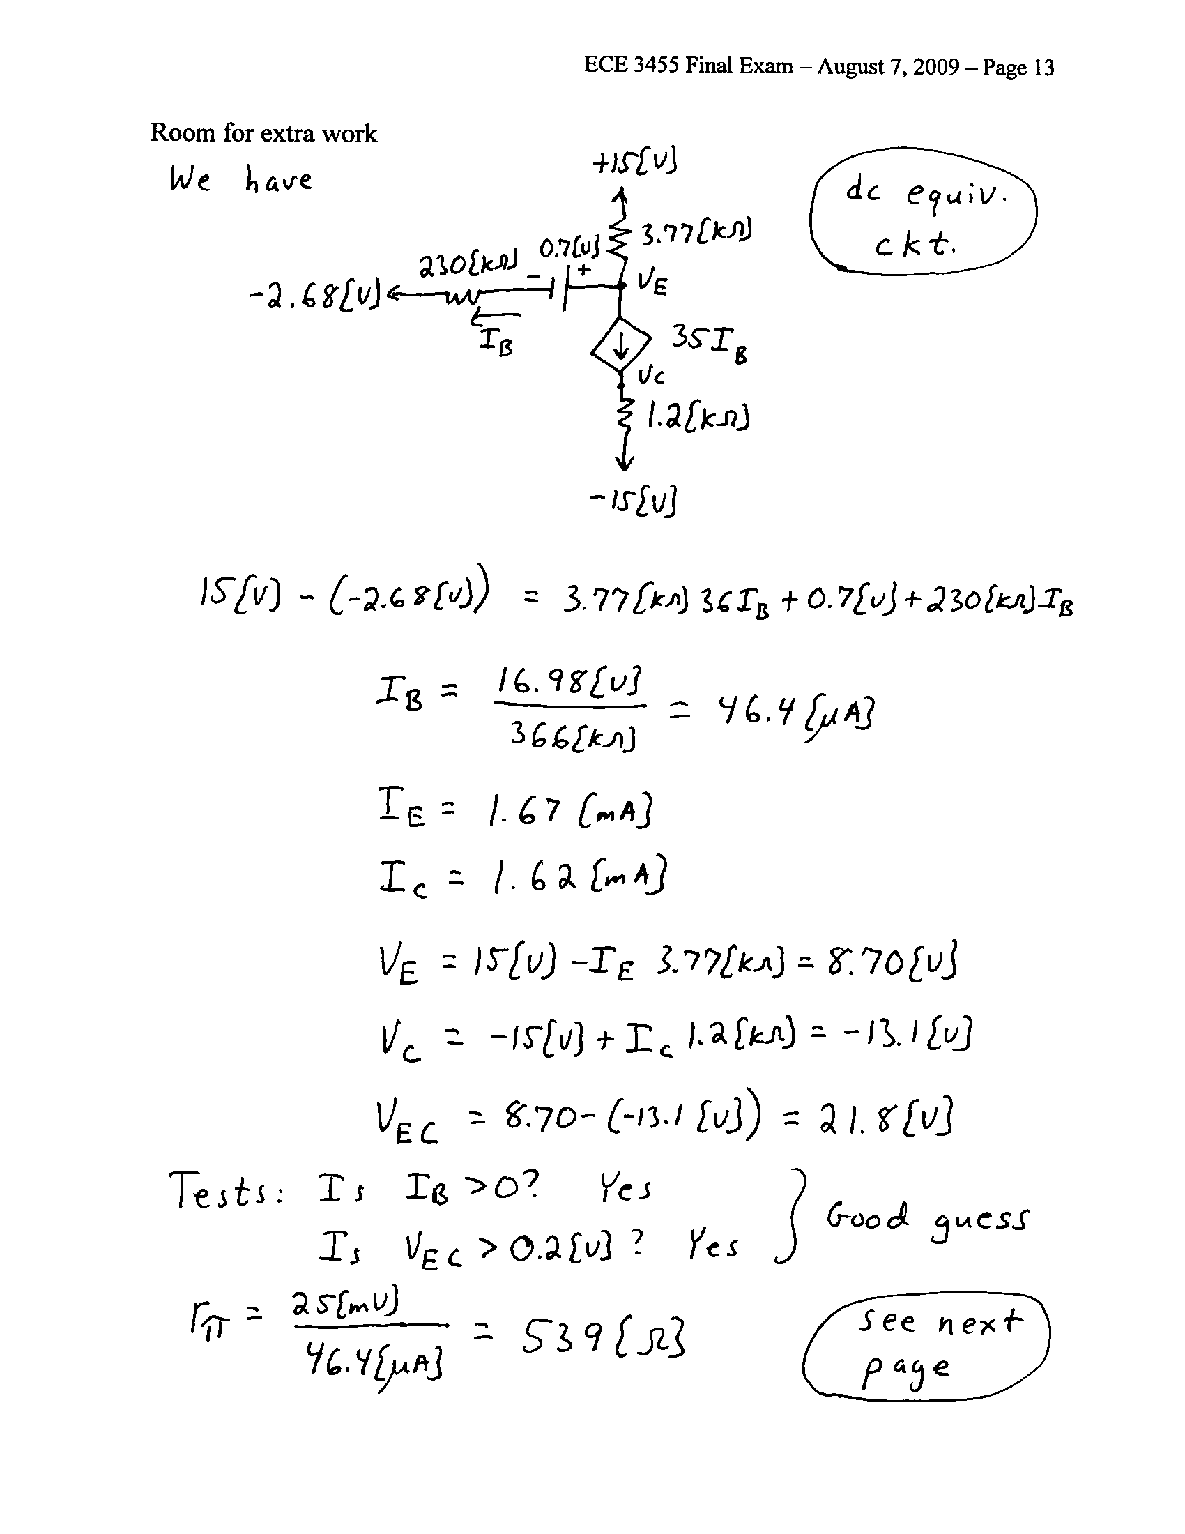
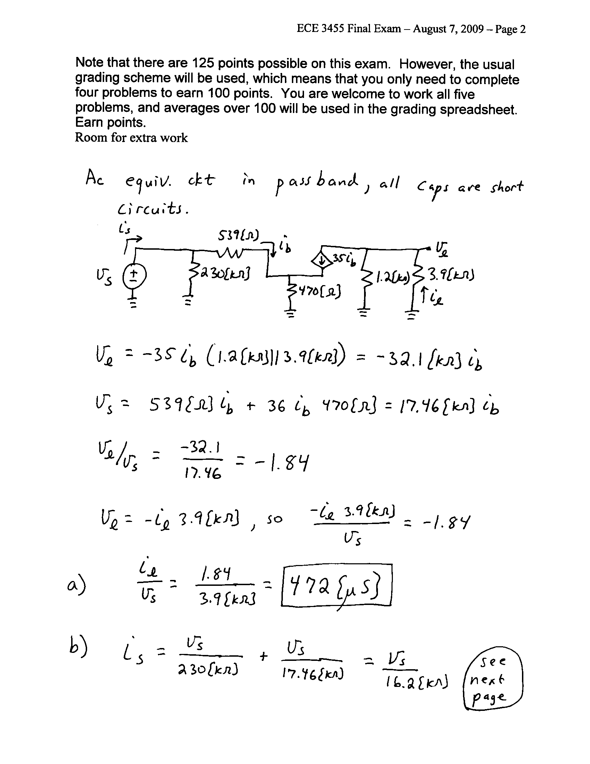

5. {25 Points} A device known as a brazilior has the schematic symbol shown in Fig. 1. The characteristic curves for this device are shown in Fig. 2 and Fig. 3. A brazilior has been connected in the circuit in Fig. 4, on the next page. (Hint: you can draw a load line on Fig. 2 based on the information in the schematic in Fig. 4.)
a) Find the small signal voltage gain v_{r} /v_{s}, in the passband.
b) Find the small signal input resistance seen by v_{s}(t), in the passband.
c) Find the small signal output resistance seen by R_{L}, in the passband.
