Name: _____________________________ (please print)
Signature: __________________________

ECE 3455 – Midsemester Exam
July 2, 2009

Keep this exam closed until you are told to begin.

1. This exam is closed book, closed notes. You may use one 8.5” x 11” crib sheet, or its equivalent.
2. Show all work on these pages. Show all work necessary to complete the problem. A solution without the appropriate work shown will receive no credit. A solution that is not given in a reasonable order will lose credit. Clearly indicate your answer (for example by enclosing it in a box).
3. It is assumed that your work will begin on the same page as the problem statement. If you choose to begin your work on another page, you must indicate this on the page with the problem statement, with a clear indication of where the work can be found. If your work continues on to another page, indicate clearly where your work can be found. Failure to indicate this clearly will result in a loss of credit.
4. Show all units in solutions, intermediate results, and figures. Units in the exam will be included between square brackets.
5. Do not use red ink. Do not use red pencil.
6. You will have 120 minutes to work on this exam.

1. ________________/25
2. ________________/25
3. ________________/25
4. ________________/25
Total = 100
Room for extra work
1. {25 Points} Two identical amplifiers are connected in the circuit shown in Figure 1. The equivalent circuit for these identical amplifiers is given in Figure 2. Note that the terminal numbers show the positions of each of the devices in Figure 1. As you work, please note that the current labeled i_{x} in Figure 2 can be different for each of the amplifiers in Figure 1. Use appropriate notation to indicate that the currents at the two inputs can be different.
a) Find the output resistance as seen by the load, R_{L}. Use the values
R_{i} = 1[kΩ], and R_{o} = 20[kΩ].
b) Find the input resistance seen by v_{s3}. Use the values R_{i} = 0, and R_{o} = ∞.

Room for extra work

2. {25 Points} The straight-line approximation to the phase Bode plot for H(f) is shown below. There are no poles or zeroes for H(f) outside the range
0.01[Hz] < f < 10⁶[Hz]. It is given that |H(1[Hz])| = 37[dB].
Find the numerical expression for the transfer function H(f) that would result in this straight-line approximation to the phase Bode plot, for the data given. Show your analysis steps clearly.

Room for extra work

3. {25 Points} Use the circuit below to find the numerical value of the following quantities. Assume ideal op amps.
- Find v_{y}(t).
- Find i_{x}(t).
- Find the output resistance seen by the load, R_{L}.
- Find the transconductance, i_{o}/v_{s}.

Room for extra work

4. {25 Points} A probe inserted into the optic nerve of a horseshoe crab, with respect to ground, can be modeled as a 75[mV_{rms}] voltage source in series with a 20[GΩ] resistance. The desire is to view the signal from this optic nerve on the oscilloscope in the UH Electronics Laboratory.
a) Describe the signal that would appear on the screen of the oscilloscope that would result from connecting the wire from this probe directly into the input of the oscilloscope. Show your work.
b) Describe the signal that would appear on the screen of the oscilloscope that would result from connecting the wire from this probe, through the 10X oscilloscope probe, and then into the input of the oscilloscope. Show your work.
c) Design an amplifier that would allow a researcher to reasonably view the signals from the optic nerve of a horseshoe crab using the oscilloscope in the UH Electronics Laboratory. Use an amplifier with input and output resistances which are finite and nonzero. You may use any gain you choose. Explain why your design will work.

Solutions:
1. {25 Points} Two identical amplifiers are connected in the circuit shown in Figure 1. The equivalent circuit for these identical amplifiers is given in Figure 2. Note that the terminal numbers show the positions of each of the devices in Figure 1. As you work, please note that the current labeled i_{x} in Figure 2 can be different for each of the amplifiers in Figure 1. Use appropriate notation to indicate that the currents at the two inputs can be different.
a) Find the output resistance as seen by the load, R_{L}. Use the values
R_{i} = 1[kΩ], and R_{o} = 20[kΩ].
b) Find the input resistance seen by v_{s3}. Use the values R_{i} = 0, and R_{o} = ∞.

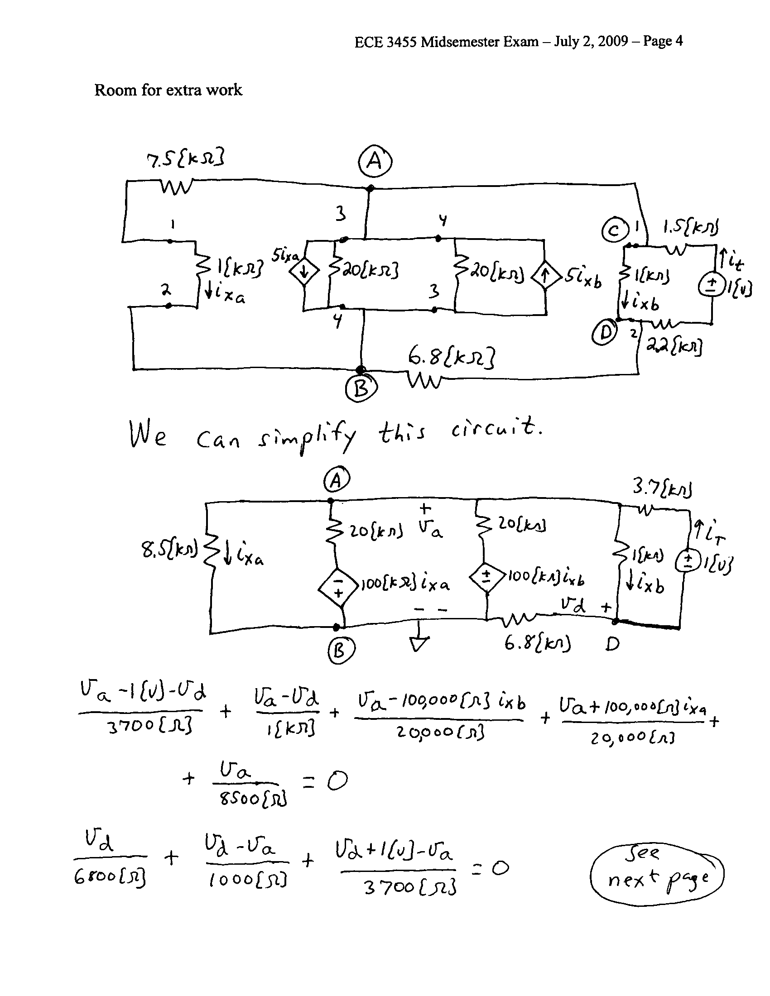
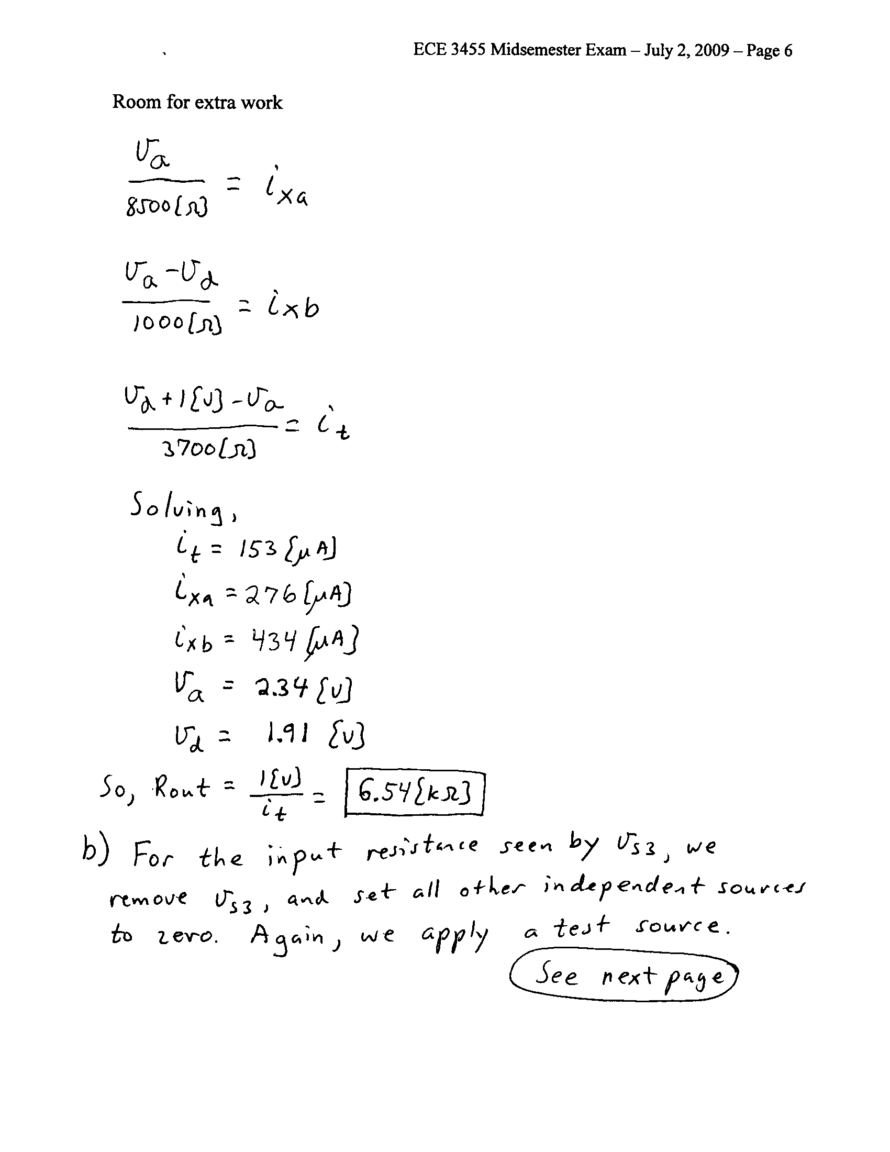
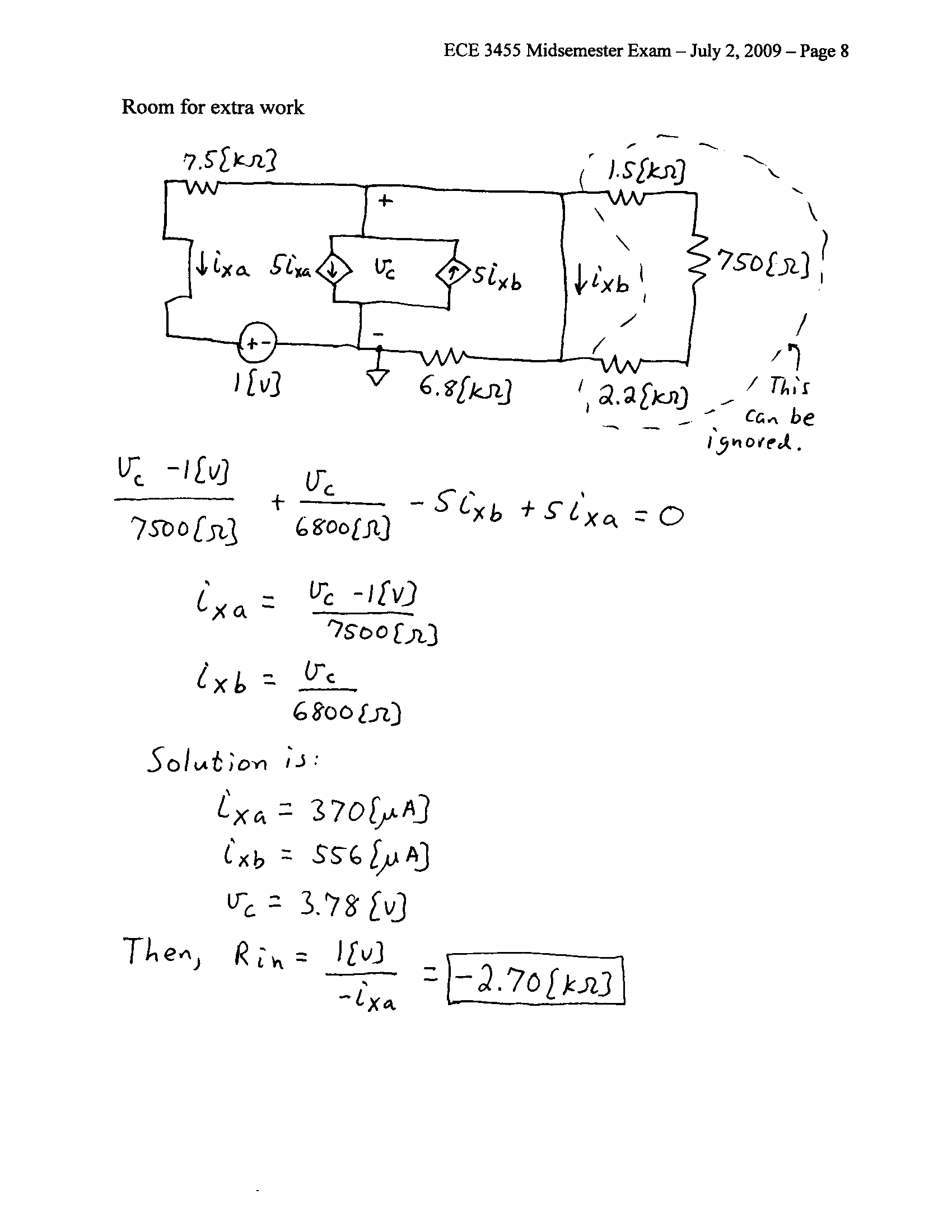

2. {25 Points} The straight-line approximation to the phase Bode plot for H(f) is shown below. There are no poles or zeroes for H(f) outside the range
0.01[Hz] < f < 10⁶[Hz]. It is given that |H(1[Hz])| = 37[dB].
Find the numerical expression for the transfer function H(f) that would result in this straight-line approximation to the phase Bode plot, for the data given. Show your analysis steps clearly.
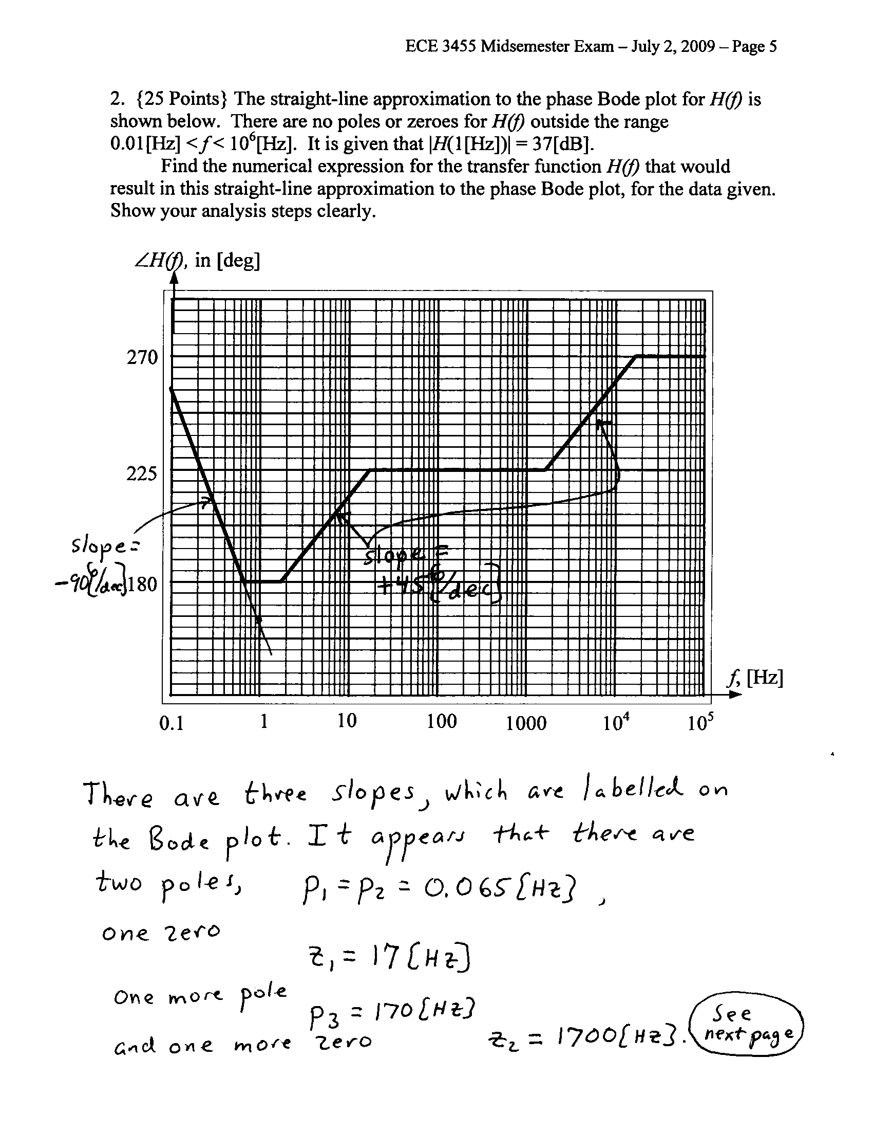
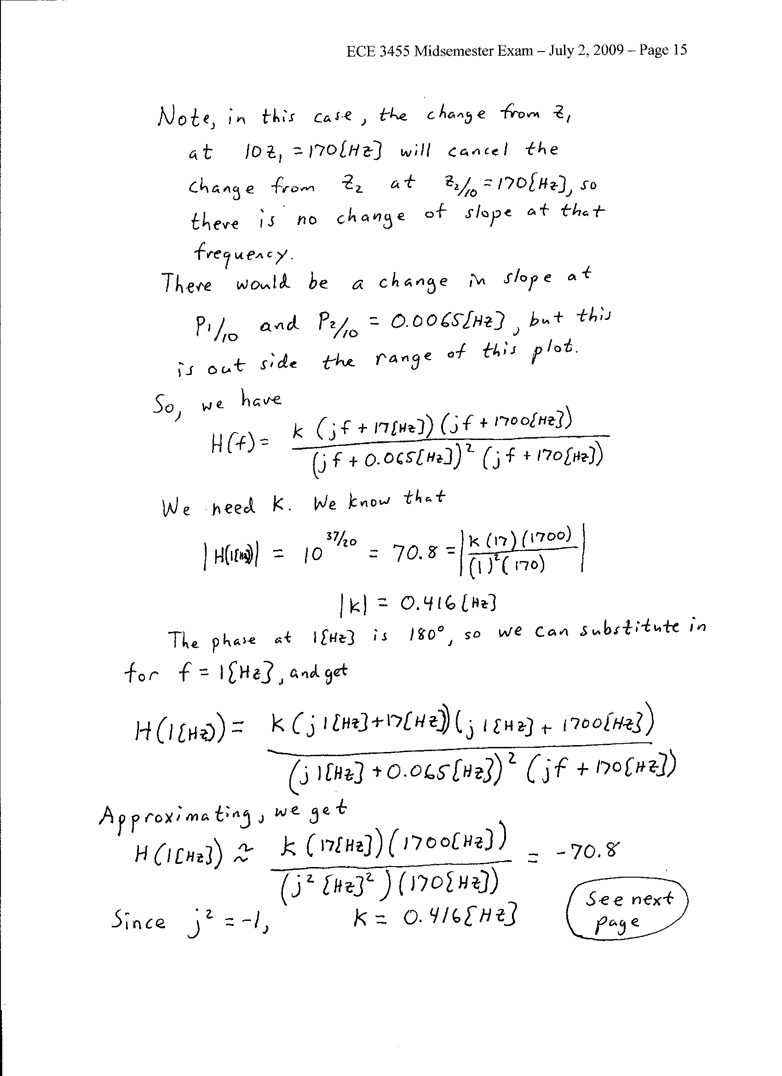
3. {25 Points} Use the circuit below to find the numerical value of the following quantities. Assume ideal op amps.
- Find v_{y}(t).
- Find i_{x}(t).
- Find the output resistance seen by the load, R_{L}.
- Find the transconductance, i_{o}/v_{s}.

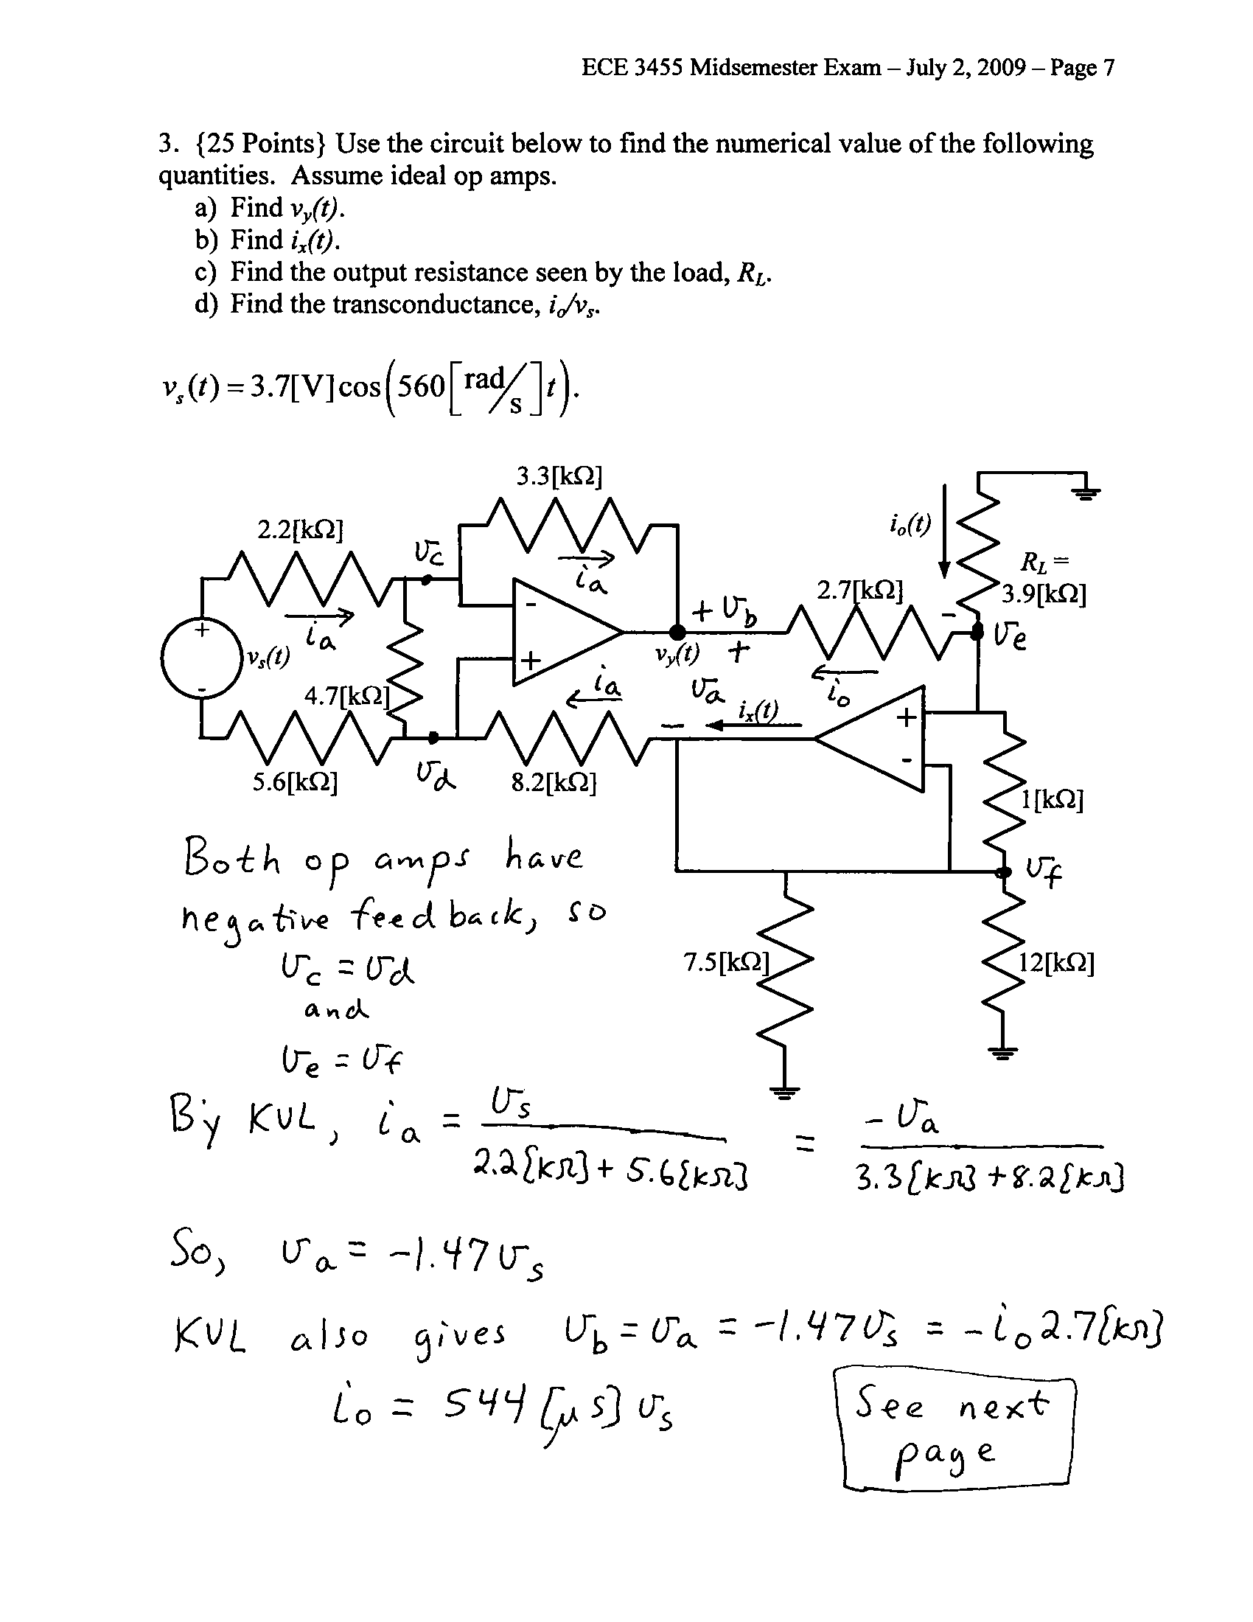
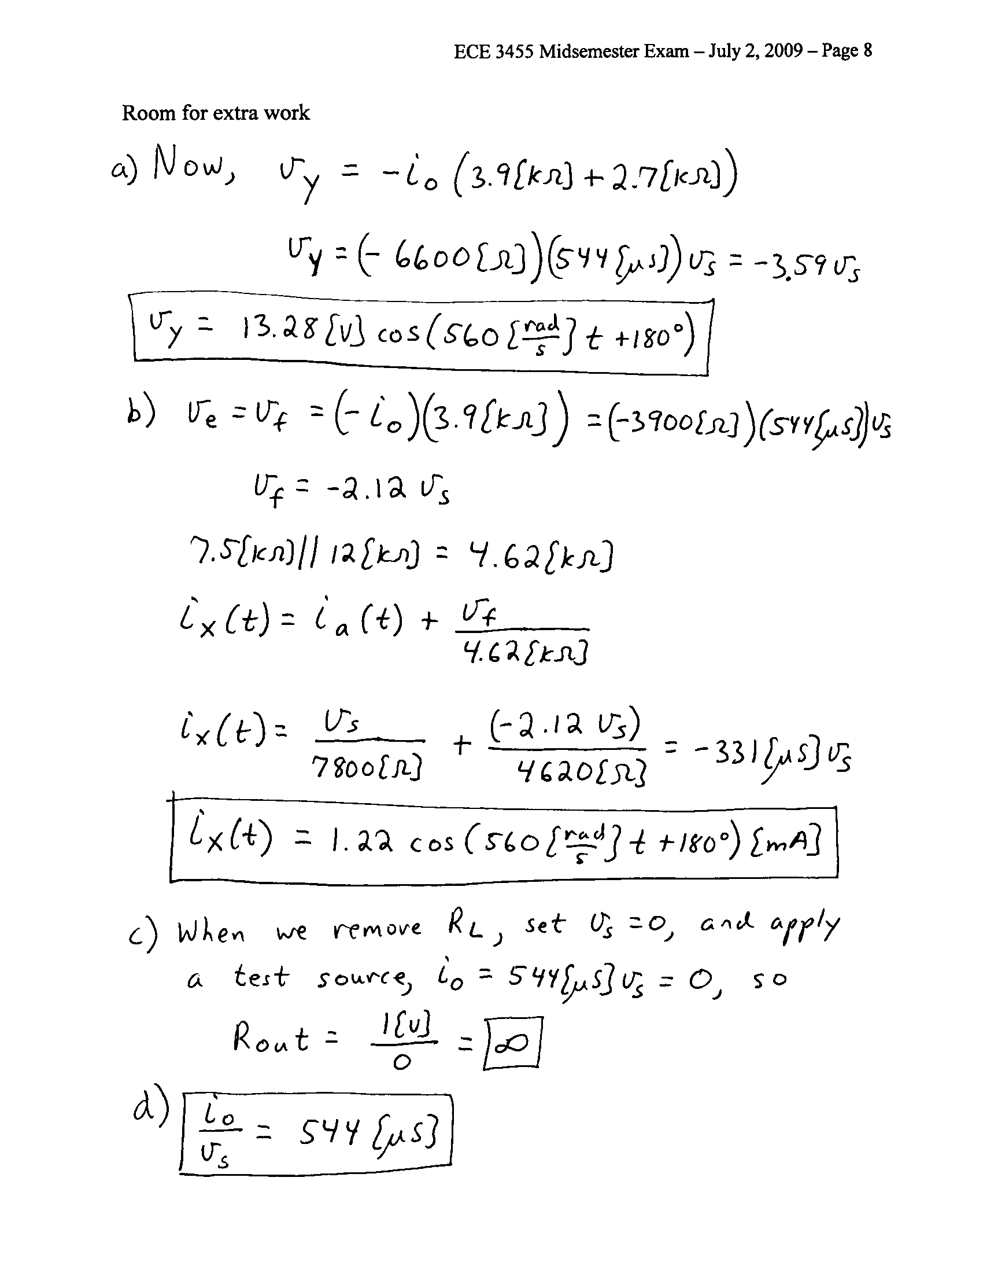

4. {25 Points} A probe inserted into the optic nerve of a horseshoe crab, with respect to ground, can be modeled as a 75[mV_{rms}] voltage source in series with a 20[GΩ] resistance. The desire is to view the signal from this optic nerve on the oscilloscope in the UH Electronics Laboratory.
a) Describe the signal that would appear on the screen of the oscilloscope that would result from connecting the wire from this probe directly into the input of the oscilloscope. Show your work.
b) Describe the signal that would appear on the screen of the oscilloscope that would result from connecting the wire from this probe, through the 10X oscilloscope probe, and then into the input of the oscilloscope. Show your work.
c) Design an amplifier that would allow a researcher to reasonably view the signals from the optic nerve of a horseshoe crab using the oscilloscope in the UH Electronics Laboratory. Use an amplifier with input and output resistances which are finite and nonzero. You may use any gain you choose. Explain why your design will work.

