Name: _____________________________ (please print)
Signature: __________________________

ECE 3355 – Exam 1
July 5, 2016

Keep this exam closed until you are told to begin.

1. This exam is closed book, closed notes. You may use one 8.5” x 11” crib sheet, or its equivalent.
2. Show all work on these pages. Show all work necessary to complete the problem. A solution without the appropriate work shown will receive no credit. A solution that is not given in a reasonable order will lose credit. Clearly indicate your answer (for example by enclosing it in a box). If your answer is a plot, no box is needed.
3. It is assumed that your work will begin on the same page as the problem statement. If you choose to begin your work on another page, you must indicate this on the page with the problem statement, with a clear indication of where the work can be found. If your work continues on to another page, indicate clearly where your work can be found. Failure to indicate this clearly will result in a loss of credit.
4. Show all units in solutions, intermediate results, and figures. Units in the exam will be included between square brackets.
5. Do not use red ink. Do not use red pencil.
6. You will have 100 minutes to work on this exam.

1. ________________/35
2. ________________/30
3. ________________/35
Total = 100
Room for extra work
1. {35 Points} An amplifier is shown inside the middle dashed line below, as a part of a circuit with feedback.
a) Find an equivalent circuit for the amplifier shown.
b) Find the input resistance seen by the source in the circuit shown in the diagram below.
c) Find the voltage gain v_{o}/v_{s} for the circuit shown in the diagram below.

Room for extra work

2. {30 Points} Use the graph paper provided to plot the straight–line approximation to the phase Bode plot for the transfer function H(ω) given below. Use a frequency range that includes all of the non-zero poles and zeroes. An extra piece of graph paper is provided for convenience only.

3. {35 Points} Assume ideal op amps.
- Find v_{A}.
- Find v_{B}.
- Find the input resistance seen by v_{I}.

Room for extra work

Solution:
1. {35 Points} An amplifier is shown inside the middle dashed line below, as a part of a circuit with feedback.
a) Find an equivalent circuit for the amplifier shown.
b) Find the input resistance seen by the source in the circuit shown in the diagram below.
c) Find the voltage gain v_{o}/v_{s} for the circuit shown in the diagram below.
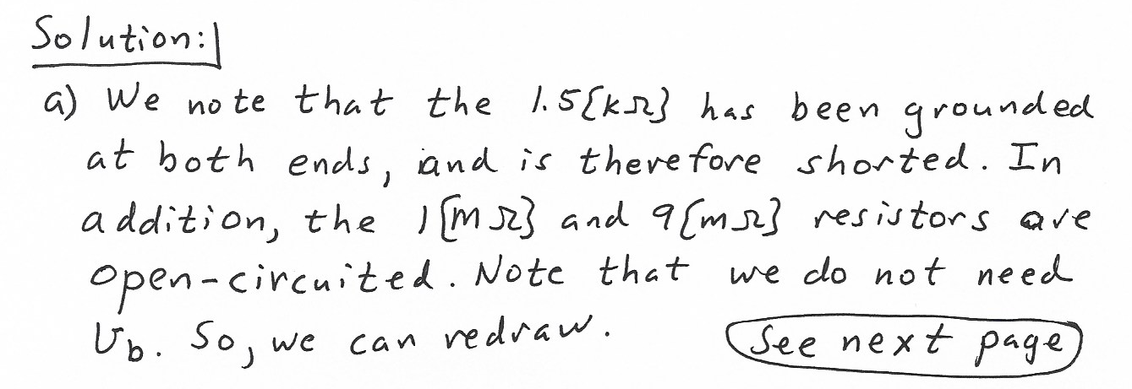
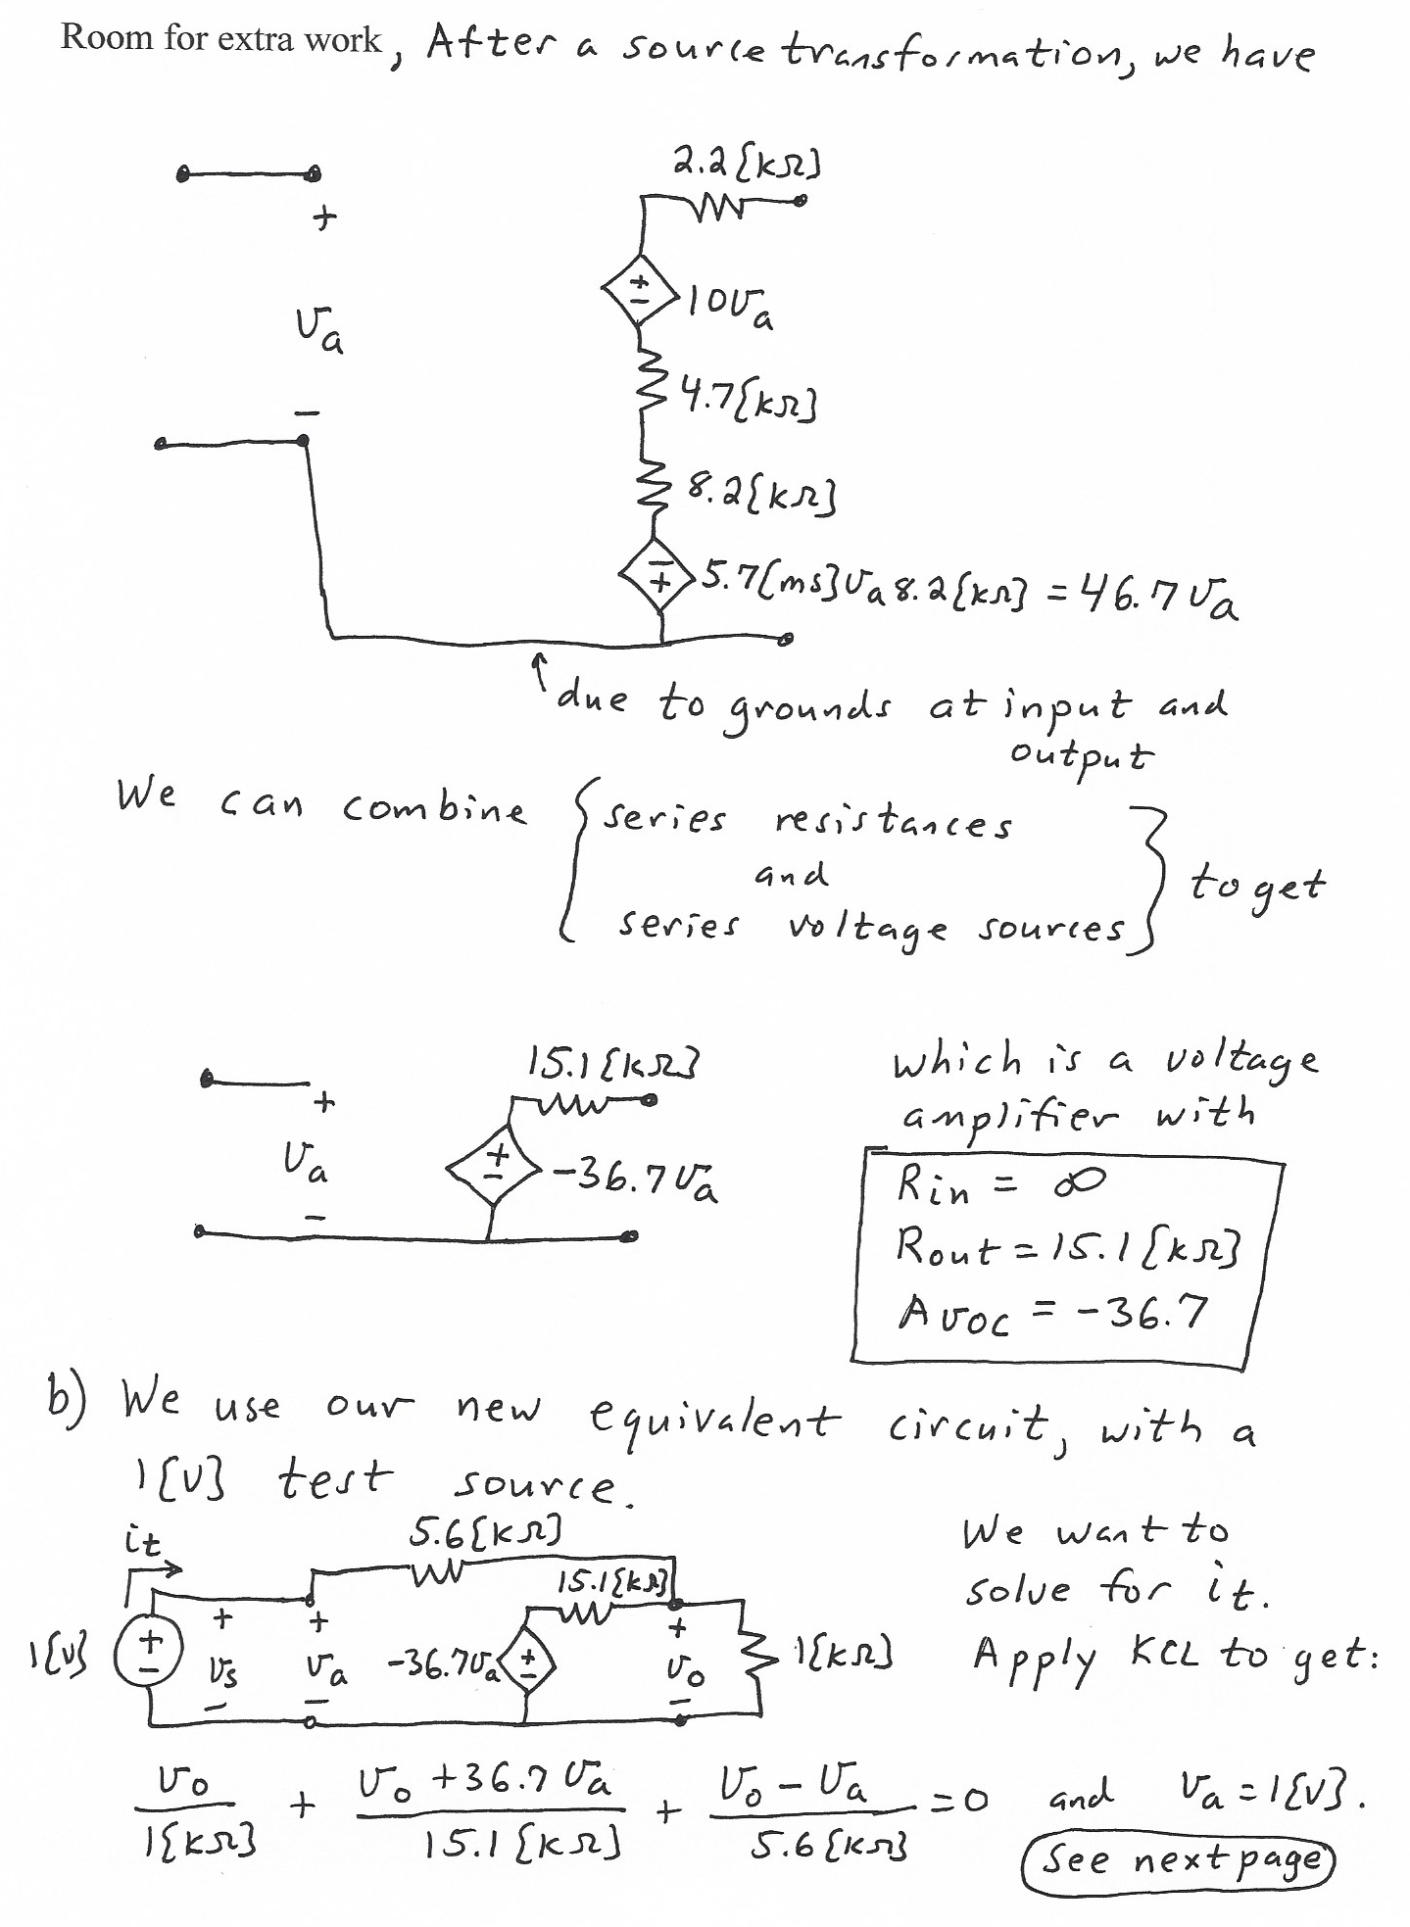
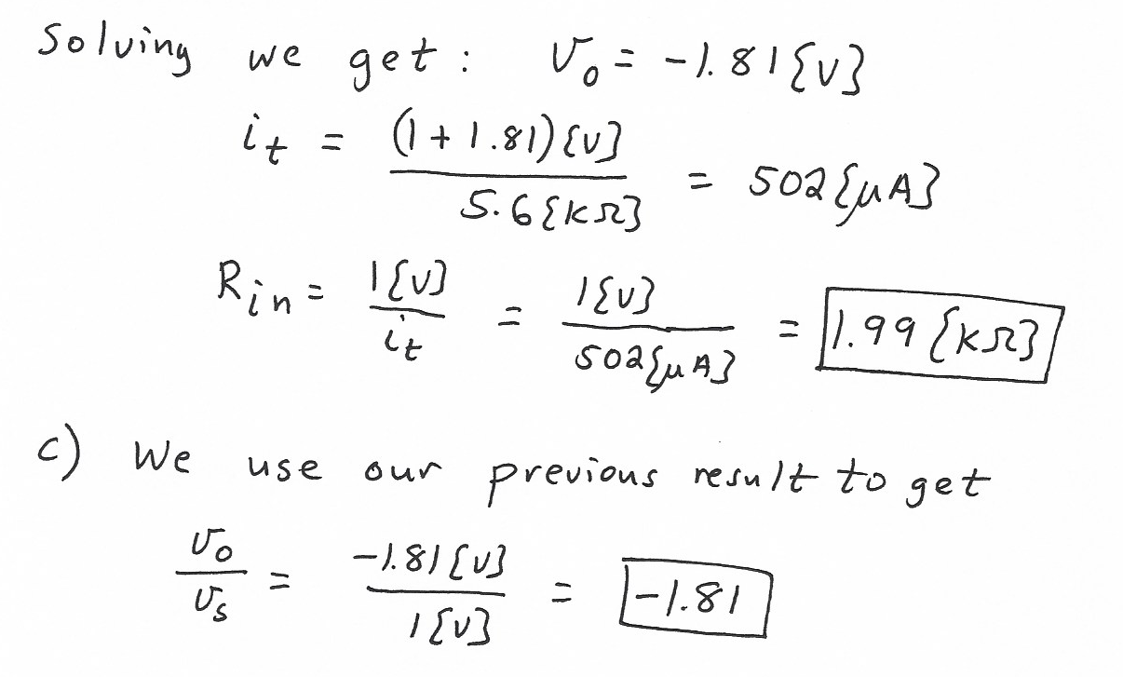

2. {30 Points} Use the graph paper provided to plot the straight–line approximation to the phase Bode plot for the transfer function H(ω) given below. Use a frequency range that includes all of the non-zero poles and zeroes. An extra piece of graph paper is provided for convenience only.
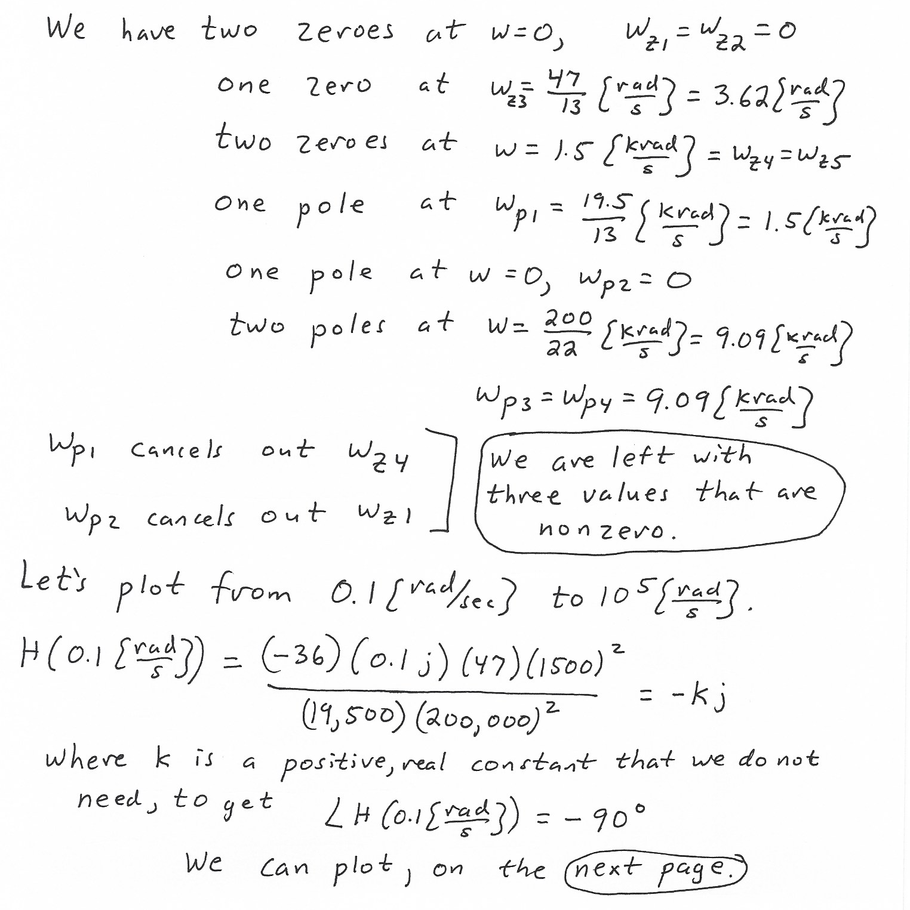
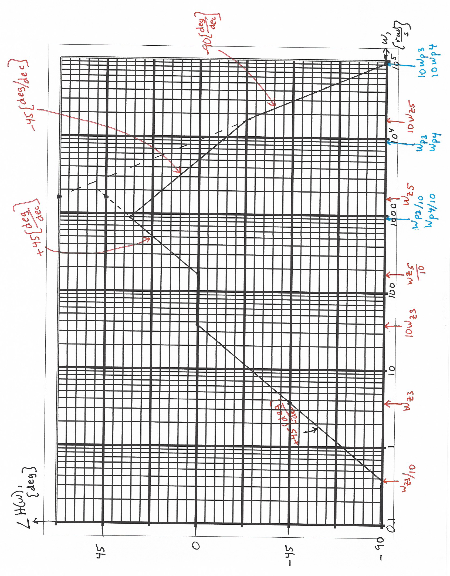

3. {35 Points} Assume ideal op amps.
- Find v_{A}.
- Find v_{B}.
- Find the input resistance seen by v_{I}.
