Name: _____________________________ (please print)
Signature: __________________________

ECE 3355 – Final Exam
July 26, 2016

Keep this exam closed until you are told to begin.

1. This exam is closed book, closed notes. You may use one 8.5” x 11” crib sheet, or its equivalent.
2. Show all work on these pages. Show all work necessary to complete the problem. A solution without the appropriate work shown will receive no credit. A solution that is not given in a reasonable order will lose credit. Clearly indicate your answer (for example by enclosing it in a box). If your answer is a plot, no box is needed.
3. It is assumed that your work will begin on the same page as the problem statement. If you choose to begin your work on another page, you must indicate this on the page with the problem statement, with a clear indication of where the work can be found. If your work continues on to another page, indicate clearly where your work can be found. Failure to indicate this clearly will result in a loss of credit.
4. Show all units in solutions, intermediate results, and figures. Units in the exam will be included between square brackets.
5. Do not use red ink. Do not use red pencil.
6. You will have 170 minutes to work on this exam.

1. ________________/40
2. ________________/40
3. ________________/40
4. ________________/40
5. ________________/40
6. ________________/40
Total = 240
Room for extra work

1. {40 Points} An audio amplifier has been designed to have the straight-line approximation to the magnitude Bode plot shown in the plot below.
a) Find the value of f₁.
b) Determine whether there are poles or zeroes at f₁, and if so, how many of them.
c) Find the value of f₂.
d) Determine whether there are poles or zeroes at f₂, and if so, how many of them.

Room for extra work

2. {40 Points} Use the circuit below to solve this problem. Assume ideal op amps.
a) Find the voltage v_{A}.
b) Find the current i_{A}.

Room for extra work

3. {40 Points} Assume an ideal op amp in the figure below. Assume that the diode can be modeled with the ECE 3355 piecewise-linear diode model, with
V_{f} = 1[V], r_{d} = 1[kΩ], and I_{s} = 1[mA].
a) Find v_{O}, with v_{I} = 5[V]. You should be able to complete at least two complete guesses in the time period available.
b) Find v_{O}, with v_{I} = -5[V]. You should be able to complete at least two complete guesses in the time period available.
c) Sketch the transfer characteristic v_{O} versus v_{I} for this circuit, for the range
-5[V] < v_{I} < 5[V]. Show appropriate numerical values on your characteristic.

Room for extra work

4. {40 Points} The characteristic curves for the device, called a tailerswiftee, are shown in Figures 1, 2 and 3. The device schematic symbol is shown in Figure 4.
- Find a DC model, or a large-signal model, for Region 3 of this device, and draw it labeling terminals F, G, and H.
- Find an ac model, or a small-signal model, for Region 3 of this device, and draw it labeling terminals F, G, and H.

Room for extra work

5. {40 Points} Use the circuit shown to solve this problem. Assume that for the transistor β = 200, and that it is operating at room temperature.
a) Find V_{E}.
b) Find the voltage gain v_{d} / v_{a}, in dB, in the passband.
c) Find the output resistance seen the load R_{L}, in the passband.

Room for extra work

6. {40 Points} An amplifier has the transfer characteristic given in Figure 1. This amplifier is connected in the circuit shown in Figure 2.
a) Find the transconductance gain i_{b} / v_{a}, for small signals.
b) Assume that v_{a}(t) is a zero-mean sinusoid. Find the largest rms value for v_{a}(t) that will yield an undistorted output for i_{b}(t).

1. {40 Points} An audio amplifier has been designed to have the straight-line approximation to the magnitude Bode plot shown in the plot below.
a) Find the value of f₁.
b) Determine whether there are poles or zeroes at f₁, and if so, how many of them.
c) Find the value of f₂.
d) Determine whether there are poles or zeroes at f₂, and if so, how many of them.

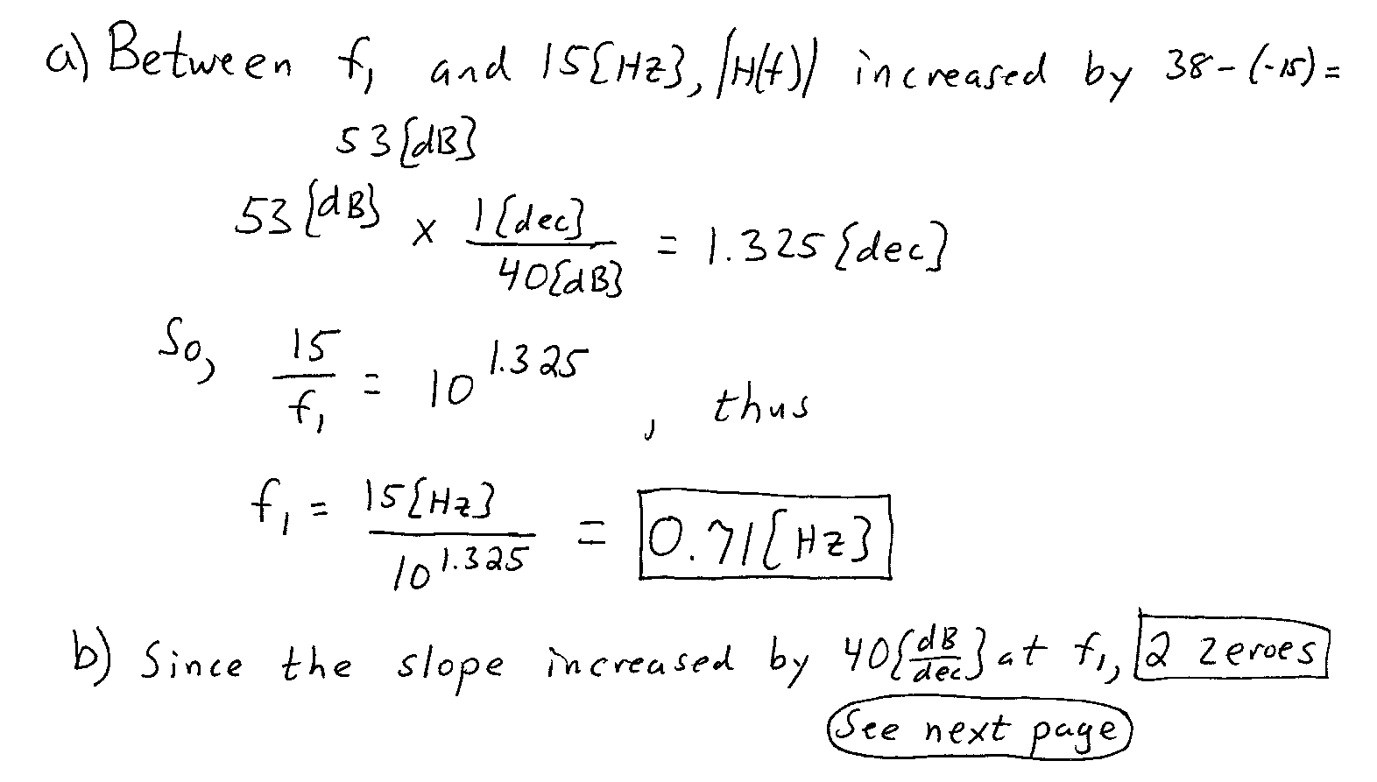
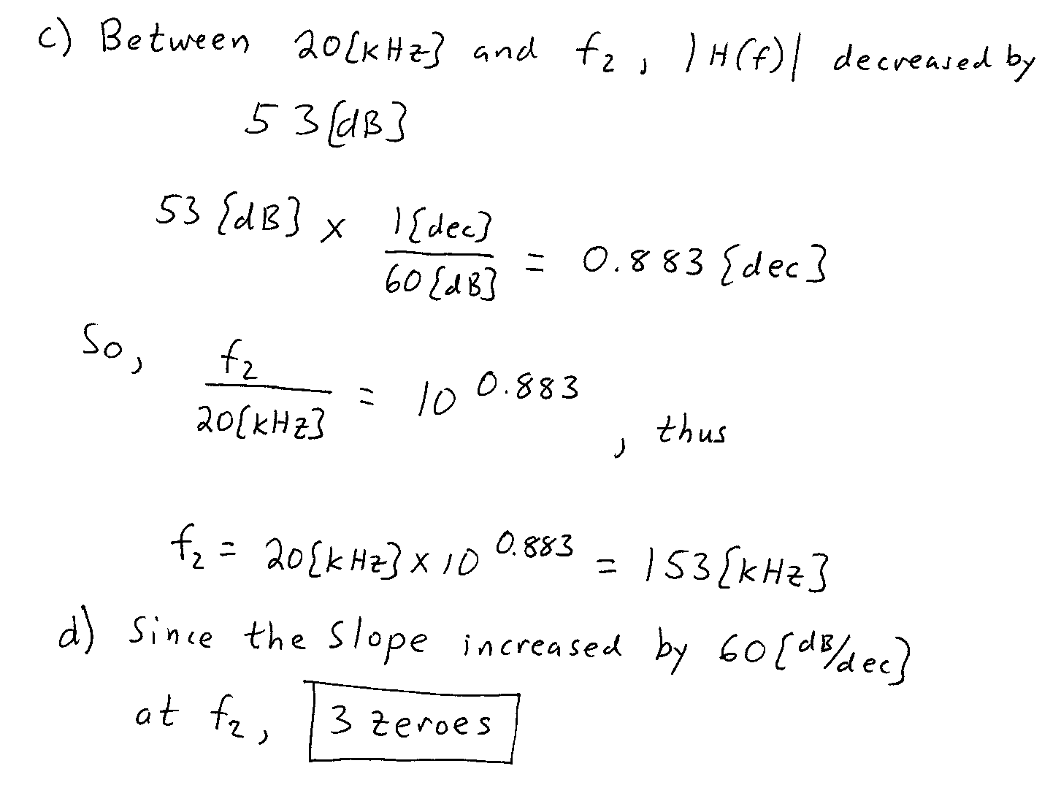
2. {40 Points} Use the circuit below to solve this problem. Assume ideal op amps.
a) Find the voltage v_{A}.
b) Find the current i_{A}.
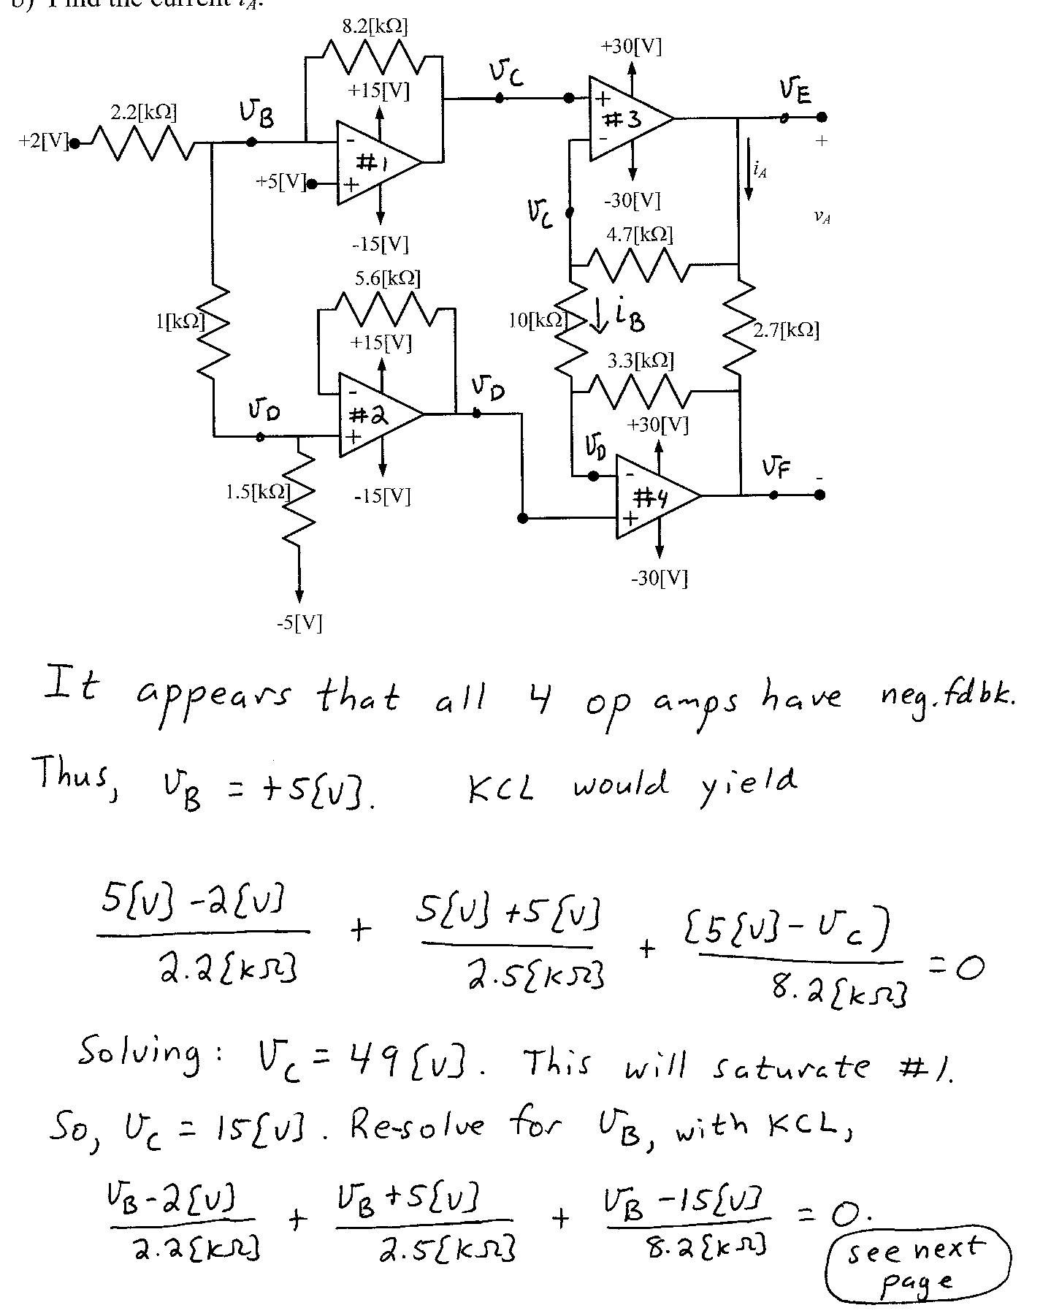
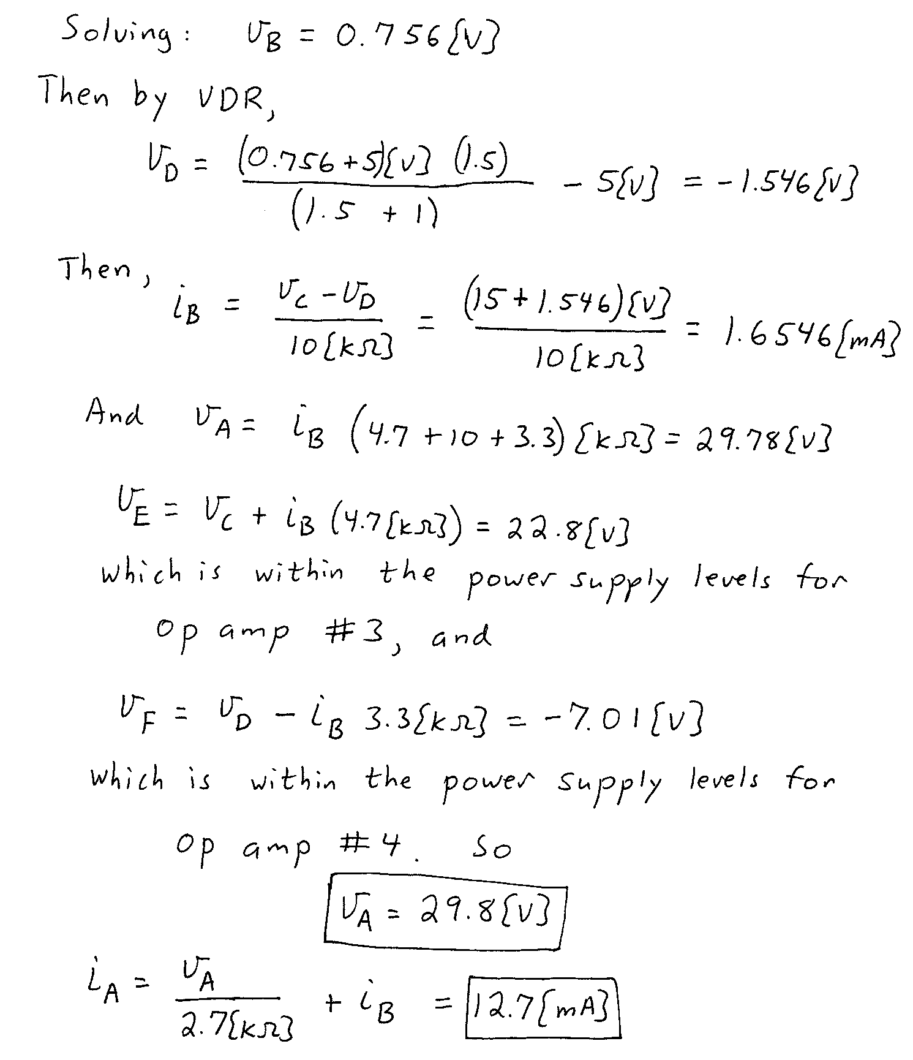

3. {40 Points} Assume an ideal op amp in the figure below. Assume that the diode can be modeled with the ECE 3355 piecewise-linear diode model, with
V_{f} = 1[V], r_{d} = 1[kΩ], and I_{s} = 1[mA].
a) Find v_{O}, with v_{I} = 5[V]. You should be able to complete at least two complete guesses in the time period available.
b) Find v_{O}, with v_{I} = -5[V]. You should be able to complete at least two complete guesses in the time period available.
c) Sketch the transfer characteristic v_{O} versus v_{I} for this circuit, for the range
-5[V] < v_{I} < 5[V]. Show appropriate numerical values on your characteristic.
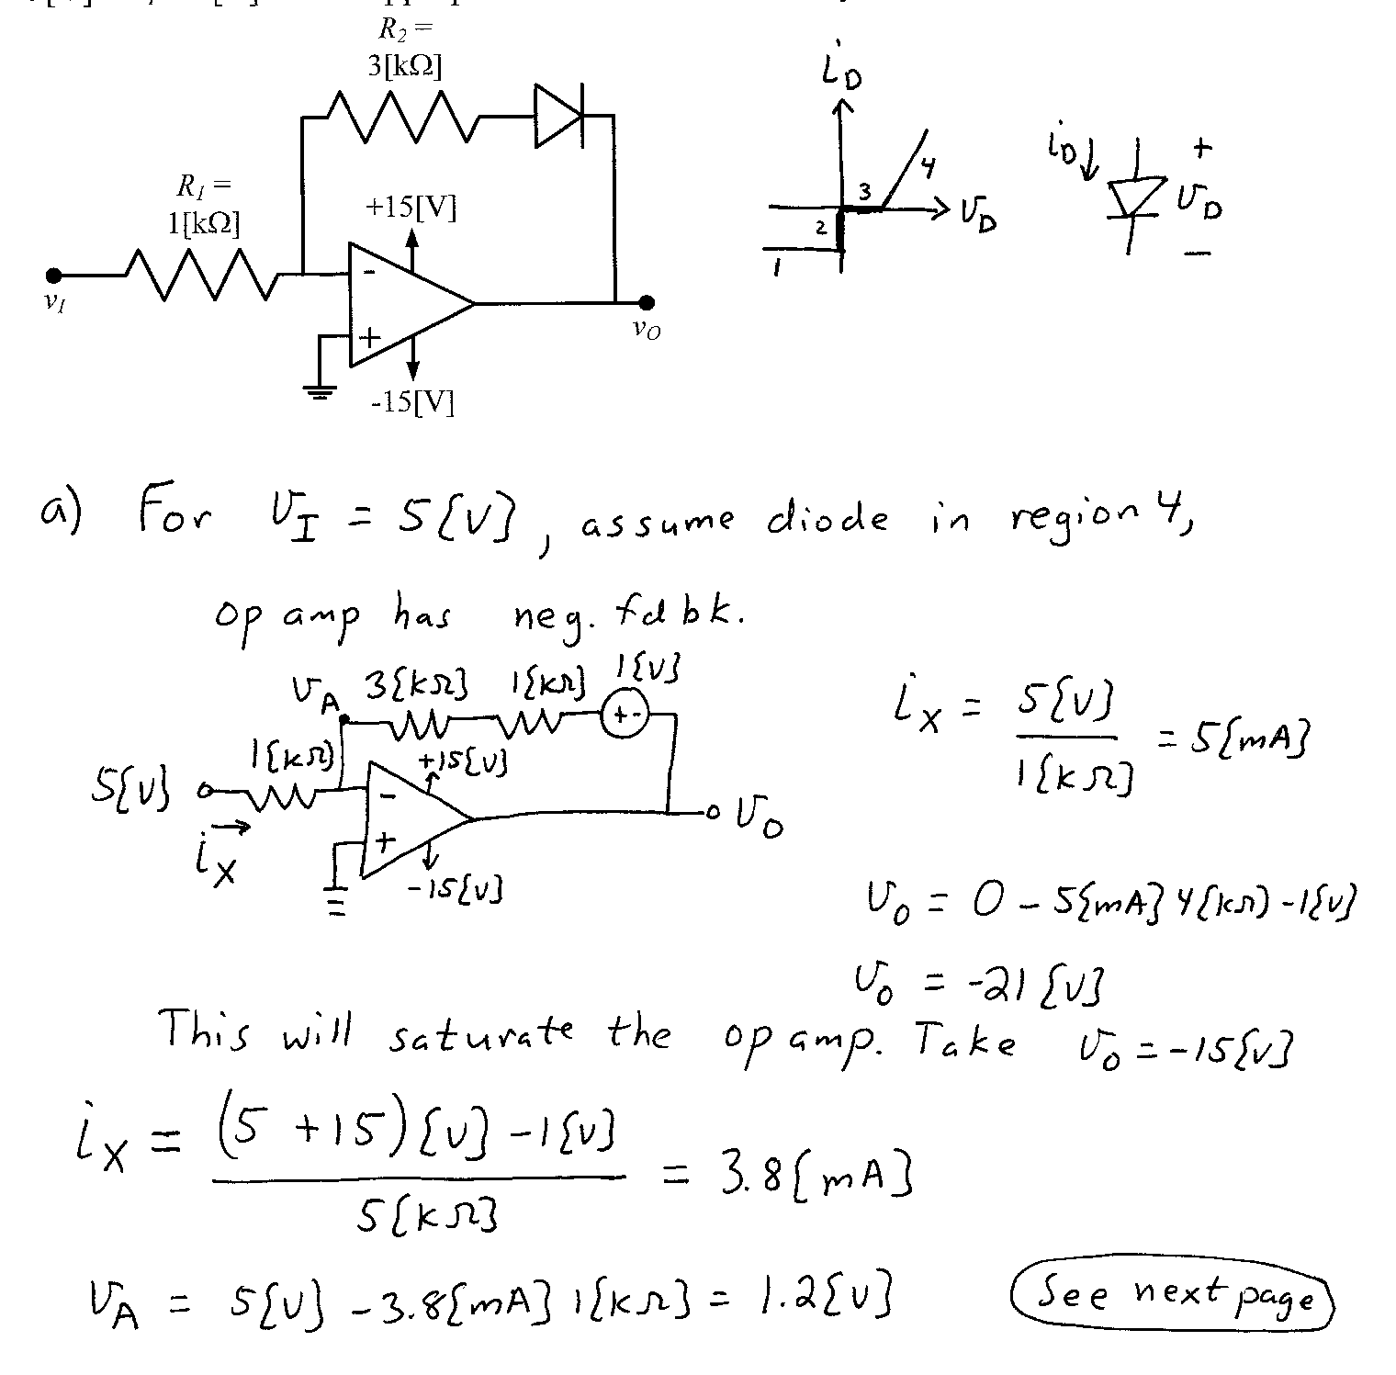
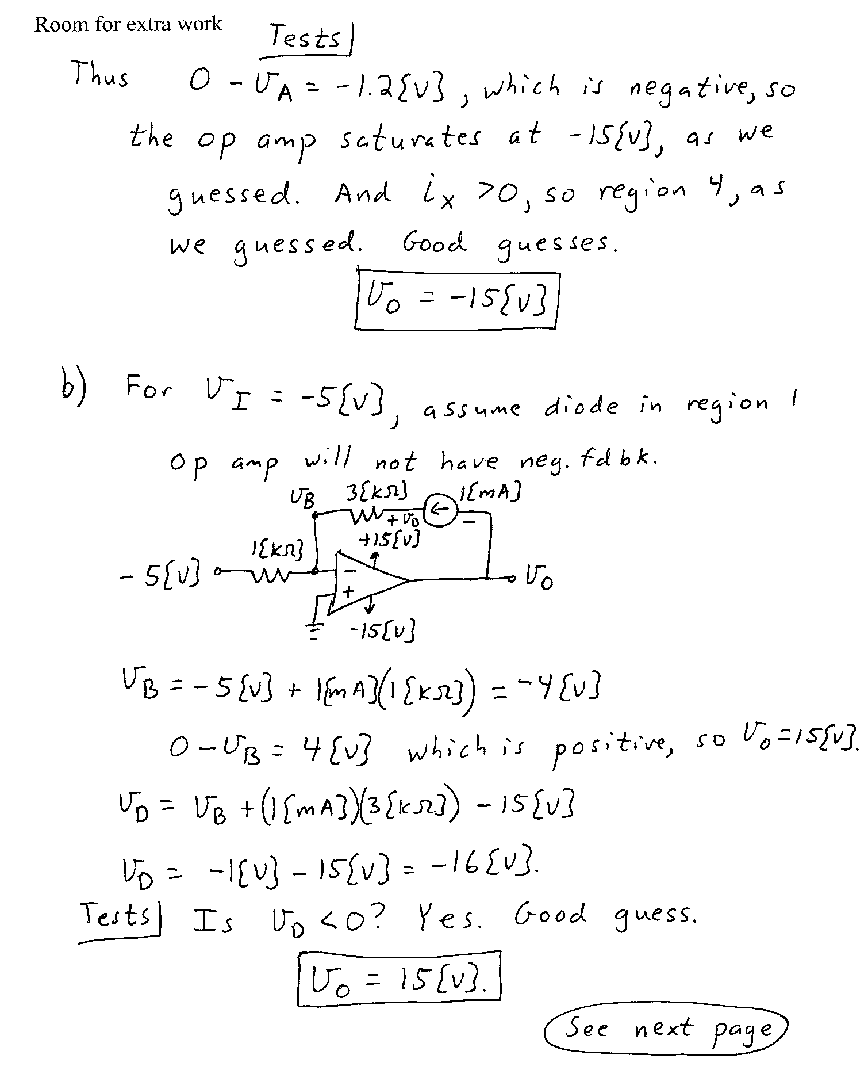
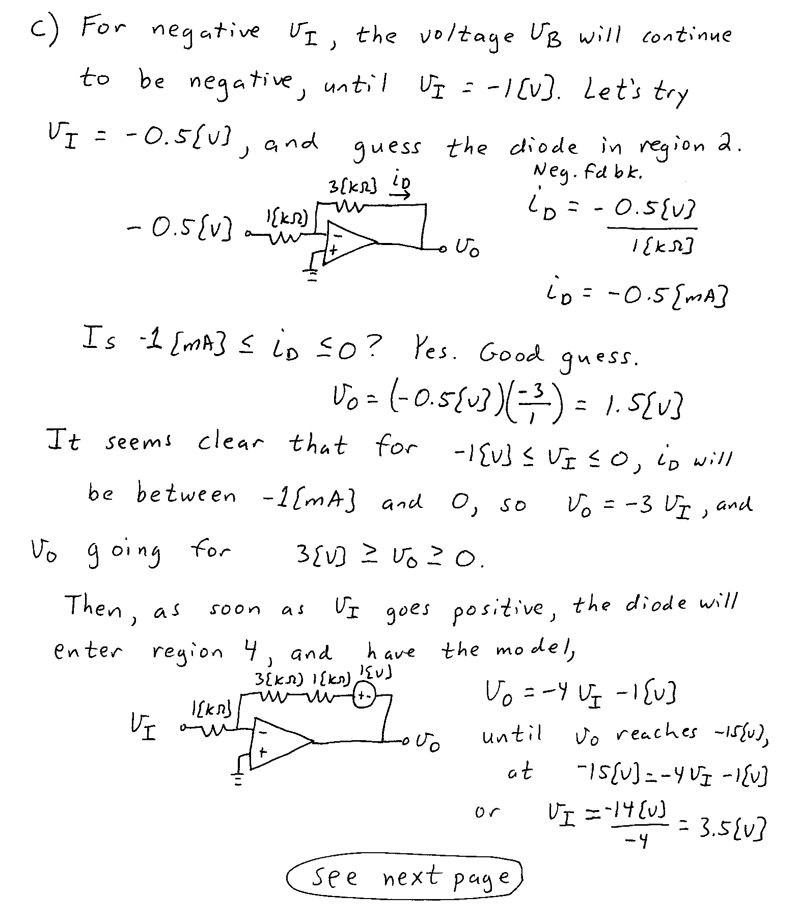
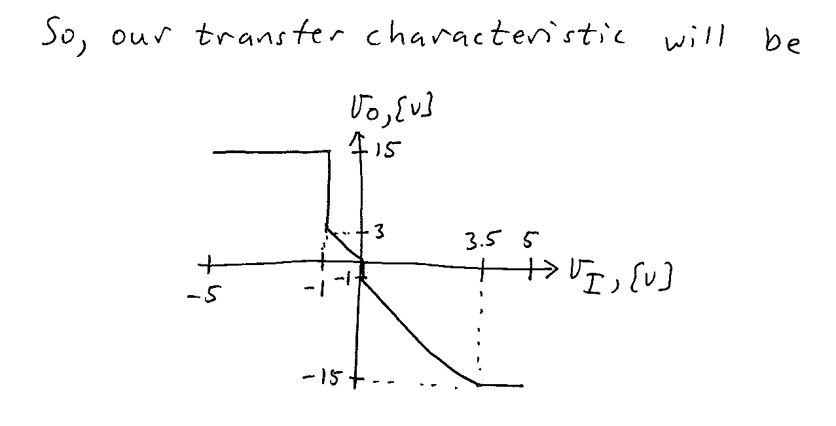

4. {40 Points} The characteristic curves for the device, called a tailerswiftee, are shown in Figures 1, 2 and 3. The device schematic symbol is shown in Figure 4.
- Find a DC model, or a large-signal model, for Region 3 of this device, and draw it labeling terminals F, G, and H.
- Find an ac model, or a small-signal model, for Region 3 of this device, and draw it labeling terminals F, G, and H.
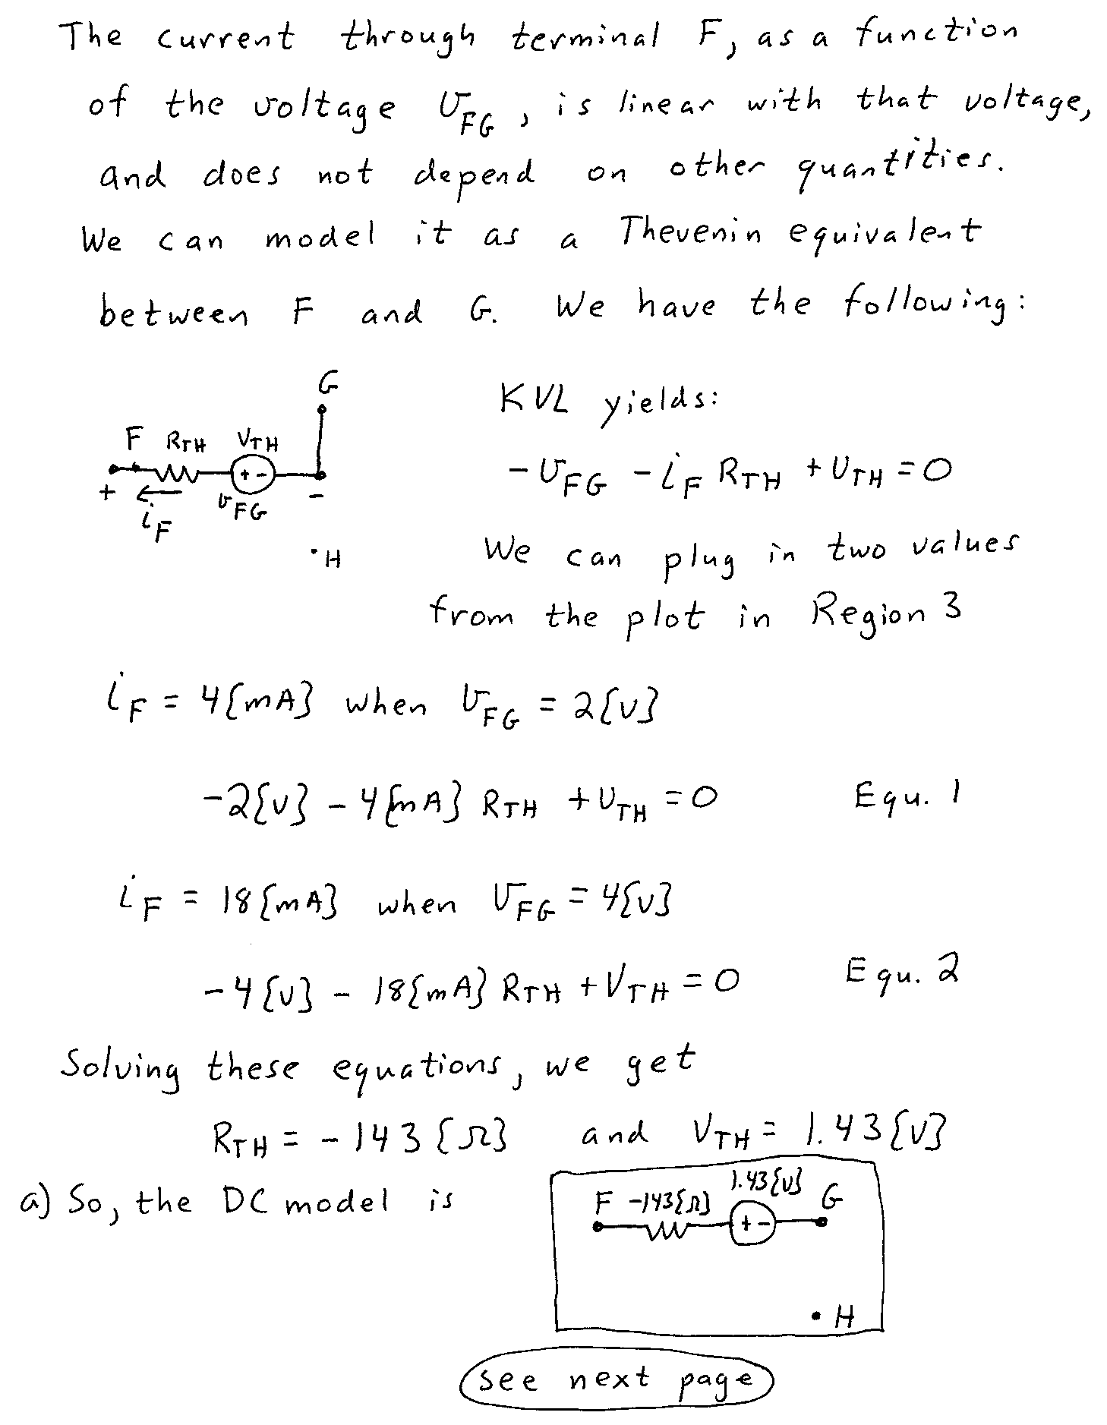
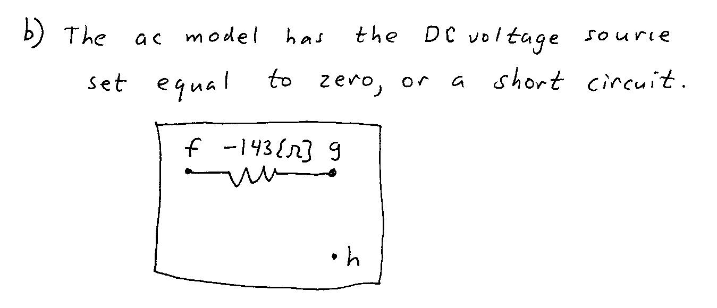
5. {40 Points} Use the circuit shown to solve this problem. Assume that for the transistor β = 200, and that it is operating at room temperature.
a) Find V_{E}.
b) Find the voltage gain v_{d} / v_{a}, in dB, in the passband.
c) Find the output resistance seen the load R_{L}, in the passband.

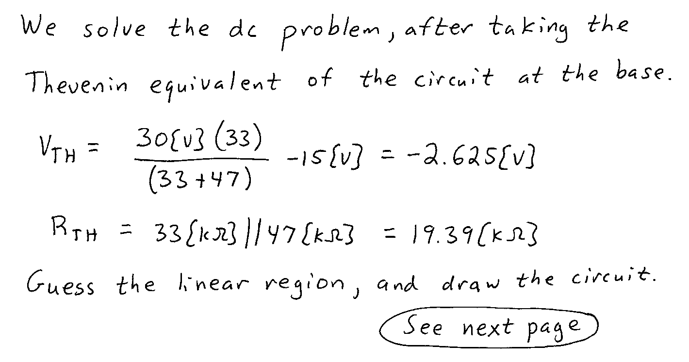

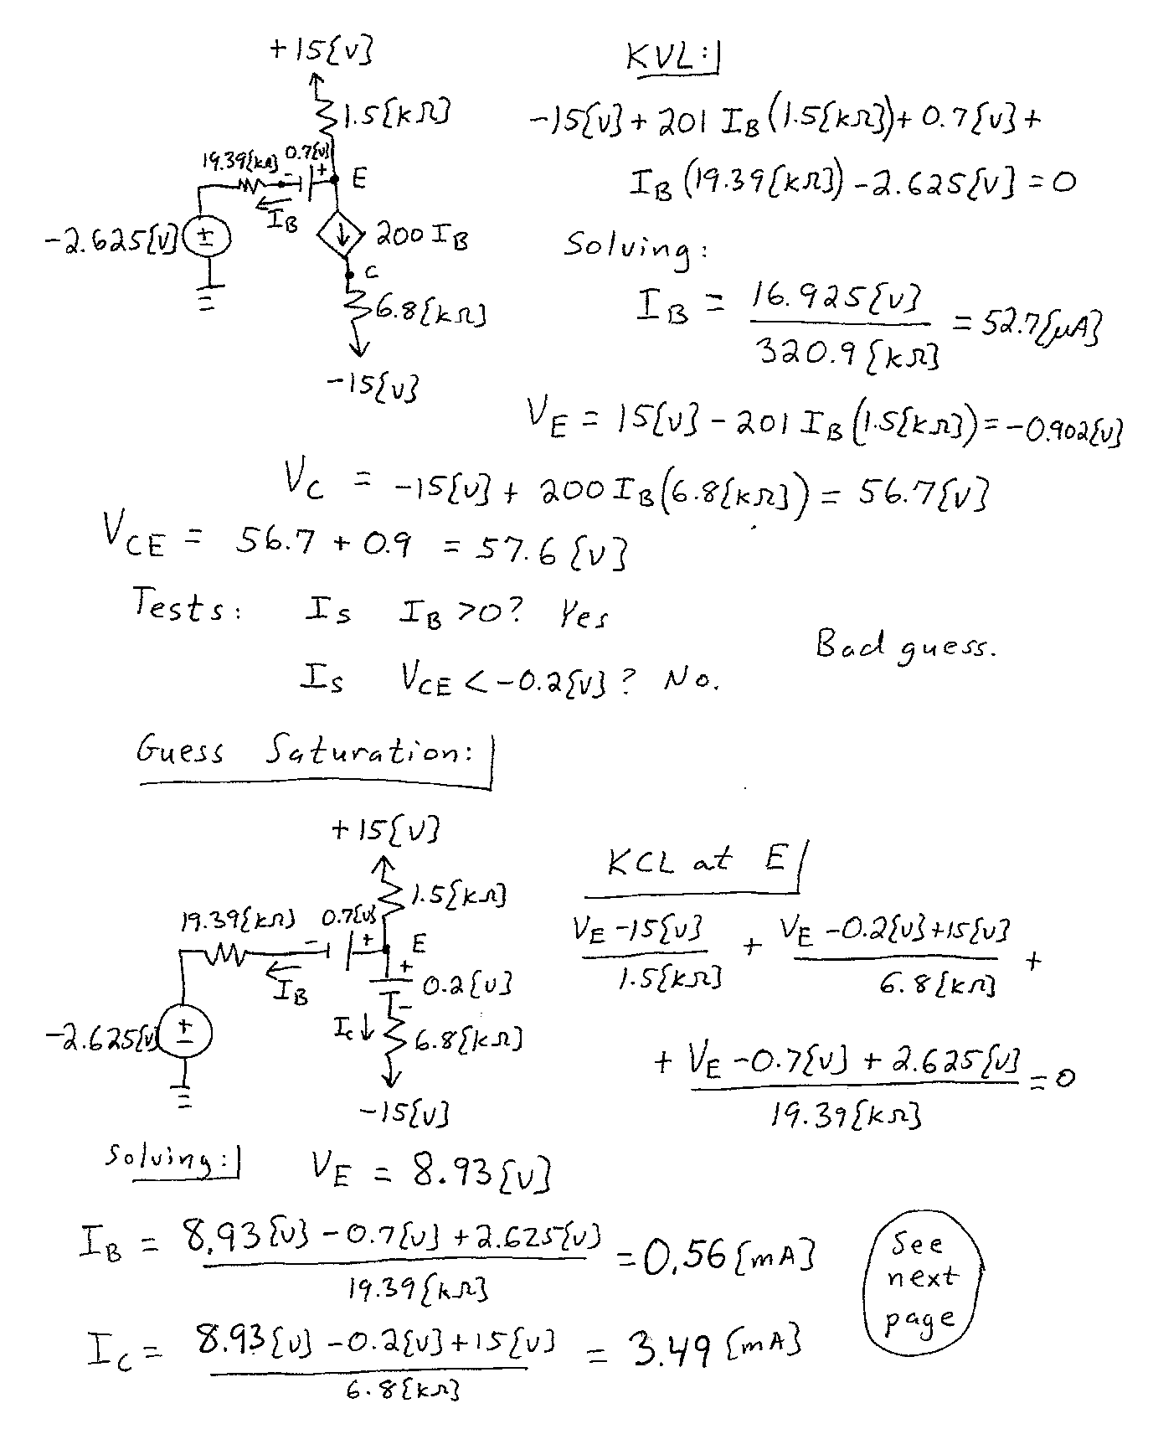
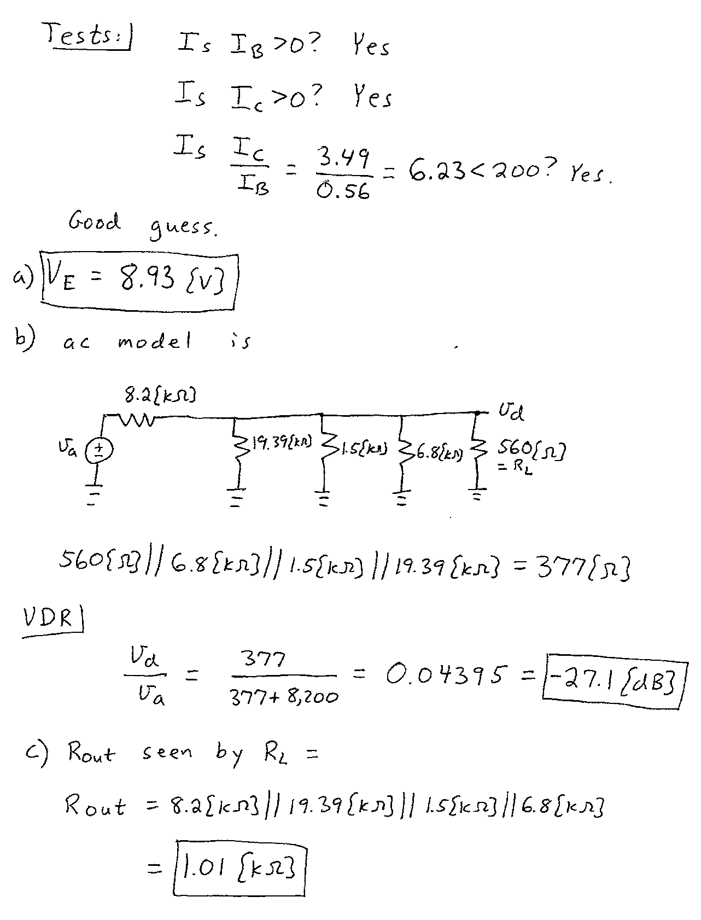
6. {40 Points} An amplifier has the transfer characteristic given in Figure 1. This amplifier is connected in the circuit shown in Figure 2.
a) Find the transconductance gain i_{b} / v_{a}, for small signals.
b) Assume that v_{a}(t) is a zero-mean sinusoid. Find the largest rms value for v_{a}(t) that will yield an undistorted output for i_{b}(t).
