Electronics: ECE 3355
Homework 2

Sedra and Smith, 7th Ed., Chapter 1: Problems 1.43, 1.44, 1.47, 1.48, D1.50, 1.56, 1.58
From handout below: Problems E2.1, E2.2, E2.3, E2.4

E2.1. A compact disc (CD) player laser pick-up provides a signal output of 10[mV]pp and has an output resistance of 10[kΩ]. The pick-up is to be connected to a speaker whose equivalent resistance is 8[Ω].
- Calculate the voltage that would be delivered to the speaker if the speaker were connected directly to the pick-up.
- Assume that the speaker needs 20[V]pp to deliver clear acoustical output. Design an equivalent circuit for an amplifier that would deliver this output when connected between the pick-up and the speaker.

E2.2. An amplifier has been connected as shown below, with a signal source and a load connected. In addition, a dc voltage source (V_{F}) and a resistor (R_{F}) have been attached to provide feedback. Find the input resistance seen by the signal source with the feedback in place.
E2.3. A device, shown in Figure 3.1, can be modeled by a current source in parallel with a resistance. The relationship between the current through the device, i_{X}, and the voltage across the device, v_{X}, is given in the plot in Figure 3.2.
- Find a model for the device that would be valid when current is in the range
1[mA] < i_{X} < 5[mA]. This model must have numerical values for the current and resistance, and the polarities with respect to v_{X} and i_{X} should be shown in a diagram.
- A voltage source is applied across the device so that v_{X} = 10[V]. Find the power delivered by the device in this situation.
Remember to use lower-case variables for voltage and current.

E2.4. A circuit is shown in Figure 1. The equivalent circuits for amplifiers A, B, and C, in this circuit are shown in Figures 2, 3, and 4, respectively. Find and draw a single amplifier equivalent circuit that could be used to replace amplifiers A, B, and C.
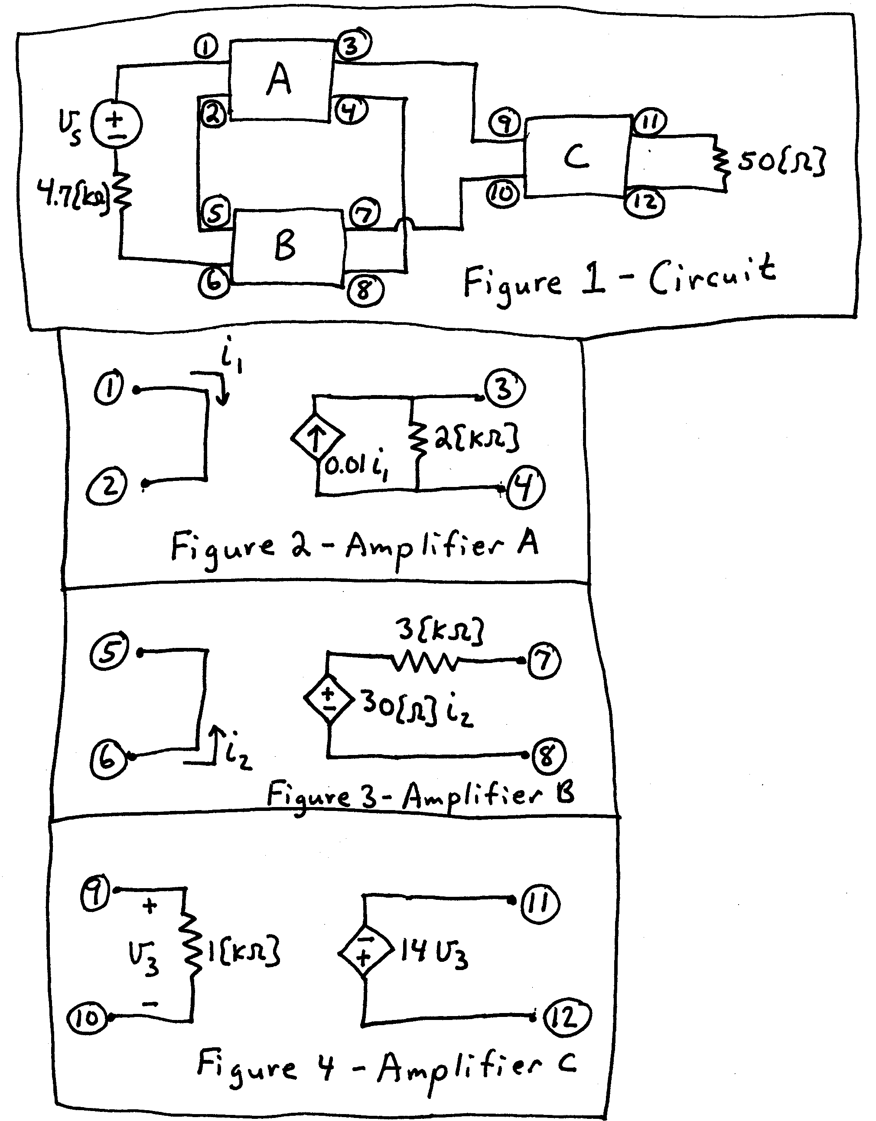
Selected Numerical Solutions:
1.43 a) 82.64 = 38.34[dB]; b) 25 = 27.96[dB]; c) 826.4 x 10⁻³ = -1.656[dB]
1.44 38.42[dB]; 71.43[dB]; 84.9[mV_{rms}]; 100[mW]
1.47 52.8[dB] vs 57.4[dB]
1.48 SABL
1.58 R_{i}/(1+R_{i}g_{m})
E2.1. There are many possible solutions. One possible solution would be a transconductance amplifier with G_{msc} = 900[S]; Ri = 10[kΩ]; Ro = 10[Ω]
E2.2. –43[Ω]
E2.3. a) The solution is a Norton equivalent. The sign of the current source depends on the reference polarity chosen, but the magnitude is 25[mA]. The resistance is –250[Ω].
b) p_{DEL,DEV} = -2[mW].

E2.4. Transresistance amplifier, with R_{IN} = 0, R_{OUT} = 0, and R_{MOC} = -117[Ω].

