ECE 3355 – ELECTRONICS

HOMEWORK #6

Problems E6.1, E6.2, E6.3, E6.4

E6.1: Assume ideal op amps.

a) Find the voltage gain, *vo/vs*.

b) Find the input resistance seen by the source.

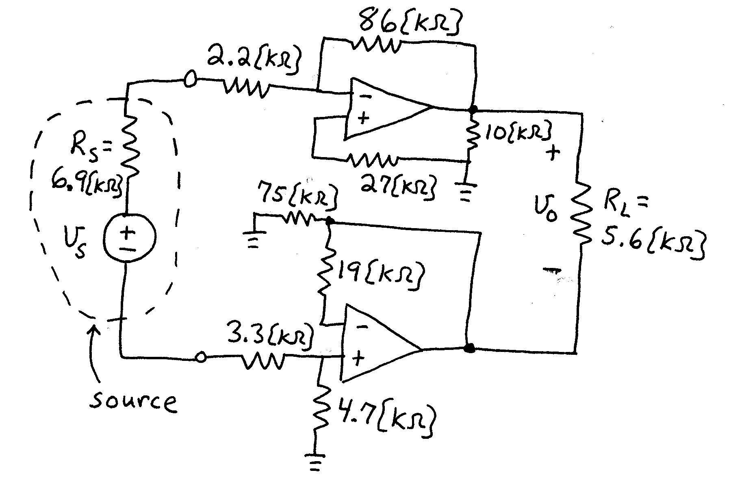

E6.2: Assume ideal op amps.

1. Find the voltage gain, *vo/vi*.
2. Find the input resistance, *vi/ii*.
3. If *vi* = 2[V], find *vq*.



E6.3: For the circuit given below, assume ideal op amps.

1. Find the transfer function, *T()* = *Vo/Vi*.
2. Find the number of poles and the number of zeroes for this transfer function.
3. Find the values of the poles and zeroes for this transfer function.



E6.4: Assume ideal op amps. Find *vO*.



Numerical Solutions:

E6.1) a) -4.75

1. 10.2[k]

E6.2) a) -4.67

1. infinity
2. 15[V]

E6.3) a) 

1. two zeroes, no poles

c) *1* = 455.2[rad/s], and *2* = 302.6x103[rad/s].

E6.4) 9.04[V]