Electronics: ECE 3355

**Homework 2**

Sedra and Smith, 7th Ed., Chapter 1: Problems 1.43, 1.44, 1.47, 1.48, D1.50, Problems E2.1, E2.2, E2.3, E2.4, E2.5

E2.1. A compact disc (CD) player laser pick-up provides a signal output of 10[mV]pp and has an output resistance of 10[k]. The pick-up is to be connected to a speaker whose equivalent resistance is 8[].

1. Calculate the voltage that would be delivered to the speaker if the speaker were connected directly to the pick-up.
2. Assume that the speaker needs 20[V]pp to deliver clear acoustical output. Design an equivalent circuit for an amplifier that would deliver this output when connected between the pick-up and the speaker.

E2.2. An amplifier has been connected as shown below, with a signal source and a load connected. In addition, a dc voltage source (*VF*) and a resistor (*RF*) have been attached to provide feedback. Find the input resistance seen by the signal source with the feedback in place.



E2.3. A device, shown in Figure 3.1, can be modeled by a current source in parallel with a resistance. The relationship between the current through the device, *iX*, and the voltage across the device, *vX*, is given in the plot in Figure 3.2.

1. Find a model for the device that would be valid when current is in the range   
   1[mA] < *iX* < 5[mA]. This model must have numerical values for the current and resistance, and the polarities with respect to *vX* and *iX* should be shown in a diagram.
2. A voltage source is applied across the device so that *vX*  = 10[V]. Find the power delivered by the device in this situation.

Remember to use lower-case variables for voltage and current.



E2.4. A circuit is shown in Figure 1. The equivalent circuits for amplifiers A, B, and C, in this circuit are shown in Figures 2, 3, and 4, respectively. Find and draw a single amplifier equivalent circuit that could be used to replace amplifiers A, B, and C.

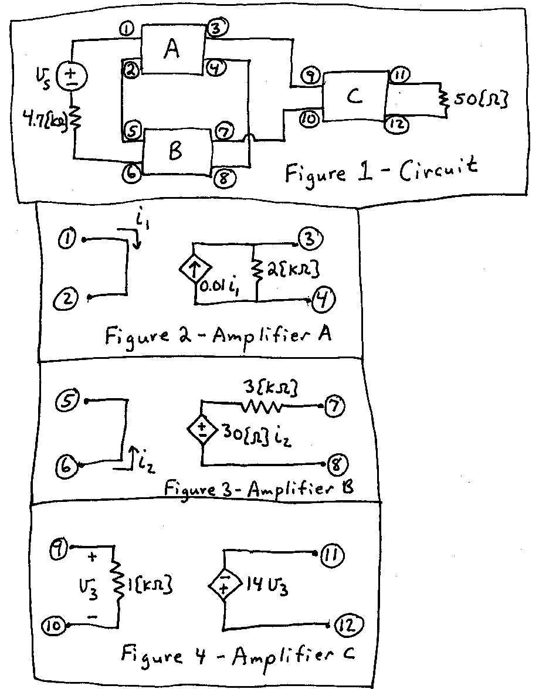

E2.5



Numerical Solutions:

1.43 a) 82.6 = 38.3[dB]; b) 25 = 28[dB]; c) 0.826 = -1.7[dB]

1.44) *Av* = 38.4[dB]; *Ap* = 71.4[dB]; 85[mVrms]; 0.1[W]

1.47) 52.3[dB] vs 57.4[dB] so gain is reduced

1.48) SABL provides the higher gain

E2.1) There are many possible solutions. One possible solution would be a transconductance amplifier with *Gmsc* = 900[S]; *Ri* = 10[k]; *Ro* = 10[]

E2.2) –43[]

E2.3a) The solution is a Norton equivalent. The sign of the current source depends on the reference polarity chosen, but the magnitude is 25[mA]. The resistance is –250[].   
b) *pDEL,DEV* = -2[mW].

E2.4) Transresistance amplifier, with *RIN* = 0, *ROUT* = 0, and *RMOC* = ‑117[].

E2.5) i) not given; ii) io/iin = infinity