# Diode Basics

Diodes are solid-state devices; they are made using integrated circuit fabrication techniques. The diodes we use commonly in the lab are made of either silicon or germanium. Diodes used as LEDs (light-emitting diodes) are typically made with III-V semiconductors (GaAs, GaN…). We will not be concerned here with diode optical properties.

## Current-Voltage Characteristics

For our purposes, the most important characteristic of the diode is its current-voltage (*i-v*) characteristic, which looks like the following.

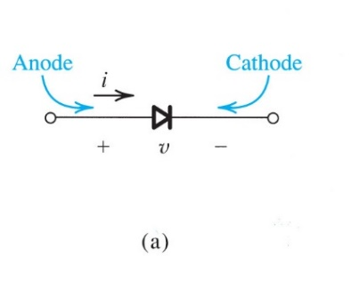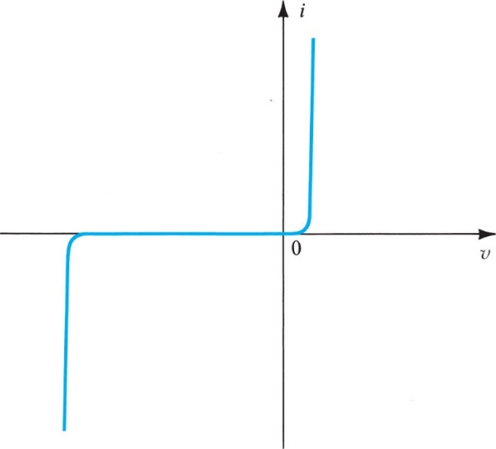

*vZ*



The inset to the graph shows the symbol we will use for the diode. It’s very important to recognize that the polarities indicated for current and voltage are the polarities plotted in the graph. If the polarities on the symbol were changed, the graph would look differently. For that reason, ***you must always indicate the voltage and current polarities*** you are using when you plot *i-v* characteristics – for any device!

Note three regions on this graph:

*v* > 0: forward bias: the current is positive, and increases exponentially with voltage (we’ll be more specific later).

*vZ < v < 0*: reverse bias: the current is very small, negative (hard to see on this graph), and roughly constant.

*v < vZ* : breakdown: the current increases very rapidly, and in the negative direction.

By adjusting the scales on the vertical axis, we can show more detail. The graph also shows the named regions we mentioned above.

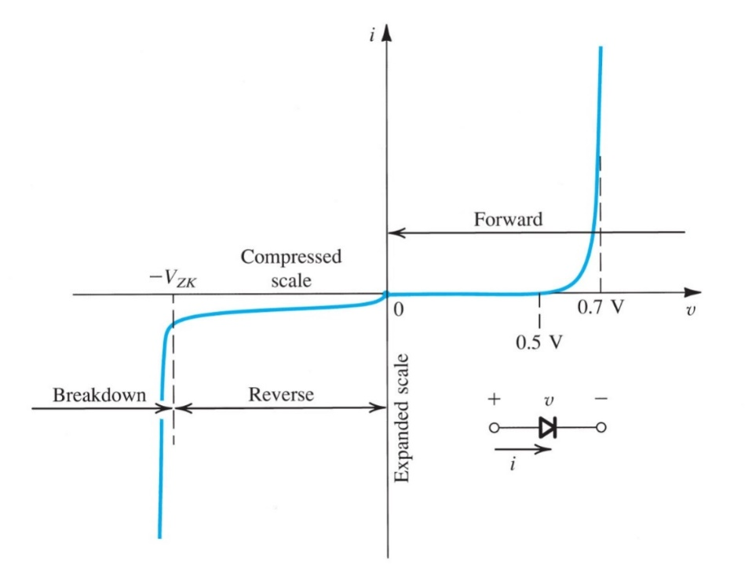





Figure 4.8 also suggests two important things:

* For *v* < 0.5 V, there is very little current, and at *v* ~ 0.7 V, the current rises rapidly. This is typical of diodes, although the voltage at which the current rises rapidly will be different for diodes made from different materials.
* There is current in the negative direction for *v* < 0. It increases slightly for increasing reverse bias, and then increases very suddenly at breakdown where v = *- VZK* (‘K’ is for ‘knee’). We will have more to say about breakdown later.

Not shown on the graph: there is a small current for 0 < *v* < 0.7 V, but it is negligible in value compared to the current above 0.7 V.

## The Ideal Diode Equation

In a solid-state device physics course we learn an equation that predicts the exponential increase in the diode current for forward bias, and the approximately constant negative current in reverse bias. Sedra & Smith do that in Chapter 3 of the 7th edition, and while you are welcome to view that chapter, we will not worry about it here. But we will quote what has become known as the ***ideal diode equation***, which results from that sort of analysis. Again **with reference to the polarities indicated in the figures above**, we have the following equation. We denote the diode current and diode voltage i and v.



The parameters in this equation are:

vT is the ***thermal voltage***.  where k is Boltzman’s constant, T is the thermodynamic temperature, and q is the electron charge.

IS is the ***reverse-bias saturation current***. Note that when vD < 0, the exponent quickly becomes negligible, and iD ~ IS.

For this course we will not need to fuss with the details of vT. We simply need to know that at room temperature (300 K), vT = 25 mV.

This is a non-linear equation. If we have to use it in a KVL or KCL to solve a circuit, it will be very messy – and even worse, we may have more than one diode in a circuit. We will want to simplify the task of figuring out what circuits with diodes are doing. For that we will look at three methods:

***Diode models***, in which we substitute one or more of the five basic circuit elements for the diodes in our circuit. For this class, those models will (almost always) involve only voltage or current sources, and resistors. More sophisticated models may require capacitance or inductance.

***Load-Line Analysis*** This is a graphical analysis in which we plot the Ideal Diode Equation along with the characteristics of the Thevenin equivalent of whatever is connected to the diode. We will not do much of this here, but you will have a lab assignment in which this is one of the tasks. We will do a simple example to illustrate it here.

***Iterative Analysis*** This is a technique in which we use the Ideal Diode Equation in our KVL or KCL, and use iterative techniques to solve for diode current and voltage. We will illustrate this with one example, but we will not do much more with this method.

We begin by looking at diode models…

## Ideal Diode Model

A good place to start is with the Ideal Diode Model:

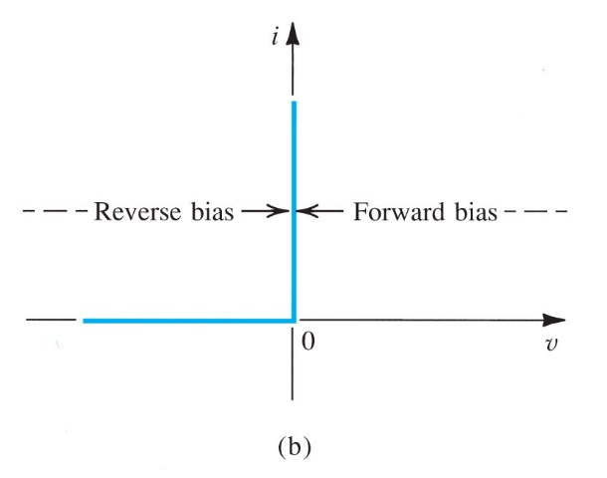

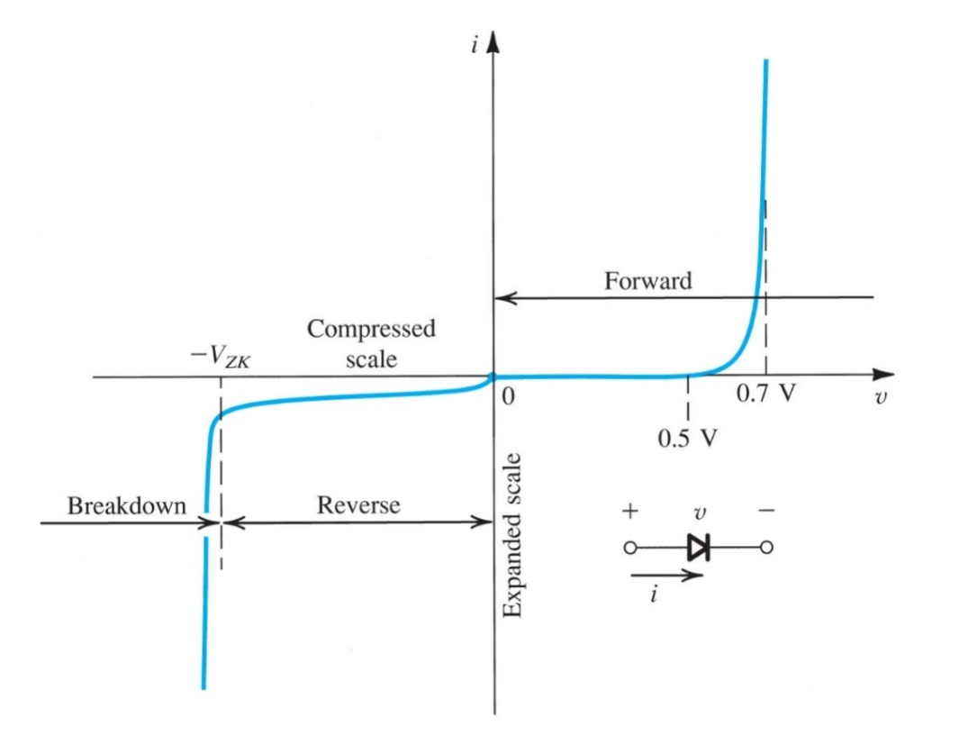

Sedra and Smith 7 ed., Figure 4.1b

In this model, forward bias means the diode is “ON” and carrying current; reverse bias means the diode is “OFF” and no current flows. So we’re treating the diode as a one-way current valve.

**What does this graph mean?** It means that ***either*** (i) the voltage across the diode is 0, in which case the current can take any positive value (or 0), or that (ii) the current through the diode is 0, in which case the voltage can take any negative value (or 0). Note for example, that within this model, we **cannot** have v = 2 V, or i = - 200 mA, because neither of these values is on the graph. We could have v = -3 V, but if that’s the case, the current cannot be 50 mA - it can only be 0.

## The Diode Rectifier

What can we do with this? Consider the following simple circuit. Note that the current and voltage in this figure are iD and vD.

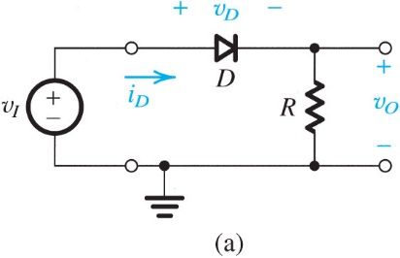

Before we start thinking about what’s going on here, we need to decide how the diode behaves in the circuit. In other words, we need a circuit model for the diode. We will use the ideal diode model.

*Figure 4.3a, Sedra & Smith 7 ed.*

From the graph above, we can see that if the voltage across the diode is 0, the current can have any positive value (or 0). We can model that with a ***short circuit***.

If the diode current is 0, the voltage can take any value. That can be modeled by an ***open circuit***. So in the circuit above the diode should be modeled by either a short, or an open, depending on whether it is conducting or not.

Now consider vI, and imagine it is the sinusoid shown below.

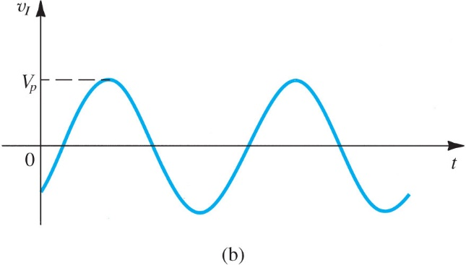

*Figure 4.3b, Sedra & Smith 7 ed.*

It seems reasonable to conclude that when vI is positive, the diode will be conducting, and current will flow: in that case, iD will be positive, and vO will be equal to vI. But when vI is negative, the diode will be off, and no current will flow. Then vO = 0. Summary:

vI > 0 ⇨ D is ON (short circuit) ⇨ vO = vI

vI < 0 ⇨ D is OFF (open circuit) ⇨ vO = 0

So the output of the circuit above will look like this:

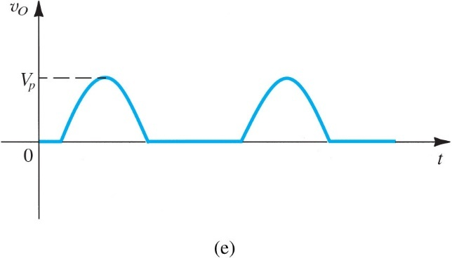

*Figure 4.3c, Sedra & Smith 7 ed.*

The circuit we are considering here is a ***rectifier***, and we say that output is a ***rectified sign wave.*** We will see later that this is useful thing to do.

Let’s show the circuit diagrams we get when we assume the diode is conducting and when it is not. When vI is positive, the diode will be conducting, so the model for it is a short:

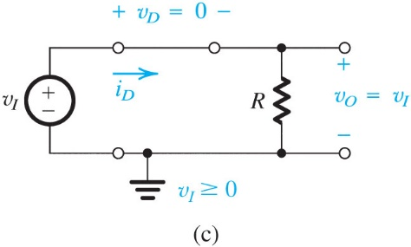

When vI is negative, the diode will be off, so it is an open:

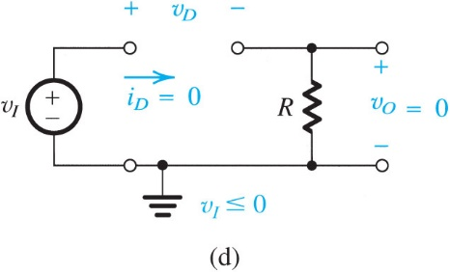

*Figures 4.3c and 4.3d,* *Sedra & Smith 7 ed.*

Note that as discussed earlier, we have substituted basic circuit elements (in this case a short circuit or open circuit) for the diode. Strictly speaking, the short and the open are not basic circuit elements, although we can think of the short as a voltage source of value 0, and the open circuit as a current source of value 0. Later, when we look at more sophisticated diode models, we will use resistors and non-zero sources, and we will see how to determine more systematically what the diode model should be.

## Transfer Characteristics

There is another way to think about what this circuit does: we can find the ***transfer characteristics***. Earlier in the course we looked at the *transfer function*, which was defined as a phasor output divided by a phasor input, for example **Vo**/**Vi**. Here we still consider the output as a function of the input, but in this case we will be interested in the time domain, and we will make a plot of the output as a function of the input. Doing that give us the transfer characteristics.

For the circuit we have been looking at, the output voltage is equal to the input voltage for positive input voltage, and 0 for negative input voltage. Plotting this as output voltage vs. input voltage gives the following.

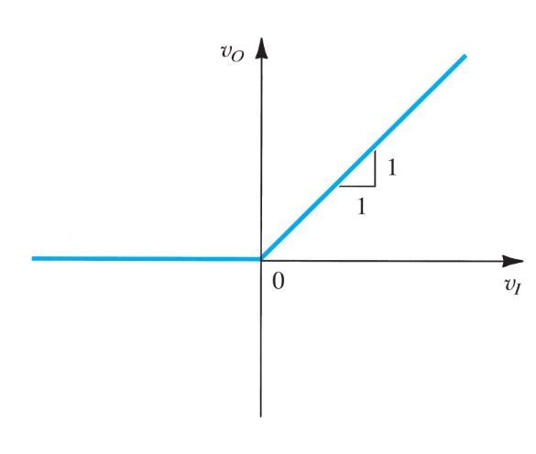

Figure E4.1, Sedra & Smith, 7 ed.

Since for positive vI , vO = vI , the slope of the curve is 1. We will look at other circuits in this way later.

## Load Line Analysis

We can also use a graphical technique that amounts to this: We find the Thevenin equivalent of whatever is connected to the diode. Then we recognize that the diode current and voltage are determined by both the Ideal Diode Equation and the equation representing the Thevenin equivalent. So plots of current-voltage for both the diode and the Thevenin equivalent will intersect at the ***operating point***; that is, at the actual diode current and voltage. An example will show what we mean.

Suppose we find the Thevenin equivalent of a circuit connected to a diode to be vTH = VDD and RTh = R.

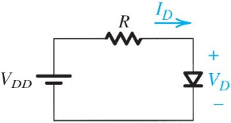

In the graph below, we plot the ideal diode equation, and on the same chart we plot the current voltage characteristics of the Thevenin equivlanet.

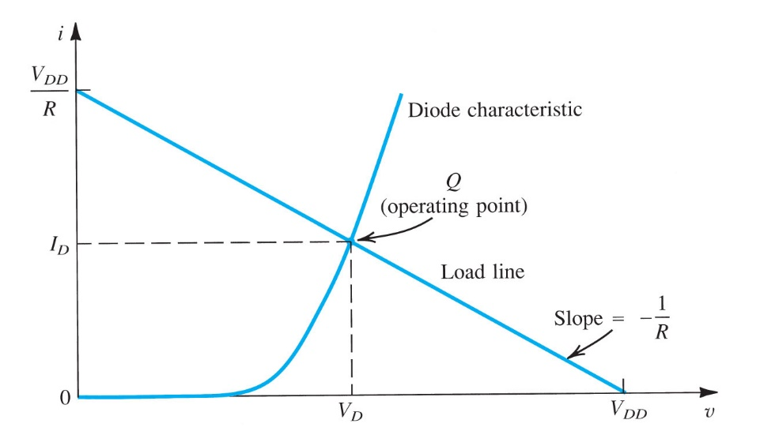

**Figure 4.11** Graphical analysis of the circuit in Fig. 4.10 using the exponential diode model.

How do we get i-v for the Thevenin equivalent? A KVL around the loop in the circuit above gives:

 ⇨ 

This equation is a straight line with slope 1/R. When v = 0, i = VDD/R, and when i = 0, v = VDD.

The intersection of this line with the ideal diode equation gives the ***operating point***, which is the point on the graph corresponding to the value of current ID in the diode and voltage VD across it. The diode is constrained by the external circuit to “operate” at this current and voltage.

We will have much more to say about load line analysis when we get to BJTs, but we will not use it very much for diodes.

## Iterative Analysis

In this method we use the Ideal Diode Equation and a given (known) initial diode voltage and current. We then find successively more accurate approximations to these values by substituting back into the diode equation. The example beginning on the next page will illustrate this technique. It is from Sedra and Smith 7 ed example 4.4.

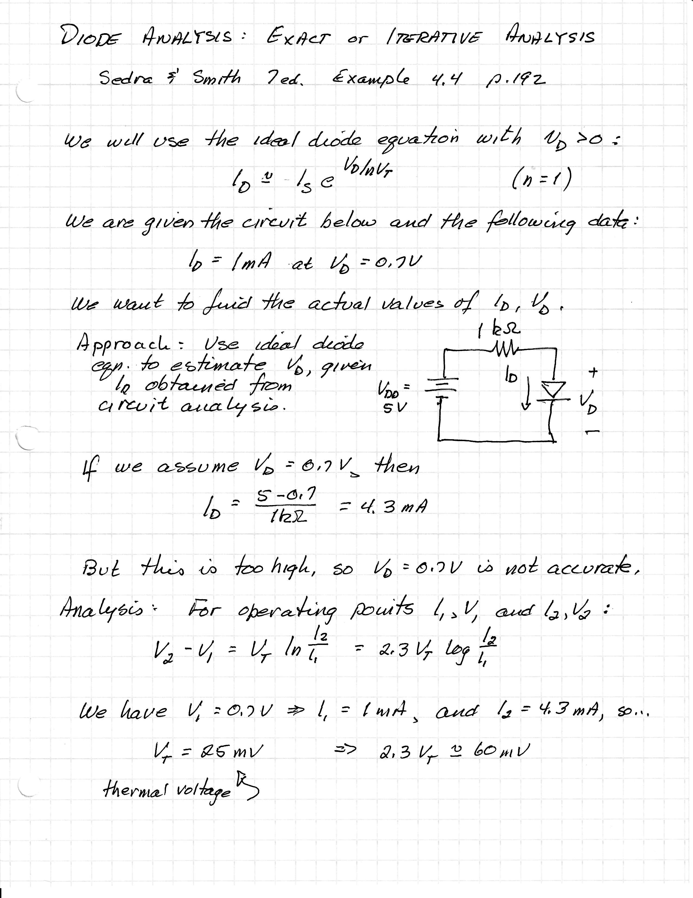

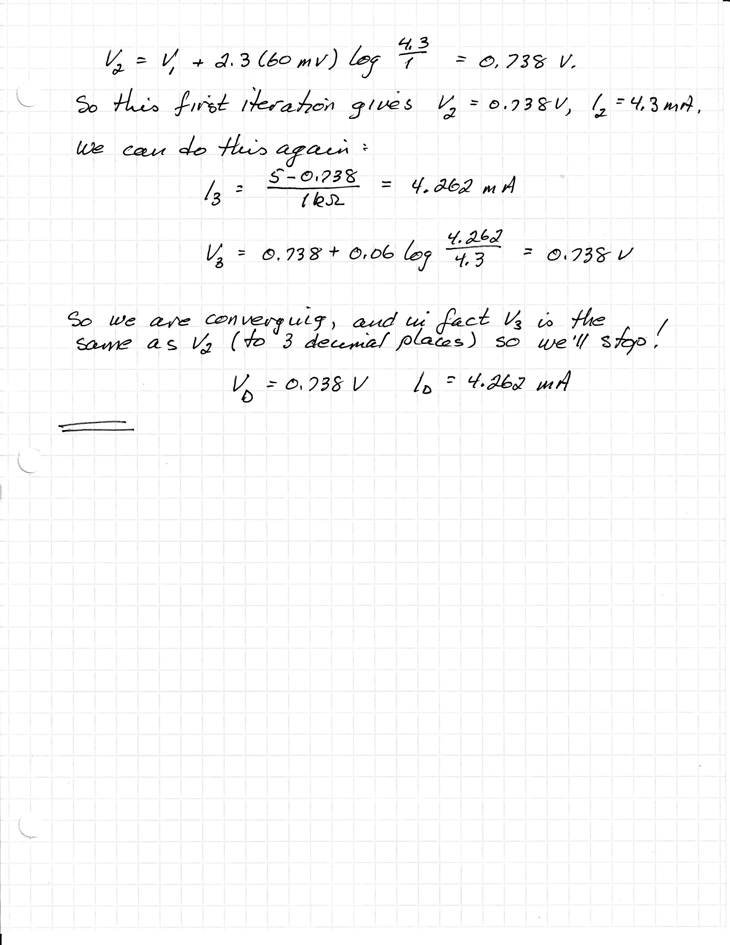

# Diode Models

We return now to modeling of diodes using basic circuit elements. This is how we will solve most of the diode problems in this class.

We have already looked at the ***ideal diode model***, in which the diode is either an open circuit (in reverse bias) or a short circuit (in forward bias).

Basic Idea: In solving problems using diode models, our method is ***guess and tes***t:

* Given a diode model and a circuit with one or more diodes, we ***guess*** what state the diode is in (we assume a state). For the ideal diode model, for example, we would guess a particular diode is either a short circuit or an open circuit. We make this guess based on intuition, and experience.
* We then ***test*** our ***guess***. We see whether it is correct by calculating the diode current and voltage implied by our guess, and see if it makes sense.

In performing the test, we impose the conditions specified by our model. That means we need to understand what our models are saying. Look at the ideal diode model, for example.



vD = 0; iD is any positive value

iD = 0; vD is any negative value

This model allows only two possibilities:

* The diode is “ON”, meaning current is positive (and of any value) and the voltage is 0.
* The diode is “OFF”, meaning current is 0 and the voltage is negative (and of any value).

If our test suggests anything different from these two possibilities, the guess was wrong.

Here are a few examples making use of the ideal diode model…

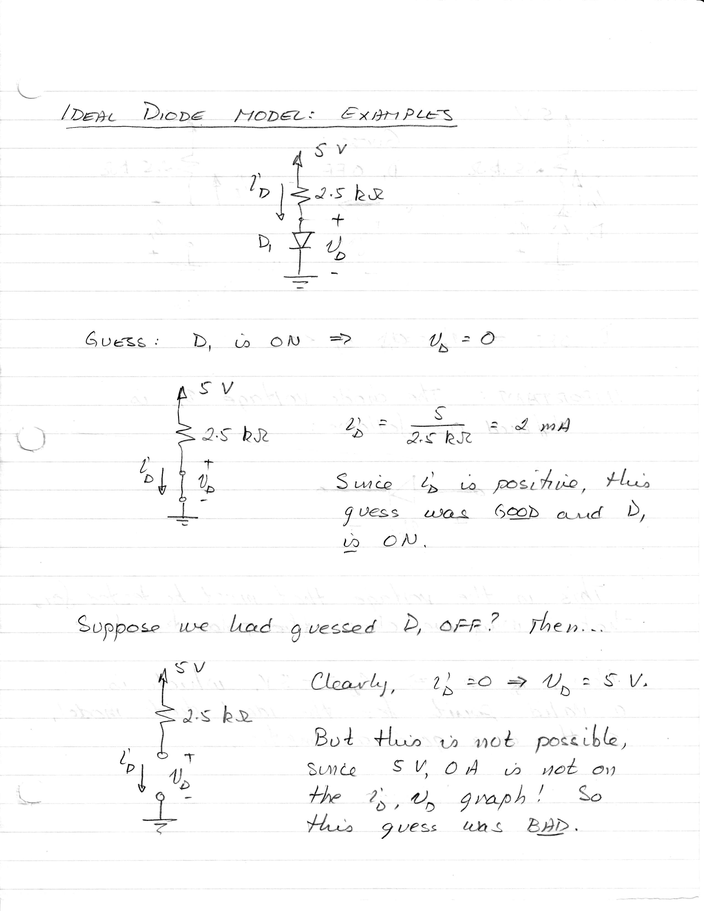

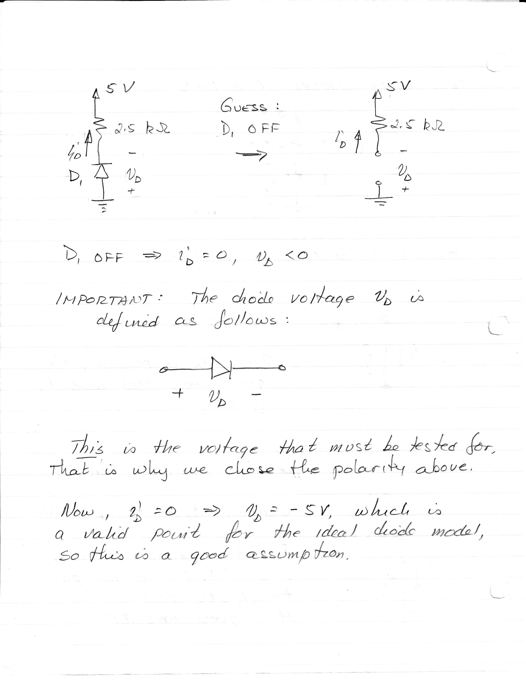

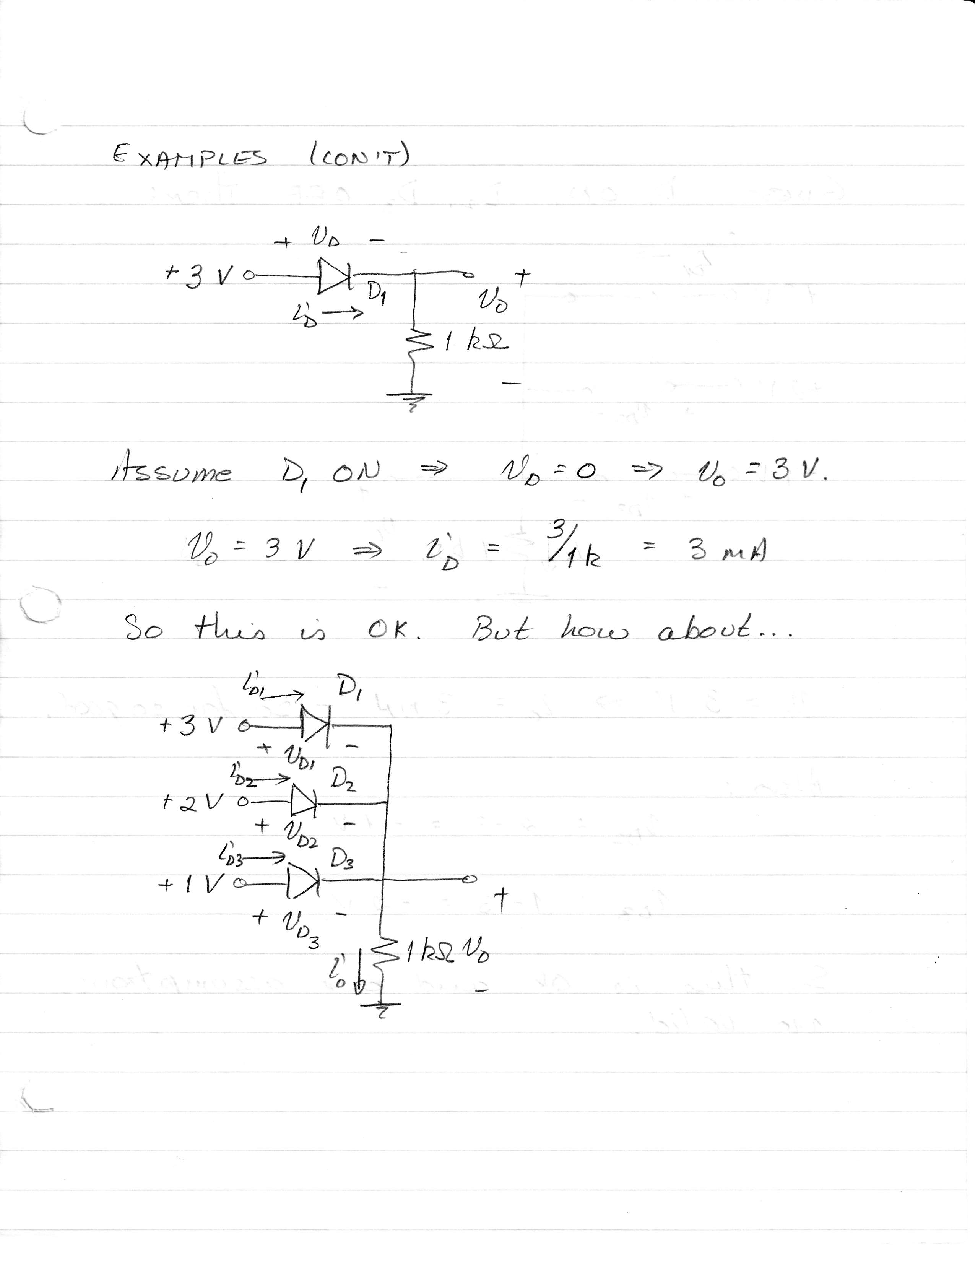

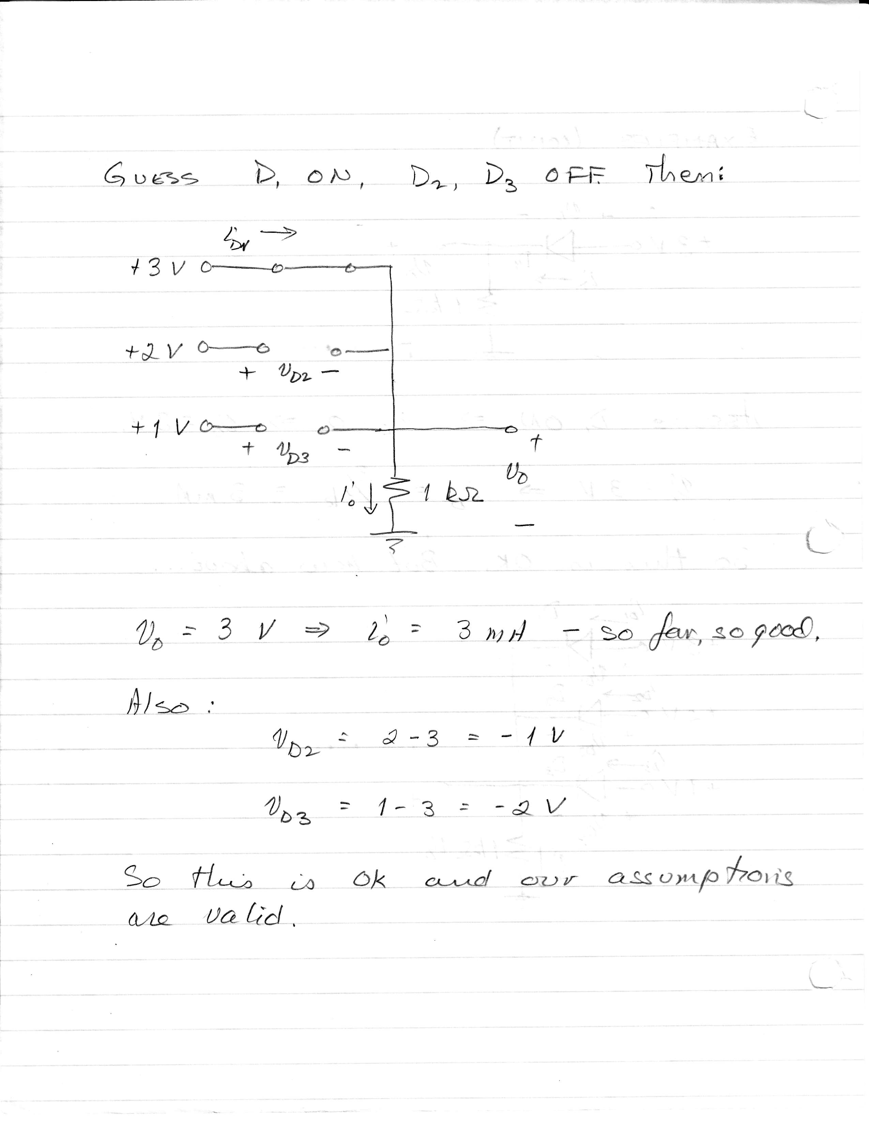

## Constant Voltage Drop Model

A more realistic, and more common model, for the diode is the ***constant voltage drop model***. Here, we recognize that there is very little current flowing through the diode until the applied voltage reaches a certain ***threshold*** value. The threshold value varies somewhat from one type of diode to another, but a good value for the common Si diode you have in your lab kit is 0.7 V.

Sedra and Smith Figure 4.12 shows this.

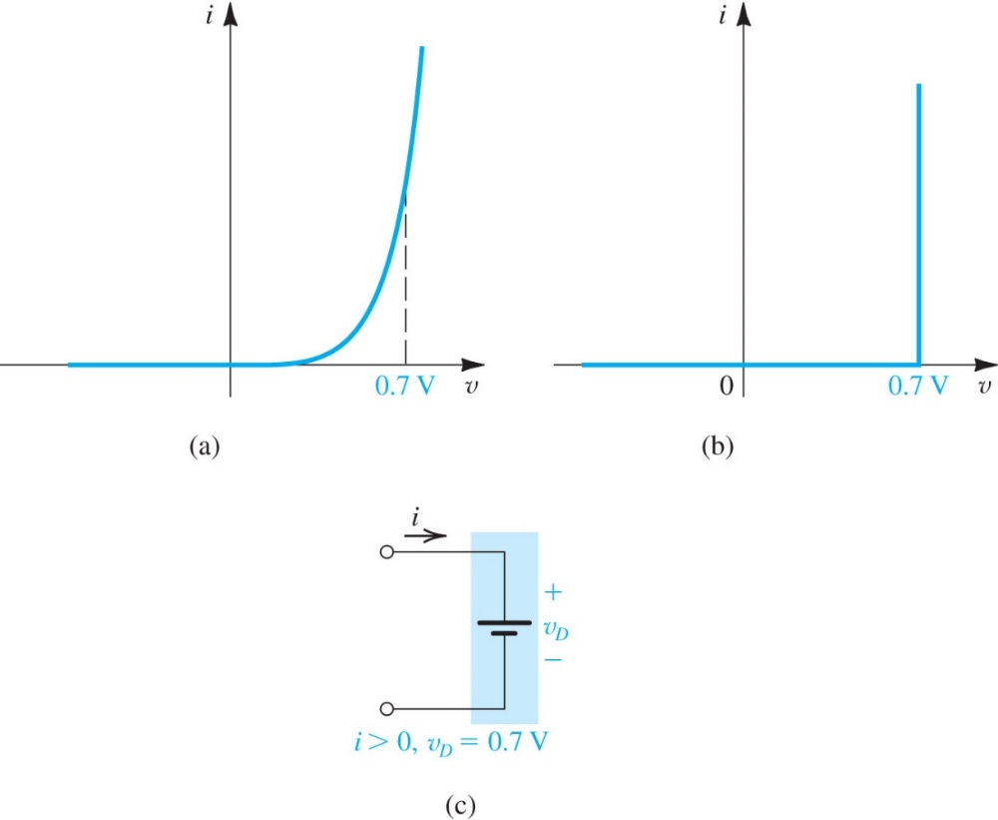

**Figure 4.12** Development of the diode constant-voltage-drop model: **(a)** the exponential characteristic; **(b)** approximating the exponential characteristic by a constant voltage, usually about 0.7 V*i*; **(c)** the resulting model of the forward-conducting diodes.

We will refer to this threshold value as Vth (note this is a slightly different notation from the Thevenin voltage VTh.)

A couple of important points:

* By *very little current flowing through the diode*, we mean very little in comparison with the current flowing in typical circuits that we build in the electronics lab. There is most definitely a positive current flowing through the diode for any voltage greater than 0, but it is negligible until we reach threshold, so we assume it is 0 for v < Vth.
* The model chosen here for the “ON” region is the ideal voltage source, with a value of 0.7 V. The model says that we can have any positive current flowing through the diode, as long as the voltage across it is 0.7 V. For any other voltage, the current is 0 (v < 0.7 V) or simply undefined (v > 0.7 V).
* Typically for the diodes we deal with in this class, we will use Vth = 0.7 V. Occasionally we may choose something smaller, like 0.6 V, for the ON voltage. This is common for the diodes that make up a BJT. More on that later…
* Other types of diodes may have slightly different Vth: Ge diodes tend to be a little smaller (0.4 – 0.5 V) and III-V semiconductor diodes used to make LEDs tend to be larger (~1 V).

If we assume this model for the simple rectifier circuit, what differences will we see? Below we show output from a MultiSim simulation. MultiSim assumes roughly 0.7 V for Vth.

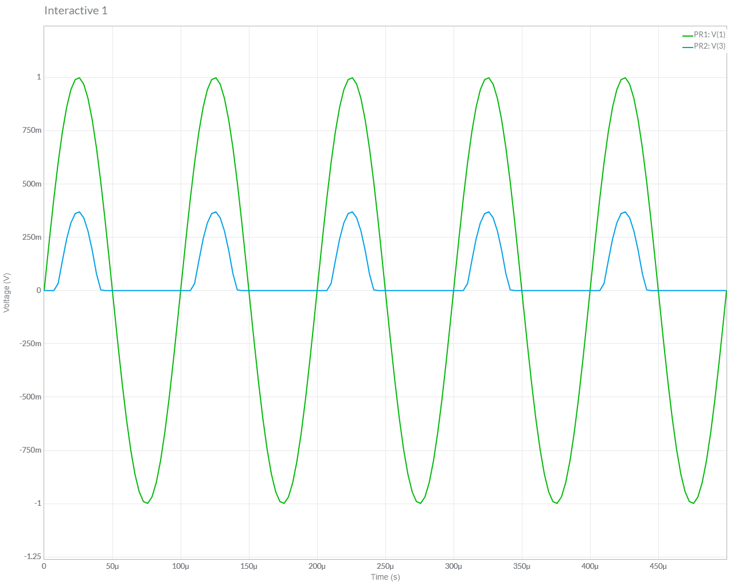

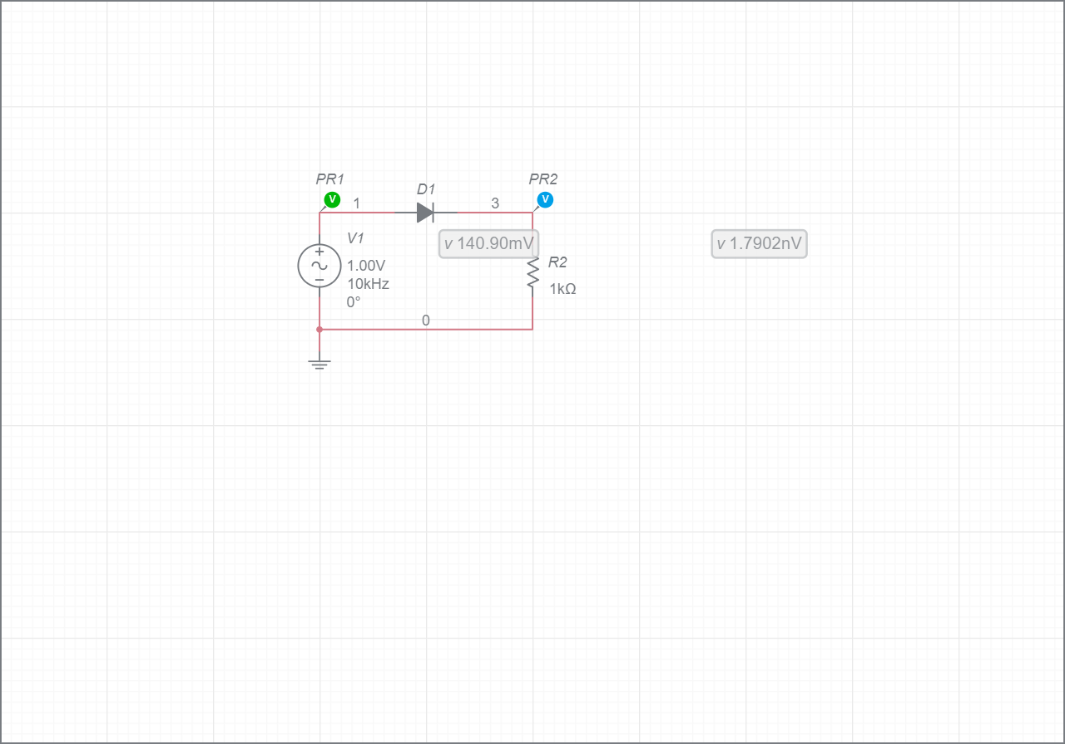

+ vD -

What’s going on here? (I know this is tough to read. We’ll do the simulation in class.)

* The output does not show much of anything for a brief period of time, until the source reaches 0.7 V. So there is a delay in the output, and it “shuts off” on the return cycle when the source drops to 0.7 V.
* The peak output voltage is 0.7 V below the peak source voltage: when the diode conducts, the “missing” 0.7 V is across the diode.

Clearly this makes a big difference, at least in this case, because the peak source value is not much bigger than Vth. If the source voltage were much larger, say 100 V, we would hardly notice these effects.

We can also look at the voltage across the diode.

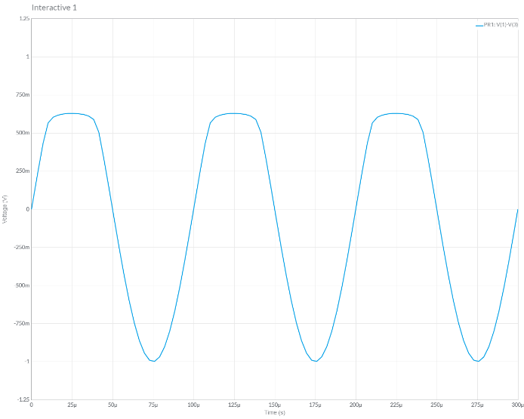

vD

The diode voltage is 0.7 V when the diode is ON, and equal to the source voltage when it is OFF.

***Practical note***: Diodes have “reverse bias breakdown” voltages, and if our source has a large amplitude, we will need to be careful not to exceed that value.

On the next few pages, we work some examples in which the diode is modeled with the constant voltage drop model, and Vth = 0.7 V. Here is the general procedure.

1. Guess whether the diode is ON or OFF.
   1. If it is ON, replace it with a 0.7 V source.
   2. If it is OFF, replace it with an open circuit.
2. Test whether your guess is correct.
   1. If you guessed ON, then you are assuming the voltage is 0.7 V, in which case the current must be positive (it can be any value, including 0, if vD = 0.7 V.)
   2. If you guessed OFF, then you are assuming the current is 0, in which case the voltage must be 0.7 V or less.

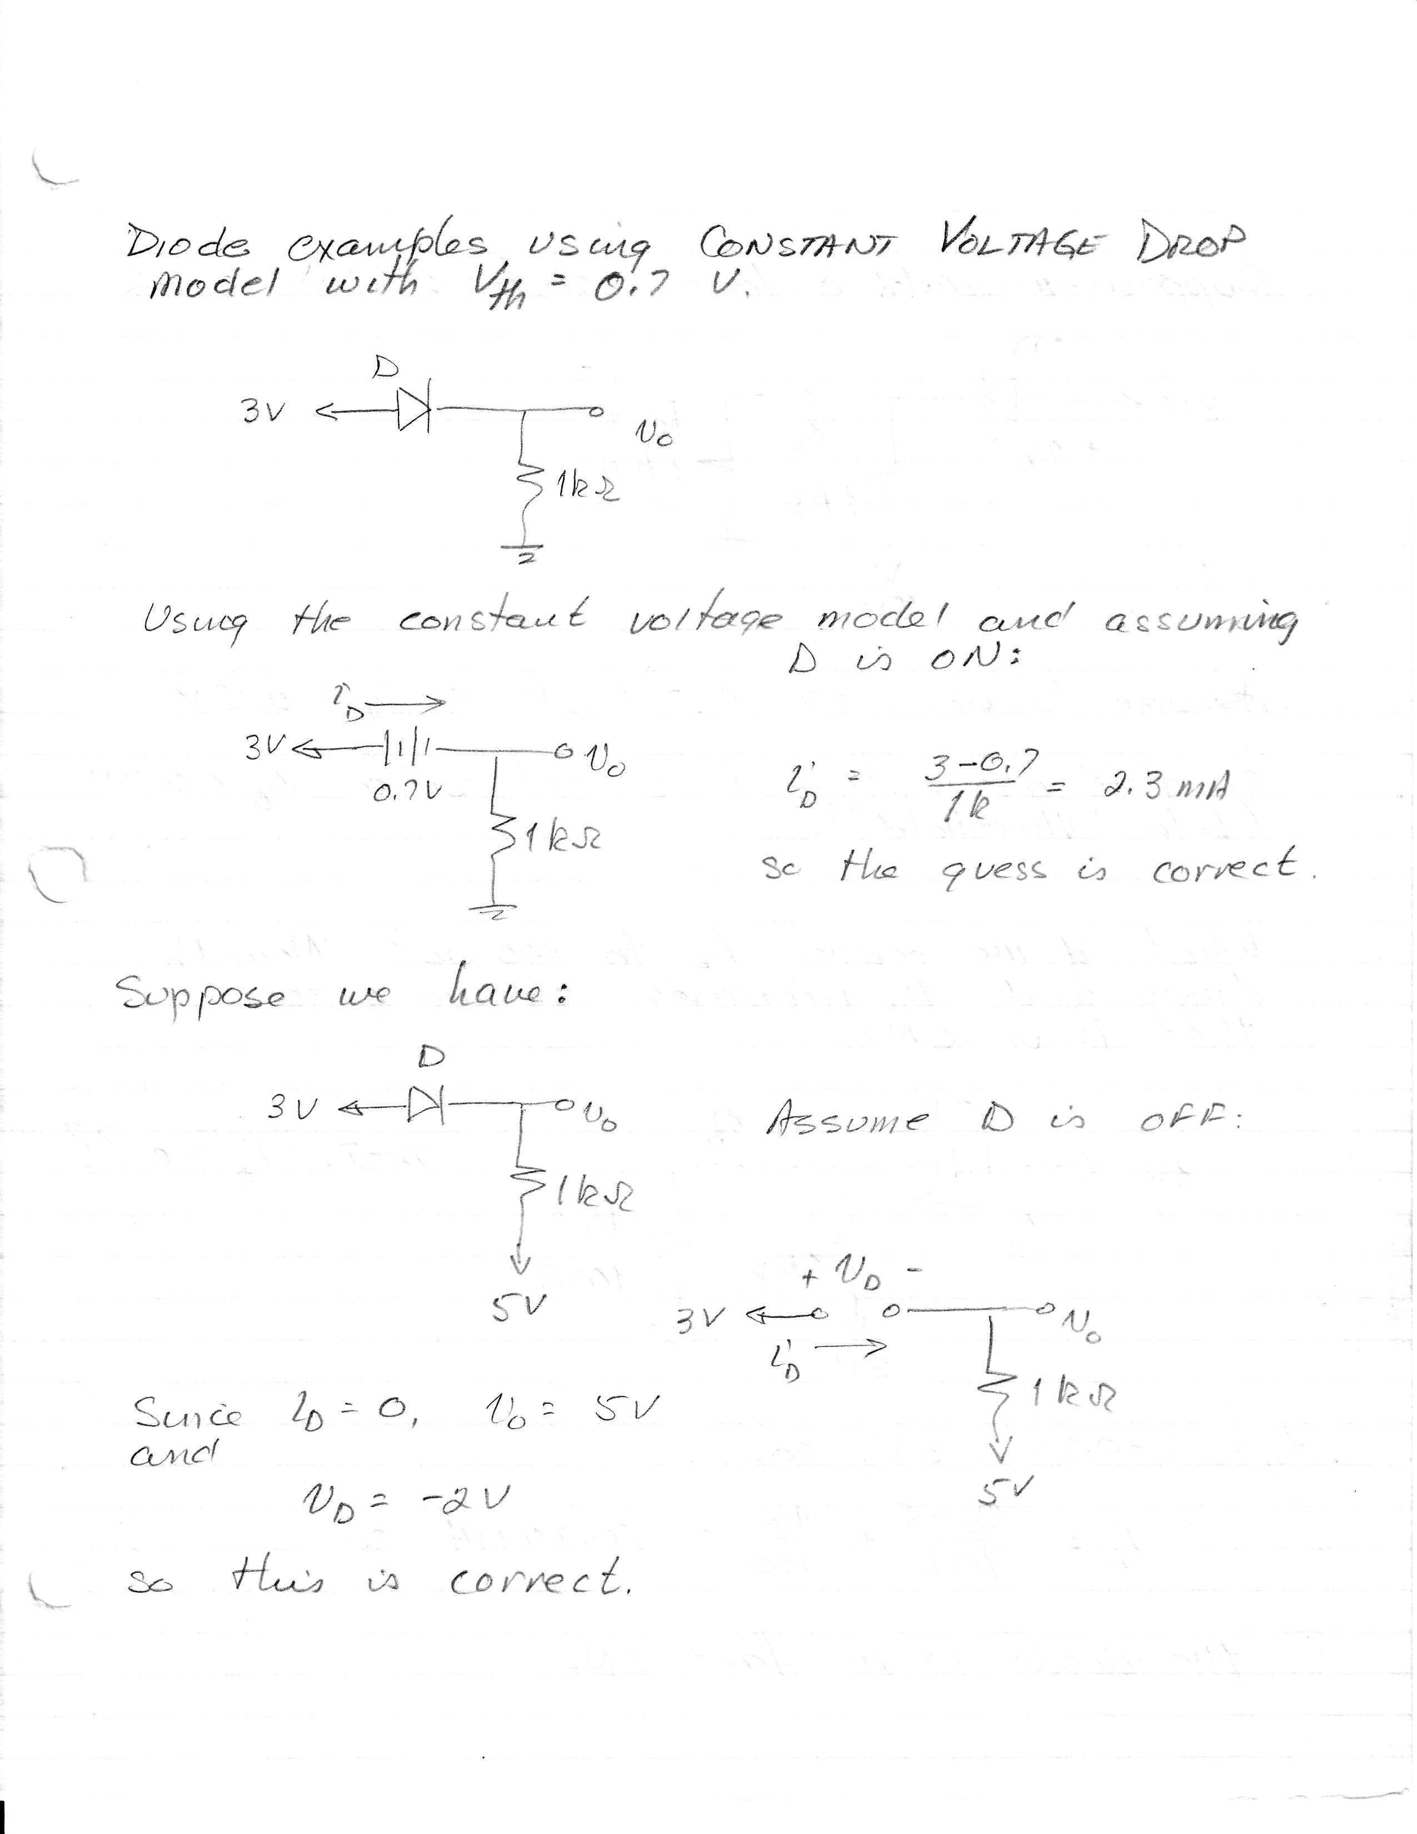

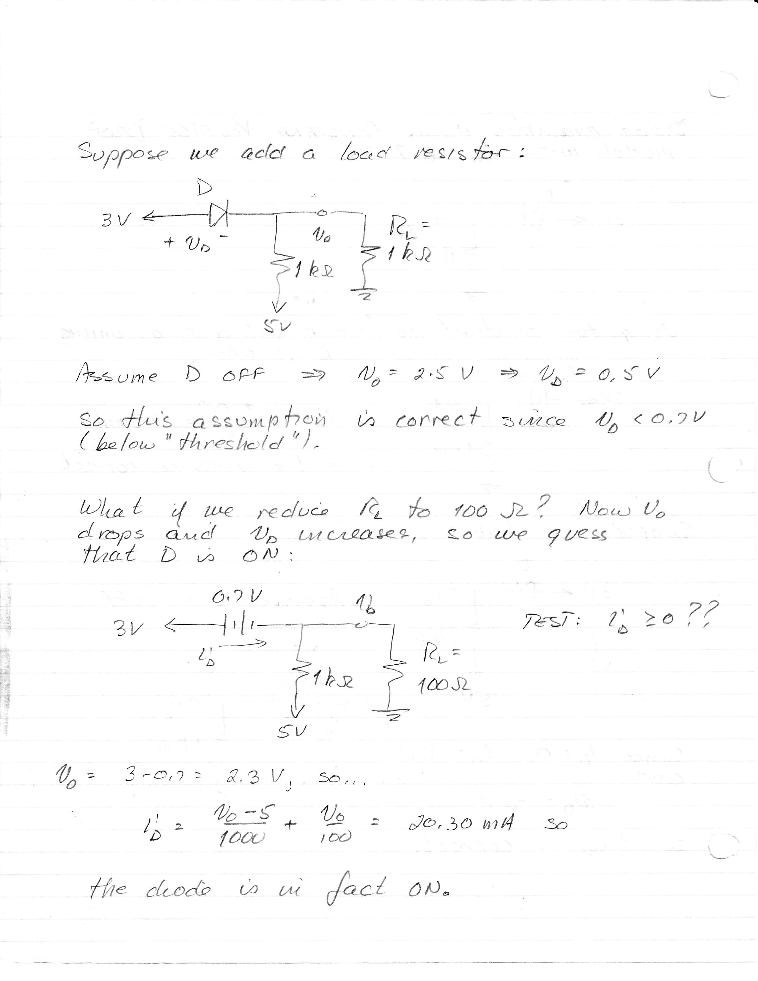

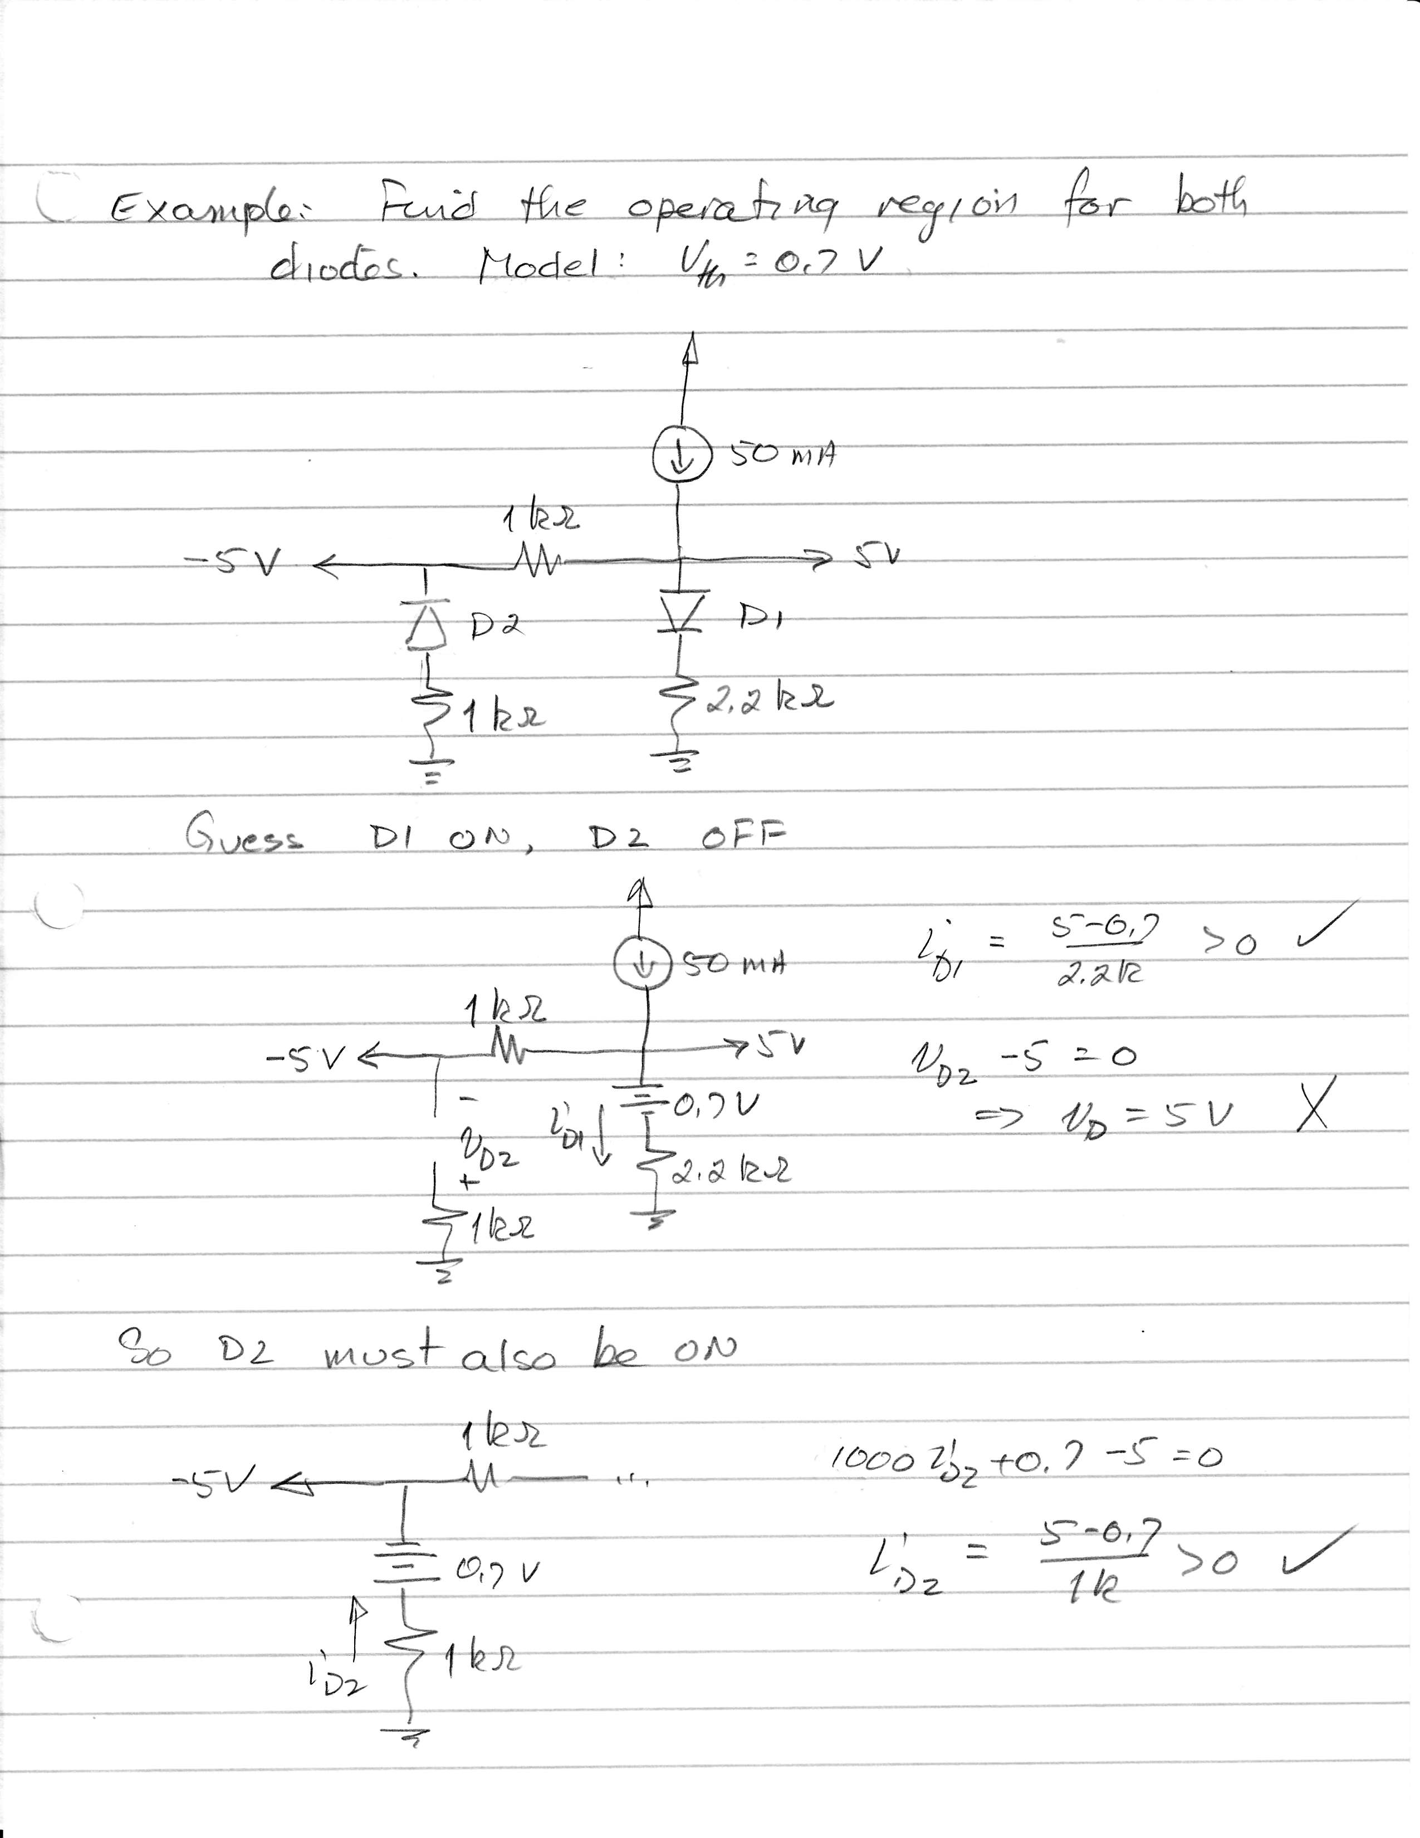

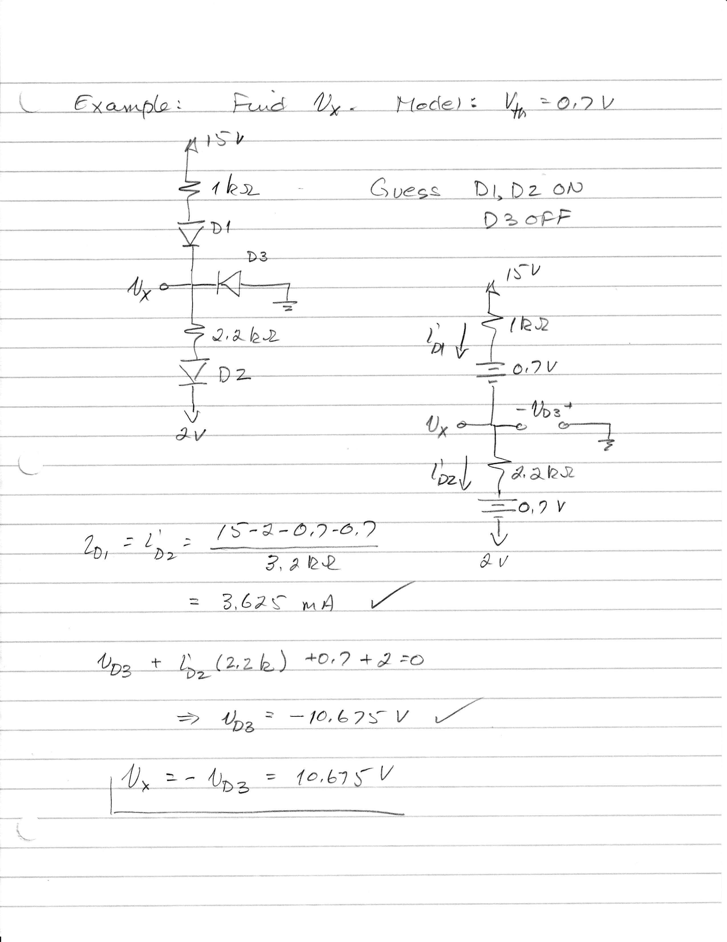

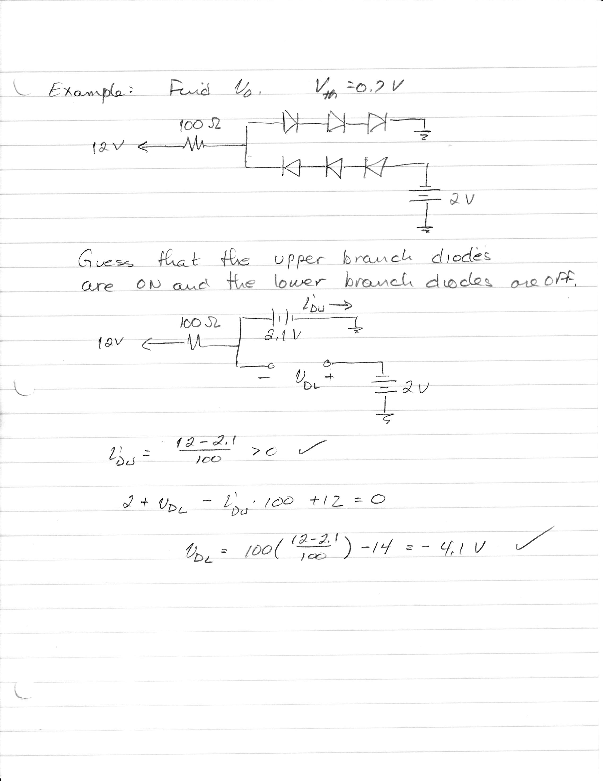

## Piecewise Linear Diode Model

We can add a bit of sophistication to our diode model. The figure below allows for…

1. a reverse-bias saturation current IS

IS is a given parameter. It is typically in the A range, but can take other values.

1. a region of zero voltage greater than the saturation current
2. a region of zero current below less than the threshold voltage
3. a threshold voltage Vth and a region above threshold that includes a series resistance rD

Vth was discussed above; it is typically 0.5 – 0.7 V, but can take other values. It is a given parameter, and it is positive.

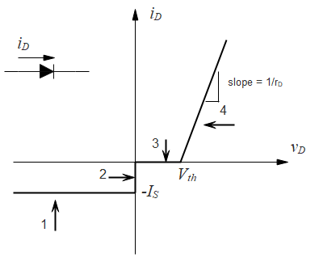

Note that with the proper choice of parameters, we can reproduce the other models:

* Vth = 0; rD = 0; IS = 0 gives the ideal diode model
* Vth = 0.7 V (or some other value); rD = 0; IS = 0 gives the constant voltage drop model

We now need to figure out what circuit model correspond to each of these regions.

For Region #...

1. Reverse bias saturation. The diode current is constant, regardless of the diode voltage. This can be modeled by a current source.

**Model Test**

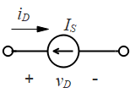



1. Zero voltage, variable current: . The current is variable, but the voltage is constant at 0 V, so this can be modeled as a short circuit.





1. Zero current, variable voltage: . This is an open circuit.





1. The current is increasing linearly with voltage (which sounds like a resistor) but there is an “offset” Vth. This is a voltage source in series with a resistor. See below for details.

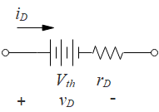

 or 

Now, our prescription for solving diode circuits is to…

* assume an operation region (1 – 4)
* substitute the appropriate circuit model
* test that the region we have assumed is correct

### The model for region 4

Let’s see if we can justify the voltage source in series with a resistor as a model for region 4.

In region 4, the equation for iD is

 with  and  .

⇨  .

Now let’s look at the circuit model, drawn a bit differently…important: convince yourself that the polarities in these two cases are the same. Note that the current enters the diode at the positive vD terminal, and moves through the voltage source from positive to negative.

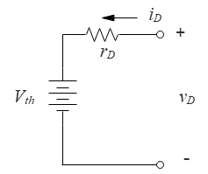A KVL here gives:

 ⇨.

So this is the same equation, and our diode circuit model for region 4 is consistent with a voltage source in series with a resistor.

Let’s do some problems…

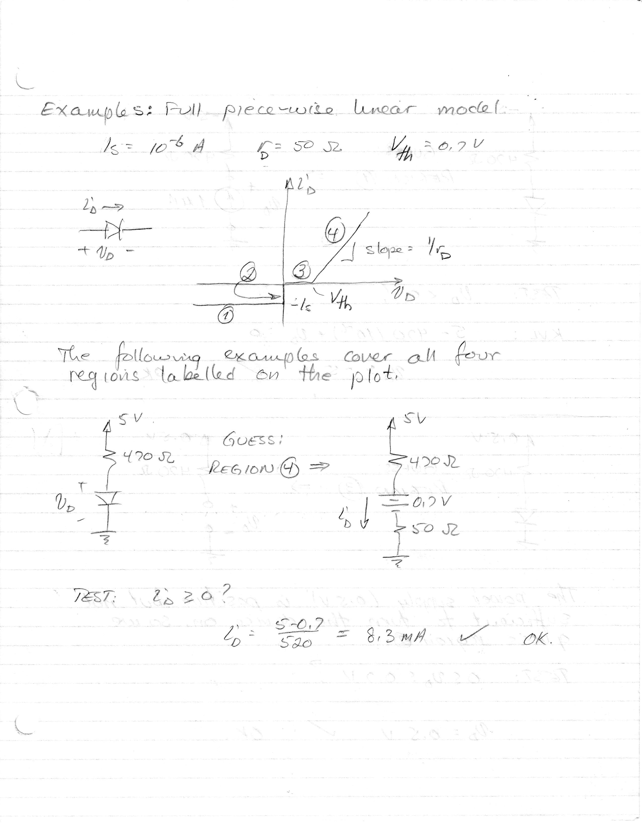

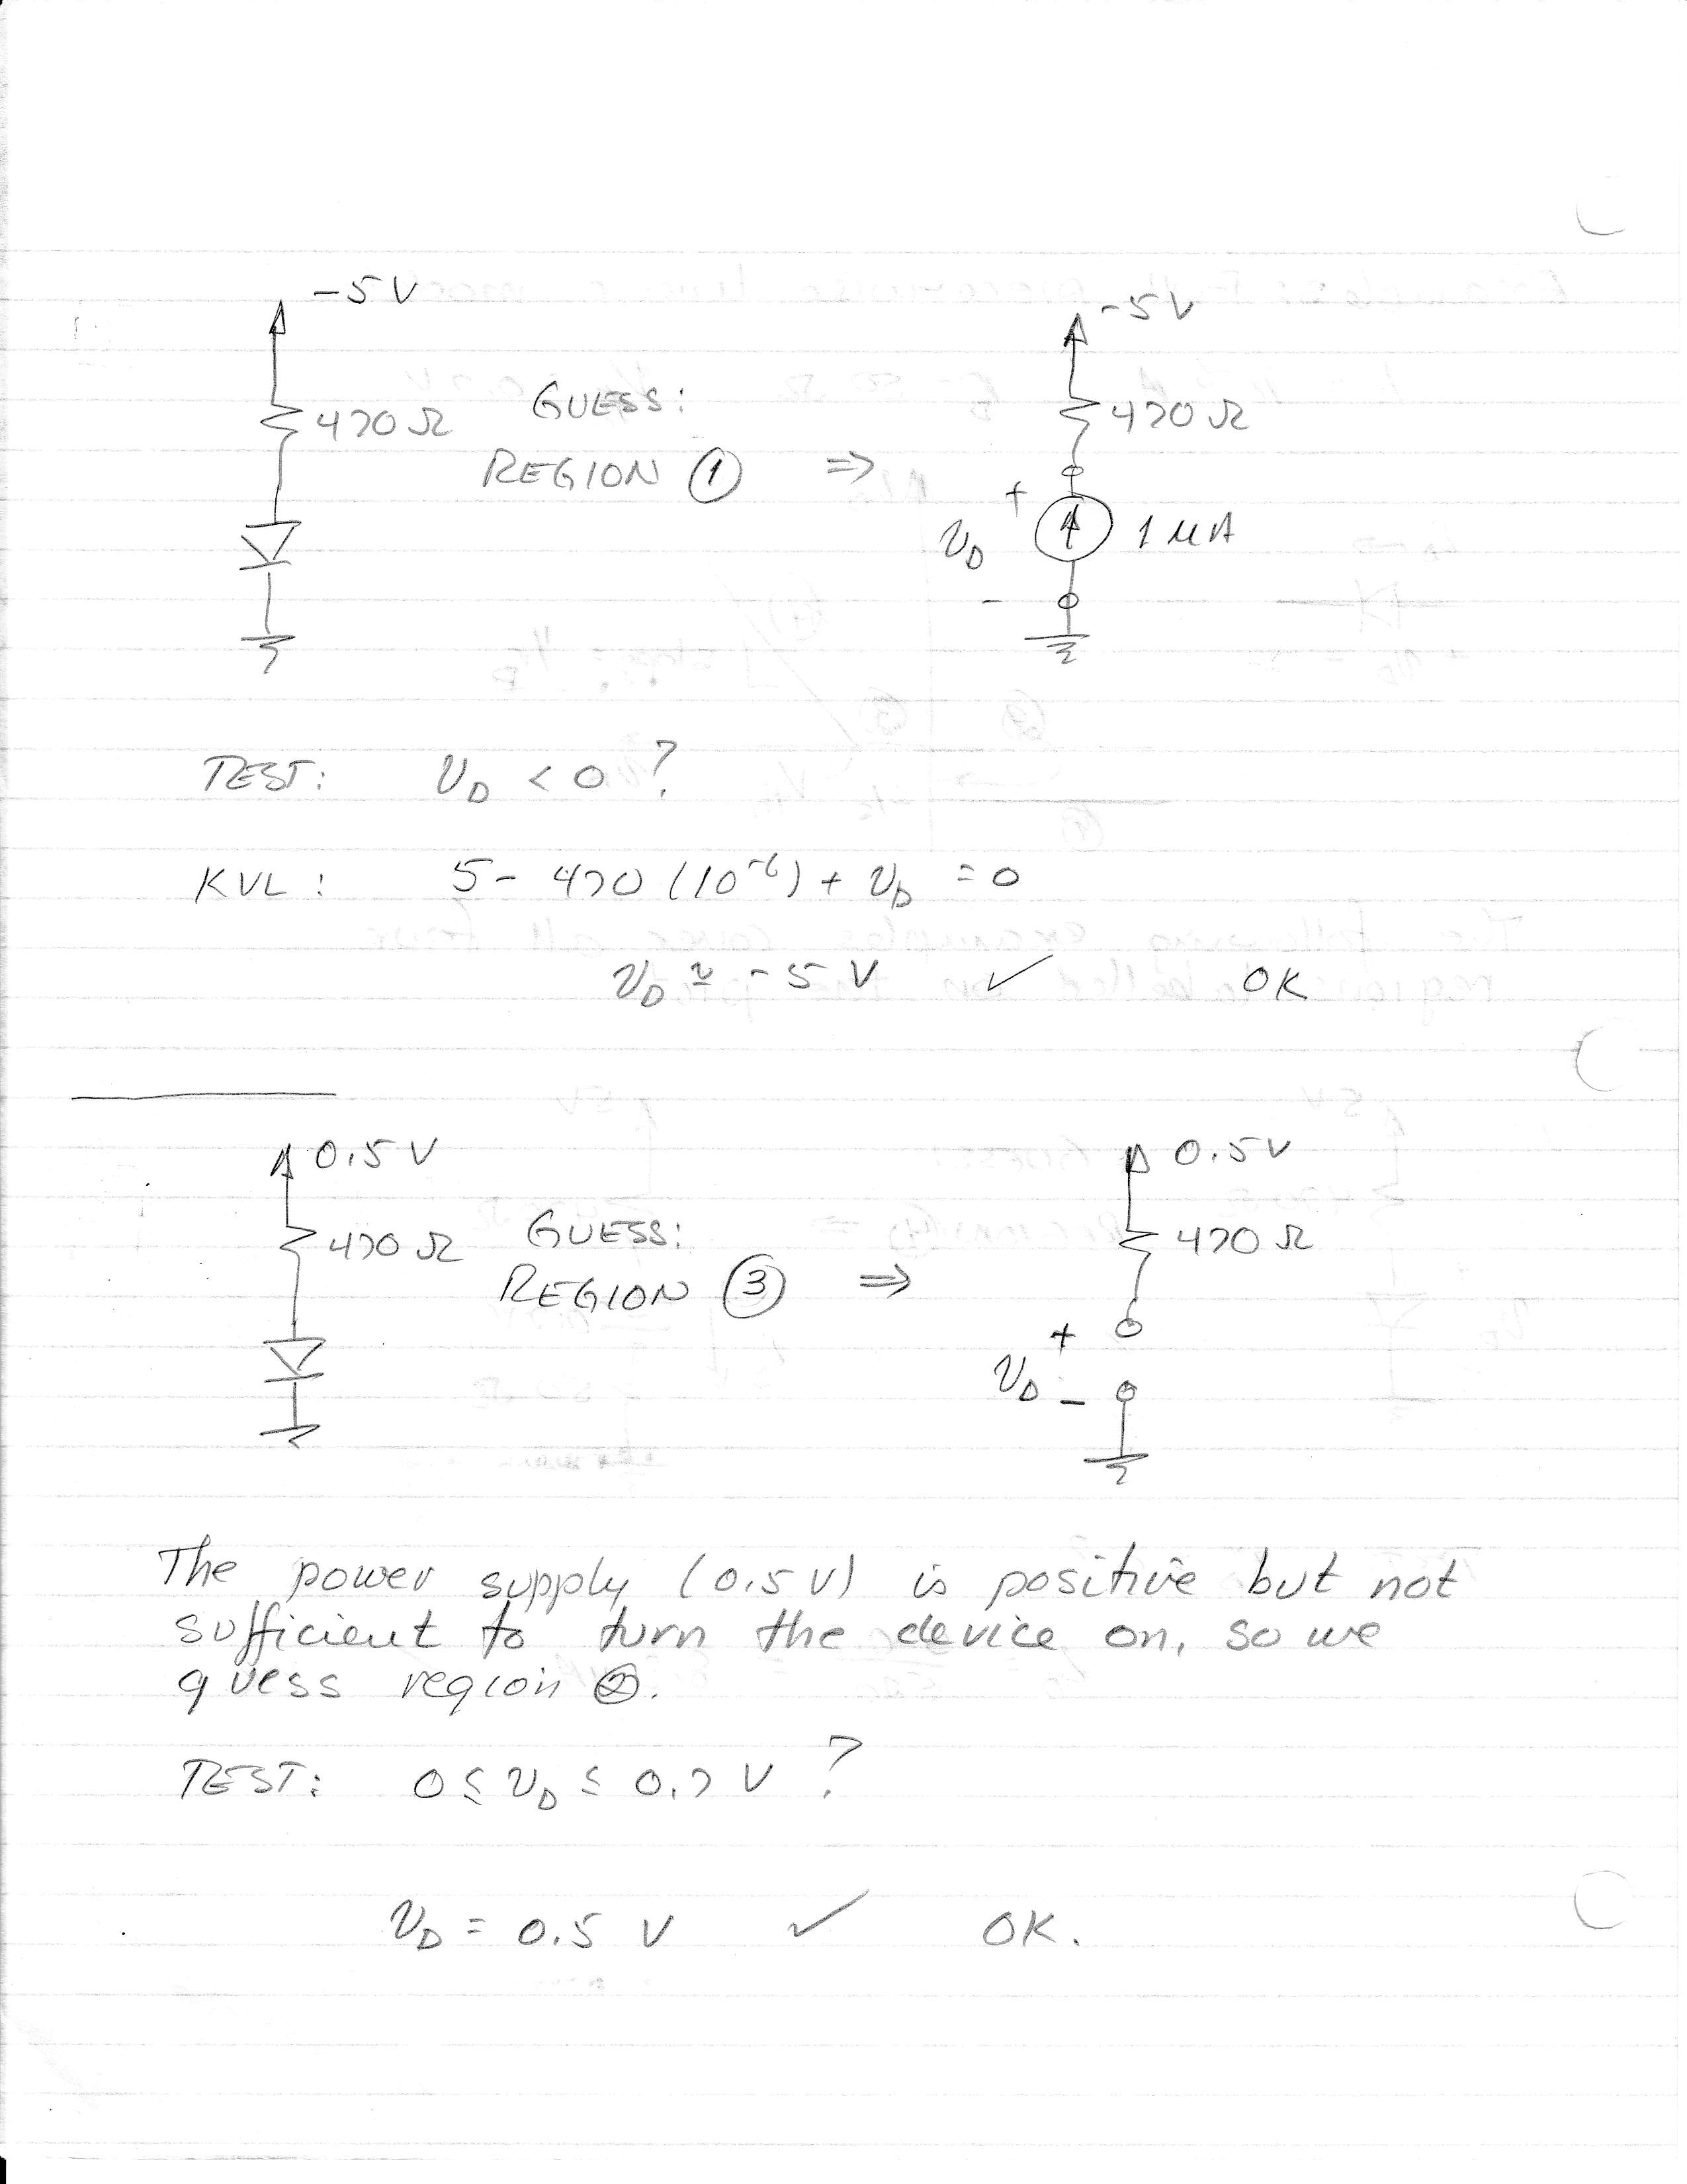

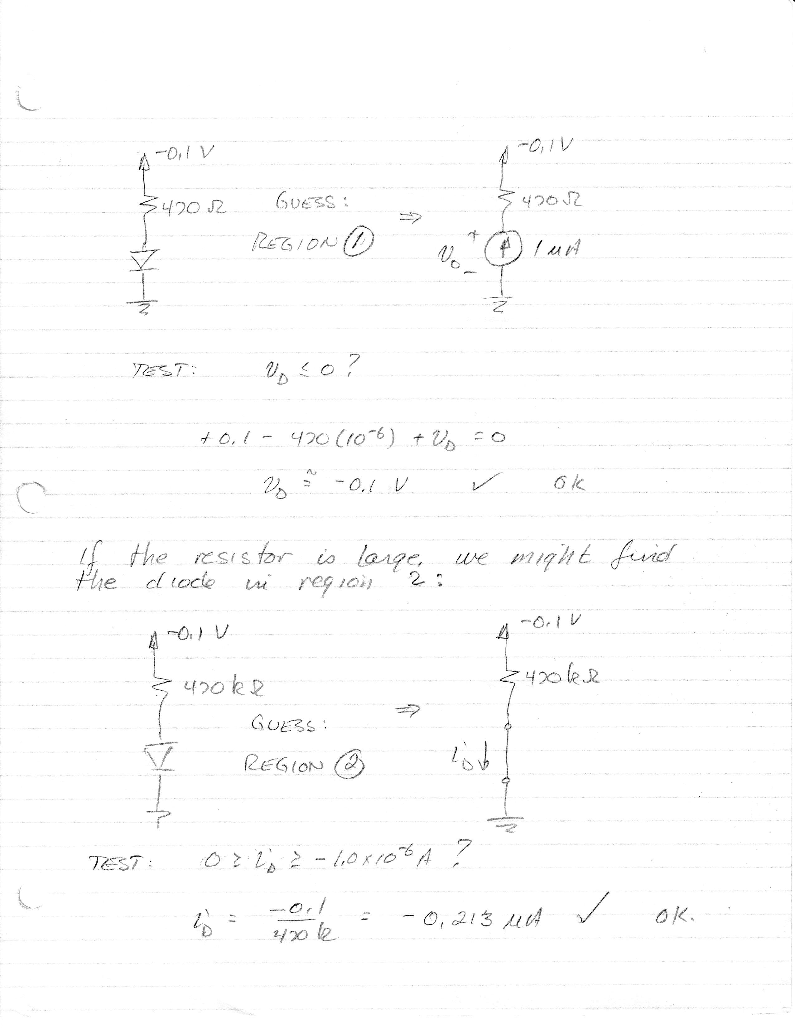

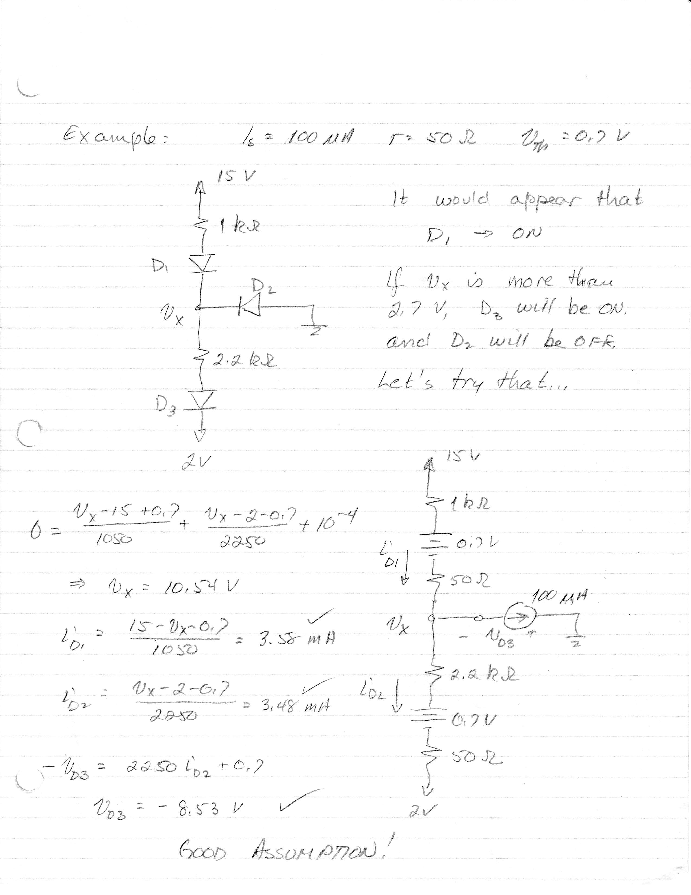

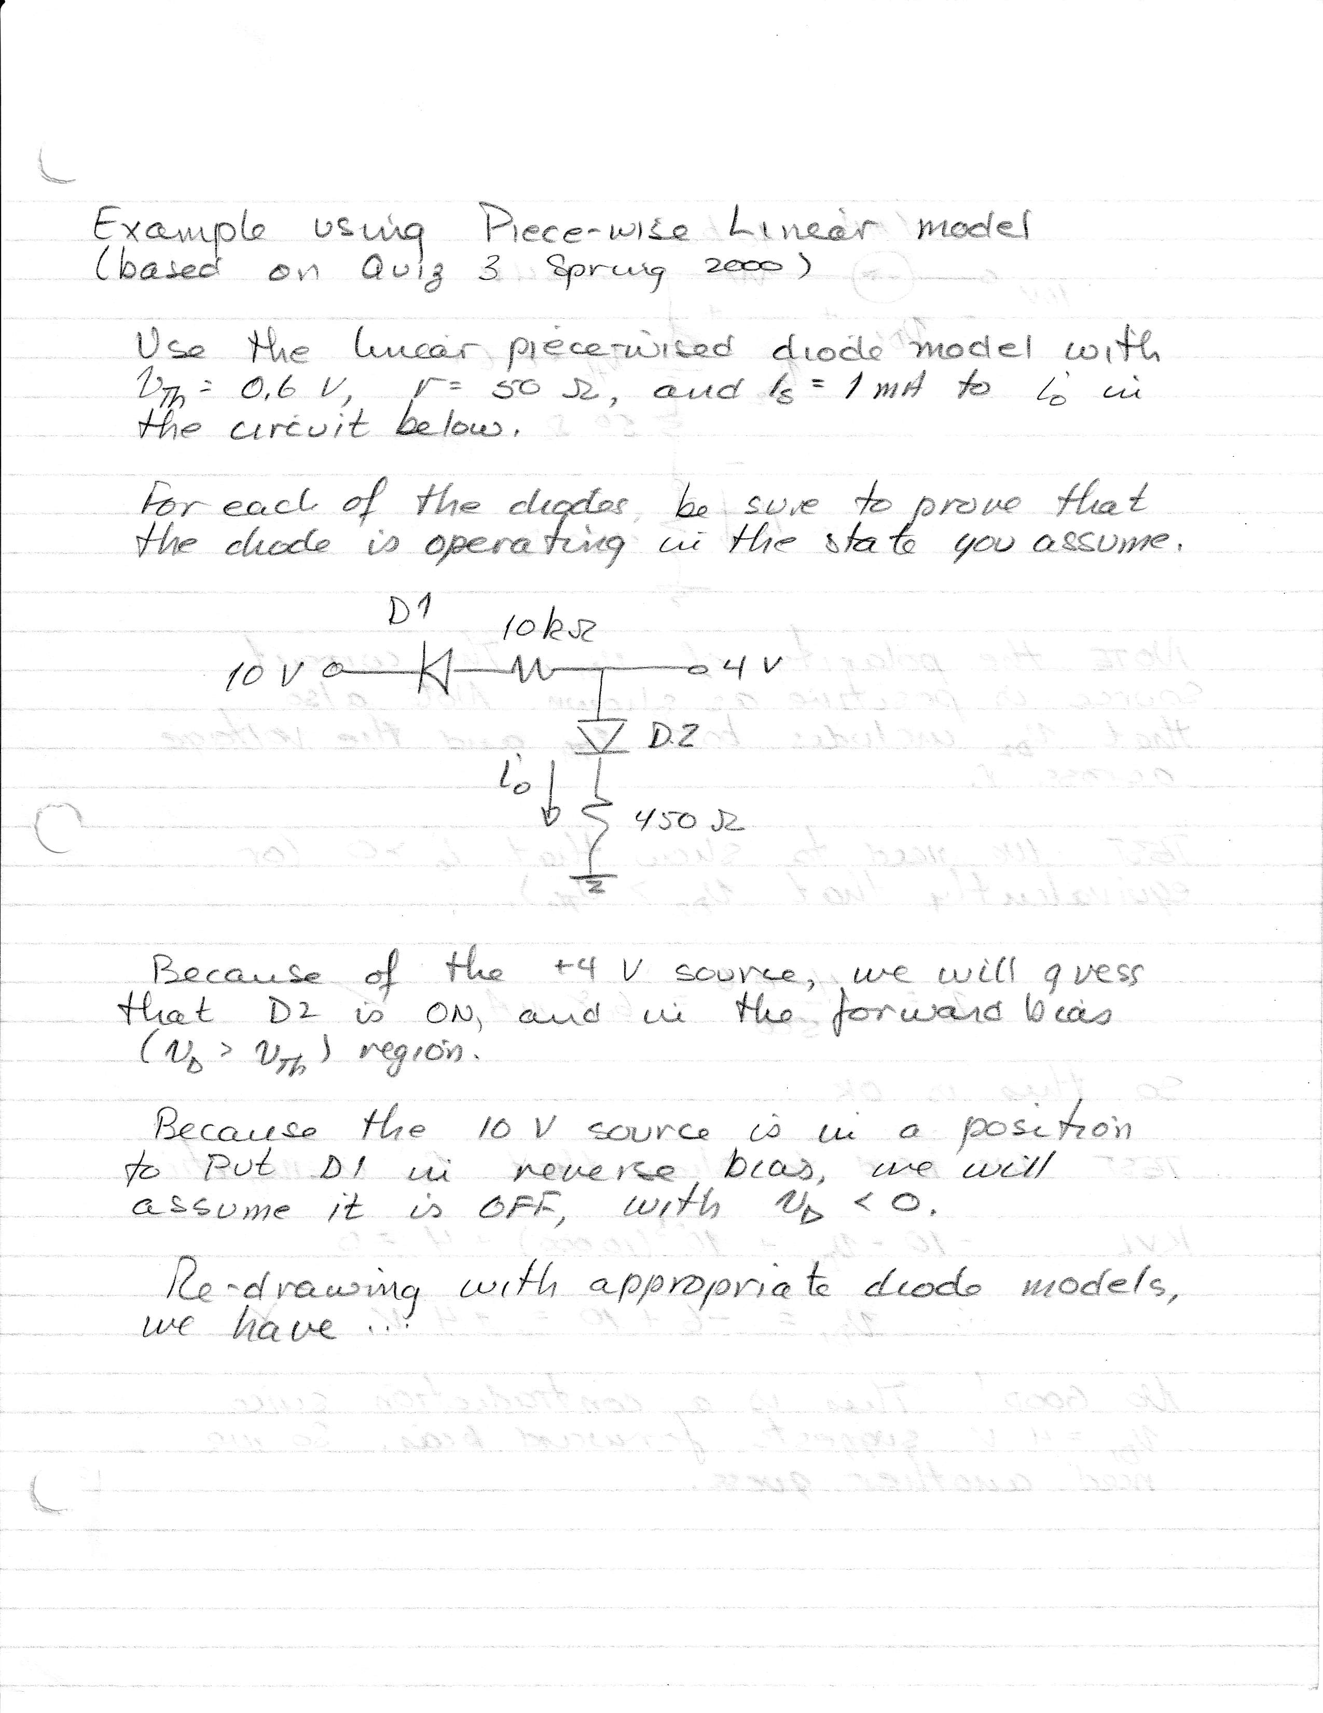

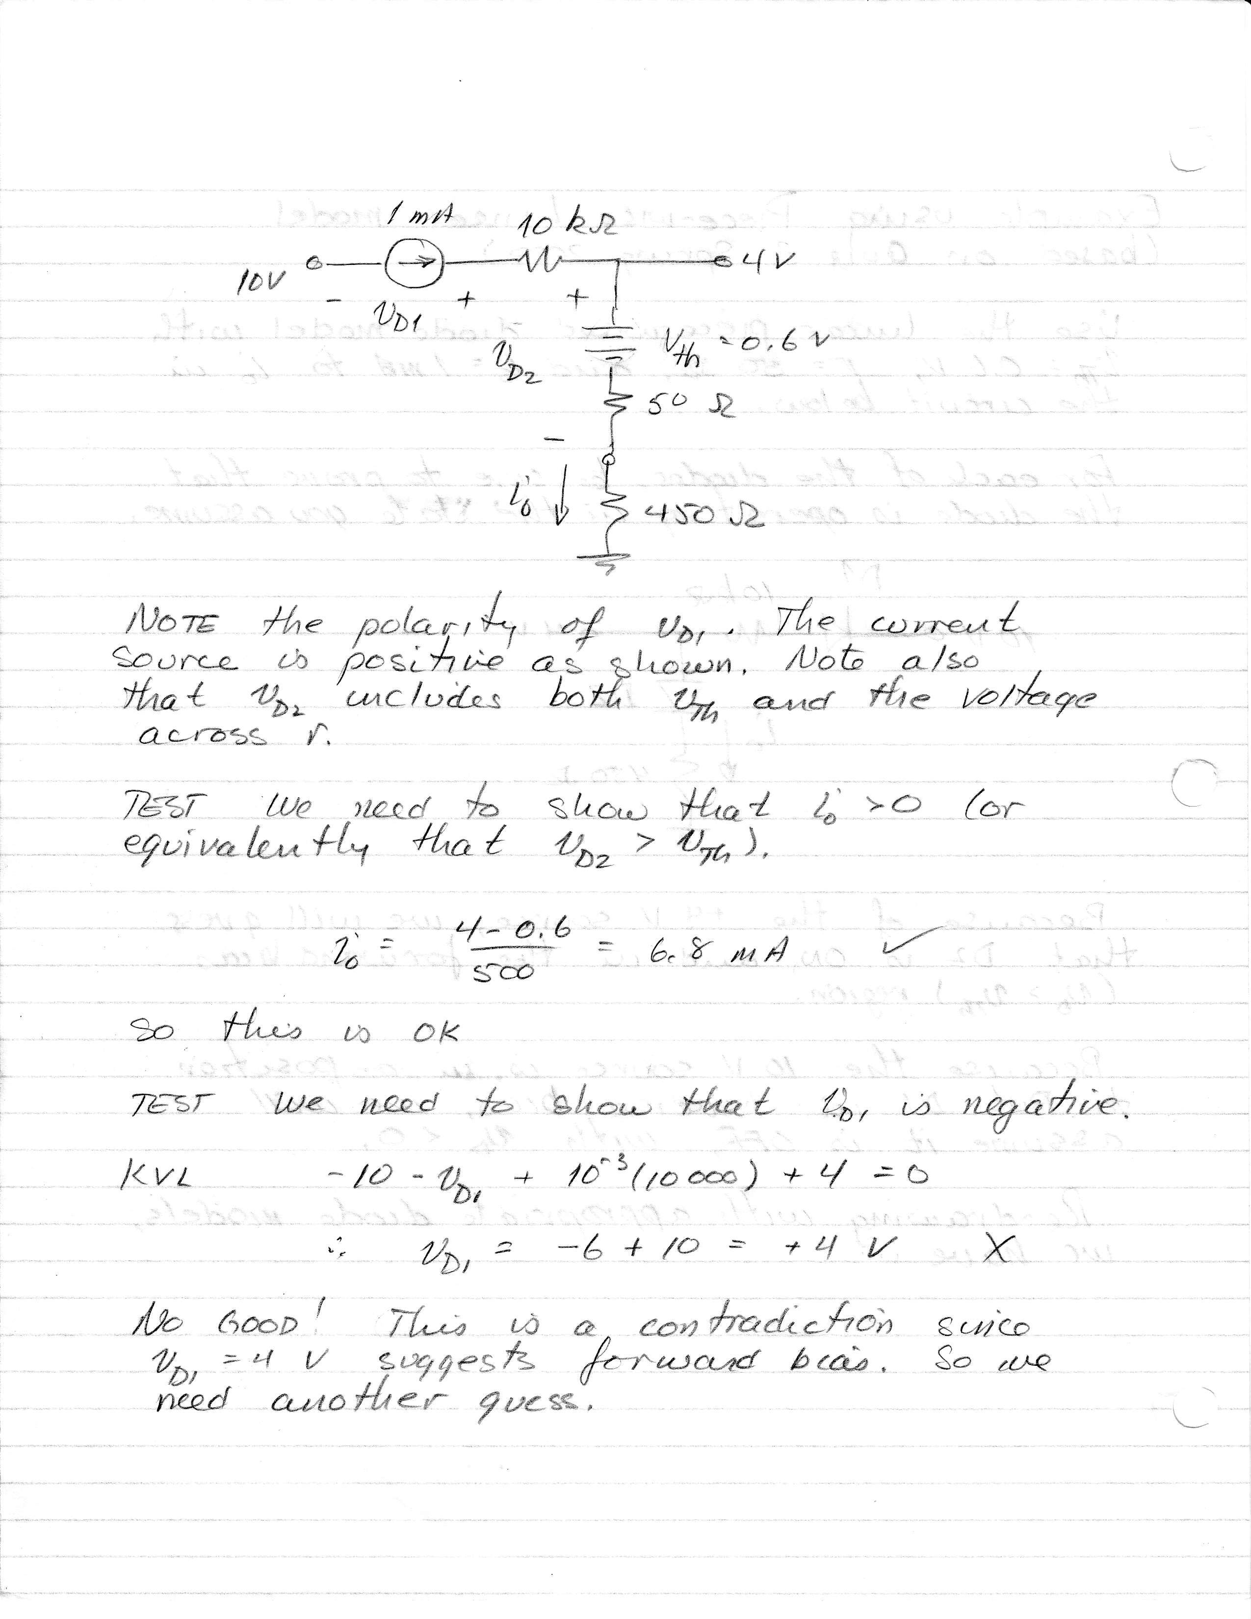

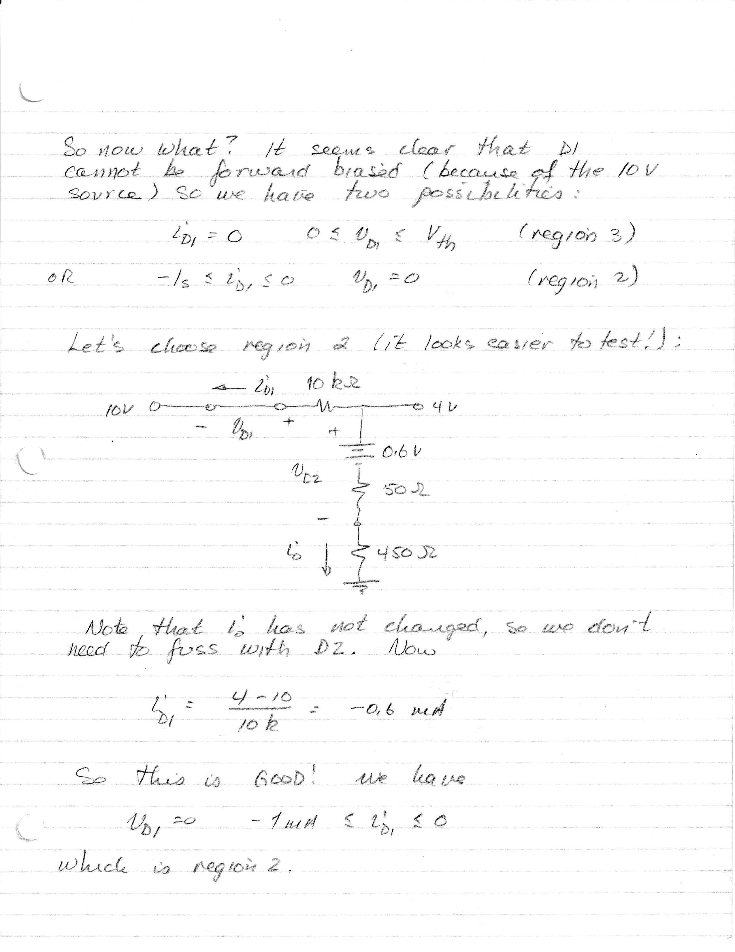

# Thevenizing

In the circuit below, we can think of the +/- 10 V sources as **biasing** – the diode is biased by these sources, which means that the sources (and of course the resistances) are determining in which region the diode is operating. We will see this kind of configuration again when we consider BJTs.

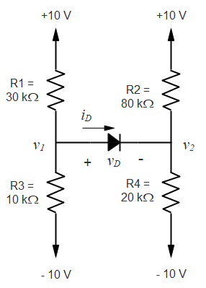

Suppose we want to find iD. Depending on the model used to substitute for the diode, this could get complicated. In this case, we will use the ideal diode model (rD = 0, IS = 0, Vth =0) to keep things simple.

One thing we can do (regardless of the model used) is assume that the diode is OFF, because it will be easy to see if that’s right. To do that, let’s calculate the voltages v1 and v2 relative to ground. Then with the diode OFF…





So we have !! This is not possible, so the diode must be ON. For the ideal diode model, we would substitute a short circuit for the diode, and then find iD. We’ll leave that to the interested student…

Let’s use a constant voltage drop model to do the previous problem, with Vth = 0.7 V. That will make for a fairly complicated problem, but we can simply by ***Thevenizing***! We will take the Thevenin equivalent of the circuit at the terminals defined by v1 and ground, and again at the terminals defined by v2 and ground.

We have just calculated the Thevenin voltage at these two terminals pairs. The Thevenin resistances are the parallel combinations of the resistors on each side. The resultant circuit with the Thevenin equivalents and the diode model inserted is as follows. Convince yourself that this is the correct circuit – we will use this idea frequently.

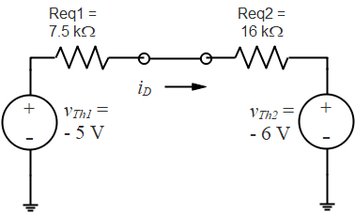





Now the analysis is easy:



This value is positive, so the assumption is a good one.

Suppose we had chosen a model with Vth = 0.7 V and rD = 100 . Then…

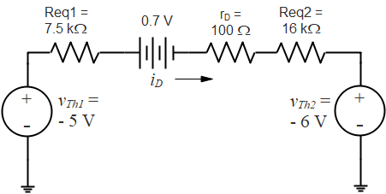



In-Class Examples

* Quiz 4 fall 2010
* Problem 2, Final Exam fall 2003

# Transfer Characteristics

We now look more closely at ***transfer characteristics***. We said earlier that this is a plot of vO vs. vI, and we looked at the simple case of a rectifier circuit in which the diode was modeled as an ideal diode. We consider more complex circuits here.

When we look for transfer characteristics, we generally don’t care what vI is. We want to plot vO for any possible value of vI, so that we have a result which is valid for any vI, whether it is a dc source or a complex time-varying function. However, we may specify a range for vI if we know, for example, that vI is a sinusoid with amplitude 1 V. When the circuit contains a diode, in general we want to make sure that we consider a range of vI that takes account of all possible diode states.

Consider the circuit we looked at earlier, but with a constant voltage-drop model for the diode with Vth = 0.7 V. Clearly, D will be OFF unless vI ≥ 0.7 V. Then

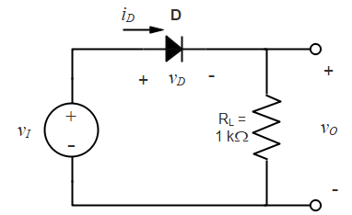

Problem TC.1

D OFF ⇨ vO = 0

D ON ⇨ 

⇨

Then the transfer characteristics are…

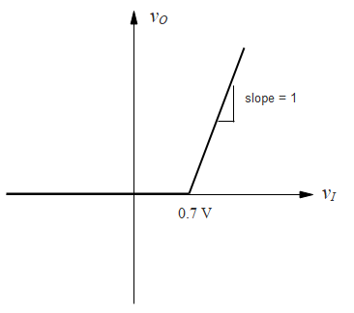

The slope for vI > 0.7 V is 1 because in that region, vO = vI.

Consider the following circuit. The diode will still be on for vI ≥ 0.7 V (think about why that’s true). Then the analysis is…

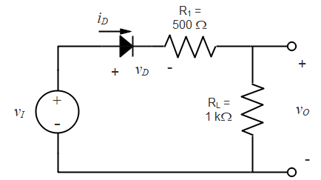Problem TC.2

D OFF ⇨ vO = 0

D ON ⇨ 

⇨

So now the slope of the transfer function for vI ≥ 0.7 V is . In the figure below, note that I have simply indicated the slope. We will not take the trouble here to make a detailed graph with annotated axes showing tick marks and labels. Showing the slope, and indicating values where the slope changes, however, must be clear on the diagram. We should be showing units, although in these discussions we will assume all voltage units are in Volts.

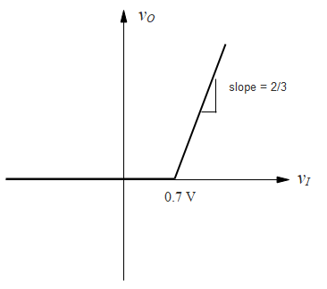

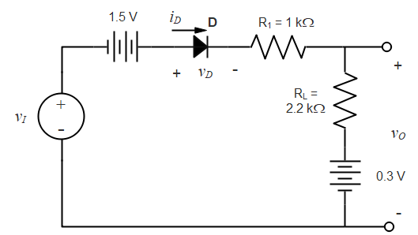Let’s look at a more complex example. We’ll again assume the constant voltage drop model, with Vth = 0.7 V.

To think about this problem, we ask “at what input voltage does the diode just begin to turn on”? To answer that question, we note that when vI has *just* reached the point where D is on, the diode voltage will be 0.7 V, but the current will be 0 (or negligibly small). Further increases in vI will cause a current to flow, but we find out when the diode just turns on by doing an analysis at iD = 0.

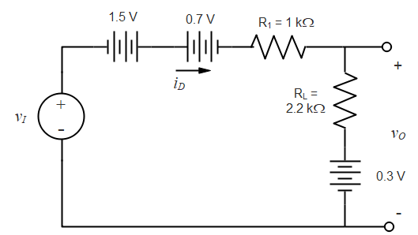

If iD ~ 0, then

⇨

and 

So the diode turns on at vI = -0.5 V, at which point vO = 0.3 V. Then if vI > -0.5 V, we have current flow:





For vI < -0.5 V we have iD =0 and vO = 0.3 V Here is the transfer characteristic. To make it clear what’s going on without tick marks, we have indicated the break in slope at - 0.5 V, the value of vO when vI = 0, and the slope.

