# Bode Plots and the Straight-Line Approximation

It is convenient and useful to show the properties of the transfer function using graphs of the magnitude (or gain) and phase as a function of frequency. This is generally done by plotting the magnitude in dB and the phase in degrees, as a function of the log of the frequency; these are the ***magnitude and phase Bode plots***.

Why log()? We are often interested in what happens to the transfer function when the frequency doubles, or is *multiplied* by 10 or by some fixed number– rather than when we *add* fixed values to the frequency. Log plots show this conveniently.

We can of course plot these things using mathematics packages. But here we will see how to do this quickly and intuitively using the *straight-line approximation*. This will allow us to quickly generate reasonably accurate plots. Also, it will give us an intuitive feel for what the transfer function looks like without even having to draw the plot.

## General Form of the Transfer Function

For this course, the transfer function can always be written in the following form:



where K is a real number. That is, the transfer function will consist of factors of  in the numerator and in the denominator.

The parameters “z” are called “zeros”, and the “p” are called poles. In other courses, you may these as the values that make the transfer function zero (the zeros) or infinity (the poles). In those cases, the transfer function is being derived a bit differently. In this course, the z’s and p’s do not make the function zero or infinity, but we call them zeros and poles anyway.

If we like, we can express the transfer function in another form, by algebraic manipulation:



Depending on how we solve for the transfer function in a circuit, either of these forms may result. Note that the multiplying factor (K) will be different (K’) if we express *T()* this way.

We will refer to the poles and zeros as ***breakpoints***. A breakpoint in the numerator is a zero; a breakpoint in the denominator is a pole. The general prescription for finding breakpoints is that they occur when the real and imaginary parts of the terms are equal. This method can be used to identify poles and zeros regardless of how the transfer function is expressed.

## Analysis of the Transfer Function

Let’s start by looking at a simple circuit: the RC circuit as a low-pass filter.

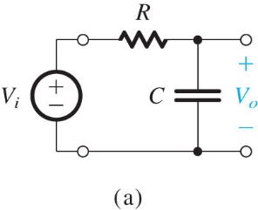



Figure 1.22a, Sedra & Smith 7 ed.

For arbitrary , we have:

 and .

If we were going to make Bode plots using pencil and paper (i.e., without a mathematics software package), we might begin by examining extreme value of , to get a sense of how the magnitude and angle functions behave.

 so , 

 so , 

We might also look at an intermediate value of ; a convenient value is :

, , 

### Magnitude Bode Plot

From this information we could plot |*T()*|, and we would get something like this:

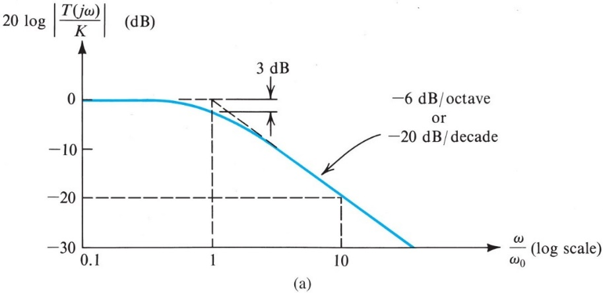

Figure 1.23a, Sedra & Smith 7 ed.

We note two regions of frequency response: one for  << o, and one for  >> o. In the figure, the horizontal axis is /o , so these regions correspond to o << 1, and o >> 1. We will consider “much greater than” to be a factor of 10, and “much less than” to be a factor of 1/10.

For o << 1 the magnitude is constant (in this case at 0 dB).

For o >> 1, the magnitude is decreasing as 1/RC. In this region, if  increases by 10, *T()* changes by 20 log(0.1) = - 20 dB (i.e., drops by 20 dB).

So when the transfer function includes a factor of (1+j/o) in the denominator, the magnitude Bode plot decreases by 20 dB per decade for  >> o. (An increase in  by 10 is an increase of 1 decade).

It should be clear that for a factor of (1+jCR) in the numerator of the transfer function, the magnitude Bode plot will *increase* at 20 dB/dec for  << o, and will be constant for  >> o.

### Phase Bode Plot

We could also plot the phase Bode plot from the information above:

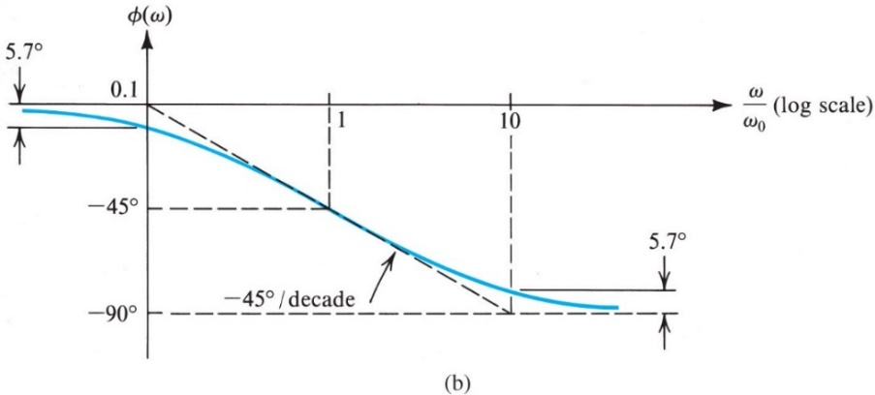

Figure 1.23b, Sedra & Smith, 7 ed.

Here we see the transition from 0 to -90o predicted earlier. Also, we note the following.

For o >> 0.1 the phase is dropping at -45o/dec, but stops dropping after o >> 10.

For o << 0.1 and o >> 10, is constant.

For a factor of (1+jCR) in the denominator of the transfer function, the phase Bode plot decreases at 45o/dec for two decades, between 0.1 o and 10 o. Outside that range, it is constant. (This behavior arises from the properties of the function, which is constant for very large and very small x.)

Not surprisingly, for a factor of (1+jCR) in the numerator of the transfer function, the phase Bode plot *increases* at 45o/dec for two decades, between 0.1 o and 10 o. Outside that range, it is constant.

Looking at Figs. 1.23a and 1.23b, we see that the magnitude and phase of the transfer function can be approximated pretty well by straight lines chosen appropriately. These are the dashed lines in those figures.

## Rules for Straight Line Approximation to the Bode Plot

We now state rules for drawing straight-line approximations to the magnitude and phase Bode plots.

Recall the general form of the transfer function:



To create the straight-line approximations, we do the following.

1. **Identify the poles and zeros.** The poles and zeros are the ***breakpoints***, and they are indicated in the function above as zi and pi.

In the example above, we have no zeros, but we have a pole at 1/RC.

1. **Magnitude Bode plot:** As you progress from low to high , the magnitude Bode plot increases by 20 dB/dec for each zero encountered, beginning at the value of the zero. For every pole encountered, the magnitude Bode plot decreases by 20 dB/dec beginning at the value of the pole.

Note that the slope changes are additive: if at some value of , we have previously encountered 2 poles and a zero, the slope at that  is -20 -20 + 20 = -20 dB/dec.

1. **Phase Bode plot:** As you progress from low to high , the phase Bode plot increases by 45o/dec beginning at 0.1x the breakpoint, and continuing to 10x the breakpoint.

The changes in slope for the phase plot are also additive, but they “run out” after two decades. But if in some range of  there are two zeros and a pole still running, the slope is +45 +45 – 45o/dec.

1. **Evaluate** at one point to set the vertical axis. Notice that we have been specifying slopes for the magnitude and phase Bode plots, but we cannot plot a straight line unless we also have one point on that line. So we have to evaluate magnitude and phase of *T()* for at least one value of  (or more if we want greater accuracy).

Very often the magnitude Bode plot has a range of  over which it is flat, as is the case in the low pass filter for low . It’s convenient to evaluate *T()* there. If there is no flat region, pretty much anyplace will do.

For the phase Bode plot, evaluating at  or at is usually the best bet.

Let’s do this for our low-pass filter. For step 4, let’s evaluate and at  = 0 to get 0 dB, and 0 deg.

Let’s assign some numbers: R = 1 k; C = 1 F. That gives us a pole at p = 1/RC = 1000 rad/s, and no other breakpoints. If we follow the rules, we should get the straight-line approximation Bode plots shown on the next page. Compare these with the plots in Sedra & Smith.

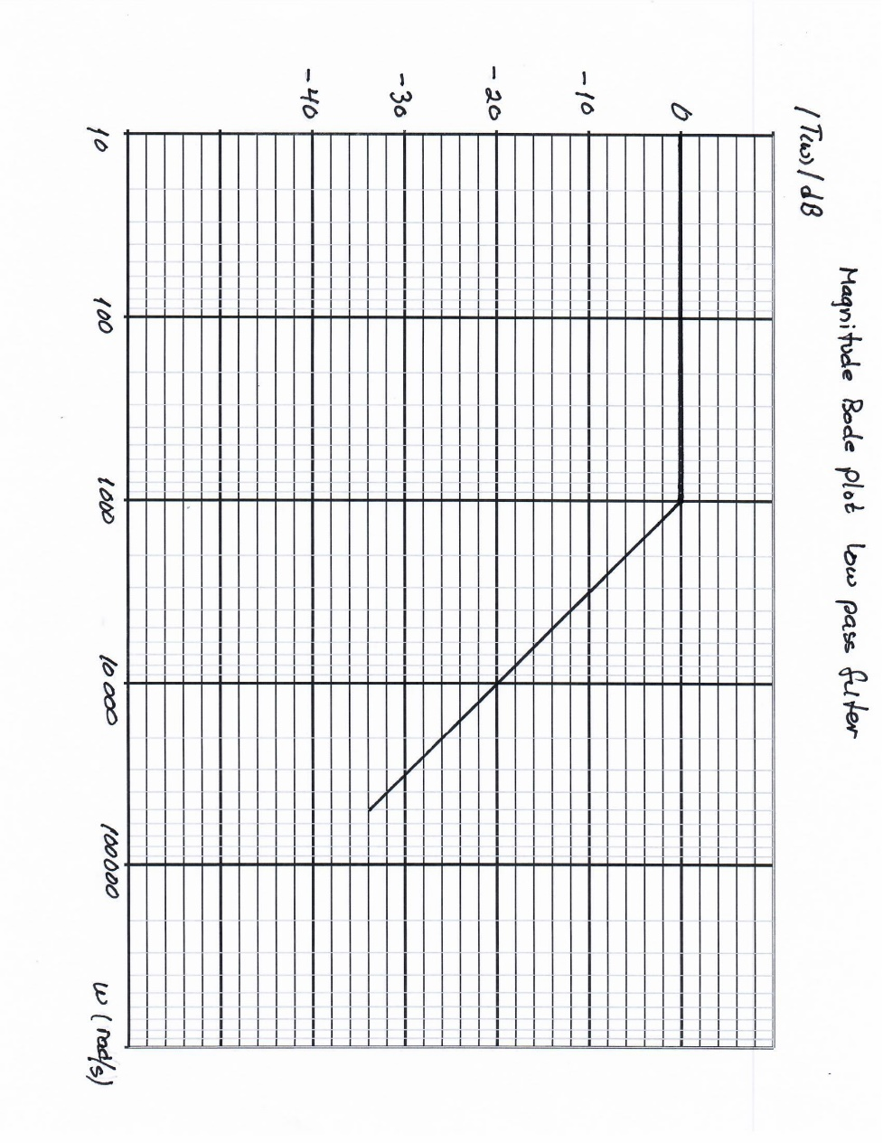

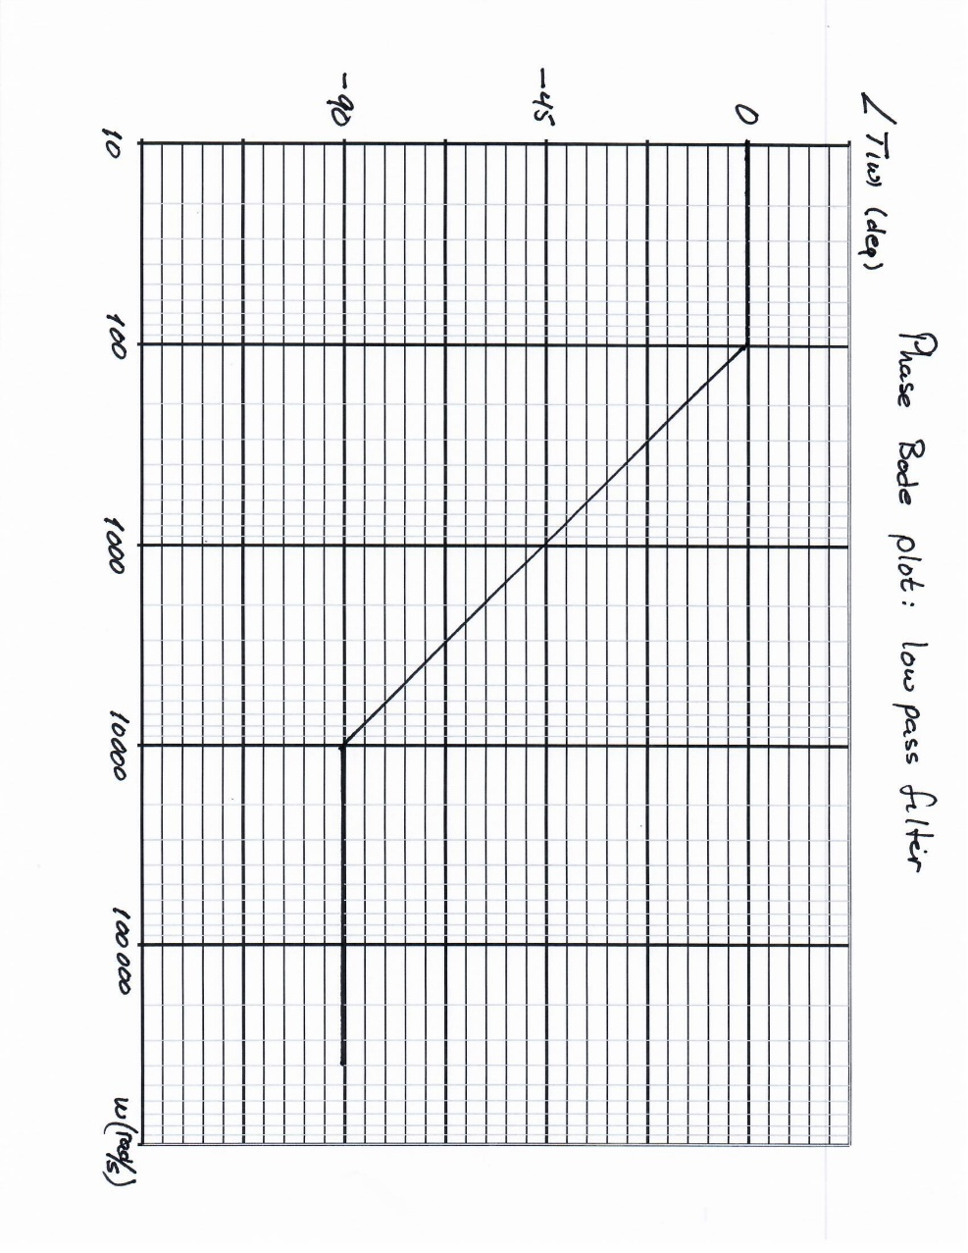

Let’s look at another example: the RC circuit set up as a high-pass filter.

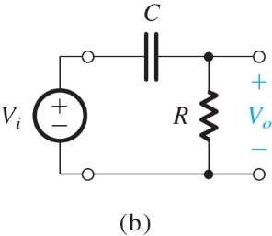



Figure 1.22b, Sedra & Smith, 7 ed.

Let’s follow our Bode plot steps. We’ll use the same R and C values as before.

1. Identify the breakpoints: Setting real and imaginary parts of the numerator equal, we get a zero at  = 0 (real part of the numerator is 0). Doing the same for the denominator, we find a pole at 1/RC, or p = 1000 rad/s.

2. Magnitude Bode plot: Since we have a zero at  = 0, the magnitude Bode plot must be increasing at 20 dB/dec beginning at  = 0. We can’t show  = 0 on the plot so we’ll just indicate the slope as beginning somewhere off to the left of the plot.

At  = 1000 rad/s, the increase of 20 dB/dec stops because we have a pole that adds a slope of -20 dB/dec, for a total of 0 dB/dec.

3. Phase Bode plot: We have a pole at  = 1000 rad/s, which means the phase plot will decrease by 45o/dec beginning at 100 rad/s and ending at 10,000 rad/s.

But what about the zero at 0? Note that the phase Bode plot will always have 0 slope at  and, because the slope stops changing after a change by a factor of 10 above and below □. Note also that a zero or pole at  = 0 will *have no effect on the slope of the phase plot*, because 0.1 x 0 = 0 and 10 x 0 = 0.

4. Evaluate: It’s not convenient to evaluate |*T()*| at , but it is convenient at . In that case, the term (1+jRC) in the denominator becomes jRC, which cancels the term in the numerator. So *T()* is 1, or 0 dB, for .

What about the phase at  = 0? Looking at the transfer function, we see that, so the phase is 90 deg. (Note that means the denominator becomes 1, but there is nothing to compare jRC to in the numerator, so we have to keep it. It does not become 0 compared to 0!)

Sedra and Smith 7 ed. have the following plots of the transfer function for the high-pass filter. On a subsequent page we show these plots on lin-log graph paper.

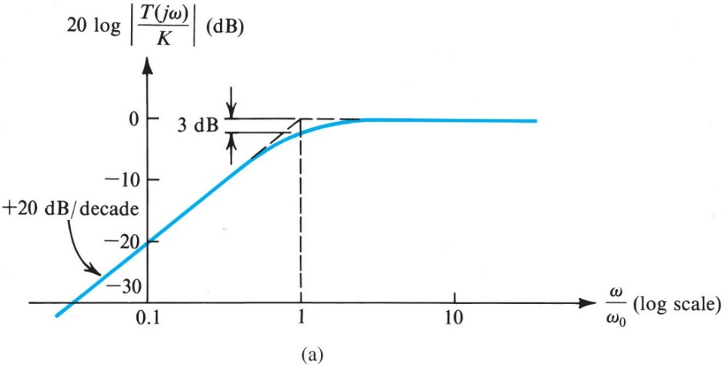

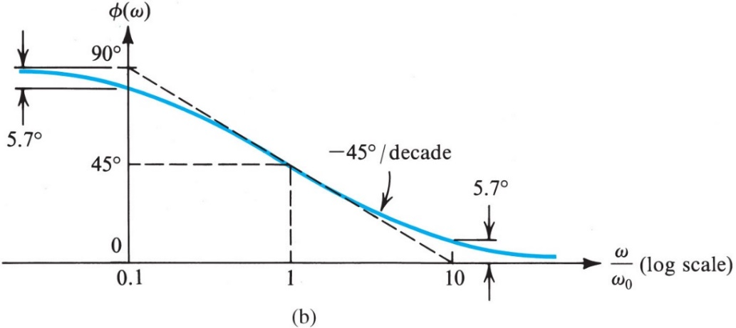

**Figure** **1.24** **(a)** Magnitude and **(b)** phase response of STC networks of the high-pass type.

Microelectronic Circuits, Seventh Edition

We leave a more careful plot to the student!

Sedra/Smith Copyright © 2015 by Oxford University Press

Microelectronic Circuits, Seventh Edition

**Figure** **1.24** **(a)** Magnitude and **(b)** phase response of STC networks of the high-pass type.

A more complex example is done below. This is the amplifier circuit we looked at earlier in the course. We will not be too fussy about where 31.2 and 3120 rad/s fall. Indicating these points at just past 30 and 3000 rad/s will be good enough.

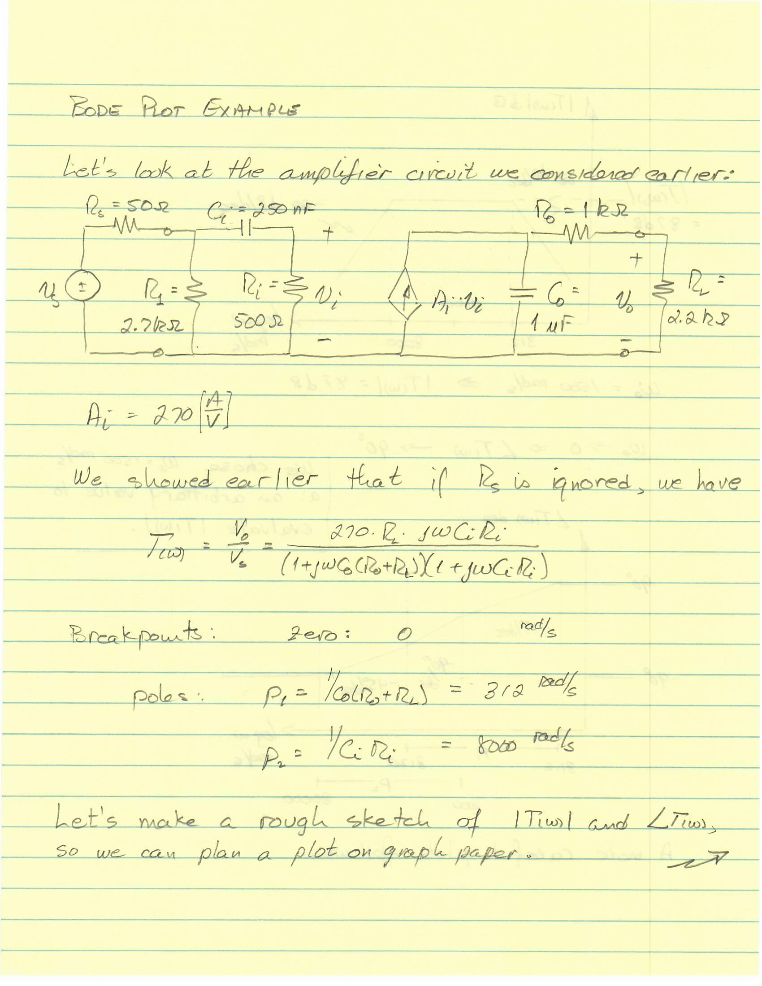

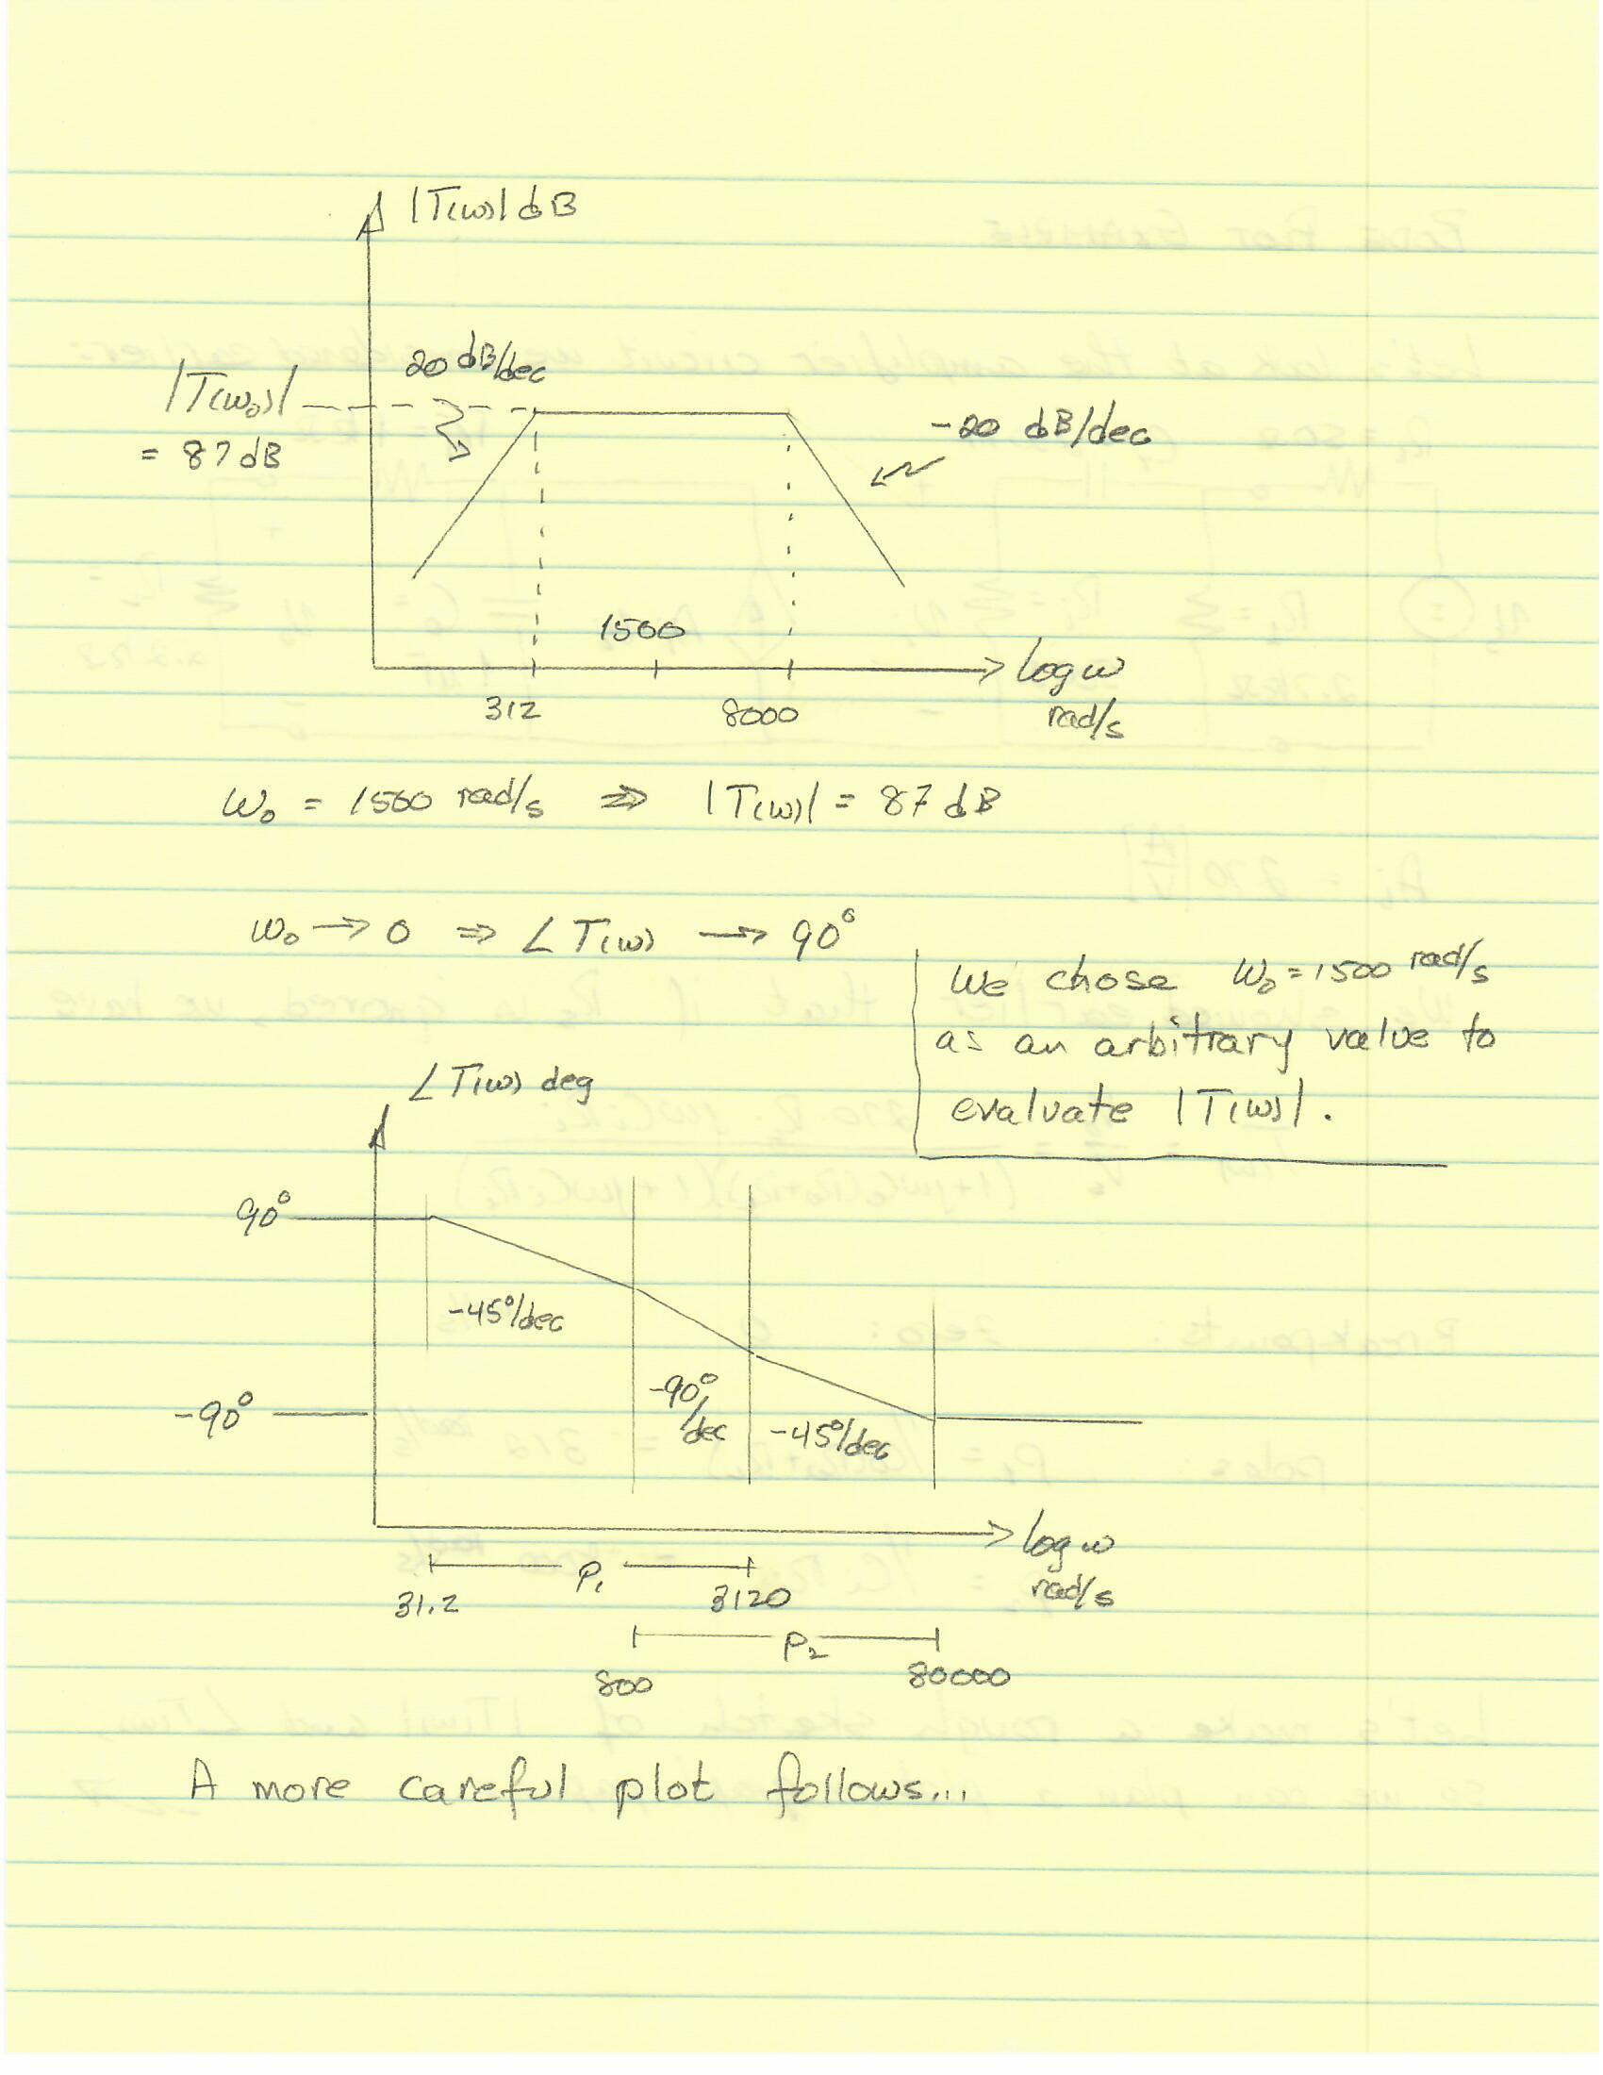

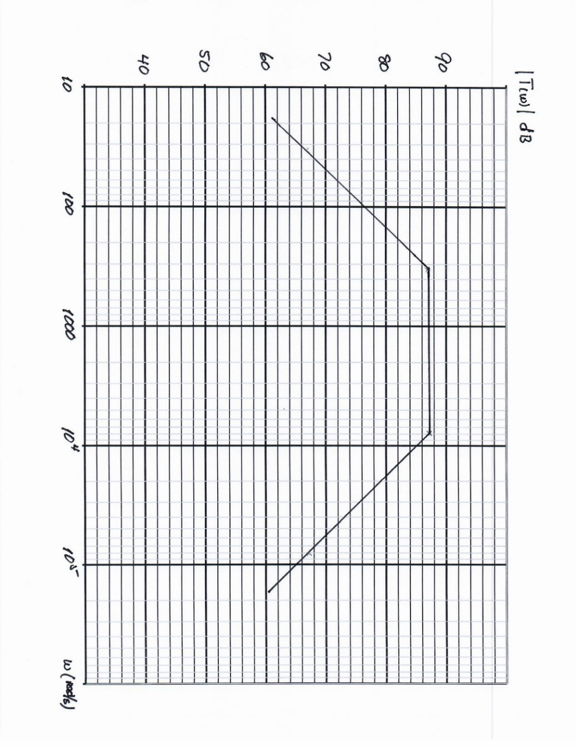

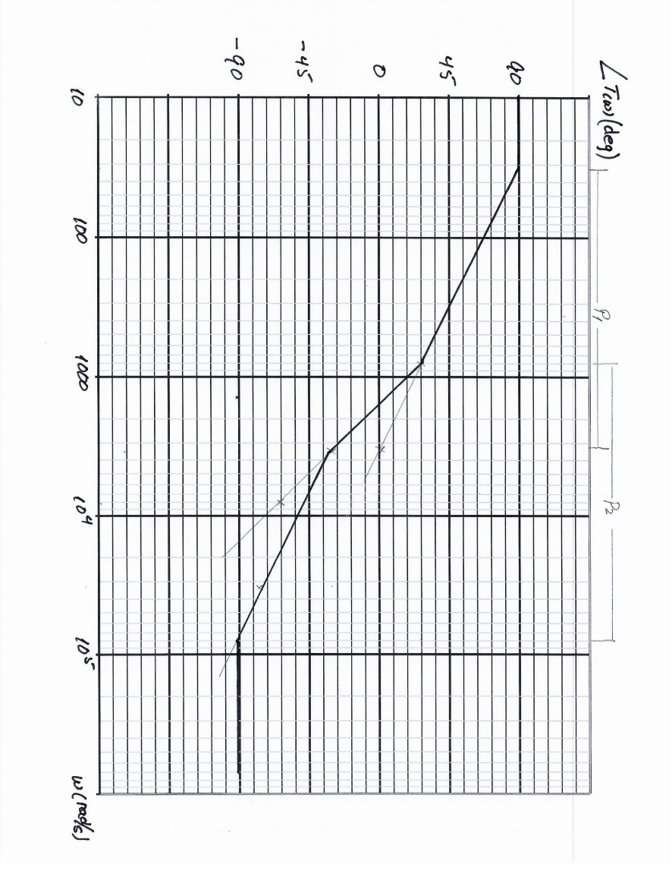

### Errors in the Straight Line Approximation

Let’s go back to the low-pass filter example taken from Sedra and Smith, which we discussed above. if we look at our calculation of the magnitude of the transfer function at the breakpoint in our low-pass circuit, we see that the value is -3 dB. Recall that the breakpoint was , in which case:

, .

However, in the straight-line approximation, the magnitude at the breakpoint is 0 dB. Under the approximation we’re using, this is acceptable. In fact, this is the *maximum* error in the plot: the straight line approximation will be too high by 3 dB at a pole, but more accurate elsewhere. It’s easy to show that it will be 3 dB too low at a zero. Look at the dashed line vs. the solid line in Sedra & Smith Figs. 1.23a to see what’s happening.

If we have multiple poles or zeros at the same breakpoint, the error will be higher: +/- 3 dB for each pole/zero with the same breakpoint.

The consequence is that if we do the evaluation for the magnitude (step 4) at a breakpoint, we will be off by 3 dB (for a single pole or zero). So either we should do the evaluation in the middle of a flat region, where the error is less, or else we should do the evaluation at the pole/zero, and then correct by 3 dB.

The error in the straight-line approximation to the phase Bode plot will also be a maximum at a breakpoint: +/- 5.7o. We can see this by comparing the dashed and solid lines in Sedra & Smith Figs. 1.23b.

