# Diode Small Signal Model

We mentioned the idea of biasing early in the course. Let’s look at what we said then.

The figure below (Figure 1.13 from Sedra and Smith 7 ed.) shows the transfer characteristics of a linear amplifier with power supplies L+ and L- . It also shows two sinusoidal inputs to the amplifier plotted vertically, and the corresponding outputs plotted horizontally.

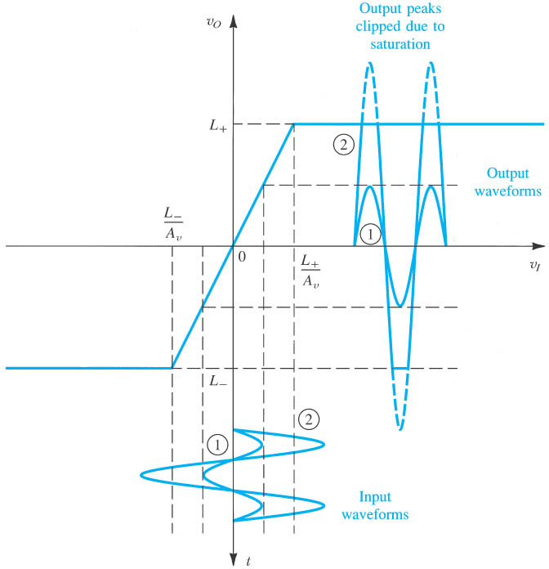

This figure makes that point that if the input signal amplitude is too large, the output will exceed the power supplies. In that case, we are not operating in the linear region, and the output “clips”. This is happening for the input labeled 2, so the output is a function that is more complex than a single sinusoid. That means it has many Fourier components, and from our definition of linearity, the circuit is not linear under those circumstances.

Figure 1.14 below shows the transfer characteristics of an amplifier that is more typical, and more complex. There is a region of the transfer characteristics where the amplifier response is approximately linear, but it is offset from 0 Volts. Therefore, to amplify a signal vi with this amplifier, we must add a DC bias voltage VI to the signal, to move the signal into a linear region of the transfer characteristics.

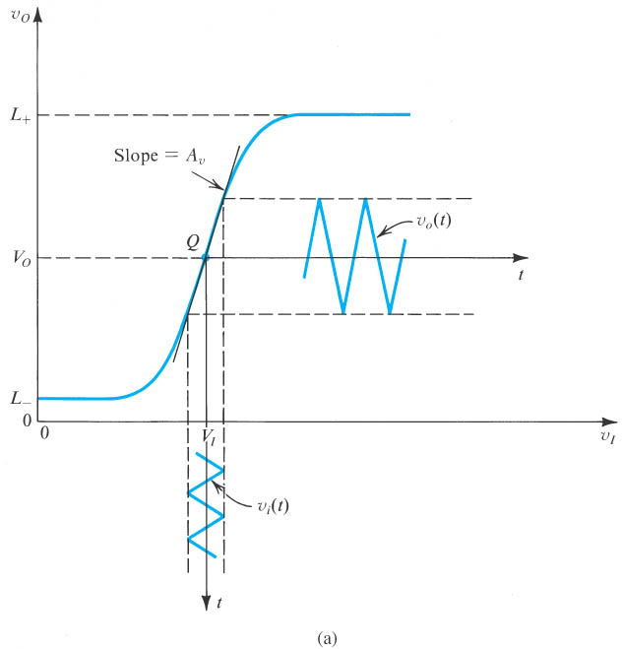

Even then, the transfer characteristics may not be precisely linear. If they are not, our output signal will be a distorted version of the input. In real amplifiers, the transfer characteristic is very nearly linear, provided we do not move too far away from the region labeled Q in the figure above. In other words, if the input signal is small in amplitude, then the transfer characteristics will be approximately linear over the range of the signal amplitude, and the output will be a good reproduction of the input.

To summarize: in real amplifiers, we must apply a bias voltage to our signal to get the signal into a region of the transfer characteristics that is approximately linear. Furthermore, the signal must be small, that is, of a small amplitude, so that it does not vary from the linear region of the transfer characteristics.

Figure 4.14 below shows the transfer characteristics iD - vD of a typical diode. We don’t usually think of a diode as an amplifier, but the notion of bias and application of a small signal still applies. In the figure, the bias voltage is VD, which is generated by the biasing source VDD. The small signal input is vd. The ac component of the output is id, and the DC component is ID. The ***quiescent point*** or ***bias point*** Q is the point on the current-voltage curve that is not varying, that is, it’s the DC voltage and current VD and ID.

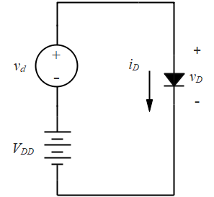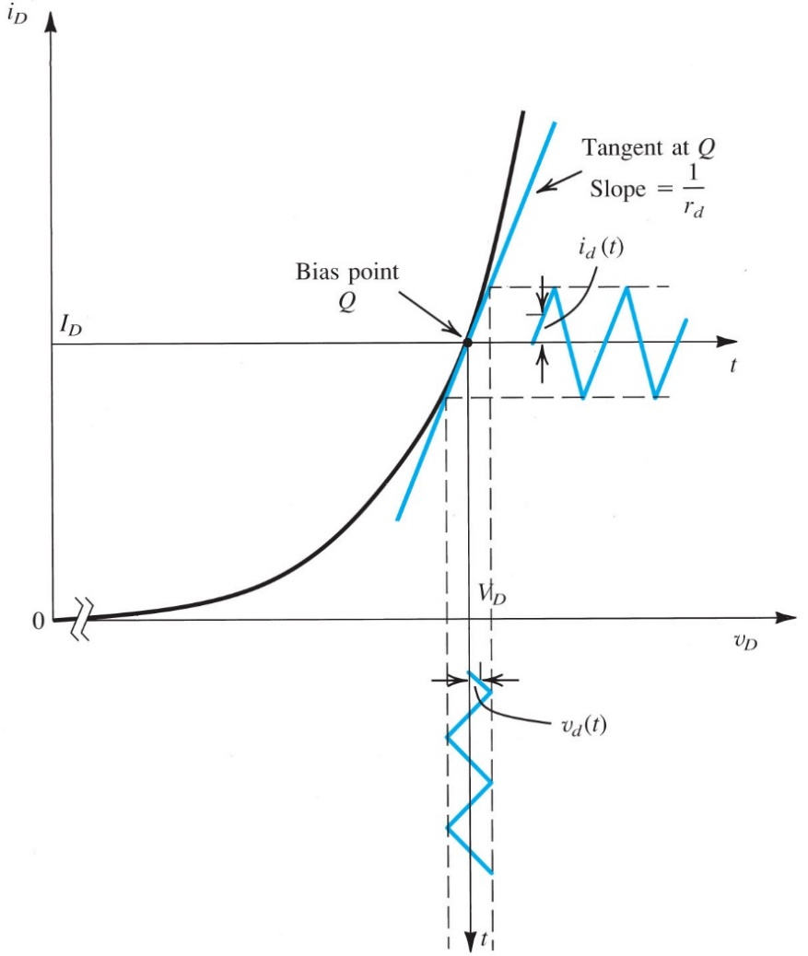





VD0

**Figure 4.14** Development of the diode small-signal model.

We will use this figure to develop the ***small signal model*** for the diode, that is, to develop a circuit model that is appropriate for a small AC signal applied to the linear region of the transfer characteristics.

## Finding the Small Signal Model

Figure 4.14 shows a tangent drawn at the bias point Q. This line approximates the transfer characteristics in the case that the signal amplitude is small. The slope of that line is an inverse resistance, and the resistance is rd, which we will call the small signal resistance of the diode. The resistance is the inverse slope of the tangent to the curve evaluated at the bias point:

.

If we extrapolate the line to iD = 0, it intercepts the axis at a value we are calling VD0.

Note that and rd are the parameters of a model for the forward bias diode of the type that we discussed in diode modeling – a voltage source in series with a resistance. But depending upon the DC bias VD and therefore on the Q point, rd and VD0 will change. For example, if VD increases, the slope of the line will increase, or rd will decrease, and VD0 will increase.

We develop the small signal model of the diode beginning with the ideal diode equation:

.

Recall that IS is the reverse bias saturation current, n is the ideality factor, and Vt is the thermal voltage, which at room temperature is 25 mV. We will consider forward bias where vD >> nVt, in which case we can approximate to

 .

Now vD has an AC and a DC component: . Putting that in our equation above gives

 .

The first term on the left is the DC current generated by application of VD:

 .

If the signal is small, specifically , we can expand the exponent :

.

Then ID is the DC component of the current, and the AC component is , where

 .

Now we have our diode small signal model. It is a voltage source VD0 in series with a resistance rd, where rd is determined by the biasing conditions, specifically ID. So we don't have to evaluate the derivative of the curve; we can simply use the formula above. But we do have to know the bias point.

Let's look at a simple circuit, and split it into its DC and AC components. To do this, we first replace the diode with the small signal model. This is done for the circuit below. (There are lots of symbols here…make sure you understand what they mean!)

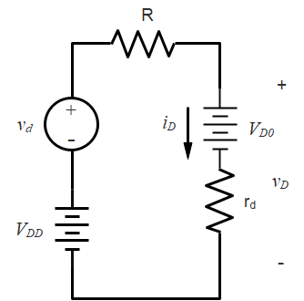

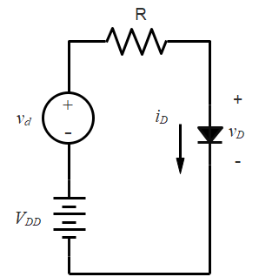

⇨

A KVL for the circuit on the right gives



We can separate the DC components and the AC components:

DC: 

AC: 

The second of the DC equations comes from recognizing that . The DC and AC circuits are shown below.

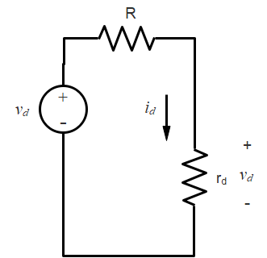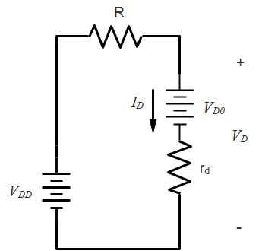

AC Model

DC Model

We have found that the ***AC model for a diode is a resistor*** whose value depends on the diode biasing value ID.

## Voltage Regulation Using Forward Bias Diode Drop

The AC model for the diode comes in handy when we want to use the diode as a voltage regulator. A voltage regulator is intended to make sure that the voltage across a load remains roughly constant even if the load changes. It is also useful when the load is constant, but there is variation in the power supply. We will explore that application here.

We will assume a power supply of 10 V with a variation of +/- 1 V – a noisy power supply. We have a load that requires about 2.1 V across it. Our circuit, shown below, takes advantage of the approximately constant forward voltage drop of a diode. We will assume a 0.7 V constant voltage drop model, and an ideality factor n = 2.

We make an approximation: we will assume that the voltage vD across each diode, including the resistance rd, is fixed at 0.7 V regardless of the load. This is in fact the constant voltage drop model. But in using the small signal model, we will allow the small signal resistance rd to change with the diode current. In the circuit below, we will calculate rd with no load, and with a load, and we will assume in each case that the total voltage across the three diodes is 2.1 V.

For the no-load case (RL removed), we consider the DC circuit only.

,

so the diode small signal resistance is

.

The figure on the right shows the result of these calculations (with RL removed).

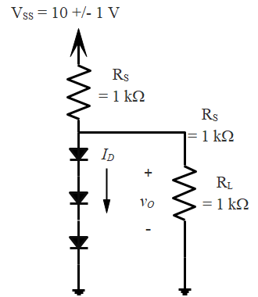

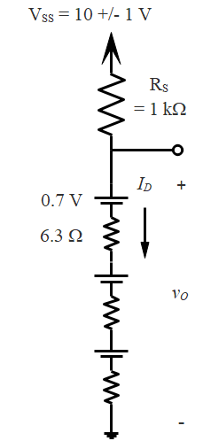

Now we can calculate the no-load variation in the output voltage. Below we show the AC model (DC sources shorted).

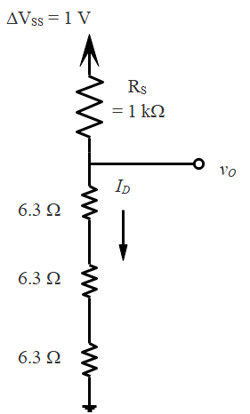Then we have

.

With VSS = 1 V, we get vO = 18.5 mV, or about 0.88% of the 2.1 V load voltage. The output voltage variation is small, even though the source is varying by 10%.

Re-doing the calculation with the load in place, we find (again assuming the output voltage is 2.1 V)

; ; 

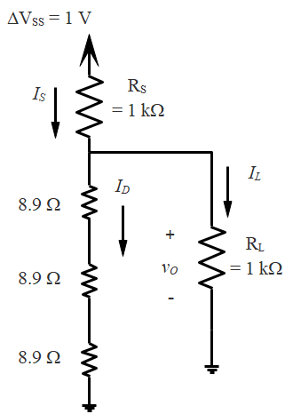

This gives , and a variation in the output voltage of

 .

Because the diode current has decreased, the diode resistance has increased, and the variation in the load voltage is not a little larger.

## Voltage Regulation Using a Zener Diode

The increase in current in the revers-bias breakdown region of a Zener diode is even more rapid than the increase in forward bias, so we often use the Zener in reverse-bias as a voltage regulator. We do not have a simple equation like the ideal diode equation for Zener breakdown, so the AC resistance is generally given. Data sheets for Zener diodes typically include the AC resistance rZ evaluated at a test current IZT, as well as the breakdown voltage VZ.

The analysis for this kind of data goes a bit differently than for the diode in forward bias. Specifically, we will calculate the zero-current diode voltage VZ0. See the diagram in Sedra and Smith Figure 4.19 below for notation.

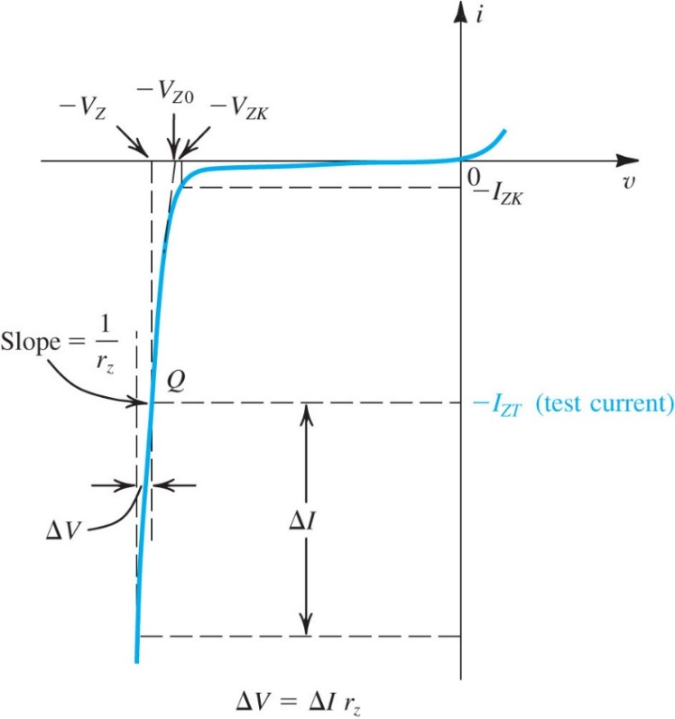

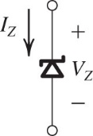

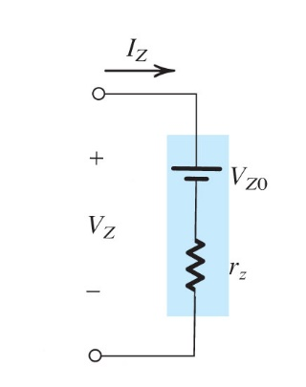

Be careful about voltage and current polarities here. The *i-v* characteristics are based on the polarities given on the Zener diode schematic symbol (upper figure on the left: Sedra and Smith Figure 4.18). But the breakdown voltage VZ and current IZ have the polarities shown in the circuit model (lower figure on the left: Sedra and Smith Figure 4.20). Note also the polarity of VZ0. These parameters are specified as positive numbers, so we need a minus sign in front of them when we draw the graph.

Let’s again assume a source, here called V+, that can vary by +/- 1 V, and that we want a constant 6.8 V across the load. Since we are typically given VZ and rZ at IZT, we need to find VZ0 to complete the problem. Here is an analysis for a 6.8 V Zener diode with rZ = 20  at IZT = 5 mA. See the schematic and circuit model in Sedra and Smith Figure 4.21.

To find the circuit model we calculate VZO:

.

This gives *VZ0* = 6.7 V. With no load, we can calculate VO and the variation VO.

.

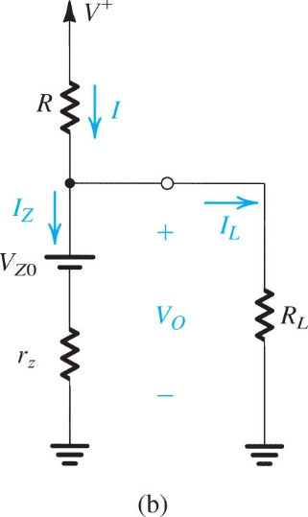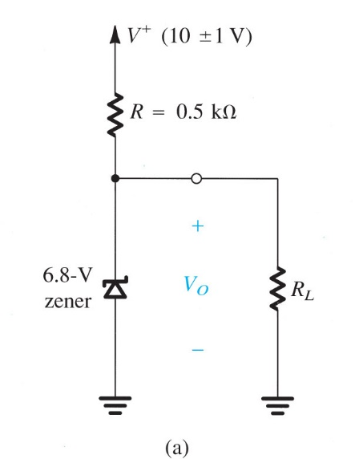

**Figure** **4.21** **(a)** Circuit for Example 4.7. **(b)** The circuit with the Zener diode replaced with its equivalent circuit model.

Then,

.

Using the AC model,

.

Thus, the line regulation  is 38.5 mV/V.

We now add a load RL = 2 k, and calculate a new VO.



This gives and

.

# Example

We bring the small signal diode model together with an amplifier model to illustrate the small signal model in the example shown next. In this example, we amplify the voltage output produced when a signal current is applied to the diode. Note the distinction between the DC bias current IB and the AC diode signal output vd. Note also that what we are trying to find is the small signal gain, that is, io/is. This is found from the AC circuit model.

