# Rectifier Circuits and Power Supplies

In this section we take up a very important application of the diode: ***rectifier circuits***, and their use in ***power supplies***.

The figure below shows a ***transformer*** connected to the line voltage (the ac wall plug). The indicated coils are simply inductors with some number of turns N. The coil on the left is the ***primary***, and the one on the right is the ***secondary***. The voltage ratio vS::vLINE = Ns::Np, where N is the number of turns in the coil, so vS can be varied.

We will not be concerned with the details of the transformer. We simply point out that it isolates the diode and resistor circuit from the ac source (which can be an important thing to do) and allows for a step-down of the voltage from the line voltage (110 Vrms) to something smaller, as described above.

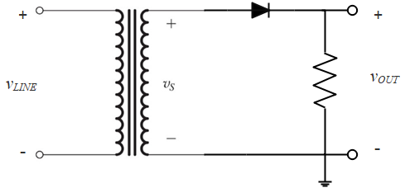

On the secondary side of the transformer is a diode and load resistor. These form a rectifier, which we looked in *Diode Basics*. We will be interested in using the rectifier to make a dc power supply, which is generally plugged into the wall outlet via a transformer.

Recall from our discussion of the rectifier circuit that if vS is a sinusoid, as in Figure 4.3b below, the output will be ***half-wave rectified sine wave***, as in Figure 4.3e

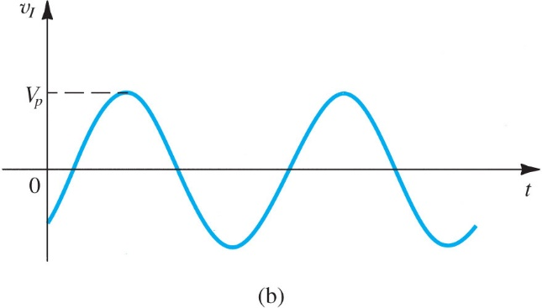

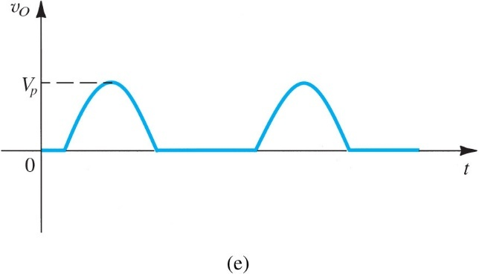

## Peak Rectifier

We can use this idea to get dc power from ac power. Consider the ***peak rectifier*** below. Here, the signal is a sinusoid. It charges the capacitor, but then when it begins to reduce in value, the capacitor holds the charge.

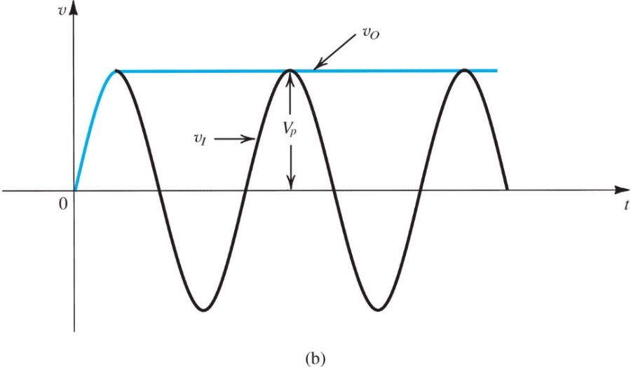

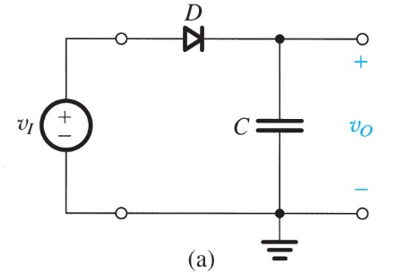

**Sedra and Smith 7 ed. Figure 4.26 (a)** A simple circuit used to illustrate the effect of a filter capacitor. **(b)** Input and output waveforms assuming an ideal diode. Note that the circuit provides a dc voltage equal to the peak of the input sine wave. The circuit is therefore known as a *peak rectifier* or a *peak detector*.

Note that if vI were increased in amplitude, the capacitor voltage would charge to the new larger value. If the capacitor were ideal, it would hold that value indefinitely.

Suppose we add a load resistance. Then when the input begins to drop from its peak, the capacitor begins to discharge through the load. The blue trace in Sedra and Smith Figure 4.27b shows what happens if the discharge is slow compared to the frequency of the input, that is, the RC time constant is very large. This is the output voltage vO.

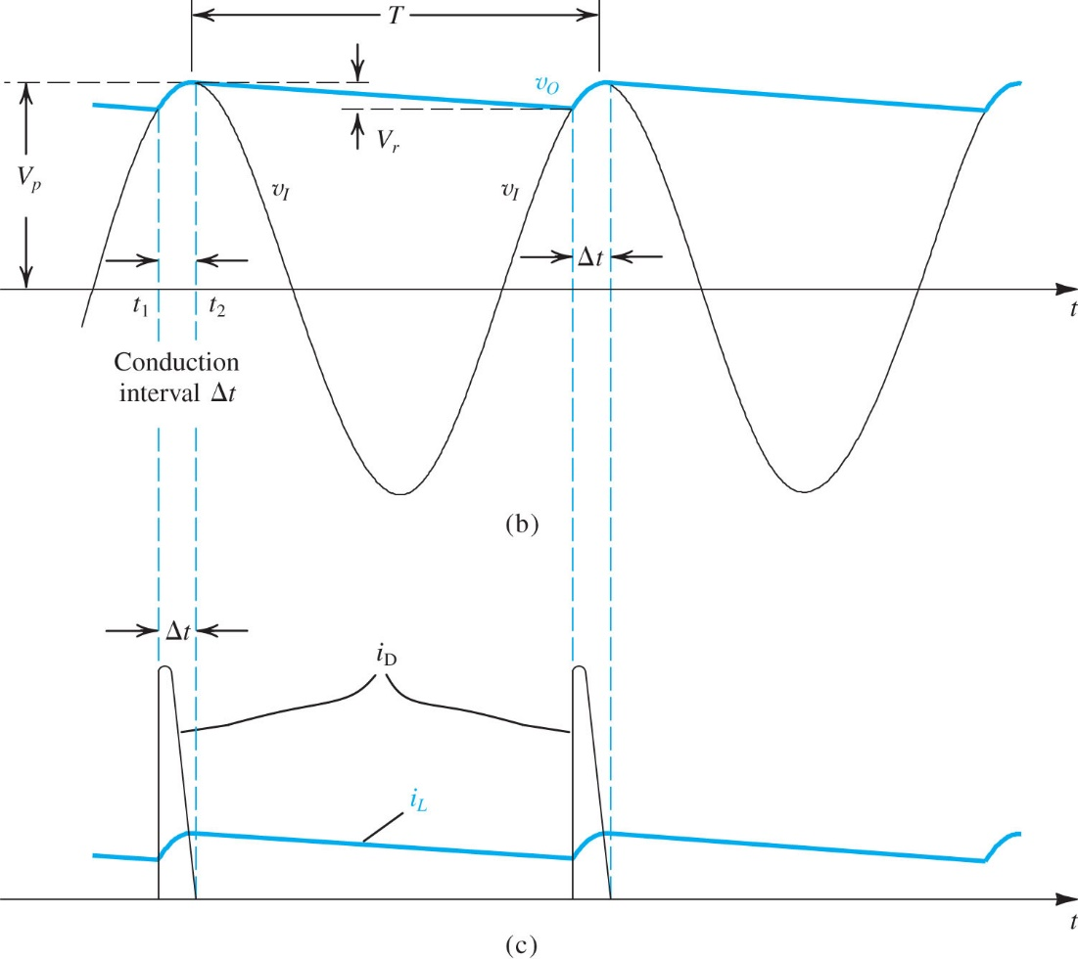

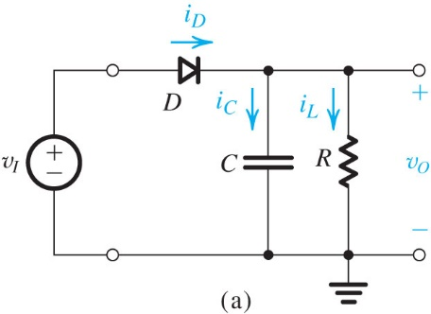

Sedra and Smith 7 ed.



Figure 4.27c shows the current flow in the diode, and in the load. The diode conducts for only a short period of time.

We can think of vO as an approximately dc value, or as a dc value with a ***ripple voltage*** Vr. If Vr is not large, we can use this output as a dc power supply. We can estimate the size of Vr, but before we do that, let’s consider a way to reduce it. The circuit below (Sedra and Smith Figure 4.25) is a ***full-wave rectifier*** (as opposed to the ***half-wave rectifier*** we have been looking at so far). It produces the output shown in Figure 4.25b.

There are several ways to make a full-wave rectifier. This one is called the ***diode bridge rectifier***. Let’s see how it works…

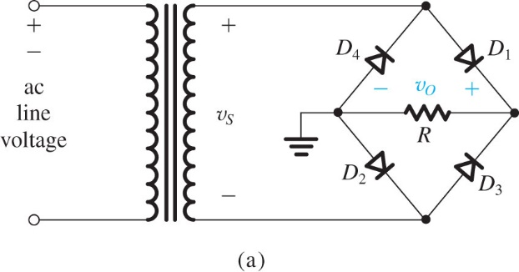

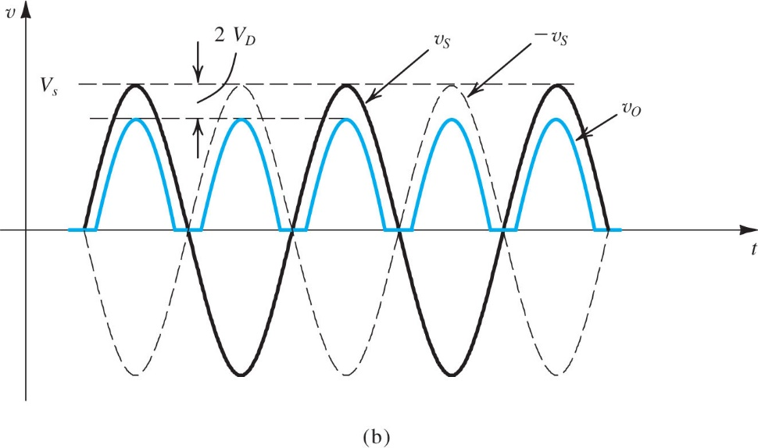

The blue trace is the rectified output. We are assuming that there is voltage drop across the diode of value VD.

**Figure** **4.25** The bridge rectifier: **(a)** circuit; **(b)** input and output waveforms.

Consider vS when it takes positive values. Then the two diodes shown in the next figure will be ON. Current will be flowing as shown through the load resistor.

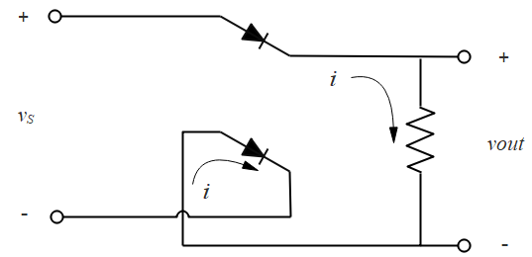

Now consider vS when it takes negative values. The other diodes will be ON, and current flows through the load resistor in the same direction! So on both halves of the input voltage cycle, the output voltage is positive.

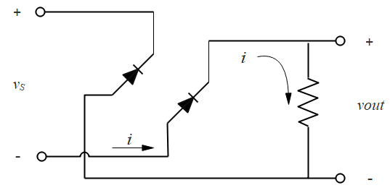

By the way, convince yourself that the load resistor is connected in the same way in Figure 4.25a and the two drawings immediately above.

Now we will estimate the ripple voltage for the full-wave rectified diode bridge.

Refer to Sedra and Smith Figure 4.27a shown earlier. Assuming no voltage drop across the diode, the output is .

We expect RC to be large relative to the period of the waveform, so we expect that for any t, the exponent will be small. Then we can approximate the exponential as . So

.

This is the equation of a straight line for vO as a function of t, with a slope . We also have an independent expression for the output voltage: . Then, we note that during the discharge process, the capacitor loses a charge given by , since the discharge voltage magnitude is Vr. The time of the discharge is td. (In Figure 4.27a, the time td is the period T less the diode charging time t.) Putting this all together, we have

.

Now some engineering approximations: the slope m is very small so . Further, the discharge time t is very small, to . With these two approximations, we can solve for the ripple voltage:

.

For a half-wave rectifier, T = 1/f where f is the frequency (60 Hz for the line voltage). For the full-wave rectifier, the period T = 1/2f because the capacitor is getting re-charged twice as often. Finally, using this last expression, we get

.

These approximations seem crude, but in the lab we find that predict the ripple voltage well.

# Non-Linear Circuits

The term “nonlinear” has a variety of meanings. An important one is that a nonlinear circuit is one for which the output does not have the same frequency components as the input. As an example, consider the half wave rectifier. The input is a sinusoid with one frequency component. The output is a periodic signal, which Fourier theory tells us can be constructed from a sum of sinusoids of the proper frequency and amplitude. In this case, the half wave rectified signal clearly requires many more frequency components than the single component found in the input.

Note that linear filters have the same frequency components in the output as in the input, although their amplitudes may be very different. A high pass filter, for example, reproduces all the frequency components of the input signal, but it greatly attenuates the low frequency amplitudes.

We can also think of “nonlinear” as referring to circuits with an output that is not a linear function of the input. A diode is an example of a device whose output current is not a linear function of its input voltage. A resistor, of course, is linear.

The transfer characteristics of a circuit will be very important in this section.

With reference to Sedra and Smith, 7 ed, we will be looking at several sections in chapter 18.

## Bistable Multivibrators

Circuits that have two stable states, that is, whose outputs are stable, or “fixed”, at either of two possible values, are called ***bistable***. Sometimes they are used as oscillators (to produce periodic functions, for example) or in applications that involve switching between these two states, so they are referred to as ***bistable multivibrators***.

Consider the circuit below. Note that the input is at the inverting terminal, and there is no negative feedback. We have indicated the power supplies as L+ and L- (positive and negative power supply limit) as is done in Sedra and Smith.

Let’s think about what vO will be as a function of vI, that is, what are the transfer characteristics?

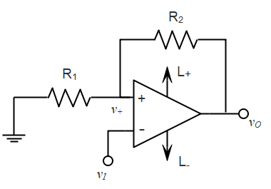

Since there is no negative feedback, we expect the output to be at either L+ or L- . Let’s assume it starts out at L+. Let’s also assume that vIN = 0. Now, v+ will be

.

This is a positive value. (Note that because we do not have negative feedback, v+ and v- are not necessarily the same.) The output will then be fixed at L+ because

,

so vO will be saturated at the positive power supply limit.

If we increase vI until it is just larger than v+, we will have , so now the output will go to L- . But then



which is negative (and vI is positive). That keeps so the output remains fixed at L-. This happens when the input is larger than . The output will switch back to L+ if we decrease vI to a value less than the new value of v+ .

Considering all of that, the transfer characteristics above look like this:

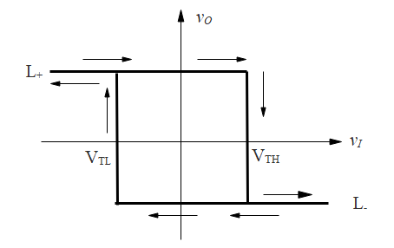







The arrows indicate the direction of vI and the corresponding transitions in vO . Because the output does not trace itself the same way as the input moves up and down, we say the transfer characteristic has ***hysteresis***.

The bistable multivibrator is also known as a ***Schmitt trigger***.

## Bistable Circuit with Noninverting Characteristics

In this next circuit we still have no negative feedback, but the input is now at the non-inverting terminal.

**Analysis**





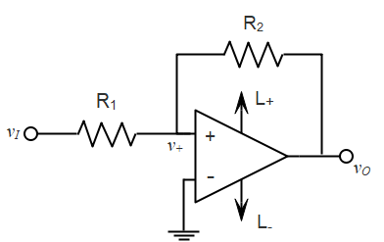

If vO happens to be at L+, it will stay there for positive values of vI because v+ will remain positive. But we can switch the state of the output if vI is such that v+ becomes negative. We can find when this happens by setting v+ = 0:

.

The transfer characteristics in this case also have hysteresis, but in a direction opposite to that for the previous case. In the figure below, we have also added a constant reference value Vr at the inverting terminal, so in addition to hysteresis, the curve has shifted its center to Vr. Using a fixed VDC in the circuit shown, we can adjust Vr by varying the resistors R3 and R4.

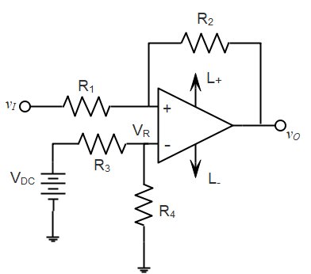

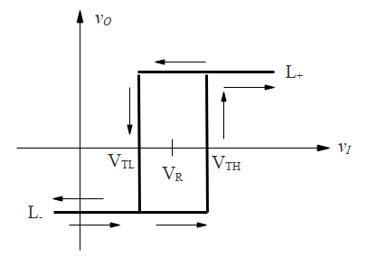





## Comparator

The circuit we have just looked at has an application as a ***comparator***. Suppose we are looking at an input signal that is varying above and below a reference voltage, and we need to know when it crosses that reference voltage. This situation occurs, for example, in your home, where the temperature is varying above and below the temperature you set on a thermostat. If we can detect where the signal crosses the reference voltage, we can turn our air conditioning unit on or off accordingly.

If the signal has noise, we don't want the thermostat switching back and forth every minute or two, so we want to ignore small variations in the signal. This is accomplished by having hysteresis, and a reference point VR. The situation is depicted in Sedra and Smith Figure 18.24.

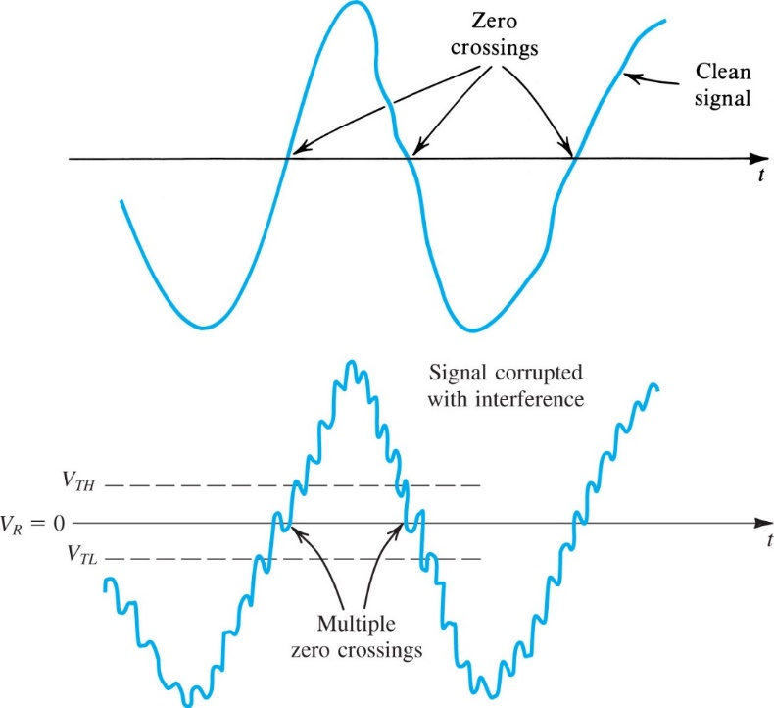

**Figure 18.24** Illustrating the use of hysteresis in the comparator characteristic as a means of rejecting interference.

## Astable Multivibrator

As the name implies, the astable multivibrator (Sedra and Smith Figure 18.26b) also has two output states, but it is not stable in either of them, that is, it is constantly switching back and forth from L+ to L- .

Note that the circuit in Figure 18.26b does not have negative feedback. Although there is a resistor connected between the output and the inverting terminal, v- is completely specified by the capacitor voltage, so the output of the op amp does not have control over that voltage.

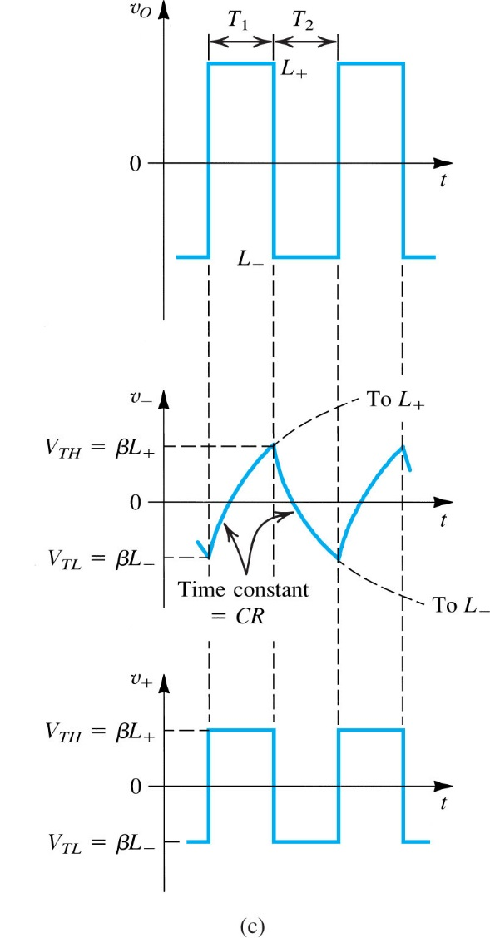

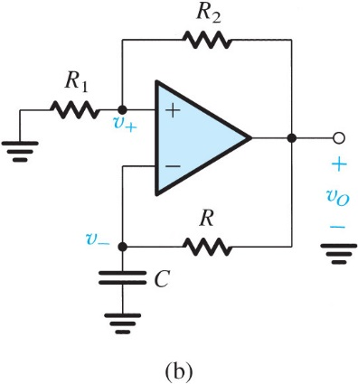

Sedra and Smith Figure 18.26

### Astable Multivibrator Operation

Assume that output vO suddenly switches to L+ . In that case, . The RC circuit connected between the output and the inverting terminal will cause the capacitor voltage to increase exponentially toward L+ . (This is a single time-constant step-response problem.)

When v- (the capacitor voltage) reaches a value just greater than v+, the output will flip to L- because at that moment, < 0. This will cause the capacitor to begin to discharge, and it will re-set v+ to . Eventually v- will become smaller than v+ and the output flips back again to L+ . Thus, the output is a square wave.

Figure 18.26c shows the output voltage, the charge/discharge cycle of the capacitor voltage, and the voltage at the non-inverting terminal. Note that v+ and v- are not equal except when the output switches state, since as we pointed out above, the circuit does not have negative feedback.

**Analysis**

Define . Assume that the output voltage has just switched to , which means that . Then we can apply the equation for first-order response:

,

with . The capacitor is charging toward a final value . Previous to the switching of the output to L+ , the capacitor voltage was at , since this is the value that caused the switching event. The next switching event will occur at . We will call that time T1. So we have

.

Solving this equation for T1 gives

.

Note that if, the power supplies have equal and opposite values, thenand the numerator in the fraction is .

We can do the analysis again for charging in the other direction, which will last a time T2. Then

.

Adding these results gives

.

This equation applies if the power supplies are equal and opposite in value.

### Triangular Waveform

We can combine a multivibrator with an integrator to create a triangular waveform (which is of course the integral of a square wave). One possibility is shown schematically in Sedra and Smith Figure 18.27. A circuit using the non-inverting bistable multivibrator is shown as well.

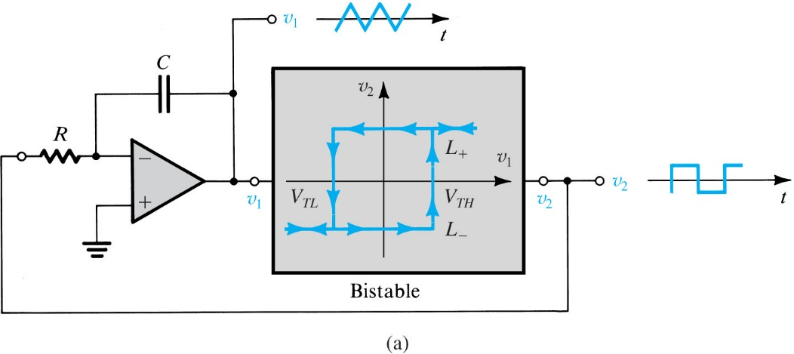

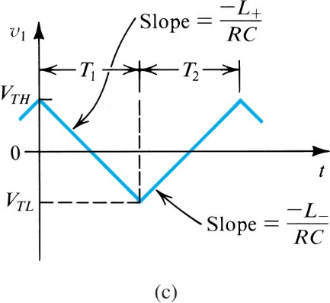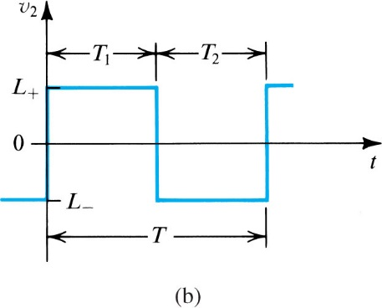

**Figure 18.27** A general scheme for generating triangular and square waveforms.

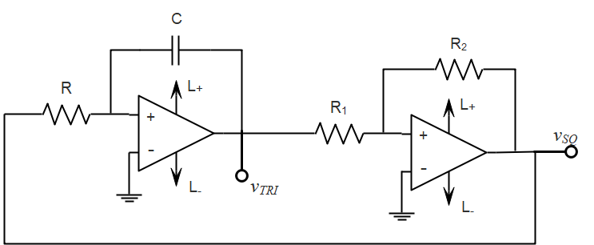

The triangle wave output vTRI will cause switching of the bistable multivibrator at the thresholds VTH and VTL (see the discussion on the noninverting bistable multivibrator). If the square wave output vSQ happens to be at L+, it will produce a current in the bistable input resistor of . This will cause a linear decrease in vTRI at a rate of (which can be verified by integrating the capacitor current). We can set this rate equal to total change in vSQ to find the switching time T1 from L+ to L- :

 .

A similar analysis for switching from L- to L+ gives 

 .

We will have asymmetric square wave if our power supply voltages are equal , but we can arrange for an asymmetric square wave if we have different power supplies.

We can think of the circuit we just discussed as an astable multivibrator with the RC circuit replaced by a non-inverting bistable multivibrator. We could also use the a stable multivibrator directly, as in the next figure.

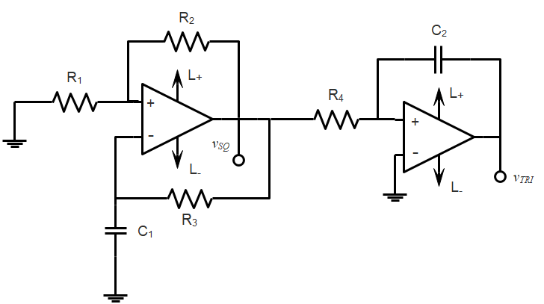

## Half-Wave Precision Rectifier: the Superdiode

We can improve the performance of a diode by putting it in the feedback loop of an op amp. Imagine a diode with a threshold voltage of 0.7 V inserted into the circuit below.

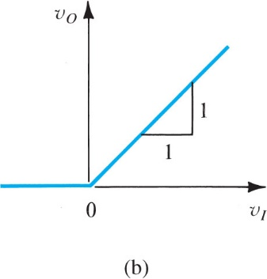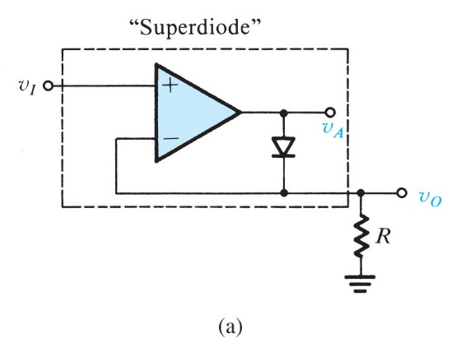

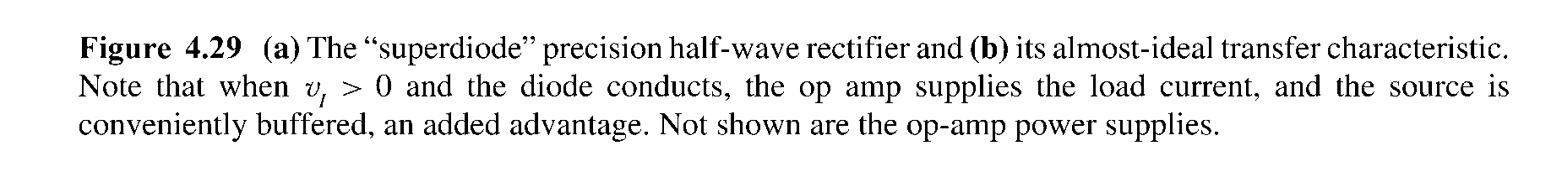

To think about the operation of this circuit, we can ask whether the op amp has negative feedback. It will not have negative feedback if the diode is OFF. In that were the case, and assuming vIN is positive, vA would saturate at the positive power supply voltage. But that would turn the diode ON, so we conclude that the diode must in fact be ON. So we have negative feedback, and vOUT is equal to vIN.

If vIN is negative, vA will saturate at the negative power supply voltage, and the dial will be OFF. Because vOUT is connected to a resistor with no current in it, vOUT will be zero.

The transfer characteristics for this circuit are shown in figure 4.2b. What we have accomplished is to hide the threshold voltage of the diode. In other words, the turn on voltage has been reduced to 0, or very close to it.

The problem with this circuit is that some time is required for an op amp to come out of saturation, and if we are interested in high speed operation, this Superdiode will not do. The circuit below is an improvement in which we still hide the diode threshold voltage, but the op amp never goes into saturation.

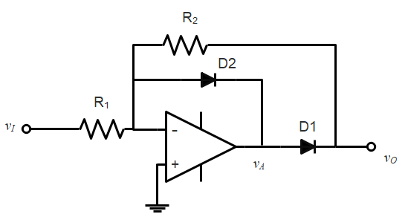

If vIN is positive, the voltage vA will tend to go to the negative power supply voltage, so we conclude that D2 will be ON and D1 will be OFF. Thus, vOUT will be zero. If vIN is negative, vA will tend to go to the positive power supply voltage, which will turn D1 ON and D2 OFF. In that case we will have . The transfer characteristics are shown below.

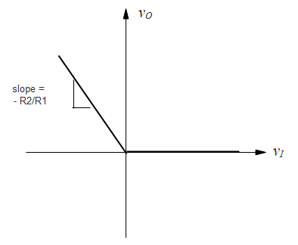

This is the Super-duper diode! It turns on for negative rather than positive input voltage, but it hides the threshold voltage and keeps the op amp out of saturation.

### Application: AC Voltmeter

Let's look at an application that uses the Superduper diode in conjunction with a low pass filter to create an AC voltmeter. In the figure below, if the input is a sinusoid of amplitude VP, the output of the first stage, vX, will be half-wave rectified sinusoid. Such a function has an average value given by . A measurement of this value will be proportional to Vp, which is what we are trying to find.

Although vX has the average value given above, it also contains, by Fourier's theorem, an infinite number of frequency components. The dc component is the average, but the signal also contains the fundamental frequency o, and harmonics of that frequency. To measure the average value (i.e., the dc component), we need to filter all frequency components above the dc value. That can be done with a low pass filter whose breakpoint (cut off) is well below o. A graphical representation of what we are trying to do is shown below.

The figure shows, schematically, the dc ( = 0) component and four ac components of vX. It is typical of Fourier series that the component amplitudes decrease with increasing frequency, and we have represented that here. The dash - dot line shows a straight-line approximation to a Bode plot with a break point, or cut off, at bp. The frequency of the breakpoint is smaller than the lowest frequency ac component of the Fourier series, . If we design our low pass filter to behave like this, the only frequency component that will have any significant amplitude is the dc component. This is what we are trying to measure.

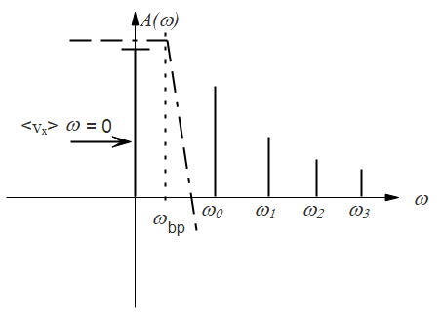

The circuit below shows a Superduper diode followed by an active lowpass filter. A phasor analysis of the filter stage gives.

.

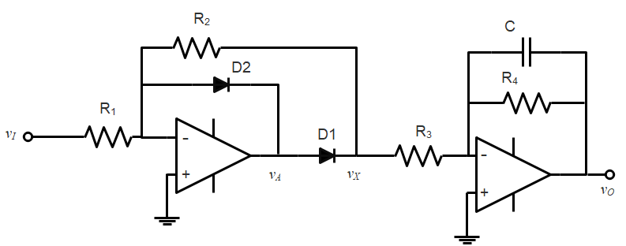

Thus, we want . This will ensure that all frequency components except <vX> are present at the output vO. The frequency component  is called the fundamental frequency, and is given by  where T is the period of the input sinusoid. Including the filter stage, the final output will be

.

We could choose another amplification stage to multiply this by , which would leave the value we are looking for.

At the input, before the sinusoidal signal reaches the diode rectifier, we may also want to add a high-pass filter to remove dc components that might “contaminate” our answer. We will not consider that in detail here.

## Precision Peak Rectifier

Here we present two circuits that take advantage of the Superdiode in a peak rectifier application. The first is the ***precision peak rectifier***, which uses a Superdiode in the peak rectifier configuration.

In the second, we create a ***buffered precision peak detector***, which is designed to have an output which is the peak value of vIN, even if that value changes. It is simply a modified version of the Superduper diode used in the precision peak rectifier with an infinite load resistance provided by op amp A2.

**Precision Peak Rectifier**

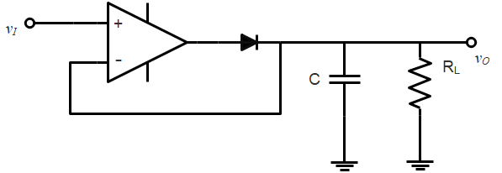

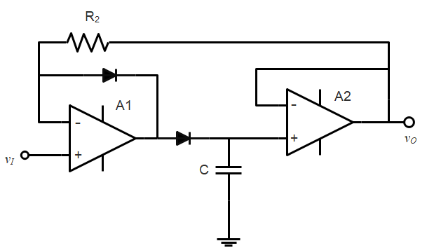**Buffered Precision Peak Detector**

# Examples

In the following pages we show several examples and applications using diodes and op amps. Unless indicated, we did not cover these in class.

