Autonomous Quad Copter Docking System

Justin Brandon Zachary May Scott Garrison Jamal El Alaoui

Final Technical Report
December 9, 2014

Cover letter is missing.

Abstract:
Unmanned aerial vehicles, or UAV’s, have become abundant in the military and private sectors in the last decade. One particular type of UAV is a quad copter. These quad copters are especially popular in the private sector for commercial and personal use. However, one flaw with these quad copters is that they require four engines to fly which draws more power from the batteries and results in the need to recharge more frequently. This report outlines details in the development of an autonomous docking system that can be added to any quad copter available on the open market. The purpose of the docking system is to locate the nearest recharging pad and autonomously navigate to it and land. The system detects the changing voltage on the battery and determines when the battery is low based on preprogrammed settings. This system uses a GPS sensor to locate a preprogrammed recharging pad and begin the initial journey. A compass sensor is also used to determine the correct trajectory. A barometer sensor calculates the height of the quad copter and helps to adjust for the most accurate detection of the pad and is used in landing the quad copter. Once the copter is within the acceptable accuracy range of the GPS, a localized communication system will take priority over the GPS. This localized system is a combination of colored shapes and LED’s on the pad that will be captured with a camera on the copter, then analyzed to allow the copter to orientate with the top of the pad and land accurately. Bluetooth communication is added to allow the copter to communicate with the pad. The acceptable accurate range for landing is within 2 inches off center. This project was obtained late in the semester, so the objective for this semester is to develop the designs for the controllers, trouble shoot potential problems before building them, and order the supplies needed.

Contents
Abstract: ii
Introduction: - 1 -
Background and Goals - 1 -
Problem, Need, and Significance - 2 -
Theoretical discussion: - 2 -
User Analysis - 2 -
Overview Diagram - 3 -
Target Objective and Goal Analysis - 4 -
Limitations: - 7 -
Engineering Specifications and Constraints - 7 -
Engineering Standards - 7 -
Budget - 8 -
Conclusion: - 8 -

Table of Figures
Figure 1: Overview Diagram of Autonomous Docking System - 3 -
Figure 2: Overview of Goal Analysis - 4 -
Figure 3: Goal Analysis of stable flight using radio controller. - 5 -
Figure 4: Goal Analysis of GPS controller. - 5 -
Figure 5: Goal Analysis of visual recognition software controller. - 6 -
Figure 6: Goal Analysis of voltage reading sensor and input priority changes. - 6 -

Introduction:

Background and Goals
This report is to document the progress made on the development of an autonomous docking system for an Unmanned Aerial Vehicle, or UAV, specifically a quad copters. The autonomous docking system is a set of sensors and controllers that will monitor the life of the battery, and at the appropriate time, it will switch the copter into an autonomous mode that will navigate it to the nearest recharging station.
In this report the various components used to perform these tasks will be listed and discussed in detail. Additionally, the potential problems that are foreseen will be discussed and troubleshooting solutions will be given as well. The ultimate goal of this project is to have a quad copter accurately land autonomously on a recharging pad. Another goal of this project is to make it available to anyone, so the actual quad copter itself is arbitrary. For this reason, as well as budgeting reasons which will be discussed further in this document, an available quad copter was chosen for modification.
This project was divided up into two main phases. First is design and troubleshooting, and second is testing and implementation. The first semester goal was to design the various aspects of the system and begin to troubleshoot foreseeable problems. Due to a lack of components available, there was no construction or testing done in this first semester. The goal for next semester is to have a working prototype of the system that can autonomously land in the center, or within the margin of error, of the recharging pad. Therefore all design work will be completed before the start of the second semester.

Problem, Need, and Significance
A quad copter is an unmanned aerial vehicle that requires four motors and propellers to fly. Due to the extra motors, the copter draws power from its batteries more quickly than a traditional remote controlled helicopter or airplane. One of the major problems with flying these quad copters is the battery life and having to frequently recharge them.
The UAV needs a failsafe that allows the vehicle to land itself safely before its battery runs out of power. These UAV’s can become very expensive very quickly and there is the potential for them to lose power midflight and come crashing to the ground. With this system the remote pilot will not have to worry about that and can utilize the UAV to its fullest potential.
Some of the potential groups interested in this system range from the military to the private sector and include retailers and hobbyist. For retailers like Amazon.com, who have leaked that they are exploring the use of quad copters as delivery drones, this system would be vital to their operation.

Theoretical discussion:

User Analysis
The versatility of quad copters and other similar UAV’s make them desirable, and sometimes even necessary, pieces of equipment to own. They are mainly used in military application and by personal hobbyists. Due to the range of potential users, the system is being designed to be adaptable to all types of quad copters. For this reason, no additional experience other than basic quad copter knowledge will be required for the use of this system.

Overview Diagram
Figure 1 below is an overview of the desired outcome of this project.
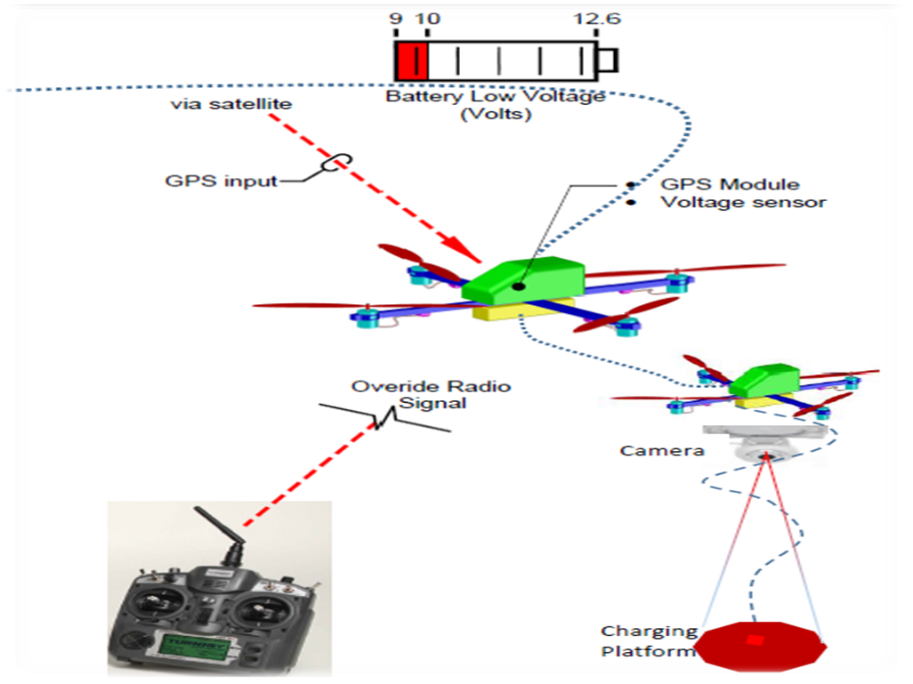
Figure 1: Overview Diagram of Autonomous Docking System
Once the volt meter detects that the voltage has dropped below the predetermined threshold, the MCU will switch the priority of the input signals. This will allow the quad copter to start navigating toward the nearest recharging pad autonomously. As the copter reaches within the GPS coordinates margin of error, the MCU will switch the priority of the input signals again and then the camera will begin taking pictures to identify the landing pad. Finally, the system will use different inputs through a PID controller to accurately land on the charging station.

Target Objective and Goal Analysis
The goal of this project is to have a UAV land autonomously on a charging pad in a preprogrammed location. This large scale project will take several different controllers, so each will be tested and implemented separately. The overview of the goal analysis is shown in Figure 2 below. This shows a generalization of the different controllers used, each of which will need to function separately and therefore be tested separately.
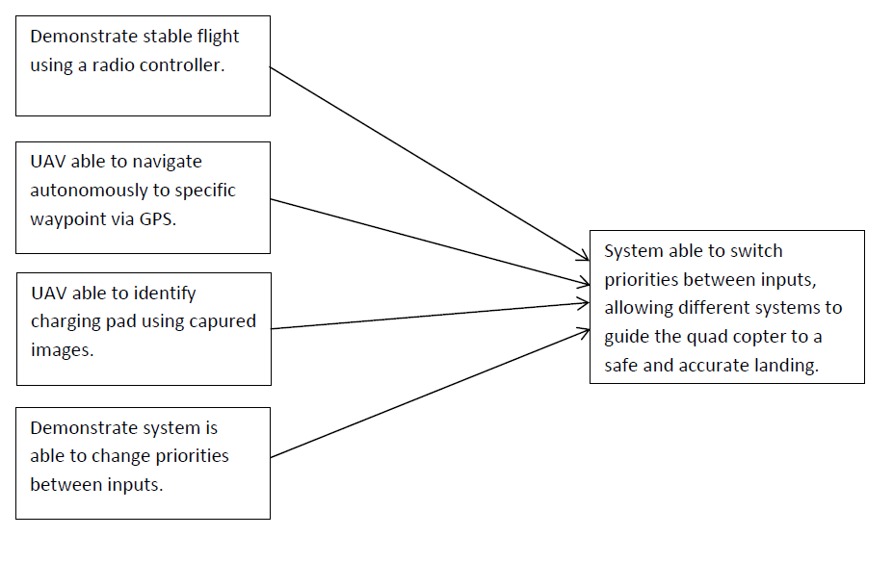
Figure 2: Overview of Goal Analysis
The first block will be testing the motor controlling system, Hoverfly. This is a preexisting system and will need special testing to determine its accuracy. A radio transmitter with a receiver chip was ordered and is going to be installed upon arrival. It will be tested separate from the rest of the system. The Hoverfly system, which controls the motor speeds and stability, will also need to be tested separate from the rest of the system. Below in Figure 3, these steps are laid out,
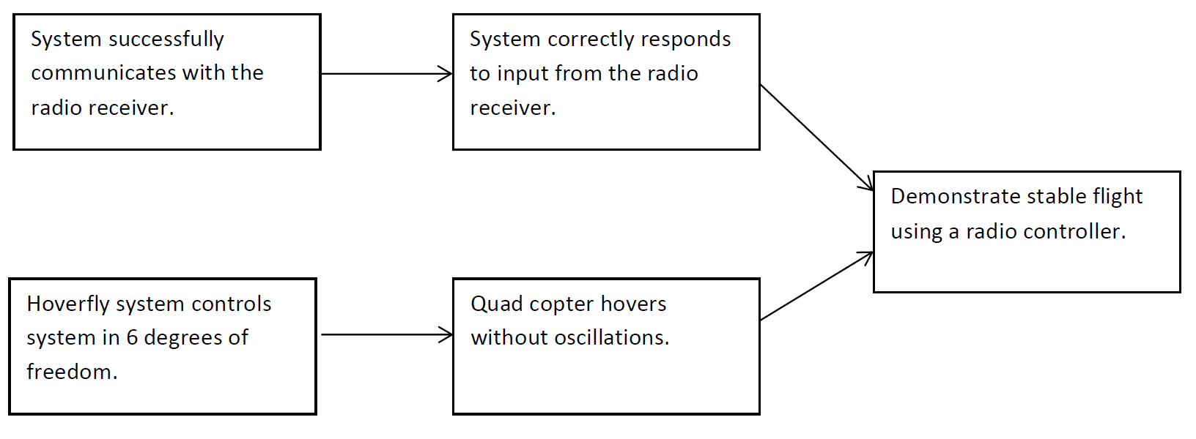
Figure 3: Goal Analysis of stable flight using radio controller.
Once it is determined the radio controller and Hoverfly system are working properly, the GPS system will need to be tested. A NEO-6M GPS Module was ordered and will be tested upon arrival. First the GPS’s output will need to be determined, then it will be installed and the system will be tested. The MCU needs to be able to read the output of the GPS and accurately evaluate it. Once the output is read, the system will determine the closest GPS waypoint and output commends to the Hoverfly system to navigate toward this point. When all these components are working together, the UAV will be able to accurately navigate toward the GPS coordinate as laid out in Figure 4 below.
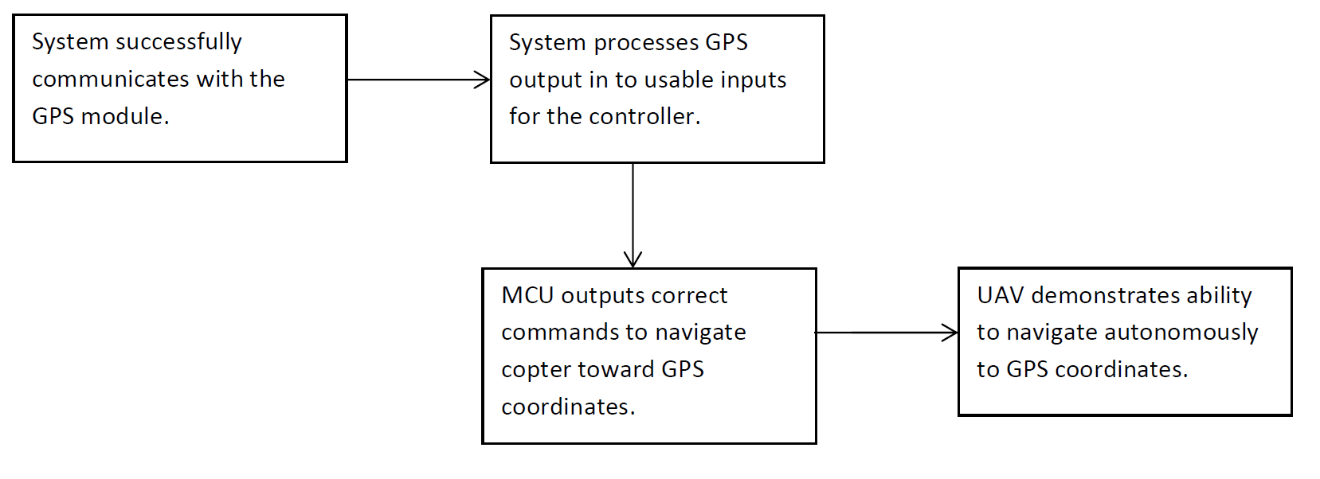
Figure 4: Goal Analysis of GPS controller.
The most challenging controller to develop will be the image capture and recognition software system. This system is still in the design phase, as the team is trying to determine the most efficient way to utilize the image recognition software. What is known however, is that the system will need to be able to communicate with the camera, then compare the image taken with several preprogrammed images, and then produce an output to the Hoverfly based on the image comparison. Several proposals on how to do this are to use large colored images or multicolored LED’s. Either way, the basic steps that need to be taken are shown below in Figure 5,
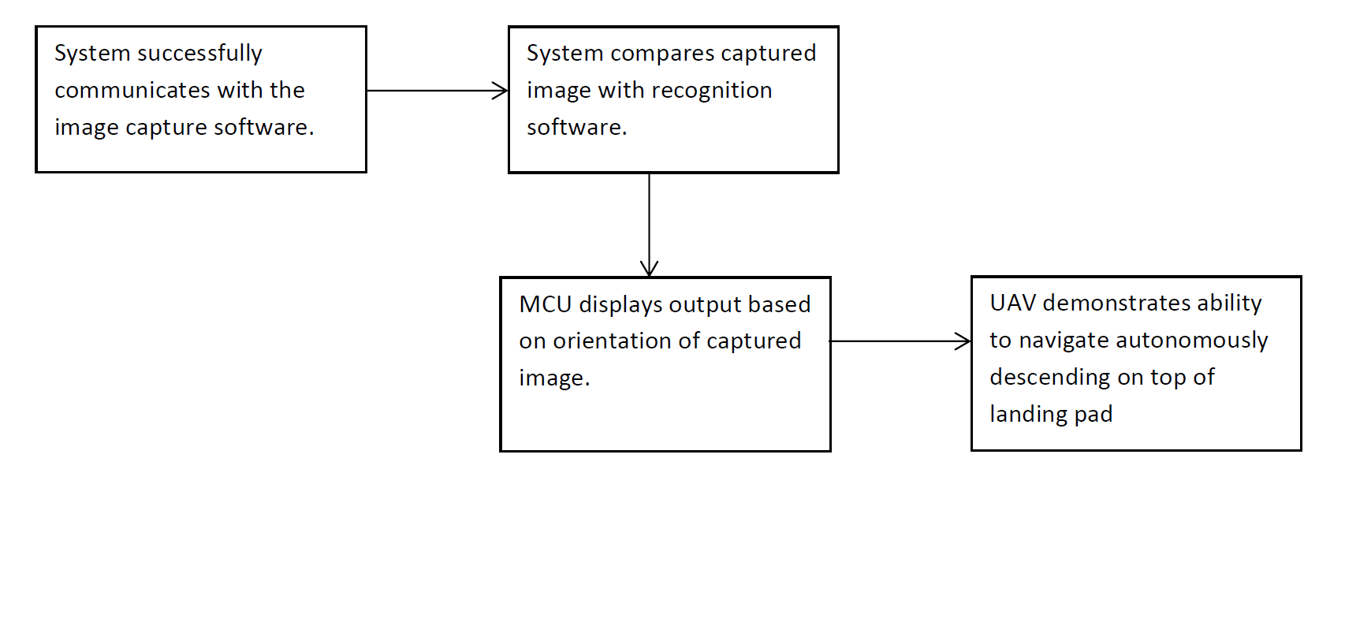
Figure 5: Goal Analysis of visual recognition software controller.
The last, and most important, part of development will be programming the MCU to change the priority of the input signals. This will be accomplished using a system of interrupts that change the destination of the various input signals. Additionally, the MCU will need to be constantly monitoring the voltage level of the battery cells. These steps are shown in Figure 6 below,
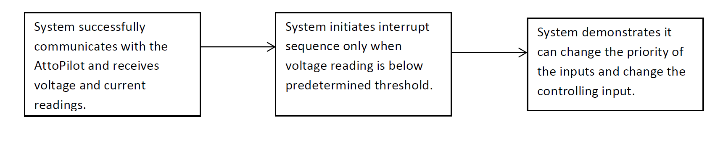
Figure 6: Goal Analysis of voltage reading sensor and input priority changes.
Once all of these subsets in Figures 3,4,5, and 6 are in full functioning order, the system will be fully tested and the final product should be an autonomous UAV that navigates and lands accurately on a charging pad as described before in Figure 2.

Limitations:

Engineering Specifications and Constraints
Some specifications were laid out at the start of this project due to the coordination efforts with the wireless charging station team. To consider this project a success, the quad copter will need to land within 2 inches off center of the platform. Additionally, the GPS is only accurate up to 3 meters horizontally tangent to the Earth’s surface, so the UAV will need to be able to identify the landing pad from an undetermined height within the given range. Also, the quad copter will need to autonomously fly to within this 3 meter distance. Finally, the voltage will need to accurately be measures, so an allowance of +-0.5 volts will be given.
With these specifications also come some constraints. The biggest constraint will be the available weight on the quad copters payload. Since this team is using a prebuilt UAV, we are limited by its 5lb carrying capacity. There will be a camera, additional circuitry and sensors, and a charging coil that all need to be carried on the UAV. The quad copter will also be communicating with the landing pad via Bluetooth. The limited range on the Bluetooth will also pose some small constraints. Finally, there may be some unforeseen constraints moving forward as this team coordinates with the wireless recharging team.

Engineering Standards
In addition to the physical specifications and constraints laid out by the teams and manufacturers working in this project, there are also federal regulations concerning quad copters specifically. These constraints are in accordance with the FAA Modernization and Reform Act of 2012 and they are as follows:
- The UAV will be limited to less than 55lbs total weight.
- The UAV is operated in a manner that does not interfere with and does give way to any and all manned aircrafts.
- The UAV is not flown within 5 miles of an airport.
- The UAV is always within visual line of sight of the operator.
- The UAV does not exceed an altitude of 400ft.
All of the FAA regulations should not be a concern and should be easily followed.

Budget
This project was established late in the semester due to another project coming to an unexpected close. Since the bulk of the labor for this semester was spent on the last project, the team is well under budget on labor for this project. The team is paid a rate of #50 / hour and the advisors and faculty are paid at $100 / hour. Each team member has spent approximately 10 hours this semester on this project, with aid from advisors and faculty at about 5 hours each. So the total labor dollars spent for this semester is $3000. The total labor budget is $30,000 for the entire year. Additionally, the total parts budget for this project was $500. This semester the parts bought cost $192. So out of the total $30,500 budget, $3192 was spent this semester leaving $26,808 for next semester. The bulk of the time next semester will be spent on testing and implementing components. If all test go as expected, then the team will end the year under budget. Although the likelihood of that actually happening is slim so with a reasonable amount of error calculated in the team should still come within budget. This allots each member about 132 hours in the semester to work on the project. Another way is about 8 hours a week.

Conclusion:
Although the project had a very late start, all of the designs for the controlling systems have been created. Due to the holiday season, it is unlikely that the parts ordered will arrive before the semester ends. Even without the new components, the troubleshooting and brainstorming process is well underway. The foreseen problems, like the accurate range of the GPS, have been worked through and contingency plans have been set in place. Knowing that there is still a lot of work to do, the team plans to meet several times during the holiday season after components arrive. For this semester, however, the design and troubleshooting is the only deliverable this team has to offer.

