Bradley Bounds
bhbounds@uh.edu
(423) 914-9797

Dr. Contreras-Vidal
University of Houston
Houston, TX 77004

Dr. Contreras-Vidal:

Please find the attached end-of-semester report regarding the progress our team has made on the Brain Health Monitoring Kit. I am writing this letter on behalf of my teammates, Ben Madison and Jorge Jimenez. The contents of the report are a result of a group effort, as each member has contributed to its composition.

We are nearing the halfway point in this project, with only the spring semester remaining. To date, we are behind where we anticipated being at the beginning of the semester. Research into Parkinson’s disease (PD), electroencephalogram (EEG) measuring techniques, human test-study methods and the biology of the brain took much longer than anticipated.

Development of the sensor has been progressing at a steady rate over the last few weeks. We are able to gather raw EEG data wirelessly and visualize the data graphically. The material for creating a dry electrode is currently under test for the final sensor. The other components of the overall system (smartphone application and web-based servers) have not been addressed this semester. An experiment with human subjects suffering from Parkinson’s has been designed and is under review with the University of Houston Committee for the Protection of Human Subjects (CPHS). This study aims to further the team’s knowledge on how dopaminergic replacement therapy (DRT) affects both brain activity and physical manifestations of the disease on a temporal basis. A detailed review of journal articles and other research did not find any similar studies that have been completed previously. This study will help identify the optimal placement of the sensor and help to confirm that PD symptoms can be verified using EEG sensing techniques.

Although our progress has been slow, I am confident that we will be able to finish this project by the end of the 2016 spring semester.

Sincerely,

Bradley Bounds

Brain Health Monitoring Kit

Team Members: Bradley Bounds, Benjamin Madison, Jorge Jimenez
Faculty Sponsor: Dr. Contreras-Vidal

Abstract
The Brain Health Monitoring Kit (BHMK) is an EEG-monitoring system designed to provide real-time and historical data on a Parkinson’s disease (PD) patient’s brain activity to their doctor(s). PD patients are currently prescribed medication using generalized schedules, based on limited observation and interaction between the doctor and patient. The BHMK will provide doctors the ability to have nearly continuous, individualized information for determining the most efficient medication schedule for patients, thus optimizing the benefits of medication and minimizing the negative side-effects.
The BHMK consists of three components. A purpose-built EEG sensor is worn by PD patients throughout the day to collect raw EEG data. A smartphone application running on Android receives the raw EEG data, displays basic information and provides medication notifications. Finally, a cloud-based server suite is used to process the raw EEG data and display the resulting information to the patient’s doctor.
Currently, the BHMK is behind schedule given the amount of research that was required to start developing the EEG sensor and the additional research project that was initiated mid-way through the semester. This research project aims to quantify the ability to detect PD-on/off symptoms using only EEG patterns and is currently awaiting approval from the UH Committee for the Protection of Human Subjects (CPHS).
The project is currently over budget for the one- year project. Labor costs are the cause of this overage, specifically the time spent on research. Despite being behind schedule, the team is confident in our capability to complete the project by the end of the spring 2016 semester.

Purpose and Background
The purpose of the Brain Health Monitoring Kit (BHMK) is to increase the quality of life for those suffering from Parkinson’s disease (PD). Current treatment methods are subjectively based on limited doctor interaction, which can lead to over-/under-prescribing medication. These inaccuracies can lead to an increase in negative side-effects and/or an increase in PD symptoms.
According to recent research, Levodopa (L-dopa) is the most commonly prescribed medication for PD. L-dopa is a dopaminergic replacement therapy (DRT) used to correct brain chemistry that has been affected by PD deterioration. Experiments have generally shown improvement in PD patients on L-dopa, both in movement-based [4] and EEG-based [3] tests.
There are associated side-effects to continued L-dopa use. The main two are Levodopa Induced Dyskinesia (LID) and early wear-off (EWO). LID is characterized by additional motor difficulties and involuntary movements. EWO shortens the time that an L-dopa load is effective in reducing symptoms of PD. Since LID occurs at peak concentrations of the drug, it is often countered by reducing individual doses and increasing the frequency of successive doses [7]. Conversely, EWO can be improved by increasing either the number of daily dosages or the quantity of one dose [7]. An example of these level fluctuations can be seen in Figure 1. The severity of the LID can be seen to correlate with the concentration of L-dopa in the system. Similarly, as the concentration drops, the EWO symptoms begin to appear just before the next dose is taken. With prolonged treatment, the time scale will compress. Altering dosage levels will affect the peak level concentration. It has been shown that new patients may have a 6-8 hour window of improved behavior while more advanced patients may only have 0.5-2 hour windows before faster and less-predictable wearing off periods [8] [9] [10]. Each patient’s absorption model is different depending on body chemistries, the length of time that the patient has been taking L-dopa, etc. Furthermore, an individual patient’s model may change daily due to exercise levels, high protein meals, etc. The research summary in Appendix A provides additional information regarding DRT.
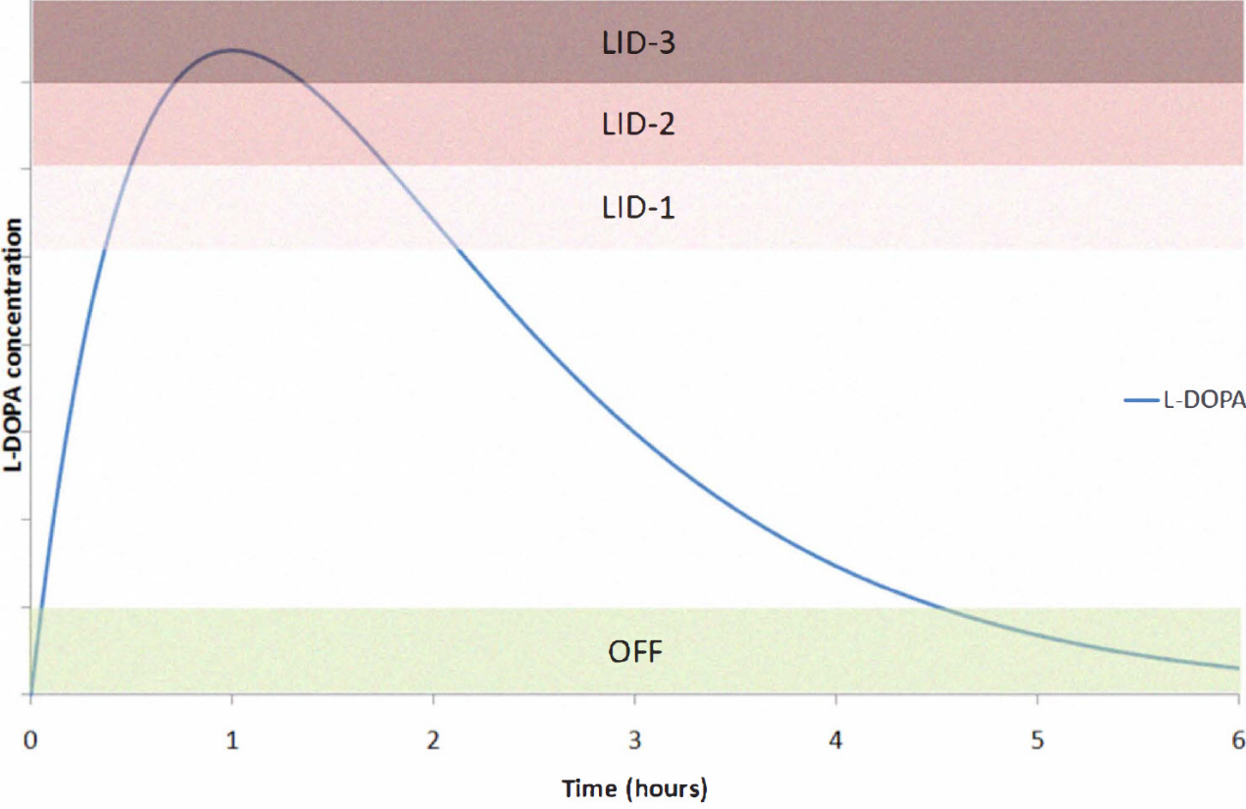
Figure 1: Levodopa (L-Dopa) concentration within a patient’s body over time. L-Dopa is metabolized within the body into catecholamines (e.g. dopamine, epinephrine). High levels of L-dopa in the system can result in L-dopa induced dyskinesia (LID), resulting in additional physical tremors beyond the normal disease symptoms. As the medication is further metabolized, the concentration drops resulting in medication wear off (early wear-off), as shown in the green region at the bottom after 4.5 hours. [7].
The BHMK will utilize an EEG sensor worn throughout the day which will connect to the patient’s smartphone. The EEG data collected will be visible to the patient’s doctor, allowing the doctor to make adjustments in medication when appropriate. These adjustments will appear as notifications on the patient’s phone and are based on observed symptom fluctuations and medication side effects by his/her doctor. Fig. 2 shows the interaction between the BHMK components and will be discussed in more detail below.
The unique nature of this project calls for research to be completed with human test subjects suffering from PD. A research experiment has been designed that seeks to correlate physical behavior, brain activity and time elapsed since the patient’s last medication dosage. The aim is to identify the ideal placement of the BHMK EEG sensor and confirm the reported correlation between physical symptoms and EEG signal patterns. Furthermore, as a detailed review of journal articles and other research did not find any similar studies that have been completed previously, this research aims to clarify current understandings of how DRT interacts with the body over time. A review of current research studies into these correlations can be found in Appendix A.
The research experiment that has been designed will cover one cycle of the participant’s medication schedule. For example, if a participant takes a pill every four hours, the study will monitor him/her for approximately four hours. At predefined intervals, tasks have been developed to monitor the known symptoms of PD. Arm extensions will be administered according to the Universal Parkinson’s Disease Rating Scale (the standard observation procedure in PD treatment) to measure bradykinesia and dyskinesia. Writing samples and spirals will be collected to measure micrographia. During all these tasks, the participant’s brain activity will be monitored using a full EEG cap. The resulting data will be analyzed to determine both the optimal placement of the sensor to register PD-on/off and find any data that can provide a temporal correlation between physical symptoms and brain activity. The submitted application to CPHS is attached as Appendix B.

Problem, Need and Significance
Current methods of prescribing and following medication dosages are inefficient and potentially unhealthy. Dosages are prescribed by physicians based on limited interaction with and feedback from their patients. Inaccurate dosages may not provide the full benefit of the drugs and have the potential for dangerous side effects. Even an accurately prescribed regimen does not account for varying daily activities and individual metabolic rates that can affect the efficiency of each dose.
Patients and doctors require more constant data to ensure their medication dosages and timing are properly individualized. This data will provide doctors with a timeline of dosage information, environmental factors (diet, exercise, sleep), bodily reactions to the dosage levels, and help determine an individualized dosage plan based on the patient.
The more information that is made available to doctors, the more likely an optimal medication schedule can be prescribed. This will greatly enhance the lives of PD patients, as the benefits of DRT can be prolonged before the negative side-effects that arise with continued use appear.

User Analysis
The BHMK is specifically being designed based on previous and upcoming research on idiopathic Parkinson’s disease. As PD is a disease that affects older patients, most users utilizing the sensor will be in their 60s or 70s. These users will also have been prescribed a DRT regimen, as part of their treatment. Interaction with the BHMK will require the ability to operate a smartphone. Additionally, the patient will be required to connect the EEG sensor to the phone using Bluetooth.
The second group interacting with the BHMK will be the user’s doctor(s). Their interactions will be isolated to the web interface (cloud server). They will need to login and navigate a web-based application for viewing patient data and modifying patient medication regimes. Given the preponderance of computer use in the medical field, this requirement is not expected to exclude any potential doctors from use.

Overview Diagram
The BHMK consists of three (3) primary components: EEG sensor, smartphone application, and cloud servers (Fig. 2).
The most visible part of the BHMK is the EEG sensor. The user will wear the sensor throughout the day in order for his/her brain activity to be recorded and analyzed. For medical applications, wet sensors are the only electrodes that are precise enough to be relied upon for accurate EEG data. However, there are drawbacks to these types of sensors that would preclude them from being utilized for extended use, as is required for the BHMK. Wet sensors require a conductive gel to be applied between the skin and the electrode to reduce skin impedance and make the EEG signals easier to measure. With prolonged use, this setup causes skin irritation and discomfort for the subject. Additionally, wet electrode measurements often require a light skin abrasion before use to further reduce skin impedance. Users of the BHMK would most likely not be interested in repeating this action daily. To combat these issues, researchers are working to develop dry electrodes with the goal of replacing the wet electrode standard, especially for implementations similar to the BHMK.
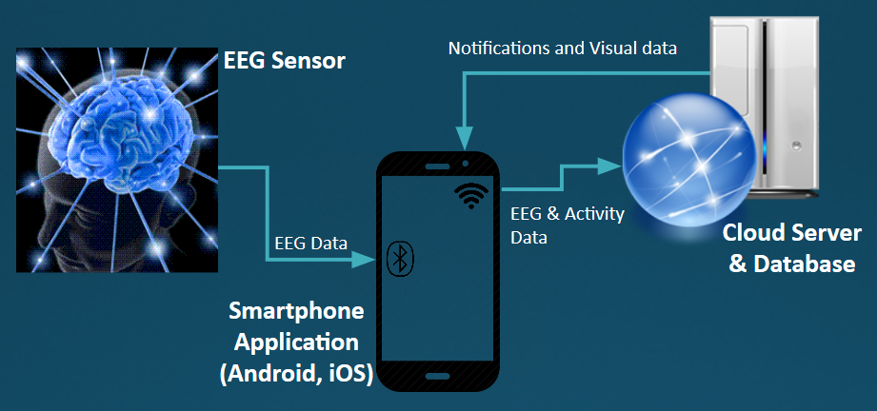
There are many types of dry electrodes, but the current plan for the BHMK is to implement a sensor using conductive fabric-over-foam components. The compressibility of the foam will help maintain a consistent interface when pressure is applied in the inwardly radial direction. The final form factor that is being considered will use a circular adhesive bandage that will be applied to the head, in the location determined to provide the best indicator of PD-on/off. The pressure will also allow the dry electrode to stay in place, minimizing artifacts from eye-blinking and other movement. The electrode will connect via shielded wires to a microcontroller, digitizing the raw voltages before sending them via Bluetooth to the user’s smartphone.
Figure 2: Overview diagram of the BHMK project. EEG data is collected and sent via Bluetooth to the user’s smartphone. The data is then forwarded to a cloud-based server and database for processing. The processed data is made available to the user’s doctor for review. Graphical EEG data and notifications from the doctor are then sent back to the user’s phone.
The raw EEG data is received via Bluetooth and immediately forwarded to the web application server for processing. The smartphone application will have a user interface displaying processed brain activity that has been received from the web application. The user interface will also allow the user to enter daily activities and medication details (e.g. exercise amounts, sleep times, types of meals, time of medications). The application will also maintain the prescribed medication schedule as identified by the patient's doctor. Notifications on the phone will alert the patient when medication is to be taken. These notifications will be managed within the web server by the doctor, and delivered to the phone. Additional movement data will be collected using location services and accelerometer/pedometer data collected by the phone (in cases where enabled by the user).
The raw data that is sent from the smartphone will be stored in an online database with unique identifiers to a patient's profile. The data will be processed using an online server application and presented in the form of graphs and tables. All data will be visible to any doctor assigned to a patient’s profile. Periodically, generalized graphs will be sent back to the user’s phone, allowing the user access to their daily brain activity information. The smartphone will also collect the environmental data provided by the user and store it in the database. This information will also be processed and available to the doctor assigned to the profile. The doctor can view this information and update medication schedules within the interface. These updated schedules are then sent back to the patient’s phone application for notifications.

Target Objective and Goal Analysis
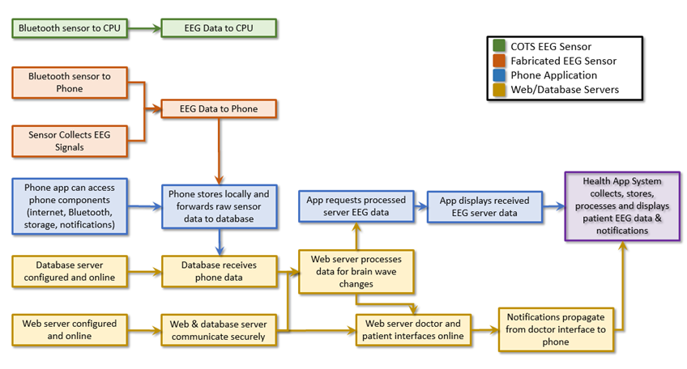
The goal analysis diagram showing the progress made this semester can be seen in Fig. 3. Items that have been fully completed are denoted with a red slash. An additional aspect of our project that is not shown is the human test study research that will be conducted.
Figure 3: Goal Analysis diagram of the BHMK showing progress to date. The three main components of the project are differentiated by color. The interdependence of these three areas can be clearly seen from this diagram.

Engineering Specifications and Constraints

EEG Sensor
- Specifications
  - Bluetooth v4.2+ radio
  - 16+ Hour Battery Life
  - Detect 12-30 Hz EEG Signals (β waves are shown in current research to be of the most interest in detecting PD-on/off)
  - Sampling rate > 200 Hz
  - 3 inputs (EEG, Reference, Ground)
  - 750 kB storage (30 minutes of EEG data)
- Constraints
  - Clean connection to scalp
  - Patient comfort level wearing sensor
  - Bluetooth radio range limitations

Phone Application
- Specifications
  - Android 2.0 development platform
  - Data transfer to server every 1 minute
  - Adaptable graphing for phone screen size
- Constraints
  - Android graphing capabilities

Web Servers
- Specifications
  - Python Server
  - MySQL Database
  - HIPAA Compliant Servers
  - Elastic Computing Capable
  - Fully encrypted communications (AES-256 or greater)
- Constraints
  - Cost of hosting services
  - Available authentication methods

Statement of Accomplishments
The consumer-over-the-shelf (COTS) sensor testing has been completed. A Muse headset was connected to a laptop via Bluetooth and sample raw data was transmitted in real-time. This data was able to be parsed and displayed based on the frequency ranges relevant to this project (α-, β-, δ- and θ-waves).
The EEG sensor being developed for this project is currently under construction. The dry electrode method is being developed and a fabric-over-foam implementation has been chosen. The material is in-hand and being tested. A TGAL II application-specific integrated circuit (ASIC) chip has been identified as a possible candidate for the collection of raw EEG data. Currently, testing is underway to identify if the ASIC is capable of providing the accuracy and reliability required for the BHMK system. This ASIC is attached to a Bluetooth module allowing for data transmission to the phone. The TGAL II is also capable of splitting the raw EEG signal into frequencies. An algorithm has been implemented using an Arduino microprocessor to convert this data into the standard frequency ranges used in measuring brain activity. Using a steel electrode with grounding clips connected to the ear, sample data has been sent via Bluetooth to a laptop. An example of the collected data can be seen in Fig. 4. Two frequency band traces are shown on the graph (high-alpha and high-beta). The power magnitude is graphed against time. During this data collection period, five different situations were recorded for 30 seconds each. The situations included variations of eyes closed, eyes blinking, eyes open, left reference electrode disconnected, and right reference electrode disconnected.
The phone application and web servers have not been developed in any detail this semester. However, login and permission enabling screens have been implemented in the smartphone application (Appendix C). The web server will be hosted by Amazon Web Services, utilizing their dynamic storage and computing capabilities. An account has already been created and is ready for development, using Python scripting.
The team has conducted research and developed a human study to assess the ability of EEG sensors to detect PD on/off conditions and L-Dopa ingestion correlation. At this point, the application documents (Appendix B) have been submitted and the research study is pending approval.
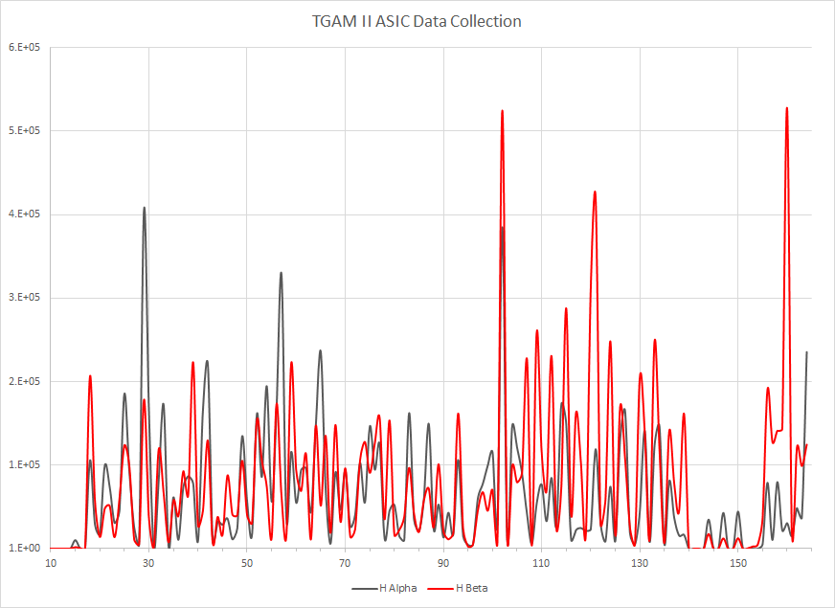
Figure 4: TGAM II High Alpha and High Beta wave recordings over time [sec]. Five different cases were recorded for 30 seconds each. For example, at 140 seconds, the grounded reference pickup was disconnected to test the result in that situation. The sensor was unable to record voltage differences reliably in this case, resulting in a much lower signal.

Engineering & Medical Standards
If sold commercially, the BHMK sensor must meet FDA approvals for a medical device and would be classified under the U.S. Code of Federal Regulations (CFR), Title 21, §882.1240. EEG devices are rated as Class II by CFR regulation and require 501(k) premarket notification to the FDA before they can be offered commercially.
Also, given the purpose of the BHMK is to regulate patient medication schedules, the phone application and web servers require adherence to IEEE 730-2014 (Software Quality) and HIPPA Regulations for patient medical data protections.

Budget
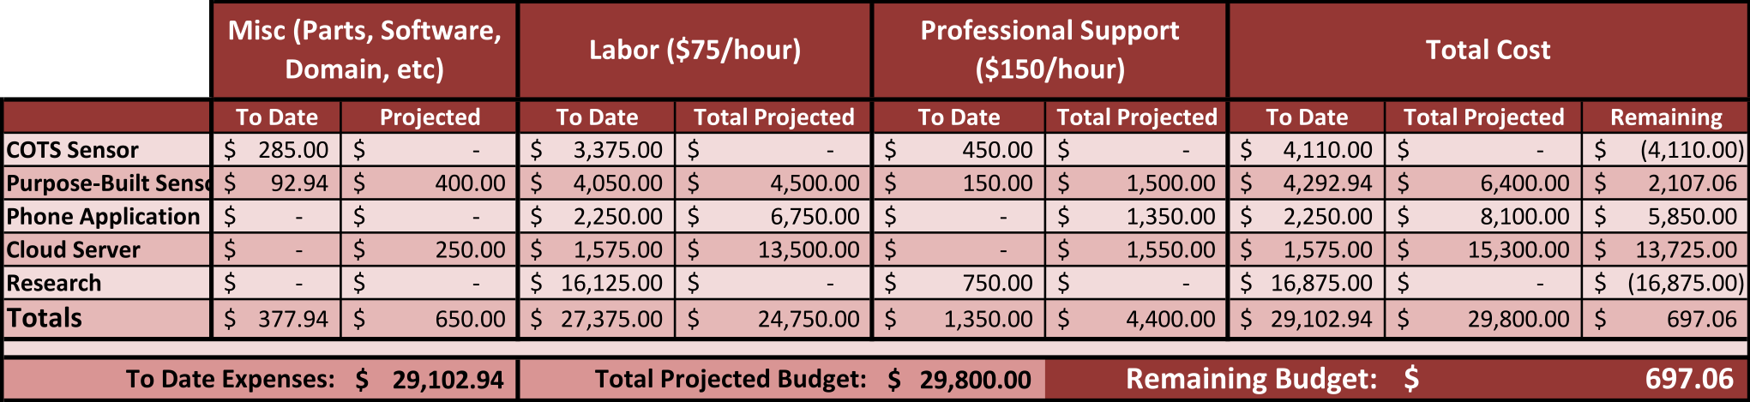
The BHMK budget is shown in Fig. 5. Currently we are $697.06 under the annual budget, with the second semester of the project yet to be completed. The reason for the budgetary situation is the unaccounted research expenses (labor) of $16, 125. This accounts for 55% of the anticipated budget.
Figure 5: BHMK Budget, including labor, expenses and Professional Support costs. To Date expenses are compared to projected expenses.
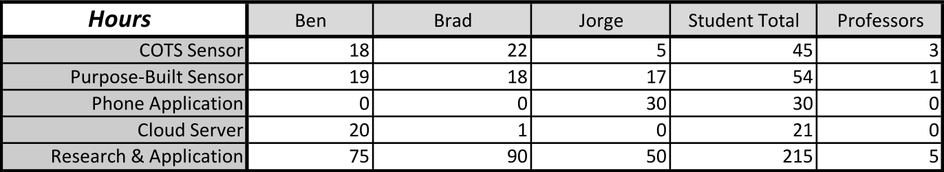
Additionally, the labor expenses for the project were self-reported by each team member and tabulated in Fig. 6.
Figure 6: Individually identified hours for each section of the BHMK project.

Risks
Given much of the project is still incomplete, there are several potential risks to on-time completion. For the EEG sensor, there are two main risks: the TGAL II ASIC is unable to provide the precision and accuracy required forcing a new implementation plan and the fabric-over-foam pickup under development is unable to register strong enough signals.
The programming involved in the phone application and the web servers should not cause any risks, other than potentially difficult calculations required in defining algorithms to process the raw data (see Analysis and Predictor Algorithms in Appendix A). Although transmitting, manipulating and graphing data should not be difficult, these tasks have not been implemented. Therefore, it is not possible to say with certainty these items will be implemented without risk of set-backs.
The research study also has two main risks. The first is a lack of volunteer participation in the study. Guidance was provided as to the best way to attract participants, but this is not guaranteed. Furthermore, the entire study is dependent on the CPHS approving the application. Should additional clarification be required, the study could potentially be postponed up to several weeks.

Conclusions
This semester, the BHMK team has researched EEG measurement techniques, Parkinson’s disease, treatment methods and EEG sensor types. Using this knowledge, a commercial EEG sensor was procured and tested to further the team's understanding on brain wave functionality. Additionally, a basic electrode and algorithm were used with the ASIC chip and Bluetooth module we plan on implementing in the final version of the sensor for data collection. A data set was collected via Bluetooth, confirming the sensor’s connection capabilities.
The development of the phone application is still in its infancy, but the logins and permissions have been established. The cloud servers (web and database) were created within Amazon’s Elastic Cloud services and loaded with Python and MySQL. No development of the servers has begun regarding specifics required by the BHMK system. Amazon was contacted regarding the requirement for HIPAA compliance and agreements required for this level of service have been received by the BHMK team.
The team has also developed a research protocol for human testing of Parkinson’s patients. This study is intended to temporally correlate EEG data to motor function changes and L-dopa concentrations. It will also ensure the placement of the EEG sensors in the BHMK can reliably detect PD-on/off. The testing will be carried out with standard medical EEG components (not the sensor being developed for the BHMK). Currently the application is under review with the University of Houston Committee for the Protection of Human Subjects (CPHS).
The original scope of the project was to complete the entire BHMK this semester except for algorithm refinement. The amount of research that was required to understand the background of the Parkinson’s disease, electrode technology, and experimental methods in relation to PD took much longer than was initially estimated. This background research also introduced an entirely new aspect to our project, by prompting the team to develop a human subject study for clarification of EEG monitoring capabilities in detecting PD patient symptoms. Furthermore, the initial goals did not include developing our own dry electrode (a goal that was introduced later in the semester). Additional research was required for this task, and a solution has been designed and is currently in the build stage. Despite this, progress is being made and we are confident that the entire project and the research study will be completed by the end of the spring 2016 semester.

Summary of Current Research on Telemedicine Approaches to Parkinson’s disease
Bradley Bounds, Benjamin Madison, Jorge Jimenez; University of Houston

INTRODUCTION
P
ARKINSON’S disease (PD) affects the oscillatory patterns of the brain. These patterns create local field potentials (LFP) that can be measured using an electroencephalogram (EEG). The different frequencies at which the LFPs resonate are defined in bands as seen in Table 1.

Table 1 – Frequency bands for cerebral oscillatory patterns.
Band | Frequency Range
δ | 2 – 4 Hz
θ | 4 – 8 Hz
α | 8 – 12 Hz
β | 12 – 30 Hz
In an effort to provide remote monitoring of many of the symptoms of PD, telemedicine approaches have started to be developed. These approaches allow patients and/or physicians to access historical and/or real-time data that has been gathered using some defined method.
One technique used to determine severity of PD and the effects of medicine is EEG collection. Monitoring activity in the frequency bands shown in Table 1 can give insight to what is happening in the brain across a temporal domain. However, due to the low voltages and currents produced by LFPs across the brain membranes, it can be difficult to filter unwanted noise that may occur due to sweating, movements, muscle activity or electrical interference in the surrounding environment [1].
According to recent research, Levodopa (L-dopa) is the most commonly prescribed medication for PD. L-dopa is a dopaminergic replacement therapy (DRT) to help with brain chemistry that may be affected by PD deterioration. [2] suggests that many symptoms may be caused by neural feedback between skeletal muscles and motor neurons found in bone marrow. [3] adds that dopaminergic loss can affect many of the synaptic systems of the brain, explaining why DRT is a common treatment. Experiments have generally shown improvement in PD patients on L-dopa, both in movement-based [4] and EEG-based [3] tests. Some older research, however, does question the effectiveness of L-dopa, citing results showing that brain activity was unaffected by the drug and suggesting that continued use could further impair brain chemistry [5]. In general, “L-dopa therapy remains a gold standard for the treatment of PD” [6] [7].
There are associated side-effects to continued L-dopa use. The main two are Levodopa Induced Dyskinesia (LID) and early wear-off (EWO). LID is characterized by additional motor difficulties and involuntary movements. EWO shortens the time that a L-dopa load is effective in reducing symptoms of PD. Since LID occurs at peak concentrations of the drug, it is often countered by reducing individual doses and increasing the frequency of successive doses [7]. Conversely, EWO can be improved by increasing either the number of daily dosages or the quantity of one load [7]. An example of these levels can be seen in Figure 7. The severity of the LID can be seen to correlate with the concentration of L-dopa in the system. Similarly, as the concentration drops, the EWO symptoms may begin. With prolonged treatment, the time scale will compress. Altering load levels will affect the peak level concentration. It has been shown that new patients may have a 6-8 hour window of improved behavior while more advanced patients may only have 0.5-2 hour windows before faster and less-predictable wearing off periods [8] [9] [10]. Each patient’s absorption model will be different depending on body chemistries, etc. Furthermore, an individual patient’s model may change daily due to exercise levels, high protein meals, etc.
When monitoring the EEG behavior of PD patients, it is important to understand the relevancy of each frequency band. Many PD EEG studies focus on differences at the higher frequency bands (α and β). α-waves are associated with relaxed
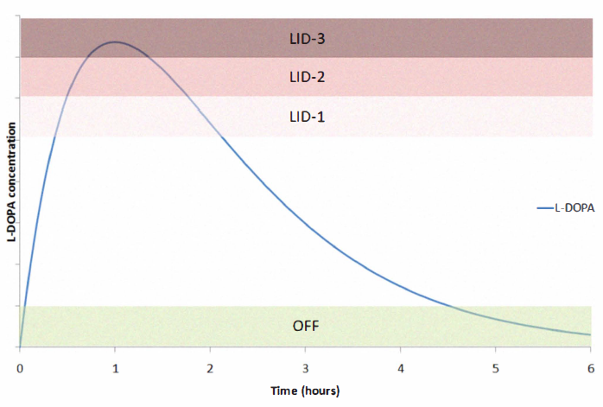
Figure 7 – A sample L-dopa absorption model as shown in [7].
state, eyes-closed neural activity. Increasing the α-wave activity reduced the resting arm tremor commonly associated with PD patients who are off their medication (at least 12 hours since last dose) [3]. Similarly, increasing β-wave activity reduced arm rigidity, another symptom of PD [3]. Motion-based studies have also showed that β-wave activity is tied to motor movement and that PD patients demonstrated a slower increase in β-wave activity during movement [11]. This slowness of movement, bradykinesia, is also a symptom of PD. Most EEG-based PD studies focus on these higher frequency bands since many of the main symptoms of PD have been demonstrated to be directly related to α- and β-wave activity.

Current Treatment Monitoring Methods
Once a patient has been diagnosed as PD and been prescribed L-dopa, the follow-up treatment consists of limited clinical visits and subjective patient journals. Brief doctor visits may not be able to provide the physician with a full picture of how the patient is reacting to L-dopa [12]. As shown in Figure 1, the concentration of the drug changes over time from dose to dose, and with that, the symptoms will also change. In order to avoid over- or under-prescribing the medication or dosage schedule (to avoid LID and EWO), the doctor relies on a snapshot view of the patient and a subjective scoring of the Unified Parkinson’s Disease Rating Scale (UPDRS), a common technique in diagnosing disease severity. Furthermore, patients in rural areas or who have trouble moving and travelling will have even more difficulty in maintaining a consistent and regular appointment schedule.
Due to the inability of physicians to constantly monitor their patients, patient journals are often implemented. These consist of the patient tracking their symptoms throughout the day. This can be extremely inaccurate if patients forget to fill out their journal or do not accurately note the time that symptoms occurred. Patient recollections of their symptoms and severity are also subjective and not a consistent measure across a physician’s entire clientele [12].

Problem
A review of the current methods used to treat and monitor PD shows there are areas that need improvement. Individual body chemistries, metabolisms, etc. can change the concentration of the L-dopa load that reaches the brain. Furthermore, even one patient’s absorption model can change daily or even throughout a single day. This may be due to diet, exercise, environment, etc. that is not consistent at all times of every day.
Limited clinical visits also limit the physician’s available information to make the appropriate recommendations for treatment. Seeing multiple patients in a day does not allow a doctor to observe a patient throughout an entire process of absorbing a L-dopa load. The UPDRS can provide somewhat consistent results, but the score is based on a moment in time and often unreliable patient journals. When the doctor is unable to constantly observe patients, symptoms severity is based of patient accounts, which can vary widely. This makes finding the optimal dosage load and schedule to avoid LID or EWO extremely difficult.

Current Monitoring Research

EEG monitoring in research labs
EEG monitoring is generally conducted using electrode pickups in contact with the scalp. The most accurate information is collected by inserting a pickup into the skull and monitoring brain activity from the source [13], but this is dangerous, difficult, and unfeasible for most research studies.
Most studies are conducted using a full EEG monitoring cap, consisting of at least 18 channels [14] [15] [11] [3] [5] [16]. The frequencies being monitored are from 1-50 Hz, so a band-pass filter is often employed to remove DC and standard AC power interference (0 and 60 Hz respectively) and other higher frequency communication or electromagnetic fields that are experienced in normal environments [16] [14] [15] [11] [3] [1] [5]. Additionally, the data is often sampled between 512 and 1,024 Hz, easily meeting the Nyquist rate restrictions on accurately sampling data [16] [14] [15] [11].
Each study had a specific set of reproducible experiments to collect the raw EEG data. [3] showed at resting state, eyes-closed conditions, L-dopa loads affected the α and β activity in the central-parietal region of the brain when monitored for 5 minute intervals before and an hour after taking L-dopa. [15] developed a statistical model using Independent Component Analysis and Welch’s power spectrum to distinguish patients on and off medication.
Patients reached for a virtual box when prompted by a tone while EEG data was recorded for 1 second before and after the reach in [16] to demonstrate the differences in patients on and off medication. [11] analyzed data of patients moving a joystick to an on-screen target to show β-wave differences in the left hemisphere of the brain between control and PD patients. Incorporating EEG data and motion control, [14] devised a system to provide a counterforce to subject movement while on and off medication and found no tremors when subjects were on medication and that subjects did not register their tremor when off medication.

Motion monitoring
PD is visible in the effects to motor control, involuntary movements (tremors) and slowness of movement (bradykinesia) when patients are untreated. Therefore, there have also been numerous studies to monitor the movement of PD patients. The majority of the studies that have been done in the last five years that monitor movement disorders in relation to PD are focused on movement during pre-defined tasks that occur at set times throughout the day. [2] and [14] use weights to highlight and counteract tremors, respectively. The effects of DRT were noticeable in both cases. Additional EEG data was collected in [14], showing a pronounced difference in brain activity in the left-center of the scalp.
Visually guided tracking exercises were also employed in [4], where patients tracked a target travelling on a spiral shape on a screen a few feet away. The error between the target and where the patient pointed was tracked and analyzed using statistical methods (data-mining and K-mean clustering techniques). The results of the study showed marked improvement from patients 12 hours removed from their last L-dopa load to patients who were on-medication [4].
Telemedicine approaches were employed in [12] and [8] using smartphone applications at testing equipment. In both studies, a baseline test was done in the morning before DRT when symptoms are most present. [12] required the patients to complete the test 4 times daily for week-long test periods, while [8] required a morning baseline and then periodic testing throughout the day when symptoms were more controlled.
Additional studies were conducted by collecting data throughout the day. As most modern smartphones have a three-dimensional internal, integrated accelerometer, [17] created an application to collect data on arm tremors and walking motions by strapping the phone to the back of the subjects arm and ankle, respectively. Specific objective movements were given to the subject for completion. The resulting data accurately predicted PD severity using hand tremors and gait characteristics [17]. This method works for short, periodic intervals, however, in normal use, the phone cannot be strapped to the patient in such a manner.

Cloud-based systems
As access to the internet has become much more universal, focus has also been placed on remote monitoring techniques that do not require in-person, physician observation. As mentioned above, [17] used a smartphone to gather data. Once collected, the data was temporarily stored on the device before being forwarded to a cloud-based service for processing. The data was saved in SQL based databases and was available post-processing for patient viewing and, at the request of the subject, the patient’s physician. In [12] and [18], one potential framework of a telemedicine system is outlined. Data was collected using a personal handheld device to conduct a testing battery. The raw data was forwarded to a server where it was stored in relational databases (SQL). The raw data was accessed and processed using Java, SQL, etc. and stored again in a database. The processed data was then made available in a clinical setting where doctors and nurses could navigate a web-based application that displayed patient trends [18]. Further work focused on techniques to minimize the required bandwidth to send the data between the different system modules.
Many PD patients are older and may not be either as familiar or comfortable using technology to monitor their disease. Studies were conducted to test the feasibility of a patient-controlled, remotely monitored system. [8] found that 90% of patients were able to complete the study successfully. [12] found that 94% of patients were willing and able to complete the study. These results suggest it is reasonable to expect a high degree of compliance when remotely monitoring PD symptoms using wearables, objective testing and subjective e-Journals when testing is done periodically for short intervals.

Analysis and Predictor Algorithms
Monitoring of PD collects a large amount of raw data, but for physicians to feel comfortable altering the current methods of observation and prescribing, the manner in which the raw data is processed and presented must be shown to be accurate and reliable. Initial pre-processing often occurs using tools like the EEGLAB toolbox from MATLAB. This allows for filtering of the raw data, even if a BPF was not initially used in the data collection. Furthermore, many of these tools allow for easy conversions between time and frequency domains through numerically calculated Fast Fourier Transforms. The frequency information is important to determine activity is certain frequency bands that is often correlated to symptoms of PD. Additionally, there are common statistical methods that are employed at the research stage to verify results and draw conclusions. Examples of statistical and programming methods used in research include Cover’s Theorem [16], Independent Component Analysis [15], Welch’s averaged periodogram [15], and various artifact removal processes from EEGLAB.
In order to verify results further, [7] developed a predictor algorithm that used the raw data collected to predict the best course of treatment to minimized LID and EWO. The results were shown to be very close to the recommendations of physicians on dosage schedules and quantities. The study also demonstrated that the predicted recommendations could be sent to the physician who could change the patient’s DRT schedule or quantity at a glance [7].

Need
Studies that provide remote monitoring of PD patients are focused on motion-based data. This data is important, as PD is outwardly noticeable as a motor control and motion restricting disease. However, PD is a neural disorder and can therefore be monitored using brain activity, as shown above. While motion-based studies often require specific tasks to be completed, there is a potential to use EEG data collected at all points during the day, no matter what the subject is doing. This is extremely valuable in encouraging participation. Additionally, data collected on a constant basis, will allow for better absorption rates and schedules to be determined. There is a need for a remote EEG monitoring solution for PD.
Current techniques in basing treatment off of limited observation can be changed to provide the physician with objective, potentially constant, accurate information instead of relying on brief clinical visits and subjective, inaccurately time-stamped patient journals. The better information the physician is given, the more likely that PD, LID and EWO can be optimally treated. There is a need for a cloud-based monitoring system to provide the physician with this information.
Despite the high compliance rates in cloud-based, remote studies, [12] showed that participation dropped after a number of weeks. Subjects cited a lack of feedback from both the application and their physician on the subject’s compliance and performance [12]. There is a need for feedback on the application that shows the patient’s performance over time as well as the ability for physicians to be able to leave messages of feedback to their patients using the remote monitoring systems to help motivate continued participation.
Given the widespread usage of smartphones that are connected to the internet, it is also possible for patients to receive notifications from their physician and reminders when it’s time for the next load to be administered. As mentioned above, notifications and physician feedback are useful motivational tools to encourage continued participation. Reminders to take medicine at the correct time allow the absorption of a dose to be optimized (see Figure 1). The optimum time to medicate may change from patient to patient and from day to day, depending on any number of parameters. Constant monitoring will allow this optimal dosage time to be relayed to the patient to help minimize symptoms of PD and the risk of LID and EWO. There is a need for a notification and reminder system to be implemented using the patient’s smartphone.
A system meeting the needs outlined above can eventually be expanded to include a daily journal for diet, exercise, symptoms, etc. This journal can be used by the physician or provide more data to further individualize treatment. Accelerometers can be used alongside EEG monitoring to provide the best possible representation of a patient’s condition on a real-time basis. [17] showed that a single accelerometer (possibly in the patient’s phone) can be used to determine severity of symptoms. A remote monitoring system could potentially also be applied to various other neural disorders.

References

[1] | L. Hellstrom-Westas and I. Rosen, "Continuous brain-function monitoring: State of the art in clinical practices," Seminars in Fetal & Neonatal Medicine, vol. 11, pp. 503-511, 2006.
[2] | I. Fukumoto, "A Study for Automatic Diagnosing System of Parkinson Disease".
[3] | J.-M. Melgari, G. Curcio, F. Mastrolilli, G. Salomone, L. Trotta, M. Tombini, L. di Biase, F. Scrascia, R. Fini, E. Fabrizio, P. Rossini and F. Vernieri, "Alpha and beta EEG power reflects L-dopa acute administration in parkinsonian patients," Frontiers in Aging Neuroscience, vol. 6, no. 302, pp. 1-7, 2014.
[4] | Y. Liu, C. Lee, J. Stevenson and M. McKeown, "Analysis of Visually Guided Tracking Performance in Parkinson's Disease," in IEEE 16th International Conference on e-Health Networking, 2014.
[5] | P. Stanzione, M. Marciani, M. Maschio, M. Bassetti, F. Spanedda, M. Pierantozzi, R. Semprini and G. Bernardi, "Quantitative EEG changes in non-demented Parkinson's Disease patients before and after L-dopa therapy," European Journal of Neurology, vol. 3, pp. 354-362, 1996.
[6] | H. Yuan, Z. Zhang, L. Liang, X. Wang, S. Ren, H. Ma, S. Jiao and P. Liu, "Treatment strategies for Parkinson's Disease," Neuroscience Bulletin, vol. 26, no. 1, pp. 66-76, 2010.
[7] | G. Rigas, P. Bougia, D. Baga, M. Tsipouras, A. Tzallas, E. Tripoliti, S. Tsouli, M. Chondrogiorgi, S. Konitsiotis and D. Fotiadis, "A decision support tool for optimal Levodopa administration in Parkinson's disease," 2010.
[8] | T. Mera, D. Heldman, A. Espay, M. Payne and J. Giuffrida, "Feasibility of home-based automated Parkinson's disease motor assessment," Journal of Neuroscience Methods, vol. 203, no. 1, pp. 152-156, 2012.
[9] | J. E. Ahlskog and M. Muenter, "Frequency of levodopa-related dyskinesias and motor fluctuations as estimated from the cumulative literature," Movement Disorders, vol. 16, pp. 448-458, 2001.
[10] | S. Fahn, "A new look at levodopa based on the ELLDOPA study," Journal of Neural Transmission Supplemation, pp. 419-426, 2006.
[11] | G. Tropini, J. Chiang, Z. Wang and M. McKeown, "Partial directed coherence-based information flow in Parkinson's disease patients performing a visually-guided motor task," in 31st Annual International Conference of the IEEE EMBS, Minneapolis, Minnesota, USA, 2009.
[12] | M. Memedi, D. Nyholm, A. Johansson, S. Palhagen, T. Willows, H. Widner, J. Linder and J. Westin, "Validity and responsiveness of at-home touch-screen assessments in advanced Parkinson's disease," IEEE Journal of Biomedical and Health Informatics, pp. 1-9, 2015.
[13] | T. Gilmour, C. Lagoa, W. K. Jenkins, A. Rao, M. Berk, K. Venkiteswaran and T. Subramanian, "Transfer entropy between cortical and basal ganglia electrophysiology," Signal Processing in Medicine and Biology Symposium, pp. 1-5, 2012.
[14] | N. Govil, A. Akinin, S. Ward, J. Snider, M. Plank, G. Cauwenberghs and H. Poizner, "The Role of Proprioceptive Feedback in Parkinsonian Resting Tremor," in 35th Annual International Conference of the IEEE EMBS, Osaka, Japan, 2013.
[15] | P. Wen-Hsin Lee and Z. J. Wang, "Mutual Information Based Relevance Network Analysis: A Parkinson's Disease Study," in IEEE International Conference on Acoustics, Speech and Signal Processing, Las Vegas, NV, USA, 2008.
[16] | J. Weyhenmeyer, M. Hernandez, C. Lainscsek, T. Sejnowski and H. Poizner, "Muscle Artifacts in Single Trial EEG Data Distinguish Patients with Parkinson's Disease from Healthy Individuals," in 36th Annual International Conference of the IEEE, EMBC, Chicago, IL, USA, 2014.
[17] | D. Pan, R. Dhall, A. Lieberman and D. Tetitti, "A mobile cloud-based Parkinson's disease assessment system for home-based monitoring," JMIR mHealth uHealth, vol. 3, no. 1, pp. 1-27, 2015.
[18] | M. Memedi, J. Westin, D. Nyholm, M. Dougherty and T. Groth, "A web application for follow-up of results from a mobile device test battery for Parkinson's disease patients," European Journal of Neurology, 2010.

The CPHS application for the designed human-subject testing is attached. The file is the extract from the UH RAMP system and includes all documentation submitted to the Committee related to the planned testing.

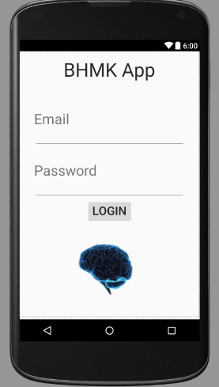
Figure 8 displays the initial screen of the phone application. Details on the application, such as profile creation and calendar syncing are being developed. The only user existing in the application is Administrator with password BHMK. The creation of different users will be also added after the SQL Database is sync with the app.
Figure 8 – Login screen for smartphone application

Figure 9 presents the application requesting permission to turn on the Bluetooth and pair up with a device. This screen will appear once the user logs in to the app.
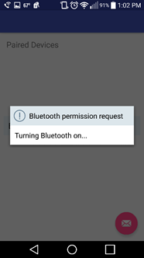
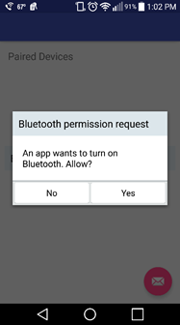
Figure 9 – Application requests permission to turn on Bluetooth

Manuscript created October 28, 2015. This work was written as a review of prior research in an effort to help define a problem for a year-long project. The authors are undergraduate students at the University of Houston, Houston, TX 77004 USA.

