From: The University of Houston

4800 Calhoun Road

Houston, Texas 77004

Date: December 14, 2015

Subject: Final Technical Report Fall 2015

To: Steve Rodriguez

Omron Oilfield and Marine

9510 N. Houston-Rosslyn Road

Houston, Texas 77088

Dear Mr. Rodriguez:

Enclosed you will find the Final Technical Report of the semester for the Omron Wireless Project. The report contains an overview of the project and includes a statement of accomplishments. Accomplishments up to this point include: testing model encoder accurately measures rotational and vertical position, wireless sensor systems power analysis rated for 2 month lifespan, sensor unit transmits data to microprocessor via wired (USB) connection, and MCU communicates positional data to PC.

The PLC controlled testing model is functioning within the intended accuracy specifications, with a movement error of 0.0278%. Transmitting positional data, albeit not accurate, was a major milestone for the project. This signals the end of the hardware development phase as the team moves into calibrating positional data and establishing wireless communication.

The team would like to acknowledge the assistance of Dr. Jackson of the Electrical Engineering Department at The University of Houston. After consulting with him, a radio frequency of 918 [MHz] was determined to be the optimal frequency to communicate in an electrically/thermally noisy environment.

The team would like to take this opportunity to thank you for the opportunity to work on this project with Omron.

Regards,

Marcos Rodriguez

Brendan Murphy

Nguyen Tran

Md Farshid Zaman

Omron Wireless Sensor Network



**Brendan Murphy**

**Md Farshid Zaman**

**Nguyen Tran**

**Marcos Rodriguez**

Capstone Design Project

Fall 2015

Abstract

According to the Houston Chronicle, from 2007 to 2012 there were 663 deaths in oil field-related industries in the US. In 2012 alone, the newspaper found 79 people lost limbs, 82 were crushed and 675 broke bones in oil-field work related accidents [1]. The objective of the Omron Wireless Sensor Network is to deliver a real-time, positional monitoring system for drilling equipment in the field. Our wireless sensor network will provide accurate positional data from drilling equipment on-site to a control center. With this real-time positional data, oil companies will be able to shut down equipment before accidents occur. In this particular project we will be monitoring the vertical movement of a top drive using an accelerometer. We’ll also be monitoring the angular/rotational movement of a bail arm using a gyroscope. Each sensor will be communicating with a microcontroller unit (MCU), which will transmit the data wirelessly, using a small radio, to a ‘radio hub’ MCU in the field. The radio hub will then send the positional data back to a control center via Ethernet/IP. Overall, the cost of the three MCU’s, two IMU’s (accelerometer/gyroscope), and batteries should not exceed five-hundred dollars. At such a low cost, we expect similar sensor networks to be implemented across the nation in order increase worker safety and decrease insurance liability and production downtime.

Purpose and Background

The purpose of the Omron Wireless Sensor Network project is to increase the safety of workers around drilling rig equipment, maximize productivity of drilling ventures, and save company cost on liability and legal issues. We will achieve this goal by creating a wireless positional sensor network which sends equipment positional data to a control room at a drilling site in order monitor the movement and position of their drilling equipment. When any part of the equipment reaches a dangerous position or speed that might be unsafe for the workers surrounding the equipment, the machine will shut down automatically. This will prevent accidents in drilling sites and also should decrease company cost in worker compensation insurance and legal issues.

The idea of the project was brought to us by the sponsor OMRON oilfield and marine. Omron approached the University of Houston’s Cullen College of Engineering with a project that they deemed appropriate for Capstone Design. The main idea of the project is to create a wireless sensor network capable of monitoring the position of on-shore drilling equipment, more specifically, the vertical position of a top drive, and the angular and rotational position of a bail. Below in figure 1.1 and 1.2, we show each of these pieces of equipment, along with the positional movement our sensors will be monitoring.

Z

X

Y

Fig. 1.1: Bail, angular/rotational monitoring Fig. 1.2: Top Drive, vertical position monitoring

The top drive will be moving vertically up and down a derrick that is approximately 50 ft tall. The top drive will be moving at a maximum velocity of 6 ft/sec. The bail is attached to the base of the top drive and is approximately 10ft in length. It can rotationally move (in the x-y plane), and angularly rotate (in the x-z plane). The angular movement (x-z plane) can reach a maximum of 45° from the negative z-axis on the derrick’s open side, and a maximum angle of 20° from the negative z-axis on the derrick’s closed side. The bail is also free to rotate in 360° rotationally (in the x-y plane). In the figure 2 below we can see a diagram of a top drive and bail, with the positional movement limitations our sensor network will be monitoring.

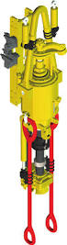

Top Drive

Bail

360°

≤ 6 ft/sec

45°

20°

Derrick

(50 ft)

Fig. 2: Movement limitations of the equipment to be monitored

The sensor network will need to communicate wirelessly to a radio hub. To do this we will have sensing units that communicate via radio signal to a radio hub microprocessor that is connected to a network via Ethernet cable. We will need each sensing unit to have a microprocessor, sensor (accelerometer or gyroscope), compatible antenna attachment, and durable battery pack.

Problem, Need and Significance

At the present time, there is a lack of real-time positional monitoring of drilling equipment and a need for such a system on equipment to increase the safety of workers on-site. This project aims to resolve this problem with an ambition to create a better and safer work environment.

User Analysis

The sensor system will be used by technicians working on drill sites for drilling ventures, particularly by technicians working in the control room. The technicians who will use the system need to be able to read positional data sent to PC from Radio Hub, interact with the system through a Java Script running on PC in order to stop, reset, and shut it down.

Overview Diagram

An overview diagram of the sensor network can be seen in figure 3 below.

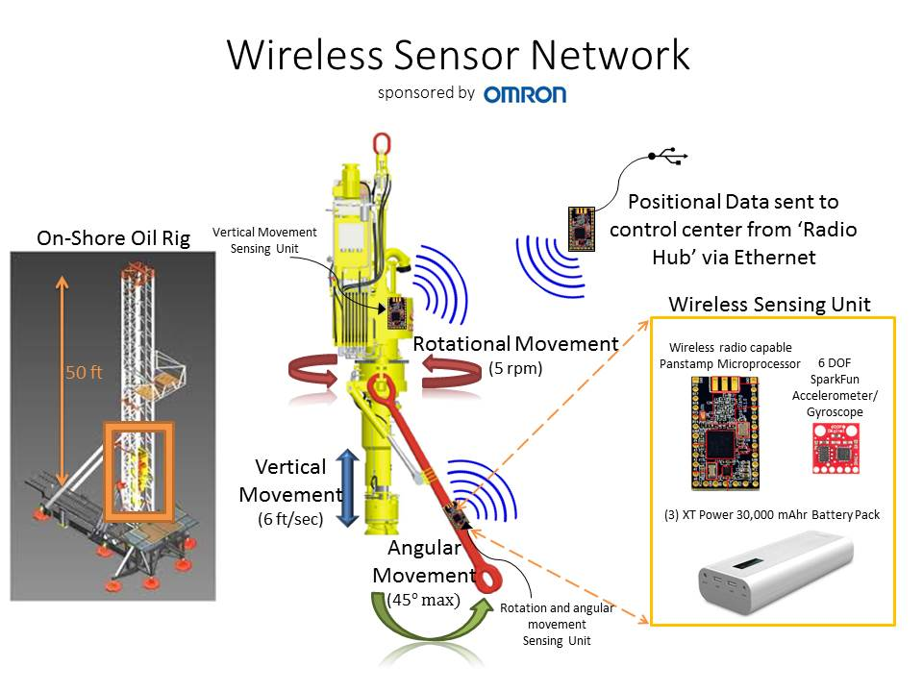

Figure 3: Overview diagram for the Wireless Sensor Network

Target Objective and Goal Analysis

The target objective can be seen in the furthest right box in the goal analysis flowchart in figure 4 below. Please note the difference in colors refers to the different fall and spring semesters.

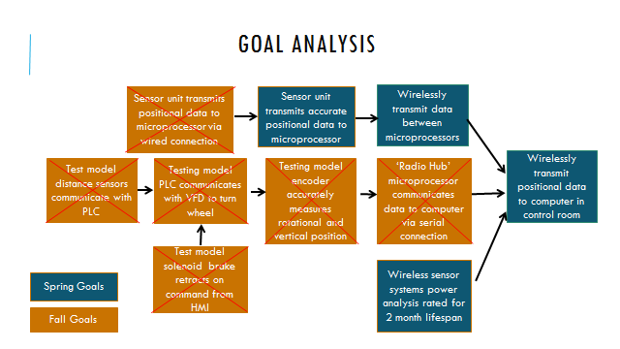

Figure 4: Goal Analysis for the Wireless Sensor Network

Engineering Specifications and Constraints

The specifications for the project have been provided by Omron. We are designing our wireless sensor network, including the components, according to the specified requirements below:

Specifications

* Top drive positional accuracy (Vertical movement) : < 0.8%
* Bail angle positional accuracy (Rotational/Angular movement) : < 1o
* Sensing unit lifespan without recharging : 2 months
* Data refresh rate: 100 Hz
* Wireless radio communication between sensor systems and ‘radio hub’

In meeting the specifications mentioned, we have come across numerous constraints that we have designed our network around.

Constraints

* Low-power consuming devices: Since we have to run our sensing unit for 2 straight months without recharging it, we had to make sure our sensing unit consumes as less power as possible. We have chosen the very low-power consuming Panstamp NRG2 microprocessors and SparkFun 6DOF IMU sensors to address this constraint.
* Long-lasting, uninterrupted power supply: The system has to run for 2 months without recharging. We decided to choose a high capacity XTPower MP 30000 battery pack (30,000 [mAh]) to address this constraint. To meet the specified 2 month life span, we will need three battery packs to power one sensing unit. A significant drawback to using these batteries is their high cost ($120 each), which has drastically increased our budget.
* Size of the batteries: The size of the battery packs also need to be considered because they must be mounted onto a top drive and bail without protruding and hindering the workspace. We chose the XTPower MP 30000 battery due to its relatively light weight of 1.82 lbs, and its compact dimensions of 8.424 in x 3.150 in x 1.152 in. Using these battery packs will allow our team the ability to design a compact, functional sensing unit that is not overly bulky
* Electrically and thermally noisy environment: One critical constraint for our project is replicating the electrical and thermal noise similar to that in the actual environment for our test model. In real life, the sensing unit is to be used at a drilling site, which has electrical and thermal radiation that can interfere with the sensor measurements, MCU processing, and wireless radio transmission. This type of radiation will most likely be generated by the drill motor or power source. The strength of the radiation at the sensing unit depends on the distance from the motor or power source. We have contacted Omron for specific field drawings to get a better idea of the distances and TOSHIBA to help us replicate a noisy environment in our test model to ensure an accurate system in the field.

Statement of Accomplishments

At the end of this semester our group has accomplished all the objectives we initially set out to complete. Our test model distance sensors communicate with the PLC and the solenoid brake retracts on command from the HMI screen allowing our wheel to rotate. The PLC is communicating with the variable frequency drive (VFD) to turn the test model wheel. We’ve programmed the correct parameters into our code so that the encoder accurate measures rotational distance, enabling us to turn the test model wheel within 0.1° accuracy.

We’ve constructed our sensing units comprised of a SparkFun 6DOF IMU sensor and Panstamp NRG2 MCU. The sensors are transmitting positional data to the MCU via I2C connection, and then to the PC via USB. We are now in the process of interpreting the positional data, and calibrating our sensors for accuracy.

Engineering Standards

The MCU and IMU communicate through Inter-Integrated Circuit (I2C). This is a communication method usually used in lower speed (less than 1 [MHz]) microprocessors. I2C works as a bus with 2 lines, a serial clock line (SCL) and a bidirectional serial data line (SDA). There is a communication protocol with I2C that begins with transmitting a devices address. This is done by the master node, which generates the clock and initiates communication with what is known as the slave node. The slave node is the node that receives the clock and responds when the master node addresses it.

Omron requested that the Wireless Sensor Network be enclosed in Class 1/Division 1 rated enclosure. The National Electric Code defines Class 1/Division 1 as an area “where ignitable concentrations of flammable gases, vapors, or liquids are present continuously or frequently within the atmosphere under normal operation conditions.”[2] The finished Wireless Sensor network will have to be enclosed in a Class 1/Division 1 rated enclosure once it is completed.

Most radio frequency (RF) devices in the U.S. must adhere to part 15 of the Federal Communications Commission (FCC) rules for limits to the unintentional and intentional emission of radiation. These rules set maximum radiation levels for RF devices. However, Part 15. 103 exempts any device that is “used exclusively as industrial… test equipment.” Part 15.23 of the rules states “[e]quipment authorization is not required for devices that are not marketed, are not constructed from a kit, and are built in quantities of five or less.” [3] Both rules exempt the Omron Wireless Sensor Network from FCC regulations.

The team will adhere to the previously mentioned standards and protocols, and will continue researching to ensure no engineering standards are broken though out the remainder of this project.

Budget

In figure 5 below, please see the total projected budget for fall and spring semesters.



Figure 5: Budget for the Wireless Sensor Network

Risks

We have not yet purchased a battery system due to budget constraints. Our power calculations will have to be redone if the batteries perform poorly once tested in the lab. This concern can potentially cause us to not meet the 2 months of uninterrupted power specified by Omron. Also, we are having problems of interpreting the positional data now. It is much more complicated than we originally expected so it may take us longer than expected to have our sensor system accurately measuring and display data. The last concern the team has is drifting of yaw (rotational movement). We can solve this by using a nine degree of freedom sensor, but it will use a magnetometer which might be even more susceptible to electrical/thermally noisy environment

Conclusions

As for the end of this semester, the team is on schedule and on budget. We have achieved all the goals we had planned to achieve. We were forced to make slight changes to our schedule because due to ordered parts coming in late, but we were eventually successful in completing the goals set for this semester. We now have a working test model, and sensor system that sends positional data to our PC. In the next semester, we plan to obtain accurate data, establish wireless communication and meet all the specifications desired by our sponsor. We are confident that our team, with members having expertise in hardware, power, and microprocessors, can complete this project within the requested timeline.

Appendix A: Works Cited

[1] ‘Report: Texas Accounts 40% of U.S. Oil Field Deaths,’ *Insurance Journal*. Wells Media Group 2015. Accessed 12/13/2015.

[2] NFPA 70: National Electric Code (NEC) 2014 Edition. Accessed 12/8/2015

[3] Federal Communication Commision Part 15.23. Accessed 12/4/2015.

Appendix B: Code

[code]

#include "HardwareSerial.h"

#include <FreeSixIMU.h>

#include <FIMU_ADXL345.h>

#include <FIMU_ITG3200.h>

#define DEBUG

#ifdef DEBUG

#include "DebugUtils.h"

#endif

#include "CommunicationUtils.h"

#include "FreeSixIMU.h"

#include <Wire.h>

//ATTENTION: FOR SENSING UNIT 1 ONLY!!!

float angles[3]; //Get Euler angles

float xyz[3];

int sec = 0; //Sleep time in seconds

CCPACKET packetout; //packet object send thru RF

//Create an object for positional data

FreeSixIMU location = FreeSixIMU();

void wirelessISR(CCPACKET *packetin) //To wake up during sleep

{ //Hub send a packet to wake

panstamp.wakeUp();

//if they want to sleep again

}

void setup() {

panstamp.init(CFREQ_918); //918MHz

panstamp.radio.setChannel(0); //Channel 0

panstamp.radio.setSyncWord(0xB5, 0x47); //default value

panstamp.radio.setDevAddress(02); //First sensing unit, 01 reserved for radio hub, 00 reserved for broadcasting

panstamp.radio.setCCregs(); //Set configuration register in radio

panstamp.radio.enableAddressCheck(); //Enable address check

panstamp.setPacketRxCallback(wirelessISR);//???

panstamp.attachInterrupt(wirelessISR); //???

Serial.begin(38400);

Wire.begin();

delay(5);

location.init();

delay(5);

}

void loop() {

while (sec == 0)

{

location.getEuler(angles);

Serial.print(angles[0]);

Serial.println("");

Serial.print(angles[1]);

Serial.println("");

Serial.print(angles[2]);

Serial.println("");

angles[0]=0; angles[1]=0;angles[3]=0;

location.getValues(xyz);

Serial.print(xyz[0]);

Serial.println("");

Serial.print(xyz[1]);

Serial.println("");

Serial.print(xyz[2]);

Serial.println("");

xyz[0]=0; xyz[1]=0;xyz[3]=0;

delay(5000);

byte* ar0 = (byte*) &(angles[0]); //Convert to byte array to sendout

byte* ar1 = (byte*) &(angles[1]);

byte* ar2 = (byte*) &(angles[2]);

packetout.length = 13; //12 bytes for angles

packetout.data[0]=01; //Send to hub

for (int i = 1; i<13; i++)

{

if (i < 5)

{ packetout.data[i] = ar0[i-1];}

else if (i < 8)

{ packetout.data[i] = ar1[i-5];}

else

{ packetout.data[i] = ar2[i-10];}

}

panstamp.radio.sendData(packetout);

//Receive sleep command as in seconds to break while loop

}

panstamp.sleepSec(sec);

loop();

}

[/code]

Appendix C: MCU and Sensor Drawings

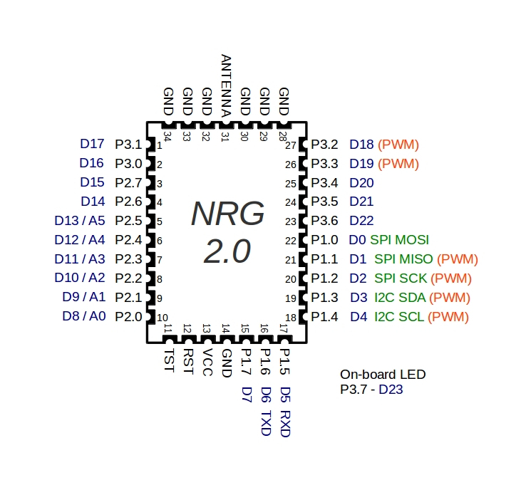

Figure 1 - Panstamp NRG 2 pin mapping

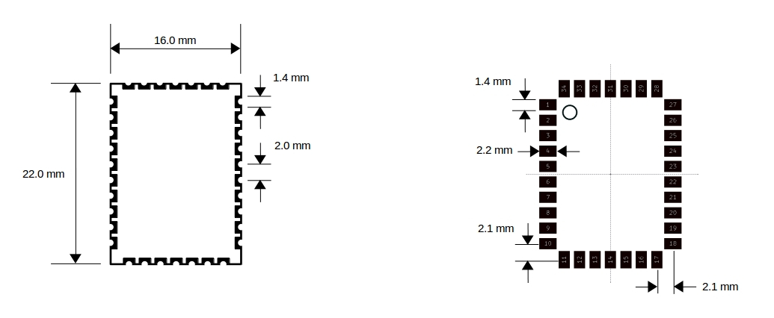

Figure 2 – Panstamp NRG 2 Foot print

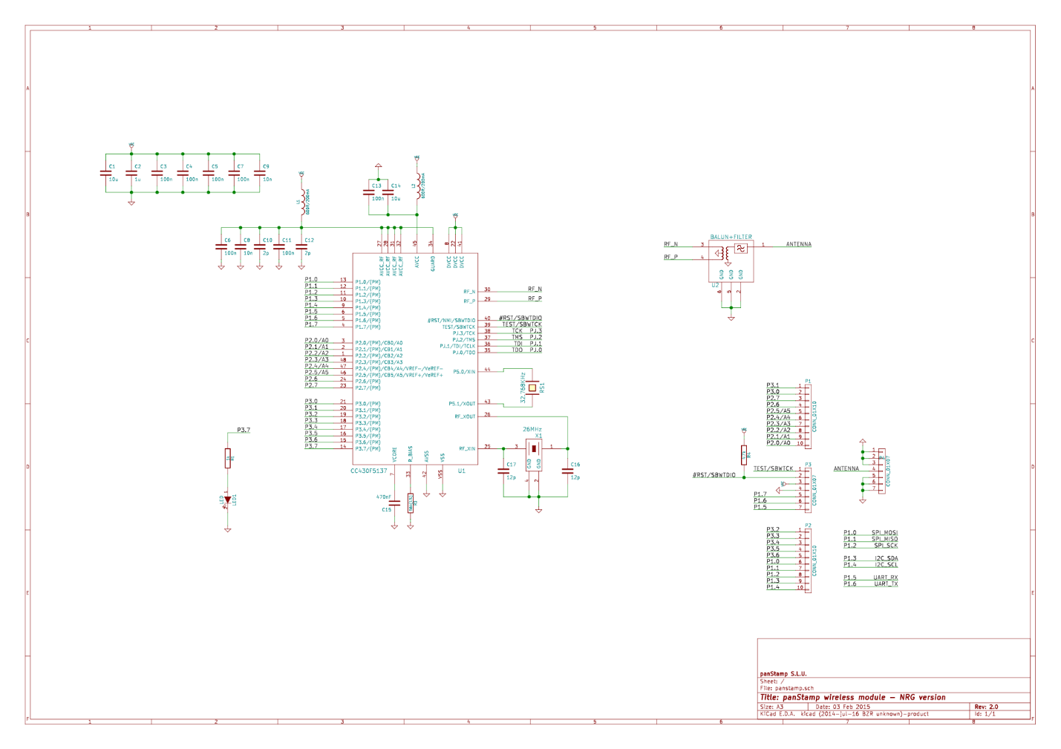

Figure 3 - Panstamp NRG 2 Schematic

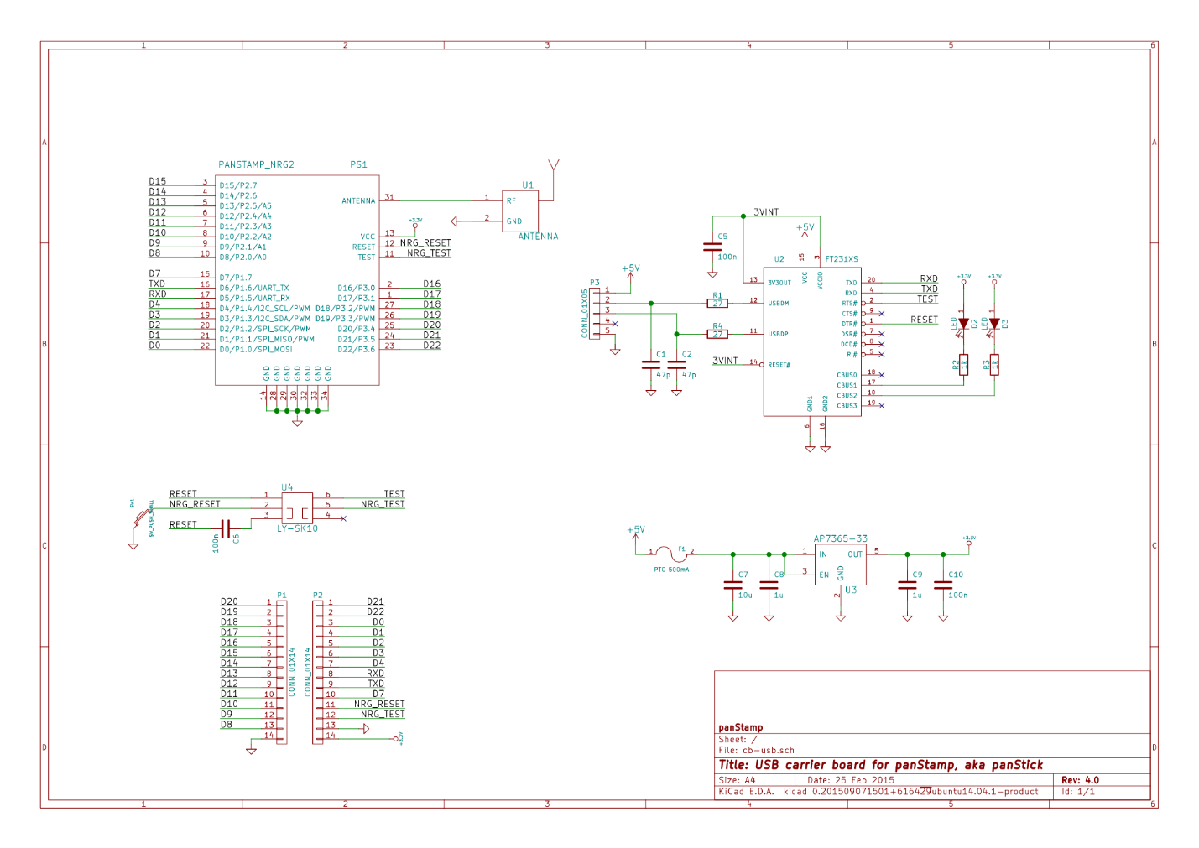

Figure 4 - Panstamp Panstick Schematic

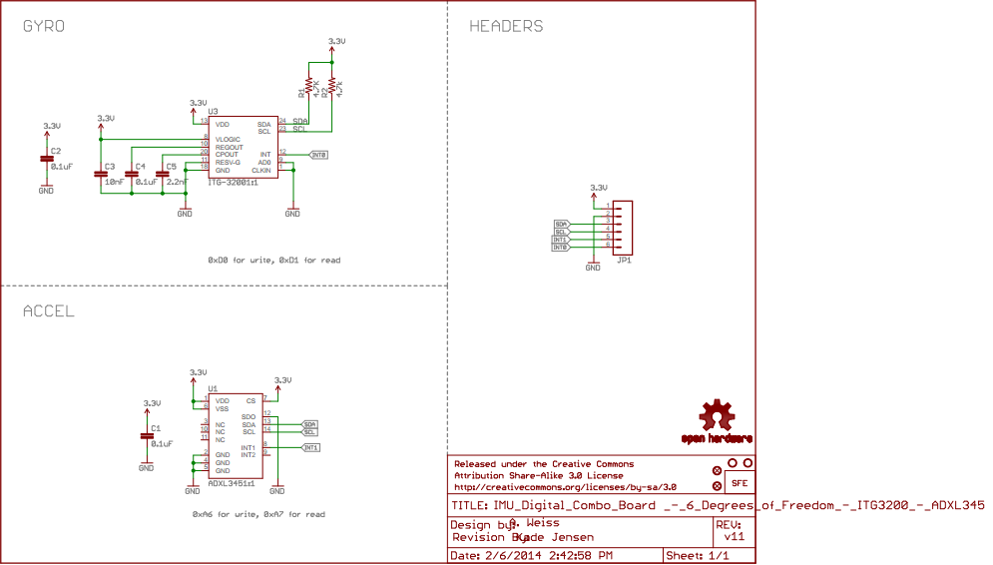

Figure 5 - Sparkfun 6DOF Sensor Schematic