December 9, 2015

|  |  |  |  |  |  |
| --- | --- | --- | --- | --- | --- |
|  | Gary O’Day, James Boswell & Michael Whatley  ECE 4335, Student Team 4 (IEEE Team 2) |  |  |  |  |

Dear Dr. John Glover,

This letter is in regards to the IEEE Team 2 Capstone Design project: designing an autonomous robot to compete in the IEEE Region 5 Robotics Competition. Our deliverable for the Fall 2015 semester is complete and ready for review. The current deliverable, our beta prototype, is assembled and has achieved autonomous wall following. The imaging system is capable of transmitting signature frame data for target recognition, and the gripper servos are now functional. The robot has fully operational subsystems, and is nearing the completion of tasks necessary for full autonomous functionality. The following report details the current state of our Fall 2015 deliverable, please contact us with any questions or comments that you may have.

Thank you,

Gary O’Day, James Boswell & Michael Whatley

[gloday@uh.edu](mailto:gloday@uh.edu)

[jaboswell@uh.edu](mailto:jaboswell@uh.edu)

mwhatley2@uh.edu

IEEE Region 5 Robotics Competition



Gary O’Day, James Boswell & Michael Whatley

**Contents:**

**List of Tables and Figures:** ii

Abstract 1

Project Title and Sponsor 2

Purpose and Background 2

Problem, Need and Significance 2

User Analysis 2

Overview Diagram 3

Target Objective and Goal Analysis 6

Engineering Specifications and Constraints 7

Statement of Accomplishments 8

Engineering Standards 14

Budget 14

Risk and Hazard Assessment 15

**Conclusion** 16

**References** 16

**Appendices** 17

**Appendix A: Motion Control Testing Data** 17

**Appendix B: Pixy CMUcam5 Imaging System** 20

Test plan for the Pixy CMUcam5 20

Pixy CMUcam5: Phase One Data Collection 26

**Appendix C: Component Specification Sheets** 37

Freescale MC33926 General Specifications: 37

Standard Motors RP-360ST/15260: 39

Sharp GP2Y0A41SK0F: 40

Parallax Ping Ultrasonic Sensor: 42

Texas Instruments Tiva C TM4C123GH6PM: 43

RobotGeek Gripper: 45

# **List of Tables and Figures:**

**Figure 1.** April 2016, IEEE Region 5 Robotics Competition course [1]. 3

**Figure 2.** Overview diagram of the prototype robot. 5

**Figure 3.** Goal analysis for IEEE region 5 robotics competition robot 6

**Figure 4**. IEEE Robotics Team 2 Budget. 15

**Figure 5**. Measured samples for 90 degree turns with 1 degree error bars 17

**Figure 6**. Measured samples for 180 degree turns with 1 degree error bars. 18

**Figure 7**. Robot stopping distance, with error bars. 18

**Figure 8**. PID Wall Following Error Values 19

**Figure 9.** Pixy CMUcam5 Imaging Sensor 36

**Figure 10**. Freescale MC33926 Dual Motor Driver 37

**Figure 11**. Wiring diagram for the Freescale MC 33926 39

**Figure 12**. Detail of RP-360ST motor 40

**Figure 13**. Sharp Gp2Y0A41SK0F Infrared Analog Distance Sensor. 40

**Figure 14**. The useable range for the Sharp IR distance sensor is 4 [cm] - 30 [cm] 41

**Figure 15**. Parallax Ping Ultrasonic Distance Sensor 43

**Figure 16**. Texas Instruments Tiva C TM4C123GH6PM Microcontroller 44

**Figure 17**. RobotGeek Gripper for victim retrieval. 45

**Table 1**. A sample of PID wall following error values and rms error. 19

**Table 2**. Trial 1: Low Light, 21 [lx], 3000 [kHz] – 3200 [kHz] 26

**Table 3**. Trial 2: Low Light, 11 [lx], 4000 [kHz] – 5000 [kHz] 28

**Table 4**. Trial 3: Adequate Light, 25 [lx], 5000 [kHz] – 5200 [kHz] 31

**Table 5**. Trial 4: Very High Light, 2000 [lx] – 90000 [lx], 5200 [kHz] – over 7000 [kHz] 33

**Table 6**. General specifications for the Freescale MC33926 38

**Table 7**. Motor Specs for the RP-360ST 39

**Table 8**. General Specifications for Sharp GP2Y0A41SK0F Infrared Analog Distance Sensor. 42

**Table 9**. General Specifications for Parallax Ping Ultrasonic Distance Sensor. 42

**Table 10**. General Specifications for the Texas Instruments Tiva C TM4C123GH6PM 43

**Table 11**. RobotGeek Gripper General Specifications 45

**Table 12**. RobotGeek Gripper FS90MG Servo Specifications 46

**Table 13**. RobotGeek Gripper RG-SRV180 General Specifications 46

## Abstract

The focus of this project is to design a fully autonomous robot that can carry out a search and rescue mission for the IEEE region 5 robotics competition in spring 2016. The project is split into two semesters. The first semester focuses on the assembly of the robot and developing and testing the individual subsystems of the robot. The motion control subsystem has achieved the ability to move in both forward and reverse directions, and perform turns on command. It can also automatically stop based on the detection of a barrier. The robot has also achieved PID wall following. The image processing subsystem has the ability to recognize different colors and objects as well as execute pan and tilt functions. The communication driver for the Tiva C is capable of both receiving and transmitting data frames from the imaging system. The robotic gripper is now mounted on the prototype build and is capable of closing the gripper and lifting the arm from commands entered into the command interpreter. The significance of these accomplishments is it confirms the functionality of individual components and the software’s ability to control and utilize these components.

One problem identified during testing was the original specification for executing turns within +- 10 degrees. This spec was based on a deviation of +- one encoder count, but due to the resolution of the encoder being 42 pulses per revolution the best achievable would be +- 8.5 degrees. This drove the team to make a design change and go with higher resolution encoders which should allow the team to improve the specification to +- 3 degrees. Another problem the team ran into was difficulties in implementing an SPI driver for the imaging system. This resulted in the utilization of  communication. This is a slower communication method; however it is far simpler to implement in the Tiva C. Testing will determine if  is fast enough for the needs of this project.

This project is on track to complete all goals for the fall 2015 semester. Along with achieving the goals on schedule, the project is also under budget. The total projected labor costs for the fall 2015 semester was $46,075 and the team is currently at $33,750. The team has also managed to spend only $229 on material, which includes all of the key expensive items.

## Project Title and Sponsor

**IEEE Region 5 Robotics Competition.**

Sponsored by Dr. John Glover

## Purpose and Background

The purpose of this project is to bring recognition to University of Houston, and the Cullen College of Electrical and Computer Engineering by competing in and winning the IEEE Region 5 Robotics Competition in Kansas City, Mo, in April 2016.

## Problem, Need and Significance

The IEEE Region 5 Robotics Competition is an annual event that brings together several talented robotics teams from major universities in the IEEE Region 5 District which encompasses much of the Southwestern United States. The University of Louisiana Lafayette was the first place winner for the 2015 contest in New Orleans, La. The University of Houston has an excellent ECE department, and our robotics teams should be fully capable of winning this competition; however U of H has not won this competition in some time. This needs to change this year, and is something that is significant to the school, the ECE department, the U of H IEEE and Dr. John Glover.

## User Analysis

The end-user for this project will be a competition judge who starts the robot’s autonomous navigations and then evaluates the overall performance of the robot throughout the course. The robot must be entirely autonomous and cannot accept outside input i.e., over Wi-Fi or Bluetooth. The only controls provided will be a button to start the autonomous navigation and a required kill switch to shut the robot down if something goes dangerously wrong.

## Overview Diagram

The overall goal of this project is to design a robot that can autonomously search for and rescue all victims positioned on the course seen in Figure 1, below. The victims are either painted red or yellow, with the color corresponding to the severity of the wound. Once a victim is retrieved it needs to be placed into the hospital that corresponds to the color of the rescued victim. These can be seen at the bottom, in the white painted “city” section of the course in Figure 1. The green “off-road” section of course at the top will be covered in an outdoor carpeting similar to Astroturf. Obstacle detection and avoidance will be necessary in this section as points can be lost for hitting the obstacles placed throughout.

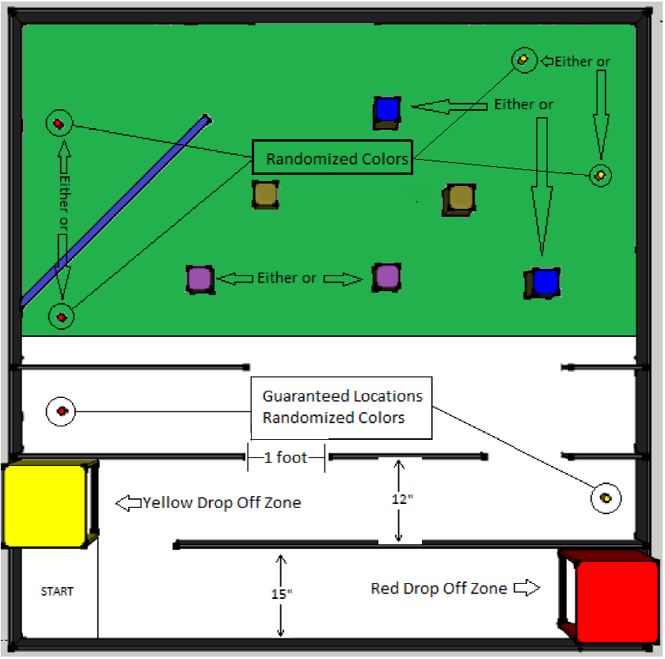

**Figure 1.** April 2016, IEEE Region 5 Robotics Competition course [1].

To achieve the goal of rescuing the victims, the team is developing an autonomous robot to perform the search and rescue operation. Figure 2, below, shows the prototype build for the competition robot. At the heart of the project is the Texas Instruments Tiva C microcontroller (A), which will control the navigation of the robot and the victim retrieval, and will interface with the PIXY CMUcam5 camera (B) for image processing. The PIXY CMUcam5 has its own microcontroller that will handle the image processing and pan and tilt functions. It will communicate with the Tiva C using the  bus. The motion control subsystem (C) utilizes salvaged Roomba wheels which have a gear ratio of 25:1. The Roomba wheels have 32 pulses per revolution optical encoders mounted before the gear reduction which in turn provides 800 encoder counts to one revolution of the wheel. This provides the resolution necessary for accurate navigation. These wheels are driven by RP360-ST motors and a Freescale MC33926 dual motor driver. Navigation through the course relies on sensor feedback. The sensors providing this feedback (D) are the sharp GP2Y0A41SK0F infrared analog distance sensor and the Parallax ultrasonic “Ping” sensor. The IR sensor is used for the wall-following PID in navigating through the city portion of the course. The ultrasonic sensor will be used primarily for checking the robot’s position on the course. The position determined by the ultrasonic sensors will be compared to the position determined by encoder counts. The ultrasonic sensor will also be used to navigate in and out of the hospital drop-off zones and for obstacle avoidance. The victim retrieval subsystem (E) is composed of a RobotGeek gripper with one servo to control the gripping of the victim and an additional servo to raise and lower the victim.

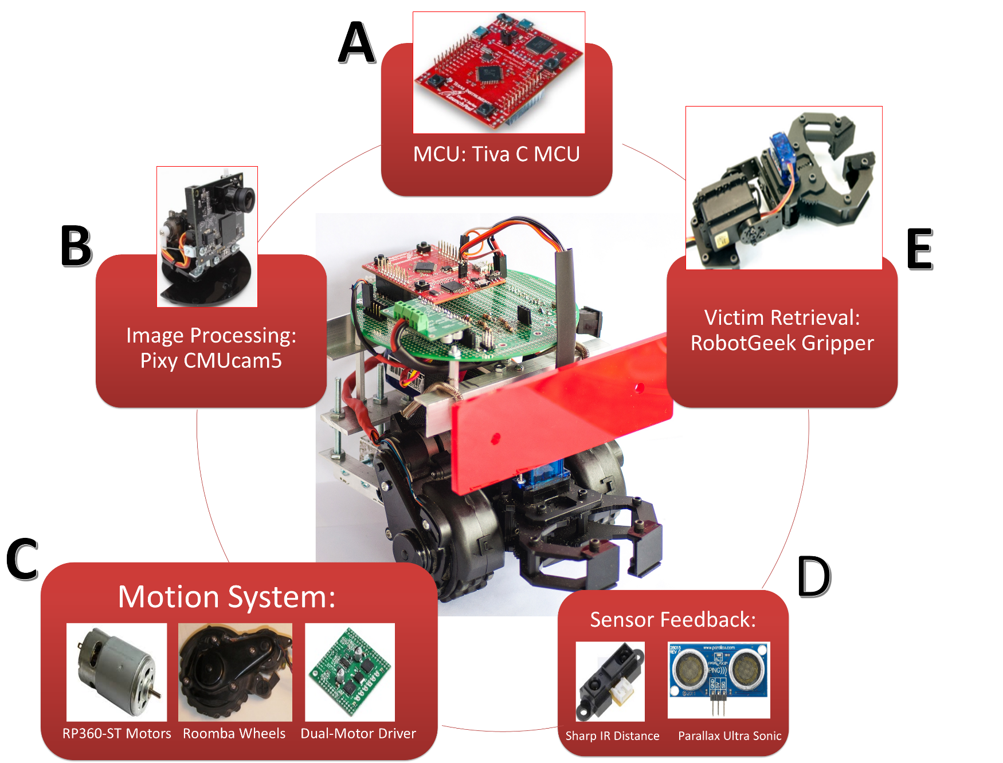

**Figure 2.** Overview diagram of the prototype robot.

## Target Objective and Goal Analysis

The final target objective is that the robot navigates the entire course, rescuing all victims. Spring 2016 the team plans to deliver a fully functional robot that can autonomously navigate the IEEE region 5 competition course. The goal diagram, in Figure 3, below, highlights the milestones necessary to achieve the target objective. The goal diagram is broken into three main subsystems: motion control, image processing and gripper control. 

**Figure 3.** Goal analysis for IEEE region 5 robotics competition robot*.* *Blue* highlighted boxes indicate goals that were completed in the Fall 2015 semester. *Green* highlighted goals are to be completed during the Spring 2016.

The Fall semester goals, highlighted in blue, have all been completed with one exception. The gripper control does not yet detect when a victim is centered in the gripper. The team had planned to use a line break sensor for this, but has not yet found a suitable sensor. Some rudimentary testing with sensors found around the lab has helped the team to eliminate some options, and narrow the choices down to either an IR line break sensor, or a short-range discrete IR distance sensor, that has a range of .5 to 5 cm. These are being ordered and, once testing has determined a successful candidate, are to be installed before the beginning of the Spring 2016 semester. The image processing and motion control systems are on track, and in fact the latter has achieved a Spring semester goal and can currently perform PID wall following ahead of schedule.

## Engineering Specifications and Constraints

The engineering specifications for this project have been selected by the team to serve as performance criteria. These specifications will be used in the testing process, for goals that require a specific operating tolerance, to determine whether or not a goal has been achieved. The constraints for this project are limitations provided by IEEE in the competition rules, for all participants of the competition.

1. Specifications
   1. Turns should be completed within +- 3 degrees of desired turn. This particular spec has currently improved from the team’s previous specification, based on the results of new encoders which provide a much higher encoder count, greatly increasing the accuracy.
   2. Robot should stop within 1 to 1.5 inches of a barrier or object. This should be sufficient room to allow for minor rotation in either direction for securing victims.
   3. PIXY camera should have at a minimum a 90% success rate for color and object recognition.
   4. PIXY camera can measure the distance of an object within a maximum of 10% error.
2. Constraints [1]
   1. Robot must be completely autonomous
   2. The only controls allowed on the robot are: a button to begin the autonomous search and rescue, and an emergency stop in case of malfunction.
   3. Robot must fit in 1 [] box
   4. Victims must be retrieved without damage to the victim or course
   5. Robot must not have any external communication of any kind during the competition, i.e. Wi-Fi, Bluetooth.

## Statement of Accomplishments

This section provides the testing approach, pass or fail criteria, and the results of the testing for the team’s Fall semester goals. To perform manual functions the robot was outfitted with a BlueSMiRF silver Bluetooth wireless device to allow UART serial communication between the Tiva C and a computer. This allows a command to be sent from any computer terminal emulator software via Bluetooth to the robots command interpreter. Successful testing of these subsystems has confirmed completion of goals set for the Fall 2015 semester.

1. Forward and reverse operation via user input
   1. Test approach

The goal of this test was to ensure the wiring of the motor circuit was correct and the software was performing the proper initialization and motor control functions. The forward and reverse commands were operated at different speeds to verify the software was appropriately adjusting the PWM duty cycle.

* 1. Test Pass/ Fail criteria

For this particular test the criteria for a passing result was the robot would correctly respond to its commands. A forward command resulted in running in the forward direction and to a reverse run command by running in reverse direction.

* 1. Test Result

The results for the forward and reverse testing were successful. The robot responded correctly to the commands every time it received them, and therefore the goal is complete.

1. Robot executes turning functions (Encoder feedback)
   1. Test approach

The goal of this test was to ensure the robot could accomplish the desired turning functions. This confirms that the encoder circuits were wired up correctly and the software is counting the encoder pulses properly. The robot was placed on a coordinate axis where the center of the wheels were positioned on the x axis and the front of the robot was positioned on the y axis. After the robot executed the turn, the angle was measured with a protractor to determine the angle of rotation.

* 1. Test Pass/ Fail criteria

The criteria for passing the test of making 90 and 180 degree turns was to execute the desired turn within +- 10 degrees.

* 1. Test Results

The results of the tests can be seen in figure 5 and 6 in the appendix. The 90 and 180 degrees turns both passed the desired criteria and are therefore completed the goal. However, during the testing, the team realized that the specification was not sufficient for our final robot. It was determined that being off by an amount that was up to 10 degrees could cause the robot to drift away significantly from the desired coordinates on the course. This finding was the driving force behind the decision to move to the salvaged iRobot Roomba wheels as they can provide 800 counts per revolution. This is a significant increase in encoder resolution as the initial encoders provided only 48 pulses per revolution. Due to the design change, the team has improved this specification to +-3 degrees based on this conclusion, new encoder testing is underway currently and should be finished before the Spring semester. Preliminary testing shows that the results of this test should be much more promising than previous trials.

1. Robot executes auto stopping (ultra-sonic sensor feedback)
   1. Test approach

The purpose of this test was to ensure that the Parallax ultra-sonic distance sensor was wired up correctly and the software is correctly interpreting the distance from the sensor to the object. The ultrasonic sensor was mounted on the front of the prototype and used for stopping to avoid collision. First, the sensor was tested manually at different distances and measured with a ruler to verify accuracy of the software timer’s that are used to measure the period of the echo return pulse width. Next, the robot was driven forward towards a black cardboard box and expected to stop before making contact with the box. The distance of the robot to the box was then measured.

* 1. Test Pass/ Fail criteria

The criteria that indicated a successful test for the ultra-sonic sensor was the robot would successfully stop within 1 to 1.5 inches from the barrier.

* 1. Test Results

The robot did stop within the specified range consistently and therefore passed this test. This confirmed that the software driver for the ultra-sonic sensor was working properly and the timers are handling the pulse command and the echo measurement back properly. Figure 7, in the appendix, shows the results from the stopping tests.

1. Robot executes PID wall following (IR sensor feedback)
   1. Test approach

The purpose of this test was to ensure that the Sharp IR sensor was wired up correctly and the software is correctly interpreting the distance from the sensor to the wall. The IR sensor was mounted on the side of the prototype and used for calculating distance error. First, the sensor was tested manually at different distances for repeatability. Next, the robot was driven forward along a wall and root-mean square error (RMS) was calculated.

* 1. Test Pass/ Fail criteria

The criteria that indicated successful wall following was that the robot did not hit the wall, even when a perturbation of ½” was created in the wall that was being followed. In addition a RMS error value of less than 20 should be maintained.

* 1. Test Results

The robot did perform wall following within the specification consistently and therefore passed this test. There were no collisions with the wall, and all RMS values were well under the requirement. This confirmed that the software driver for the IR sensor was working properly and the PID gain values were valid for keeping the robot in this range. Figure 8 and Table 1, in the appendix, show the error results for one sample of the wall following tests.

1. Pixy Recognizes Red and Yellow ‘Victim’ Objects, Blue Obstacle Objects
   1. Test approach

The goal of this test was to ensure proper color signature tracking by the imaging system. The first phase of testing did not require that the camera be mounted to the chassis. The Pixy CMUcam5 has onboard processing, which was tested using the Pixy connected to its GUI software interface. First, using red and yellow victim objects, the Pixy was taught the color signature of first red, then yellow objects. It was then made to track one signature which was panned from right to left and then left to right. This was conducted ten times with both red and yellow victim objects in various lighting conditions meant to simulate the variability in lighting one might find in a typical commercial building, such as the venue for the IEEE Region 5 Conference. Three indoor locations were chosen, as well as one outdoor location. It is uncertain how the spectrum of available light might affect the tracking ability, and testing against natural light might provide some insight into the cameras ability to differentiate color. This test was then repeated with the blue obstacle objects.

* 1. Test Pass/ Fail criteria

For this particular test the criteria for a passing result was that the Pixy showed successful tracking of the defined signature object. Fail criteria was determined to be the Pixy having a failure to track, or when the camera gets “lost” and is hunting the signature. This test has a tolerance of no more than 10% failure rate per color.

* 1. Test Results

It should be noted that the three Lowes part numbers specified for the red, yellow and blue colors were not available at Lowes, or Lowes online store. Efforts are being made to obtain this paint, but thus far it has proven to be fruitless. In an effort to test accurately, varying shades of each color were selected to simulate variability in paint mixing, tint, etc. The values from the four chosen shades should be averaged. The tests were conducted in five locations: Low light, 21 [lx], 3000 [kHz] to 3200 [kHz] spectrum; Low light, 11 [lx], 4000 [kHz] – 5000 [kHz] spectrum; Adequate light, 25[lx], 5000 [kHz] – 5200 [kHz]; and Natural Light, 2000 [lx] – 90000 lx], 5200 [kHz] – over 7000 [kHz]. There was some variance in the outdoor lighting condition due to intermittent cloud cover. Tests showed that in all lighting conditions, the imaging system was able to accurately track when the distances were within 1 [ft] range. Tracking was generally successful within selected tolerance for the 1[ft] to 3[ft] range; however, once the values were taken out at a range of 6 [ft], the Pixy had trouble maintaining, and sometimes acquiring a lock on the target signature. The angle that the signature was set had to be maintained for good tracking. For the robot to track accurately from any angle, a signature range might need to be defined. Further testing with the addition of a lamp, in phase two, may show more consistent results by attempting to normalize the illumination and lighting color. Phase two of this testing will take place before the Spring semester.

1. Gripper servos function from user input
   1. Test approach

The purpose of this test was to ensure that the servos were wired up correctly and the software was sending the appropriate PWM signals to open and close the gripper and raise and lower the gripper.

* 1. Test Pass/ Fail criteria

The criteria that indicated a successful test for the griper is pass or fail. When the command interpreter was sent a command to open gripper the gripper opened and when commanded to close the gripper closed. The same process was used for raise and lower functions.

* 1. Test Results

The gripper functioned as was expected and when a command was sent to the robot, the correct function was executed each time. Therefore, testing concluded with a passing result.

## Engineering Standards

This project utilizes “off the shelf” hardware, and there isn’t much in the way of engineering standards that are being applied to the robot; however, this project is largely software. The code being written for the robot is generated using the ANSI c programming standard.

## Budget

The budget for the project can be seen in Figure 4, below. The labor costs were less than what was originally projected for the Fall portion of this project. The total labor costs projected for the Fall was $46,075 and the team is currently at $33,750. The team is also significantly below the original projected material cost. The current total for the Fall is $229 and this includes all of the key expensive items.



**Figure 4**. IEEE Robotics Team 2 Budget.

## Risk and Hazard Assessment

The primary hazard associated with the robot is the use of a Lithium-Polymer (Li-Po) battery. Li-Po batteries can result in fire when mishandled. The team is taking appropriate precautions, including: only charging the battery with a UL listed charger intended for that battery, and removing the battery and keeping it in a storage case when not in service. The amount of current being drawn by the robot is very low, and does not constitute a reasonable hazard; however, battery safety precautions are being followed to ensure that there are no mishaps for which the team and/or university are liable.

# **Conclusion**

Overall, the project is going well and the team deliverable for the Fall semester is an assembled robot with functioning subsystems. The goals for motion control, image processing subsystem and gripper assembly have been met, with one exception. The sensor used to detect when a victim is in correct position for retrieval is still undergoing selection and testing, as this criteria has been redesigned. In addition to achieving the goals on schedule, the project is also well under budget. The total projected labor costs for the Fall 2015 semester was $46,075 and the team ended the semester at $33,750. The team has also managed to spend only $229 on material, including the key expensive items necessary to complete the robot. In conclusion, the project is on schedule, under budget and has a functioning, tested deliverable going into the Spring 2016 semester.

# **References**

|  |  |
| --- | --- |
| [1] | IEEE Region 5, "IEEE Region 5 Robotics Competition," 2 9 2015. [Online]. Available: http://r5conferences.org/documents/2015/09/robotics_competition-rules.pdf. [Accessed 2 9 2015]. |
| [2] | Pololu.com, "Freescale MC33926," Pololu, 2015. [Online]. Available: https://www.pololu.com/product/1212/specs. [Accessed 9 Dec 2015]. |
| [3] | Pololu.com, "Sharp GP2Y0A41SK0F," Pololu, 2015. [Online]. Available: https://www.pololu.com/product/2464. [Accessed 9 Dec 2015]. |
| [4] | Parallax, "Ping Ultrasonic Distance Sensor," Parallax, 2015. [Online]. Available: https://www.parallax.com/product/28015. [Accessed 9 Dec 2015]. |
| [5] | Trossen Robotics, "RobotGeek Gripper," Trossen Robotics, 2015. [Online]. Available: http://www.trossenrobotics.com/robotgeek-gripper. [Accessed 9 Dec 2015]. |

# **Appendices**

## **Appendix A: Motion Control Testing Data**

Figures 5 and 6 below show the results of the 90 and 180 degree turning tests. The data samples are plotted in blue and red with 1 degree error bars. It also shows the +- 10 degree tolerance ranges. Figure 7 shows the stopping distance test run. Figure 8 and Table 1 show a sample of error data from the PID wall following test.

**Figure 5**. Measured samples for 90 degree turns with 1 degree error bars

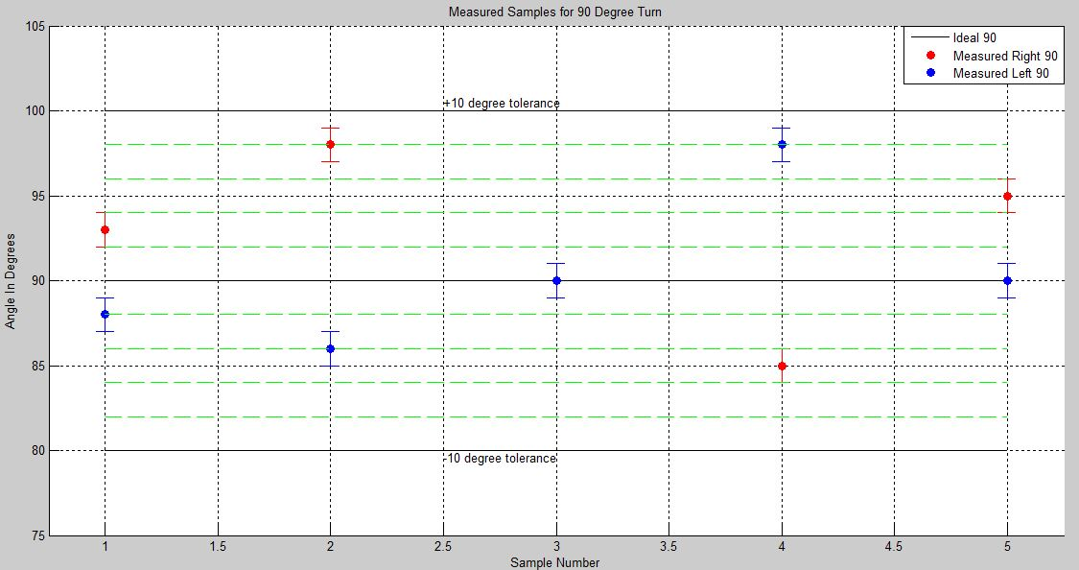

.

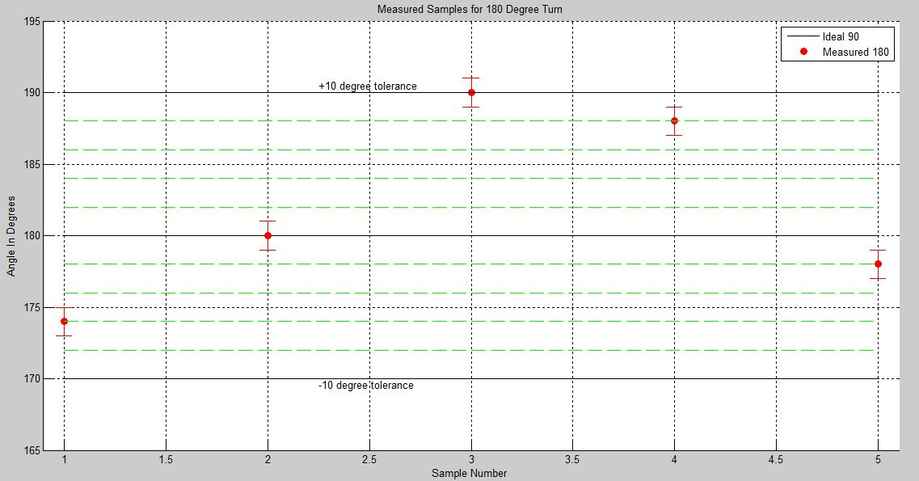

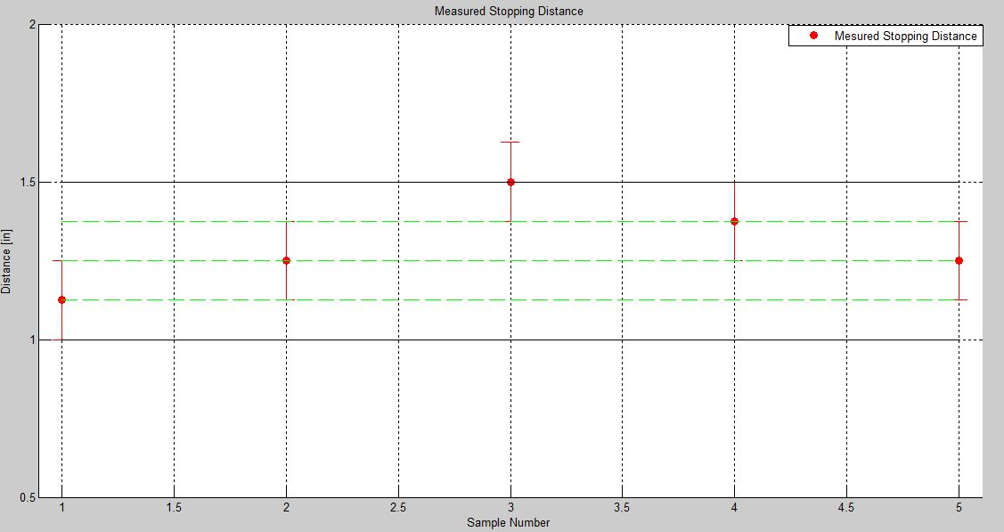**Figure 6**. Measured samples for 180 degree turns with 1 degree error bars.

**Figure 7**. Robot stopping distance, with error bars.

Table 1, below shows a sample of error data taken when testing the wall following algorithm and PID control. Error values are used to calculate the rms error. This can also be seen in Figure 8, below, with error plotted as a blue line, and rms error in red.

**Table 1**. A sample of PID wall following error values and rms error.

|  |  |  |  |  |  |  |  |  |  |  |
| --- | --- | --- | --- | --- | --- | --- | --- | --- | --- | --- |
| Error | 4 | 2 | 5 | 5 | 5 | 7 | 6 | 1 | 16 | 2 |
|  | 16 | 4 | 25 | 25 | 25 | 49 | 36 | 1 | 256 | 4 |
| Error | 10 | 18 | 8 | 9 | 8 | 13 | 32 | 0 | 15 | 9 |
|  | 100 | 324 | 64 | 81 | 64 | 169 | 1024 | 0 | 225 | 81 |
| RMS  value | 11.3 |  |  |  |  |  |  |  |  |  |

**Figure 8**. PID Wall Following - error values appear as the blue line, the red line indicates rms error of 11.5 which is less than the specification, which is at 20.

## **Appendix B: Pixy CMUcam5 Imaging System**

### Test plan for the Pixy CMUcam5

The purpose of this testing section is to layout the testing approach, pass or fail criteria, and the results of testing for the Pixy CMUcam5. Most of the goals are simply pass or fail criteria, while others have a specified operating range. The Pixy CMUcam5 test plan will take place in four phases, of which only one has been implemented thus far. Further testing will take place moving into the Spring 2016 semester. Tables 1 – 4, below, show the data collected during the first phase of testing with the Pixy.

1. **Pixy Recognizes Red and Yellow ‘Victim’ Objects, Blue Obstacle Objects**
   1. Test approach

The goal of this test is to ensure proper color signature tracking by the imaging system. Color and object recognition is necessary for accurate maneuvering to victim objects, and for obstacle avoidance as well. Picking up victim objects will also require coordinate precision. This all depends on the imaging systems ability to accurately track color. The first phase of testing does not require that the camera be mounted to the chassis. The Pixy CMUcam5 has onboard processing, which will be tested using the Pixy connected to its GUI software interface. First, using red and yellow victim objects, the Pixy will be taught the color signature of first red, then yellow objects. It will then be made to track one signature which will be panned from right to left and then left to right. This will be conducted ten times with both red and yellow victim objects in various lighting conditions meant to simulate the variability in lighting one might find in a typical commercial building, such as the venue for the IEEE Region 5 Conference. Three indoor locations will be chosen, as well as one outdoor location. It is uncertain how the spectrum of available light might affect the tracking ability, and testing against natural light might provide some insight into the cameras ability to differentiate color. This test will be repeated with the blue obstacle objects.

* 1. Test Pass/ Fail criteria

For this particular test the criteria for a passing result is that the Pixy shows successful tracking of the defined signature object. Fail criteria is determined to be the Pixy having a failure to track, or when the camera gets “lost” and is hunting the signature. This test has a tolerance of no more than 10% failure rate per color.

* 1. Test Result

It should be noted that the three Lowes part numbers specified for the red, yellow and blue colors were not available at Lowes, or Lowes online store. Efforts are being made to obtain this paint, but thus far it has proven to be fruitless. In an effort to test accurately, varying shades of each color were selected to simulate variability in paint mixing, tint, etc. The values from the four chosen shades should be averaged.

The tests were conducted in four locations: Low light, 21 [lx], 3000 [kHz] to 3200 [kHz] spectrum; Low light, 11 [lx], 4000 [kHz] – 5000 [kHz] spectrum; Adequate light, 25[lx], 5000 [kHz] – 5200 [kHz]; and Natural Light, 2000 [lx] – 90000 lx], 5200 [kHz] – over 7000 [kHz]. There was some variance in the outdoor lighting condition due to intermittent cloud cover and changing angle of the earth during testing.

Tests showed that in all lighting conditions, the imaging system was able to accurately track position when the distances were within 1 [ft] range. Tracking was generally within selected tolerance for the 1[ft] to 3[ft] range; however, once the values were taken out at a range of 6 [ft], the Pixy had trouble maintaining, and sometimes acquiring a lock on the target signature.

The angle that the signature was set had to be maintained for good tracking. For the robot to track accurately from any angle, a signature range might need to be defined. The reflectivity of the painted objects will also be a factor in image recognition, as is the color of the light, and its intensity.

Further testing with the addition of a lamp, in phase two, may show more consistent results by attempting to normalize the illumination and lighting color.

1. **Pixy Recognizes Red, Yellow and Blue Objects, Normalized Lighting**
   1. Test approach

The goal of this test is to explore whether adding a light to attempt to normalize lighting conditions, or light spectrum, would have any impact on test results. The second phase involves the same series of tests, with a 200 [lumen] LED lamp attached to the pixy in an attempt to normalize our lighting conditions and color spectrum available.

* 1. Test Pass/ Fail criteria

The criteria for passing the test is the same as for the phase one series of tests. Successes and failures will be recorded and plotted against the first series of tests to see if the addition of an LED lamp will affect the outcome or if it makes no difference at all on the imaging sensor color recognition.

* 1. Test Results
* Test yet to be conducted -

1. **Pixy communicates with microcontroller**
   1. Test approach

The goal of this test is to verify successful communication between the Pixy CMUcam5 and the Tiva C robot microcontroller. The third phase requires the camera be mounted on the functioning robot chassis and communication established. Communication will be tested by reading in X-Y coordinate values of stationary signatures against the data from the X-Y coordinate pins on the Tiva C. This data will be brought in via the Tiva C ADC.

* 1. Test Pass/ Fail criteria

The criteria for passing the test is accurate X-Y coordinate reporting to +/- 10% tolerance. The two sets of data will be plotted against each other to determine deviation, lag-time and other visible phenomenon.

* 1. Test Results
* Test yet to be conducted -

1. **Robot Recognizes Red and Yellow Objects, Blue Obstacle Objects**
   1. Test approach

The goal of this test is, once successful communication has been verified, to ensure the ability of the robot to make tracking decisions based on color signature. This will be tested by having the robot drive toward a defined color signature. The robot tracking will be tested with all three color signatures, in a similar manner as in phase one, above, in the same Four locations. The robot will drive forward towards a color signature object which will be moved from right to left and then left to right to determine the vehicle’s ability to successfully track the object and respond.

* 1. Test Pass/ Fail criteria

The criteria for passing the test is the same as for the phase one series of tests, and is also a pass/fail test with a +/- 10% tolerance. Successes and failures will be recorded and plotted against the first series of tests to see if the percentage failure rate increases with the fully assembled robot, versus the imaging system by itself. This will determine if there are problems in communication lag, and unforeseen problems that could arise as the complexity of the design increases.

* 1. Test Results
* Test yet to be conducted –

### Pixy CMUcam5: Phase One Data Collection

**Table 2**. Trial 1: Low Light, 21 [lx], 3000 [kHz] – 3200 [kHz]

|  |  |  |  |  |  |  |  |  |  |  |
| --- | --- | --- | --- | --- | --- | --- | --- | --- | --- | --- |
| **Valspar 1009-1 Oh So Red** | | | | | | | | | | |
| Distance | 1 | 2 | 3 | 4 | 5 | 6 | 7 | 8 | 9 | 10 |
| 0.5 [ft] | Pass | Pass | Pass | Pass | Pass | Pass | Pass | Pass | Pass | Pass |
| 1.0 [ft] | Pass | Pass | Pass | Pass | Pass | Pass | Pass | Pass | Pass | Pass |
| 3.0 [ft] | Pass | Pass | Pass | Pass | Pass | Pass | Pass | Pass | Pass | Pass |
| 6.0 [ft] | Pass | Pass | Pass | Fail | Pass | Pass | Pass | Pass | Pass | Pass |
| **Valspar 1009-3 Radiant Red** | | | | | | | | | | |
| Distance | 1 | 2 | 3 | 4 | 5 | 6 | 7 | 8 | 9 | 10 |
| 0.5 [ft] | Pass | Pass | Pass | Pass | Pass | Pass | Pass | Pass | Pass | Pass |
| 1.0 [ft] | Pass | Pass | Pass | Pass | Pass | Pass | Pass | Pass | Pass | Pass |
| 3.0 [ft] | Pass | Pass | Pass | Pass | Pass | Pass | Pass | Fail | Fail | Pass |
| 6.0 [ft] | Pass | Pass | Pass | Fail | Pass | Pass | Pass | Fail | Pass | Fail |
| **Valspar 1010-2 Bright Red** | | | | | | | | | | |
| Distance | 1 | 2 | 3 | 4 | 5 | 6 | 7 | 8 | 9 | 10 |
| 0.5 [ft] | Pass | Pass | Pass | Pass | Pass | Pass | Pass | Pass | Pass | Pass |
| 1.0 [ft] | Pass | Pass | Pass | Pass | Pass | Pass | Pass | Pass | Pass | Pass |
| 3.0 [ft] | Pass | Pass | Pass | Pass | Pass | Pass | Pass | Pass | Pass | Pass |
| 6.0 [ft] | Pass | Pass | Pass | Pass | Pass | Pass | Pass | Pass | Fail | Pass |
| **Valspar 2009-4 Fairmont Suite Clay Red** | | | | | | | | | | |
| Distance | 1 | 2 | 3 | 4 | 5 | 6 | 7 | 8 | 9 | 10 |
| 0.5 [ft] | Pass | Pass | Pass | Pass | Pass | Pass | Pass | Pass | Pass | Pass |
| 1.0 [ft] | Pass | Pass | Pass | Pass | Pass | Pass | Pass | Pass | Pass | Pass |
| 3.0 [ft] | Pass | Pass | Pass | Pass | Pass | Pass | Pass | Pass | Pass | Pass |
| 6.0 [ft] | Pass | Pass | Pass | Pass | Pass | Pass | Pass | Pass | Pass | Pass |
| **American Tradition 3009-2 Sunset Glow** | | | | | | | | | | |
| Distance | 1 | 2 | 3 | 4 | 5 | 6 | 7 | 8 | 9 | 10 |
| 0.5 [ft] | Pass | Pass | Pass | Pass | Pass | Pass | Pass | Pass | Pass | Pass |
| 1.0 [ft] | Pass | Pass | Pass | Pass | Pass | Pass | Pass | Pass | Pass | Pass |
| 3.0 [ft] | Pass | Fail | Pass | Pass | Fail | Pass | Pass | Pass | Pass | Pass |
| 6.0 [ft] | Pass | Fail | Fail | Pass | Fail | Pass | Fail | Fail | Pass | Fail |
| **Valspar 3010-1 Sunny Jonquil** | | | | | | | | | | |
| Distance | 1 | 2 | 3 | 4 | 5 | 6 | 7 | 8 | 9 | 10 |
| 0.5 [ft] | Pass | Pass | Pass | Pass | Pass | Pass | Pass | Pass | Pass | Pass |
| 1.0 [ft] | Pass | Pass | Pass | Pass | Pass | Pass | Fail | Pass | Fail | Pass |
| 3.0 [ft] | Pass | Pass | Pass | Pass | Pass | Pass | Pass | Fail | Pass | Pass |
| 6.0 [ft] | Fail | Pass | Pass | Fail | Pass | Pass | Pass | Fail | Pass | Fail |
| **Valspar 3010-3 Heraldic Gold** | | | | | | | | | | |
| Distance | 1 | 2 | 3 | 4 | 5 | 6 | 7 | 8 | 9 | 10 |
| 0.5 [ft] | Pass | Pass | Pass | Pass | Pass | Pass | Pass | Pass | Pass | Pass |
| 1.0 [ft] | Pass | Pass | Pass | Pass | Pass | Pass | Pass | Pass | Pass | Pass |
| 3.0 [ft] | Pass | Pass | Pass | Pass | Fail | Pass | Pass | Pass | Pass | Pass |
| 6.0 [ft] | Pass | Pass | Fail | Fail | Pass | Pass | Fail | Fail | Pass | Fail |
| **HGTV Home by Sherwin Wiliams HGSW1182 Griffin Gold** | | | | | | | | | | |
| Distance | 1 | 2 | 3 | 4 | 5 | 6 | 7 | 8 | 9 | 10 |
| 0.5 [ft] | Pass | Pass | Pass | Pass | Pass | Pass | Pass | Pass | Pass | Pass |
| 1.0 [ft] | Pass | Pass | Pass | Pass | Pass | Pass | Pass | Pass | Pass | Pass |
| 3.0 [ft] | Pass | Pass | Pass | Pass | Pass | Pass | Pass | Pass | Pass | Pass |
| 6.0 [ft] | Pass | Pass | Pass | Pass | Fail | Pass | Fail | Pass | Pass | Pass |
| **Valspar 4009-7 Indigo Cloth** | | | | | | | | | | |
| Distance | 1 | 2 | 3 | 4 | 5 | 6 | 7 | 8 | 9 | 10 |
| 0.5 [ft] | Pass | Pass | Pass | Pass | Pass | Pass | Pass | Pass | Pass | Pass |
| 1.0 [ft] | Pass | Fail | Fail | Fail | Fail | Pass | Pass | Fail | Fail | Pass |
| 3.0 [ft] | Fail | Fail | Fail | Fail | Fail | Fail | Fail | Pass | Fail | Fail |
| 6.0 [ft] | Fail | Fail | Fail | Fail | Fail | Fail | Fail | Fail | Fail | Fail |
| **Olympic B52-5 Starry Nightl** | | | | | | | | | | |
| Distance | 1 | 2 | 3 | 4 | 5 | 6 | 7 | 8 | 9 | 10 |
| 0.5 [ft] | Pass | Pass | Pass | Pass | Pass | Pass | Pass | Pass | Pass | Pass |
| 1.0 [ft] | Pass | Fail | Pass | Pass | Pass | Fail | Pass | Pass | Pass | Fail |
| 3.0 [ft] | Fail | Fail | Fail | Fail | Fail | Pass | Fail | Fail | Fail | Fail |
| 6.0 [ft] | Fail | Fail | Fail | Fail | Fail | Fail | Fail | Fail | Fail | Fail |
| **HGTV Home by Sherwin Wiliams HGSW2363 Ebb Tide** | | | | | | | | | | |
| Distance | 1 | 2 | 3 | 4 | 5 | 6 | 7 | 8 | 9 | 10 |
| 0.5 [ft] | Pass | Pass | Pass | Pass | Pass | Pass | Pass | Pass | Pass | Pass |
| 1.0 [ft] | Pass | Pass | Pass | Pass | Pass | Pass | Pass | Pass | Pass | Pass |
| 3.0 [ft] | Pass | Pass | Pass | Pass | Pass | Pass | Fail | Pass | Pass | Pass |
| 6.0 [ft] | Fail | Fail | Pass | Fail | Fail | Pass | Pass | Fail | Fail | Fail |
| **HGTV Home by Sherwin Wiliams HGSW2331 Oceanside Ble** | | | | | | | | | | |
| Distance | 1 | 2 | 3 | 4 | 5 | 6 | 7 | 8 | 9 | 10 |
| 0.5 [ft] | Pass | Pass | Pass | Pass | Pass | Pass | Pass | Pass | Pass | Pass |
| 1.0 [ft] | Pass | Pass | Pass | Pass | Fail | Pass | Pass | Fail | Pass | Pass |
| 3.0 [ft] | Pass | Pass | Pass | Pass | Pass | Fail | Pass | Pass | Pass | Pass |
| 6.0 [ft] | Fail | Fail | Pass | Pass | Pass | Fail | Fail | Fail | Pass | Pass |

**Table 3**. Trial 2: Low Light, 11 [lx], 4000 [kHz] – 5000 [kHz]

|  |  |  |  |  |  |  |  |  |  |  |
| --- | --- | --- | --- | --- | --- | --- | --- | --- | --- | --- |
| **Valspar 1009-1 Oh So Red** | | | | | | | | | | |
| Distance | 1 | 2 | 3 | 4 | 5 | 6 | 7 | 8 | 9 | 10 |
| 0.5 [ft] | Pass | Pass | Pass | Pass | Pass | Pass | Pass | Pass | Pass | Pass |
| 1.0 [ft] | Pass | Pass | Pass | Pass | Pass | Pass | Pass | Pass | Pass | Pass |
| 3.0 [ft] | Pass | Pass | Pass | Pass | Pass | Pass | Pass | Pass | Pass | Pass |
| 6.0 [ft] | Pass | Pass | Pass | Pass | Pass | Pass | Fail | Pass | Fail | Pass |
| **Valspar 1009-3 Radiant Red** | | | | | | | | | | |
| Distance | 1 | 2 | 3 | 4 | 5 | 6 | 7 | 8 | 9 | 10 |
| 0.5 [ft] | Pass | Pass | Pass | Pass | Pass | Pass | Pass | Pass | Pass | Pass |
| 1.0 [ft] | Pass | Pass | Pass | Pass | Pass | Pass | Pass | Pass | Pass | Pass |
| 3.0 [ft] | Pass | Fail | Pass | Pass | Fail | Fail | Fail | Pass | Fail | Pass |
| 6.0 [ft] | Fail | Fail | Fail | Pass | Fail | Pass | Fail | Fail | Fail | Fail |
| **Valspar 1010-2 Bright Red** | | | | | | | | | | |
| Distance | 1 | 2 | 3 | 4 | 5 | 6 | 7 | 8 | 9 | 10 |
| 0.5 [ft] | Pass | Pass | Pass | Pass | Pass | Pass | Pass | Pass | Pass | Pass |
| 1.0 [ft] | Pass | Pass | Pass | Pass | Pass | Pass | Pass | Pass | Pass | Pass |
| 3.0 [ft] | Pass | Pass | Pass | Pass | Pass | Pass | Pass | Pass | Pass | Pass |
| 6.0 [ft] | Pass | Pass | Fail | Fail | Pass | Pass | Pass | Pass | Fail | Fail |
| **Valspar 2009-4 Fairmont Suite Clay Red** | | | | | | | | | | |
| Distance | 1 | 2 | 3 | 4 | 5 | 6 | 7 | 8 | 9 | 10 |
| 0.5 [ft] | Pass | Pass | Pass | Pass | Pass | Pass | Pass | Pass | Pass | Pass |
| 1.0 [ft] | Pass | Pass | Pass | Pass | Pass | Pass | Pass | Pass | Pass | Pass |
| 3.0 [ft] | Pass | Pass | Pass | Pass | Pass | Pass | Pass | Pass | Pass | Pass |
| 6.0 [ft] | Pass | Pass | Pass | Pass | Fail | Pass | Pass | Fail | Pass | Pass |
| **American Tradition 3009-2 Sunset Glow** | | | | | | | | | | |
| Distance | 1 | 2 | 3 | 4 | 5 | 6 | 7 | 8 | 9 | 10 |
| 0.5 [ft] | Pass | Pass | Pass | Pass | Pass | Pass | Pass | Pass | Pass | Pass |
| 1.0 [ft] | Pass | Pass | Pass | Pass | Pass | Pass | Pass | Pass | Pass | Pass |
| 3.0 [ft] | Pass | Pass | Pass | Pass | Pass | Pass | Pass | Pass | Pass | Pass |
| 6.0 [ft] | Pass | Pass | Fail | Fail | Fail | Pass | Fail | Fail | Fail | Fail |
| **Valspar 3010-1 Sunny Jonquil** | | | | | | | | | | |
| Distance | 1 | 2 | 3 | 4 | 5 | 6 | 7 | 8 | 9 | 10 |
| 0.5 [ft] | Pass | Pass | Pass | Pass | Pass | Pass | Pass | Pass | Pass | Pass |
| 1.0 [ft] | Pass | Pass | Pass | Pass | Pass | Pass | Pass | Pass | Pass | Pass |
| 3.0 [ft] | Pass | Pass | Pass | Pass | Pass | Pass | Pass | Fail | Pass | Pass |
| 6.0 [ft] | Fail | Fail | Fail | Fail | Fail | Fail | Pass | Pass | Fail | Pass |
| **Valspar 3010-3 Heraldic Gold** | | | | | | | | | | |
| Distance | 1 | 2 | 3 | 4 | 5 | 6 | 7 | 8 | 9 | 10 |
| 0.5 [ft] | Pass | Pass | Pass | Pass | Pass | Pass | Pass | Pass | Pass | Pass |
| 1.0 [ft] | Pass | Pass | Pass | Pass | Fail | Pass | Pass | Pass | Fail | Pass |
| 3.0 [ft] | Pass | Fail | Fail | Fail | Pass | Fail | Fail | Fail | Fail | Fail |
| 6.0 [ft] | Fail | Fail | Fail | Fail | Fail | Fail | Fail | Fail | Fail | Fail |
| **HGTV Home by Sherwin Wiliams HGSW1182 Griffin Gold** | | | | | | | | | | |
| Distance | 1 | 2 | 3 | 4 | 5 | 6 | 7 | 8 | 9 | 10 |
| 0.5 [ft] | Pass | Pass | Pass | Pass | Pass | Pass | Pass | Pass | Pass | Pass |
| 1.0 [ft] | Pass | Pass | Pass | Pass | Pass | Pass | Pass | Pass | Pass | Pass |
| 3.0 [ft] | Pass | Pass | Pass | Pass | Pass | Pass | Pass | Pass | Pass | Pass |
| 6.0 [ft] | Pass | Pass | Fail | Fail | Fail | Fail | Pass | Fail | Pass | Pass |
| **Valspar 4009-7 Indigo Cloth** | | | | | | | | | | |
| Distance | 1 | 2 | 3 | 4 | 5 | 6 | 7 | 8 | 9 | 10 |
| 0.5 [ft] | Pass | Pass | Pass | Pass | Pass | Pass | Pass | Pass | Pass | Pass |
| 1.0 [ft] | Pass | Pass | Pass | Pass | Pass | Pass | Pass | Pass | Pass | Pass |
| 3.0 [ft] | Pass | Pass | Pass | Fail | Pass | Pass | Fail | Pass | Pass | Pass |
| 6.0 [ft] | Pass | Pass | Pass | Fail | Fail | Pass | Pass | Fail | Pass | Pass |
| **Olympic B52-5 Starry Nightl** | | | | | | | | | | |
| Distance | 1 | 2 | 3 | 4 | 5 | 6 | 7 | 8 | 9 | 10 |
| 0.5 [ft] | Pass | Pass | Pass | Pass | Pass | Pass | Pass | Pass | Pass | Pass |
| 1.0 [ft] | Pass | Pass | Pass | Pass | Pass | Pass | Pass | Pass | Pass | Pass |
| 3.0 [ft] | Pass | Pass | Pass | Pass | Pass | Pass | Pass | Pass | Pass | Pass |
| 6.0 [ft] | Fail | Fail | Fail | Fail | Fail | Pass | Pass | Fail | Fail | Fail |
| **HGTV Home by Sherwin Wiliams HGSW2363 Ebb Tide** | | | | | | | | | | |
| Distance | 1 | 2 | 3 | 4 | 5 | 6 | 7 | 8 | 9 | 10 |
| 0.5 [ft] | Pass | Pass | Pass | Pass | Pass | Pass | Pass | Pass | Pass | Pass |
| 1.0 [ft] | Pass | Pass | Pass | Pass | Pass | Pass | Pass | Pass | Pass | Pass |
| 3.0 [ft] | Pass | Pass | Pass | Pass | Pass | Pass | Pass | Pass | Pass | Pass |
| 6.0 [ft] | Pass | Pass | Pass | Pass | Pass | Pass | Pass | Pass | Pass | Fail |
| **HGTV Home by Sherwin Wiliams HGSW2331 Oceanside Ble** | | | | | | | | | | |
| Distance | 1 | 2 | 3 | 4 | 5 | 6 | 7 | 8 | 9 | 10 |
| 0.5 [ft] | Pass | Pass | Pass | Pass | Pass | Pass | Pass | Pass | Pass | Pass |
| 1.0 [ft] | Pass | Pass | Pass | Pass | Pass | Pass | Pass | Pass | Pass | Pass |
| 3.0 [ft] | Pass | Pass | Pass | Pass | Pass | Pass | Pass | Pass | Pass | Pass |
| 6.0 [ft] | Pass | Pass | Pass | Fail | Fail | Fail | Fail | Fail | Fail | Fail |

**Table 4**. Trial 3: Adequate Light, 25 [lx], 5000 [kHz] – 5200 [kHz]

|  |  |  |  |  |  |  |  |  |  |  |
| --- | --- | --- | --- | --- | --- | --- | --- | --- | --- | --- |
| **Valspar 1009-1 Oh So Red** | | | | | | | | | | |
| Distance | 1 | 2 | 3 | 4 | 5 | 6 | 7 | 8 | 9 | 10 |
| 0.5 [ft] | Pass | Pass | Pass | Pass | Pass | Pass | Pass | Pass | Pass | Pass |
| 1.0 [ft] | Pass | Pass | Pass | Pass | Pass | Pass | Pass | Pass | Pass | Pass |
| 3.0 [ft] | Pass | Pass | Pass | Pass | Pass | Pass | Pass | Pass | Pass | Pass |
| 6.0 [ft] | Pass | Pass | Pass | Pass | Pass | Pass | Pass | Pass | Pass | Pass |
| **Valspar 1009-3 Radiant Red** | | | | | | | | | | |
| Distance | 1 | 2 | 3 | 4 | 5 | 6 | 7 | 8 | 9 | 10 |
| 0.5 [ft] | Pass | Pass | Pass | Pass | Pass | Pass | Pass | Pass | Pass | Pass |
| 1.0 [ft] | Pass | Pass | Pass | Pass | Pass | Pass | Pass | Pass | Pass | Pass |
| 3.0 [ft] | Pass | Pass | Pass | Pass | Pass | Pass | Pass | Pass | Pass | Pass |
| 6.0 [ft] | Pass | Pass | Pass | Pass | Pass | Pass | Pass | Pass | Pass | Pass |
| **Valspar 1010-2 Bright Red** | | | | | | | | | | |
| Distance | 1 | 2 | 3 | 4 | 5 | 6 | 7 | 8 | 9 | 10 |
| 0.5 [ft] | Pass | Pass | Pass | Pass | Pass | Pass | Pass | Pass | Pass | Pass |
| 1.0 [ft] | Pass | Pass | Pass | Pass | Pass | Pass | Pass | Pass | Pass | Pass |
| 3.0 [ft] | Pass | Pass | Pass | Pass | Pass | Pass | Pass | Pass | Pass | Pass |
| 6.0 [ft] | Pass | Pass | Pass | Pass | Pass | Pass | Pass | Fail | Fail | Pass |
| **Valspar 2009-4 Fairmont Suite Clay Red** | | | | | | | | | | |
| Distance | 1 | 2 | 3 | 4 | 5 | 6 | 7 | 8 | 9 | 10 |
| 0.5 [ft] | Pass | Pass | Pass | Pass | Pass | Pass | Pass | Pass | Pass | Pass |
| 1.0 [ft] | Pass | Pass | Pass | Pass | Pass | Pass | Pass | Pass | Pass | Pass |
| 3.0 [ft] | Pass | Pass | Pass | Pass | Pass | Pass | Pass | Pass | Pass | Pass |
| 6.0 [ft] | Pass | Pass | Pass | Fail | Fail | Pass | Fail | Pass | Pass | Fail |
| **American Tradition 3009-2 Sunset Glow** | | | | | | | | | | |
| Distance | 1 | 2 | 3 | 4 | 5 | 6 | 7 | 8 | 9 | 10 |
| 0.5 [ft] | Pass | Pass | Pass | Pass | Pass | Pass | Pass | Pass | Pass | Pass |
| 1.0 [ft] | Pass | Pass | Pass | Pass | Pass | Pass | Pass | Pass | Pass | Pass |
| 3.0 [ft] | Pass | Pass | Pass | Pass | Pass | Pass | Pass | Pass | Pass | Pass |
| 6.0 [ft] | Pass | Pass | Pass | Pass | Pass | Pass | Pass | Pass | Pass | Pass |
| **Valspar 3010-1 Sunny Jonquil** | | | | | | | | | | |
| Distance | 1 | 2 | 3 | 4 | 5 | 6 | 7 | 8 | 9 | 10 |
| 0.5 [ft] | Pass | Pass | Pass | Pass | Pass | Pass | Pass | Pass | Pass | Pass |
| 1.0 [ft] | Pass | Pass | Pass | Pass | Pass | Pass | Pass | Pass | Pass | Pass |
| 3.0 [ft] | Pass | Pass | Pass | Pass | Pass | Pass | Pass | Pass | Pass | Pass |
| 6.0 [ft] | Pass | Pass | Pass | Pass | Pass | Pass | Pass | Pass | Pass | Pass |
| **Valspar 3010-3 Heraldic Gold** | | | | | | | | | | |
| Distance | 1 | 2 | 3 | 4 | 5 | 6 | 7 | 8 | 9 | 10 |
| 0.5 [ft] | Pass | Pass | Pass | Pass | Pass | Pass | Pass | Pass | Pass | Pass |
| 1.0 [ft] | Pass | Pass | Pass | Pass | Pass | Pass | Pass | Pass | Pass | Pass |
| 3.0 [ft] | Pass | Pass | Pass | Pass | Pass | Pass | Pass | Pass | Pass | Pass |
| 6.0 [ft] | Pass | Pass | Pass | Pass | Pass | Pass | Pass | Pass | Pass | Pass |
| **HGTV Home by Sherwin Wiliams HGSW1182 Griffin Gold** | | | | | | | | | | |
| Distance | 1 | 2 | 3 | 4 | 5 | 6 | 7 | 8 | 9 | 10 |
| 0.5 [ft] | Pass | Pass | Pass | Pass | Pass | Pass | Pass | Pass | Pass | Pass |
| 1.0 [ft] | Pass | Pass | Pass | Pass | Pass | Pass | Pass | Pass | Pass | Pass |
| 3.0 [ft] | Pass | Pass | Pass | Pass | Pass | Pass | Pass | Pass | Pass | Pass |
| 6.0 [ft] | Pass | Pass | Pass | Pass | Pass | Pass | Pass | Pass | Pass | Pass |
| **Valspar 4009-7 Indigo Cloth** | | | | | | | | | | |
| Distance | 1 | 2 | 3 | 4 | 5 | 6 | 7 | 8 | 9 | 10 |
| 0.5 [ft] | Pass | Pass | Pass | Pass | Pass | Pass | Pass | Pass | Pass | Pass |
| 1.0 [ft] | Pass | Pass | Pass | Pass | Pass | Pass | Pass | Pass | Pass | Pass |
| 3.0 [ft] | Pass | Pass | Pass | Pass | Pass | Pass | Pass | Pass | Pass | Pass |
| 6.0 [ft] | Pass | Pass | Pass | Pass | Pass | Pass | Pass | Pass | Pass | Pass |
| **Olympic B52-5 Starry Nightl** | | | | | | | | | | |
| Distance | 1 | 2 | 3 | 4 | 5 | 6 | 7 | 8 | 9 | 10 |
| 0.5 [ft] | Pass | Pass | Pass | Pass | Pass | Pass | Pass | Pass | Pass | Pass |
| 1.0 [ft] | Pass | Pass | Pass | Pass | Pass | Pass | Pass | Pass | Pass | Pass |
| 3.0 [ft] | Pass | Pass | Pass | Pass | Pass | Pass | Pass | Pass | Pass | Pass |
| 6.0 [ft] | Pass | Pass | Pass | Pass | Pass | Pass | Pass | Pass | Pass | Pass |
| **HGTV Home by Sherwin Wiliams HGSW2363 Ebb Tide** | | | | | | | | | | |
| Distance | 1 | 2 | 3 | 4 | 5 | 6 | 7 | 8 | 9 | 10 |
| 0.5 [ft] | Pass | Pass | Pass | Pass | Pass | Pass | Pass | Pass | Pass | Pass |
| 1.0 [ft] | Pass | Pass | Pass | Pass | Pass | Pass | Pass | Pass | Pass | Pass |
| 3.0 [ft] | Pass | Pass | Pass | Pass | Pass | Pass | Pass | Pass | Pass | Pass |
| 6.0 [ft] | Pass | Pass | Pass | Pass | Pass | Pass | Pass | Pass | Fail | Fail |
| **HGTV Home by Sherwin Wiliams HGSW2331 Oceanside Ble** | | | | | | | | | | |
| Distance | 1 | 2 | 3 | 4 | 5 | 6 | 7 | 8 | 9 | 10 |
| 0.5 [ft] | Pass | Pass | Pass | Pass | Pass | Pass | Pass | Pass | Pass | Pass |
| 1.0 [ft] | Pass | Pass | Pass | Pass | Pass | Pass | Pass | Pass | Pass | Pass |
| 3.0 [ft] | Pass | Pass | Pass | Pass | Pass | Pass | Pass | Pass | Pass | Pass |
| 6.0 [ft] | Pass | Pass | Pass | Fail | Fail | Pass | Fail | Fail | Fail | Fail |

**Table 5**. Trial 4: Very High Light, 2000 [lx] – 90000 [lx], 5200 [kHz] – over 7000 [kHz]

|  |  |  |  |  |  |  |  |  |  |  |
| --- | --- | --- | --- | --- | --- | --- | --- | --- | --- | --- |
| **Valspar 1009-1 Oh So Red** | | | | | | | | | | |
| Distance | 1 | 2 | 3 | 4 | 5 | 6 | 7 | 8 | 9 | 10 |
| 0.5 [ft] | Pass | Pass | Pass | Pass | Pass | Pass | Pass | Pass | Pass | Pass |
| 1.0 [ft] | Pass | Pass | Pass | Pass | Pass | Pass | Pass | Pass | Pass | Pass |
| 3.0 [ft] | Pass | Pass | Pass | Pass | Pass | Pass | Pass | Pass | Pass | Pass |
| 6.0 [ft] | Pass | Pass | Pass | Pass | Fail | Pass | Pass | Pass | Pass | Pass |
| **Valspar 1009-3 Radiant Red** | | | | | | | | | | |
| Distance | 1 | 2 | 3 | 4 | 5 | 6 | 7 | 8 | 9 | 10 |
| 0.5 [ft] | Pass | Pass | Pass | Pass | Pass | Pass | Pass | Pass | Pass | Pass |
| 1.0 [ft] | Pass | Pass | Pass | Pass | Pass | Pass | Pass | Pass | Pass | Pass |
| 3.0 [ft] | Pass | Pass | Pass | Pass | Pass | Pass | Pass | Pass | Pass | Pass |
| 6.0 [ft] | Pass | Pass | Fail | Pass | Fail | Pass | Pass | Fail | Pass | Pass |
| **Valspar 1010-2 Bright Red** | | | | | | | | | | |
| Distance | 1 | 2 | 3 | 4 | 5 | 6 | 7 | 8 | 9 | 10 |
| 0.5 [ft] | Pass | Pass | Pass | Pass | Pass | Pass | Pass | Pass | Pass | Pass |
| 1.0 [ft] | Pass | Pass | Pass | Pass | Pass | Pass | Pass | Pass | Pass | Pass |
| 3.0 [ft] | Pass | Pass | Pass | Pass | Pass | Pass | Pass | Fail | Pass | Pass |
| 6.0 [ft] | Pass | Fail | Pass | Pass | Fail | Pass | Pass | Pass | Pass | Pass |
| **Valspar 2009-4 Fairmont Suite Clay Red** | | | | | | | | | | |
| Distance | 1 | 2 | 3 | 4 | 5 | 6 | 7 | 8 | 9 | 10 |
| 0.5 [ft] | Pass | Pass | Pass | Pass | Pass | Pass | Pass | Pass | Pass | Pass |
| 1.0 [ft] | Pass | Pass | Pass | Pass | Pass | Pass | Pass | Pass | Pass | Pass |
| 3.0 [ft] | Pass | Pass | Pass | Pass | Pass | Fail | Pass | Pass | Pass | Pass |
| 6.0 [ft] | Pass | Pass | Pass | Pass | Fail | Pass | Pass | Pass | Pass | Pass |
| **American Tradition 3009-2 Sunset Glow** | | | | | | | | | | |
| Distance | 1 | 2 | 3 | 4 | 5 | 6 | 7 | 8 | 9 | 10 |
| 0.5 [ft] | Pass | Pass | Pass | Pass | Pass | Pass | Pass | Pass | Pass | Pass |
| 1.0 [ft] | Pass | Pass | Pass | Pass | Pass | Fail | Pass | Pass | Pass | Pass |
| 3.0 [ft] | Pass | Fail | Pass | Pass | Fail | Fail | Pass | Pass | Pass | Fail |
| 6.0 [ft] | Pass | Pass | Pass | Pass | Fail | Pass | Pass | Fail | Fail | Fail |
| **Valspar 3010-1 Sunny Jonquil** | | | | | | | | | | |
| Distance | 1 | 2 | 3 | 4 | 5 | 6 | 7 | 8 | 9 | 10 |
| 0.5 [ft] | Pass | Pass | Pass | Pass | Pass | Pass | Pass | Pass | Pass | Pass |
| 1.0 [ft] | Pass | Fail | Pass | Pass | Pass | Pass | Pass | Pass | Pass | Pass |
| 3.0 [ft] | Pass | Pass | Fail | Fail | Pass | Pass | Pass | Pass | Pass | Pass |
| 6.0 [ft] | Fail | Fail | Fail | Fail | Fail | Fail | Pass | Fail | Fail | Fail |
| **Valspar 3010-3 Heraldic Gold** | | | | | | | | | | |
| Distance | 1 | 2 | 3 | 4 | 5 | 6 | 7 | 8 | 9 | 10 |
| 0.5 [ft] | Pass | Pass | Pass | Pass | Pass | Pass | Pass | Pass | Pass | Pass |
| 1.0 [ft] | Pass | Fail | Pass | Pass | Pass | Pass | Pass | Pass | Pass | Pass |
| 3.0 [ft] | Pass | Pass | Pass | Pass | Pass | Pass | Fail | Fail | Pass | Pass |
| 6.0 [ft] | Fail | Fail | Fail | Pass | Fail | Pass | Pass | Pass | Pass | Pass |
| **HGTV Home by Sherwin Wiliams HGSW1182 Griffin Gold** | | | | | | | | | | |
| Distance | 1 | 2 | 3 | 4 | 5 | 6 | 7 | 8 | 9 | 10 |
| 0.5 [ft] | Pass | Pass | Pass | Pass | Pass | Pass | Pass | Pass | Pass | Pass |
| 1.0 [ft] | Pass | Pass | Pass | Pass | Pass | Pass | Pass | Pass | Pass | Pass |
| 3.0 [ft] | Pass | Pass | Pass | Pass | Pass | Pass | Pass | Pass | Pass | Pass |
| 6.0 [ft] | Pass | Pass | Pass | Pass | Pass | Pass | Pass | Pass | Pass | Pass |
| **Valspar 4009-7 Indigo Cloth** | | | | | | | | | | |
| Distance | 1 | 2 | 3 | 4 | 5 | 6 | 7 | 8 | 9 | 10 |
| 0.5 [ft] | Pass | Pass | Pass | Pass | Fail | Pass | Pass | Pass | Pass | Pass |
| 1.0 [ft] | Pass | Pass | Pass | Pass | Pass | Pass | Pass | Fail | Pass | Pass |
| 3.0 [ft] | Pass | Pass | Pass | Pass | Pass | Pass | Pass | Pass | Pass | Pass |
| 6.0 [ft] | Pass | Pass | Pass | Pass | Pass | Pass | Fail | Fail | Pass | Fail |
| **Olympic B52-5 Starry Nightl** | | | | | | | | | | |
| Distance | 1 | 2 | 3 | 4 | 5 | 6 | 7 | 8 | 9 | 10 |
| 0.5 [ft] | Pass | Pass | Pass | Pass | Pass | Pass | Fail | Pass | Pass | Pass |
| 1.0 [ft] | Pass | Pass | Pass | Pass | Pass | Pass | Pass | Fail | Fail | Pass |
| 3.0 [ft] | Pass | Pass | Pass | Pass | Pass | Pass | Pass | Pass | Pass | Pass |
| 6.0 [ft] | Pass | Fail | Pass | Pass | Pass | Pass | Pass | Pass | Pass | Pass |
| **HGTV Home by Sherwin Wiliams HGSW2363 Ebb Tide** | | | | | | | | | | |
| Distance | 1 | 2 | 3 | 4 | 5 | 6 | 7 | 8 | 9 | 10 |
| 0.5 [ft] | Pass | Pass | Pass | Pass | Pass | Pass | Pass | Pass | Pass | Pass |
| 1.0 [ft] | Pass | Pass | Pass | Pass | Pass | Pass | Pass | Pass | Pass | Pass |
| 3.0 [ft] | Pass | Pass | Fail | Pass | Pass | Pass | Pass | Pass | Pass | Pass |
| 6.0 [ft] | Pass | Pass | Pass | Pass | Pass | Pass | Pass | Fail | Fail | Pass |
| **HGTV Home by Sherwin Wiliams HGSW2331 Oceanside Blue** | | | | | | | | | | |
| Distance | 1 | 2 | 3 | 4 | 5 | 6 | 7 | 8 | 9 | 10 |
| 0.5 [ft] | Pass | Pass | Pass | Fail | Fail | Pass | Fail | Fail | Fail | Pass |
| 1.0 [ft] | Pass | Fail | Fail | Fail | Fail | Pass | Pass | Pass | Fail | Fail |
| 3.0 [ft] | Fail | Fail | Fail | Fail | Fail | Fail | Fail | Pass | Pass | Fail |
| 6.0 [ft] | Fail | Fail | Fail | Fail | Fail | Fail | Fail | Fail | Fail | Fail |

Pixy CMUcam5 Technical specs

The Pixy, seen in Figure 8, below, has on-board image processing and provides “vision as a sensor” for robotics projects requiring imaging, such as the IEEE competition.

* Processor: NXP LPC4330, 204 MHz, dual core
* Image sensor: Omnivision OV9715, 1/4", 1280x800
* Lens field-of-view: 75 degrees horizontal, 47 degrees vertical
* Lens type: standard M12 (several different types available)
* Power consumption: 140 mA typical
* Power input: USB input (5V) or unregulated input (6V to 10V)
* RAM: 264K bytes
* Flash: 1M bytes
* Available data outputs: UART serial, SPI,, USB, digital, analog

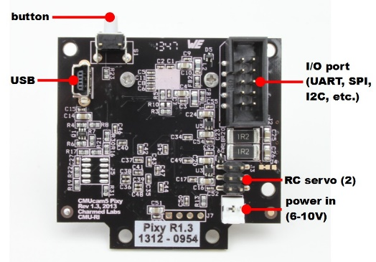

**Figure 9.** Pixy CMUcam5 Imaging Sensor

## **Appendix C: Component Specification Sheets**

The following technical specification sheets detail some of the components used in the construction of the robot.

## Freescale MC33926 General Specifications:

Figure 9, below, is the pinout diagram for the Freescale MC33926 Dual Motor Driver. This is a sizeable H-Bridge, but considering the use of 14 [V] Li-Po batteries, and the almost 1 [A] stall current of the iRobot Roomba wheels, the team felt that the extra 1.5 [A] of overhead was necessary. Table 5, below, lists the maximum voltages and currents that this motor driver can handle. As shown here, 14 [V] and 1 [A] are well within range. Figure 10, below, shows the MC33926 wiring diagram. [2]

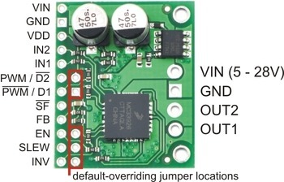

**Figure 10**. Freescale MC33926 Dual Motor Driver

**Table 6**. General specifications for the Freescale MC33926 Dual Motor Driver. An H-Bridge of this size was necessary considering the almost 1A stall current of the Standard Motors RP-360ST/15260

|  |  |
| --- | --- |
| Motor driver: | MC33926 |
| Motor channels: | 1 |
| Minimum operating voltage: | 5 V[**2**](https://www.pololu.com/product/1212/specs#note2) |
| Maximum operating voltage: | 28 V[**3**](https://www.pololu.com/product/1212/specs#note3) |
| Continuous output current per channel: | 2.5 A[**4**](https://www.pololu.com/product/1212/specs#note4) |
| Peak output current per channel: | 5 A |
| Current sense: | 0.525 V/A |
| Maximum PWM frequency: | 20 kHz[**5**](https://www.pololu.com/product/1212/specs#note5) |
| Minimum logic voltage: | 2.5 V[**6**](https://www.pololu.com/product/1212/specs#note6) |
| Maximum logic voltage: | 5.5 V |
| Reverse voltage protection?: | Y[**7**](https://www.pololu.com/product/1212/specs#note7) |

**1** Without included hardware.

**2** Operation from 5 V to 8 V reduces maximum current output.

**3** The device is protected for transients up to 40 V.

**4** Can be improved by addition of heat sink or forced air flow.

**5** SLEW pin should be HIGH for frequencies above 10 kHz.

**6** Input HIGH threshold can be as high as 2.0 V.

**7** On motor voltage only; logic voltage does not have reverse protection.

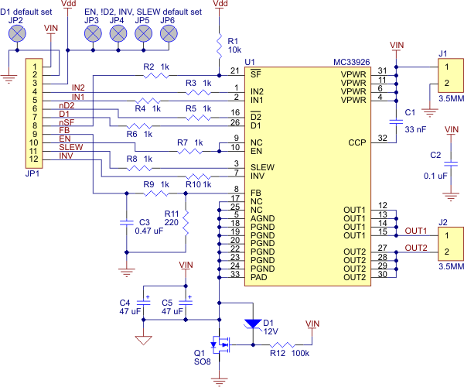

**Figure 11**. Wiring diagram for the Freescale MC 33926

## Standard Motors RP-360ST/15260:

The RP-360ST is a high rpm motor used in the iRobot Roomba wheels. Table 6, below details the motor specifications. Figure 11, below provides a detail drawing.

**Table 7**. Motor Specs for the RP-360ST

|  |  |  |  |  |  |  |  |  |  |  |  |  |  |  |  |  |  |  |  |  |  |  |  |  |  |  |  |  |  |  |  |  |  |  |  |  |  |  |  |  |
| --- | --- | --- | --- | --- | --- | --- | --- | --- | --- | --- | --- | --- | --- | --- | --- | --- | --- | --- | --- | --- | --- | --- | --- | --- | --- | --- | --- | --- | --- | --- | --- | --- | --- | --- | --- | --- | --- | --- | --- | --- |
| |  |  |  |  |  |  |  |  |  |  | | --- | --- | --- | --- | --- | --- | --- | --- | --- | --- | | No Load | | Max Efficiency | | | Max Output | | | Stall | | | Current | Speed | Current | Speed | Torque | Current | Speed | Torque | Current | Torque | | A | rpm | A | rpm | g.cm | A | rpm | g.cm | A | g.cm | | 0.055 | 7058 | 0.21 | 5602 | 52 | 0.43 | 3529 | 126 | 0.81 | 252 | |

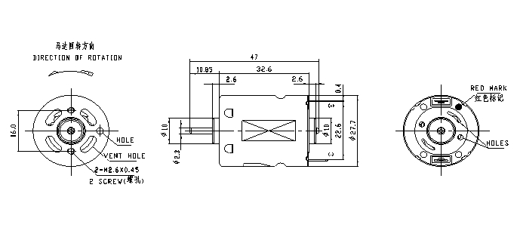

**Figure 12**. Detail of RP-360ST motor

## Sharp GP2Y0A41SK0F:

The Sharp GP2Y0A41SK0F Infrared Analog Distance sensor is a common and useful input sensor for robotics projects. They provide simple reliable control for stopping, and wall following algorithms, and as a backup to ultrasonic distance sensors. The sensor can be seen in Figure 12, below. The Sharp IR has a useable range of 4 [cm] – 30 [cm]. This can be seen in Figure 13, below. Table 7, also below, lists some specifications for the Sharp IR distance sensor. [3]

**Figure 13**. Sharp Gp2Y0A41SK0F Infrared Analog Distance Sensor.

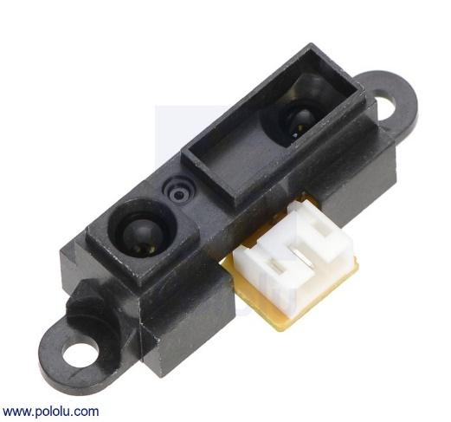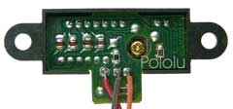

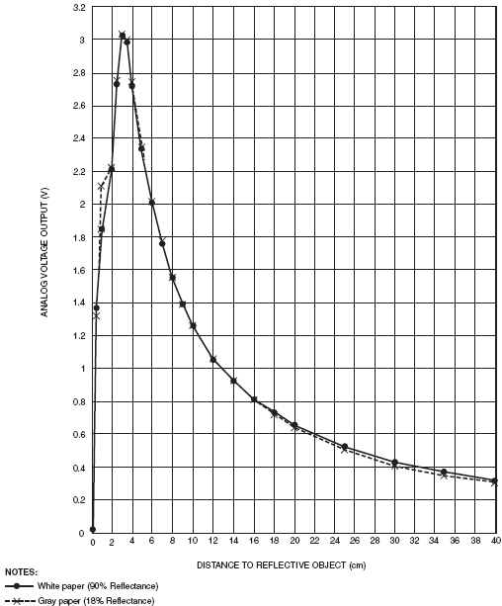

**Figure 14**. The useable range for the Sharp IR distance sensor is 4 [cm] - 30 [cm]

**Table 8**. General Specifications for Sharp GP2Y0A41SK0F Infrared Analog Distance Sensor.

|  |  |
| --- | --- |
| Maximum range: | 30 cm |
| Minimum range: | 4 cm |
| Sampling rate: | 60 Hz[**1**](https://www.pololu.com/product/2464/specs#note1) |
| Minimum operating voltage: | 4.5 V |
| Maximum operating voltage: | 5.5 V |
| Supply current: | 12 mA[**2**](https://www.pololu.com/product/2464/specs#note2) |
| Output type: | analog voltage |
| Output voltage differential: | 2.3 V |

**1** Typical; can be as low as 50 Hz.

**2** Average; this sensor draws current in large, short bursts, which is why it is recommended a 10 µF capacitor or larger be placed across power and ground close to the sensor.

## Parallax Ping Ultrasonic Sensor:

The Parallax Ping is an ultrasonic distance sensor that is accurate up to 3 [m]. Figure 14, below, shows the Ping sensor. General specifications are provided by Table 8, below. [4]

**Table 9**. General Specifications for Parallax Ping Ultrasonic Distance Sensor.

|  |
| --- |
| Narrow acceptance angle |
| Range: approximately 1 inch to 10 feet (2 cm to 3 m) |
| 3-pin male header with 0.1" spacing |
| Power requirements: +5 VDC; 35 mA active |
| Communication: positive TTL pulse |
| Dimensions: 0.81 x 1.8 x 0.6 in (22 x 46 x 16 mm) |
| Operating temperature range: +32 to +158 °F (0 to +70 °C) |

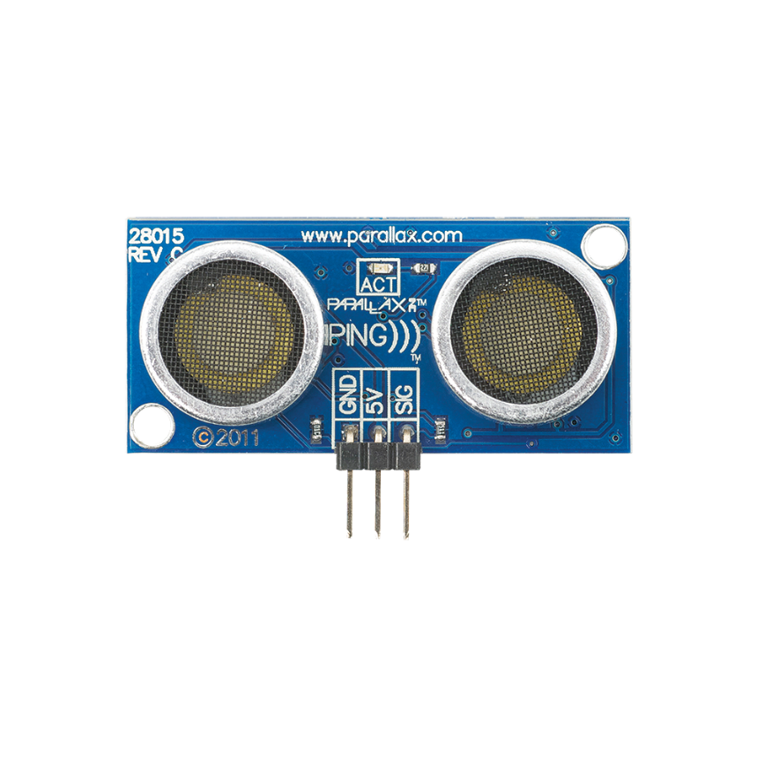

**Figure 15**. Parallax Ping Ultrasonic Distance Sensor

## Texas Instruments Tiva C TM4C123GH6PM:

The TI Tiva C has extensive documentation online at Texas Instruments website. Figure 15, below, shows some details for the evaluation kits being used to control this robot. The Tiva C provides a fast, responsive platform for the robot. Table 9, below lists some of the general specifications and features of this controller.

**Table 10**. General Specifications for the Texas Instruments Tiva C TM4C123GH6PM

|  |
| --- |
| 80MHz 32-bit ARM Cortex-M4F CPU |
| 256KB Flash, 32KB SRAM, 2KB EEPROM |
| Two Controller Area Network (CAN) modules |
| USB 2.0 Host/Device/OTG + PHY |
| Dual 12-bit 2MSPS ADCs, motion control PWMs |
| 8 UART, 6 I2C, 4 SPI |



**Figure 16**. Texas Instruments Tiva C TM4C123GH6PM Microcontroller

## RobotGeek Gripper:

The RobotGeek Gripper is the victim retrieval subsystem for the robot. Figure 16, below, is an overhead shot of the grip. Tables 10 - 12, below lists some of the general specifications for the gripper. [5]

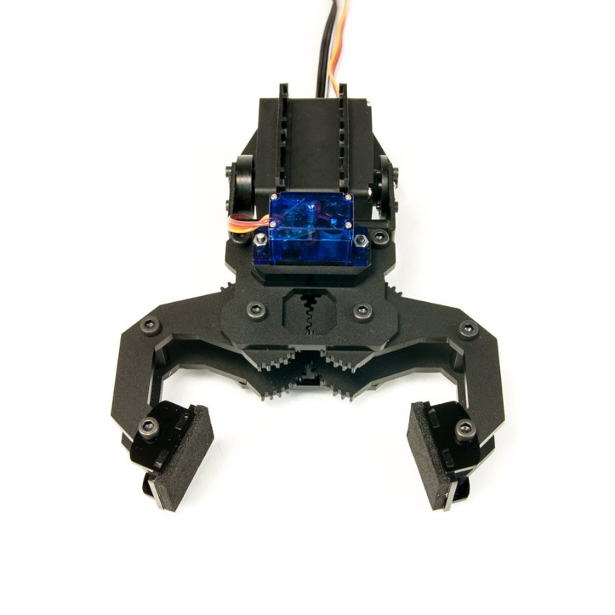

**Figure 17**. RobotGeek Gripper for victim retrieval.

**Table 11**. RobotGeek Gripper General Specifications

|  |  |
| --- | --- |
| Weight With Servo | 150g |
| Weight without Servo | 74g |
| Full Open | 6cm |
| Full Close | 0cm |
| Gripping strength | 50g Lifting Capacity |

**Table 12**. RobotGeek Gripper FS90MG Servo Specifications

|  |  |
| --- | --- |
| Operating Voltage | 6v |
| No-load Speed | 0.10sec/60degree |
| Stall Torque | 1.8 kg·cm / 25.04 oz·in |
| Operating Angle | 180° |
| Weight | 14g |
| Size | 23.2 × 12.5 × 22 m |
| Control Protocol | PWM |
| Cable Length | 250mm |
| Material | Plastic Body and Metal Gears |

**Table 13**. RobotGeek Gripper RG-SRV180 General Specifications

|  |  |
| --- | --- |
| Operating Voltage | 6v |
| Stall Torque | 8.5 kg·cm / 118.2 oz·in |
| No-load Speed | 43 RPM; 0.23 seconds/60° |
| Operating Angle | 180° |
| Weight | 60g |
| Size | 30 x 45 x 51 mm |
| Stall Current | 900 mA |
| Standby/No Load Current | 150 mA |
| Control Protocol | PWM |
| Cable Length | 270mm |
| Material | Plastic Body and Metal Gears |