Cougar Village

4385 Wheeler St.

Houston, TX 77004

8 December 2015

University of Houston

4800 Calhoun Rd.

Houston, TX 77004

Dr. Trombetta:

The Cube Satellite Solar Orient team successfully developed a less costly solar orientation system to replace the ones in current cube satellites in the hopes of making space exploration more economical for broadening our scientific knowledge. The report will review the deliverables of the project as well as provide an overview diagram displaying the components of the final product. The specifications and constraints are extensively documented. The goal analysis will be presented along with the test plan, budget, and the conclusions will follow. Currently, the team is ready to provide a demonstration of its solar orientation system, proving that the CubeSat can indeed accept light input from its solar panels, determine from the data the position of the light source, and then orient itself to face the light source.

Sincerely,

Abby Zinecker

Julia London

Tiffany Yao

CubeSat Solar Orient

Final Report

December 14, 2015

Team Members

Abby Zinecker

Julia London

Tiffany Yao

Advisors

Dr. Glover – Software Advisor

Dr. Provence – Controls Advisor

Dr. Trombetta – Project Advisor

Abstract
This report provides a final overview of the CubeSat Solar Orient’s accomplishments. The project’s purpose is to develop a less costly solar orientation system, significantly saving thousands of dollars in the cost of space orientation systems and allowing researchers to allocate the saved funds to other aspects of space research. Those who will use the new system must have a basic understanding of how to interface with computers. The main specification of the project is the ability to align the CubeSat with the sun within a tolerance of ±3 degrees. The volume of the CubeSat for containing the sun sensor components, keeping the total cost of parts below $100, the size and weight of the components for gimbal movement, and the surface area of the cube’s faces for solar panel mounting are all constraints. All the tasks in the goal analysis for the first semester were accomplished. The CubeSat can read light data, for the processor accepts the light sensor data and relates the data to the light’s position. The motors receive the position through wireless communication and aligns the CubeSat with the sun (light source). Engineering standards for wireless communication and C programming language were utilized. Although the cost of labor and the total cost of materials were more than projected, the cost for all parts actually involved in the final deliverable sun sensor (excluding the motors, gimbal, and CubeSat model itself) was under $100. The risks that may stand in the way of completing the project in time are the breakdown of wireless communication with the failure of the Xbees, not delivering sufficient power to the system, and the instability of the gimbal. Should such setbacks occur, the team plans to bypass the wireless communication by directly wiring the components for direct communication, using different power sources to deliver sufficient current to the system, and adding support to the unsupported side of the CubeSat to stabilize the gimbal. The project was successful in orienting the CubeSat to towards the light, although delivering insufficient power to the system to enable wireless communication with the motors remain an issue. The team will continue to fix this issue next semester alongside adding magnetic field detection (simulating earth).

Purpose and Background
The purpose of this project is to economize space vehicle orientation for CubeSat use. CubeSats are small satellites that are used primarily for space research. They are composed of one or more cube units with dimensions of about 10x10x10 [cm] and weigh typically no more than 1.33 [kg] per unit. Their small design allows them to be launched into space as secondary payloads or to be released by the International Space Station after being carried to the station via a cargo spacecraft. Attitude, or orientation, is essential in CubeSat operation. However, current solar orientation systems used in CubeSats are still very expensive, so adopting more affordable technology with the same reliability will help researchers to allocate more money and resources for improving other aspects of CubeSat design. This allows us to go further in learning about our solar system and broadening our scientific knowledge, with space exploration becoming easier and more economical.
This CubeSat Solar Orientation system is built using a microcontroller, the processing component of the deliverable, which is housed within the CubeSat. In space, the CubeSat would control itself using flywheels or possibly small thrusters, but because of our gravity on earth, we require the use of a motorized gimbal. Following instructions from a program uploaded to the microcontroller to sense and search for light, the gimbal will orient the CubeSat’s attitude to optimize the amount of light facing it, aligning with the sun (or some other source of light, as during testing.) The program will also allow the CubeSat to save the various locations of its orientations and to communicate wirelessly both with a laptop and with the servomotors mounted in the gimbal that will turn to move the CubeSat.
Problem, Need, and Significance
Currently, CubeSat attitude determination is very expensive. Sun and star trackers designed for this purpose can cost up to $70,000. This team believes attitude determination for CubeSats can be made for less than $100. This would save researchers thousands of dollars and enable them to focus on other equipment.

User Analysis
To use the CubeSat project, the user must have a basic understanding of computer interfacing in order to interact with the program made to control the CubeSat using premade commands. Computer interfacing requires knowledge of how to use a keyboard, mouse, and familiarity with opening and closing programs. Understanding how to select functions and click buttons within a computer program is also necessary.
Overview Diagram
This diagram shows all the components that fit into the design, function, and structure of the CubeSat model. The CubeSat is mounted in the center of the gimbal, a frame that simulates free-form movement in zero gravity on earth. Solar panels attached to the faces send their voltage readings to the Tiva C Microcontroller sitting inside. Arduino Pro Minis on each ring of the gimbal wirelessly receive instructions from the Tiva C to direct the position of the servo motors and thereby move the gimbal. The Xbee and the Bluesmirf are devices used to transmit data wirelessly between the CubeSat, the motors, and the laptop (simulating earth).

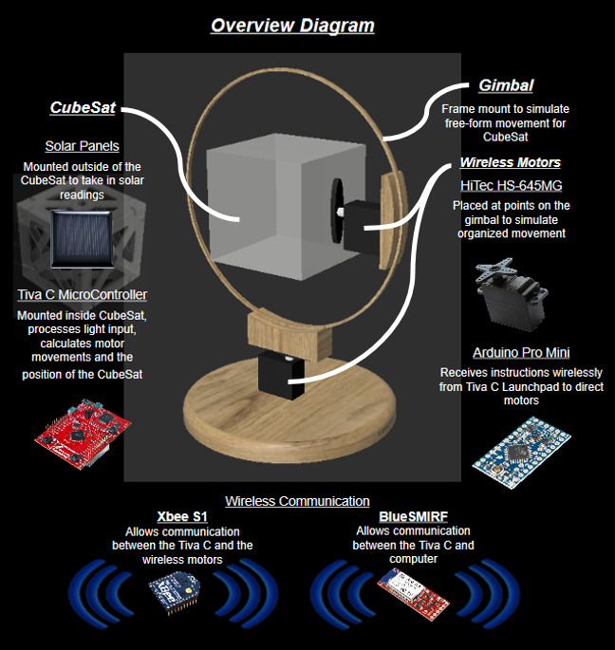
Figure 1 - The overview diagram shows all the structural and electrical components of the CubeSat
Target Objective and Goal Analysis
The CubeSat will align with the sun (a light source) and the earth (a magnetic field) by communicating with a laptop and motors that control its motion.
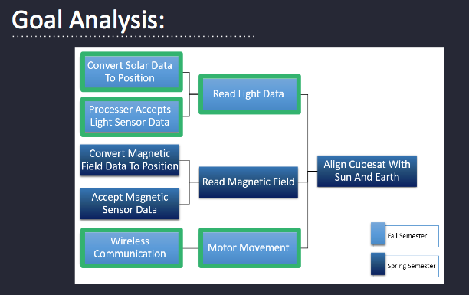
Figure 2 - The goal analysis gives a breakdown of all the tasks that must be accomplished to fulfill the target objective
Engineering Specifications and Constraints
Specifications:
- Align CubeSat with sun: The CubeSat must be able to align its solar panels to a light source with an accuracy of ±3 degrees in order to match the accuracy of current sun sensors [1]. To do this, the CubeSat must have controlled angular movement around the x and y axes to simulate the zero gravity environment found in space. Since a CubeSat will be far away from external power and control, it must be enabled with wireless communication with earth and with its own internal systems for both attitude determination and control.
- Read light data: Once the light sensor data is accepted by the microcontroller, it must relate that data to the position. Then, the CubeSat will turn to that position, facing the light source head on.
- Motor movement: There are two motors mounted on the gimbal to control the x and y axes. This simulates the zero gravity of space by allowing free movement in two angular directions. The motors have to be small and lightweight so as to not interfere with smooth movement of the gimbal. They must provide enough power to rotate the CubeSat at a slow angular velocity so as to not interfere with light reading collection. The motors must have an accuracy of ±1 degree to be consistent with the accuracy of current attitude control methods [1].
- Wireless communication: The launchpad must be able to communicate wirelessly via bluetooth to a laptop and to each Xbee for each motor mounted on the two gimbal axes. Communication must be wireless to the motors and laptop because otherwise the wires could get caught in the gimbal; a secondary reason it must be wireless to the laptop is because in this case the laptop represents mission control down on earth and the commands from earth must obviously be given from afar.
- Processor accepts light sensor data: Solar panels will act as light sensors. They must be located on the outside of the CubeSat to detect light intensity and communicate that data with the microcontroller on a readable scale. The sensors should be able to collect data on command from a laptop or continuously. Because the solar panels are fixed to the outside faces and wires connecting to the microcontroller within the CubeSat would not get caught in the gimbal, the panels need not be wireless.
- Convert solar data to position: Sample light sensor data for three sensors must be converted to a position such that the CubeSat would be facing the light source. Therefore, a readable scale of light intensity must indicate whether the sensor is facing the light source or not and at what angle it is off by. The microcontroller must have the computational power and space to do these calculations quickly and remotely.
Constraints
The budget is the main constraint for this project since the purpose of this project is to make attitude detection more economical for CubeSats. The cost for all parts involved in the sun sensor including testing (excluding the motors, gimbal, and CubeSat model itself) should be kept under $100. Since this cannot be tested in space due to budget constraints, zero gravity and free movement will be simulated with a 3-dimensional gimbal controlled by a motor for two axes. Solar panels are very inexpensive and small and have the ability to detect light intensity; they can therefore be used as the light sensors. The gimbal, motors and CubeSat model itself should also be kept under the combined budget of $100 for the sake of the students and the department funding. The structure of the gimbal should block solar detection as little as possible.
All parts of the sun sensor must fit inside approximately 10% the volume of the CubeSat (1000 [cm³]) to leave room for other critical subsystems. Furthermore, the CubeSat system must weigh no more than 0.5 [kg] as the typical CubeSat weighs no more than 1.33 [kg]. The solar panels must not exceed the surface area of one side of the cube (100 [cm²]). The size and weight of each motor system must be small and the rate of rotation of each motor must be slow so as to avoid instability of the gimbal when rotating. Therefore, motors are constrained by size and power to low voltage motors.
Statement of Accomplishments
The first task we were able to accomplish this semester was “Processor accepts light sensor data.” The solar panels output different voltages based on the light intensity input and transfer that output to the Tiva C. The Tiva C converts the voltages to unitless numbers which correspond to voltages in a linear fashion. By controlling how much light shines on the solar panel, the voltage output could be varied in increments of 0.1[V] between the minimum and maximum values of 0-3[V]. For each voltage output, five readings were taken through the ADC pin where the solar panel output was connected. Taking the average of the readings at each voltage value, corresponding unitless readings could be matched to the actual voltage. These corresponding values were plotted against each other, showing a linear relationship shown in the appendices Figure 1.
The next task we were able to accomplish was “Convert solar data to position.” Because light conditions and intensity may vary depending on the point source as well as ambient light, the light data was not really converted to position so much as the light data recorded at each angle. How it works is as the angle of incidence changes, the new light value is compared with the old one and the maximum is kept. This way, after all angles have been checked, the value returned is the total maximum which is attached to its corresponding angle. This was tested in a dark room with a single point source of light that did not change position. The solar panel was mounted on a servo which was used to move the panel to specific angles. Each angle was tested and was given a light reading with a small delay between angles in order to ensure that enough time is given for the data to be sent and received. This was tested 5 times and the average results including error bars of positive and negative the standard deviation can be seen in the appendices Figure 2. These results indicate a clear peak in the direction the light source was located and the angle chosen was very close for each test. We will test this several more times to ensure success in finding the same angle in each attempt.
The “Read light data” task was accomplished when the processor could accept light sensor data and convert it to a position indicating where the light is coming from. That position is recorded as the location of highest light intensity and is saved in the program for later use in directing the servo motors of the gimbal to turn the CubeSat to that position. This has been tested in one dimension only in the same method as described in the previous paragraph.
“Motor Movement” is another task that was accomplished. To move the CubeSat to the desired position, servo motors attached to the axes of the gimbal receive an angle/position through electrical pulses to the signal wire. Since the team must wirelessly relay the position to the servo motor, an Arduino Pro Mini receives the position as an input through the Xbee connected to its UART port. A program uploaded to the Arduino Pro Mini successfully allows it to serially receive the position as an input and output that position to the servo motor so that it turns to the desired angle. The serial input could be sent through a wired serial connection or wirelessly between two Xbees. A range for the servos were established and defined, and the range of values was scaled in the program.
Engineering Standards
The Xbee follows the IEEE 802.15.4 standard for wireless communications. It is considered a type of wireless personal area network (WPAN) meant to address the need for replacing wires in serial communication over short distances.
The Bluesmirf follows the RN-42 Bluetooth module. Bluetooth is a standard for wireless communication that operates in the ISM band from 2.4-2.485 GHz. The ISM bands are portions of the radio spectrum reserved internationally for wireless local area networks.
The programs for both the Tiva C microcontroller and the Arduino Pro Mini are both written in the C language and adhere to ANSI C - the standards for the C programming language set by the American National Standards Institute and the International Standards Organization (ISO). Libraries of functions and APIs ensure compatibility across compilers.
Budget
The total amount of money projected to spend in this project was $5,878.45 and total amount spent on this project was $8,480.44. The total project ran over-budget by $2,601.99; however, this was due mainly because the team members worked more hours than were originally projected to complete this project. The other contributing factor was that shipping costs were not included in the projected costs. Labor costs totaled over 90% of this project’s budget. Without labor costs, the total cost of this project was $717.94, which was $104.49 more than projected due to shipping costs. The budget for this project is broken down in the appendices in Figures 3-5.
There were several pieces of equipment that were bought but could not be used, such as the DC motors and Velcro that was not as sticky as needed. Extras of several items were also purchased because of changing design of the solar orientation system.
Next semester we intend to purchase items necessary to equip the CubeSat with magnetic field detection capabilities. We estimate that the equipment plus testing supplies will cost approximately $50. Some other things may be improved upon in our current design, but we believe our current supply to be enough to make these improvements.
Risks
The biggest issue that could prevent the team from accomplishing the final target objective is possible failure in the wireless communication between the Tiva C microcontroller and the Arduino Pro Minis through the Xbee devices. Also, user reviews online corroborate that the Xbees are of a sensitive nature, prone to short circuits. If this device breaks, it takes time to order another one from the company and have it shipped and delivered. If an Xbee does not work reliably or it breaks and such an issue cannot be resolved in time, the alternate plan is to wire the output pins of the Tiva C microcontroller directly to each servo motor so that the data can be successfully transmitted to turn each of them to the desired angle/position.
Another risk the team faces is the possibility that the computer code uploaded to the Tiva C microcontroller might not work correctly to reliably move the gimbal in two dimensions. It might take longer than anticipated to debug and polish the final program. Overall, the program does successfully read in and process the light input from the solar panels. It also can calculate where the highest light reading comes from and direct the motor to face that location in one direction. If the team cannot reliably and successfully extend this capability to two dimensions, the team can demonstrate as a proof of concept that the CubeSat can indeed identify light input and rotate to face it in one direction.
Another smaller risk is that the gimbal will be unstable. The motor shafts are very thin and all the weight of the CubeSat rests on them. To nullify this risk, we may have to introduce stabilization onto the other side of the cube opposite the inner motor in the form of a counterweight. This may interfere with solar panel placement and is yet to be determined.
Conclusions
The CubeSat Solar Orient project successfully orients itself towards the light in both the x and y directions and construction of the CubeSat and gimbal was completed. The materials for building the solar orientation system remained well within budget. The main area of improvement for the team is ensuring that the electrical components are properly powered. Although the wireless communication between the Tiva C, the Arduino Pro Minis directing the servo motors, and the laptop is successful using a mix of Bluetooth and Xbee, the components require fully powered batteries in order to deliver enough current, and therefore power for this to work. In addition, powering the Tiva C requires more current and anticipated and must be connected to the computer to function properly. Next semester, the team will work to improve those areas and add magnetic field detection as a new feature to simulate earth detection.

Bibliography:
[1] Griffin, Michael D., and James R. French. "Attitude Determination and Control." Space Vehicle Design. Washington, DC: American Institute of Aeronautics and Astronautics, 1991. N. pag. Print.
Appendix A
Figure 3 shows the relationship between the voltage output from the solar panels to the light readings from the Tiva C. The relationship is very linear and has the best fit equation y = 0.8039x + 6.9759 where y is voltage and x is the light reading. This equation can be applied to any light reading made by the Tiva C to find the voltage output by the solar panel.
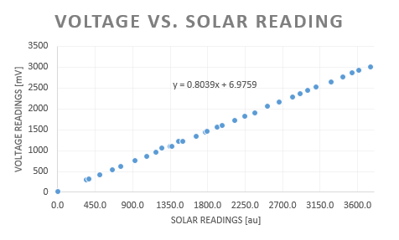
Figure 3- This plot shows the linear relationship between voltage output of the solar panel and the light readings from the Tiva C. The equation of best fit is also noted on the graph.
Appendix B
Figure 4 is a plot of the light readings (in mV) that are output depending on the angle of incidence of the light that hit the solar panel. It is clearly visible that the voltage is highly dependent on angle of incidence and has a peak where the light is perpendicular to the solar panel face.

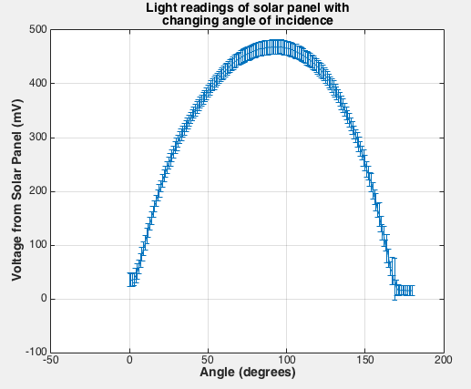
Figure 4- This is a plot of light readings as voltage from the solar panel with changing angle of incidence.

Appendix C
Figure 5 shows the total amount of money spent on labor for the project. Each team member and advisor are logged, and the projected hours of each member can be compared to the total hours actually worked for documentation.
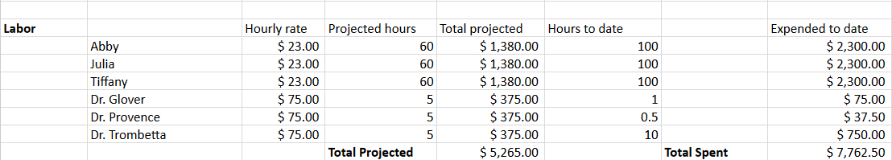
Figure 5- Above is the total amount of money projected and spent on labor for this project.

Figure 6 gives a breakdown of the total cost of the used and unused parts involved in the building of the CubeSat.
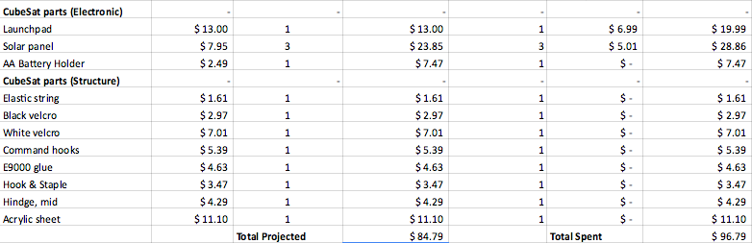
Figure 6- Above is the total amount of money projected and spent on the CubeSat for both structure and electrical for this project. This includes both used and unused parts.

Figure 7 provides a log for the cost of the used and unused parts involved in the building of the gimbal.
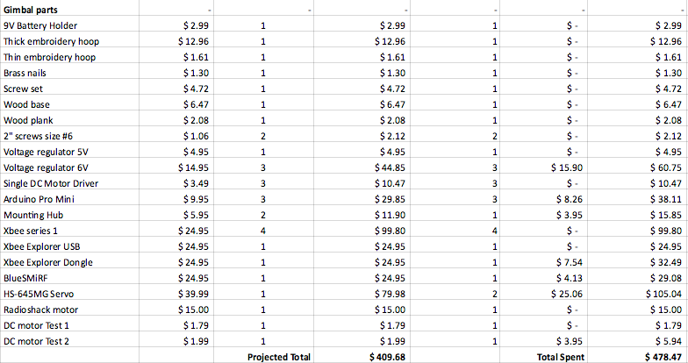
Figure 7- Above is the total amount of money projected and spent on the gimbal used in this project. This includes both used and unused products.

Figure 8 provides a log for the cost of the used and unused tools involved in the building of this project.
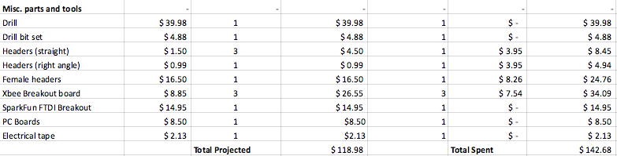
Figure 8- Above is the total amount of money projected and spent on the miscellaneous parts and tools used in this project. This includes both used and unused products.

Appendix D
The circuit schematic of the components for each of the wireless servo motors is shown in Figure 9, comprising of the Arduino Pro Mini 3.3 [V]/8 [MHz], Xbee Series 1, Step Up/Down Voltage Regulator 6[V], and a servo motor.
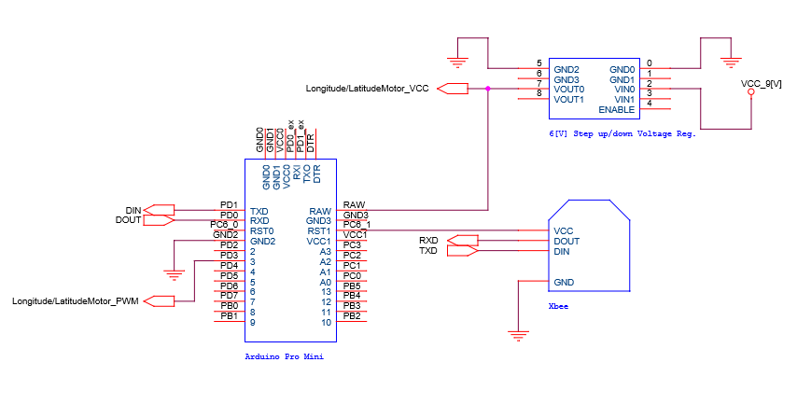
Figure 9 - The circuit schematic of the components for each of the wireless servo motors is shown.

The circuit schematic of the components for the microcontroller mounted within the CubeSat is shown in Figure 10. The microcontroller reads in light data, relates the data to the position, and passes the position and data wirelessly. The components comprise of the Tiva C microcontroller, Xbee Series 1, Step Down Voltage Regulator 5[V], a max 3[V] solar panel, and a Bluesmirf Silver.
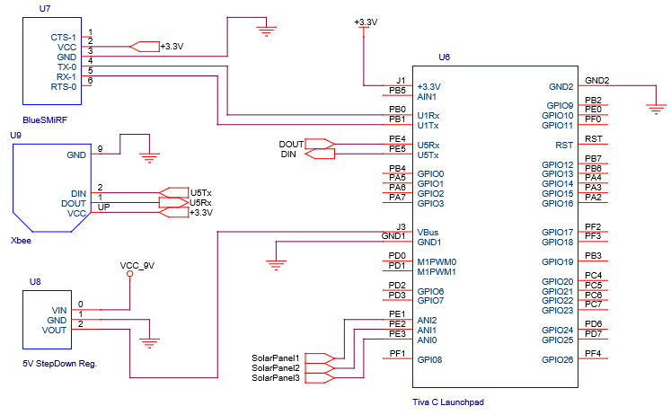
Figure 10 - The circuit schematic of the components for the microcontroller mounted within the CubeSat.

The circuit schematic for the gimbal for when the motors are wired directly to the Tiva C microcontroller can be seen in Figure 11. Everything works the same as in Figure 10, but the controlling PWM pulse is directly connected to the motor that moves the Cubesat in the longitude and latitude directions.
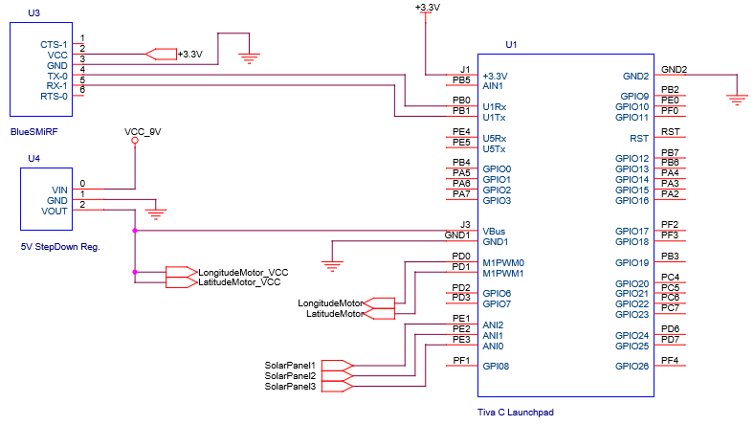
Figure 11 - The circuit schematic of the alternative set-up for directly wiring the Tiva C microcontroller to the longitude and latitude motors.

Appendix E
The flow chart visualizes what the CubeSat Orient Program does to take user input commands. The program is written in Code Composer Studio, and it executes the desired tasks of searching for light, orienting the CubeSat to the light source, and setting the user’s desired locations.
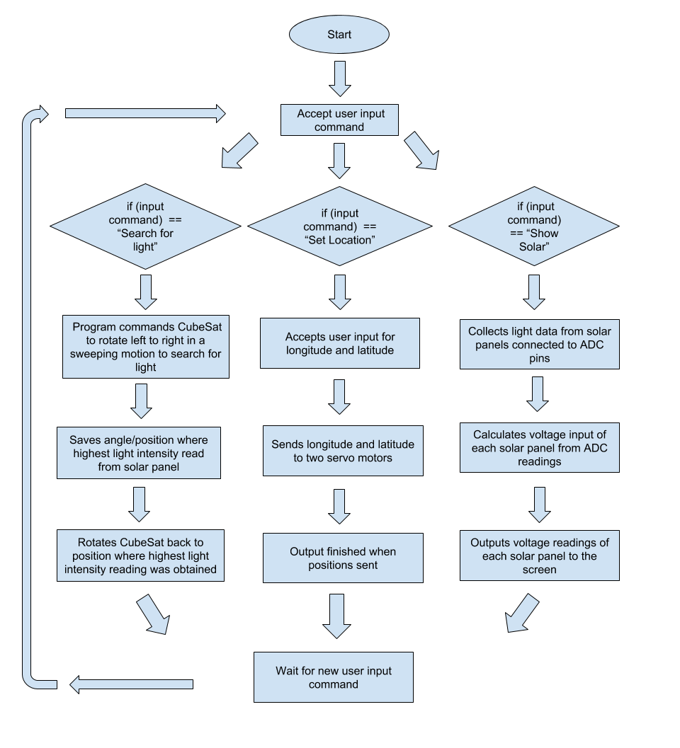
Figure 12 - The flow chart that visualizes what the CubeSat Orient Program does step-by-step.

