4800 Calhoun Road
Houston, TX 77004
May 4, 15

Jose Luis Contreras-Vidal
4800 Calhoun Road
Houston, TX 77004

Dear Dr. Contreras-Vidal:

This document outlines the current status of the pLEGS pediatric exoskeleton project, which is the result of collaboration between students from the University of Houston and Tecnologico de Monterrey. This project focuses on developing a pediatric robotic exoskeleton to be used to assist children with gait limitations due to spinal cord injury or neurological disorders. This report outlines what has been completed thus far and what remains to be completed.

We obtained data detailing the gait walking patterns of several children and averaged them into an ideal walking pattern. We programmed this walking pattern into a Tiva C microprocessor and graphed the results from the motors. Our hope for this project is to develop a mechanical design that is efficient, safe, and adaptable.

Regards,

The pLEGS team
Danny Abounasr, Mary Faltaous, Chi-Lun Chu and David Eguren
Team 1: pLEGS
Danny Abounasr, Mary Faltaous, Chi-Lun Chu and David Eguren
Spring 2015 Final Report
May 8, 2015
Project Sponsor: Dr. Contreras-Vidal

Abstract
This report outlines the advancement performed on the PLEGS project. The project focuses on developing a robotic exoskeleton that aids children with spinal cord injury in learning to walk in a way that mimics the proper gait of a child. The exoskeleton should also provide gait feedback to the therapist so that the data can be used in improving the child’s therapy. This semester’s target objective was to get the motors sequenced to the gait data. The three major objectives were completed for the implementation of the motors to the exoskeleton. First, it was imperative to drive the motors with the microcontroller, then we needed to interpret the potentiometer readings with the microcontroller, and lastly we needed to provide lower extremity range of motion with the motors. Software tests were designed in order to accomplish the driving of the motors with the microcontroller and providing the lower extremity range of motion with the motors. A hardware setup including a motor, wave-gear and potentiometer was constructed to read the analog voltages from the potentiometer. We have achieved an accuracy of 0.083% in the potentiometer readings and have implemented the gait data into the motors. The primary focus of this semester was to drive and control the motors with the proper gait data. Next semester we plan to implement various data acquisition sensors such as EMG and force sensors and focus on the impedance control of the motors while developing a working exoskeleton prototype.

Table of Contents
Abstract ii
Background and Goal 1
Problem, Need, Significance 1
User Analysis 2
Overview Diagram 3
Target Objective and Goal Analysis 4
Engineering Specifications and Constraints 7
Statement of Accomplishments 9
Engineering Standards 9
Budget 10
Conclusion 11
Appendix A 12
Appendix B 13
Works Cited 15

Figures
Figure 1: Overview diagram for pediatric exoskeleton. 3
Figure 2: Goal analysis chart for Spring 2015 semester 4
Figure 3: The results for the Motors Provide Lower Extremity Range of Motion 5
Figure 4: Motor output of gait data for the hip joint 6
Figure 5: Motor output of gait data for the knee joint 6
Figure 6: Motor output of gait data for the ankle joint 7
Figure 7: TI Tiva-C microcontroller pin out. 12
Figure 8: Logic diagram for motor 12

Tables
Table 1: Identified hazards list for safety tests 7
Table 2: Safety testing worksheet 8
Table 3: Adjustability ranges for exoskeleton 9
Table 4: Pediatric exoskeleton budget (Spring 2015) 11
Table 5: Electrical Hazards (a) safety sheet 13
Table 6: Electrical Hazards (b) safety sheet 13
Table 7: Testing Related Injury safety sheet 13
Table 8: Falling/Tripping when running on battery power safety sheet 14
Table 9: Burns safety sheet 14
Table 10: Electric Potential safety sheet 14
Table 11: Under-voltage of individual battery safety sheet 15
Table 12: Overheating safety sheet 15

Background and Goal
The purpose of this document is to present the progress that has been made on the pediatric exoskeleton device during the Spring 2015 semester. The final target objective for the semester is to have an exoskeleton prototype on which the motors at each joint (hip, knee and ankle) perform the correct gait sequence. This is a foundational step in creating a functional prototype that can be used with various sensors to provide a rehabilitation device for children with gait limitations due to spinal cord injuries, or other medical prognoses that limit a child’s seamless gait pattern.
This document contains information regarding the target population, tests and corresponding results on the implementation of the gait data into the motors, and the methods used to implement the gait data. It also contains various figures including the semester objectives, an overview diagram of the components currently being used in the system, and a project budget.
The pediatric exoskeleton project is supported by the University of Houston Laboratory for Noninvasive Brain-Machine Interface Systems and its director Jose L. Contreras-Vidal, Ph.D. This project is a coordinated effort between students at the University of Houston as well as students in Monterrey, Mexico at the Tecnológico de Monterrey that are tasked with updating the mechanical design of the system, creating IRB protocol for Electromyography (EMG) data collection, and assisting with EMG data collection and processing. Other notable individuals involved with the project include the project coordinator, Jeff Gorges, as well as University of Houston Masters degree students Sri Ranga Prasad Maddi and Justin Brantley that have provided technical assistance.

Problem, Need, Significance
Pediatric spinal cord injury (SCI) affects approximately 500 children under the age of 15 every year. A spinal cord injury resulting in paralysis can bring about important negative psychological and physiological consequences for the child and child’s family. The lifetime average cost of care for an individual with lower limb paralysis can reach up to three million dollars. Also, if the injury occurs during the early stages of the skeletal development in the child there is a high chance that scoliosis will occur [1].
There are currently no exoskeleton rehabilitation devices designed specifically for children. Our group’s hope for this project is that the device will be used to assist a child in his/her recovery from a spinal cord injury, and that it might alleviate some of the negative consequences previously mentioned.

User Analysis
The target population for this system is children 4-8 years old, ranging from the 5th percentile of 4 year-olds up to the 95th percentile of 8 year-olds. The system is designed based on the physical needs of children with incomplete SCI with an American Spinal Injury Association (ASIA) grade of B-D for SCI and the injury location at lumbar vertebra 2 (L2) and below. The system is adjustable to accommodate children between the heights of 3’0” and 4’6” and it is capable of withstanding a maximum weight of 77 lbs. The system is not designed to be self-balancing. If a child is unable to balance him or her self, then crutches or a walker will need to be used [2]. A medical professional should accompany the user during the rehabilitation sessions. The medical assistant should be familiar with how the device operates, but it is not assumed the child will have had any previous experience using the device. The system will have an interface that includes control of initiating and stopping the walking sequence. It will also have a preprogrammed sequence for moving from a seated to a standing position and vice versa.

Overview Diagram
Figure 1 shows the overview diagram for the system. It includes items such as the motor control boards, motors and the power supply. The photographs including the young boy and woman are meant to indicate that this project utilizes ideas and technology from exoskeleton devices for adults in an attempt to create a pediatric specific system.
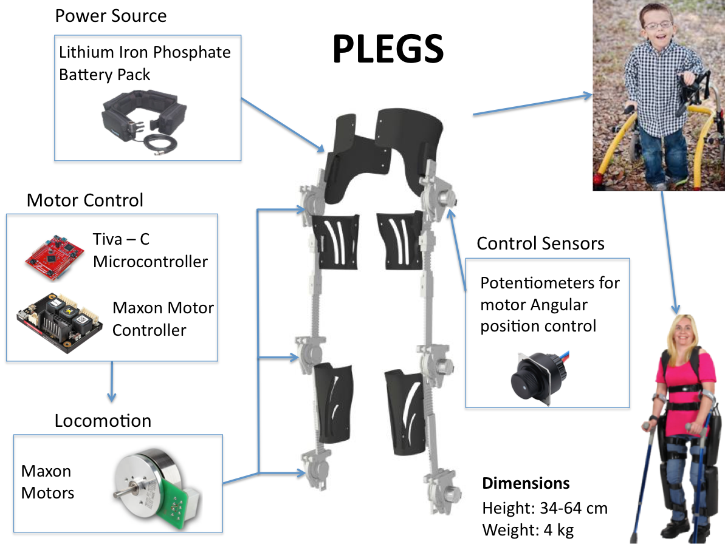
Figure 1: Overview diagram for pediatric exoskeleton.

Target Objective and Goal Analysis
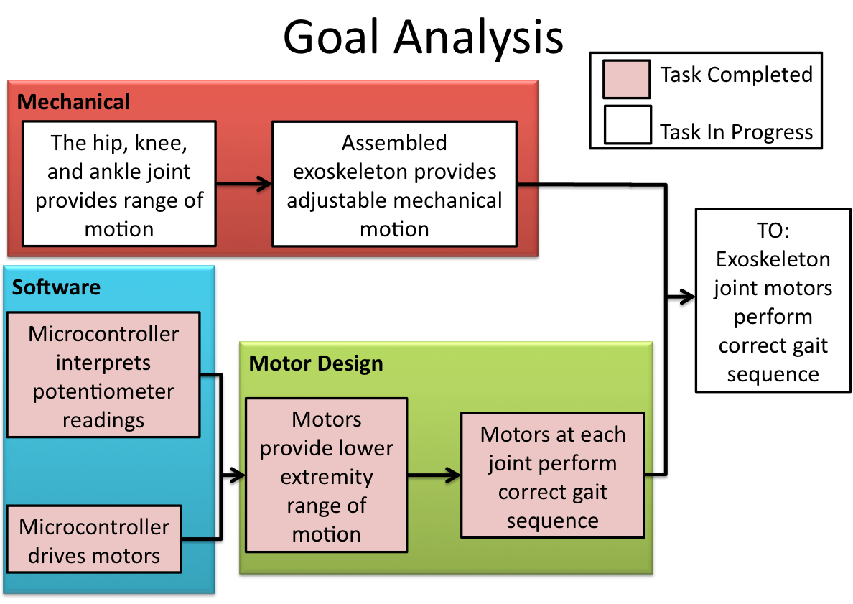
Figure 2: Goal analysis chart for Spring 2015 semester
As can be seen in Figure 2 above, the target objective for the fall 2015 semester was to have an exoskeleton prototype with which the motors performed the correct gait sequence at each of the joints. In order to accomplish this objective, the project was separated into three different categories (software, motor design, and mechanical). Our team members in Monterrey performed the mechanical design updates; therefore this section will focus primarily on the other two categories. The gait data used throughout this project was taken from a clinical gait analysis study entitled "Normalized Regressions of Kinematics & Kinetics for Children" [3].
The software category is comprised of two objectives related to the Tiva-C microcontroller. The first is that the potentiometer values would be accurately read, and the second is the motors would be driven by the microcontroller. The voltage values from the potentiometer were measured with an oscilloscope and were compared to the values read by the microcontroller. We found that the values were accurate within 0.083%.
The second category of objectives is motor design. This category includes two objectives which are the motor providing the lower extremity range of motion and the correct gait sequence at each joint. To complete the motor provides the lower extremity range of motion task, programming the gait pattern into the microprocessor was required. We first translated the gait data into voltage readings. The results are shown below in Figure 3. We set an upper limit (red line) of 3700 [mV] and a lower limit (green line) of 2300 [mV] to check if the motors would pass beyond the range of the Knee gait data. We also verified that the first peak was within 200 [mV] of the original position, and the higher peak was within 1100 [mV] of the same position. We were able to prove that the motors could follow the data points without extending beyond the set range.

Figure 3: The results for the Motors Provide Lower Extremity Range of Motion
Once the motors were programmed, we tested the accuracy of the gait sequence by graphing the output of the motor data alongside the original gait data. Initially, overshoot issues were experienced at high motor revolutions per minute, but the used of a PID controller allowed the motors to be accurately tuned to match the gait data. Figure 4, Figure 5, and Figure 6 below, display the motor output for the objective “motors display correct gait sequence at each joint”, graphing the change in angle over time, for the hip, knee, and ankle respectively. The graphs are taken from a series of 30 test trials and display the standard deviation that was received as a result of these trials.

Figure 4: Motor output of gait data for the hip joint

Figure 5: Motor output of gait data for the knee joint

Figure 6: Motor output of gait data for the ankle joint

Engineering Specifications and Constraints
Due to the medical nature of this device, and the rehabilitation subjects will be children, the primary constraint for this project is safety. Various safety tests for the system have been outlined and are mentioned in the following paragraph. Other constraints for this project include both the size and weight of the system.
The model for the safety tests that will be performed is a risk mitigation report created for the NASA X1 exoskeleton. In this report various potential hazards are identified along with probable causes and possible methods for control and prevention of the hazards.
Table 1 lists the identified hazards that are being considered in the system’s safety tests.
Table 1: Identified hazards list for safety tests
Hazard
1. Un-commanded Motion | 6. Burns
2. Electrical Hazards (a) | 7. Electrical Potential
3. Electrical Hazards (b) | 8. Under Voltage
4. Testing Related Injury | 9. Overheating
5. Falling/Tripping

Table 2 is an example of a hazard analysis worksheet that will be used during testing. Important features of the worksheet include: title and description of the hazard, potential causes, and possible methods of prevention. This worksheet, and the others, which can be found in Appendix B, will provide a guideline for each respective safety test.
Table 2: Safety testing worksheet
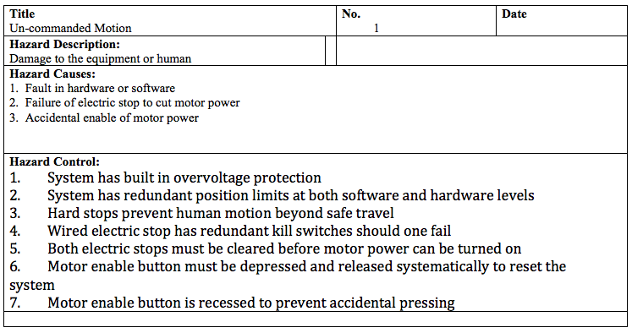
Other important safety features include limiting the range of motion through which the joint are capable of moving. This is done in software and firmware by programming limits for the motor movements, and is reinforced in the mechanical design through hard stops that provide a fail- safe should software or firmware malfunctions occur. Another important feature of the system is a full over-ride kill switch capable of cutting power to the system should any form of unanticipated event occur.
The size and weight constraints are in place in order to prevent the system from hindering the user during the rehabilitation sessions. Many exoskeletons use a backpack to house the battery and various electronics. We are attempting to move away from this idea in order to reduce the size of the system. We will be using a battery belt in which two 12 [V] batteries will be situated on each side of the hips. The weight of the batteries will be evenly distributed around the pelvic area reducing the added weight in the user upper section, thus reducing the chances of loss of balance. Weight limits for the entire system including the batteries have been set at 30% of the total weight of a child. An eight year old child that lies within the 95th percentile, will weigh on average 35 kg, limiting the system to a weigh of 10 kg [4]. Size is also limited by the target population and as listed in the user analysis the system should be able to accommodate children between the heights of 3’0” and 4’6”. Therefore the system has maximum and minimum adjustable lengths in the femoral and tibia regions shown in Table 3 below.
Table 3: Adjustability ranges for exoskeleton
 | Femur | Tibia
Maximum [cm] | 35 | 30
Minimum [cm] | 24.8 | 21.6

Statement of Accomplishments
During the fall 2015 semester, we completed all of the objectives within the software and motor design categories of the goal analysis diagram shown in the Target Objective and Goal Analysis section. In order to complete these tasks, we converted gait data from a clinical gait analysis from degrees to voltage values, and used the voltage values to program the motors to perform the correct walking sequence. We compared the motor output to the graphs of the original data and used a PID controller to tune the accuracy. We also performed a power system analysis based on force and torque data from the same gait analysis. This was done in order to make a selection for a power source. The battery has not been purchased yet, but a survey of various chemistries resulted in the selection of Lithium Iron Phosphate (LiFeSO4) for safety reasons. We did not complete our target objective due to the fact that the mechanical design has yet to be completed. When it is we will be able to attach the motors and begin the next phase of the project, which includes the incorporation of feedback sensors.

Engineering Standards

The FDA considers pediatric exoskeletons for medical use to be Class II devices. As such, a verification and validation process must be followed to ensure a successful FDA submission. To perform the verification and validation process various non-medical tests must be performed. These tests are performed as outlined in several standards. The standards that we will be focusing on are IEC 60601-1: Medical electrical equipment - Part 1: General requirements for basic safety and essential performance, IEC 60601-1-2: Medical electrical equipment - Part 1-2: General requirements for basic safety and essential performance - Collateral Standard: Electromagnetic disturbances - Requirements and tests, and ISO 7176-16: Resistance to ignition of postural support devices. These standards are used for different types of testing. IEC 60601-1 is a general standard from which the outlines the requirements for electrical testing. IEC 60601-1-2 is used for the electromagnetic testing to ensure that the exoskeleton will not be harmful to the child. Finally, ISO 7176-16 specifies requirements and test methods to assess the resistance to ignition by match flame equivalent of all postural support devices that are supplied to be part of a wheelchair or its seating system. It will be used it to test the flammability hazards associated with our exoskeleton.

Budget

At the time our team joined the project, some of the hardware had already been purchased, most notably the motors and the motor controllers. In Table 4 the items provided to our team, the items we have purchased, and those that will be purchased during the summer and fall 2015 semester, are indicated on the right hand side in the status section. The most significant purchases that remain are the wave gears and the batteries for the system. Other significant items mentioned are the labor cost, amount spent to date, and the total projected cost.
Table 4: Pediatric exoskeleton budget (Spring 2015)
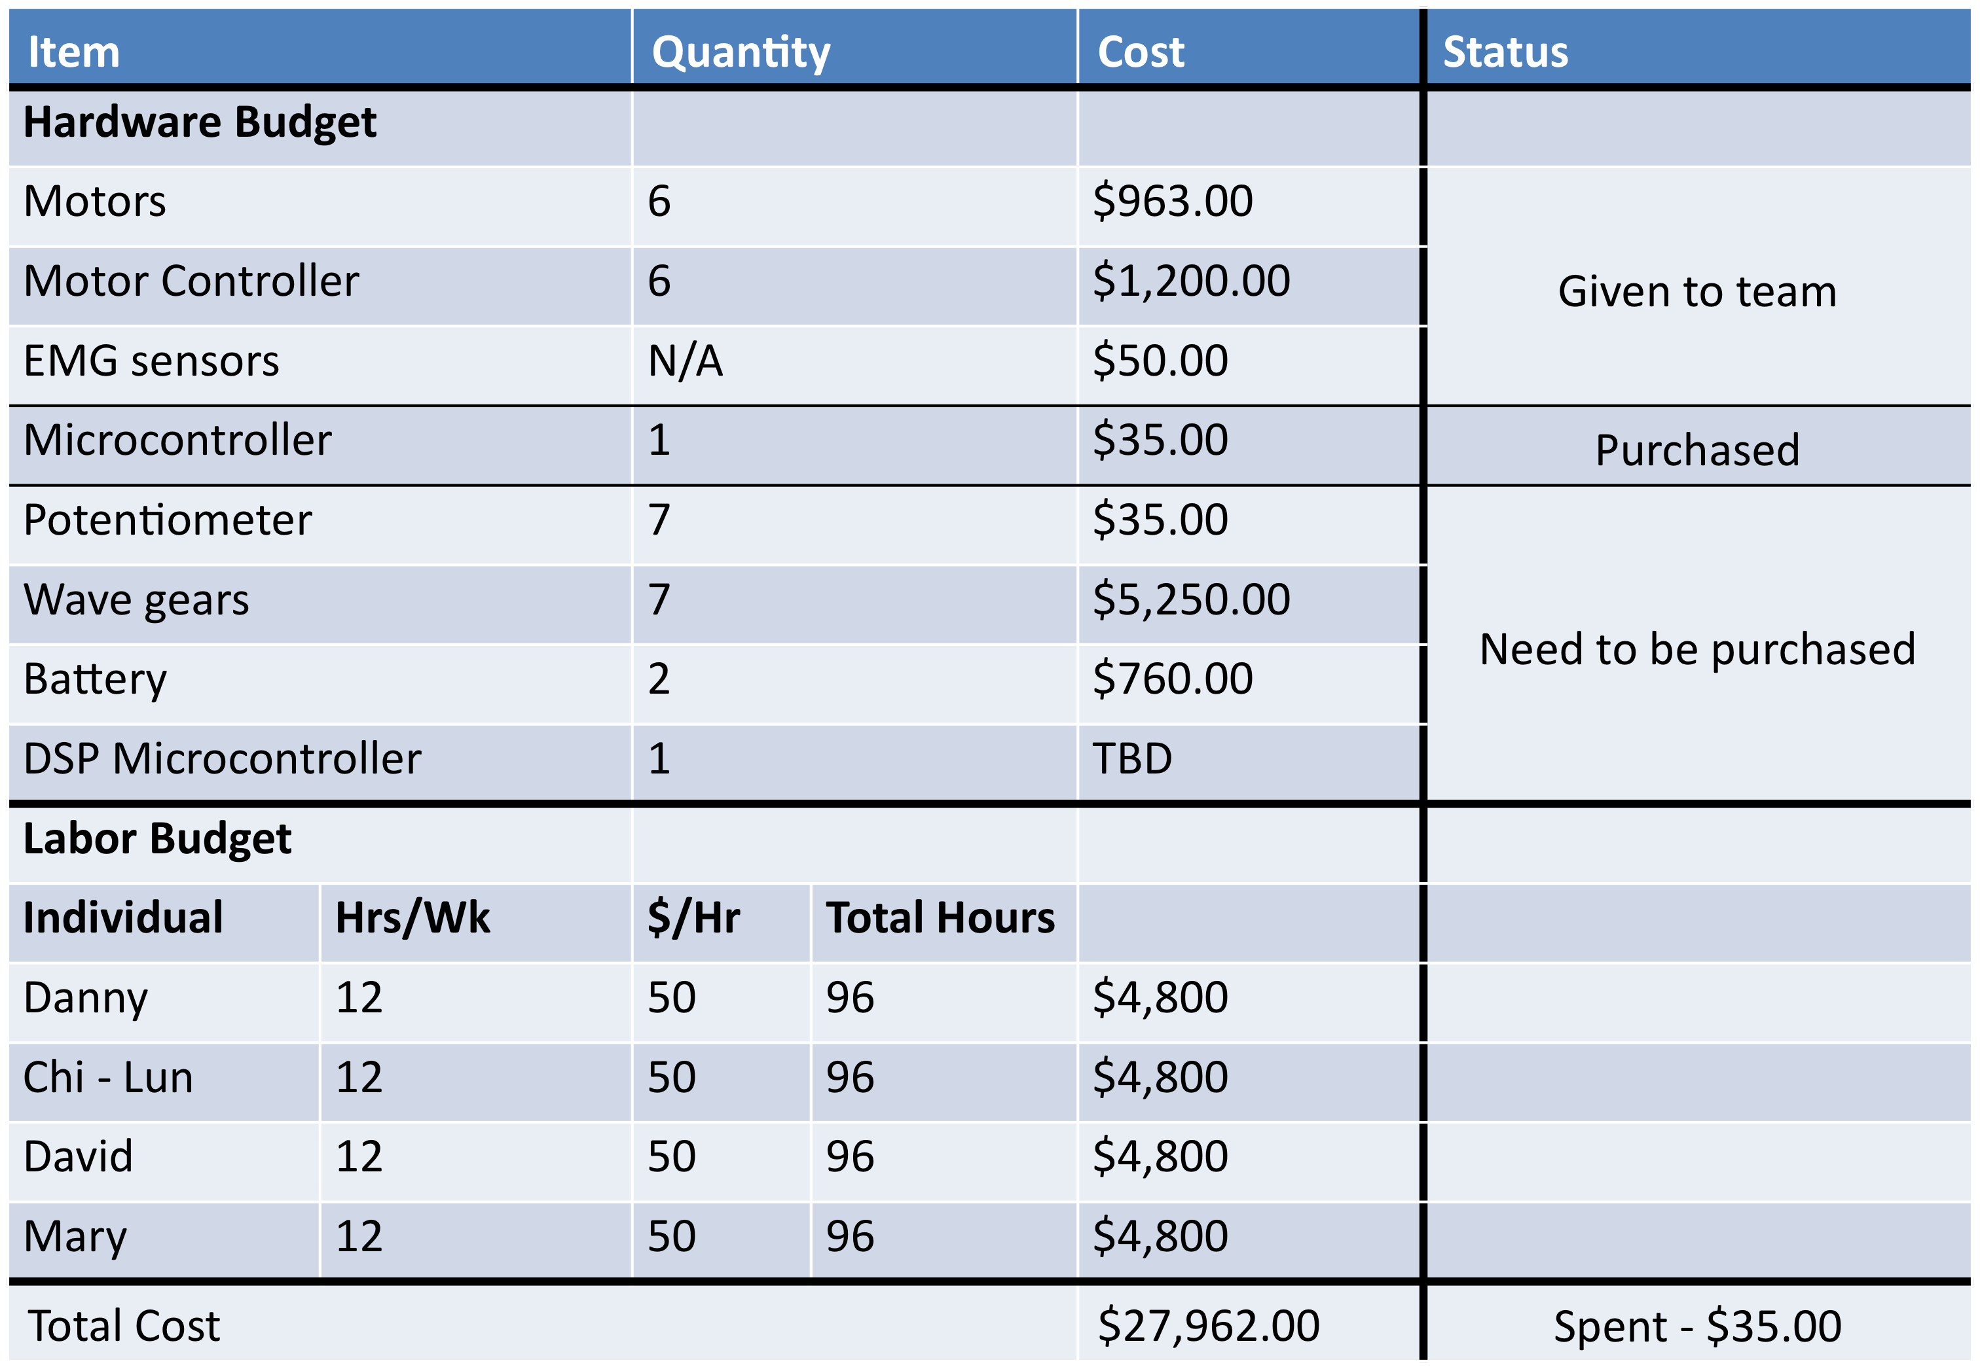

Conclusion
Through the joint effort of the teams at the Tecnológico de Monterrey and the University of Houston, we are assembling a pediatric exoskeleton device capable of performing basic walking movements. We have successfully programmed the motors with correct gait data for a child, performed the power system analysis for the selection of the battery and the system’s mechanical design has been updated to better simulate a natural gait. These are foundational steps to creating an adaptive exoskeleton system capable of providing a customizable rehabilitation experience according to the specific needs and capabilities of the user. The primary focus of this semester was to drive and control the motors with the proper gait data. Next semester we plan on implementing various data feedback sensors such as EMG and force sensors and focus on the impedance control of the motors.

Appendix A
In this appendix, Figure 7 shows the Tiva-C microcontroller with the pins labeled to clarify where the wires were connected. Also, Figure 8 displays the wiring logic employed when connecting the Tiva-C and the Motor Controllers.
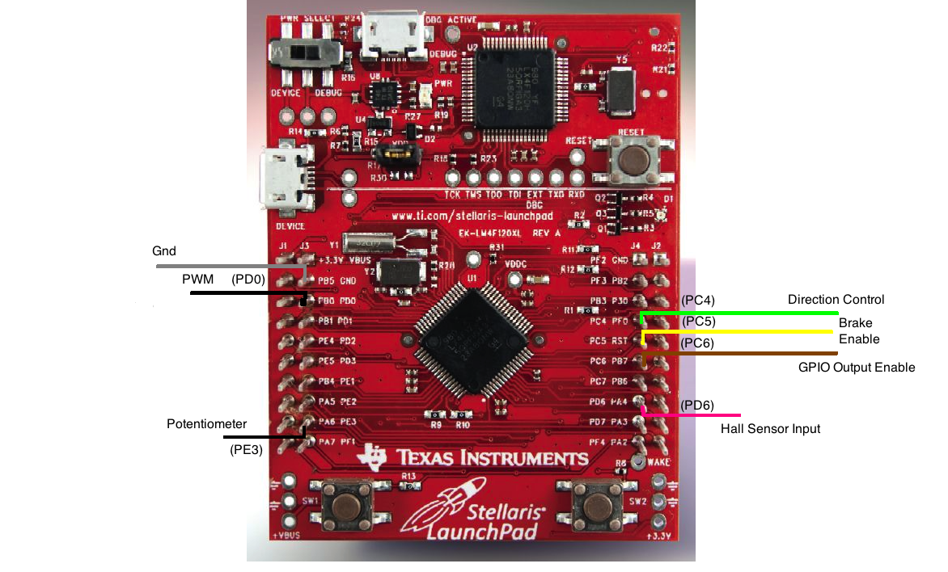
Figure 7: TI Tiva-C microcontroller pin out.

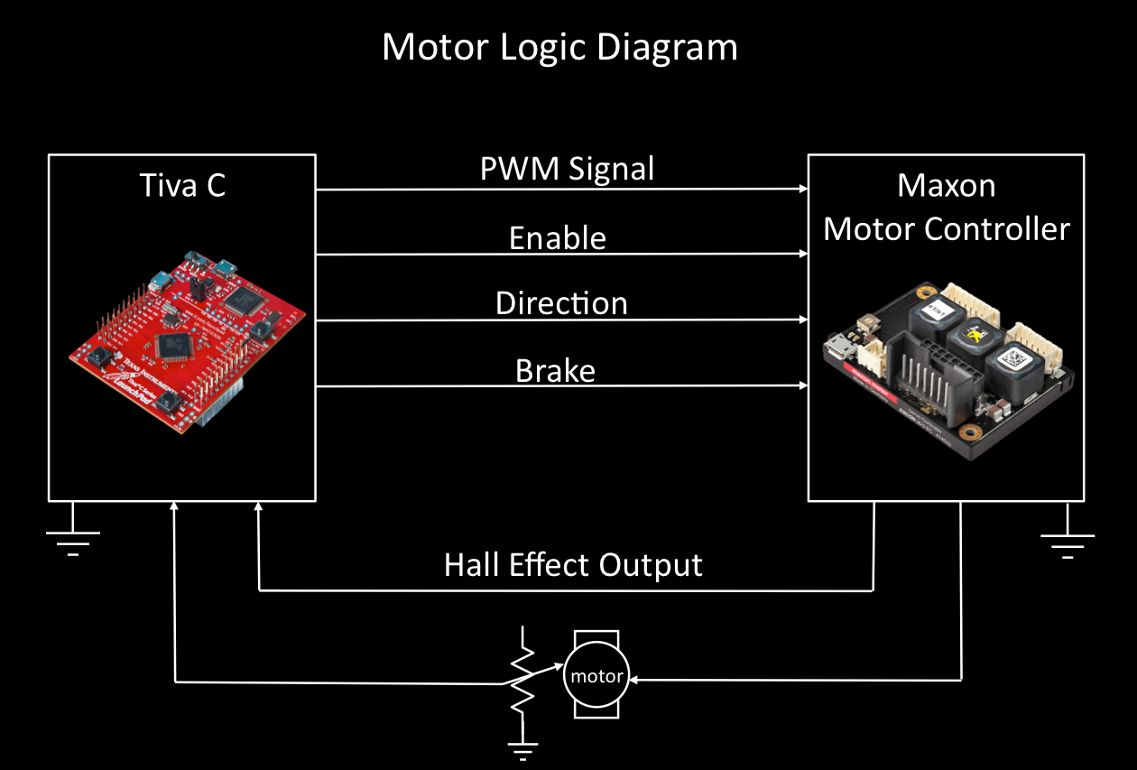
Figure 8: Logic diagram for motor

Appendix B
This appendix contains the remaining hazards and counter measures tables, which will be used for the safety testing.
Table 5: Electrical Hazards (a) safety sheet
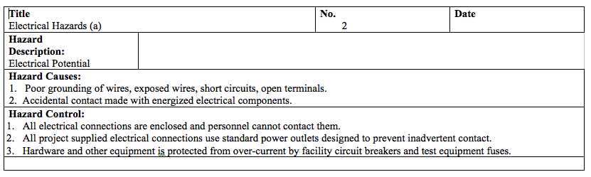
Table 6: Electrical Hazards (b) safety sheet
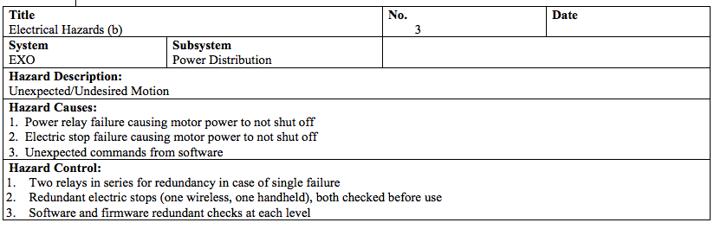
Table 7: Testing Related Injury safety sheet
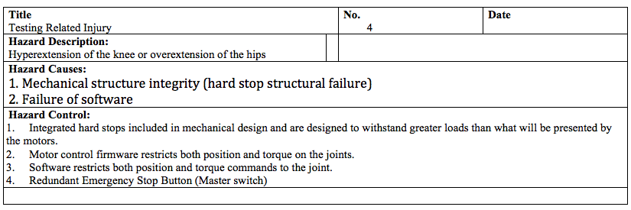
Table 8: Falling/Tripping when running on battery power safety sheet
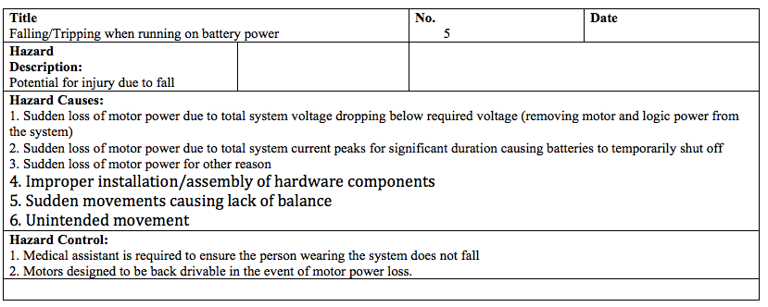
Table 9: Burns safety sheet
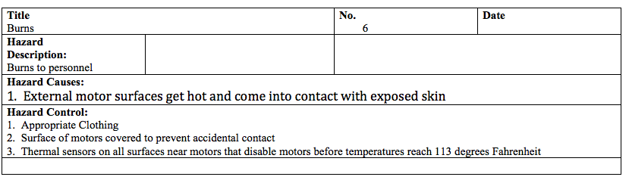
Table 10: Electric Potential safety sheet
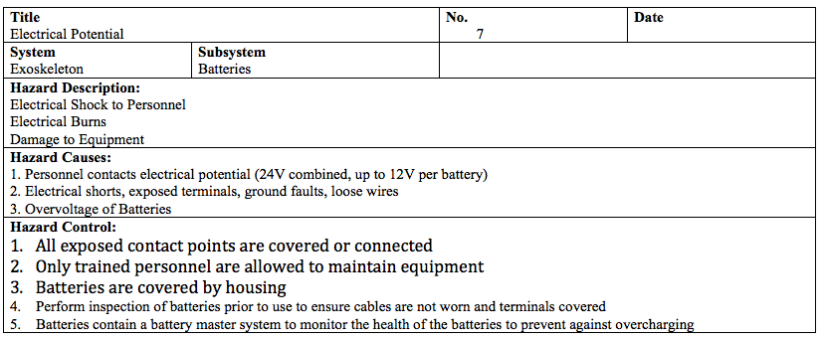
Table 11: Under-voltage of individual battery safety sheet
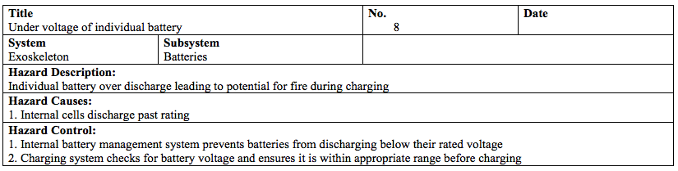
Table 12: Overheating safety sheet
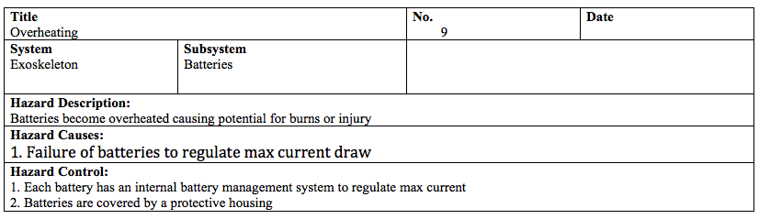

Works Cited
- Parent S, Mac-Thiong JM, Roy-Beudry M, Felix Sosa J, Labelle H. "Spinal Cord Injury in the Pediatric Population: A Systematic Review of the Literature." Vols. 28: 1515-24. J Neurotrauma. , Aug 2011 .
- Justin A. Brantley, Jonathan W. Kung, Marina Canela, Jesus G. Cruz-Garza, Andre V. S. SigoraJustin A. Brantley, Jonathan W. Kung, Marina Canela, Jesus G. Cruz-Garza, Andre V. S. Sigora. "Design of a powered pediatric exoskeleton for lower limb rehabilitation." Department of Electrical & Computer Engineering, University of Houston, 2014.
- Stansfield, Ben, and Chris Kirtley, Dr. "Normalised Regressions of Kinematics & Kinetics for Children.". 03 Feb 2015 <http://www.clinicalgaitanalysis.com/data/>.
- CDC. 2 to 20 Years: Boys Stature-for-age and Weight-for-age Percentiles. 2015 <http://www.cdc.gov/growthcharts/data/set1clinical/cj41l021.pdf>.

