Senior Design Team 5

4800 Calhoun Rd

Houston, TX 77204

United State

27 February 2015

Dr. Leonard P. Trombetta

Associate Professor

N 308 Engineering Building 1

Houston, TX 77204

United State

Dear Dr. Trombetta

This is the Final Technical Report that you requested. This report is to inform you about our team’s accomplishments throughout this semester as well as has technical details of our project.

This semester the team finished the hardware portion of the project. To be more specific, the hardware portion of the project includes a headset that contains electrodes for current delivery and extra electrodes that will be used to take brain waves and display an EEG signal.

The current source will be a voltage controlled current source with the voltage coming from an Arduino microcontroller. This voltage from the microcontroller will go into an op-amp with a resistor feedback which will give us the desired current. To ensure that the desired current is being sent through the electrodes, our system has a feedback control that displays the current passing through the electrodes once a load is inserted between the electrodes. In order to test the current delivery of our system, we used resistors to “model” our brain on the electrodes. We understand that this is severely simplifying the human brain but we have seen research done by Dr. Bikson that shows how current travels through the brain.

For the EEG portion of the headset, there will be electrodes attached to the scalp that will pick up the brain waves. The original brain waves will then go through a differential amplifier that will filter out noise. Then the amplified brain waves will go through a second amplifier that will make the signals large enough to be able to display by the Arduino.

Please feel free to contact us for clarification on this report.

Sincerely,

Senior Design Team 5

Transcranial Direct Current Stimulation

Prepared by Jonathan Cantu

Javier Herrera

Hieu Bui

Bao Tran

Sponsored by Dr. Han Q. Le

Final Technical Report

May 4, 2015

# Abstract

The goal for this project is to provide at-home users viable access to laboratory-level transcranial direct current stimulation rehabilitation without the burden of excessive medical expenses, services, and equipment. The team will achieve this goal providing a headset that will deliver current to the user’s scalp and also record brain waves to display an EEG signal. Currently, commercial units have insufficient or inadequate design with little to no flexibility for control or monitoring. This project will allow users to choose the current intensity as well as give them feedback on how much current is actually being passed through their scalp. This product’s main consumer market will be people who suffer from neurological disorders. Anyone who has basic knowledge of electricity and smart phones should be able to use this product.As humans, everyone has a different electric resistivity that depends on the structural biology and skin humidity which can range anywhere from 300[Ω] to 100[kΩ]. For this device to work correctly, calculations show that skin resistivity should be no larger than 5.6[kΩ]. This can be accomplished by cleaning the point of contact on the skin as well as using a conducting gel on the electrodes. The current delivery system provides at least 87% of the desired current under the correct conditions. The EEG half of the project does not work to perfection. The electronics portion of EEG design works correctly and the proof is that the team was able to pick up an EKG signal. However when placed on brain, no brain waves were picked up. This leads the team to believe that the problem is the electrodes and that they must be replaced with EEG specific electrodes.The team stayed within the budget of $5300 by only spending $5,195.11 and the deliverable will be shown on May 6th.

# Background and Goal

The goal for this project is to provide at-home users viable access to laboratory-level transcranial direct current stimulation rehabilitation without the burden of excessive medical expenses, services, and equipment. The team hopes to achieve this goal by providing a headset that will deliver current to the user’s brain (no?) and also record brain waves to display an EEG signal.

The brain is a human organ that controls the body’s other organs by using neurons. When someone suffers from a neurological injury, such as a stroke, they may have secondary effects such as loss of hearing, taste, or motor functions. Medical researchers are trying to create more effective ways to rehabilitate post-stroke patients and think that transcranial direct current stimulation, also known as tDCS, is one of those methods.

Although passing current through the brain has been around since the 19th century, it wasn’t until the last decade that medical researchers decided to start using it for brain stimulation instead of as a punishment. Transcranial direct current stimulation uses a low, constant current that is delivered directly into the part of the brain doctors are interested in via small electrodes.

One of the first companies to put a tDCS system out commercially is the Thync Company and they claim their product “can help people alter their mood as and when they want” [1]. Their reviews have been fairly positive from multiple sources that have tried their product which leads to another question in the neuro-scientific discipline. If tDCS can be used to alter your mood recreationally, could it also be used to rehabilitate the brains that are suffering from neurological disorders? Obviously, the part of the brain that needs to be treated depends on the neurological disorder one is suffering from, and that is where this project gains importance.

The headset will be composed of fixed electrodes in different places within the cap that will allow for the possibility of treatment to different parts of the brain. These electrodes will be able to provide current at different levels of intensity that will be chosen by the user. Additionally, the headset will be able to collect brain waves, amplify them, and convert them into usable signals that will be displayed as an EEG. Aside from designing and building the headset, a user friendly control system will be developed that will allow the user to modify the intensity of current, and time intervals they would like the device to be active.

# Problem, Need, and Significance

While tDCS is growing in popularity, commercial units have insufficient or inadequate design including little to no flexibility for control, no feedback sensing or monitoring, and a general lack of user friendly interface. Transcranial direct current stimulation has a growing trend of being used for two main applications: to enhance the cognitive capability and mood control for the general population [2] and treatment of neurological disorders [3]. However, unless a patient is treated by tDCS experts with resources such as fMRI at their disposal, there is little help available to those who wish to apply the method on their own with current tDCS systems on the market. This project aims to produce a more powerful and capable but affordable tDCS system for broader usage.

This product’s main consumer market will be people who suffer from neurological disorders. These neurological disorders can range from depression to sensory or motor function loss after suffering a stroke. These consumers would be interested in this device because it allows them to experience an inexpensive, easy to use treatment. In fact, Michael Donnelly, a man who had suffered from depression for 30 years and would take medication to control it fell into a deep depression where nothing was working. He started tDCS treatment and felt that he was coming out of depression within a month of starting the treatment [4]. This device will also allow clinicians to offer an alternative to traditional pharmaceutical treatments such as pills and medicine.

# User Analysis

By the end of this project someone with very basic knowledge of electricity and smart phone capability will be able to use this device. The electrodes will be in a fixed position with a female contact dangling while the microcontroller will have the male portion of the connection. This will allow for the user to only have to link the two connections for the device to work as instructed. The smart phone capability will be needed when the application to control the device wirelessly is developed. Although the two skills mentioned above are highly critical to the success to this project, they are easily obtainable and commonly found in people living in the United States.

# Overview Diagram

Below is a graphic representation of the team’s spring deliverable in Figure 1. It shows which parts were needed to accomplish current delivery as well as EEG display. On the right hand side the focus is on the current delivery portion of the project and on the opposite side the focus is on the EEG portion.



Figure 1: The overview for the project is shown below. This is a graphic representation of the overall project.

# Target Objective and Goal Analysis

The target objective for this project is to provide a transcranial direct current stimulation system for potential neurological and clinical applications. In order to complete the aforementioned objective, multiple subprojects must be completed and these can be seen below in Figure 2.

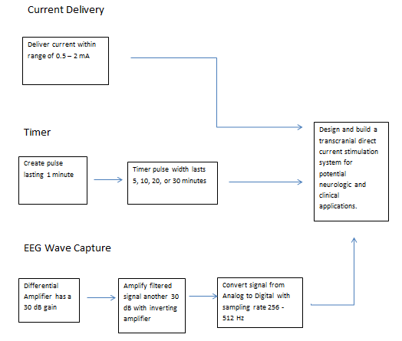

Figure 2: Shows the objectives needed to be accomplished needed to meet the target objective.

To test the current source in this project, the team used a 741 op-amp to build a voltage controlled current source as shown below in Figure 3.

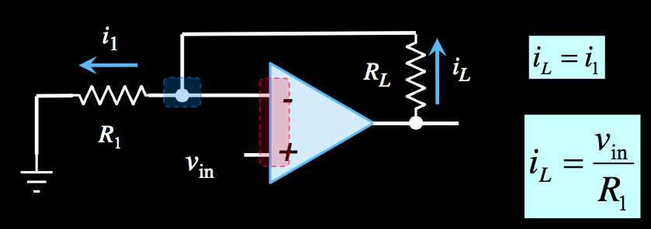

Figure 3 shows the voltage controlled current source schematic.

The current that will be sent into the headset is found with the following equation:

|  |  |  |
| --- | --- | --- |
|  | $$i_{L}= \frac{v_{in}}{R_{1}}$$ | (1) |

The op amp was powered by Vcc, ±13[V], and Vin is connected to the Arduino output that was programmed to supply different DC voltages within the 0[V]-5[V] range. The team chose R1 to be ~ 1[kΩ] and RL is the user body resistance. For this project, the exact value of R1was found to be 0.895[kΩ].Research shows that people have different electric resistivity, depending on the structural biology and skin humidity. In fact, the body resistance is anywhere from 300[Ω] when wet to 100,000 kΩ] when it is dry.

The max output voltage is ±13[V] therefore, in order to maintain the max output current (2[mA]), the max load resistance can be calculated with Equation 2 below:

|  |  |  |
| --- | --- | --- |
|  | $$R_{Lmax}= \frac{13V-(2mA*0.896 kΩ)}{2 mA}=5.6kΩ$$ | (2) |

The purpose of this test was to verify that the current source could deliver the expected current intensity to different constant resistors at a maximum supplied voltage. During the test, different resistors were used: 390[Ω], 3.29[kΩ], 5.58[kΩ] and 17.9[kΩ]. A milliamp meter was placed in series with RL to get the current values. The recorded data is shown in table below:

Table 1 displays the data acquired when testing the current delivery portion of the project. Any value greater than 15% is in Red.

|  |  |  |  |  |  |  |  |  |
| --- | --- | --- | --- | --- | --- | --- | --- | --- |
|  | 390Ω | | 3.29 kΩ | | 5.58 kΩ | | 17.9 kΩ | |
| Current Requested [mA] | Actual Current | Error | Actual Current | Error | Actual Current | Error | Actual Current | Error |
| 0.5 | 0.46 | 8.00% | 0.468 | 6.40% | 0.469 | 6.20% | 0.468 | 6.40% |
| 1 | 0.858 | 14.20% | 0.95 | 5.00% | 0.953 | 4.70% | 0.653 | 34.70% |
| 1.5 | 1.314 | 12.40% | 1.435 | 4.33% | 1.437 | 4.20% | 0.653 | 56.47% |
| 2 | 1.814 | 9.30% | 1.917 | 4.15% | 1.879 | 6.05% | 0.653 | 67.35% |

As seen in the data table, for the first three resistors, the actual output currents are reasonable with only a 15% error. With the 17.9 [kΩ] resistor, the current source cannot output the desired value of 1 [mA]. Under these conditions the Op Amp becomes saturated and the max current possible is 0.693 [mA]. This value can be found with the equation below.

|  |  |  |
| --- | --- | --- |
|  | $$I= \frac{13 V}{\left(17.9+0.869\right)kΩ}=0.693 [mA]$$ | (3) |

From this data, it can be concluded that the current source has a resistance limit in order to be able to deliver the desired current. The resistance in our schematic that needs to be kept under 5.6 [kΩ] is the body resistivity. This can be done by applying conductive gel on the surface of the skin as well as keeping the electrode contact area clean.

The pulse width modulation turned out to be a lot simpler than was expected. The microcontroller has a built in clock that can be used for time measurements. The only requirement for this section of the project was to write the code using the built-in “delay” function of the microcontroller to give us the desired time of operation.

The EEG was tested using the following procedure. The schematic of the differential amplifier is shown in the figure below.

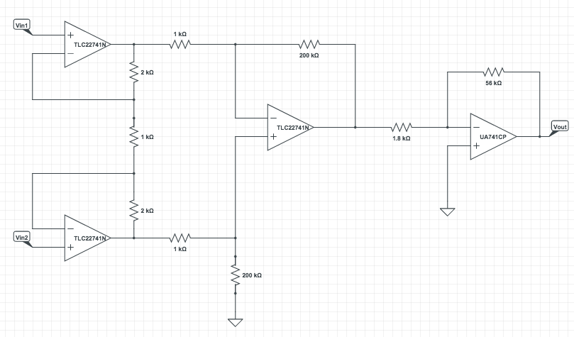

Figure 4 Differential Amplifier Schematic

The input signal was generated using a function generator. A voltage divider was used to get the sinusoidal input down to 21[mV] peak to peak. The signal was then split and put into Vin1 and Vin2. An oscilloscope was used to measure the Vout. Vout was measured to be 10.1[V]. The total gain was calculated to be around 53[dB]. The results from the oscilloscope for the differential amplification stage are shown in the figure below.

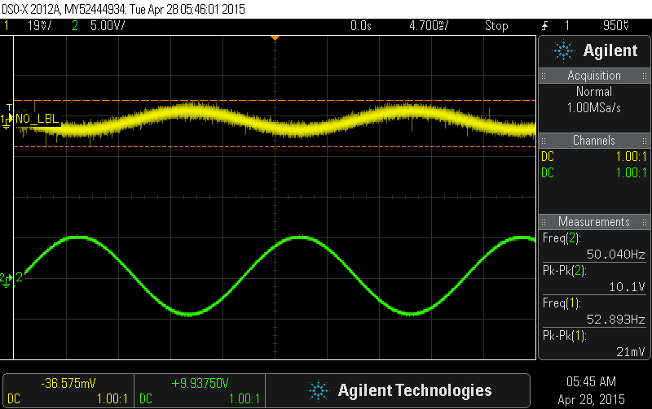

Figure 5 Differential Amplifier

The EEG wave was then passed through an inverting op-amp stage. Using the set-up shown in the Figure 6 below. An input of 0.1[V] was used and Vout was measured to be 3[V]. The gain was aproximately 30[dB].



Figure 6 Inverting op-amp stage used for added amplification

The Arduino display was tested using an EKG signal (heartbeat). An EKG signal was inputted to the differential amplifier. The EKG was measured from the stomach to the heart. The output of the differential amplifier was put into the Arduino. The results displayed are shown in the figure below.

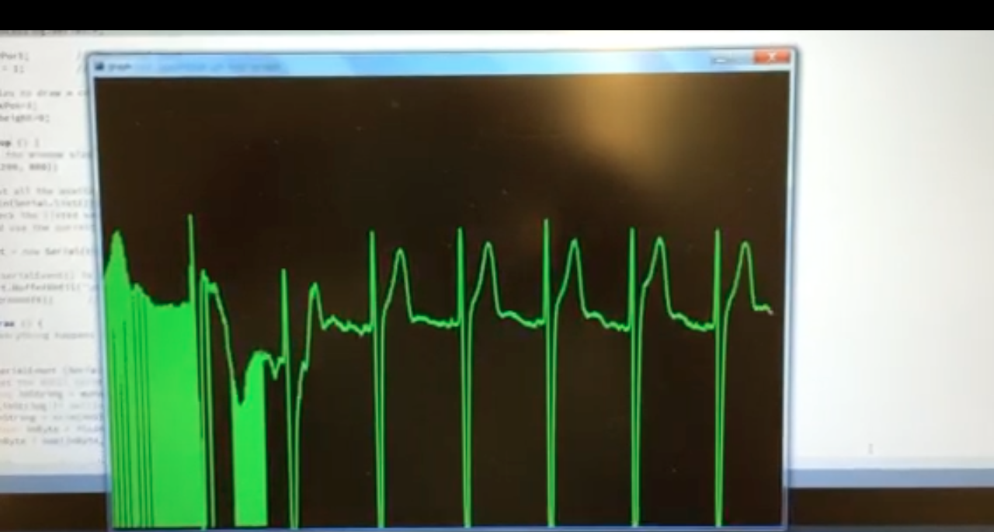

Figure 6 EKG display from the Arduino

# Engineering Specifications and Constraints

For this project there are two major constraints, which are safety of the user and brain waves being in the 10 – 100 [μV] range. These two constraints helped the team set specifications for this project.

The human brain can be modeled as a complex electrical circuit. If too much current is passed through the brain, the effects can range from temporary loss of senses to up to permanent loss of senses and ultimately death. The Federal Drug Administration has determined that for the effects of tDCS to be positive and not fatal, a maximum current of 6 [mA] can be passed through the brain. For engineering projects that are exposed to the public, the standard safety factor is 2 but since this project deals with a human brain and can damage a person’s livelihood if all precautions are not taken into consideration, the team has chosen to increase the safety factor to 3. This is the main reason that the maximum output of current has been chosen to be 2 [mA].

The EEG portion of this project begins with the waves being picked up from the scalp. These waves are usually in the region of 10 – 100[μV], which are fairly small to analyze correctly. Because these waves are small if they were to just be amplified, the signal would also pick up a good amount of noise. For this case, two-stage amplification is the best method to be able to analyze the signals. The first stage is a minimum 30 [dB] gain with a differential amplifier that allows the team to filter out noise. The second stage is another stage with 30[dB] gain with a non-inverting amplifier to get an amplified signal of the original instead of an inverted signal that was seen coming out of the differential amplifier. A minimum total of 60[dB] gain between the two stages is needed to amplify the signal and filter out the noise in order to have a healthy EEG signal.

# Statement of Accomplishment

This semester the team accomplished a great portion of the project. The current delivery system is finished and has been tested with constant resistances as well as on test subjects. We did find that every user’s skin resistivity is different, so the team implemented a warning sign to display when the resistance was too high.

The EEG portion of the project is not completed. The two stage amplification works and proof of this is that the team was able to display a graphic of a human heartbeat. However, when put up to the scalp to measure brain waves, the electrodes were not able to pick up the required signals. All signs point to the electrodes not being the correct type for that type of measurement and will need to be replaced by electrodes specifically for EEG measurements.

# Budget

The team had a parts budget of $300 and a labor budget of $5,000 for this semester. After a full semester, the team is below the grand total budget of $5,300. A part by part breakdown of the costs can be seen in the table below with a graphic representation of budget distribution percentages after the table.

Table 2 shows the cost breakdown of parts and labor for this project.

|  |  |  |  |
| --- | --- | --- | --- |
| **Part Name** | **Price** | **Quantity** | **Total** |
| Arduino Uno Kit | $54.99 | 1 | $54.99 |
| Hi Resolution mA meter with Display | $16.92 | 1 | $16.92 |
| Current Delivery Electrodes | $16.00 | 2 | $32.00 |
| JFET Low noise ADA4891-4ARZ | $2.80 | 4 | $11.20 |
| Quad Low noise TLC2274AIN | $2.00 | 10 | $20.00 |
| LM317 Voltage Regulator | $0.63 | 10 | $6.25 |
| LM344 3 Terminal Adjustable Current Source | $0.63 | 6 | $3.75 |
| Taxes | $50.00 | 1 | $50.00 |
|  | **Parts** | **Total** | $195.11 |
| **Labor** | **Value** | **Hours Worked** | **Total** |
| Javier Herrera | $50.00 | 25 | $1,250.00 |
| Bao Tran | $50.00 | 25 | $1,250.00 |
| Hieu Bui | $50.00 | 25 | $1,250.00 |
| Jonathan Cantu | $50.00 | 25 | $1,250.00 |
|  | **Labor** | **Total** | $5,000.00 |
|  | **Grand** | **Total** | $5,195.11 |

Figure 7 is a graphic representation of the budget distribution.

It is anticipated that the budget next semester will be an extra $5,300 with the same distribution of $5,000 for labor and $300 for parts.

# Conclusion

The goal for this project is to provide at-home users viable access to laboratory-level transcranial direct current stimulation rehabilitation without the burden of excessive medical expenses, services, and equipment. Anyone with a basic knowledge of electricity and smart phones will be able to use our device by the time the project is completely finished. This semester the main focus was on the hardware part and being able to implement the current delivery and EEG wave system.

The current delivery system works as designed with at least 87% of desired current being passed through the scalp under the correct conditions. The EEG portion of the project is not working as desired. The electronics share of the EEG works correctly since a signal can be put into the amplifiers and we get the desired gain at the output of both stages. Further proof of this is shown when the team was able to pick up a heartbeat and display it correctly. This leads the team to believe that the electrodes are not sensitive enough to pick up the brain waves and will need to be replaced with EEG specific electrodes.

As far as costs go, the team stayed within the $5,300 budget by only spending $5,195.11. The majority of the costs went towards labor for this project with a total of $5,000. The extra $195.11 was spent on parts and the extra $104.89 was unused. It is expected that next semester’s budget will be similar to the $5,300 for this semester.

# Works Cited

|  |  |
| --- | --- |
| [1] | T. Balaam, "Future Media Lab," [Online]. Available: http://futuremedialab.com/ces-2015-thyncs-new-mood-changing-wearable/. [Accessed 13 February 2015]. |
| [2] | M. M. Roy Hamilton, "tDCS Update: Recent Trends and Applications," 2010. |
| [3] | A. D. Y. H. J. D. R. M. B. J. F. L. C. P. Jacek P. Dmochowski, "Targeted transcranial direct current stimulation for rehabilitation after stroke," *Elsevier,* 2013. |
| [4] | P. Belluck, "Promising Depression Therapy," NY Times, 2013. |

What’s with reference 3?