Wednesday, May 13, 2015

Dr. L. Trombetta
University of Houston
Cullen College of Engineering
W 310 Engineering Building 1
Houston, TX 77004-4005

Dear Dr. Trombetta,

Attached you will find our final technical report for the Spring 2015 semester senior design class. This report will explain in detail what we have accomplished on the “E.R.F.I – The Hands-Free Robot” project. The report will contain the main goal along with the problem, need, and significance as well as the user analysis, overview diagram, target objective and the budget. At this point of the project, the functions E.R.F.I. is able to perform include being able to receive commands from a computer terminal, detect obstacles in its path, and provide live video feed via Wi-Fi. Once a command is received E.R.F.I. will turn green which will indicate an all clear to GO. If an object is nearby within 24 inches, it will turn red and stop in its path and wait for a new command.
I hope you find the following report satisfactory.

Best Regards,

Team 3:
Fabiola Villanueva
Isaac Zavala
Raul Cabrera
Elmer Berrones
You are missing the Accomplishments section, and the Standards section.

E.R.F.I. – The Hands-Free Robot:

Final Report

ECE 4335

By

Fabiola Villanueva

Isaac Zavala

Raul Cabrera

Elmer Berrones

Wednesday, May 13, 2015

Abstract
For the E.R.F.I. (Elmer Raul Fabi Isaac) “The Hands-Free Robot” project we are employing the concept of wearable technology by designing wristbands that will provide commands to E.R.F.I. The purpose of this project is to explore new methods of controls with different emerging technology. Our team sees promise in creating remote controllers for a robot through the use of wearable wristbands. Such a controller would be easy to carry around and would free the user’s hands when needed without the user having to let go of the controller. The main problem our team will face will be obtaining data from the wrist bands and translating such data to reliable commands. To achieve this, our team will have to implement a control algorithm that will take in gyroscope readings mounted on the wristbands and provide smooth operational commands. The logic will be processed by microcontrollers mounted on the robot and on the wristbands. Our deliverable for the month of May is E.R.F.I. The Hands-Free Robot which processes computer commands and moves accordingly. The December deliverables will include two sets of wristbands that will control E.R.F.I. The Hands-Free Robot through Bluetooth communication. Our expected budget for the entire project is $38,042.53.

Background and Goal
In recent years there have been continuous advancements in the development of wearable technologies such as smart watches and fitness bands. While there are various types of wearable technology, there are little to no devices which use it as means of a remote controller. Our team sees potential in exploring new methods for a remote controller through the use of wearable technology. Such a controller would be easy to carry around and would free the user’s hands when needed without the user having to let go of it. Our team’s goal for this project is to explore new means in remote controlling concepts by developing a robot that can be remotely maneuvered through hazardous areas with the use of wearable wristbands.
Our robot named E.R.F.I. (Elmer Raul Fabi Isaac) sits on a set of caterpillar tracks which allows it to navigate through various types of terrains. This robot has an onboard camera that streams video to the user’s internet enabled devices. The user will be able to remotely control the displacement of the robot and the up and down tilt movement of the camera. This system will execute these actions by employing a set of microcontrollers, gyroscopes and accelerometers.
The following document will provide the information required to understand what is needed to complete the project. It will also address the problems the team has encountered and the necessary steps the team has taken to overcome such problems. This report will provide the problem, the need, the significance, user analysis, an overview diagram, the target objective, the goal analysis, the engineering specifications and constraints, significant accomplishments, and the budget of the project.
As of now the target objective for the Spring 2015 semester, which was to create a fully functional robot, has been completed. The completion of the robot sets the path for the final target objective which is to incorporate the wristband controllers by the end of the Fall 2015 semester.

Problem, Need, and Significance
Problem
Remotely operated robots employ controllers that limit the user to maintain both hands occupied. This limitation can become a challenge in situations where quick reactions from the user might be necessary.

Need
To develop a new portable type of controller that allows the user to mobilize immediately without having to abandon the controllers and keeping the hands free. A user performing operations with a remote controlled device in environments that can present hazardous conditions or unforeseen situations needs to be able to mobilize immediately if required. Controllers are designed to be placed in a stationary manner or require both hands be used to provide input. This has the potential to become a handicap when the need for immediate response arises.

Significance
Personnel working in hazardous conditions or rescue operations often need to mobilize at a moment’s notice. The wristband controllers reduce the chance of misplacement and the burden of having the hands occupied when mobilizing in addition to providing greater portability. Individuals working in the field of robotics could also use the wristband concept as the basis to further improve portable remote controllers.

User Analysis
The device will be used by people in the work field and possibly hobbyists. The user does not need a high level of expertise as it will be easy to learn and fun to operate. The user will interface with the device with the movement of the wristband.

Overview Diagram
Figure 1 shows the overview diagram for E.R.F.I. which displays the two microcontrollers used to control the motion and video features of the robot.
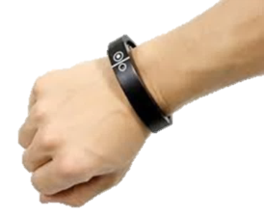
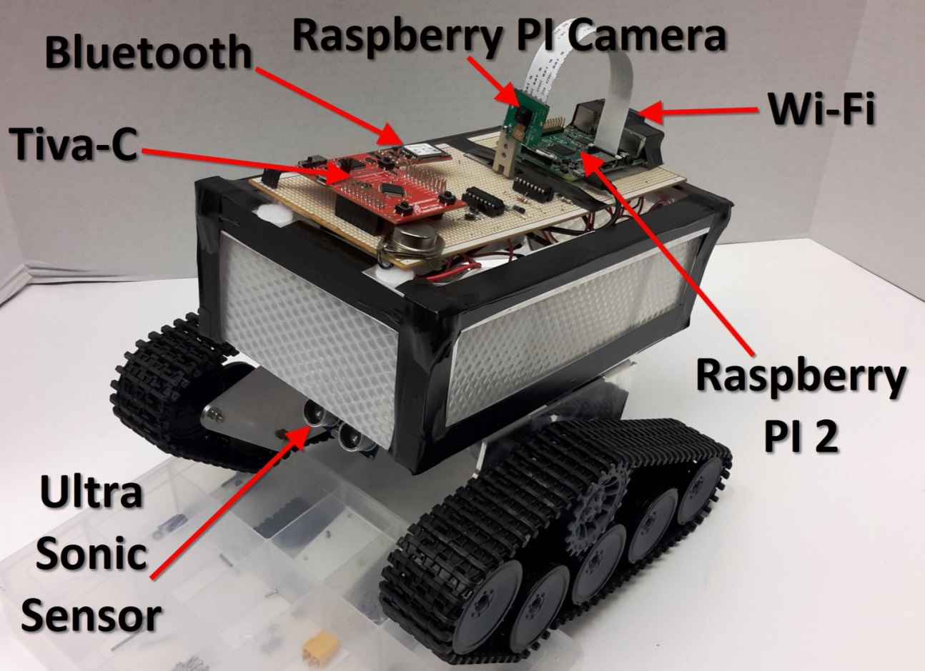
Figure 1 Overview Diagram of E.R.F.I.
The Raspberry Pi microcontroller will be responsible for the video processing and will transmit the video to an internet enabled device through WI-FI. The Tiva-C microcontroller will be used to process the robot’s motion by outputting a PWM signal to the DC motors to control the speed.

Target Objective and Goal Analysis
The following diagram presents the overall goal analysis with each block representing an objective of our project.
Figure 2 Goal Analysis
The blocks colored green represent objectives that have been met as of now, while the purple blocks are objectives that we expect to complete by the end of the Fall 2015 semester. The following sections will explain in further detail the completed objectives.

Recognize Object and stop 24 inches away
In order to recognize obstacles in the robot’s path, the HR-SR04 Ultrasonic Distance Sensor by Cytron technologies was mounted in the front of the robot and interfaced to the Tiva-C. We decided to set a stopping distance of 24 inches from an obstacle in order to provide the robot enough room to make a safe turn. To achieve the desired accuracy for the distance read by the sensor, a series of trials was performed in order to adjust the timing of the values fed to the Tiva-C by the ultrasound sensor. The following table displays the trials and the distance read by the sensor which was corroborated with a meter stick.
Table 1 Obstacle distance
Trials | Distance away [inches]
1 | 20
2 | 22
3 | 21
4 | 22
5 | 22
6 | 24
7 | 23
8 | 24
9 | 25
10 | 24

Limit movement to stationary spin until forward path is clear
When an obstacle is detected, the robot will stop and wait for the user to send a new command. The user will then need to specify whether the robot will spin to the right or spin to the left and stop. Then it can continue on its path until another obstacle is met again.

0-100% variable PWM output signal for each motor
Through a computer terminal command, we have been able to vary the speed of the robot from standstill to full motor power. The duty cycle is the percentage of one period in which a signal is active. This duty cycle will be specified by the user to dictate the speed at which point the Tiva-C will output the corresponding pulse width modulated signal to the DC motors.

Two-way communication from computer to raspberry PI through Wi-Fi
The raspberry PI is configured to automatically connect at startup (boot up) to the local wireless network. In addition, an open source script loaded in the raspberry PI will make it send its IP address to a specified email. This is done because the IP must be known beforehand in order to connect to the camera through an internet enabled device. Without the automated email script, the user would have to connect a display to the Raspberry Pi and go to its command terminal to retrieve the IP address.

Continuous Wireless Video stream to smart phone
Once the raspberry PI has established connection to the local wireless network by using the IP received in the email, the user will be able to access the open source camera interface by typing the IP address in a web browser.

Engineering Specifications and Constraints
For our goal analysis we have various specifications that we are trying to meet. In the process we have and expect to run into constraints that will challenge our project. In this page there will be a various specifications with a short description followed by a list of constraints with a short description.

Specifications

- One inch Distance sensor resolution - Our team has decided to set a small resolution for our sensor to be able to accurately read distance in front of the robot. This distance measurement will be used to prevent the robot from running into walls. Our robot does not have back motion so when a forward object is detected our robot will enter a stage where it will only be able to spin in place until a clear forward path is found. This is done to prevent the robot from becoming trapped.
- 10 Meter Control Range – Because of the Bluetooth’s module signal strength, our Team has decided to start with a specification of a 10 meters radius for our controller distance for a reliable connection. For this experimental stage of the controller, we plan on focusing on the controller’s algorithm and a 10 meter distance from the robot to the user will let our team test the mobility of the robot without a big restrain.
- Color 5MP image with no IR filter - We feel it’s important for our robot to be able to navigate through different environments. A camera with infrared capability will give our robot the ability to navigate in places where illumination is limited. The 5MP resolution will produce a clear image of the environment, in addition to the standard resolution for cameras readily available for the Raspberry Pi.
- 3 Axis controller - To control our robot we will use gyroscopes that will provide feedback of the orientation of the wrist. This data will be translated into commands to move the robot forward, left, right, and to control the camera tilt. We also intend to use the capabilities of the gyroscopes to translate a quick twist of the wrists as a command to turn on and off the wristbands.

Constraints

- Limited motion from wrist - One of the constraints for our robot design is the possible motions a user can make with his/her wrist. Our team is using gyroscopes to read the direction the wrist band is facing. The readings that can be obtained are limited to only a few possible variations. Our team is making the best of this and has planned to use the data as efficiently as possible to be able to maximize our controls.
- Microcontroller capability - For our project we want to transmit video to a phone and control the robot’s speed. The Raspberry Pi has the ability to input video data but lacks multiple PWM output needed to drive both motors as well not having a Real Time Operating System (RTOS). The Tiva-C has multiple PWM outputs but lacks the input for video. Therefore, by using these two affordable microcontrollers in tandem, we can implement both functions and keep the budget at a reasonable level.

Budget
An up to date expenditure has been done for the project. Table 2 shows the current expenses that have been made and the estimated expenses in parts for the Fall 2015 semester. Table 3 shows the Labor expenses that have been made to date. Finally, table 4 shows the total expenditures as of date.
Table 2 Overall Parts
Description | Price
Integy c23212 Lipo Voltage | $2.42
SainSmart Infrared Night Vision Surveillance Camera | $39.99
Raspberry PI 2 model B | $41.93
4 Red LED pods | $15.8
4 Green LED pods | $15.8
Caterpillar Wheels | $130
Voltage Regulator | $13.89
Plexi Glass | $5
Plexi Glass Cutter | $4.47
Wi-Fi adapter | $16.23
Frame | $40
SD card | $17
Total for Spring = | $342.53
Estimated expenses for Fall
4 Gyroscopes | 60.00
2 Microcontrollers | 60.00
2 Bluetooth Modules | 30.00
Batteries | 20.00
Total for Fall | $170.00
Overall total | $512.53

Table 3 Labor for Spring 2015
Labor | Rate/hour | hours/week | Current week | Subtotal
Isaac | $50 | 5 | 15 | $3,750
Elmer | $50 | 5 | 15 | $3,750
Raul | $50 | 5 | 15 | $3,750
Fabi | $50 | 5 | 15 | $3,750
Dr. Len Trombetta | $50 | 5 | 15 | $3,750
 |  |  | Total | $18,750

Table 4 Expenditures as of date
Type | Projected Cost | Expenditures as of date
Parts | 542.53 | $342.53
Labor | $37,500 | $18,750
total | $38,052.53 | $19,092.53

Conclusions
The E.R.F.I. project is intended to explore new means for a controller. Our team sees potential in wearable technology to help portability for a controller. Our team will explore this new form of controller by implementing two sets of wristbands that will control the motions of a robot. These motions will be translated for gyroscopes mounted on the wristbands to motor motion by the robot. Due to changes in the project design our team has had to change our time line to adjust for the new design. We are now on schedule in the new time line and have completed our target objective for the semester to build a robot that moves through wireless commands by the user. We are still within our budged for both parts and labor.

