‘Smart’ Drip-Irrigation System for Greenhouse Demonstration Garden in Nicaragua
4800 Calhoun Rd, Houston, TX 77086 | 713-385-2998 | arucoba@uh.edu
Adilene Rucoba, Joseph Pompa, Albert Truong, and Carlos Quiroga

November 21, 2016

Michael Richardson
Director
BioNICA
1100 Principal
Managua, Nicaragua

Dear Michael,
As of November 7, 2016 The ‘Smart’ Water Irrigation Team completed installation of the ‘Smart’ Drip-irrigation system at the National Agrarian University at Nicaragua (UNA). The University of Houston (UH) team worked alongside National University of Engineering (UNI) student, Miguel Escorcia Rojas, to meet specifications requested by the project managers Drs. Contreras-Vidal and Pei, and our clients: UNA professor, Dr. Henry Duarte. Attached to this letter is a detailed analysis of the process, development and installation of the ‘Smart’ Drip-Irrigation System. If you have any questions please do not hesitate to ask.

Sincerely,
‘Smart’ Water Irrigation Team

‘Smart’ Drip-Irrigation
System for Demonstration and Research Greenhouse Garden in Nicaragua
Sponsor: Dr. Doug Varret
Advisor: Dr. Len Trombetta
Project Managers: Dr. Steven Pei, Dr. Vidal Contreras
University of Houston
December 2016

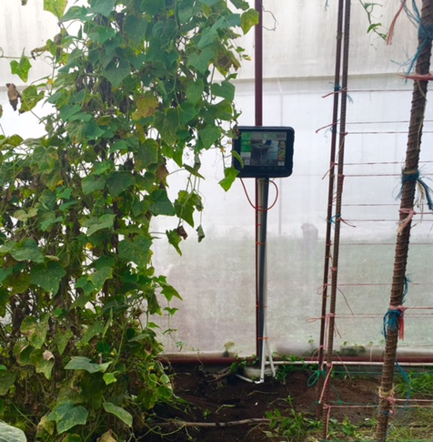
Project Manager: Adilene Rucoba
Software/Hardware: Albert Truong
System Design: Joseph Pompa
Software: Carlos Quiroga

Abstract:

The ‘Smart’ Drip-Irrigation System (SDIS) is a microcontroller-based system installed in a greenhouse within campus grounds of the National Agrarian University in Managua, Nicaragua. This system provides UNA professors and students with environmental data to be utilize for research and analysis of crop-growing practices. At the same time the installed system fulfills UH team’s agenda of optimizing water supply and testing the system against time and climate for the future development of a small-scale system for farming families. Testing the SDIS at the University of Houston proved that water usage is maximized through the use of the system’s sensors. Also, testing of the system’s robustness is currently in process at the UNA greenhouse in Managua, Nicaragua. Recommendations for development of the farmer system are continued monitoring and maintenance of the greenhouse research system. In conclusion, although we have installed a system proven to optimize water usage in comparison to a purely mechanical system, testing is still in process for the next stage of the project: smart drip-irrigation system for small-scale farmers.

Table of Contents
Introduction and Background 1
Methodology 2
Design Overview 4
Statement of Goals 5
Specifications and Constraints 7
Engineering Standards 8
Financial Summary 8
Results 9
Conclusions 10

Introduction/Background and Goal
Purpose:
To deliver a research and development tool that provides crop irrigation data so that farmers can perform more efficient and lucrative irrigation practices; all while optimizing water supply and testing the system against time and climate for the future development of a low-cost, small-scale system for farming families. The beneficiary of the ‘Smart’ drip-irrigation system is The National Agrarian University (UNA), located in Managua, Nicaragua.
Project Description:
The ‘Smart’ Drip-Irrigation System (SDIS) is a microcontroller-based system installed in a 66 [ft] x 16.5 [ft] greenhouse within campus grounds of the National Agrarian University in Managua, Nicaragua. Managua is part of the country’s “dry corridor” region which experiences a much harsher dry season in comparison to the rest of the country, so maximizing water supply is critical. The SDIS will irrigate efficiently without compromising crop yield, and provide professors and students with data to optimize watering practices in Nicaragua’s “dry corridor.” The second phase of this project will test robustness of the electrical components to support the development of a system for small-scale farming in Nicaragua.
Testing of the installed system will help determine a defined balance between cost and robustness.
Based on a moisture reading input from the moisture sensors, and predetermined watering cycles, the microcontroller will actuate the solenoid valves and irrigate the crops. The drip system will model the Chapin Living Waters distribution system with the exception that it will have automated valves rather than mechanical valves. Data from water flow meters and electronic soil pH meters will be collected and stored to be made available for later analysis.
The system uses moisture sensors which apply time-domain reflectometry to measure the dielectric constant of the soil. From this dielectric constant, Volumetric Water Content (VWC) of the soil is obtained. VWC is the ratio of water volume to soil volume.
Soil Moisture
Through evapotranspiration, soil loses moisture. Just before the crop reaches permanent wilting point (PWP), the system opens the drip valves and waters the crops. PWP occurs when the volumetric water content of the soil is too low for the plant’s roots to extract water due to high soil tension. The system provides the soil with water until it reaches the maximum amount of water that it can store for plant use. This upper limit is known as field capacity (FC). Using Figure 1, the greenhouse soil was determined to be ‘Medium Loam’ which has a FC of 28% and a PWP of 14%.

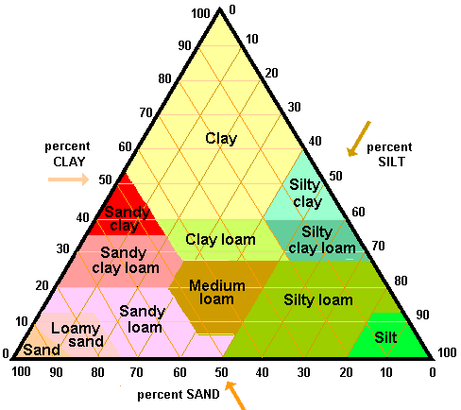
36% Silt
36% Silt
40% Sand
22.8% Clay

Figure 1. Soil texture triangle
40% Sand

Temperature & Humidity
In order for the crops to thrive, an ideal temperature and humidity level is desired. Using a temperature and humidity sensor, the user can control a misting system which works by way of evaporative cooling to regulate temperature and humidity.
Based on the level of reliability and accessibility of Nicaragua’s electrical distribution system, our team has determined that solar power is the best alternative to power the electrical system. A simple 12-volt battery being charged by a photovoltaic array will provide power to the microcontroller and solenoid valves.

Overview Diagram
The smart water irrigation system uses sensors to regulate relative air humidity, air temperature, and soil moisture (VWC) through control valves. The sensors also allow the user to monitor their data and experiment by making adjustments to control valve thresholds.
The System Installed in Managua, Nicaragua offers historical data upload to an SD card. The system in Managua is powered by a photovoltaic system that is self-adjusting. The demonstration system uploads historical data to a web site (Thingspeak.com) where it is displayed on a dashboard and archived, and this system is grid powered.
Altogether the system provides the study of a given plant subject and aims to improve on watering techniques and water usage in a specified environment. Figure 2 shows a one-line of the ‘Smart’ Drip-Irrigation system.

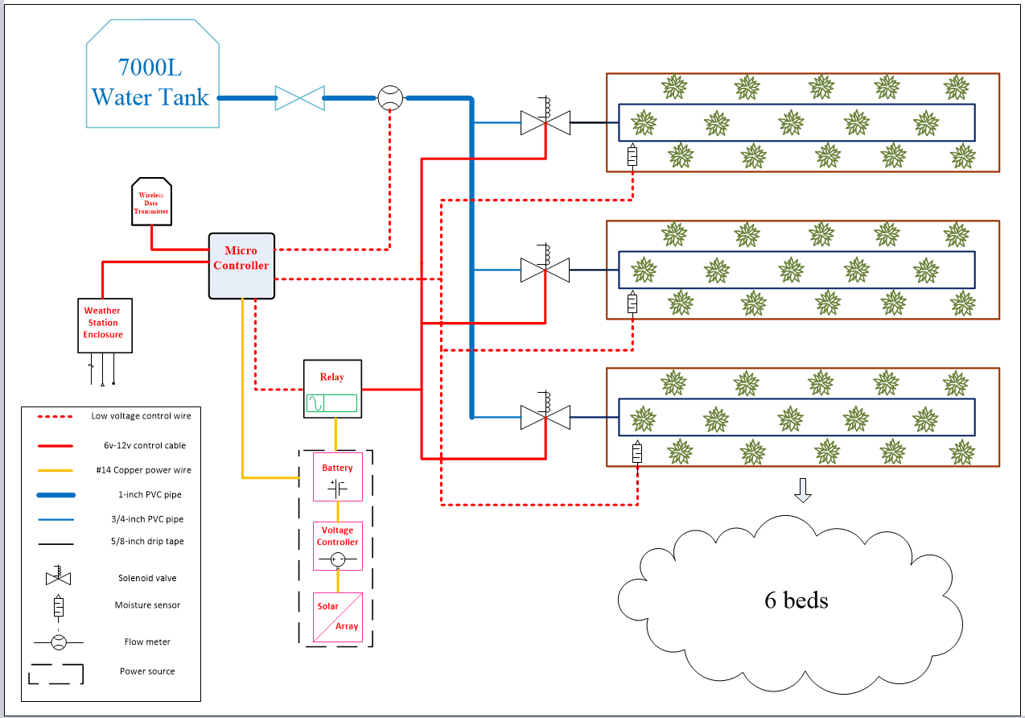

Figure 2. One line diagram of the ‘Smart’ Drip Irrigation System.
Statement of Goals
Our target objective for this semester has been accomplished. The ‘Smart’ water team has built the prototype system and it has illustrate the most basic features of our system. Those features include sensing moisture content in the soil, actuating the water solenoid and using moisture data to open and close the solenoid. The block diagram in Figure 3 helps illustrate and clarify the goals and their mutual dependence.
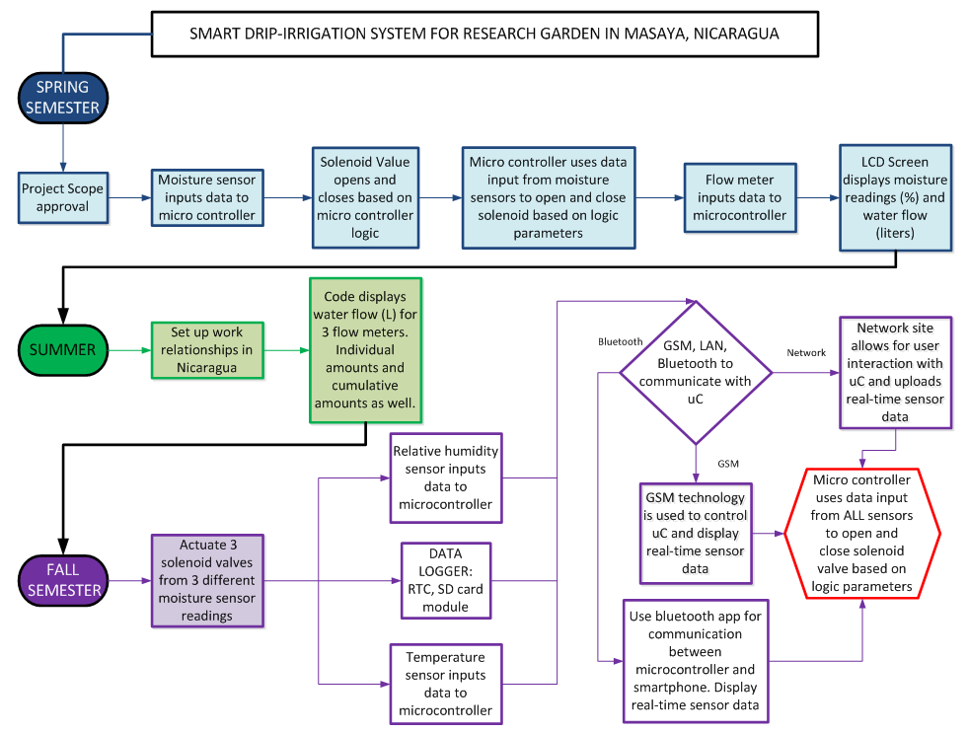Figure 3. Goal analysis with Spring 2016 Goals (blue), Summer 2016 (green), and Fall 2016 goals (purple).

Engineering Specification and Constraints
Specifications:
- Water Distribution: System must be capable of irrigating 100 m² (1076 ft²). The water distribution will consist of a 7,000 liter reservoir, 1” head pipe, and 3/4” manifolds which are connected to 3/8” drip hoses which irrigates the crops.
- Power: 12V battery capable of providing a source current of 5A. With 2 valves, each drawing approximately 3 mA, a 12V-5A source should be sufficient to supply power to the system. Additionally, the power system must be able to sustain the ‘Smart’ irrigation system for up to two days of no sunlight.
- Longevity: The system must be robust enough to last at least four years in Nicaragua’s climate.
Constraints:
The purpose of the ‘Smart’ irrigation system is to collect data to be analyzed by the user so it is imperative that we collect the data as accurately as possible. Coupled with the fact that we need a reliable, low-maintenance, and robust system, our budget limits the quality of sensors we purchase and thus, affect the accuracy and longevity of the system. With quality, proven, off-the-shelf soil moisture sensors, the price of just the moisture sensors comes to approximately $100. Though the price is within our budget, it would surely mean that we would lose funds from the power system and again, affect the reliability and longevity of the system. Cheaper off-the-shelf soil moisture sensors are available, but surely won’t last through much of Nicaragua’s harsh climates. On the other hand, the use of micro-strip soil moisture sensors are currently being explored. These build-it-yourself micro-strip sensors are known for being cheap and reliable.
Engineering Standards
The system will require a weatherproof box due to the fact that it will be deployed in a high ambient temperature and humid environment. Environmental elements such as water, soil, sunlight, and heat can damage the system. An IP55 power cord connection box will provide dust and water protection for the system.

Budget
The budget for the ‘Smart’ irrigation system can be seen in Table 1. The financial total for the project is $25,787.01.
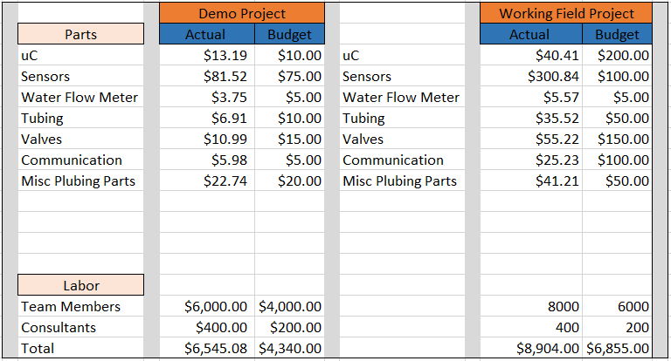
Table 1. Financial Breakdown

Results
The system installed in Managua, Nicaragua performed as expected when tested in the greenhouse environment. The electronics were enclosed within an IP55 rated box. The wiring was secured through PVC conduit and sealed to provide extra protection from environmental factors such as water and pests.
The demonstration system also performed as expected. Real-time sensor data uploaded to Thingspeak.com is shown in Figure 4.

Figure 3. Real-Time data as seen on Thingspeak.com mobile app and online site

Figure 4. Real-Time data as seen on Thingspeak.com mobile app and online site

Conclusion
The Smart Drip-Irrigation System has been deployed to Nicaragua. There, the system will collect soil moisture, temperature, humidity, and water usage data. Using this information, the system will irrigate crops and log the data. The user can then use logged sensor data for research and development purposes such as verifying current farming practices or developing new ones.
The long term goal of this project is to develop a system for the small-scale farmer that is cheaper, more water efficient than a traditional irrigation system, and performs as well or better than the traditional system. After some time, the robustness of the R&D system can be assessed, and, using the data collected, future teams can develop a version of the system for the small-scale farmer.

