From: Team 5
University of Houston
4800 Calhoun Rd.
Houston, TX 77004
Date: December 5, 2016
Subject: Final Report
To: ECE Department
University of Houston
4800 Calhoun Rd.
Houston, TX 77004
ECE Department:

This report will go over the final stages of the ECE Segway and what has been accomplished for the whole academic year. The objectives finished for ECE 4335 are the Tiva C can now communicate with the senor hub, the motors can be controlled with the processor, and finally the correct signal is now sent to the motors to control movement for forward and backward direction. For the fall semester we have a connected all the components onto the frame and have built a case for our power supply to keep the user safe from any harm. We are finally at the final stage of debugging our code for self-balancing. What remains after self-balancing is to balance an individual and have full dynamic motion. Our proportional integral derivative (PID) control system has been tested for obtaining the correct KI, KP, and KD values for stability. After tuning the controller manually we found our values to be around 5 for KP, 0.15 for KI, and KD was set to zero. We have also set deadlines for all the objectives in order to finish on time. This report contains the introduction, abstract, background and goals, design & methodology, recommendations, specification & constraints, financial summary, results, and finally a conclusion to sum up.

Best,
Team 5

Project:
ECE Segway
Sponsor
ECE Department at the University of Houston

Final Report

By
Team 5
December 5, 2016

Group Members:
Emmanuel Olear
Frank Rodriguez
Nelson Grajales
Luis Camacho

Abstract
Team Segway is upgrading the ECE Segway with new hardware and a more efficient PID control to stabilize the Segway. The way the Segway will work is that it will have a feedback loop system that will balance a person that is traveling or trying to stand still on the Segway. The feedback loop system balances the person, whether traveling or not, depending on the sensor data that the microprocessor receives. After processing the data with a PID control, the algorithm is sent to the microprocessor and will output the appropriate pulse width modulated (PWM) signal that needs to be sent to the motor controller. The motor controller will then operate the motors to have the person balance while traveling or in a standing still manner.
At the start of the project the team was trying to use as much material as possible from the previous project. Due to the lack of information, components, and trying to reverse engineer the old project, with the exception of the microprocessor, the team was set back in testing due to only a few materials being left in good shape. By the first third of the spring semester the team decided to change the entire system, with the exception of some parts that needed to be replaced.
The objective for the spring semester was to have communication between components to show forward and backward motion, which was accomplished. The first deliverable was to test the motor controller by creating a PWM signal with a signal generator that would make the motors move forward and backward. The second deliverable was to get communication between the sensors and Tiva C to create and output the same PWM signal that was created by the signal generator. The last deliverable was to have the sensors, Tiva C, motor controller and motors work together to have forward and backward movement.
The objectives for the fall 2016 semester were to have the Segway balancing on its own, balance a person on the Segway while standing still and moving forward/backward. The team was able to design a functioning Segway and demo it to the instructors of the course.

Contents
Introduction and Background 1
Purpose 1
Background and Goal 1
Overview Diagram 1
Specifications 2
Constraints 3
Engineering Standards 3
Design and Methodology 4
Design 4
Methodology 4
Spring 5
Summer 7
Fall 7
Results 11
Conclusion 11
Recommendations 12
Financial Summary 12
Appendix 16

Figure 1 Overview Diagram 2
Figure 2 Goal Analysis 4
Figure 3 PWM signal 6
Figure 4 sensorHub Data 6
Figure 5 Main Menu 8
Figure 6 Option 4 testing 8
Figure 7 Controller modeled in Matlab 9
Figure 8 Transfer Function 9
Figure 9 Protective case for power system 10
Figure 10 Final Design 10
Figure 11 Schematic for Segway and connections for motors and power supply. 16

Table 1 Re-used Parts 13
Table 2 Budget 14
Table 3 Division of labor and consulting 15

Introduction and Background

Purpose

The main objective is to rebuild the ECE Segway and upgrade it with newer digital components. With that said, we also want to provide an efficient safe method of transportation.

Background and Goal

Our objective for the ECE Segway is to interest the youth by showing them the creative and rewarding side of electrical engineering. The Segway functions as a device that the ECE department will use to attract and encourage students to major in the STEM field. Many programs use different products and tools to promote the STEM field and the Segway is an excellent example that will serve this role. By bringing our users closer to how this technology works, we believe we can help show them all the great things that can be created when majoring in the STEM field.
The branches of electrical engineering that are most apparent in this project are power, controls, and embedded systems. The Segway can be explained in the following way. The microprocessor will be the brain of the feedback loop system that makes all the decisions. The microprocessor will also read angular data from the sensors, create a response to the data by outputting a pulse width modulation signal. From the signal we receive, we will send this to the input signal of the motor controller and control the motors to balance the system. This process will be repeated in a loop to keep the system stable.

Overview Diagram

The ECE Segway was a project completed by a senior design team back in fall 2008. Figure 1 shows the overview of the project and the upgrades being completed for the Segway. The left side displays the old model and the parts that were used in the design back in 2008, while the right side shows the new components that will be added to the design. This includes having a newer microprocessor/sensors, a saber tooth motor controller, and a brand new steering system. We have replaced the old microprocessor with a faster clock speed as well as replaced the motor controller with a new feature of powering and connecting all the components onto one device. The steering system is now using a joystick for turning motion. Lastly, we decided to keep the frame and motors the same to save on our budget.
Figure 1 Overview Diagram

Specifications
As mentioned the Segway is a device used for transportation and as every device of transportation it has certain specifications. The specifications set by the team for this project were that the Segway have a top speed of 10 miles per hour. The team saw it as a proper speed to have for our Segway being that after doing some research the original Segway had a top speed of 15 miles per hour. We also wanted the Segway to transport a person that had a maximum weight of 200 pounds. Being that the ECE department wanted to use this device as a means for recruiting students to get interested in STEM fields and in the college of engineering, the team saw it fit that the majority of people that would want to ride it would not exceed this amount of weight. The typical weight of teens in the ages of 12 to 20 years old is approximately 100 to 140 pounds and the typical weight of an adult man is 190 pounds. We also wanted the maximum output current to the motors to be around 30 [A] which would serve the purpose of setting the maximum speed of the Segway to 10 MPH. The team also wanted the Segway to be able to last a minimum of 1 hour at maximum performance, 10 MPH. The reason for this is that this device is not going to be used for long distance travel and due to this the batteries will be able to last a long period of time before the need to recharge. We also wanted it to have 360 degrees of dynamic movement since it is a device used for transportation it needed to be able to make turns. We also wanted to implement an algorithm having a minimum reaction time of at most 500 [ms]. In order for our Segway to be able to balance and transport an individual it needed to react fast enough so that it works properly. These are the specifications that the team wanted to give to our Segway.

Constraints
For this project there were not that many constraints that the team was restricted from in designing and creating our Segway. One of the main concerns that we did want to address but were not able to find dealt with powering the Segway. Recently there had been a product out in the market called a hover board that was causing incidents where while charging the device would start a fire. There has been a set of standards that address this issue recently but in order for the team to attain this information it would have cost us about $400 and this was not within the budget. Some constraints that we did have to abide to was that the state of Texas has a law that a self-balancing scooter cannot go over 30 MPH. This constraint was met being that our device top speed would be 10 MPH. Another constraint was that once we would get to testing we would have to run many trials in order to get the right parameters for our feedback control system and with that we had the constraint of having to have to take our batteries to charge and lose days for testing. Budget was another constraint being that the ECE department was sponsoring the project we wanted to keep our spending under $700. This was achieved being that we only spent a little under $600. Another constraint that we had was creating a safe testing environment. Like with most devices we wanted our device to be a safe method of transportation and not hurt anyone using it but trying to accomplish this was difficult since in order to tune our controller we had to find a method of testing our system. There really isn’t a way to create a safe testing environment without the proper equipment that would be too costly. Though, with all these constraints the team was able to work and design our Segway.

Engineering Standards
There is also a new standard for self-balancing scooters called the UL 2272 – Outline of Investigation for Electrical Systems for Self-balancing Scooters. Unfortunately we are not able to use this standard since we must purchase it and it costs about $250.00. This standard addresses power supply security as incidents 15 have been occurring recently, such as the batteries combusting. The current standard for the state of Texas deals with operation of a Segway on a roadway. It defines what an electric personal assistance mobility device is, which includes the Segway, and the 30mph speed limit to be operated on a roadway. The standards vary at every state.

Design and Methodology

Design

Our design for the Segway was to add a new motor controller. Utilize a new microprocessor with a new inertial measurement unit (IMU) to obtain gyro and accelerometer data. A joystick to add dynamic movement for turning. We also included from the previous team the brushed DC motors, and metal frame. All of these combined would then be used to have a full functioning Segway.

Methodology

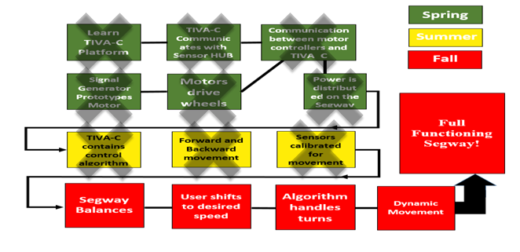
To implement our design we first had to plan out how to achieve our goal of a fully functional Segway. In figure 2 we have displayed our goal analysis showing how we approached our design.
Figure 2 Goal Analysis

Spring
We started our design by first learning all that we had to complete our design. At first we were planning to upgrade what was believed to be a working Segway but what was later discovered is that it was not. There was missing components and not enough information to reuse the current components. We pivoted our design and decided to build a Segway from the ground up.
To begin we researched microprocessors that could handle multiple threads and be able to use interrupts. Our motors were also heavy duty and we need some way to control them. We ended up selecting the TIVA C microprocessor and Sabretooth motor controller. The TIVA C has a 60 MHz clock and it would allow us to process floating point numbers at a greater speed compared to Arduino and other microprocessors. The Sabertooth motor controller was our choice as our motors produce a lot of current. During testing there were times where we burnt out our 40A fuses and had to set up to 100A to protect our system. The Sabertooth can handle continuous 60A and a peak current of 120A. It also allowed us to power the TIVA C independently which saved us time. We could also control the motors by using the PWM signal that would vary the voltage from 0-5V. 5V would be full forward, 2.5 would be stop, and 0 would be full reverse.
We purchased the items needed and while we waited we trained ourselves. We practiced programming the TIVA C processor and renewed our knowledge of lab tools such as the oscilloscope, DC power supply, and signal generator. We used the signal generator to mimic a 5V, 20 kHz pulse width modulated signal (PWM) and then varied the duty cycle from 20-80%. The DC power supply was used to power the motor controller so that we can pass along the signal to the motor controller so that we could check movement within our motors. Once we felt comfortable we moved to using the actual microprocessor to produce the PWM signal.
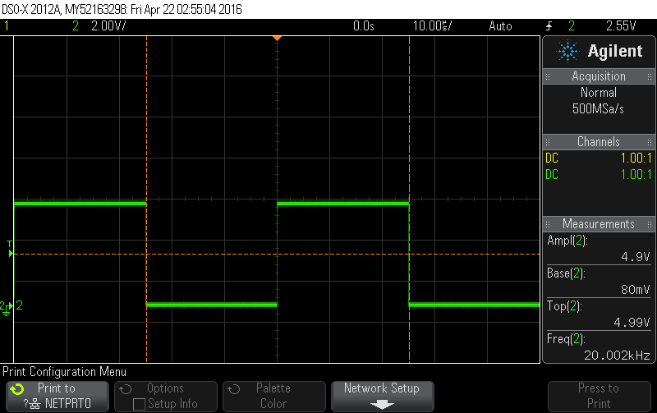
Figure 3 PWM signal
Figure 3 displays the signal generated by the TIVA C microprocessor. Once we were able to produce a signal for our motors we moved onto to interfacing the sensorHub for the TIVA C. We were able to program and read data necessary for our application such a gyro angles and other data displayed below in figure 4.
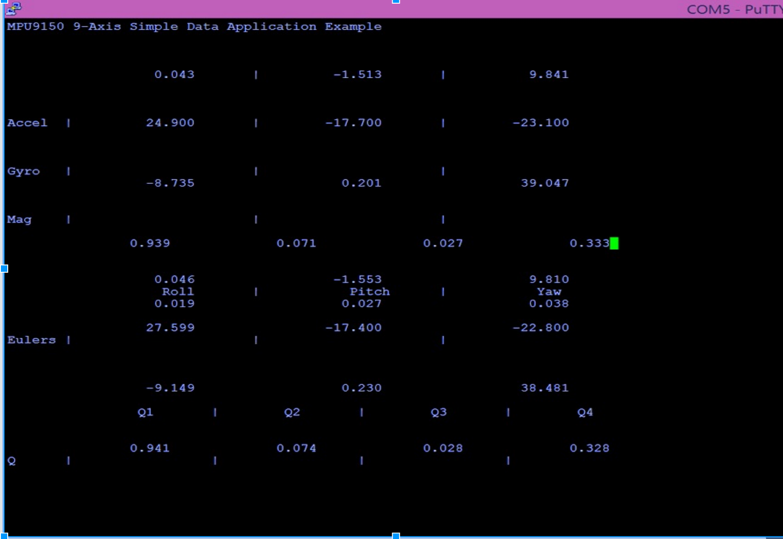
Figure 4 sensorHub Data
The values we looked at the most were the Euler angles. The Euler angles would tell us what angle the Segway was currently at. The values were also filtered to reduce noise using a complimentary filter. We had read that IMU readings can be extremely noisy and made sure to check that we were receiving correct values by using the UART displayed in figure 4. The sensor hub came with library functions where we could pass along values that would then be filtered saving us time.
Our final initiative for the spring was to interface all of our components. We attempted to tilt our microprocessor and expected to see motor movement based on the tilt of the sensor. We were able to achieve this but, we realized the signal produced by the TIVA C was 3.3V. The motors could only move forward very slowly due to the inability to produce a voltage greater than 3.3V. We also were not able to use the previous team’s batteries as they no longer could hold charge. We planned to correct these issues in the summer.

Summer
As a team we decided to use our summer well and set out to complete our goal of a functioning Segway. We first tackled the problem of amplifying the voltage from the TIVA C. The current 3.3V value was not enough so we bought a bi-directional level translator that was recommended to us from the TI forum. One of our members had to first learn how to solder and then we were able to setup the voltage to 5V. Our team also finished the power distribution system that used two 12V batteries in series to produce 24V. The batteries are lead acid and are also 30AH. A relay is used with the fuses to protect the components of our system. We assembled everything and used a makeshift board to test out forward and backward movement which we were successful. We also were able to develop a frame work for our code to ease debugging.

Fall
For fall 2016 semester team 5 was able to develop our PID code, turning code, and created a user interface for testing purposes. Figure 5 and 6 below are snippets of our user interface for testing.
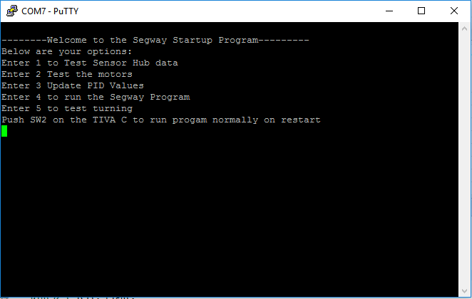
Figure 5 Main Menu
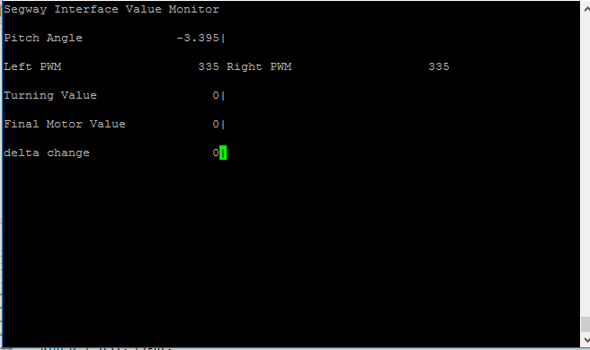
Figure 6 Option 4 testing
The interface allowed us to rapidly test for errors and test different Kp, Ki, Kd values.
Figure 5 shows how we could test for sensor data, test motor values, update PID Values, test turning and option 4 was to run the code. Option 4 is demonstrated in figure 6 showing how we can see the current angle value, motor values, turning values, final PID value and we added a delta value at the end.
Testing proved to be difficult as we came into many issues. Before we had switched out the 40A fuses we were having an issue with our motor controller no longer responding and TIVA C not responding as well. We figured out the issue with the motor controller arose from a ground wire connected from the TIVA C to the motor controller became lose on our breadboard and the influx of current shorted the protection system. For the TIVA C we believed on of our members computers had a USB port that may not have been compatible causing the connection with the TIVA C to no longer work. We luckily had backups for each, but figuring out the issues took time. Safety was always a concern so we thoroughly tested every component when it would fail.
With safety again on team 5’s mind we made sure to check our system and modeled it on MATLAB using SIMULINK. Figures 7 and 8 demonstrate how we modeled our system. We also verified our model with Dr. Provence who specializes in control theory and who is the professor for controls at the University of Houston.
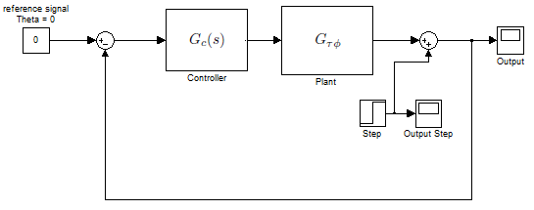
Figure 7 Controller modeled in Matlab
Figure 8 Transfer Function

After everything was verified and tested the team went to design a final layout for all the circuits and material to have it attached on the Segway. Figure 9 and 10 show our final design .
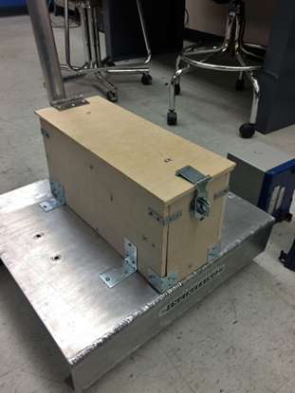
Figure 9 Protective case for power system
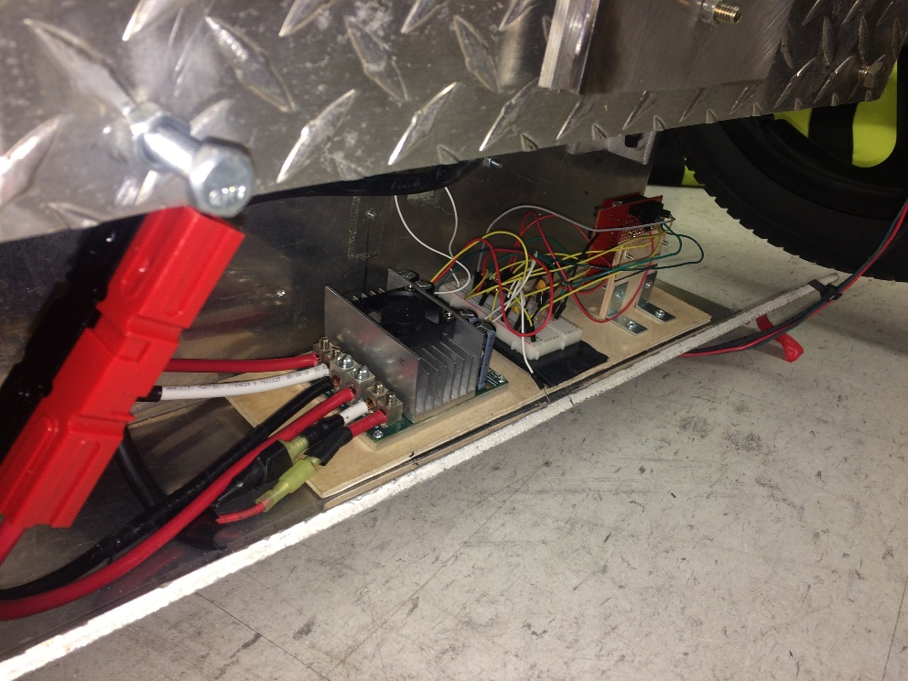
Figure 10 Final Design
The team finally began testing the Kp, Ki, Kd values. The values we received on MATLAB were used as a guide to help us balance our system. We researched that too small a Kp would cause drifting and to high would cause oscillation. Too low a Ki and the system would not react fast enough and too much would cause oscillation. A too low Kd value would not help remove oscillation and to high would cause instability.
Team 5 was able to fulfill their design requirements but we were not able to balance our system which will be discussed in results.

Results
We were able to construct a circuit that would filter the pwm signal from the tiva c processor to the microcontroller and designed a fully functioning Segway. The issue that set us back from concluding the project was the instability in the angles. The team implemented a complimentary filter to make sure that the angle readings would not be a problem. The complimentary filter is known for being more robust than the Kalman filter so we believed that it would suffice. But after working with Dr. Provence we believe that a Kalman filter would have been a better choice in order to handle the vibrations from the system as it tried to balance. We addressed the issue in our final presentation and presented recommendations to fix this issue for the next team that decides to continue this project. The Segway was able to read the PID code and would balance for short periods of time similar to the system shown in figure 7. The proportional gain would cause the system to oscillate while the integral and derivative gain would bring the oscillations down in order for the Segway to balance. The steering mechanism was also designed using a joystick to control the wheels.
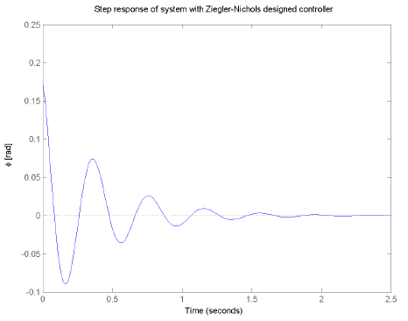
Figure 7: Ideal Step Response of a Similar System

Conclusion

The final report for the Segway project summarizes everything that team 5 was able to accomplish since spring 2016. This fall 2016 semester we have completed everything we set for our summer and spring goal analysis. For our design II section this semester we have completed turning motion as well as setting the final design for the Segway. We have also completed setting the desire speed the user will be able to control when riding the Segway. By working with Dr. Provence we learned how to tune the Segway to balance by adjusting the proportional, derivative and integral gains for the system. We were able to get the Segway to stabilize a few seconds at a time but due to the instability in the angle readings the system could not balance on its own for longer than a few seconds. Overall, the Segway was a very challenging project, but by working on this project the team members for team 5 feel confident they are ready to face the real world’s complex projects given the skills we have acquired through this course.

Recommendations

We believe that our project is near completion. To stabilize the Segway we would recommend further filtering the sensor data. We implemented a complimentary filter but we believe a Kalman filter would be more robust. We would also recommend to use tilt sensors instead as they have less noise issues compared to inertial measurement units (IMU). Once the angle readings have been corrected the project can take its next step to either become a greater educational resource or to challenge further students. To become a tool for the ECE department we believe the Segway should have a touch screen displaying in real time the information from the Segway such as Kp, Ki, Kd, current voltages, etc. This information will then be placed online so during recruitment students can see various parts of electrical engineering in one project. This would be a great way to attract and show off to prospective students. As for the challenge we believe once the Segway is balanced creating an autonomous mode would further the goal for an easy mode of transportation.

Financial Summary

The Segway project is a continuation of the Segway that was built in 2008, for that reason some of the components that were used to build it were kept the same. The following table shows the parts the team decided to keep and not modify.

Table 1 Re-used Parts
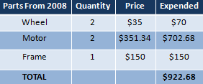

The advantage of keeping these components is that they still work and it reduced our budget about $1,000 in cost. As stated before, this project was intended to be a continuation of the old Segway, but due to missing components and missing information the team was forced to start almost entirely new. The following table shows the amount of labor and consulting that the team expects to do and the parts that are to be used to build the Segway.
Table 2 Budget
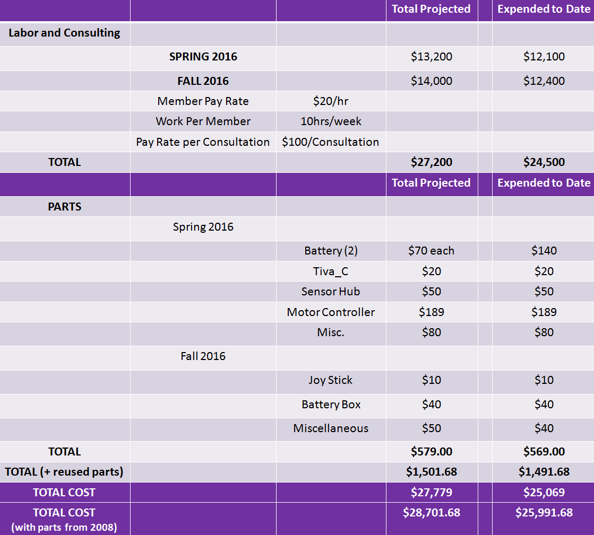
As the project comes to an end the team achieved to be under budget as represented in the table above. The main concern that was to be kept under budget dealt with the maximum $579 to be spent on parts which was accomplished by only spending $569. Being that we are being funded by the ECE department we have been trying to cut down as much of the cost as the team has been able to. The majority of the budget is the amount of labor that the team has been putting throughout the semesters into building the Segway. Table 3 explains how the labor and consulting are broken down.

Table 3 Division of labor and consulting
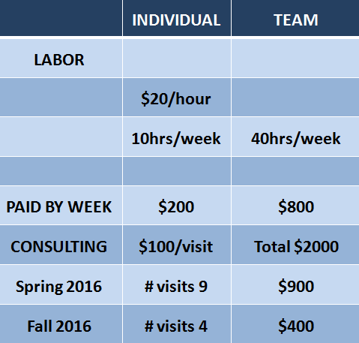
The second column labeled “individual” explains the hourly pay rate, hours worked per week, payment by week, and the total for the fall semester individually. The column labeled “team” explains the same as parameters as the “individual”. Part of the budget also includes consulting which is described by the last row of the table above. Each visit we value it as $100 and plan on meeting consultants a maximum of 20 times for the semester. We stayed under budget for consulting visits for both semesters which we made a budget of $2000 for each semester. In the spring semester we were under budget by $1100 and in the fall under budget by $1600. Through all the obstacles that we faced we were still able to be under budget.

Appendix
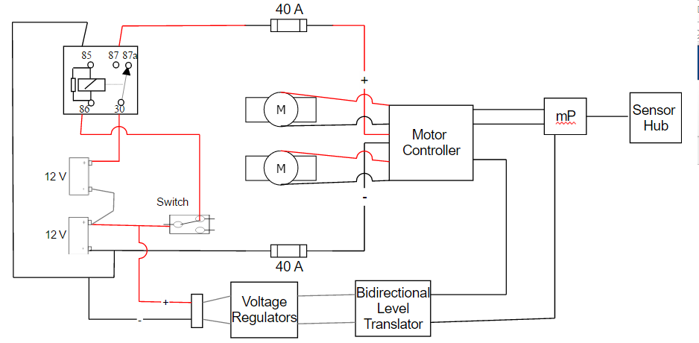
Figure 11 Schematic for Segway and connections for motors and power supply.

