Date: December 1, 2016

Subject: Final Report of the Wireless Charging and Transmission of Medical Devices Project

To: Drs. Jinghong Chen, Bhavin Sheth, & Ji Chen

CC: Drs. Jose L. Contreras-Vidal & Shin-Shem Steven Pei

Dear Drs. Chen, Sheth, & Chen,

It is a pleasure to inform you of the progress of our project for University of Houston. James Cockrell, Krystal Gengler, Seungwoo Park, and Derian Widjaja will develop the wirelessly charged biomedical device. This project will help medical doctors and patients who have to use a medical device inside of the body by avoiding battery replacement surgery. Please look at the attached report for detailed information on the design of our project. It outlines the introduction and background, goal analysis, engineering specifications & constraints, standards, risks and risk management, budget, design, methodology, results, conclusions, and further recommendations of our project.

At this time, we have successfully completed our project, including lithium-ion battery and temperature sensor research, a wireless charging circuit research, MCU and Bluetooth power optimization, calculated our electrical limitations, finished our prototype build, and final testing of our prototype inside a saline gel. All final results and future recommendations for our project have been included in this paper for your convenience. As far as parts and components of our device, we are well under budget of our project. However, due to the addition of a faculty advisor for expertise on our project, we have gone over our projected budget for labor. If you have any question regarding this project, please email me.

Thank you,

Team 7

Krystal Gengler

Electrical Engineering

University of Houston

[kdgengler@uh.edu](mailto:kdgengler@uh.edu)

**Wireless Charging and Transmission of Medical Devices**

Sponsors: Jinghong Chen & Bhavin Sheth

Assisted by: Dr. Ji Chen

James Cockrell

Krystal Gengler

Seungwoo Park

Derian Widjaja

ECE4336: Engineering Design II

Facilitators: Dr. Shin-Shem Pei and Dr. Jose Contreras-Vidal

December 1, 2016

**Abstract**

The purpose of this report is to update faculty sponsors on the completion of the Wireless Charging and Transmission of Medical Devices project. The goal of the Wireless Charging and Transmission of Medical Devices project is to provide a biomedical sensor with a way to wirelessly charge while implanted in the human body in order to prevent multiple surgeries to replace batteries, as well as a way to wirelessly transmit data via Bluetooth. From the spring semester we have carried over a device that can collect data and transmit it wirelessly over Bluetooth. This semester we have focused on adding wireless charging, making the device battery powered, and monitoring temperature data. We have focused more on the practicality of the wireless charger and Bluetooth transmission rather than the size of our device. While not large, our device is not small enough to be implanted in the human body. For this reason, our final device has been tested in an approved ASTM standard saline gel substance that has been tested to mimic human skin conditions [1].

**Table of Contents**

**Introduction & Background** 1

**Statement of Goals** 2

Figure 1: Overview Diagram 3

Figure 2: Fall 2016 Goal Analysis 3

**Specifications** 4

**Constraints** 5

Table 1: ICNIRP Limitations for Bluetooth and QI Frequency Ranges 6

**Engineering Standards** 7

**Design and Methodology** 8

Figure 3: Wireless Charging Receiver Schematic 9

Figure 4: Wireless Charging Transmitter Schematic 10

Figure 5: Block Diagram Design for Circuit 10

Figure 6: Completed Circuit Design 11

Figure 7: Wrapped Transmitter on Gel Surface 12

Figure 8: Test Plan 14

Figure 9: Demonstration of Transmitter and Receiver 15

**Results** 15

Table 2: Test 1 Results 17

Table 3: Test 2 Results 17

Table 4: Electromagnetic Properties of Device 18

Figure 10: Device Temperature Inside Saline Gel vs Time 18

**Conclusions** 19

Table 5: ICNIRP Requirements vs Device Data 20

**Recommendations** 20

**Financial Summary** 21

Table 6: Budget for Both Semesters 23

# **Introduction & Background**

The purpose of this project is to allow long-term biomedical sensors to be placed inside the body without the need for further invasive surgeries to replace batteries or to retrieve data. Doctors and hospitals will be able to implant and collect data from the sensors, while patients with the device implanted can have important medical information wirelessly transmitted. The sensor will work as a Bluetooth device, and data can be easily transmitted to the patient’s phone or doctor’s office. To charge the implanted biomedical sensor, patients will visit a medical professional with the equipment and training necessary to wirelessly charge the sensor. This device will reduce the amount of time, money, tools, and other resources needed to perform multiple battery replacement surgeries, as well as preventing further health risks associated with additional surgeries.

Medical devices designed to be implanted in the body already exist and have been in use for years. Over this time, they have been developed to use as little power as possible, but do not currently have a method to wirelessly charge the device. The closest method to being able to charge an implanted device includes running electrical contacts through to the outside of the body where they can be accessed at the skin. Although these contacts do allow for the device to be charged without invasive surgery, this method introduces a risk of infection to the patient.

Despite the fact that some products already implement inductive charging, such as some high-end mobile phones, a method to apply this to an internal medical device has been researched, but is not yet available commercially. This research primarily includes a method on Transcutaneous Energy Transfer, or TET, as a way to inductively charge devices such as artificial hearts.

# **Statement of Goals**

Our project is divided into two parts: wireless transmission of data through Bluetooth, and wireless charging of the medical sensor. Figure 1, below, shows these two parts.

In order to build the medical sensor, we must look at both power consumption and signal processing. Although we will consider them at the same time, we have separated them on our overview diagram, as seen in Figure 1. First, the signal we are reading in from our temperature sensor will be detected and transmitted from the circuit to the microprocessor (labeled MCU Signal Processing in Figure 1), where it will then be sent to a Bluetooth module and received by the user’s device. For the Spring semester we used an EKG signal as our medical sensor because of its high amplitude and unique spectrum. This allowed us to demonstrate the successful completion of our Bluetooth transmission at the end of the semester. For our final project, this was changed to the temperature sensor to more accurately represent a sensor that would be used internally.

For both systems, power will be supplied by a battery charged wirelessly through a QI-compliant wireless charging circuit while the sensor is in low-power, or sleep, mode. An inductive power retriever will receive energy from an RF power transmitter to charge the sensor’s battery. Therefore, this biomedical sensor device can save energy and transmit data within an isolated environment, such as within the body.

|  |
| --- |
|  |

Figure : Overview Diagram

The end goal of the project is to have a device that will collect temperature sensor data and transmit it wirelessly via Bluetooth, as well as the capability to charge wirelessly through induction. We will be testing our final product in an approved ASTM standard saline gel substance that mimic human skin conditions. This will allow us to test the success of our final product without performing an invasive surgery on either human or animal subjects. Figure 2 shows a block diagram of our goal analysis for the Fall semester.

|  |
| --- |
|  |

Figure : Fall 2016 Goal Analysis

# **Specifications**

The power of the device can be charged at 4.2 [W] (max) wirelessly. The charging frequency is 110 – 205 [kHz], which is within the range deemed safe for electromagnetic exposure to human skin. The overall peak AC – DC efficiency is 93%. The charging circuit is controlled by a temperature sensor and lithium-ion battery charging circuit. Temperature and battery voltage level will be monitored in real time. The transmitter and receiver will communicate within QI (WPC v1.1) protocol, thus, it will not have an external communication circuit for charging control. The maximum voltage of the receiver (battery) is 4.2 [V], and the charger will regulate it to 3.3 [V] for the MCU and temperature sensor to operate.

In order to increase the efficiency, high-level programming will be needed to reduce the working time and power consumption of the MCU. This power consumption will be found using TI software with the MCU and observed using a sensor and MCU prototype. After developing the wireless charging power system, we will continue attempting to reduce the power consumption of the MCU following the necessary safety standards for medical devices as given by the FCC.

The temperature sensor will check temperature at the battery’s surface. Accuracy of sensor is ± 0.05°C. The temperature data will be used as a feedback to control the output voltage going to the battery charging circuit as a safety measure to prevent the device from overheating (following FDA constraints listed further) or burning of the skin.The temperature sensor data will be transmitted wirelessly via Bluetooth module MIKROE-1715 attached to the MCU to a phone or PC. We have chosen to use Bluetooth Low Energy rather than an alternative, Zigbee, as Bluetooth Low Energy transmission is faster, uses less power, can transmit a wider variety of data, is able to transmit directly to the patient’s phone, and is already widely used in medical devices.

To find the maximum skin depth limitation, the receiving power gain, electromagnetic radiation, and the best position for our wireless charging device, an electromagnetic shielding room experiment is planned. The device will be tested in an ASTM standard approved saline gel, which has a conductivity (σ) equal to 0.47. The saline gel will be used to mimic human skin conditions, where we will test at varying depths for temperature, electric field, induced current, wireless charging time, and the successful transmission of wireless power and Bluetooth transmission. The saline gel used mimics the human body in that it may represent any parts of the human body, as our body’s characteristics are nearly uniform and homogeneous throughout.

# **Constraints**

A major constraint is that of skin tissue and electromagnetic field limits. The Specific Absorption Rate (SAR) is the measure of rate at which energy is absorbed by the human body when exposed to RF electromagnetic fields. This is measured in power absorbed per mass tissue [W/kg]. The FCC is stricter with its SAR guidelines than the IEEE, with limits of 1.6 [W/kg] averaged over 1 gram of body tissue for head and trunk regions. The FCC evaluates inductive wireless power transfer of devices. Applications that meet the following requirements are excluded from submitting an RF exposure evaluation to the FCC:

▪ Power transfer frequency < 1 MHz

▪ Output power from each primary coil < 5 watts

▪ Transfer system includes only single primary and secondary coils

▪ Client device is inserted in or placed directly in contact with the transmitter

▪ Aggregate leakage fields at 10 cm surrounding the device from all simultaneous transmitting coils are demonstrated to be less than 30% of the MPE limit.

Another constraint is that of battery temperature. The US FDA limits temperature rise of embedded medical devices to 2° Celsius within the user’s average body temperature. This limits the charging power of our device.

The MCU needs to be powerful enough for live processing, however we have a power consumption constraint requiring low-power to reduce the need for charging and to comply with medical safety standards for implanted devices, such as not generating heat within the body.

Another constraint is the ICNIRP standards, which set limits to any electromagnetic exposure to the human body based on different frequency ranges. Table 1, below, will show the value limits for electric field, magnetic field and strength, and power density. Since we will be using Bluetooth and QI together in one device, we will be comparing these two limits and will use the smaller of the two in order to meet both requirements.

Table 1: ICNIRP Limitations for Bluetooth and QI Frequency Ranges

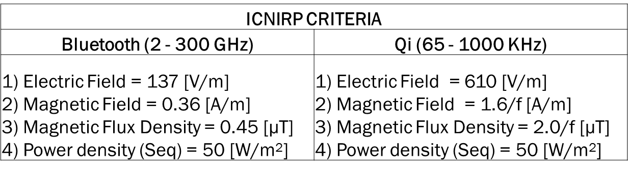

A final constraint is skin depth. Because a wirelessly charged device will act differently when implanted versus in air, we will use a gel acting as skin to test the wireless charging and transmission capabilities of the device when implanted at certain depths within the saline gel. Depending on how deep the sensor will be embedded, attenuation may occur. This will result in power loss during charging. Furthermore, it will affect the Bluetooth data transmission as it operates in the GHz rage. In this case, the signal will need to be increased in order to be strong enough to overcome the barrier.

Beyond the scope of our project, are size constraints, human and animal trials, and software analysis. Size is not a priority for the completion of our wireless charger project. Instead, the wireless charger and its practicality will be prioritized, followed by scaling down the size of the circuit. To replace the need for human and animal test trials, we will be using the ASTM standard approved saline gel provided by Dr. Ji Chen. This gel will mimic human skin conditions closely enough to test the power, electromagnetic, and charging requirements of our device without human or animal test subjects. Finally, a software simulation analysis will not take place for the testing of our project at this time. Following the advice of Dr. Ji Chen, we will perform only the physical testing of the device in the saline gel. The software simulation will require extensive EM knowledge and familiarity with the software. Our lack of familiarity could result in inconclusive data or errors rendering all data useless.

# **Engineering Standards**

For our project we are required to follow standards for wireless transmission by Bluetooth and for our power charging. In order to market our device as a Bluetooth enabled device, we must follow Bluetooth SIG Standards. Bluetooth is a way to exchange information through short-range radio frequency band. Bluetooth SIG standards require that companies using their technology must become members of the Bluetooth SIG. This is to support interoperability, conformance to the Bluetooth specifications, and to strengthening the Bluetooth brand.

In 2012, IEEE introduced the Power Matters Alliance to publish safety standards for inductive power supplies. The main features of the Power Matters Alliance include inductive coupling, digital transceiver communication, and Cloud-based power management.

Because we are working with a biomedical sensor that will be used as a medical device within the human body, we are bound to work with medical standards. The medical standards required are provided to us by the Association for the Advancement of Medical Instrumentation, the American Food and Drug Administration, and the Federal Communications Commission. These standards require testing methodology for electromagnetic compatibility and interface frequencies, and gives performance limits of EM emitters. We have contacted the FDA about standards for wirelessly charged implanted devices, however there is currently no standard that meets both of these requirements. We have decided to follow the standards presented by ICNIRP and the FCC’s requirements for medical devices using the Wireless Medical Telemetry Services regarding guidelines for exposure from electromagnetic waves directly on the human body.

# **Design and Methodology**

The circuit design we used for our circuit was inspired by a pre-existing circuit designed for wirelessly rechargeable wearable devices. This circuit is shown below in Figure 3, the receiver, and Figure 4, the transmitter. While our project is intended to be an embedded medical device, the wirelessly rechargeable aspects were similar, especially in the use of Lithium-ion batteries. We used Figures 3 and 4 to design a circuit for our device, shown in Figures 5 and 6. We chose to use a Lithium-ion battery as it stores more energy than regular batteries, and it is safe to use within the human body. After deciding to use a Lithium-ion battery for our rechargeable power source we finalized our decision on using the wirelessly rechargeable wearable device circuit design as it would utilize the Lithium-ion battery aspect. The battery itself is a PKCELL LP401230 with 3.7V and 105mAh. This specific battery was chosen as it is small enough to fit within our circuit design, it is rechargeable, and it fits the requirements for our power limitations, with a maximum charging voltage of 4.2V which can be regulated to 3.3V. The charging circuit chosen is an Adafruit 1551, part number 1904. This circuit was designed from a rechargeable cell phone design with a coil inductance of 9.7µH. The charging circuit was chosen as it is QI-compliant, a requirement for our design. We chose to incorporate a QI-compliant design as it is commonly used and affordable, already proven safe for wearable devices, and RF is low enough to safely penetrate the human body. The power for the MCU needs to be powerful enough for live processing, however we have a power consumption constraint requiring low-power to reduce the need for charging and to comply with medical safety standards for implanted devices, such as not generating heat within the body. In order to ensure minimal safety risks, we have optimized our MCU and Bluetooth device for low power. The microcontroller also allows the device to act as a base platform, adaptable for additional custom sensors and features using TI-RTOS.

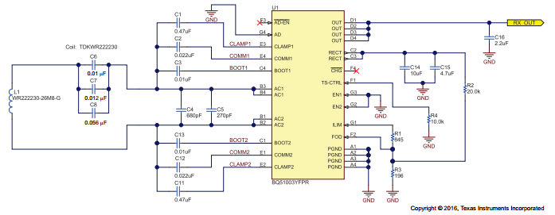

Figure : Wireless Charging Receiver Schematic

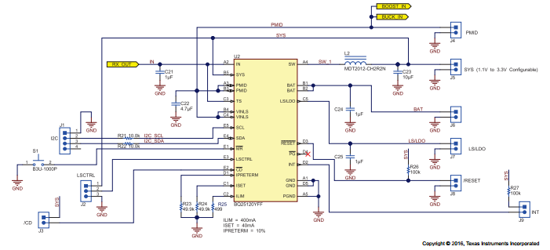

Figure : Wireless Charging Transmitter Schematic

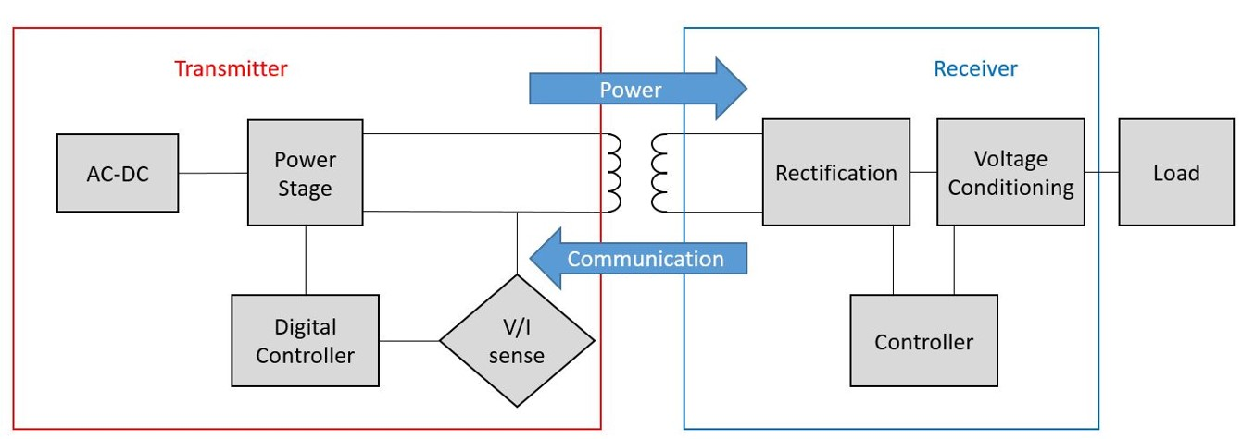

Figure : Block Diagram Design for Circuit

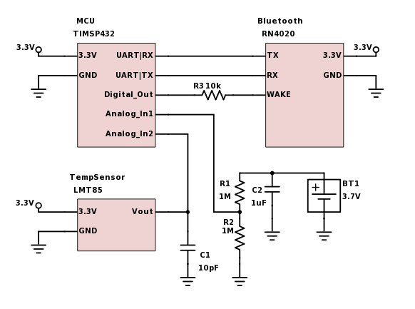

Figure : Completed Circuit Design

A risk associated with our initial circuit build was the breadboard. The breadboard is not a stable setting, and produces noise and disconnections. Due to this, we chose to solder our components onto a printed circuit board. After combining all components on a circuit board and soldering our circuit design, we added a temperature sensor to regulate the temperature increase of our circuit during the charging process. This will act as our medical sensor to send data to the user’s device via Bluetooth. The sensor chosen is a Texas Instruments LMT85LP. The temperature sensor was chosen for its small size, which is compatible with our circuit design, and its accuracy, reading a temperature within ±0.05°C. A voltage regulator was also added to ensure the battery’s charging voltage was regulated from 4.2V to 3.3V. The voltage regulator used is the Microchip Technology MCP1700-3302E/TO.

Prior to testing our circuit a way to waterproof the device was needed. As waterproofing the device was not in our original project, our device was not intended to be waterproof during initial design and build. Thus, we needed a time-efficient addition to the device to allow us to test in an ASTM-approved saline gel. To do this, we wrapped our circuit in plastic wrap and taped it closed, and then placed the covered device within a small Ziploc sandwich bag. Figure 7 shows the transmitter wrapped and placed on the surface of the saline gel.

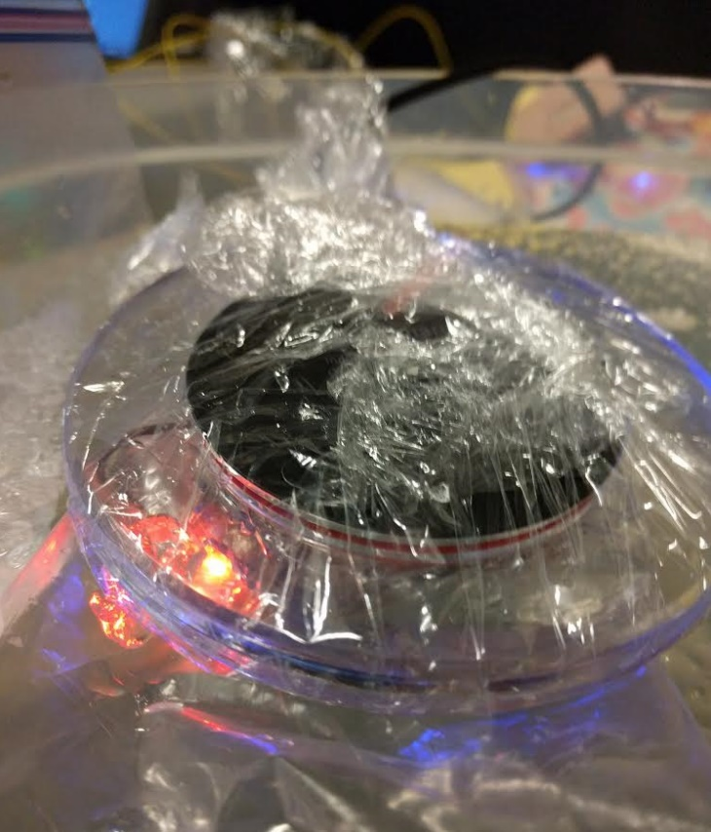

Figure : Wrapped Transmitter on Gel Surface

Our project is divided into two parts: wireless transmission of data through Bluetooth, and wireless charging of the medical sensor. First, the signal we are reading in from our temperature sensor will be detected and transmitted from the circuit to the MCU, where it will then be sent to the Bluetooth module and received by the user’s device. For both systems, power will be supplied by a Lithium-ion battery charged wirelessly through a QI-compliant wireless charging circuit while the sensor is in low-power, or sleep, mode. An inductive power retriever will receive energy from an RF power transmitter to charge the sensor’s battery.

Testing of the completed device was conducted using Dr. Chen’s Microwave Laboratory and his optic fiber temperature probes to receive measurements. An ASTM approved saline gel, placed inside a plastic tub measuring 20cm x 20cm x 10cm with a gel depth of 7cm, was used to test the device within a solution mimicking human skin electromagnetic properties. The saline gel used mimics the human body in that it may represent any parts of the human body, as our body’s characteristics are nearly uniform and homogeneous throughout. The gel was more liquid than solid, so our device was wrapped in plastic cooking wrap and placed within a small Ziploc sandwich bag before being placed within the gel. The microcontroller was used to measure the receiving power, battery voltage, and temperature to send the data. The initial temperature of the gel was measured at 21.6°C.

Figure 8 shows the test plan of our device. The first test we performed was for 0cm, marked. This was done with the wireless charger transmitter and the wireless charger receiver touching outside of the gel, in air. An optic fiber temperature probe was placed on the inductive coils in order to determine temperature at the ‘casing’ of our device. Our second step was to measure the device within the gel. We began by placing the inductive coils with the temperature probe, wireless charger receiver, and MCU, wrapped in plastic cooking wrap, within the gel at 0.25cm. We then placed the wireless charger transmitter, also wrapped within plastic cooking wrap for safety as the gel was very liquid, on the surface of the gel. After confirming a distance of 0.25cm, we began recording the temperature of our device through the temperature probe, and transmitting the data to a mobile phone to test the device’s Bluetooth capabilities. We continued the testing for 10 minutes, recording the temperature at 0 minutes, 5 minutes, and 10 minutes in Tables 1 and 2. The steps were repeated for a distance of 0.5cm, 0.75cm, and 1.0cm. Our results found that 0.75 cm and 1.0 cm depths did not charge the device. Through the testing we found that the maximum depth for a stable Bluetooth reading was 0.5cm, and the maximum depth for wireless charging of the device was 0.7 cm, however the maximum depth for a stable reading was 0.5 cm. We also found that the electric field measured 134.24 [V/m]. Figure 9 shows a demonstration of the transmitter and receiver at a depth of 0cm within the gel.

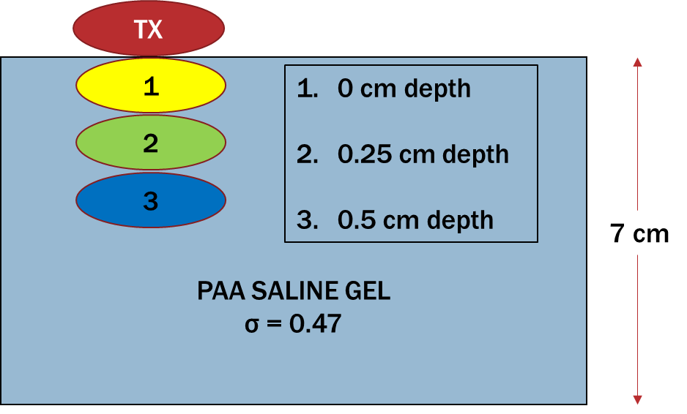

Figure : Test Plan

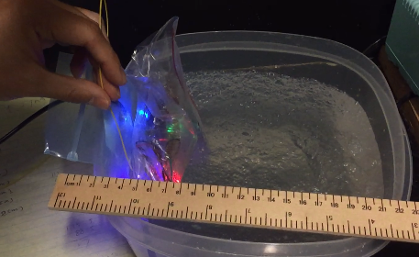

Figure : Demonstration of Transmitter and Receiver

# **Results**

Our team has successfully completed all of the goals set for the Fall semester, and have a completed project. The goals we have accomplished for our completed project are the lithium-ion battery research, wireless charging circuit research, the temperature sensor research, MCU and Bluetooth module power usage optimization, electrical limitation calculations, prototype device build completion, and testing of our device in the ASTM standard approved saline gel to demonstrate both wireless charging and transmission of data through the gel.

The MCU MSP432 can be operated in ultra-low power operation which uses only 274 [W] in typical active mode. The Bluetooth module uses 1.7 [mW] in standby mode and 40 [mW] in working mode. However, the Bluetooth module is used only when needed to send data to the user’s device, so it will work mainly within 1.7 [mW] for standby mode. We have found the sensor to have an accuracy of ± 0.05°C, and use 30.36 [W] of power. It will send a voltage output depending on the temperature feedback. We have interfaced the temperature sensor to the MCU in order to convert the voltage into a readable temperature and send it via Bluetooth. This could also be implemented to monitor the device’s temperature and act as a failsafe in the event that something in the environment causes the sensor to rise above the specified constraint of 2°C above the average body temperature. The calculated typical operation power of our device is about 15 [mW], and our lithium-ion battery, with 3.7 [V] and 105 [mA], will have enough power to operate it. The QI wireless power transmitter and receiver build and inductive coil build will work together. We have successfully combined all the parts together for the completion of our wireless charging circuit.

Testing of the completed device was conducted using Dr. Chen’s Microwave Laboratory and his infrared temperature probes to receive measurements. The gel was placed inside a plastic tub measuring 20cm x 20cm x 10cm with a gel depth of 7 cm. The wireless charger transmitter was placed on the surface of the gel, and the inductive coil and MCU were placed at the varying depths within the gel. The temperature was measured at 0 cm, 0.25 cm, 0.5 cm, 0.75 cm, and 1.0 cm within the gel. Our results found that 0.75 cm and 1.0 cm depths did not charge the device. The microcontroller was used to measure the receiving power, battery voltage, and temperature to send the data. The initial temperature of the gel was measured at 21.6°C. Through the testing we found that the maximum depth for a stable Bluetooth reading was 0.5cm, and the maximum depth for wireless charging of the device was 0.7 cm, however the maximum depth for a stable reading was 0.5 cm. We also measured the device’s electric field, magnetic field, power density, current density, induced current, and voltage gain. The results of the testing of our device is shown below in Tables 2, 3, and 4.

Table 2: Test 1 Results

|  |  |  |  |  |  |  |
| --- | --- | --- | --- | --- | --- | --- |
|  | Depths | | | | | |
| 0cm | | 0.25cm | | 0.5cm | |
| Initial Temperature | 27 °C | 80.6 °F | 22.6 °C | 72.7 °F | 22.6 °C | 72.7 °F |
| Temperature after 5 min | 33 °C | 91.4 °F | 29.5 °C | 85.1 °F | 29.5 °C | 85.1 °F |
| Temperature after 10 min | 37 °C | 98.6 °F | 33.7 °C | 92.7 °F | 34.5 °C | 94.1 °F |

Table 3: Test 2 Results

|  |  |  |  |  |  |  |
| --- | --- | --- | --- | --- | --- | --- |
|  | Depths | | | | | |
| 0cm | | 0.25cm | | 0.5cm | |
| Initial Temperature | 27 °C | 80.6 °F | 23.7 °C | 74.7 °F | 23 °C | 73.4 °F |
| Temperature after 5 min | 33 °C | 91.4 °F | 32.9 °C | 91.2 °F | 30 °C | 86 °F |
| Temperature after 10 min | 37 °C | 98.6 °F | 36.7 °C | 98.1 °F | 34.6 °C | 94.3 °F |

Table 4: Electromagnetic Properties of Device





One of our specified constraints was that of the device’s temperature. The FDA limits temperature rise of an embedded medical device to within 2°C of the average body temperature. The average temperature of the human body is 37°C. We found that our device stabilized at a temperature of 37.8°C at contact, and at 36.7°C within the saline gel. These temperatures are within the given 2°C limit for average body temperature. The rise in temperature of our device is shown is Figure 10.

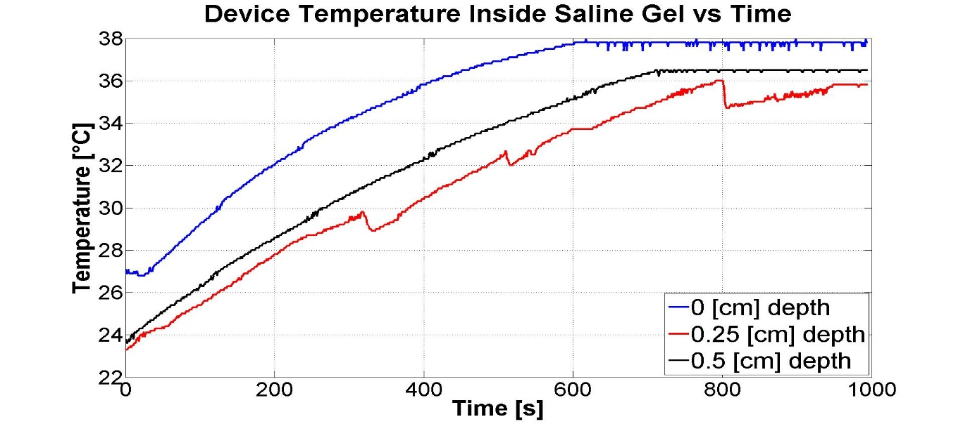

Figure : Device Temperature Inside Saline Gel vs Time

# **Conclusions**

The goal of this project consisted of creating a biomedical sensor that meets requirements to be implanted within the body and implements wireless charging and data transmission in order to prevent the need for additional surgeries to replace batteries. It reads an input of temperature sensor signals, and wirelessly transmits the data via Bluetooth. Our primary goal was to complete wireless charging of a small-scale, low-power device. While our device was not tested on or implanted in human or animal subjects, testing was completed in the most accurate and life-like way possible using an ASTM approved silicone gel that mimics human skin electromagnetic properties. We continued this project by meeting FCC standards for imbedded medical devices, primarily those for temperature and power limitations. While no standards for wirelessly charged implanted medical devices currently exist, we followed electromagnetic field and SAR limits provided by the FCC, electromagnetic exposure limits by the ICNIRP guidelines, and temperature limits for embedded devices provided by the US FDA. These guidelines are a combination of embedded medical device requirements for power and temperature, as well as standards for devices implanted in human skin or in contact with human skin (such as a wearable device) for electromagnetic fields. To test our device, the electromagnetic shielding room was used to complete testing using the silicone gel.

Our device successfully charges wirelessly via induction and transmits data via Bluetooth while inside the ASTM standard saline gel at a depth of up to 0.5cm. One of our specified constraints was that of the device’s temperature. The FDA limits temperature rise of an embedded medical device to within 2°C of the average body temperature. The average temperature of the human body is 37°C. We found that our device stabilized at a temperature of 37.8°C at contact, and at 36.7°C within the saline gel. These temperatures are within the given 2°C limit for average body temperature. Another constraint was electromagnetic limits set by ICNIRP. Table 5 shows the measured values of our device along with the requirements set by ICNIRP.

Table 5: ICNIRP Requirements vs Device Data

|  |  |  |
| --- | --- | --- |
|  | **ICNIRP Limits (Max)** | **At 0.5cm Depth** |
| **Electric Field** | 137 [V/m] | 134.24 [V/m] |
| **Magnetic Field** | 0.36 [A/m] | 0.111 [A/m] |
| **Power Density** | 50 [W/m²] | 14.88 [W/m²] |

This project was not simple to complete, as it is related to human health and safety. Currently, the American FDA is working on standards for wirelessly charged implanted devices and we hope that our project’s data can provide insight into this technology and its future.

# **Recommendations**

This was an incredibly difficult project to complete. Going into the project we were unaware of how little direction there would be in the way of standards for a device like ours. We were able to accomplish our goals with the help of professors who have extensive knowledge in the way of our device, such as electromagnetic fields and wireless charging. For the future development of our project, we strongly recommend research into a waterproof design or case for the MCU and inductive coils when placed in the gel. Our approach did not consider waterproofing of our design until testing began, and with little time remaining for its completion we used a temporary alternative. However, this proved difficult and was not wholly effective, as some gel still reached our MCU causing a delay in testing to ensure our device was still functioning appropriately.

Further improvements could be scaling down the device itself. Our PCB and device were as small as we could design for our components. With more funding and more time, smaller components could be used to design and replicate a smaller-scale device, similar to one that would be placed within the human body. The completed device for our project measured a diameter of 2.5” and a height of ¼” for the wireless charging transmitter, 3 ¾” x 2 ¼” x ¾” for the MCU, and 2” x 1.25” x 1” for the wireless charging receiver. While not large, the wireless charger transmitter and MCU are too big to be implanted comfortably and safely within the human body. The wireless charger receiver will not be placed within the human body, so size is not a necessary requirement for this device.

A final recommendation from our team for this device is to utilize our temperature sensor to enact a failsafe for the device. In the case of overheating, or rising above the FDA standard of more than ± 2° Celsius the body’s average temperature, the temperature sensor could detect the fault and shut off the wireless charging device. This failsafe would increase the user’s safety in case of a sudden rise in the device’s temperature.

# **Financial Summary**

The budget shows four team members working 220 hours at $20.00 an hour, for a total of $17,600.00. It also shows one faculty advisor working 30 hours at $70.00 an hour for a total of $2,100. This is 20 hours under our expected hours for this faculty advisor. A second faculty advisor is listed for 25 hours at $70.00 an hour for a total of $1,750. This is 25 hours under our expected hours for this faculty advisor. An additional faculty advisor was also added for the second term of our project, adding 25 hours at an hourly rate of $70.00 for a total of $1,750. This is 25 hours over our expected hours for this faculty advisor. The total expected cost for labor is listed as $24,600. Due to the additional faculty advisor, the total cost is $23,200, $1,400 under our budget.

Spring semester we purchased 22 parts, 10 Instrumentation Amplifiers for $2.58, a Bluetooth Dev. Board for $30.00, an MCU for $12.99, 5 OPA Filters for $5.24, and 5 Instrumentation Amplifiers for $4.29. The total cost for parts is $116.44, $23.56 under our estimated budget. For the Fall semester, we have spent $60.35 for buying 5 350nA Operational Amplifiers, 1 ECG Pro 3-Way Cable, 1 Wireless Power Receiver, 1 Battery Charge Management System, 2 Inductive Coils, 1 Wireless Power Transmitter, and miscellaneous parts. This puts us well under budget for the Fall semester as we did not end up needing a potentiometer that we had budgeted for, as well as purchasing very little miscellaneous parts. We also over estimated the cost of a wireless power transmitter, setting aside $199, while finding an appropriate part for only $10. We also saved money on the printed circuit board. Rather than spending our estimated $100 on a PCB, we used an old circuit board and soldered the parts ourselves. Combined with the spring semester we have spent a total of $176.79 of our parts, well under our initial budget of $580.75. This budget is shown in Table 6.

Table 6: Budget for Both Semesters

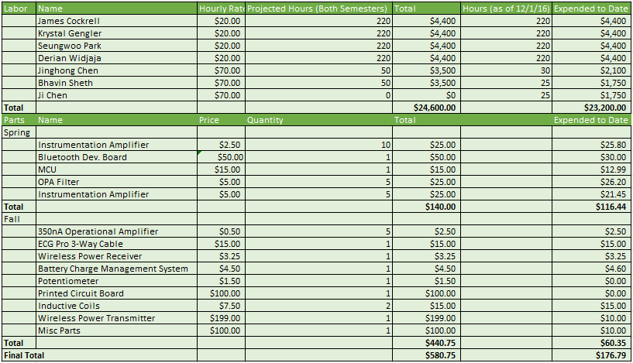

**Bibliography & Appendices**

[1] ASTM International, “Standard Test Method for Measurement of Radio Frequency Induced Heating On or Near Passive Implants During Magnetic Resonance Imaging”, 2011.

[2]”Bluetooth Special Interest Group”. *Wikipedia*, 2016. [Online]. Available: https://en.wikipedia.org/wiki/Bluetooth_Special_Interest_Group#Qualification. [Accessed: 03-May-2016].

[3] "Cepstrum", Wikipedia, 2016. [Online]. Available: https://en.wikipedia.org/wiki/Cepstrum.

[Accessed: 25- Mar- 2016].

[4] D. Widjaja, "Wirelessly Charged Biomedical Device", *Progress Report II*, 2016.

[5] "Detail Results", *Nssn.org*, 2016. [Online]. Available: http://www.nssn.org/search/DetailResults.aspx?docid=569888&selnode=. [Accessed: 04- May- 2016].

[6] ICNIRP Guidelines, “Guidelines for Limiting Exposure to Time-Varying Electric, Magnetic, and Electromagnetic Fields (up to 300GHz)”, 1998.

[7] J. Cockrell, "Wirelessly Charged Biomedical Device", *Analysis*, 2016.

[8] K. Gengler, "Wirelessly Charged Biomedical Device", *Progress Report I*, 2016.

[9] K. Hachisuka, A. Nakata, T. Takeda, Y. Terauchi and K. Shiba, 2016. [Online]. Available: http://www-mtl.mit.edu/researchgroups/mems-salon/xueen_hachisuka_03.pdf. [Accessed: 08- Sep- 2016].

[10] T. Mahn, *Wireless Medical Technologies: Navigating Government Regulation in the New Medical Age*, 1st ed. Washington, DC, 2016.

[11] "PhysioBank ATM", Physionet.org, 2016. [Online]. Available: http://physionet.org/cgi-bin/atm/ATM. [Accessed: 25- Mar- 2016].

[12] "Power Matters Alliance", *Wikipedia*, 2016. [Online]. Available: https://en.wikipedia.org/wiki/Power_Matters_Alliance. [Accessed: 04- May- 2016].

[13] "Radio Frequency Wireless Technology in Medical Devices - Guidance for Industry and Food and Drug Administration Staff", *Fda.gov*, 2016. [Online]. Available: http://www.fda.gov/MedicalDevices/DeviceRegulationandGuidance/GuidanceDocuments/ucm077210.htm. [Accessed: 08- Sep- 2016].

[14] S. Park, "Wirelessly Charged Biomedical Device", *Design*, 2016.

[15] "Standards (Medical Devices)", *Fda.gov*, 2016. [Online]. Available: http://www.fda.gov/medicaldevices/deviceregulationandguidance/standards/default.htm. [Accessed: 23- Mar- 2016].

[16] W. Storr, "Active Band Pass Filter - Op-amp Band Pass Filter", *Basic Electronics Tutorials*, 2013. [Online]. Available: http://www.electronics-tutorials.ws/filter/filter_7.html. [Accessed: 08- Apr- 2016].

[17] "Wireless Medical Devices", *Fda.gov*, 2016. [Online]. Available: http://www.fda.gov/MedicalDevices/DigitalHealth/WirelessMedicalDevices/default.htm. [Accessed: 08- Sep- 2016].

[18] Y. Matsuda, H. Sakamoto, H. Shibuya and S. Murata, "A non-contact energy transferring system for an electric vehicle-charging system based on recycled products", *J. Appl. Phys.*, vol. 99, no. 8, pp. 08R902, 2006.

[19] 2016. [Online]. Available: http://datasheets.maximintegrated.com/en/ds/MAX4194-MAX4197.pdf. [Accessed: 08- Apr- 2016].

**Outside Resources Appendix**

For our project outside research of the ASTM standard saline gel and its properties were required, as well as research into ICNIRP limits, FDA standards, and FCC guidelines. This included contacting Aileen I. Velez with the Division of Industry and Consumer Education at the FDA’s Center for Devices and Radiological Health. The information necessary to complete our device is found below.

[1] ASTM International, “Standard Test Method for Measurement of Radio Frequency Induced Heating On or Near Passive Implants During Magnetic Resonance Imaging”, 2011.

[2] ICNIRP Guidelines, “Guidelines for Limiting Exposure to Time-Varying Electric, Magnetic, and Electromagnetic Fields (up to 300GHz)”, 1998.

[3] "Radio Frequency Wireless Technology in Medical Devices - Guidance for Industry and Food and Drug Administration Staff", *Fda.gov*, 2016. [Online]. Available: http://www.fda.gov/MedicalDevices/DeviceRegulationandGuidance/GuidanceDocuments/ucm077210.htm. [Accessed: 08- Sep- 2016].

[4] "Standards (Medical Devices)", *Fda.gov*, 2016. [Online]. Available: http://www.fda.gov/medicaldevices/deviceregulationandguidance/standards/default.htm. [Accessed: 23- Mar- 2016].

[5] "Wireless Medical Devices", *Fda.gov*, 2016. [Online]. Available: http://www.fda.gov/MedicalDevices/DigitalHealth/WirelessMedicalDevices/default.htm. [Accessed: 08- Sep- 2016].

[6] 2016. [Online]. Available: http://datasheets.maximintegrated.com/en/ds/MAX4194-MAX4197.pdf. [Accessed: 08- Apr- 2016].