Date: December 5, 2016
Subject: CubeSat Payload Module Design
From: Senior Design Team 8
To: Dr. John Glover
Dear Dr. Glover,
The following is a report concerning the CubeSat payload module that the team has designed and built. It includes ours goals for the year, specifications and constraints of the project, standards applicable to the projects, results, recommendations for further improvements, and finally a financial summary of the expenditures. We hope to clearly communicate the progress and accomplishments we’ve made this year.
As mentioned in previous progress reports and final technical report from last semester, we have CAN bus fully functional for the communications system in order to send data to the C&DH module. Also, we have been able to collect image and temperature data through a camera and sensors respectively. Unfortunately, we have also encountered problems that we have not been able to successfully address this semester. As will be mentioned in this final report, the payload module is unable to cool down due to inefficient heat pumps. We hope the recommendations we provide will enable a future team to successfully correct this complication.
We hope this report is through enough to answer and address any questions and concerns you may have. As always, please don’t hesitate to contact us with any concerns with the project.
Sincerely,
Chaofan Chen
Dhruvmin Gandhi
Larry Gerhardt
Bernabe Palacios

The Development of a Small Satellite System

Final Report
By

Team 8: CubeSat Initiative

Chaofan Chen
Dhruvmin Gandhi
Larry Gerhardt
Bernabe Palacios

Submitted
December 5, 2016

For the
Facilitators of ECE 4336

Abstract
The following report provides the background, findings, and results of the project along with the conclusions reached to proceed further into the development of the final design of the CubeSat project. A CubeSat is a satellite that can be launched in order to perform a low-cost experiment within low earth orbit. The project is a continuation from the previous year in which a Command and Data Handler module was developed by another team. The command and data handler consisted of power, communications, and avionics sub-modules. Our contribution to this project is a foundation framework for a prototype payload module which will be integrated together with other modules to form a fully functioning three unit CubeSat. The resulting implementation of the initial design did not perform as expected. The communications and the sensors work. However, the insulated module did not perform well. The passive components of the thermal system meet the design specifications while the active components fell behind in performance. The active components consisting of two heat pumps and their associated heat sinks were unable to provide and maintain sufficient heat flux between the interior and exterior of the module. In summary, the current implementation of the thermal system is inadequate; however, with more resources devoted to the implementation and small changes to the design, it should be possible to meet the original prototype specifications. Our recommendation is to reanalyze the thermal system design for further performance.

Table of Contents
Abstract ii
Introduction and Background 1
Statement of Goals 2
Engineering Specifications and Constraints 4
Prototype Specifications 4
Final design Specifications 4
Constraints 5
Engineering Standards 6
Controller Area Network (CAN) Bus 6
Serial Peripheral Interface (SPI) 6
Inter-Integrated Circuit (I²C) 6
1-Wire 7
Design 7
Methodology 8
Results 8
Conclusion 11
Recommendations 12
Financial Summary 13
Bibliography I
Datasheets I
Source Code II

List of Figures

Figure 1. Project Overview Diagram 2
Figure 2. Goal Analysis 3
Figure 3. Temperature and Pressure Data from Sensors 9
Figure 4. Internal and External Temperature of Payload Module over Time 10

List of Tables
Table 1. Total Expenditures to date for fall 2016 13
Table 2. Total Expected expenditures for fall 2016 13

Introduction and Background
Small satellite systems are the next generation of space exploration in terms of scientific research and the development of new technologies. Currently, it is very expensive to conduct experiments in space using normally sized satellites. However, with the development of small satellite technology, it is becoming easier and more cost effective to conduct experiments in space. These small satellites, called CubeSats, are becoming the norm for conducting scientific research and advancing space exploration.
The purpose for this project is to conduct low-cost experiments that require low-earth orbit in space for research purposes and experimental studies. The project will develop an experimental payload module framework. The framework will allow experiments to be developed which can easily be integrated into an existing CubeSat system. This framework will allow researchers to quickly develop cost effective low earth orbit experiments.
This document provides information covering the goals of this project, the specifications and constraints of the project, the engineering standards necessary to follow in designing the module, the results and conclusion related to our design, further recommendations to improve upon this project, and a financial summary of the project to date.
Figure 1 shows the overview diagram of the payload module along with the developed command and data handler module from the previous year. The module makes use of a Linux compatible microcontroller for its main control system. The current prototype employs a Raspberry Pi Zero in this role due to ease of use during prototyping.

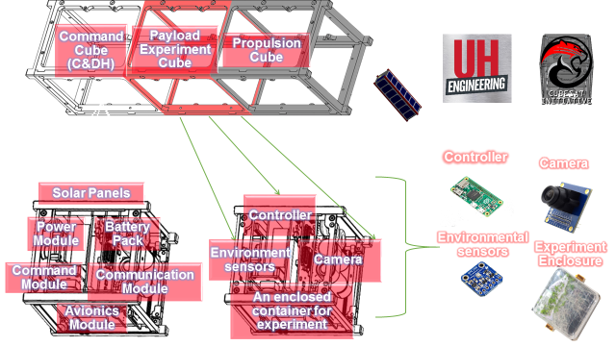

Figure 1. Project Overview Diagram
The module will make use of a variety of sensory input in order to monitor the experimental payload. The experiment itself is held within a pressure and temperature controlled enclosure.

Statement of Goals
Our target objective is to have a functional prototype payload module which is a representation of the final module design. The process to complete the objective was split into making the CubeSat payload module capable of interfacing with an external command module via CAN bus, completing the analysis and design for the fully insulated module and enclosure, and creating a prototype module with experiment enclosure that meets the desired design specifications. The team also planned to provide a draft final design for those looking to work on this project to know what could to be implemented in the future for better performance. 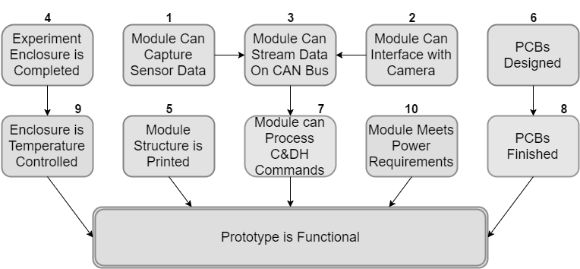
Figure 2. Goal Analysis
As seen in the goal analysis for fall 2016 in figure 2 above, the goals highlight the process we had when working to complete this project and make a functional prototype of the CubeSat payload module. If you refer to the goals by the respective numbers above them, goals 1, 2, and 3 were completed in the spring semester while goals 4-10 were to be completed during the fall semester. The spring goals were mainly dealing with the communications part of the prototype and were to be refined when completing goal 7 which would tie everything together on the communications side of the prototype. Goals 5 and 10 stand alone in terms of their purpose as they are mainly utilized for producing the functional prototype and checking if the prototype is proceeding according to the specifications we set. Goals 6 and 8 along with goals 4 and 9 were to proceed from one to the other as they mainly dealt with building the thermal system of the prototype which would be integrated together with the rest of the goals for the final building phase of the project.

Engineering Specifications and Constraints
The specifications for the goals are the desired level of functionality to complete the objective. The specifications for the payload module are split between the prototype design specs and final design specs to meet the functionality that is necessary for the objective. The specifications below are in reference to the goals in the goal analysis in figure 2 above.

Prototype Specifications
- 1: Module can measure analog data with less than 5% error.
- 3: Module can send data over CAN bus without packet loss.
- 5: Electronics must fit on a surface area of less than 30 square inches.
- 8: Module will use at most 10 Watt-hour of energy.
- 9: Enclosure must reach a differential temperature of +/- 30°C in 3 hrs.
- 9: Enclosure must maintain a differential temperature of +/- 30°C for 1 hr.
- 9: Enclosure must hold temperature within +/- 1°C.

Final design Specifications
- 1: Module can measure analog data with less than 1% error.
- 3: Module can send data to ground via C&DH without packet loss.
- 5: Electronics must fit onto two double sided 2.5in by 2.5in PCBs.
- 8: Module will use at most 5 Watt-hour of energy.
- 9: Enclosure must reach a differential temperature of +/- 60°C in 3 hrs.
- 9: Enclosure must maintain a differential temperature of +/- 60°C for 1 hr.
- 9: Enclosure must hold temperature within +/- 0.5°C.
- 9: Enclosure must be held at 1 atm of pressure.

Constraints
The constraints that this project faces include the following.

- The basic limitations that are specified for CubeSat projects:
  - Dimensions : 10 cm x 10 cm x 11.35 cm
  - Mass to not exceed 1.33 kg
  - Center of gravity within 2 cm of geometric spherical center
- Bandwidth for relaying to the ground station from low-earth orbit
- Limited power consumption of 5 Watt-hour
- Budget
- Time
The limitations imposed on the project by the CubeSat specifications include the required dimensions, and the magnitude and placement of mass. The required dimensions are 10×10×11.35 cm, approximately 4 inches per side. The mass must be under 1.33 kg, and the center of gravity must be within 2 cm of the geometric center of the module. In addition, the CubeSat specifications also requires that the module must be launched in a powered down and uncharged state. At launch a pull pin will initiate the modules startup procedure which would mainly be found in the command and data handler module.
In addition to the limitations which come directly from the CubeSat specifications, there are constraints imposed on the project due to the nature of a small satellite. These constraints include data bandwidth and power restrictions. The data bandwidth of the satellite will be narrow and will limit the data size, speed, and methods to relay data to ground station from low earth orbit. The power constraint limits the power consumption of the payload cube with a maximum limit of 5 [WH] to not affect system operations of other modules.
Finally, constraints are placed upon the project due to the university class setting. The budget is of a university undergraduate project magnitude which limits the consumption of material costs to $500 which will be expended in the year this module is developed. As well as budget, the time constraints are fixed.

Engineering Standards

Controller Area Network (CAN) Bus
Control Area Network is a message based bus protocol which allows microcontroller and devices to communicate without the need for a centralized host computer. CAN bus is commonly used in the automotive industry, but is also used in industrial applications due to its low cost of implementation. In the CubeSat it is used to communicate between the various modules within the satellite.

Serial Peripheral Interface (SPI)
SPI is a serial single-master multi-slave bus protocol. It is typically used for communication between peripheral integrated circuits and microcontrollers over a short distance. The module makes use of the protocol to communicate with the on-board CAN controller IC.

Inter-Integrated Circuit (I²C)
I²C is a serial multi-master multi-slave bus protocol. It is typically used for communication between low speed peripheral integrated circuits. The module was original intended to use the protocol to communicate with various sensors, but the choice was made to switch to a smaller and less complex array of sensors, as such although the module is capable of I²C support the prototype will not make direct use of the protocol.

1-Wire
1-Wire is a single wire serial single-master multi-slave bus protocol. The protocol is similar in many respects to I²C, but is designed to provide a simple physical interface and longer distance communication at the cost of slower transfer speeds. The module makes use of 1-Wire in communicating with the on-board temperature sensors. The protocol was chosen due to the simplicity of both the bus and the temperature sensors.

Design
The design of the project was split into two major sections, the thermal system, and the electronics and communication system. The thermal system consists of the structure of the module, insulation, and active heating and cooling. The electronics and communication system consists of electronics to control and monitor the thermal system as well as to monitor the experiment contained within the payload module, the system also handles communication with other modules within the satellite via the control area network protocol.
The design of the thermal system was split into two major components. The passive portion of the system which consists of the structure of the payload enclosure as well as insulation, and the active portion of the thermal system which consist of two Peltier heat pumps and their associated heat sinks.
The electronics of the system consists of a control system for the payload module and a communications system to handle communications with other modules on board the complete satellite. The control system was designed with a embedded Linux compatible ARM microcontroller as its core, with peripheral circuits memory, signal conversion, and power regulation. The communications system consists of a control area network (CAN) node, including a controller and transceiver.

Methodology
The methodology used to guide the design of the project was a combination of research, analysis and trial and error. Several aspects of the design of the payload module were decided before the project began. The design aspects under control of the team were initially determine based upon research of previous CubeSat projects. Once the initial design was in place and an initial prototype was built, the team analyzed the initial data gathered from testing and began to try out various techniques for improving the design.
Testing of the project consisted of basic tests and analysis of the results. The first tests of the thermal system consisted of running the system over a period of an hour and a half while logging the internal temperature readings and monitoring the external temperature. The first such test was conducted at approximately 20 degrees Celsius. Later tests were conducted at lower temperatures, approximately 5 degrees Celsius, and with two of the four internal temperature sensors moved to the outside of the module in order to record real time temperature fluctuations of the ambient temperature. The team had planned to test the system with high ambient temperature, but due to lack of results at room temperature did not in order to focus on improving implementation of the project.

Results
The project did not meet expectations. The goals of acquiring data and communicating with other modules were completed. However, the thermal system failed to meet target specifications. The module was unable to adequately raise its internal temperature and was completely unable to lower its internal temperature.

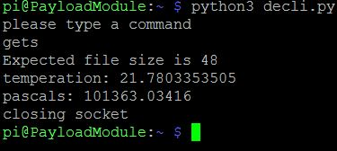
The payload module was able to acquire sensory data with less than a 5% error, the team was able to acquire various analog and digital readings to within the specified error range. In addition, the module was able to capture images on command. The module was able to use the CAN bus to communicate with an external proxy command module. The module received commands and sent data packets back in response. Figure 3 below shows a screen capture of the module sending back temperature and pressure data to a proxy command module.

Figure 3. Temperature and Pressure Data from Sensors
As well as being able to record sensor and image data, a basic data transfer protocol was written on top of the CAN protocol so that large amounts of data could be transferred between module. This protocol was able to transfer several megabytes of data in the form of images capture by the payload modules camera. The protocol was written in Python to allow for rapid development and modification as needed in the future.
The thermal system did not meet specifications. Although the specification called for a temperature differential of 30C to be maintained, both for heating and cooling of the module, we were unable to maintain a difference of greater than 15C and only when heating the module. Figure 4 below shows a graph of sample data taken during final testing of the system.
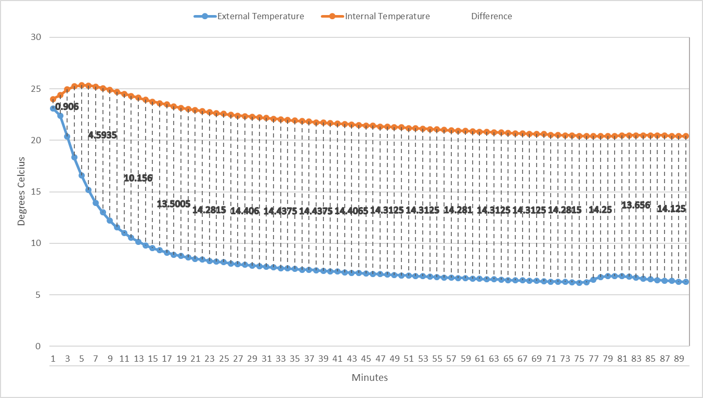
Figure 4. Internal and External Temperature of Payload Module over Time
The data acquired during testing indicates that the temperature difference peaks at 15C relatively quickly and stays at that point indefinitely. Despite spending considerable time attempting to remedy the problem, the team was unable to discover the root cause of the problem and therefore was also unable to fix the problem. Because the 15C max difference seems to occur regardless of the exact external temperature, the team believes that the plateau in temperature may be due to the heat pump hitting a certain temperature and rapidly losing effectiveness. There is some evidence for this as the temperature seems to peak, then slowly fall before rapidly peaking again, this seems to indicate that the heat pump is effectively shutting off temporarily only to turn back on once it has cooled.
The team was unable to get any positive results during attempts to cool the module. In fact, the module general heated up rather than cooled down, although not rapidly. We are unsure of the cause of this problem, although we know it is not entirely due to the heat given off by the electronics because this same effect was observable when all electronics were removed and only the heat pump and temperature sensors remained within the module’s interior.
While the module’s thermal system did not successfully hit target specifications, the team was able to meet power constraints. Even with the use of inefficient linear voltage regulators, the total power used was less than 10 Watt-hour. In addition, the team was able to fit all electronics, including the external microcontroller, within our initial specification of a maximum of 30 in^2 surface area for PCB size.

Conclusion
The CubeSat team has made considerable progress this year in designing and constructing the payload module of the miniature satellite. Despite being unable to obtain the previous team’s C&DH module, the team was able to successfully collect data from the internal environment of the payload module and using a CAN bus communication protocol transfer the data without loss of information to a stand in module for the C&DH module. Also the payload module was successfully insulated to reduce power and energy consumption by the electronics within the module. The only problem the team wasn’t able to fully address was the thermal system of the module. The active components of the thermal system revealed unexpected complications. The heat pumps weren’t able to successfully absorb the heat to cool down the interior of the module. This complication is further addressed in the recommendations section with ideas of possible solutions by the team. Outside of the thermal system, the design and implementation of the payload module meets the specifications, constraints, and standards determined and outlined at the beginning of the semester.

Recommendations
The team recommend that anyone wishing to further pursue this project perform substantial research on the components of the thermal system before continuing further. Ideally, a full analysis should be done of the thermal system before anything else. This analysis should determine the minimum expect power needs of the thermal system. Once minimal power requirements are determined the next step would be to research how to improve the efficiency of the heat pumps. Steps to improve the efficiency of the heat pumps would likely include developing a heat sink system which can provide a tight coupling between the heat pumps and the heat sinks, as well as determining the option ratio between the sizes of the heat absorbing and dissipating heat sinks. In addition, it would be ideal if a proxy for the thermal mass of the completed 3 unit CubeSat could be developed in order to improve testing and development towards a final system.
The electronics of the system function, but could be improved in terms of both functionality and efficient use of both energy and space. The very first step would be to make use of switching voltage regulators instead of linear regulators, this would greatly improve efficiency in and of itself. In addition, the size and energy requirements of the system could likely be lowered integrating an embedded Linux compatible microcontroller onto the module’s control board rather than using an external Raspberry Pi. This would have the added benefit of removing the need for a discreet CAN controller as nearly all microcontroller designed for embedded use have at least a single CAN controller built in.
In addition, the structure of the module should be modified. The current module is design so that the electronics are contained within the same space as the experiment would be. This should be changed. A possible improvement would be to take up a single wall of the module and dedicate that to the electronics which do not directly interact with the experiment, such as the microcontroller, ram, nonvolatile storage, power regulation, and various controllers. Any electronics which must interact with the experiment, such as cameras, temperature sensors, chemical sensors, and lighting, would be mounted inside the experimental enclosure and would be connected to the control board via a small standardized connection. This connection to the control board would allow for most commonly used I/O from the microcontroller as well as a variety of power supply lines so that future experiments could simply expect and work with a stand set of I/O and power and be dropped into place as needed.

Financial Summary
Listed below are the tables for our actual expenditures throughout the duration of this project.
From table 1 above, the total parts expenditure exceeded our expected budget of $515 we predicted when we started on this project. The reason for this is mainly due to the excessive amount used for the thermal management system and other miscellaneous costs that were unforeseen in the initial projection. Table 2 above shows the initial projection we presented at the beginning of the semester. The semester total expenditures showed an increase of less than 10% of the initial projection due to the change to the project direction and the differential sum of practical costs in the beginning of the semester.

Bibliography

[1] | CubeSat Design Specification, rev 13, 2014. [Online]. Available: http://www.cubesat.org/ [Accessed 4 May 2016].

Datasheets
BCM2835 – Broadcom SoC used by the Raspberry Pi Zero

MCP3004/3008 – Analog to Digital Converter

MCP2515 – CAN Controller

MCP2562 – CAN Transceiver

BMP280 – Temperature and Pressure Sensor

DS18B20ND

Source Code

