Review of ac Signals

We use ac signals in ECE 2100 in several experiments, so a brief introduction to this topic is in order. The ac signals we will be using in ECE 2100 are of two types: the sine wave and the square wave. Both are periodic functions (or waveforms) that can be generated by the function generator in the lab. The function generator output can be displayed on the oscilloscope screen; for sine and square waves the result looks something like Figure 1.

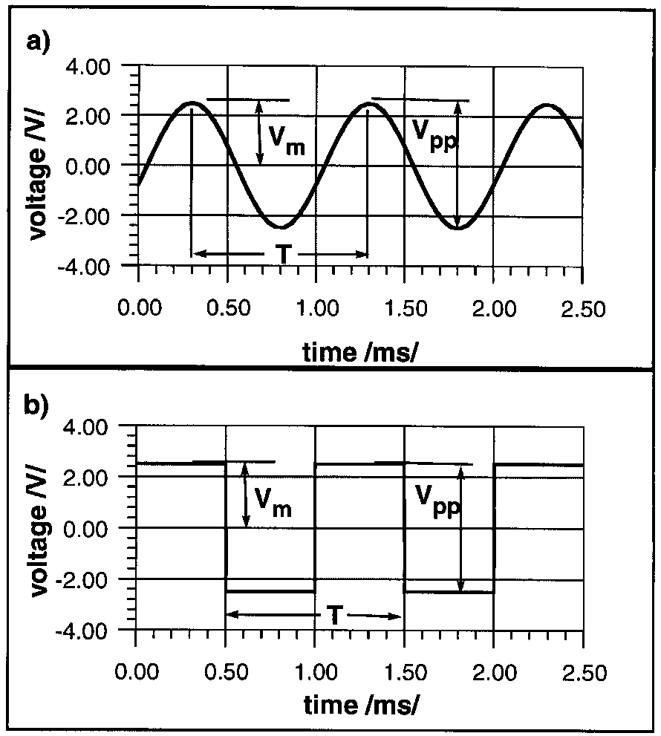

Figure 1. Illustration of a) a sinusoid and b) a square wave, showing the amplitude V_{m}, the
peak-to-peak amplitude V_{pp}, and the period T.

In Figure 1 we have labeled several important characteristics of periodic waveforms. These are the period T, the amplitude V_{m}, and the peak-to-peak amplitude V_{pp}. The period of both waveforms in Figure 1 is 1[ms]. An analytical expression for the sine wave is

(1)
where the frequency is f = 1/T and φ is the phase shift. For the waveform of Figure 1a, the frequency is 1000[Hz] and the phase shift is -108°; at t = 0 v(t) takes the value cos(-108°), so the waveform is “shifted” to the right. Note the role of the amplitude in Equation (1): the sine function varies between 1 and -1, so V_{m} is the zero-to-peak value (not the peak-to-peak value); for both waveforms in Figure 1 the amplitude is 2.5[V] and the peak-to-peak voltage V_{pp} is 5[V].

Note that the waveforms of Figure 1 are centered about 0 volts; they are not vertically “offset” in either direction. These waveforms are said to have a dc component of 0. Had we wished, we could have added a constant voltage to these waveforms; this can be done easily using the “dc offset” feature of the function generator. In that case the waveforms would have been shifted upward or downward by an amount equal to the DC offset. We would then modify Equation (1) by adding a constant term to the right hand side.

We could write an expression for the square wave as well but we will not do so here. As will become clear in later courses, the expression for a square wave can be written as an infinite series of sine waves, each with a different frequency. Thus rather than a frequency we sometimes describe the square wave in terms of its period, which is 1[ms] in Figure 1b). Alternatively, we may speak of a repetition rate, which in this case is 1[kHz].

