Name: _____________________________ (please print)
Signature: __________________________
Circle your class time: 8:30-10AM, TuTh 1-2:30PM, MW 4-5:30PM TuTh

DO NOT OPEN THIS BOOKLET UNTIL INSTRUCTED TO DO SO

ECE 2300 -- EXAM #1
February 23, 2002

1. This exam is open book, open notes. You may use any calculator or computer. Turn all cell phones or other communications devices off.
2. Show all work on these pages. Show all work necessary to complete the problem. If you go on to another page, indicate clearly where your work can be found. A solution without the appropriate work shown will receive no credit. Clearly indicate your answer (for example, by enclosing it in a box).
3. Show all units in solutions, intermediate results, and figures. Units in the exam will be included between square brackets.
4. Do not use red ink. Do not use red pencil.
5. You will have 90 minutes to work on this exam.

1. ________________/25
2. ________________/30
3. ________________/15
4. ________________/30
Room for extra work
1) {25 Points} For the circuit shown, calculate the power delivered to the circuit by the ideal dependent voltage source v_{S1}, and by the ideal dependent current source i_{S2}.
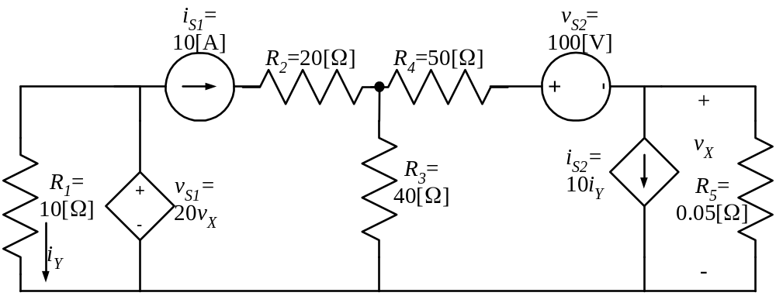
Room for extra work
2) {30 Points} a) Find i_{X}.
b) Find v_{Q}.
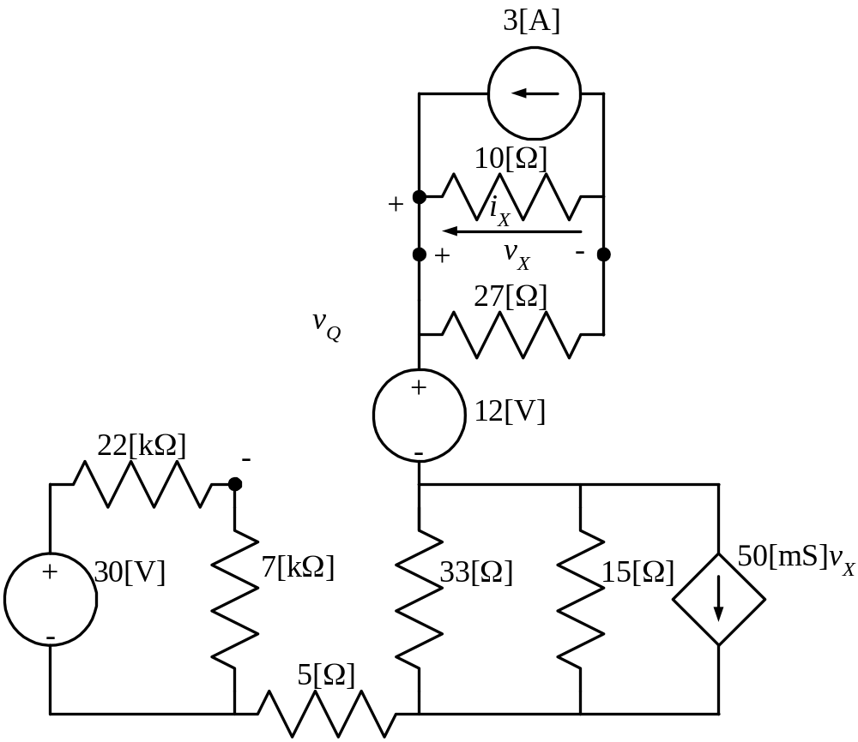
Room for extra work
3) {15 Points} Two voltmeters, and another resistor, R_{X}, are connected in series as shown below.
Voltmeter #1 has a 100[V] full-scale reading, and has a meter resistance of 200[kΩ].
Voltmeter #2 has a 50[V] full-scale reading, and has a meter resistance of 400[kΩ].
Assume that when the voltmeters are subjected to voltages greater than their full-scale readings, they are not damaged.
Using this situation, what is the largest voltage, v_{X}, that can be measured?
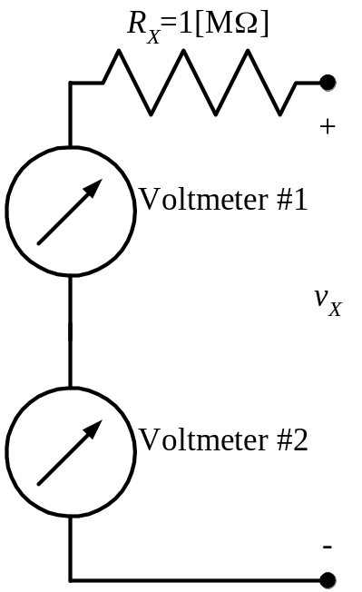

Room for extra work
4) {30 Points} For the circuit shown, use the node-voltage method to write a complete set of independent equations that could be used to solve this circuit. Do not attempt to solve the equations. Do not attempt to simplify the circuit.
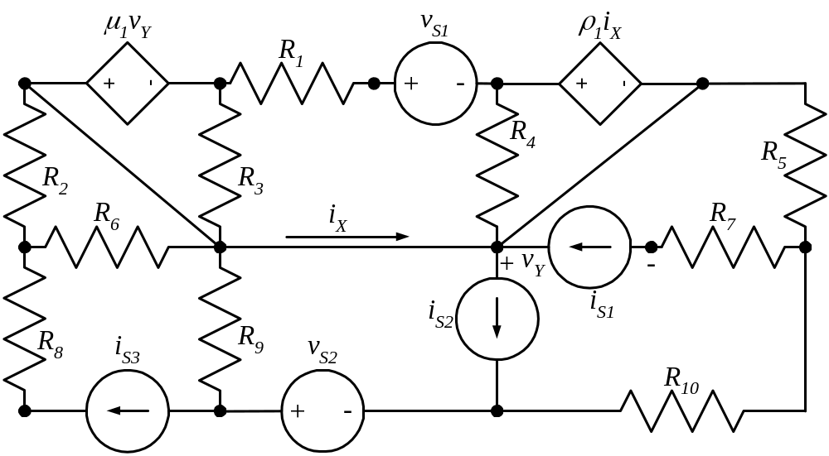
Room for extra work

1) {25 Points} For the circuit shown, calculate the power delivered to the circuit by the ideal dependent voltage source v_{S1}, and by the ideal dependent current source i_{S2}.

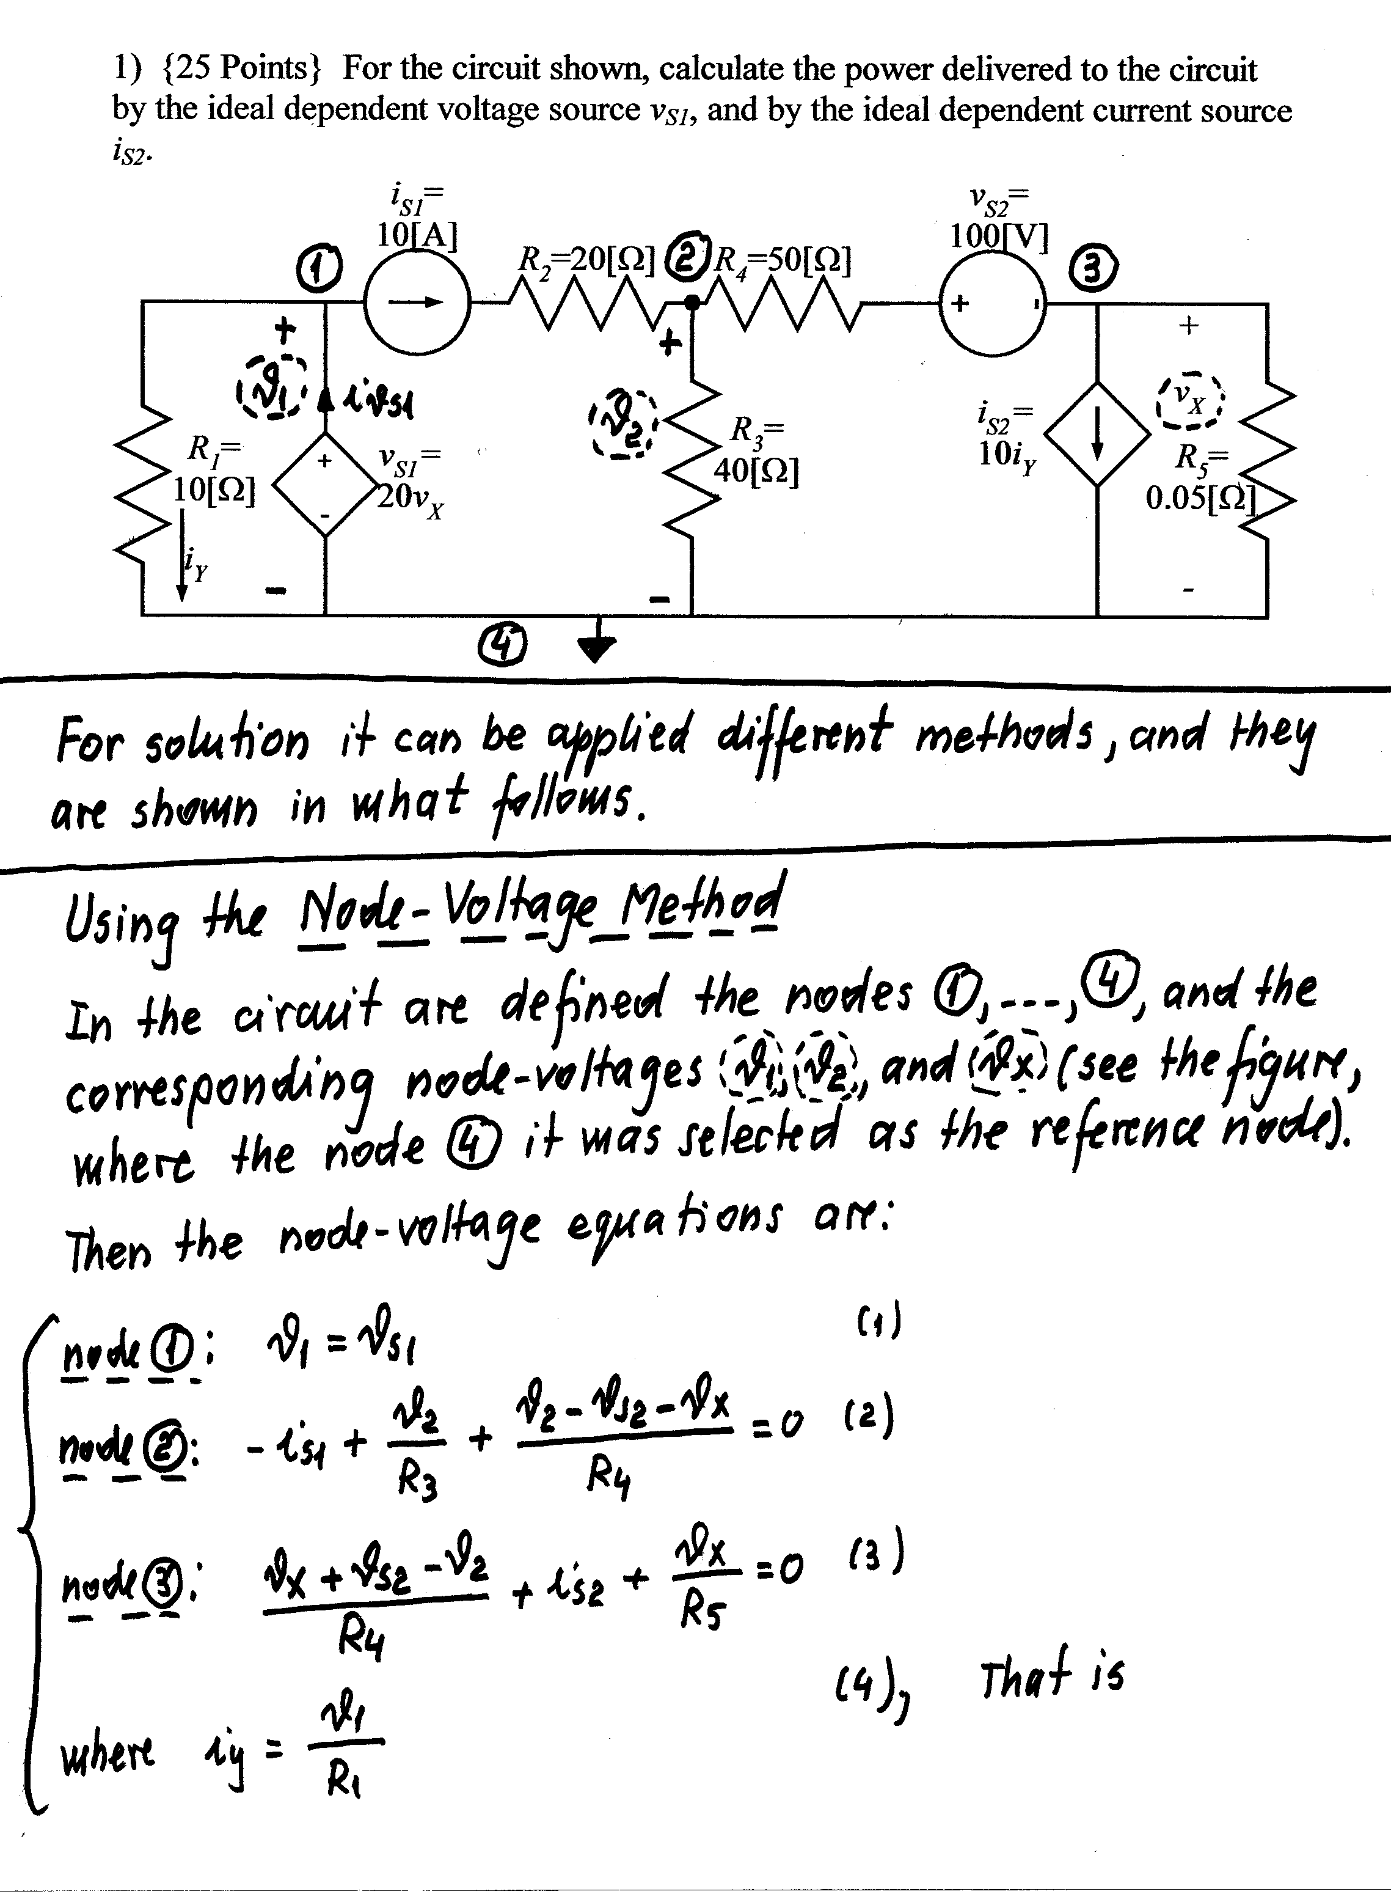
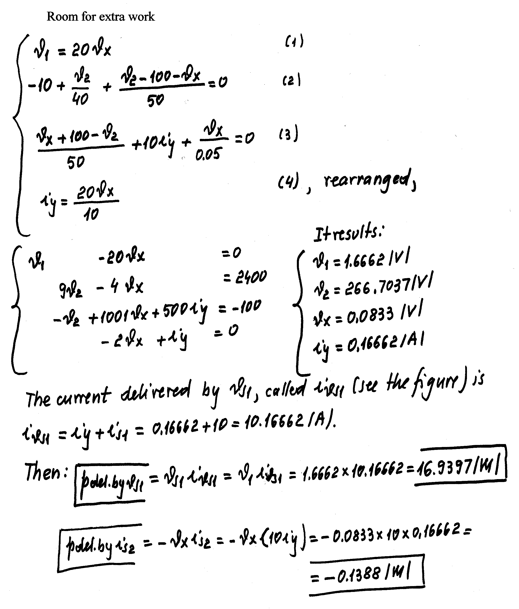
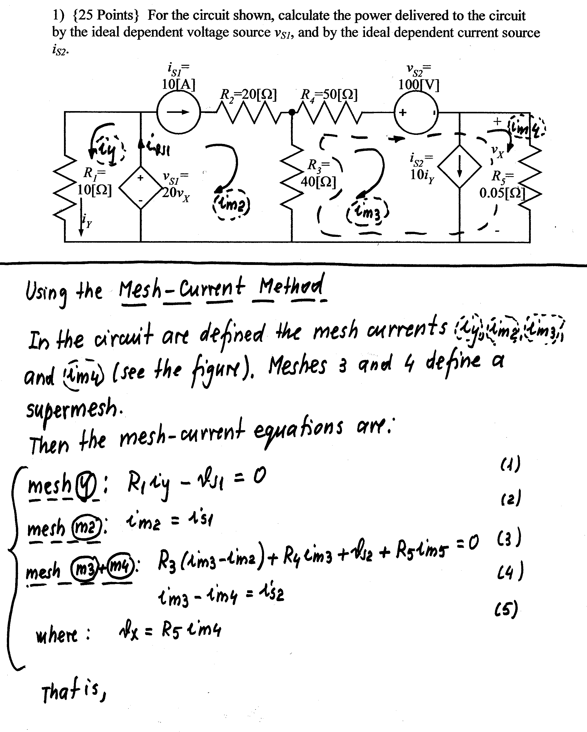
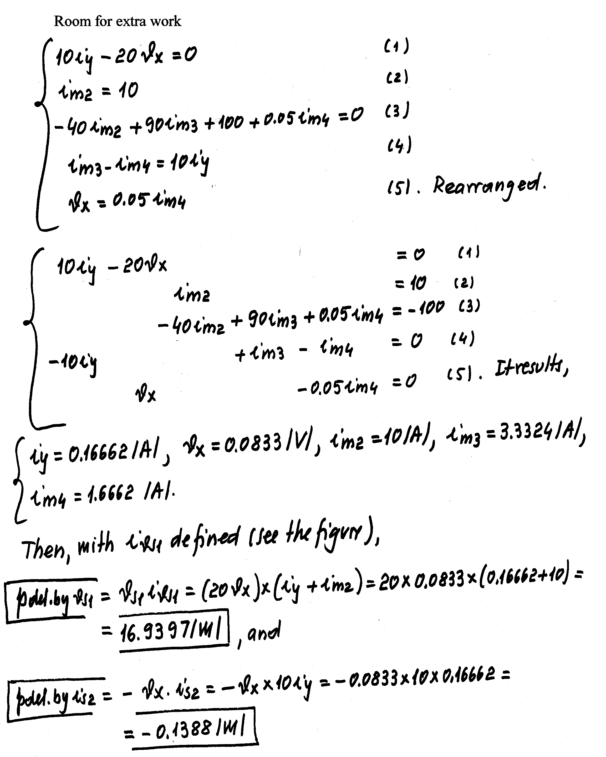
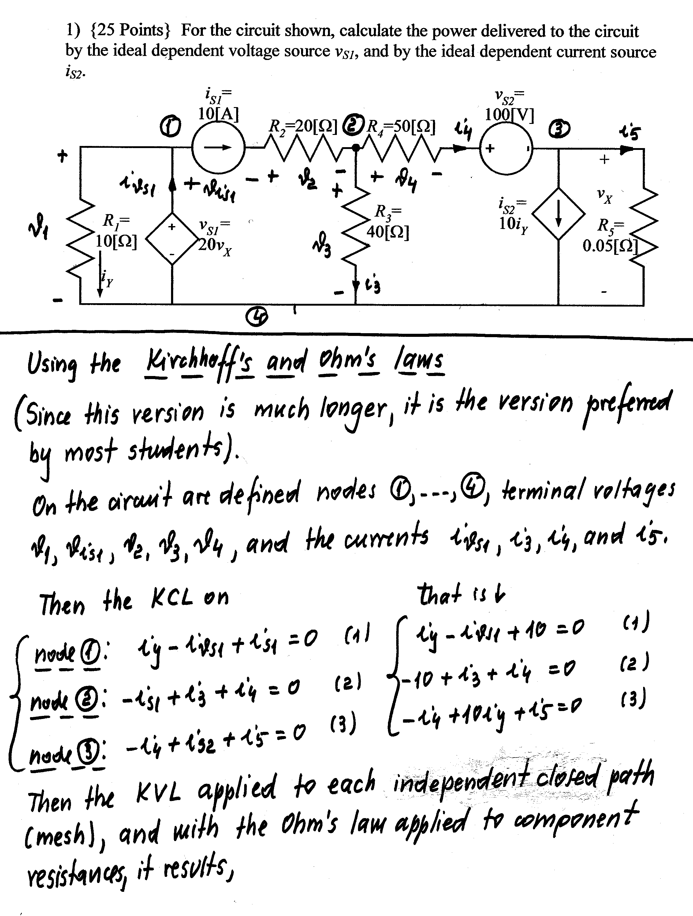
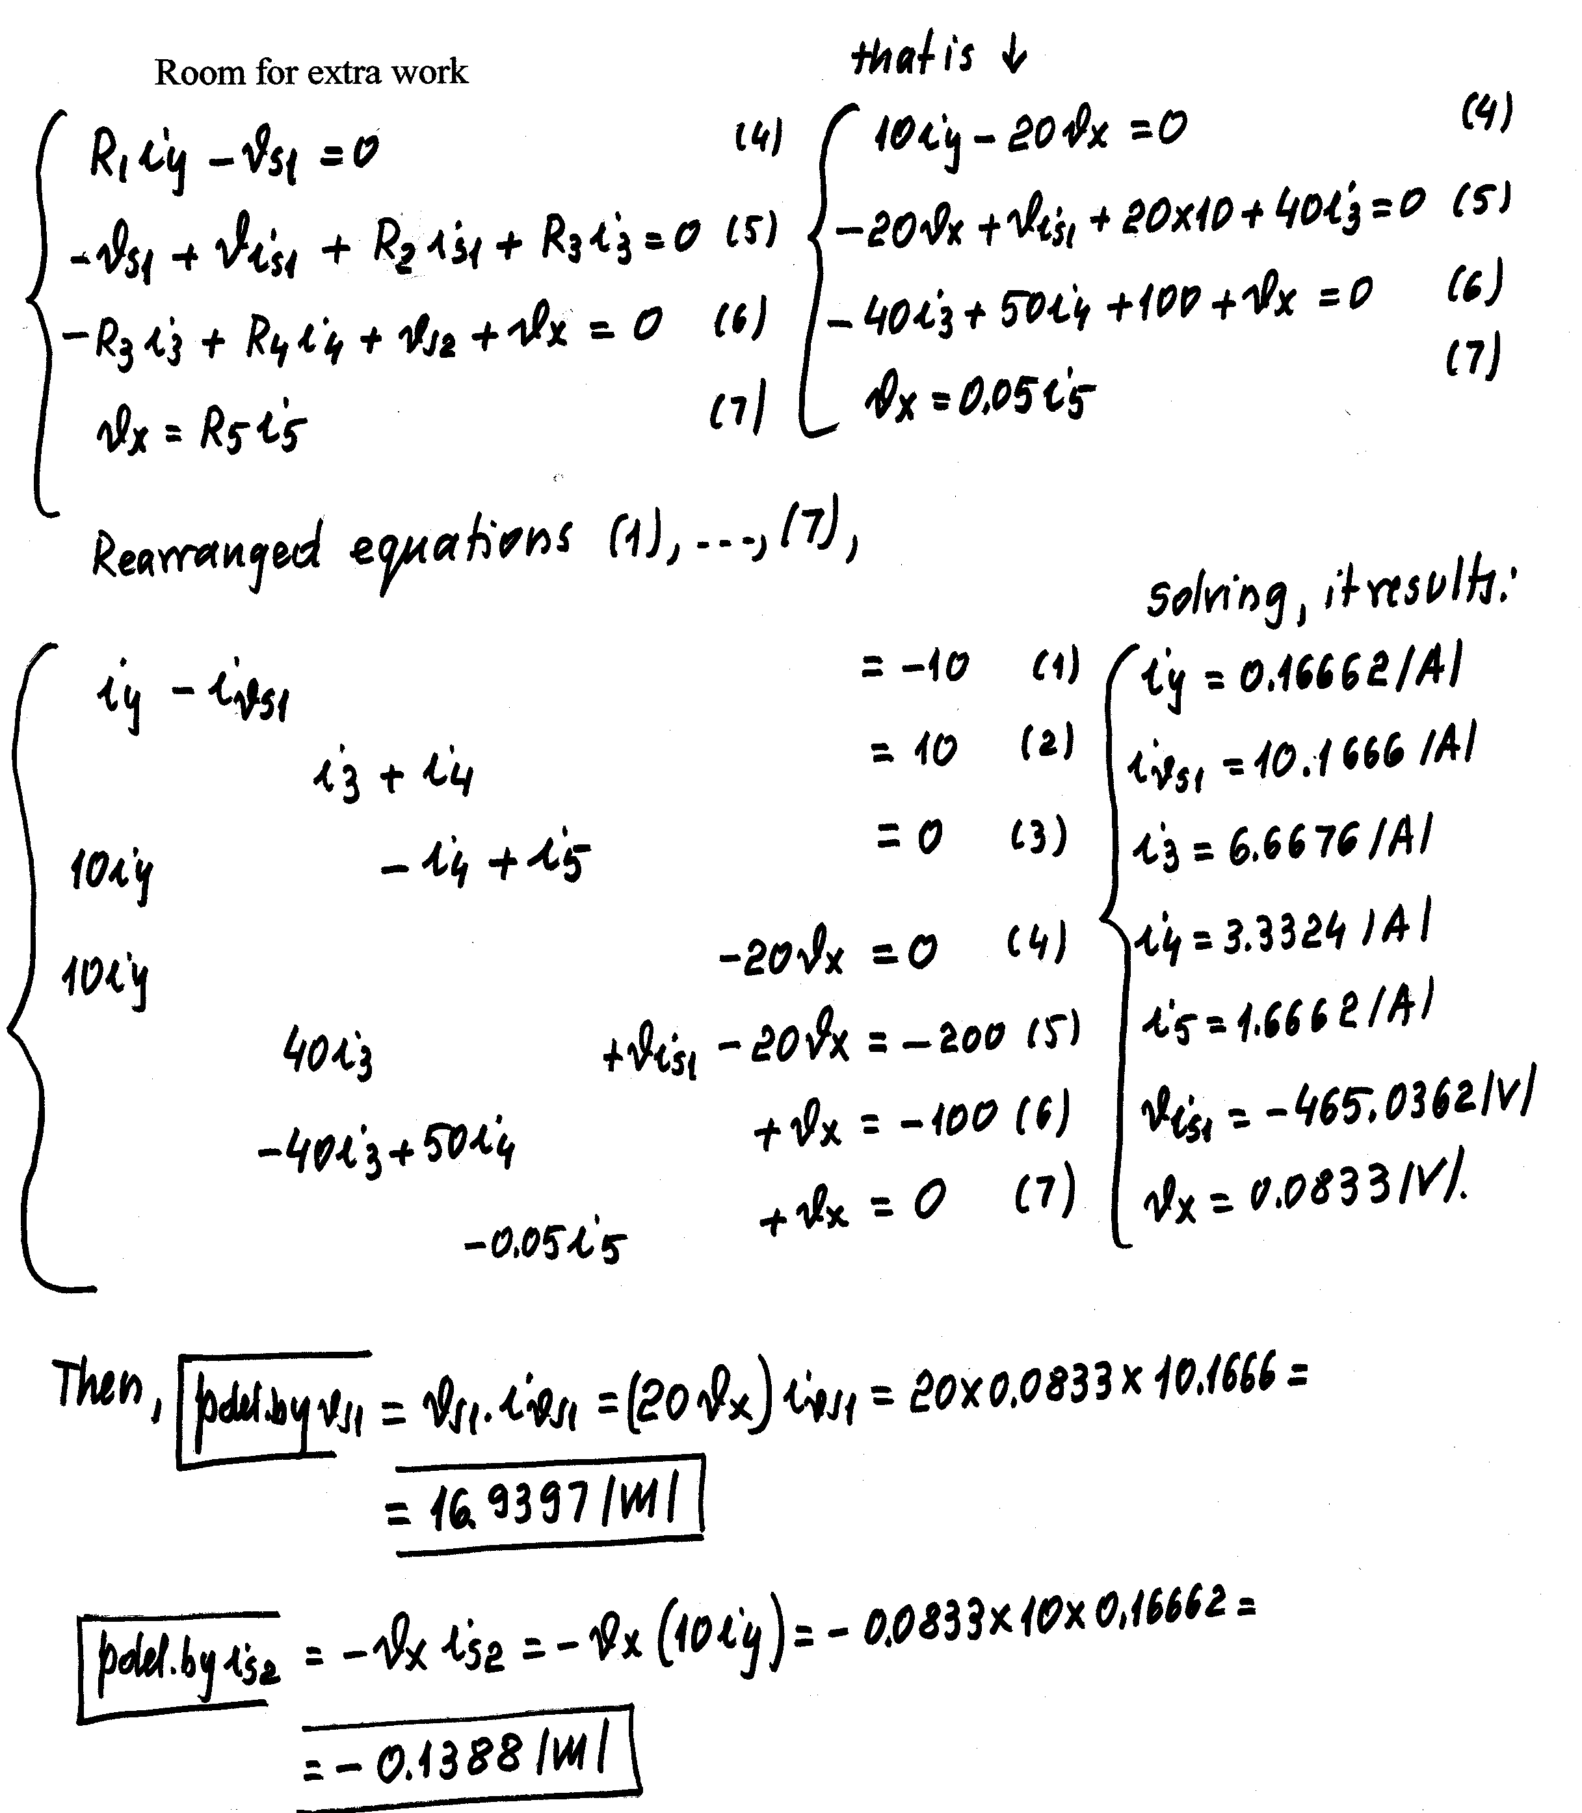

2) {30 Points} a) Find i_{X}.
b) Find v_{Q}.
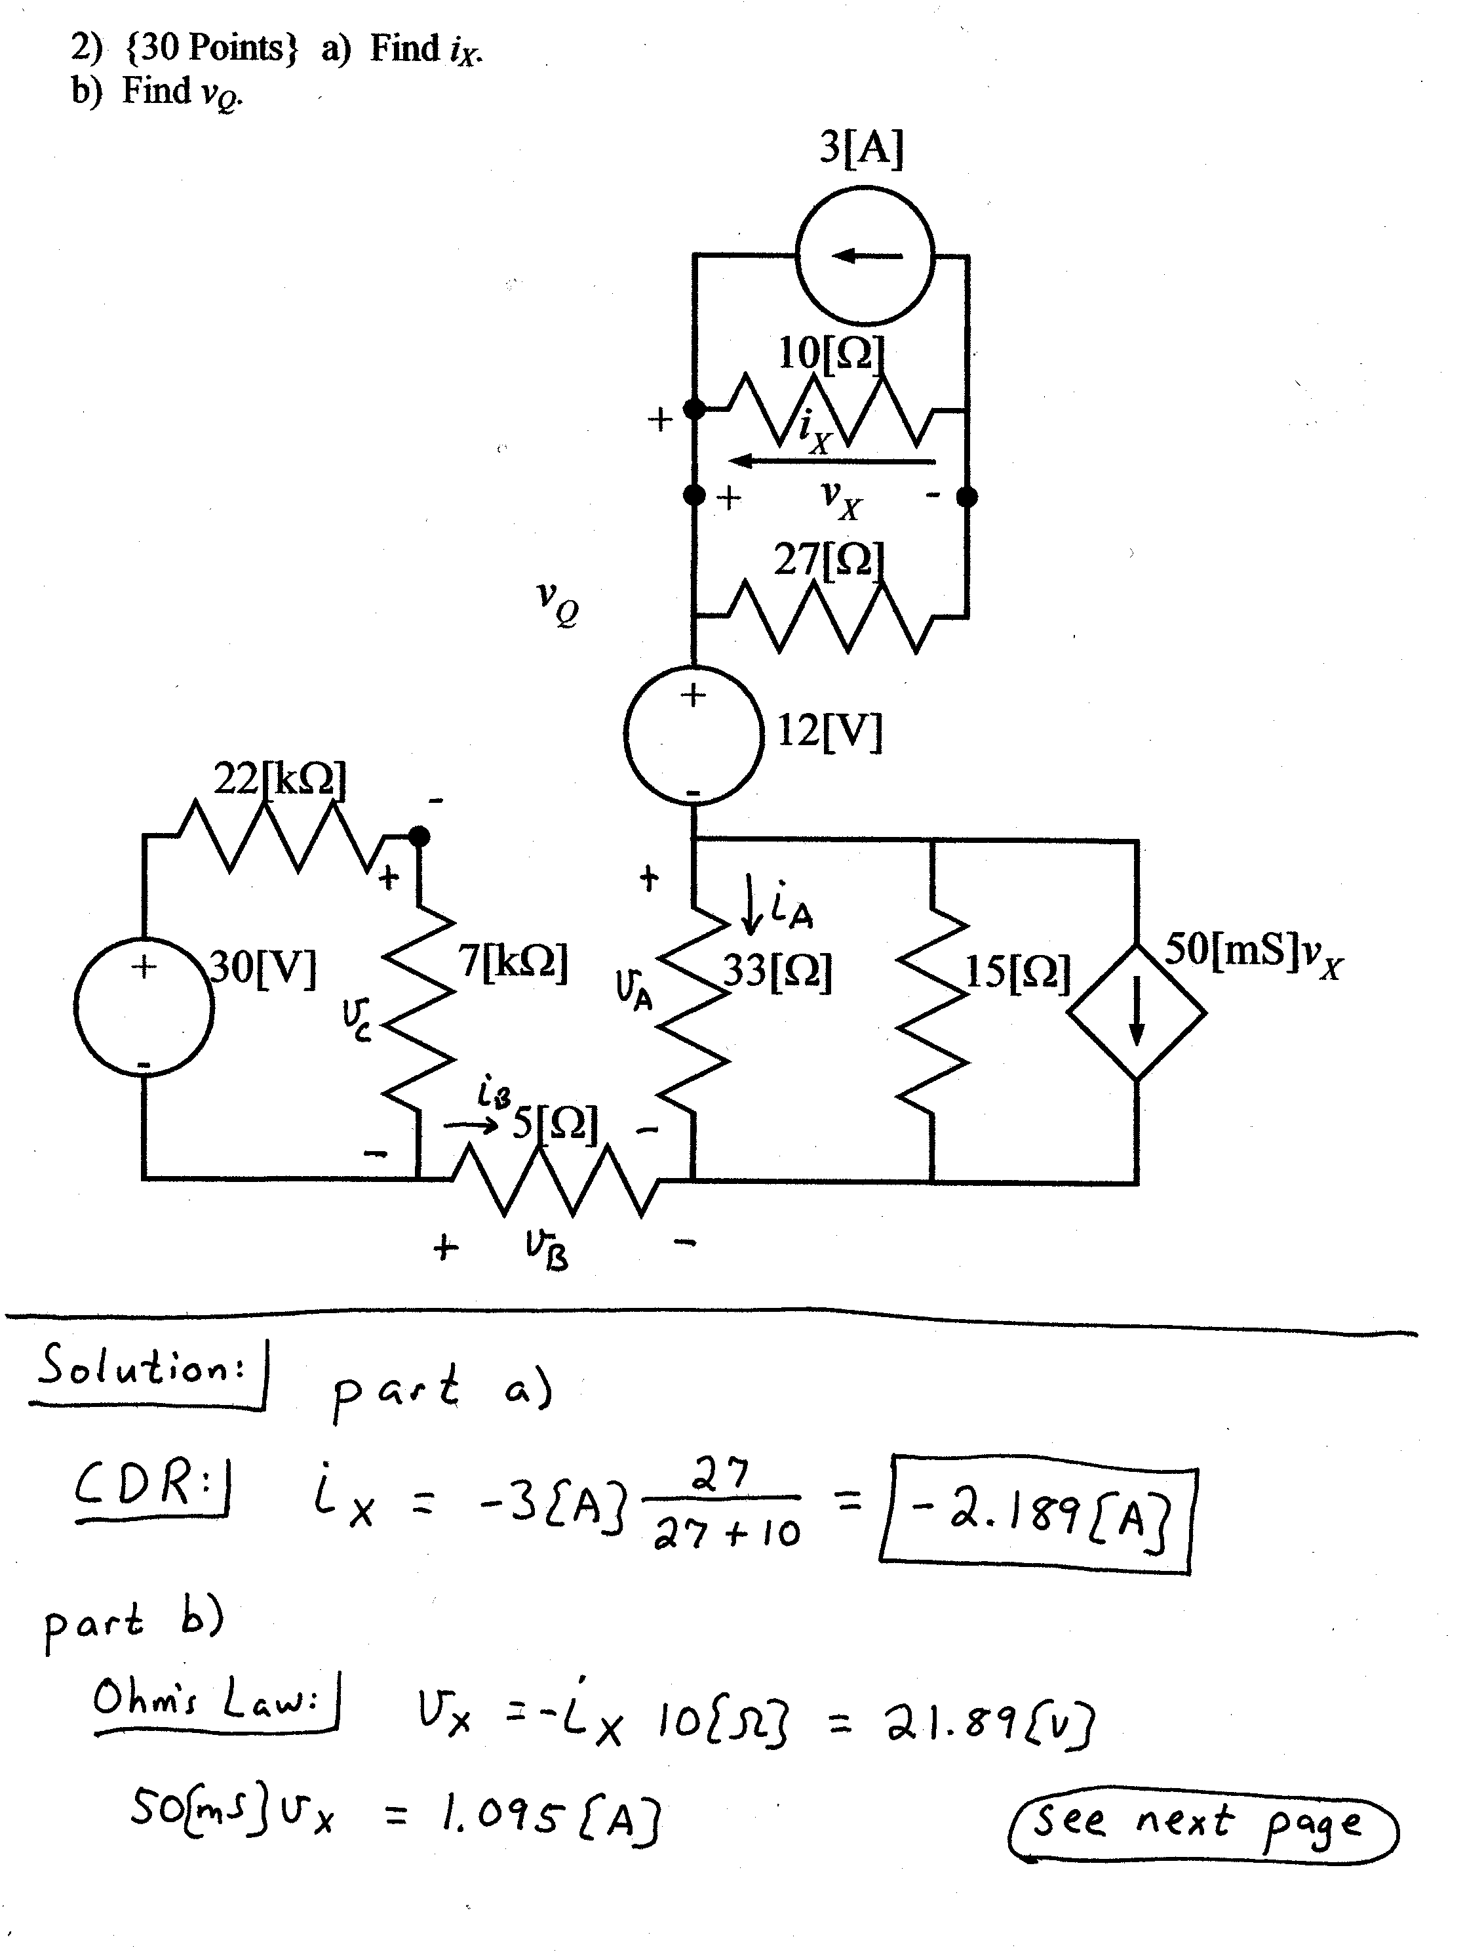
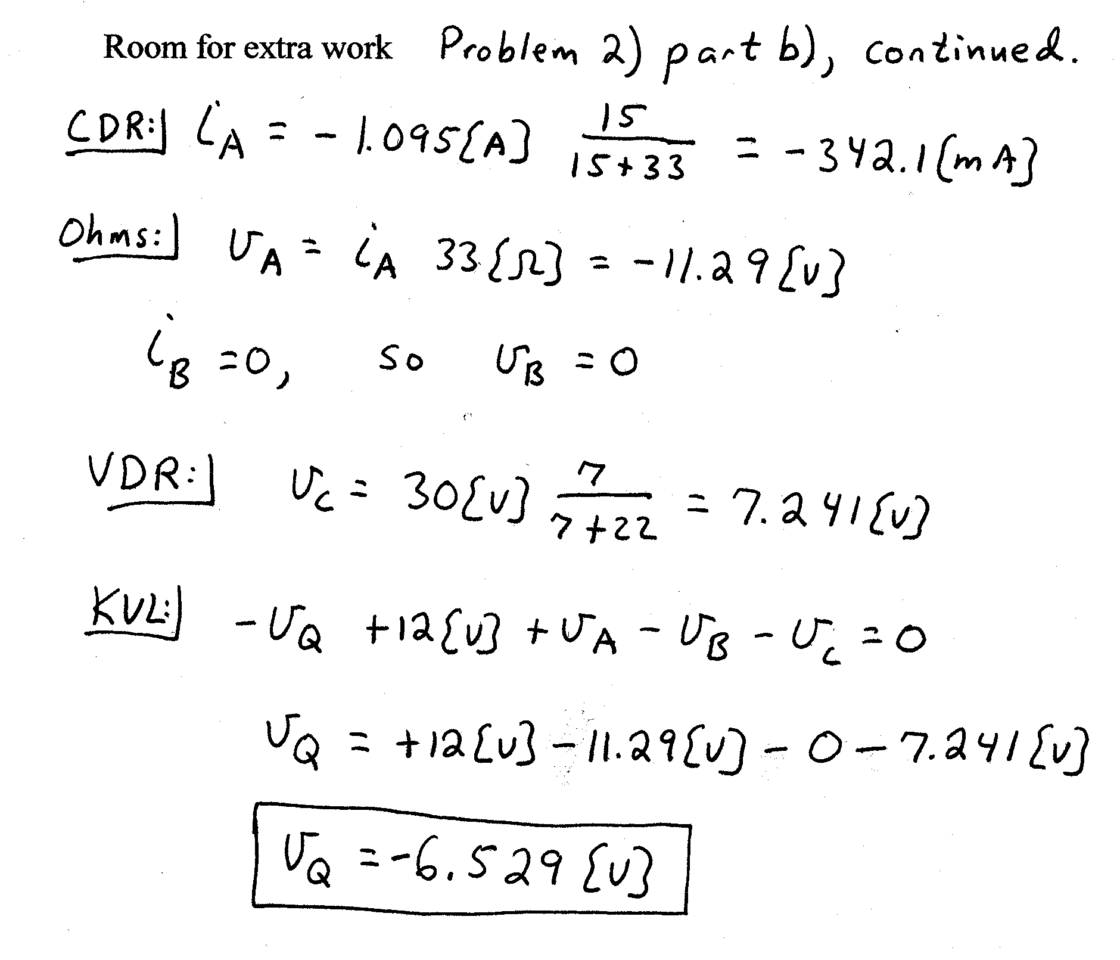
3) {15 Points} Two voltmeters, and another resistor, R_{X}, are connected in series as shown below.
Voltmeter #1 has a 100[V] full-scale reading, and has a meter resistance of 200[kΩ].
Voltmeter #2 has a 50[V] full-scale reading, and has a meter resistance of 400[kΩ].
Assume that when the voltmeters are subjected to voltages greater than their full-scale readings, they are not damaged.
Using this situation, what is the largest voltage, v_{X}, that can be measured?
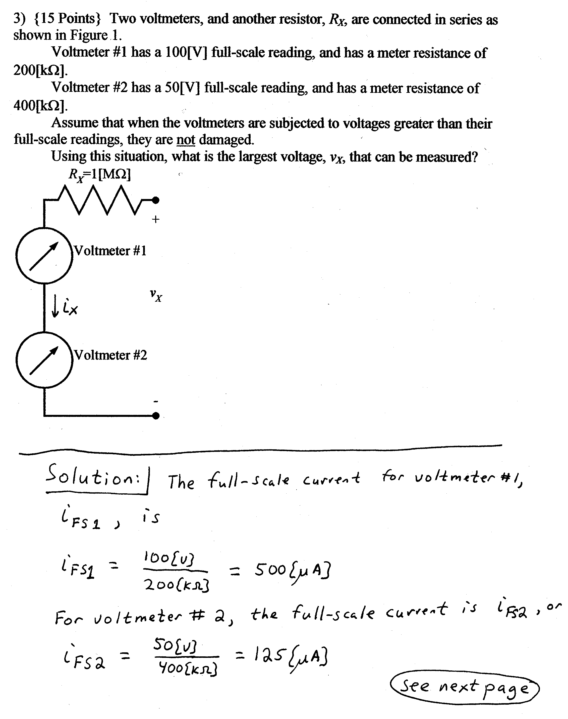
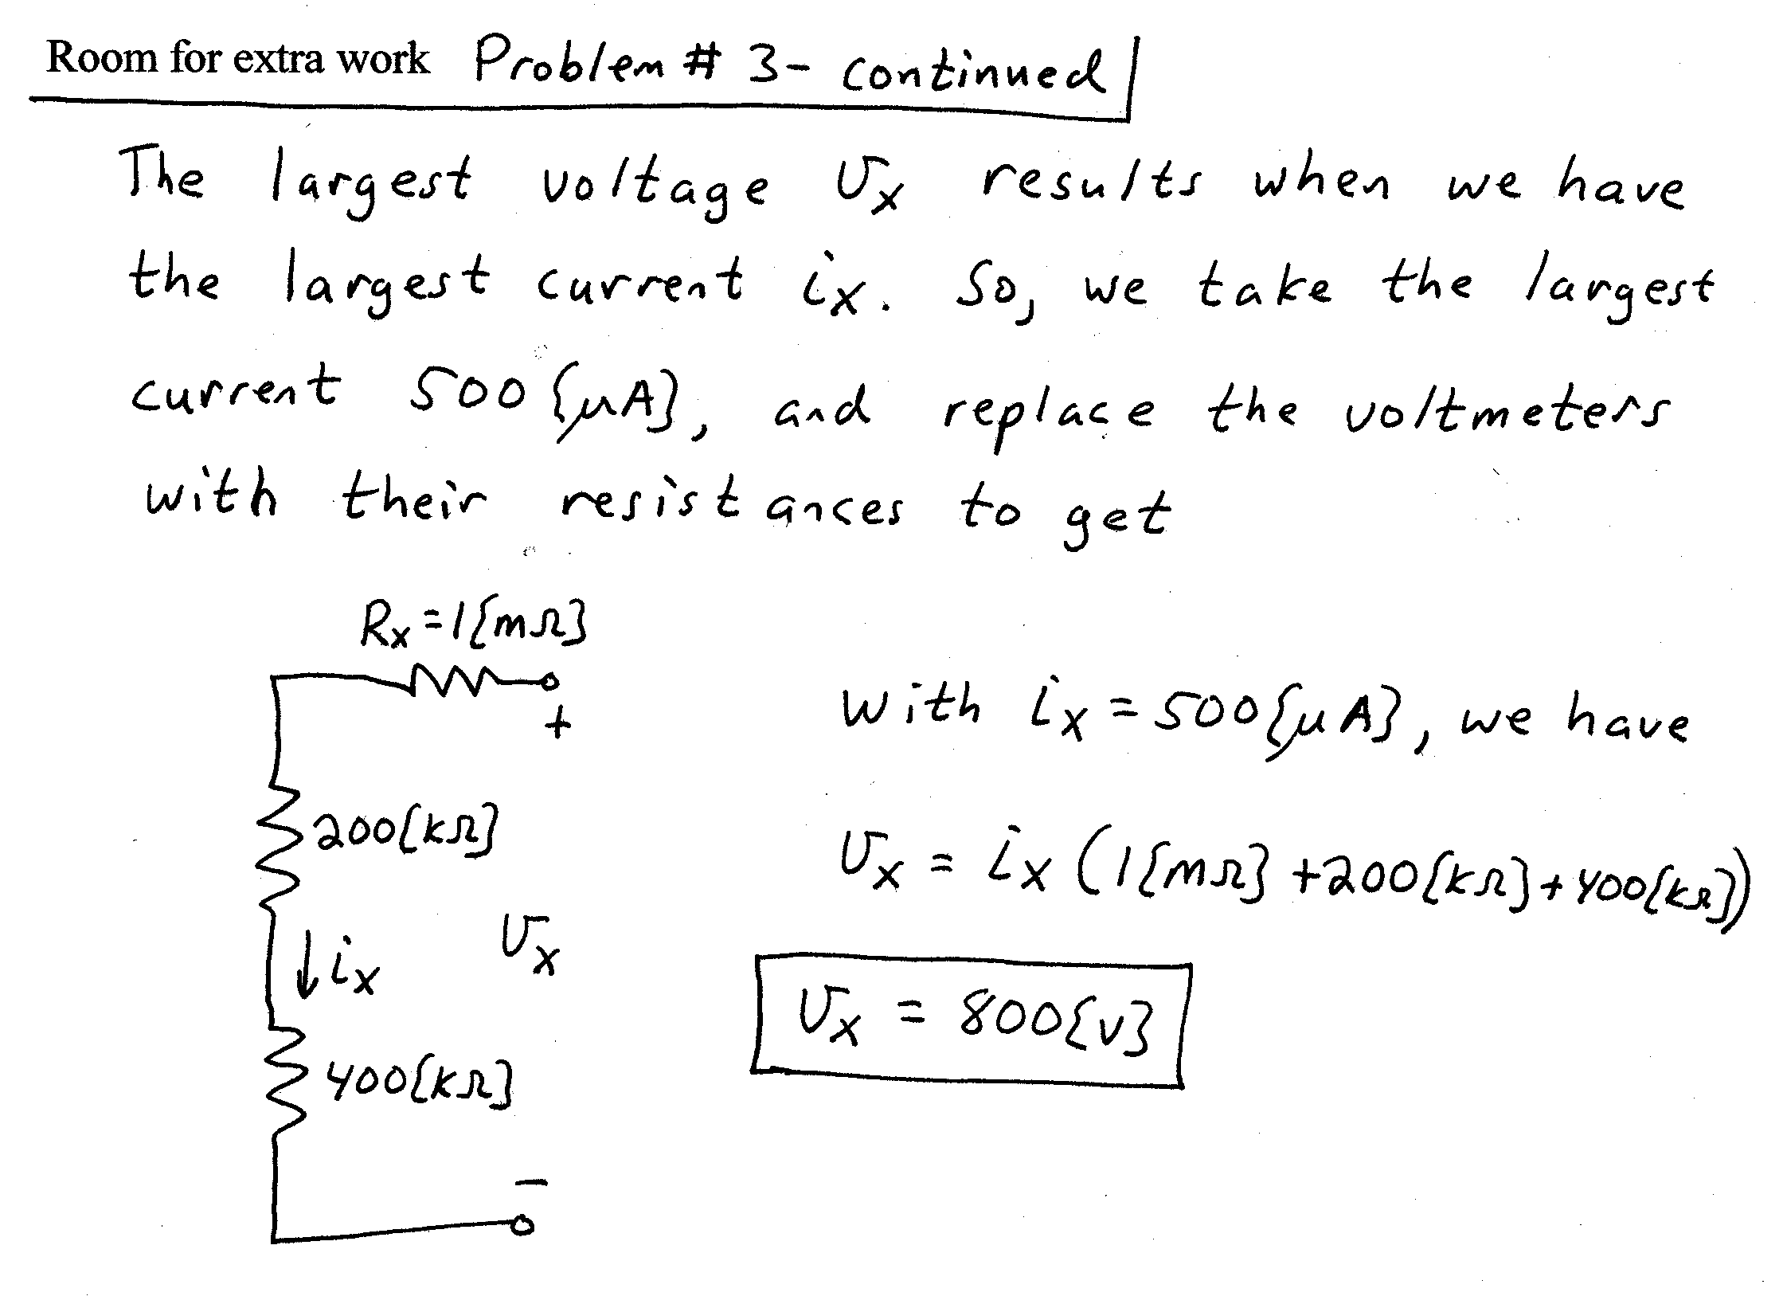
4) {30 Points} For the circuit shown, use the node-voltage method to write a complete set of independent equations that could be used to solve this circuit. Do not attempt to solve the equations. Do not attempt to simplify the circuit.


