**ECE 2201 – Circuit Analysis I**

**Homework #2**

Problems 1 and 2 below have been adapted from Nilsson and Riedel, 8th ed., Prentice Hall, 2008.

**1.** After a hard day at work, Dr. Dave and Dr. Trombetta go to their cars and find that one of them has a dead battery! They decide to “jump” start the car that has the dead battery, which they do by connecting the batteries as shown in the diagram below. (Note the little half-circle where the battery cables cross near Dr. T’s battery. This indicates that there is no connection here – the cables simply cross over each other.) Dr. Dave happens to have a current meter on him, so he measures the current ijump in the figure, and finds that it is 30[A].

a) Which car has the dead battery?

b) Assuming the current ijump and the battery voltages remain constant, how much energy is transferred to the dead battery in 1 [min]?



**2.** The manufacturer of a 9[V] flashlight battery says that the battery will deliver 20[mA] for 80 continuous hours. However, during that time the voltage will drop from 9[V] to 6[V]. Assume the voltage change with time is linear in time; in other words, the plot of voltage versus time is a straight line. Assume that the current is constant during these 80 hours.

a) How much energy does the battery deliver in 80[hours]?

b) Battery “capacity” can be stated in terms of the total charge the battery will deliver, with units of milliamp-hours [mA-h]. If the battery can be considered “dead” when the voltage reaches 6 [V], what is the capacity of the flashlight battery in [mA-h]?

**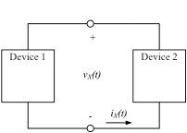3.** The diagram in Figure P2.1 shows the electrical connection of two devices. The current *iX* and the voltage *vX* are shown. Assume that the current *iX(t)* is a current made up of the flow of electrons. Assume that

Figure P2.1



a) Is Device 1 in the active or passive sign relationship with respect to *iX* and *vX*?

b) Which way are the electrons moving through Device 2 at *t* = 1[ms]?

c) Which way are the electrons moving through Device 1 at *t* = 5[ms]?

d) What is the power absorbed by Device 2 for *t* > 0?

e) Are the electrons gaining or losing energy as they move through Device 1, at t = 3[ms]?

f) What is the energy delivered by Device 2 for the time period 0 < *t* < 2[ms]?

g) What is the energy delivered by Device 1 for the time period 2[ms] < *t* < 10[ms]?

**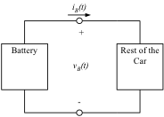4.** The diagram shown in Figure P2.4 shows a model for a car’s electrical system. The current *iB* and the voltage *vB* are given as

Figure P2.4



a) Is the battery in the active or passive sign relationship with respect to *iB* and *vB*?

b) How much energy is absorbed by the battery in the first second after ?

|  |  |
| --- | --- |
| **5.** The circuit shown in Fig. P2.5 is a combination of devices, with the voltages and currents as indicated.  a) Find the power associated with each device.  b) Determine which of the devices is delivering positive power, and add up all of those positive power values. Repeat the same process for the devices that absorb positive power.  c) The two sums that you determined in part b) should be equal. Check to see if this is true. | **Figure P2.5** |
| *vT* = 10.3[V], *vW* = -7.6[V], *vX* = -8.4[V], *vY* = -9.5[V], *vZ* = 1.9[V]  *iM* = 3.3[mA], *iN* = 24.1[mA], *iP* = 15.2[mA], *iQ* = -18.5[mA], *iR* = 5.6[mA], *iS* = -8.9[mA] | |

**6.** A student has made a series of voltage and current measurements on a circuit, and determined the values shown in Figure P2.6. You have been asked to check the validity of these values.

a) Determine whether these values can be valid by testing whether the energy is conserved in this circuit.

b) There was one sign error that was made by the student in these measurements. Determine what the error was. Do not use Kirchhoff’s Laws in your solution.



**Figure P2.6**

**hh02122_7.** The voltage in a wall socket has been measured, and found to be equal to



Next slide



A blender is connected to this wall socket, and the current in the blender is measured and found to be



The diagram shows the voltage and current polarities in this connection.

1. Find the power absorbed by the blender at *t* = 0.
2. Find the power absorbed by the blender at *t* = 4.3[ms].
3. Find the power absorbed by the blender at *t* = 8.6[ms].
4. Find the energy absorbed by the blender over one cycle of the sinusoid.

(PWA Problem 1 in Module 1)

**8.** The diagram below shows a model for a car’s electrical system. The current *iB* and the voltage *vB* are given as





The notation in the equation above should make it clear that the variable *t* is to be inserted with a number with units of [s].

a) With respect to *iB* and *vB*, is the battery in the active or passive sign relationship?

b) How much energy is absorbed by the battery in the first second after ?

(PEQWS Problem 2 in Module 1)

|  |  |
| --- | --- |
| **9.** The device shown in Figure P1.3a has the current *iQ(t)* as shown in Figure P1.3b, and the voltage *vQ(t)* as shown in Figure P1.3c.  a) The energy delivered by Device Q during the time period 1[s] < *t* < 4[s].  b) Find the power absorbed by Device Q at *t* = 3.5[s]. | Macintosh HD:Users:RebeccaHabib:Desktop:Untitled8.png |

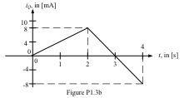 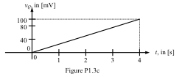

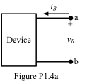**10.** The terminal voltage *vB(t)*, and the terminal current *iB(t)*, for the device shown in Figure P1.4a are changing with time. Plots of these two variables are shown in Figures P1.4b and P1.4c, both as a function of time in [s].

a) Find the numerical expressions for the power delivered by this device for the time interval 1[s] < *t* < 6[s].

b) Calculate the energy delivered by this device during the time interval   
1[s] < *t* < 6[s].

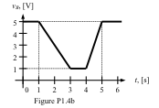 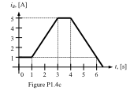

**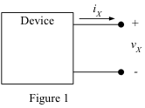11.** A device is shown, with reference polarities for voltage and current, in Figure 1. A plot of the voltage across the device, *vX*, is shown in Figure 2. A plot of the current through the device, *iX*, is shown in Figure 3.

a) Find the power absorbed by the device at *t* = 8[s].

b) Find the energy absorbed by the device in the time period 0 < *t* < 12[s].

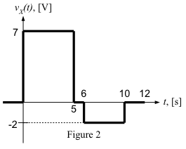 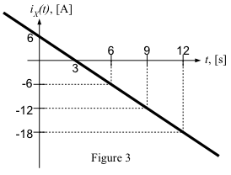

**12.** Six components, labeled A, B, C, D, E, and F, are connected as shown in the circuit diagram given in Figure 1. Some voltages and currents are defined in the equations below. The currents in this circuit are made up of the flow of electrons.

1. Find the direction that the electrons are moving through component D at *t* = 1[ms]. Your answer should be either left to right, or right to left. Explain how you got your answer.
2. Find the power delivered by component C at *t* = 2[ms].
3. Find the energy absorbed by component B during the time period from   
   *t* = 1[ms] to *t* = 4[ms].
4. Find the energy delivered by component B during the third [millisecond], counting [milliseconds] starting at *t* = 2[ms].





**Selected Numerical Solutions for ECE 2201 Homework Set #2.**

1) b) 21.6 [kJ]

2) a) 43.2 [kJ]

b) 1600 [mA-h]

3) a) passive sign relationship

1. the electrons are moving down through Device 2, from the top to the bottom
2. the electrons are moving down through Device 1, from the top to the bottom
3. 
4. gaining
5. 
6. 

4) a) active sign convention

b) -18.5[J]

5) a) 

b) Yes, the two power summations are equal.

6) Solution omitted here.

7) a) 746.9 [W]

b) -1.39 [W]

c) 746 [W]

d) 6.224 [J]

8) a) active sign relationship

b) -9.47 [J]

9) Solution omitted here, but required for you.

10) a) Solution omitted here, but required for you.

b) -41.67[J]

11) Solution omitted here.

12) d) *wDEL.BY.B =* -317.2[mJ].

**Problem 7)** is worked out in detail in the Dr. Dave Project files, as PWA Problem 1 in Module 1. This is a PowerPoint file, and is intended to work as a tutor to help you on these problems. These files are available on the course web page.

**Problem 8)** is worked out in detail in the Dr. Dave Project files, as PEQWS Problem 2 in Module 1. This is a Word file, and is intended to serve as a practice examination question, to help you prepare to solve these kinds of problems. These files are available on the course web page.