Name: _____________________________ (please print)
Signature: __________________________
Circle your class time: 5:30-7PM, TuTh 1-2:30PM, MW 2:30-4PM, MW

DO NOT OPEN THIS BOOKLET UNTIL INSTRUCTED TO DO SO

ECE 2300 -- EXAM #1
October 12, 2002

1. This quiz is closed book, closed notes. You may use one 8.5” x 11” crib sheet, or its equivalent. You may use any calculator. Turn all cell phones or other communications devices off.
2. Show all work on these pages. Show all work necessary to complete the problem. If you go on to another page, indicate clearly where your work can be found. A solution without the appropriate work shown will receive no credit. Clearly indicate your answer (for example, by enclosing it in a box).
3. Show all units in solutions, intermediate results, and figures. Units in the exam will be included between square brackets.
4. Do not use red ink. Do not use red pencil.
5. You will have 90 minutes to work on this exam.

1. ________________/1
2. ________________/25
3. ________________/25
4. ________________/20
5. ________________/30
- {1 Point} On the front page, circle your class time.

Room for extra work
2) {25 Points} The device in Figure 1 can be modeled as a current source in parallel with a resistance. When the device is connected to several different circuits, the plot shown in Figure 2 is obtained.
The same device is then connected in the circuit shown in Figure 3. Find the power delivered by the device in this circuit.
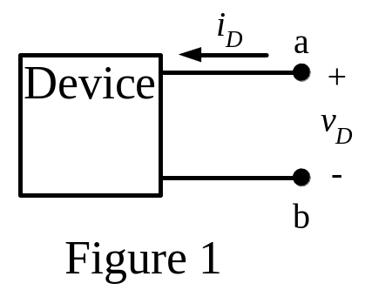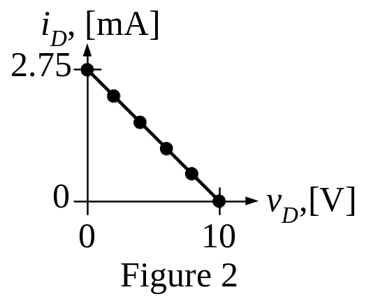
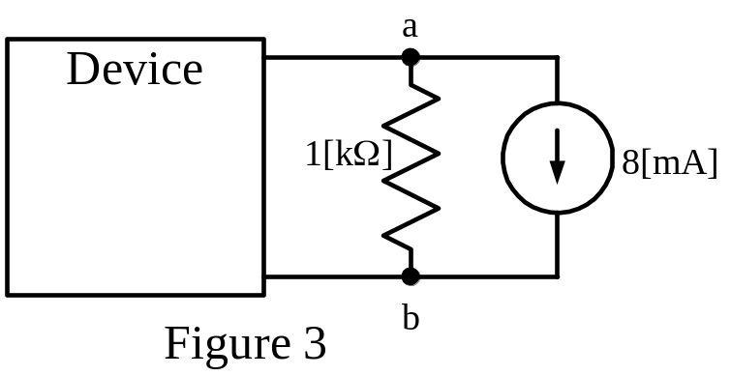
Room for extra work
3) {25 Points} Use the circuit below to solve.
a) Find v_{Q}.
b) Find v_{T}.
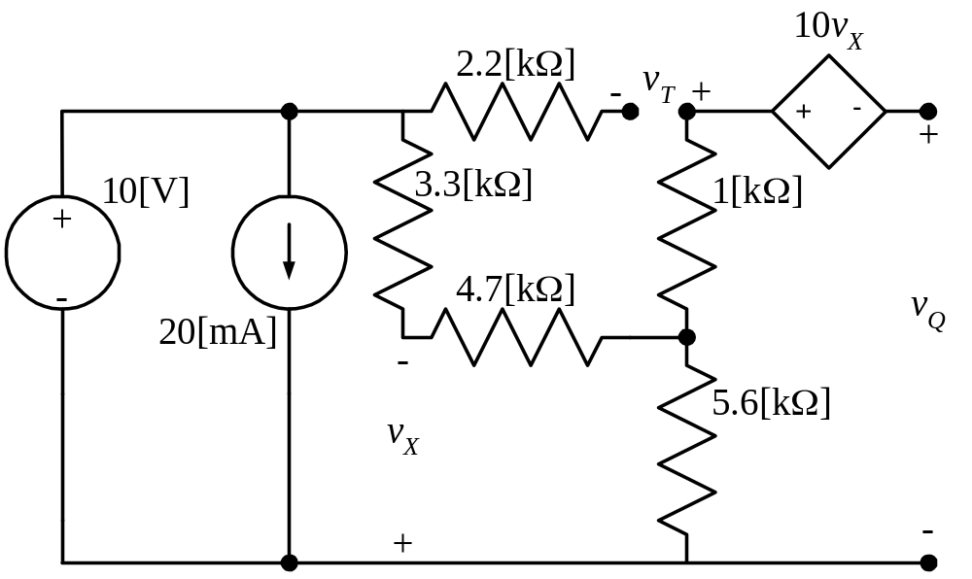
Room for extra work
4) {20 Points} An ammeter and a voltmeter are placed in a given circuit, as shown below.
The ammeter has a full-scale current of 1[A], and a meter resistance of 100[Ω].
The voltmeter has a full-scale voltage of 200[V], and a meter resistance of 100[Ω].
Both meters can read positive or negative values.
The ammeter reads a current, i₁ = - 270[mA].
The voltmeter reads a voltage, v₂ = - 27[V].

Find v_{S}.

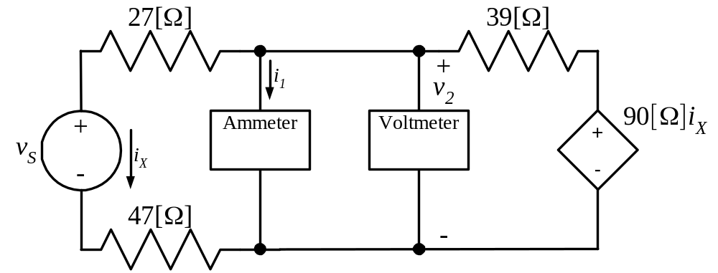
Room for extra work
5) {30 Points} For the circuit shown, use the node-voltage method to write a complete set of independent equations that could be used to solve this circuit. Do not attempt to solve the equations. Do not attempt to simplify the circuit.

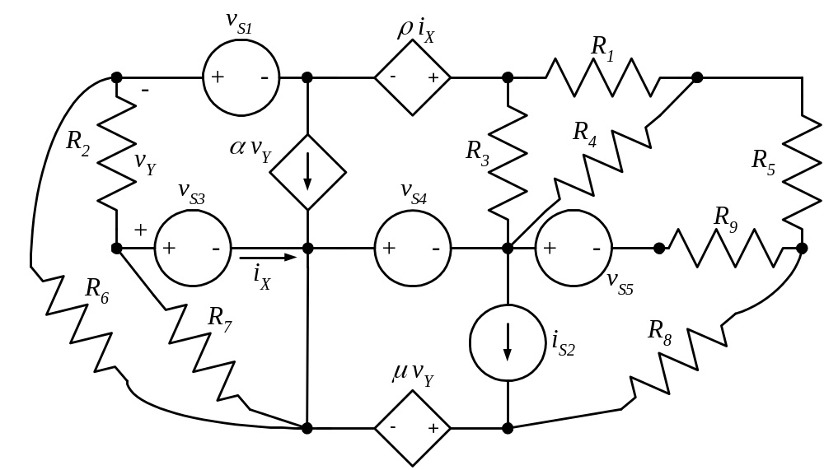

Room for extra work



