Name: _____________________________ (please print)
Signature: __________________________

ECE 2300 -- Quiz #5
Shattuck Section – Fall 2003
November 18, 2003

Keep this quiz closed and face up until you are told to begin.

1. This quiz is closed book, closed notes. You may use one 8.5” x 11” crib sheet, or its equivalent.
2. Show all work on these pages. Show all work necessary to complete the problem. If you go on to another page, indicate clearly where your work can be found. A solution without the appropriate work shown will receive no credit.
3. Show all units in solutions, intermediate results, and figures. Units in the quiz will be included between square brackets.
4. Do not use red ink. Do not use red pencil.
5. You will have 40 minutes to work on this quiz.

________________/20
Room for extra work
In the circuit shown, Switch 1 was closed and Switch 2 was in position a for a long time before t = 0. Then, at t = 0, Switch 1 opened. After that, 5[ms] later, Switch 2 moved to position b. Find the energy stored in the capacitor at
t = 11[ms].
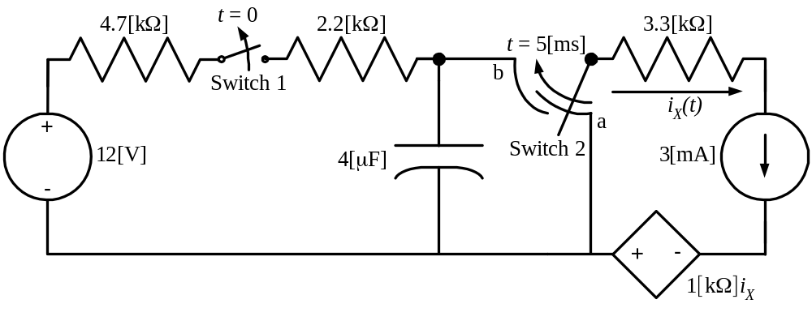

ECE 2300 -- Quiz #5 – November 18, 2003 – Shattuck Section Solution


