Name: _____________________________ (please print)
Signature: __________________________

ECE 2300 -- Exam #1
October 14, 2006

Keep this exam closed until you are told to begin.

1. This exam is closed book, closed notes. You may use one 8.5” x 11” crib sheet, or its equivalent.
2. Show all work on these pages. Show all work necessary to complete the problem. A solution without the appropriate work shown will receive no credit. A solution that is not given in a reasonable order will lose credit. Clearly indicate your answer (for example by enclosing it in a box).
3. It is assumed that your work will begin on the same page as the problem statement. If you choose to begin your work on another page, you must indicate this on the page with the problem statement, with a clear indication of where the work can be found. If your work continues on to another page, indicate clearly where your work can be found. Failure to indicate this clearly will result in a loss of credit.
4. Show all units in solutions, intermediate results, and figures. Units in the exam will be included between square brackets.
5. Do not use red ink. Do not use red pencil.
6. You will have 90 minutes to work on this exam.

1. ________________/30
2. ________________/35
3. ________________/35
Total = 100
Room for extra work
1. {30 Points} Use the circuit below to find the numerical values of the quantities requested.
a) Find v_{X}.
b) Find the power delivered by the voltage source v_{S2}.
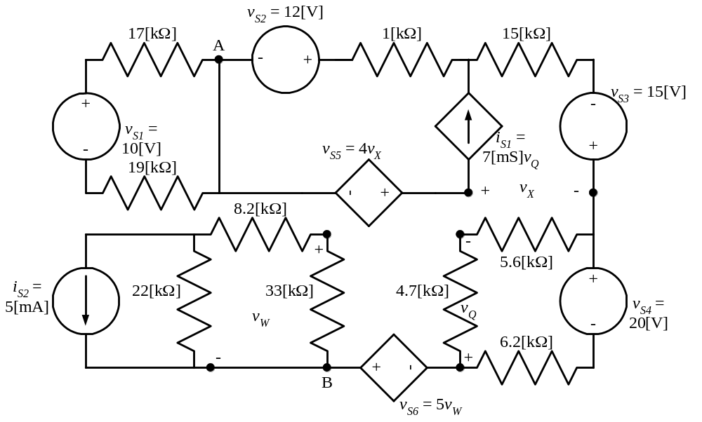

Room for extra work

2. {35 Points} Two multi-range voltmeters are shown in Figures 1 and 2. They are both connected, at the same time, to the circuit in Figure 3, connecting all the terminals labeled a together, all the terminals labeled b together, and all the terminals labeled c together.
a) Find the reading on the 150[V] scale for Meter 1.
b) Find the reading on the 100[V] scale for Meter 2.
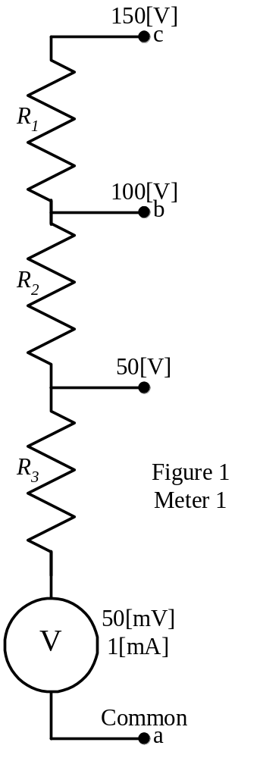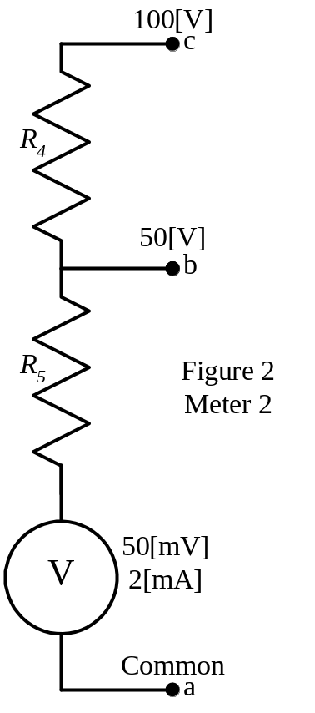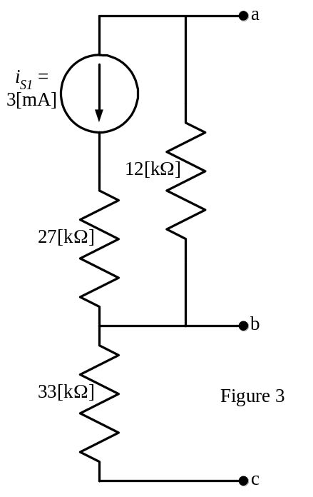

Room for extra work

3. {35 Points} For the given circuit, use either the node-voltage method or the mesh-current method to write a complete set of independent equations that could be used to solve this circuit. You only need to write one set of equations. Do not simplify the circuit. Do not attempt to solve or simplify your equations. Define all variables.

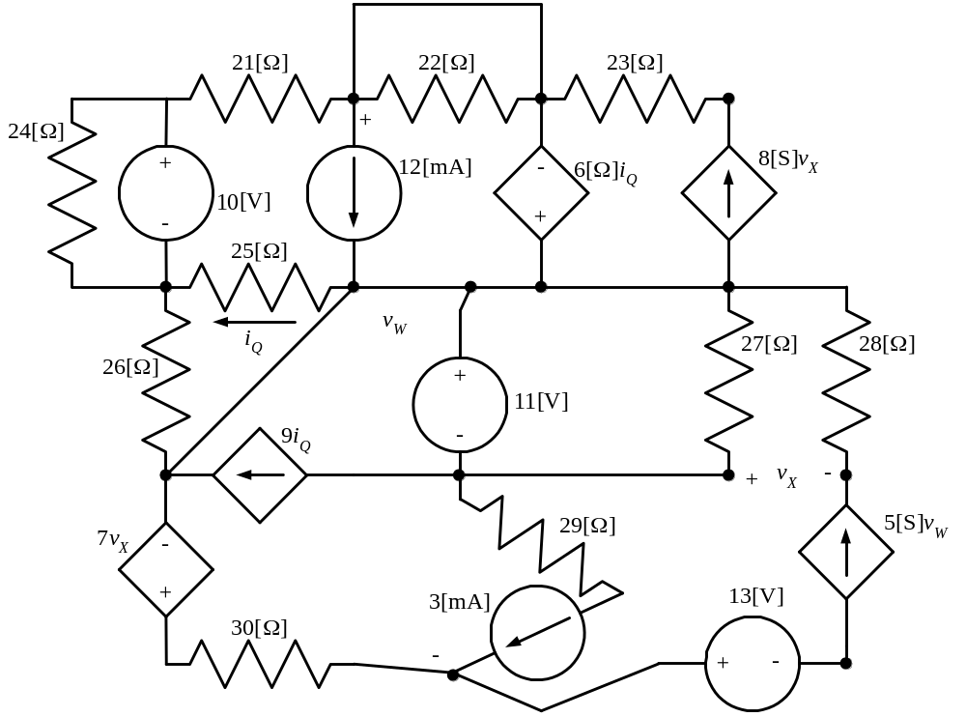

Exam Solution:
1. {30 Points} Use the circuit below to find the numerical values of the quantities requested.
a) Find v_{X}.
b) Find the power delivered by the voltage source v_{S2}.
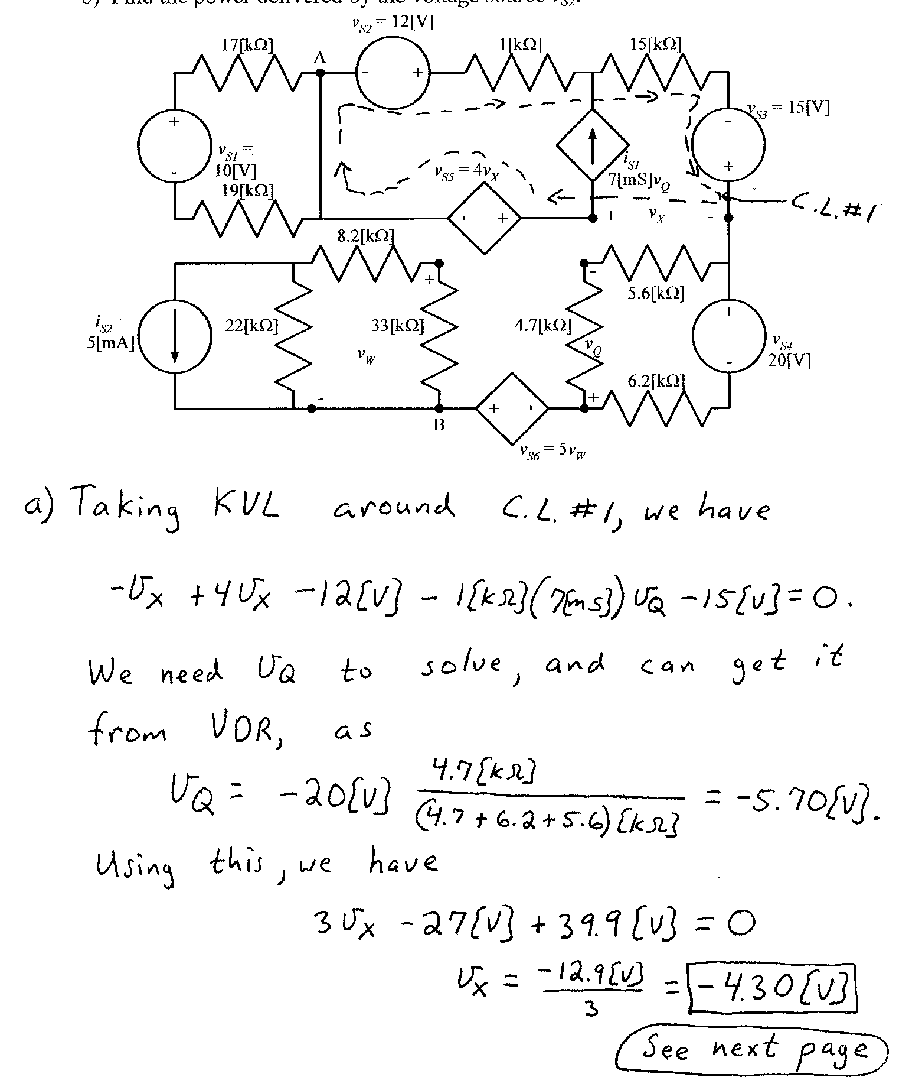
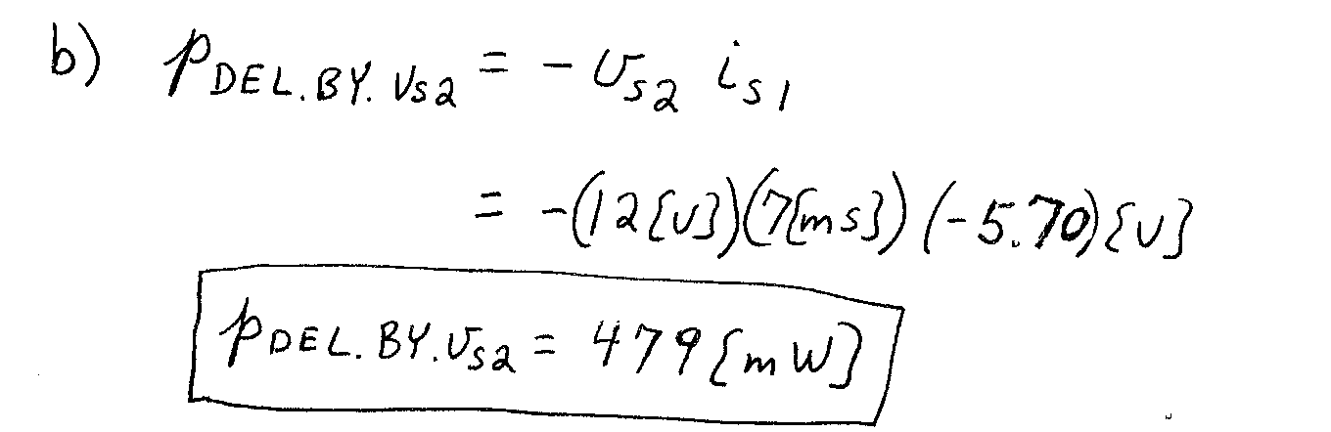
2. {35 Points} Two multi-range voltmeters are shown in Figures 1 and 2. They are both connected, at the same time, to the circuit in Figure 3, connecting all the terminals labeled a together, all the terminals labeled b together, and all the terminals labeled c together.
a) Find the reading on the 150[V] scale for Meter 1.
b) Find the reading on the 100[V] scale for Meter 2.
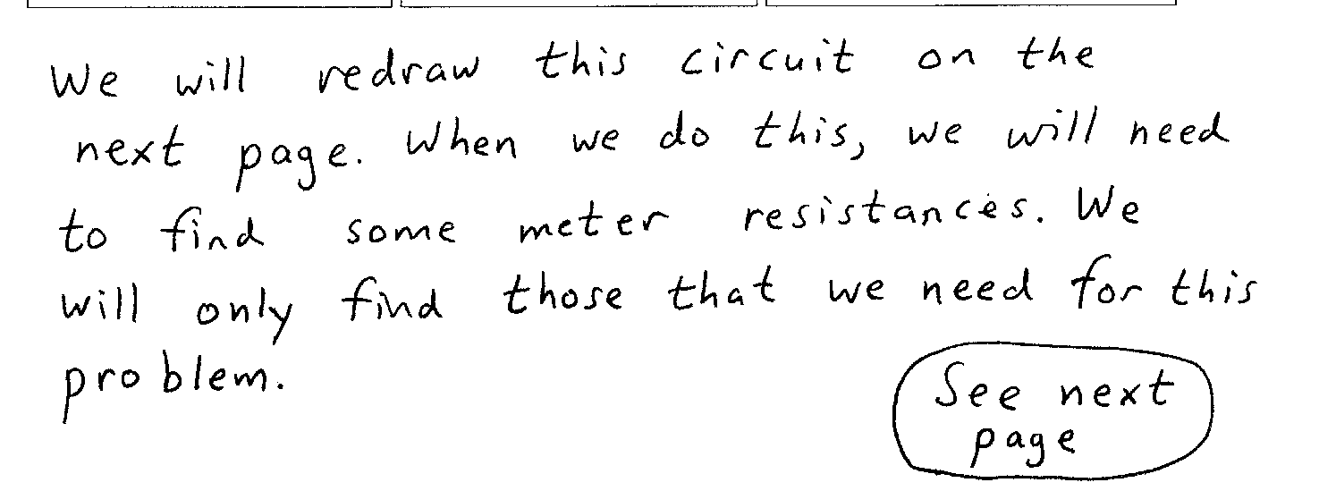
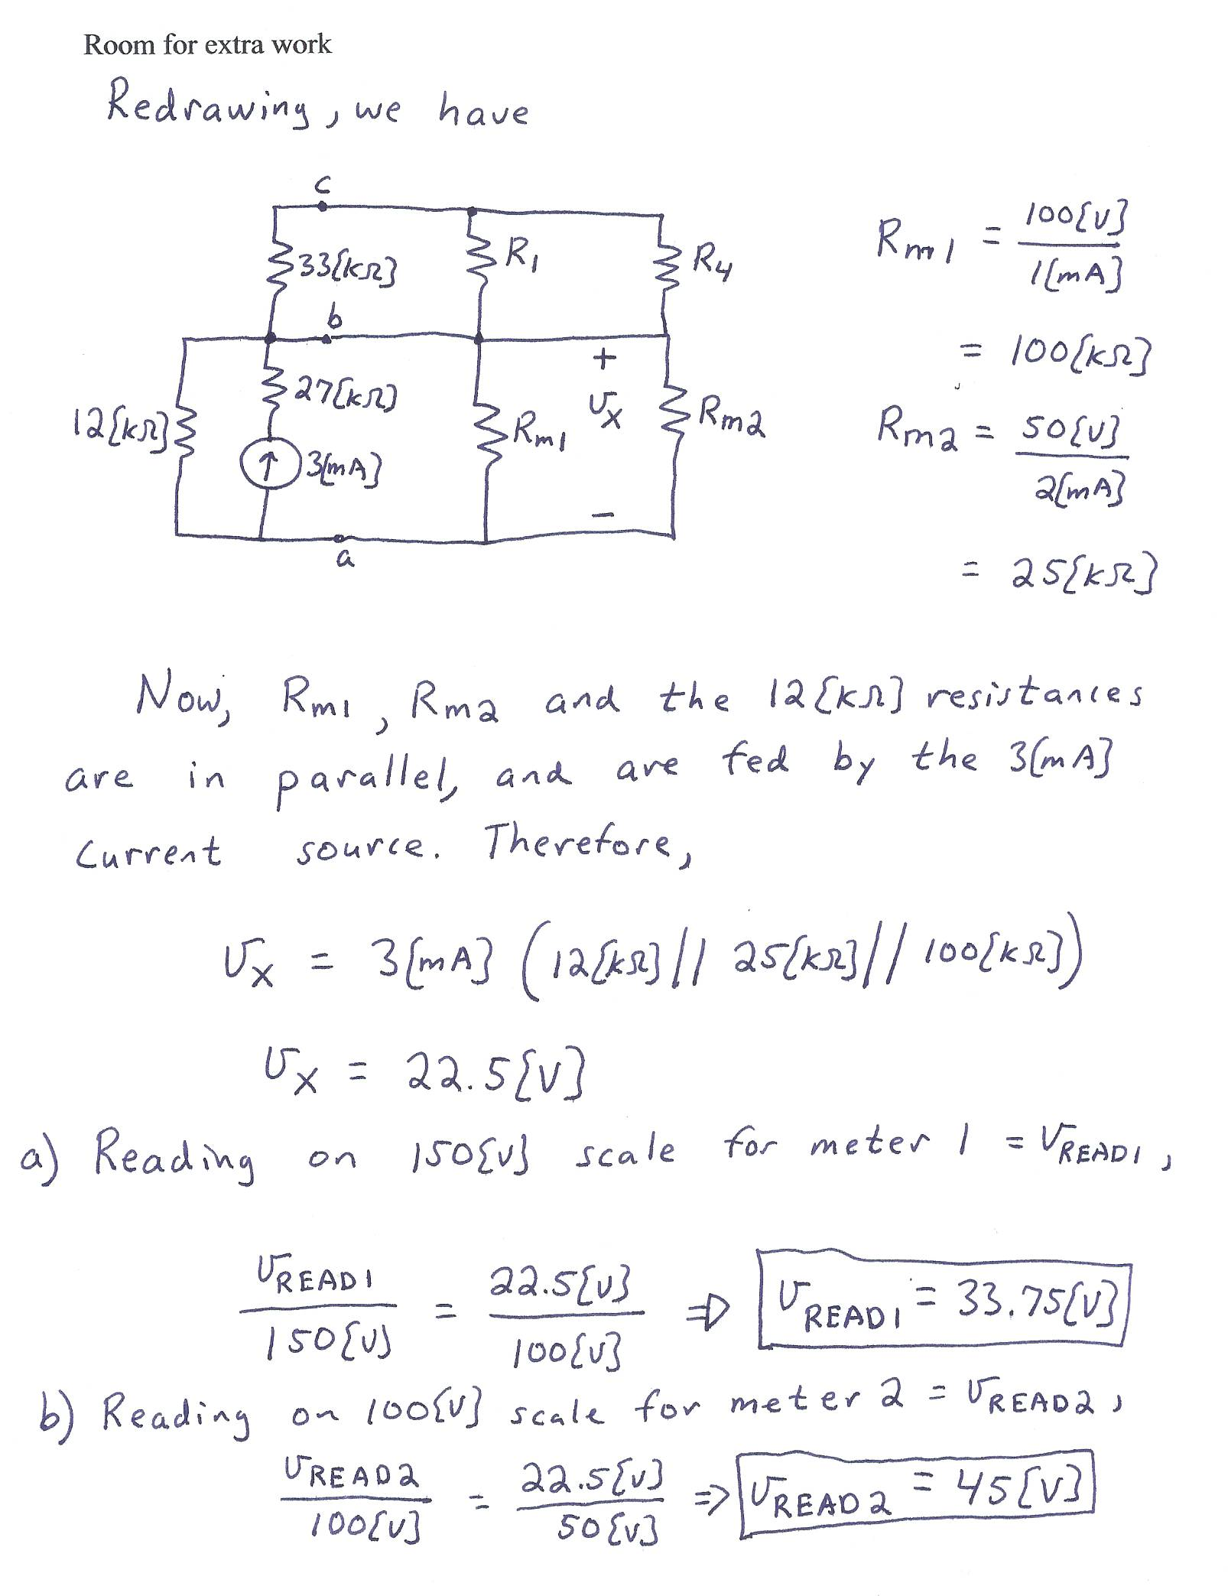
3. {35 Points} For the given circuit, use either the node-voltage method or the mesh-current method to write a complete set of independent equations that could be used to solve this circuit. You only need to write one set of equations. Do not simplify the circuit. Do not attempt to solve or simplify your equations. Define all variables.


