Name: _____________________________ (please print)
Signature: __________________________

ECE 2300 -- Exam #2
November 21, 2009

Keep this exam closed until you are told to begin.

1. This exam is closed book, closed notes. You may use one 8.5” x 11” crib sheet, or its equivalent.
2. Show all work on these pages. Show all work necessary to complete the problem. A solution without the appropriate work shown will receive no credit. A solution that is not given in a reasonable order will lose credit. Clearly indicate your answer (for example by enclosing it in a box).
3. It is assumed that your work will begin on the same page as the problem statement. If you choose to begin your work on another page, you must indicate this on the page with the problem statement, with a clear indication of where the work can be found. If your work continues on to another page, indicate clearly where your work can be found. Failure to indicate this clearly will result in a loss of credit.
4. Show all units in solutions, intermediate results, and figures. Units in the exam will be included between square brackets.
5. Do not use red ink. Do not use red pencil.
6. You will have 90 minutes to work on this exam.

1. ________________/30
2. ________________/30
3. ________________/40
Total = 100
Room for extra work
1. {30 Points} For the given circuit, use the Mesh-Current method to write a complete set of independent equations that could be used to solve this circuit. Do not simplify the circuit. Do not attempt to solve or simplify your equations. Define all variables.

Room for extra work

2. {30 Points} Use the circuit shown below to solve for the numerical values of the quantities requested.
- Find the Thévenin equivalent as seen by the i_{S1} current source. Draw the equivalent, showing the numerical values of all components, and attach the i_{S1} current source.
- Find the power delivered by the i_{S1} current source in this circuit.

Room for extra work

3. {40 Points} Switch SWA was closed for a long time, and switch SWB was open for a long time, before t = 0. Then, at t = 1[s], SWA opened and SWB closed, both at the same time. It is given that v_{X}(0) = 10[V].
a) Find v_{X} (2[s]).
b) Find the energy stored in capacitor C₂ at t = 1.01[s].

Room for extra work

Solution:
1. {30 Points} For the given circuit, use the Mesh-Current method to write a complete set of independent equations that could be used to solve this circuit. Do not simplify the circuit. Do not attempt to solve or simplify your equations. Define all variables.
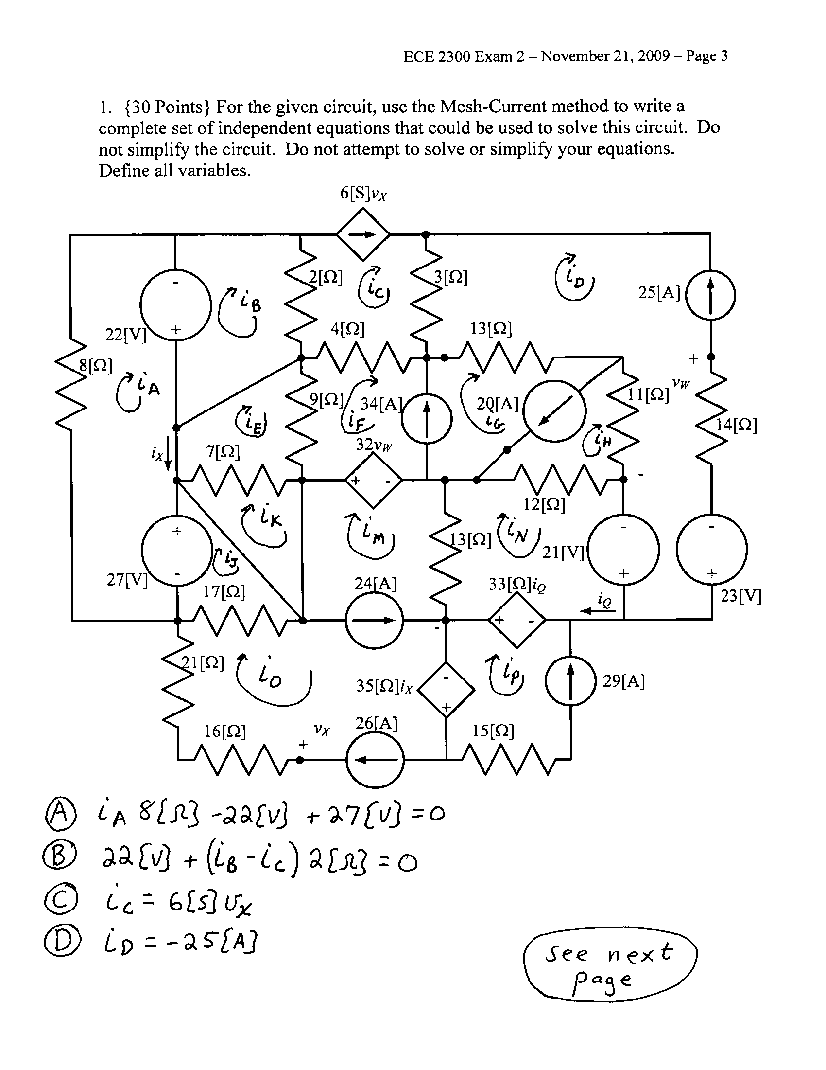
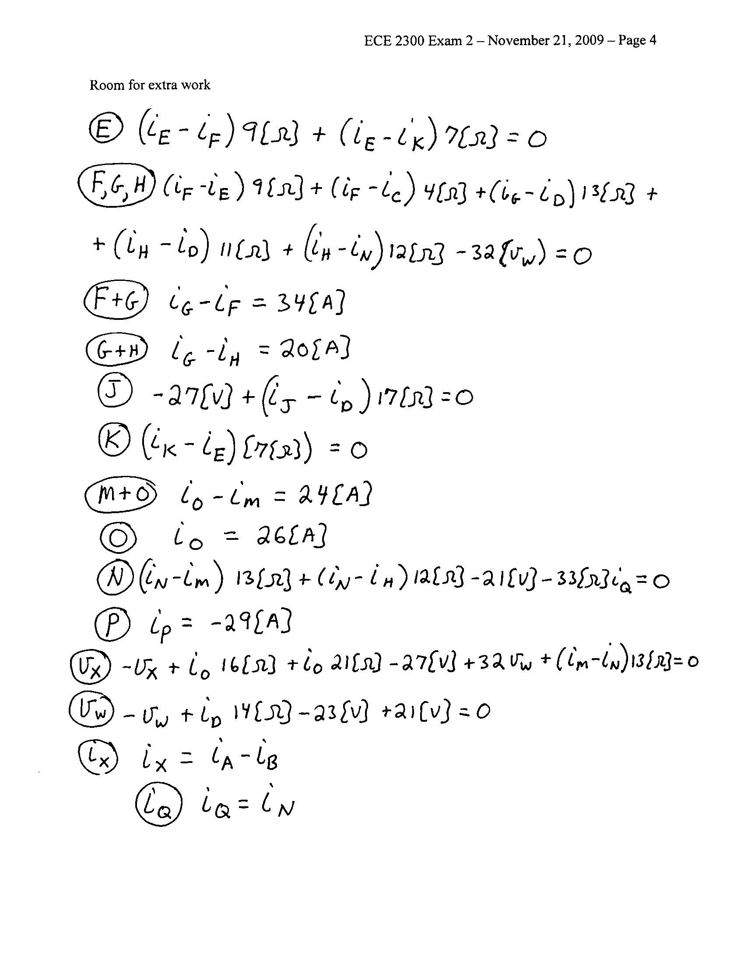

2. {30 Points} Use the circuit shown below to solve for the numerical values of the quantities requested.
- Find the Thévenin equivalent as seen by the i_{S1} current source. Draw the equivalent, showing the numerical values of all components, and attach the i_{S1} current source.
- Find the power delivered by the i_{S1} current source in this circuit.
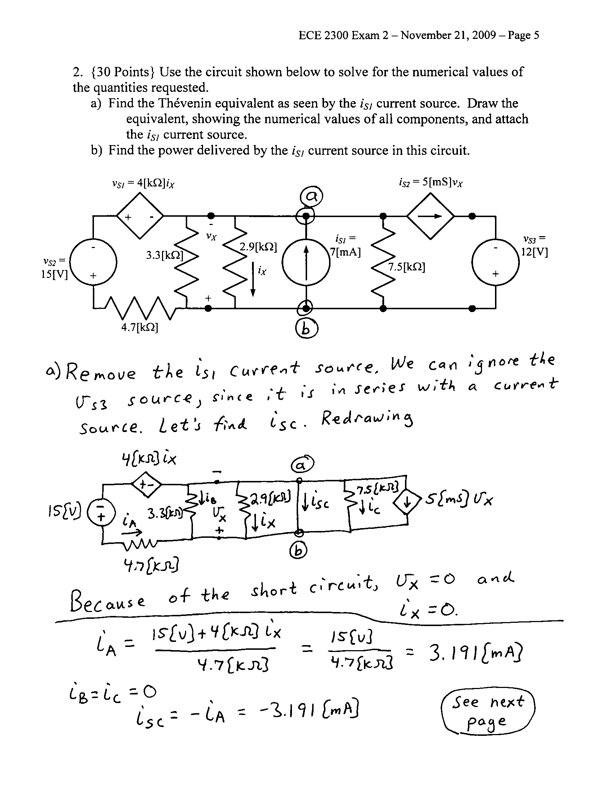
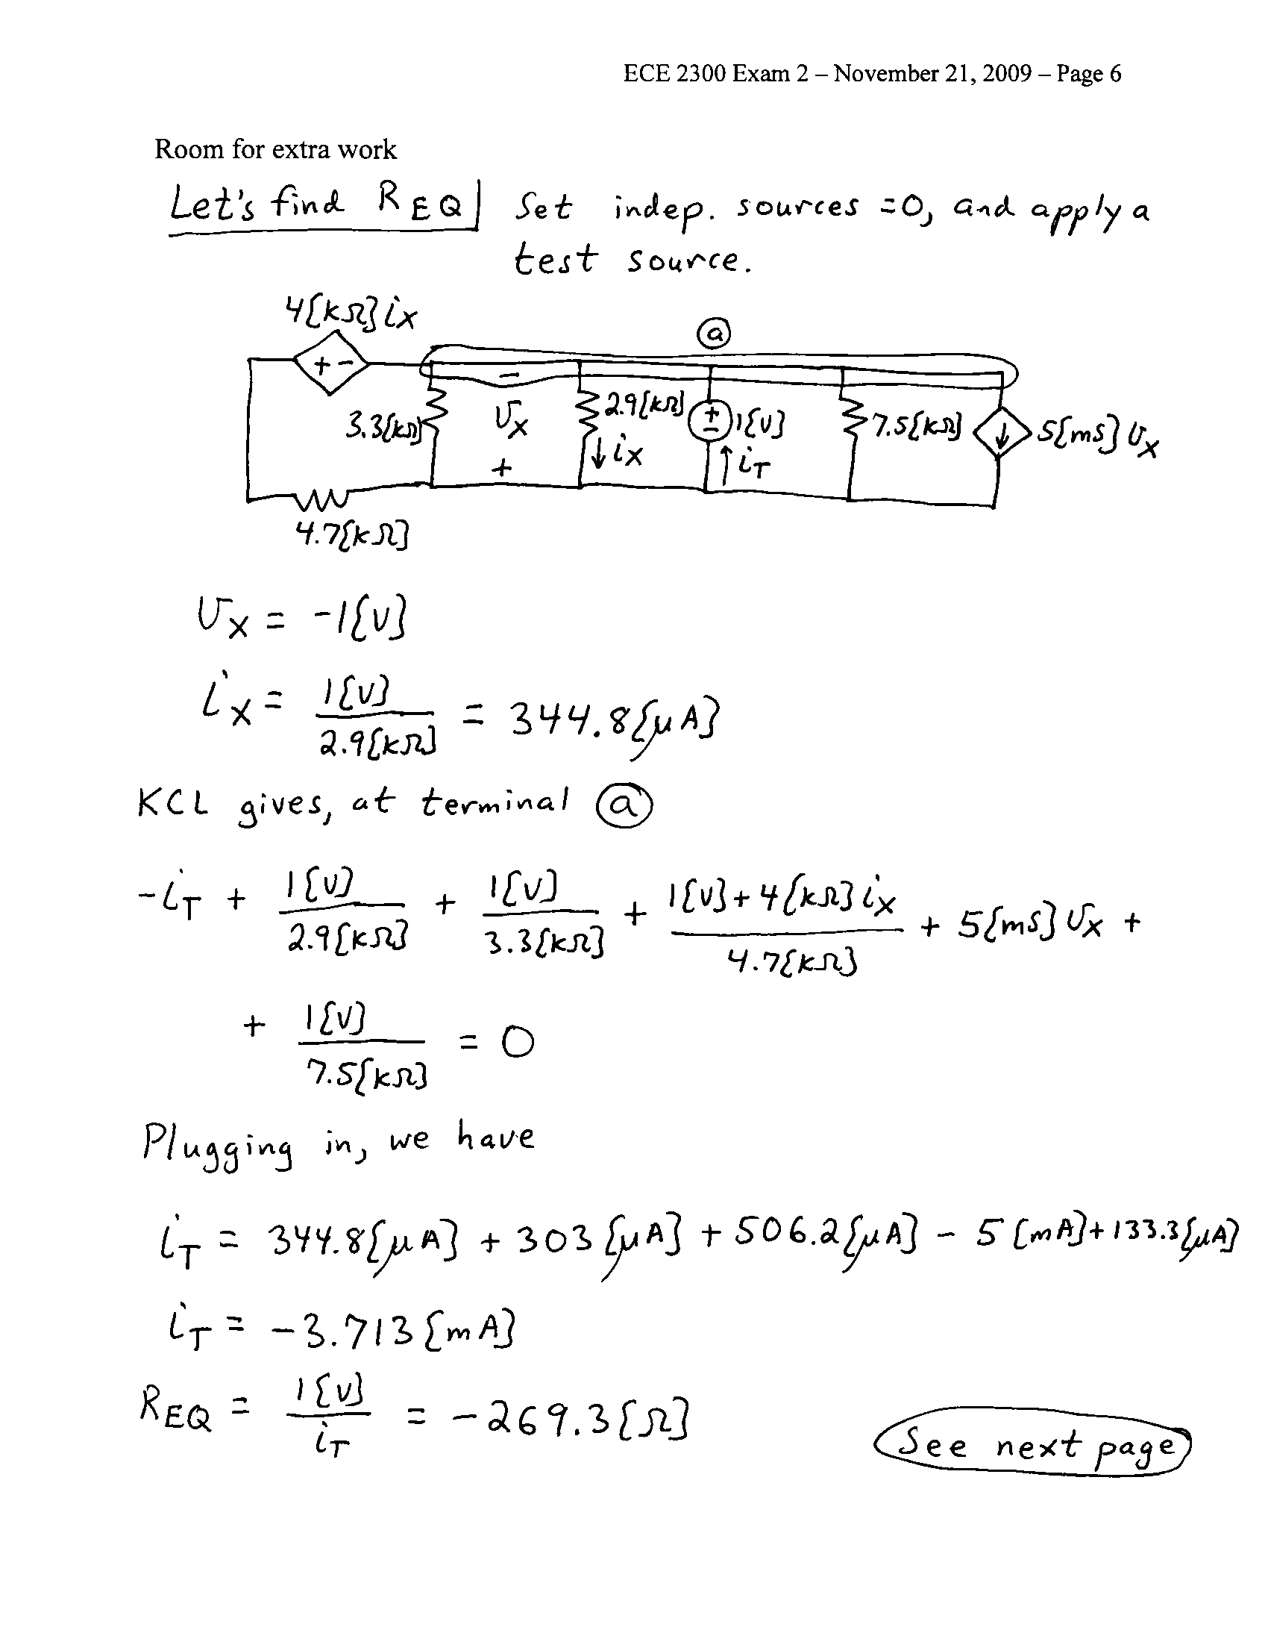
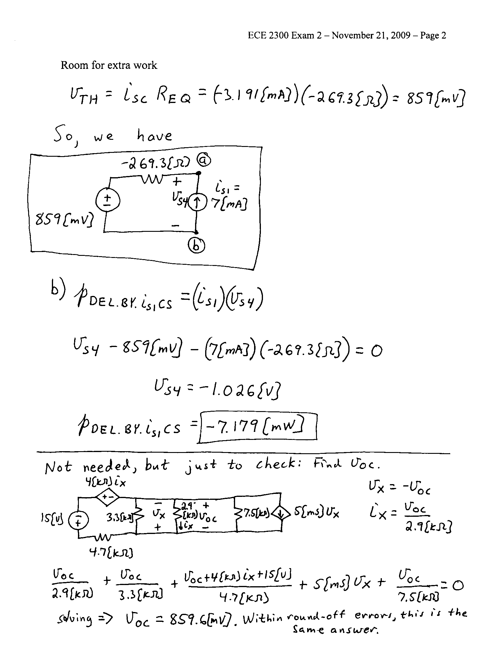

3. {40 Points} Switch SWA was closed for a long time, and switch SWB was open for a long time, before t = 0. Then, at t = 1[s], SWA opened and SWB closed, both at the same time. It is given that v_{X}(0) = 10[V].
a) Find v_{X} (2[s]).
b) Find the energy stored in capacitor C₂ at t = 1.01[s].

