Name: _____________________________ (please print)

Signature: __________________________

ECE 2300 -- Exam #1

October 12, 2013

Keep this exam closed until you are told to begin.

1. This exam is closed book, closed notes. You may use one 8.5” x 11” crib sheet, or its equivalent.

2. Show all work on these pages. Show all work necessary to complete the problem. A solution without the appropriate work shown will receive no credit. A solution that is not given in a reasonable order will lose credit. Clearly indicate your answer (for example by enclosing it in a box).

3. It is assumed that your work will begin on the same page as the problem statement. If you choose to begin your work on another page, you must indicate this on the page with the problem statement, with a clear indication of where the work can be found. **If your work continues on to another page, indicate clearly where your work can be found. Failure to indicate this clearly will result in a loss of credit.**

4. Show all units in solutions, intermediate results, and figures. Units in the exam will be included between square brackets.

5. Do not use red ink. Do not use red pencil.

6. You will have 90 minutes to work on this exam.

1. ________________/20

2. ________________/20

3. ________________/30

4. ________________/30

Total = 100

Room for extra work

1. {20 Points} Use the circuit below to solve this problem. Find the value of R, if the absorbed power by RL is equal to 30[mW].



# Room for extra work

2. {20 Points} Find *vo* by using the circuit shown below.

Room for extra work



3. {30 Points} A device can be modeled as an ideal current source in parallel with a resistance. The device is shown in Figure 1. The characteristics of the device are given in terms of the relationship between the voltage across the device, and the current through the device, as shown in Figure 2. Two identical versions of this device are connected to a circuit using terminals a and b to show the polarity, as shown in Figure 3.

a) Find a model for the device showing terminals a and b.

b) Find the power delivered by Device 1.



Room for extra work

4. {30 Points} A multi-range voltmeter is shown in Figure 1. The meter uses an analog meter, marked with three ranges, each starting at zero, and going to 10[V], 30[V] and 50[V], respectively.

a) Find the values for R1, R2, and R3.

b) Assume that a resistor RX is placed between the 30[V] terminal and the Common terminal. Find RX so that the voltage at the 50[V] terminal with respect to the Common terminal will be 150[V] when the meter reads full scale.

c) With the RX value you found in Part b) connected between the 30[V] terminal and the Common terminal, and with the source in Figure 2 connected with terminal **a** connected to the 50[V] terminal and terminal **b** connected to the Common terminal, find the reading on the 30[V] scale.

d) Repeat your steps in Part c), but this time connect the source in Figure 2 with terminal **a** connected to the 50[V] terminal and terminal **b** connected to the 10[V] terminal. Describe what would happen in this case.



Room for extra work

Solutions:

1. {20 Points} Use the circuit below to solve this problem. Find the value of R, if the absorbed power by RL is equal to 30[mW].

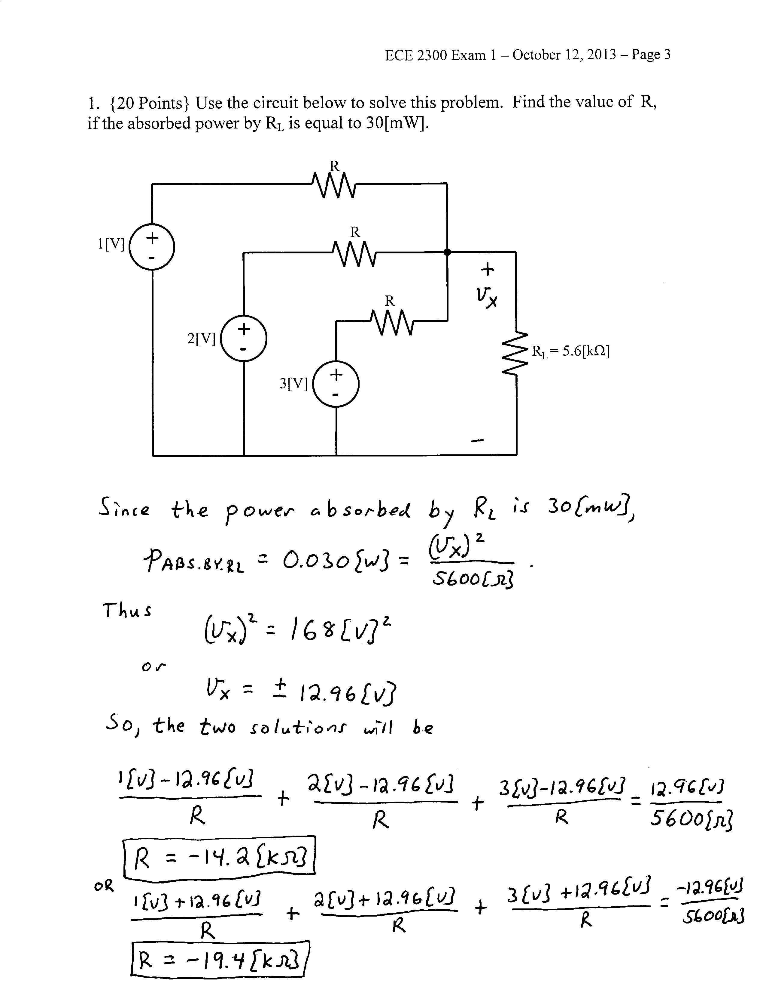

# 2. {20 Points} Find *vo* by using the circuit shown below.



3. {30 Points} A device can be modeled as an ideal current source in parallel with a resistance. The device is shown in Figure 1. The characteristics of the device are given in terms of the relationship between the voltage across the device, and the current through the device, as shown in Figure 2. Two identical versions of this device are connected to a circuit using terminals a and b to show the polarity, as shown in Figure 3.

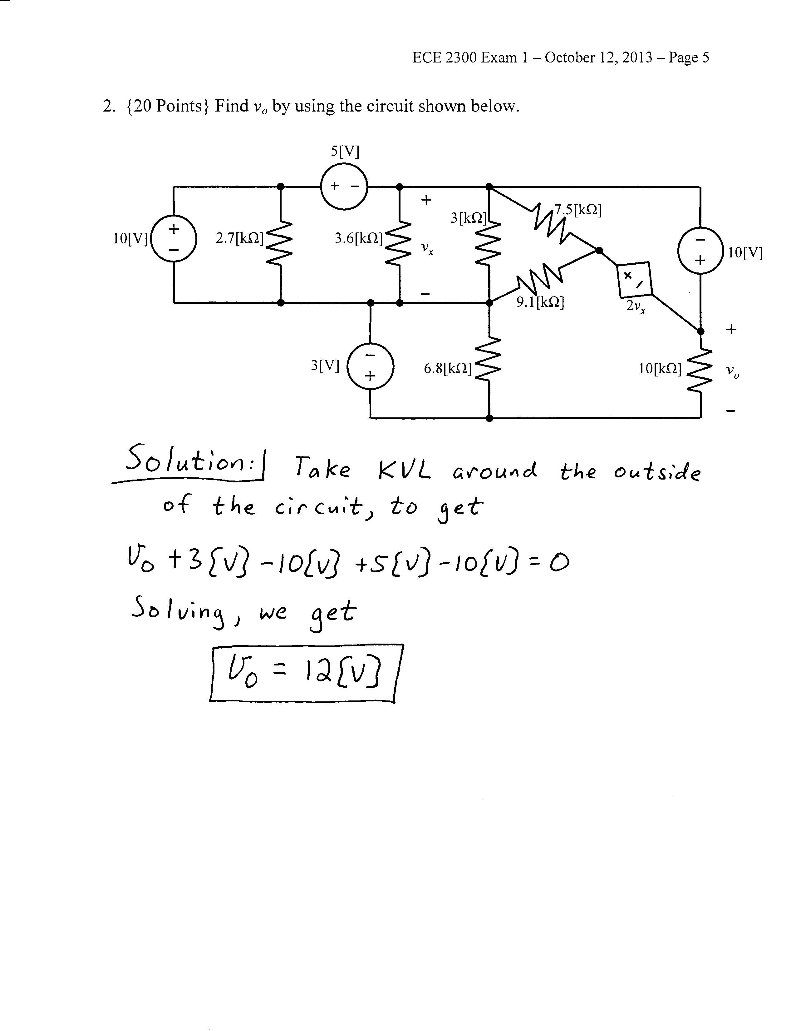

a) Find a model for the device showing terminals a and b.

b) Find the power delivered by Device 1.



See next page:

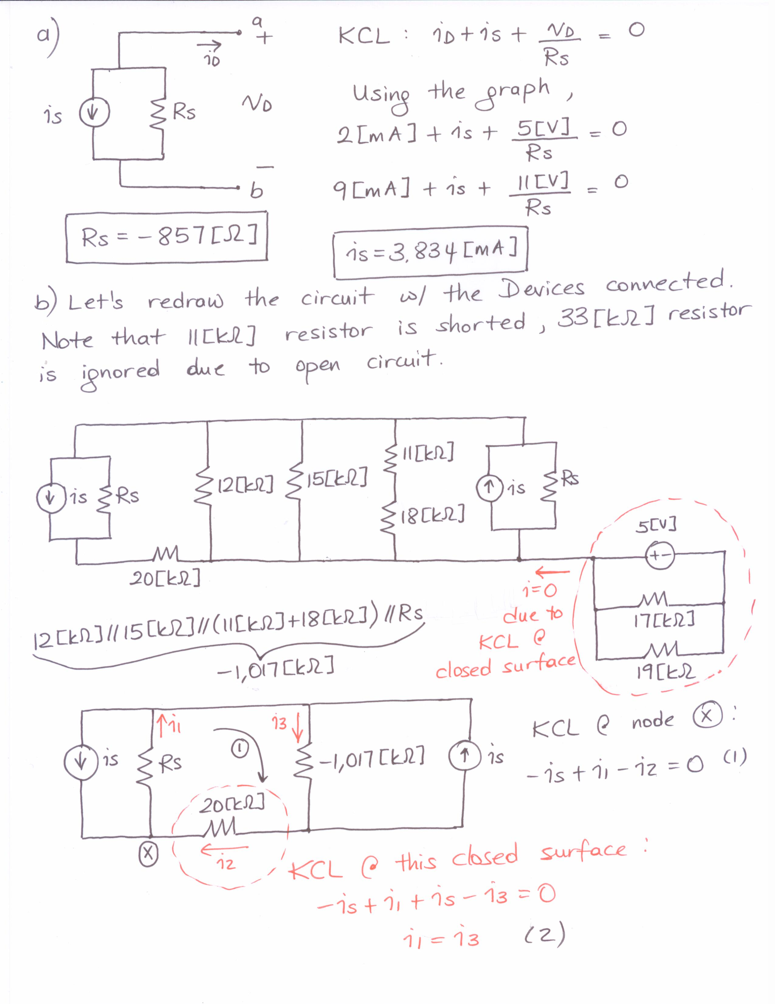

See next page.

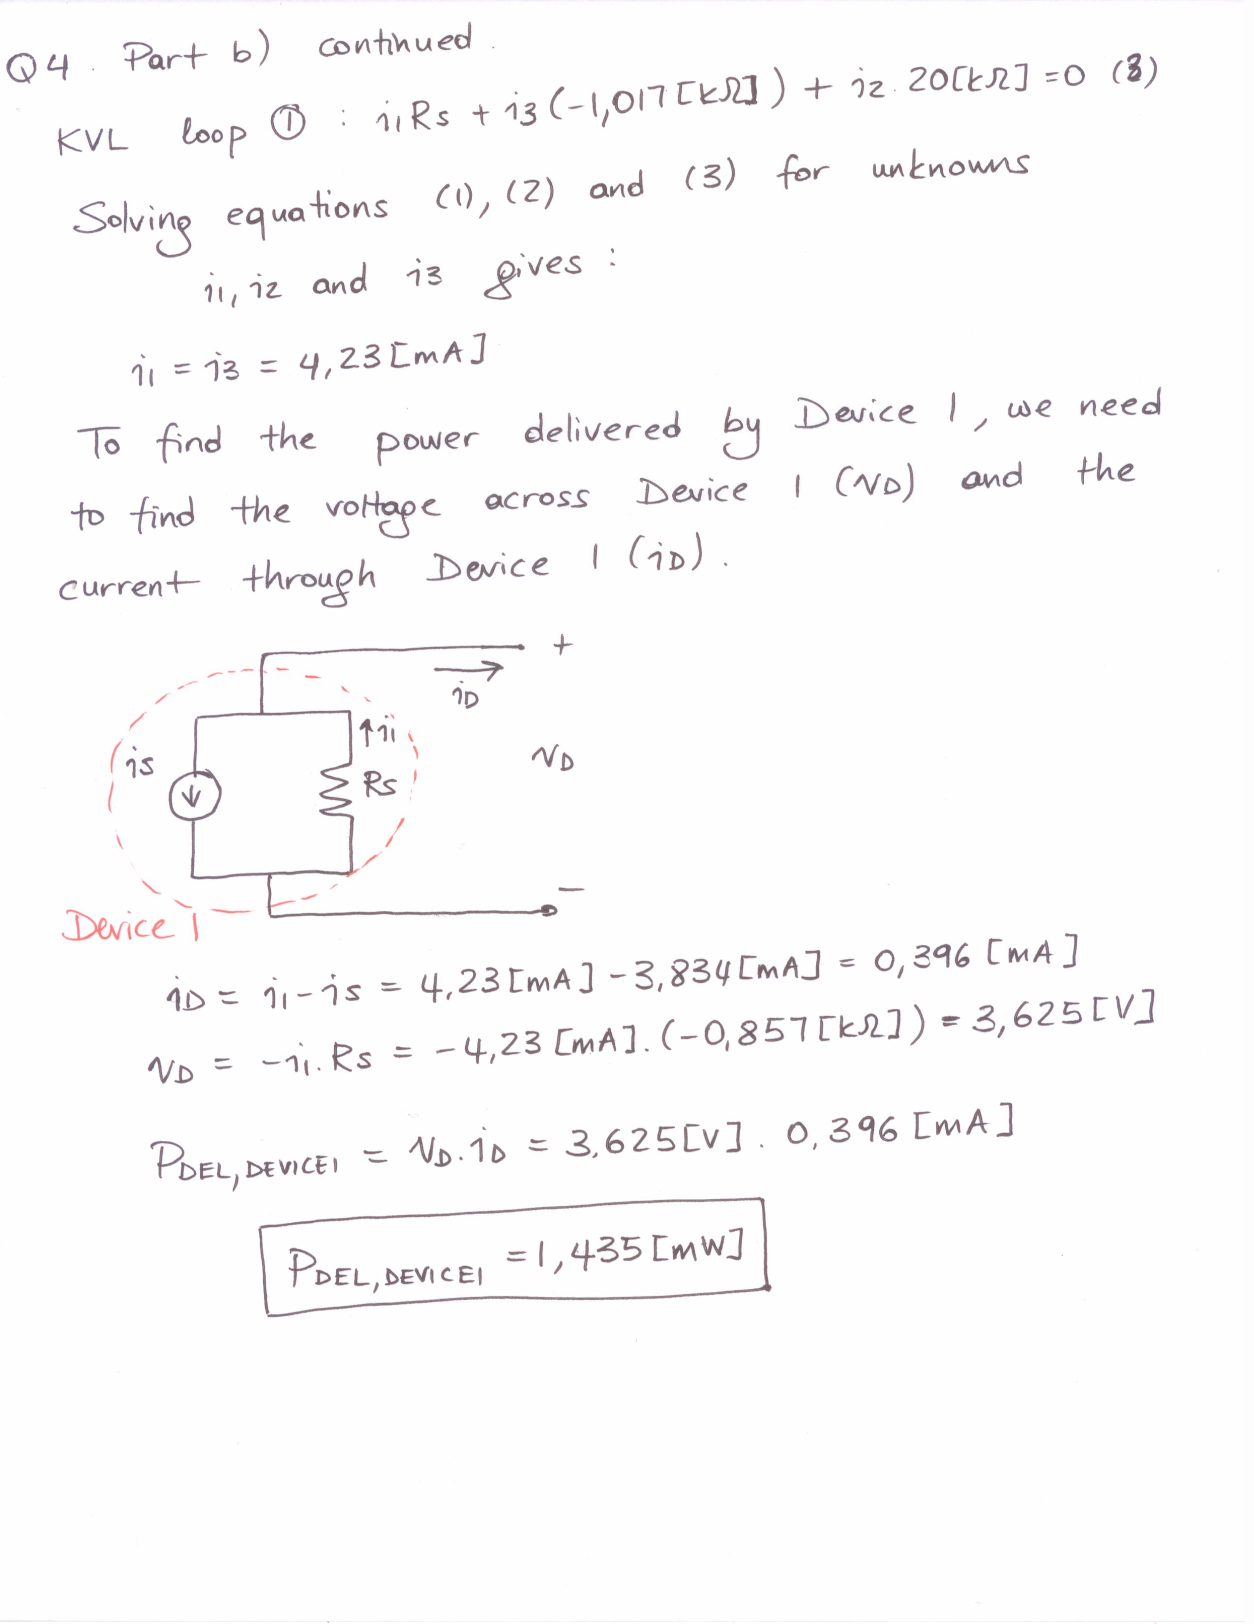

4. {30 Points} A multi-range voltmeter is shown in Figure 1. The meter uses an analog meter, marked with three ranges, each starting at zero, and going to 10[V], 30[V] and 50[V], respectively.

a) Find the values for R1, R2, and R3.

b) Assume that a resistor RX is placed between the 30[V] terminal and the Common terminal. Find RX so that the voltage at the 50[V] terminal with respect to the Common terminal will be 150[V] when the meter reads full scale.

c) With the RX value you found in Part b) connected between the 30[V] terminal and the Common terminal, and with the source in Figure 2 connected with terminal **a** connected to the 50[V] terminal and terminal **b** connected to the Common terminal, find the reading on the 30[V] scale.

d) Repeat your steps in Part c), but this time connect the source in Figure 2 with terminal **a** connected to the 50[V] terminal and terminal **b** connected to the 10[V] terminal. Describe what would happen in this case.

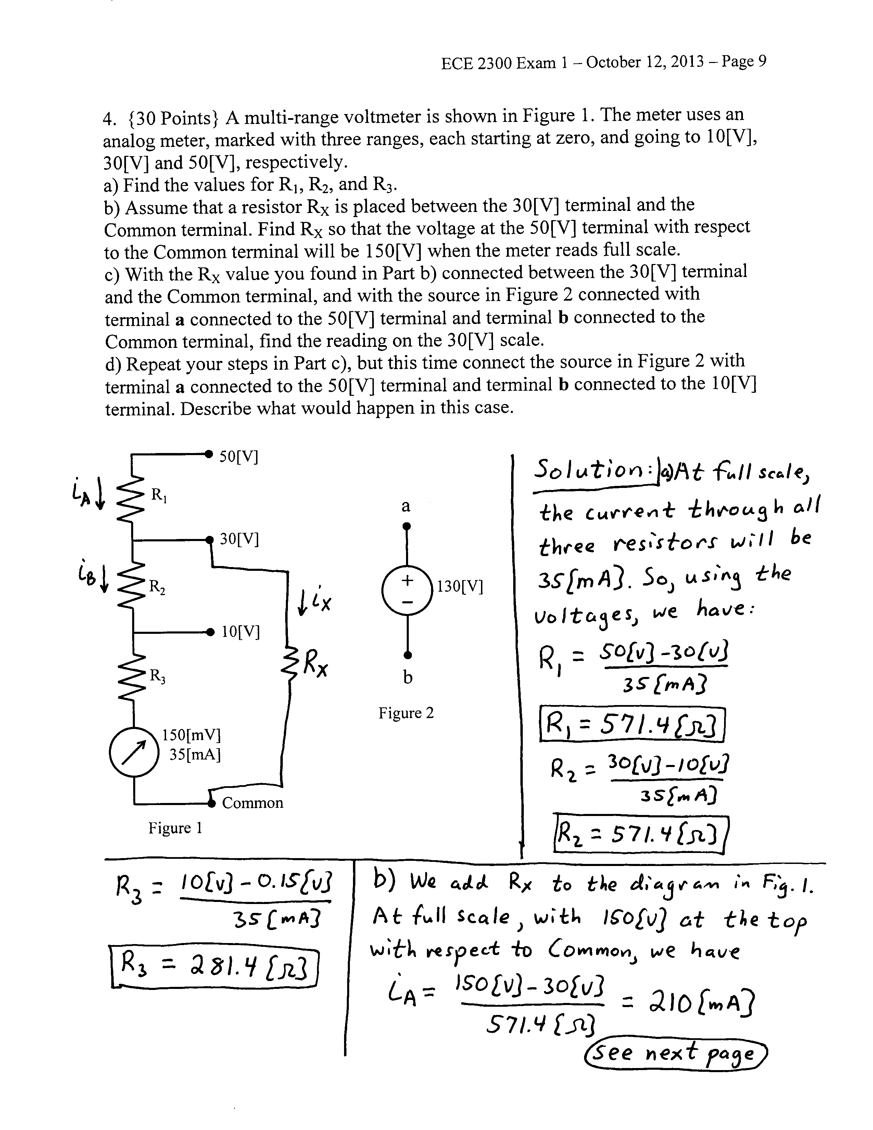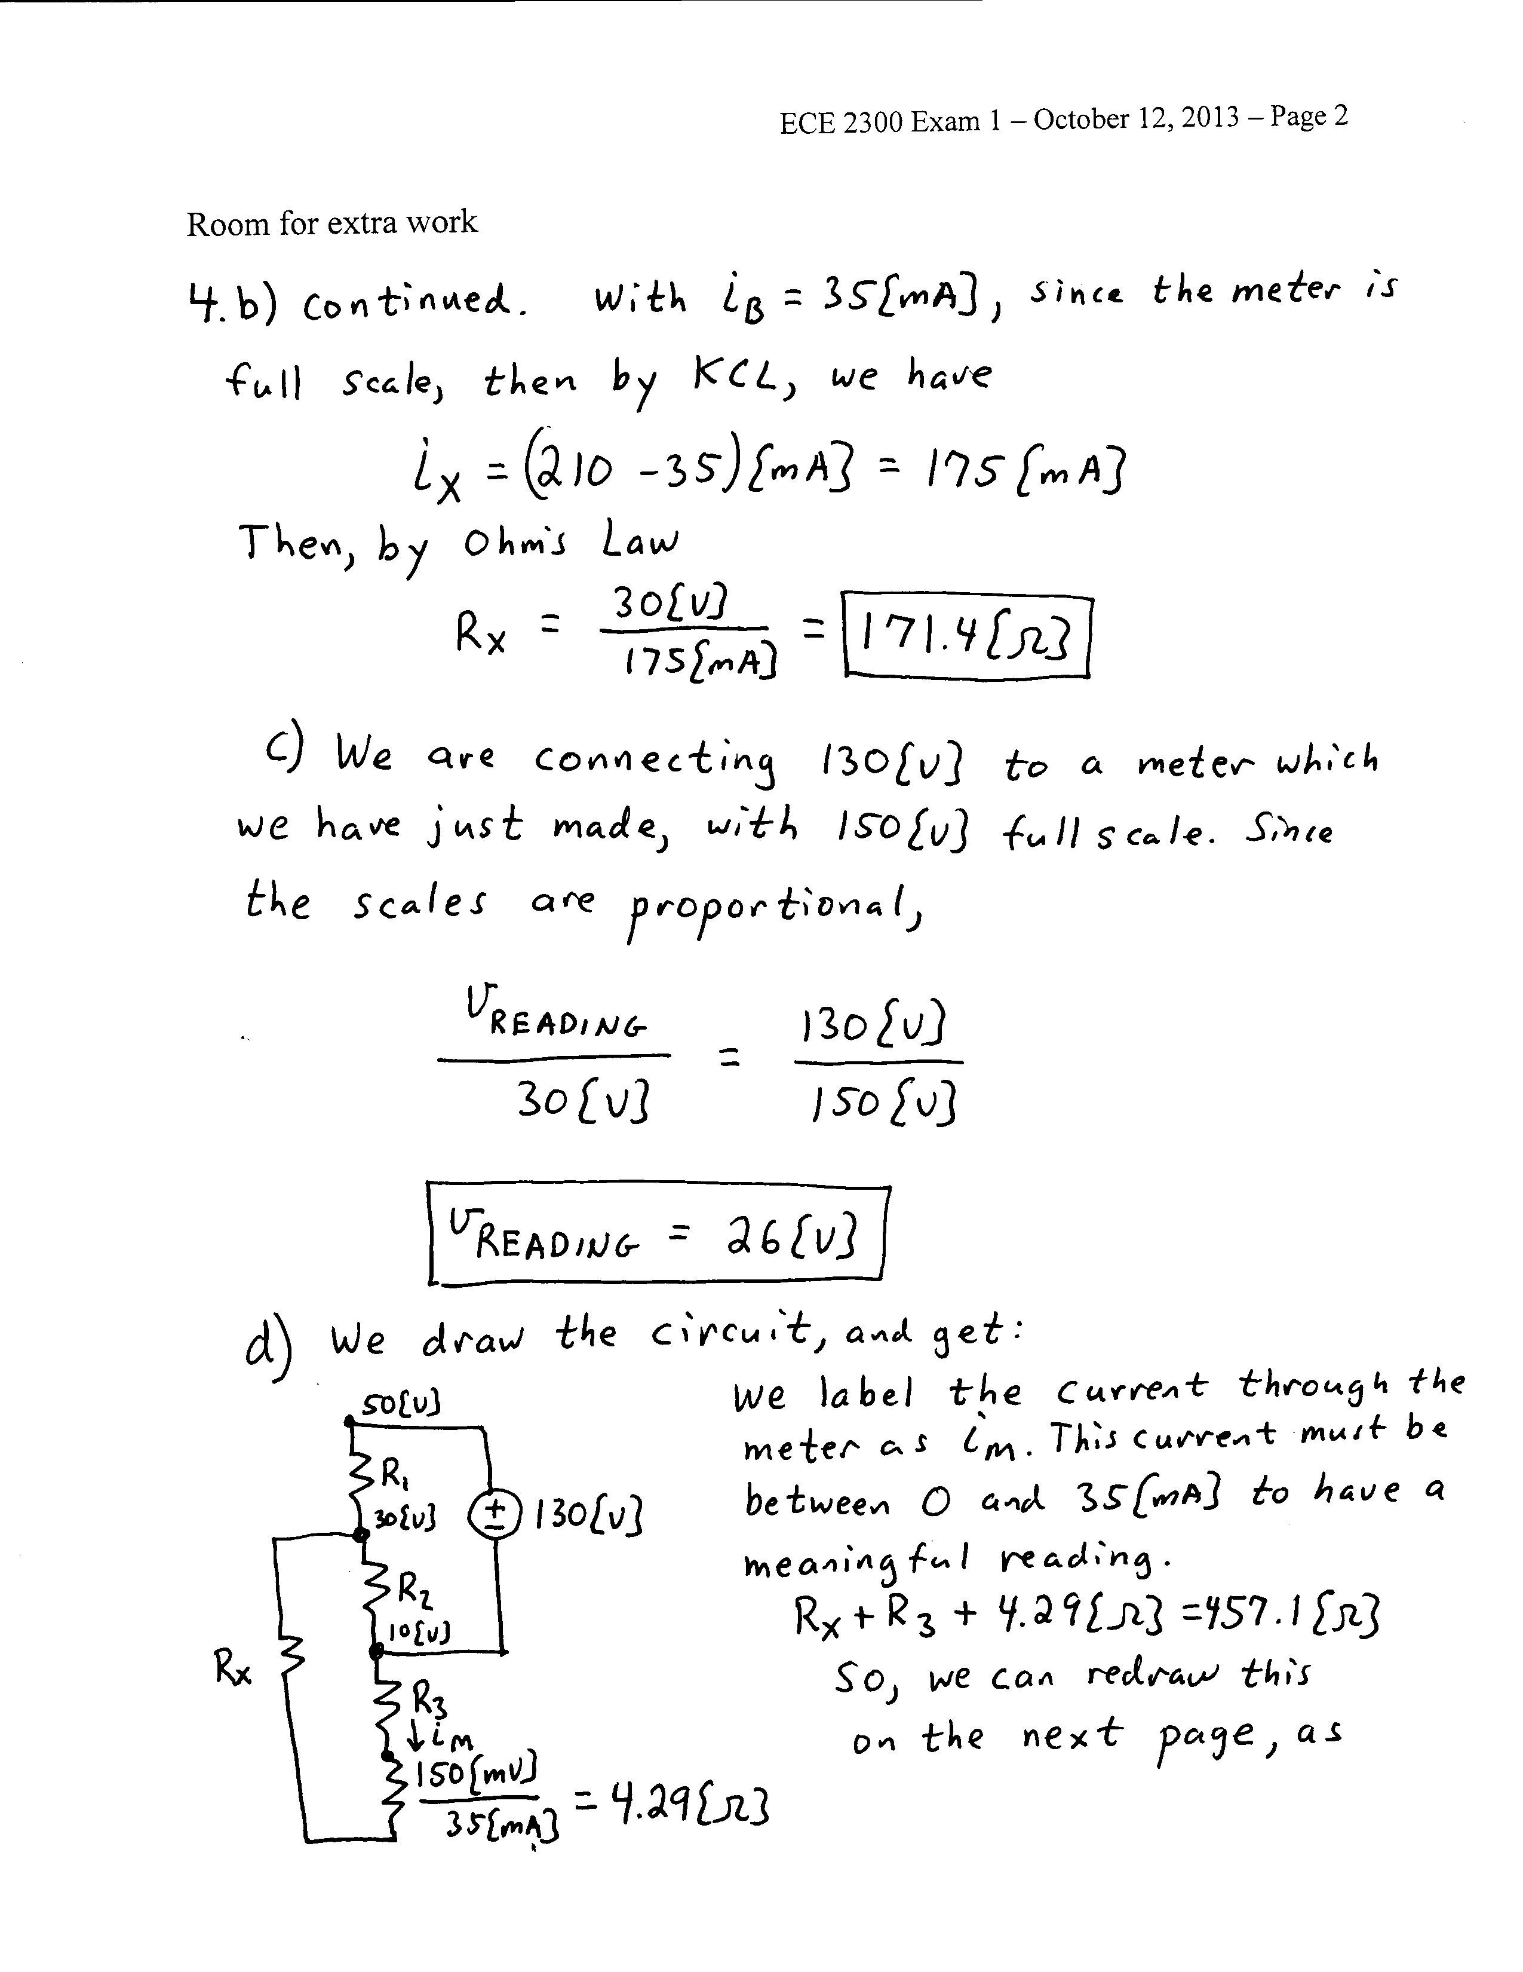

Problem 4, Part d), continued.

