Name: _____________________________ (please print)

Signature: __________________________

ECE 2300 -- Exam #2

November 16, 2013

Keep this exam closed until you are told to begin.

1. This exam is closed book, closed notes. You may use one 8.5” x 11” crib sheet, or its equivalent.

2. Show all work on these pages. Show all work necessary to complete the problem. A solution without the appropriate work shown will receive no credit. A solution that is not given in a reasonable order will lose credit. Clearly indicate your answer (for example by enclosing it in a box).

3. It is assumed that your work will begin on the same page as the problem statement. If you choose to begin your work on another page, you must indicate this on the page with the problem statement, with a clear indication of where the work can be found. **If your work continues on to another page, indicate clearly where your work can be found. Failure to indicate this clearly will result in a loss of credit.**

4. Show all units in solutions, intermediate results, and figures. Units in the exam will be included between square brackets.

5. Do not use red ink. Do not use red pencil.

6. You will have 90 minutes to work on this exam.

1. ________________/30

2. ________________/30

3. ________________/40

Total = 100

Room for extra work

1. {30 Points} Use the node-voltage method to write a complete set of equations that could be used to solve the circuit below. Do not attempt to simplify the circuit. Do not attempt to simplify or solve the equations.

**You must define all circuit variables.**



# Room for extra work

2. {30 Points} Use the circuit below to solve this problem. Find the value of the resistance *RL* that will maximize the power delivered to *RL*.

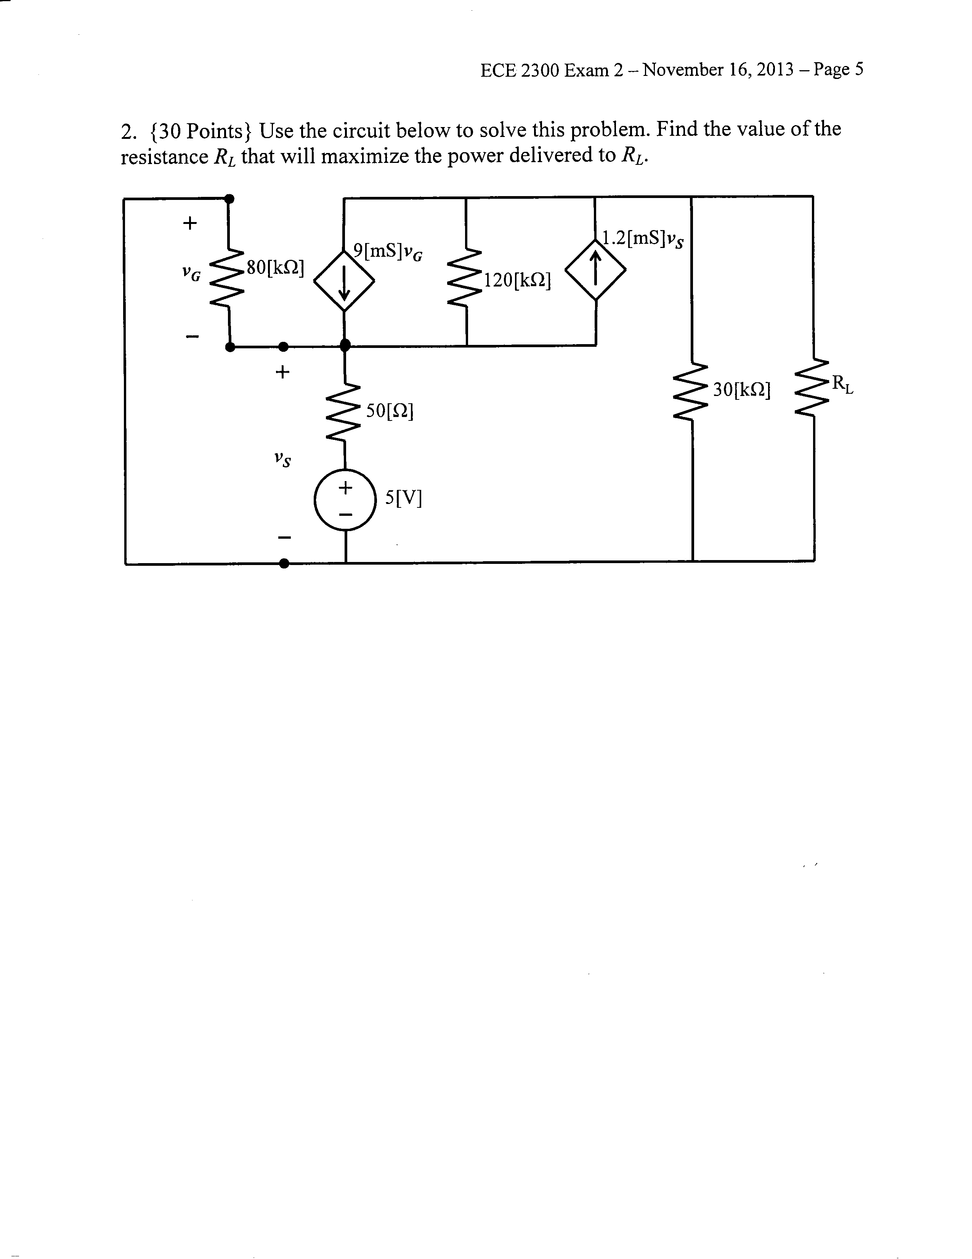

Room for extra work

3. {40 Points} Both switches in this circuit had been in position **a** for a long time before *t* = 0. At *t* = 0, switch **SW2** moved to position **b**, and switch **SW1** moved to position **b** 1[ms]later.

a) Find *iR*(2[ms]).

b) Find the energy stored in the 7.2[μF] capacitor at *t* = 2[ms].



Room for extra work

Solutions:

1. {30 Points} Use the node-voltage method to write a complete set of equations that could be used to solve the circuit below. Do not attempt to simplify the circuit. Do not attempt to simplify or solve the equations.

**You must define all circuit variables.**

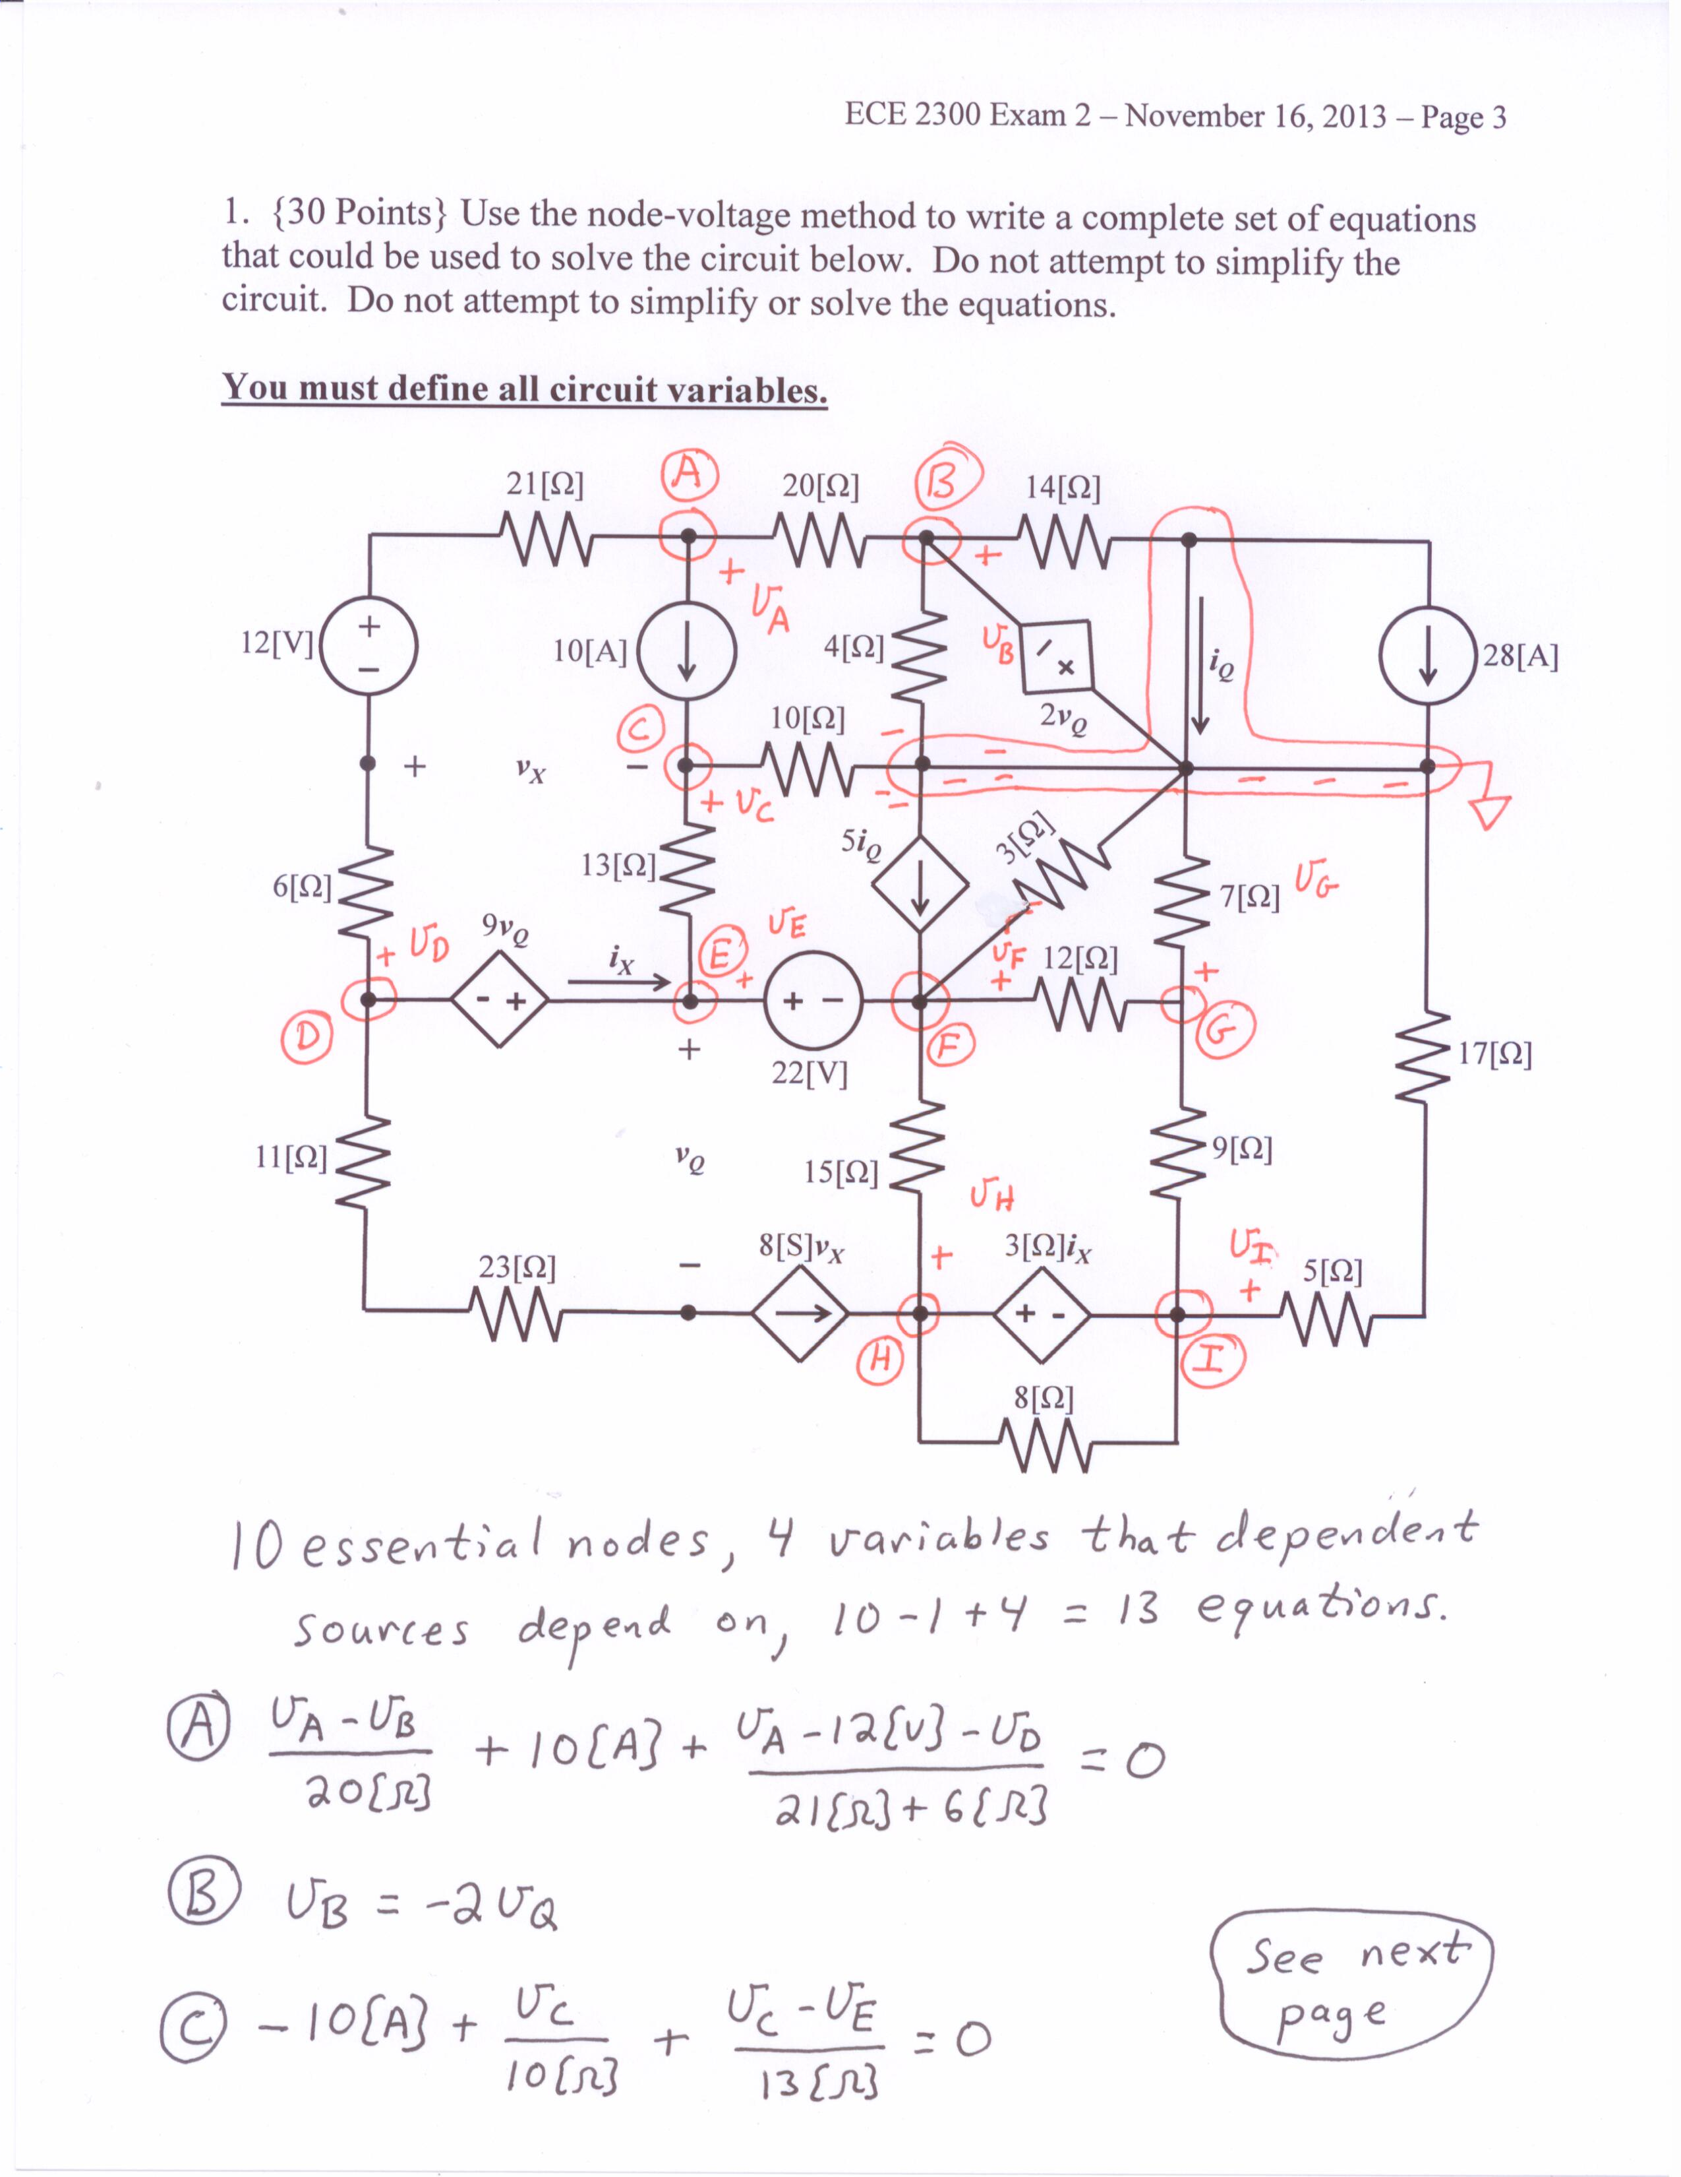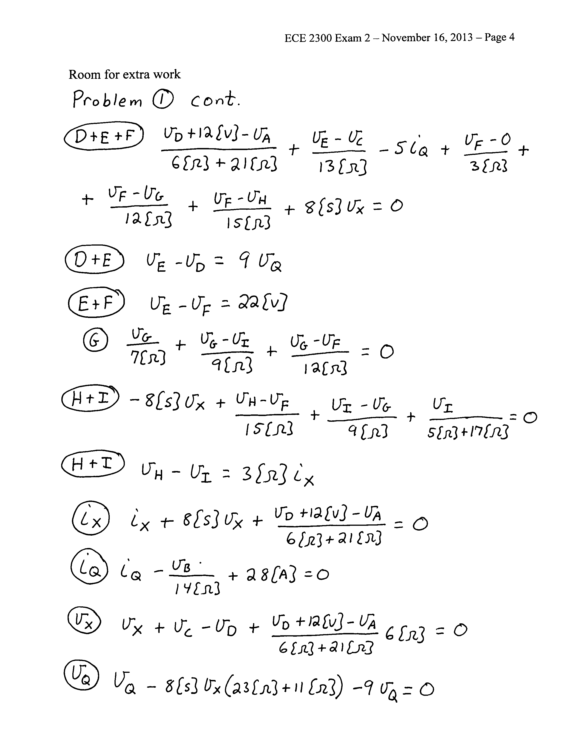

# 

2. {30 Points} Use the circuit below to solve this problem. Find the value of the resistance *RL* that will maximize the power delivered to *RL*.

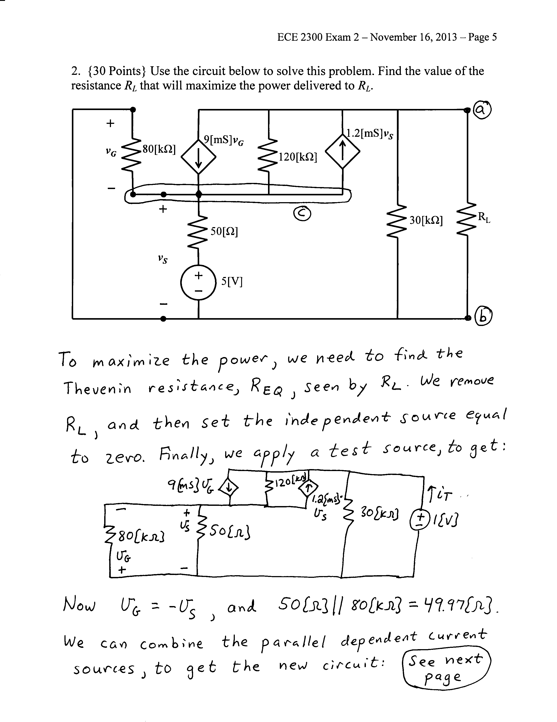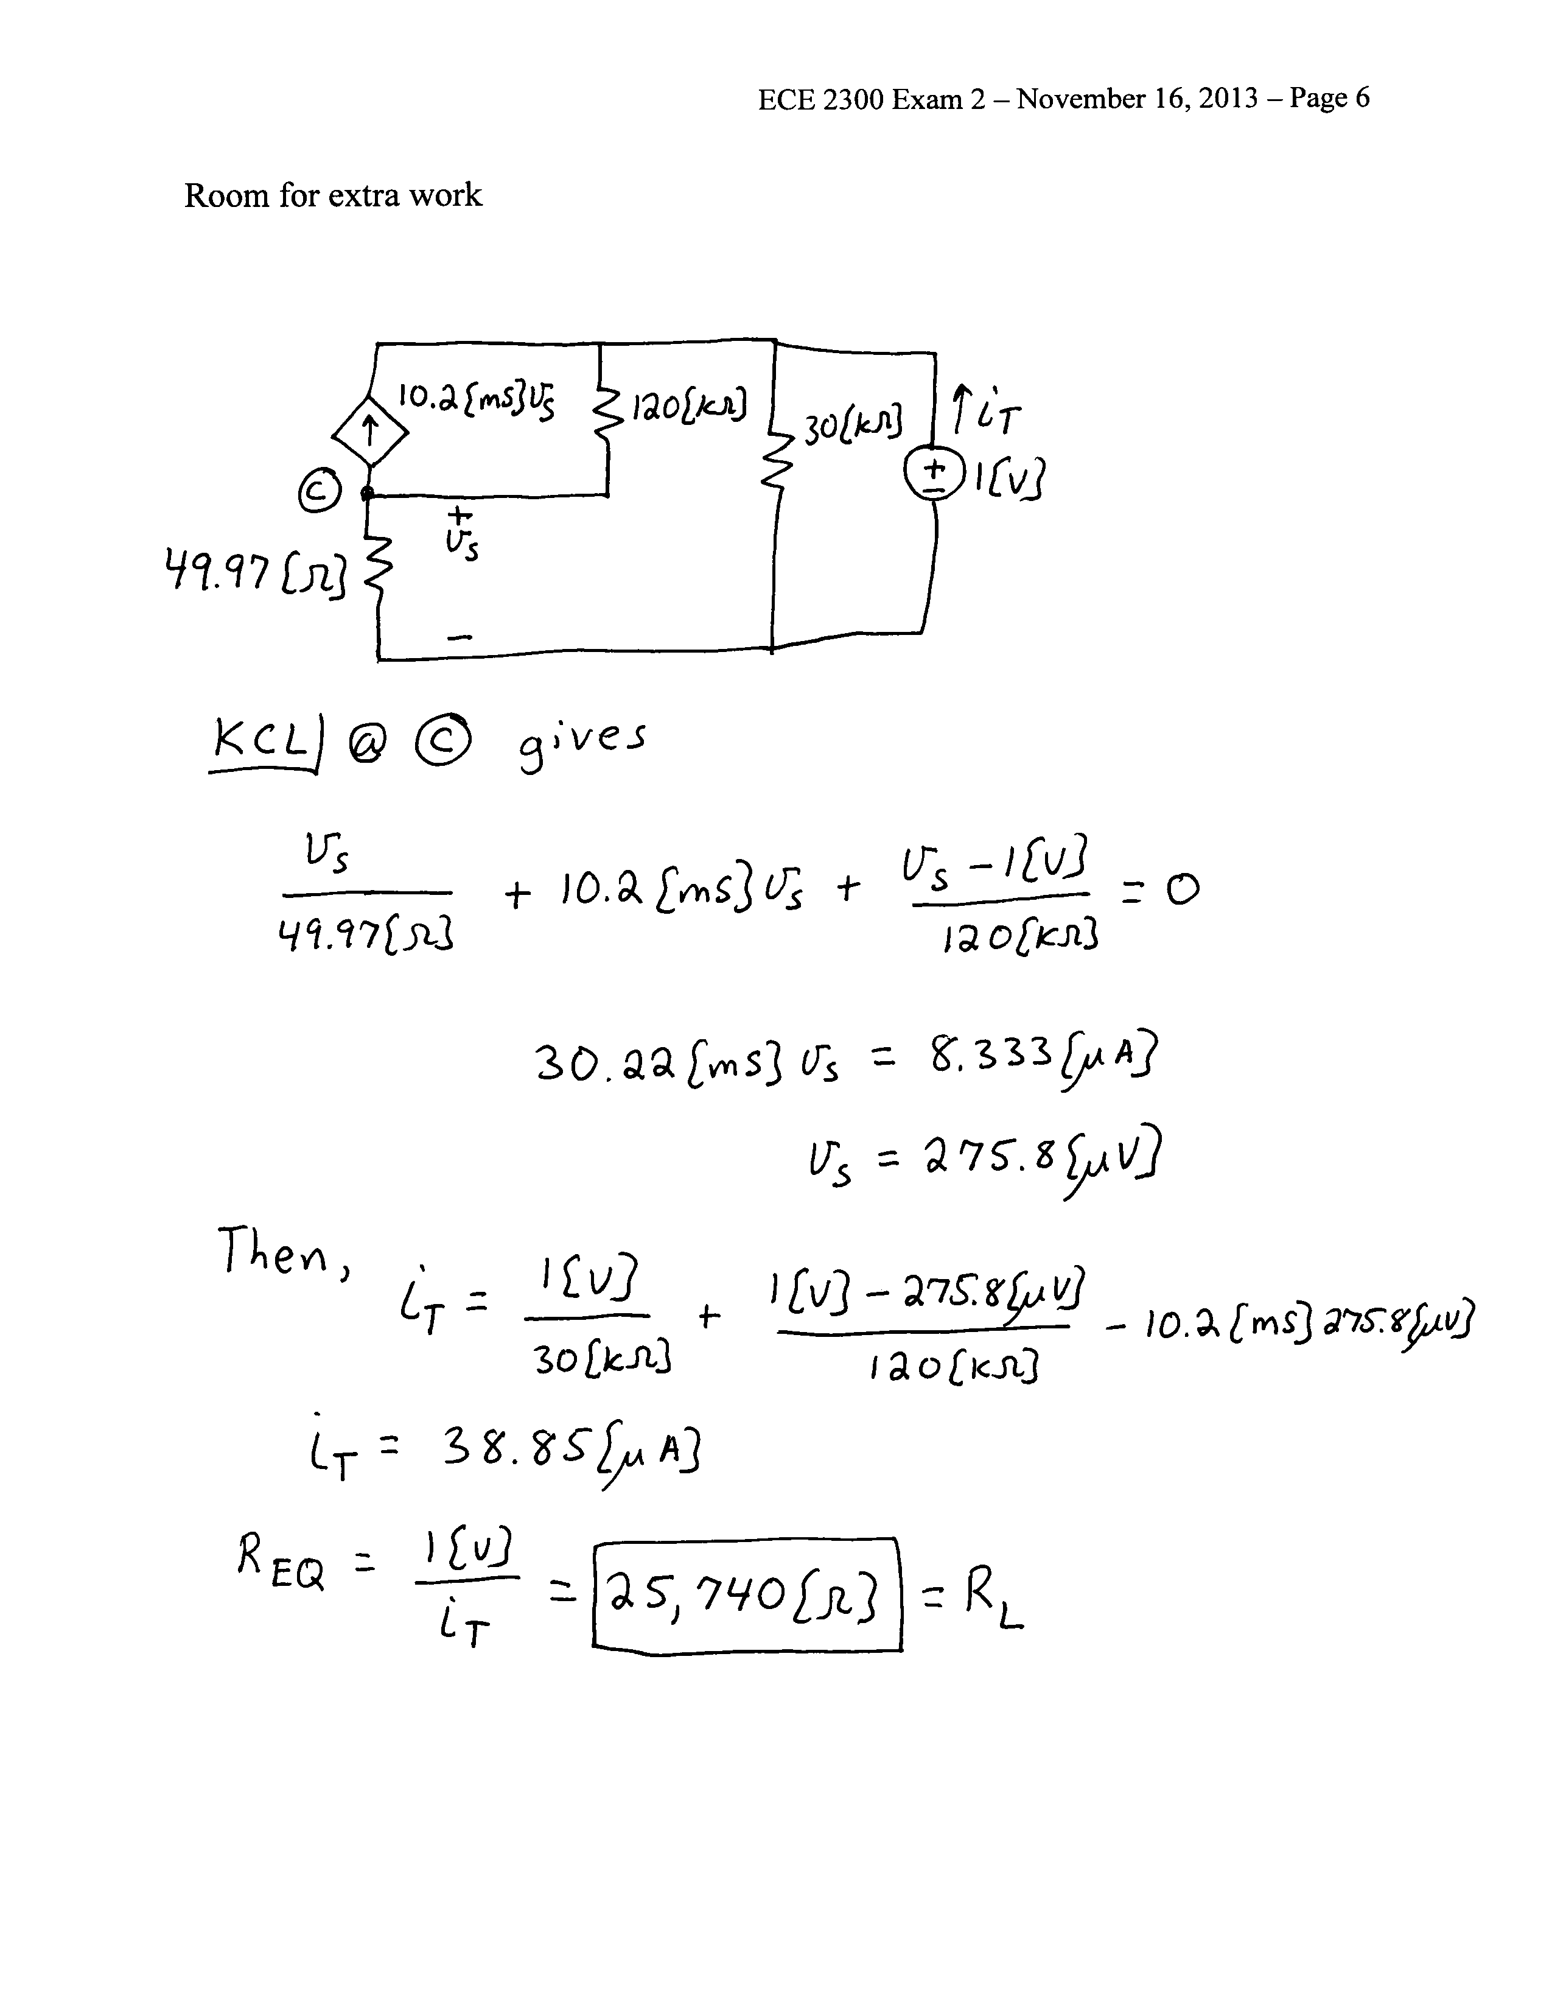

3. {40 Points} Both switches in this circuit had been in position **a** for a long time before *t* = 0. At *t* = 0, switch **SW2** moved to position **b**, and switch **SW1** moved to position **b** 1[ms]later.

a) Find *iR*(2[ms]).

b) Find the energy stored in the 7.2[μF] capacitor at *t* = 2[ms].

